Zuzanna Kaminska (2200035)

Serial position effect research report
Psych Lab (ECPS4007)

Abstract:

The aim of this study is to test the Serial Position Effect. This report includes different studies to compare them to this study. Participants were asked to look at the difference words appearing in front of them on the screen, and afterwards recall as many of them as they possibly could remember (in any other order) on a piece of paper provided. The results showed a clear Serial Position Effect, which was also present in the other studies used to compare them against each other, and in all cases, the findings were very similar and supported each other. The study was done using a list of pre randomized words (see appendix 7).

Introduction:

“Serial position effects refer to the observation that words at the beginning of a list (primacy words) and words at the end of the list (recency words) are remembered typically better than words in the middle of a list…” (Primacy Effect or Recency Effect, Murdock, 1962). In simpler terms, the Serial Position Effect means that when recalling a list of words, we are more likely to remember the words at the beginning and end better than those in the middle, due to our short term and long-term memory, as the words we hear at the beginning are stored in our long-term memory, whereas the words we hear at the end would be stored in our short-term memory. This can be related to the Primacy-Recency effect as it can be defined as “information presented early in the interview tend to have greater influence on the final decision than information presented later…” (Webster, 1964). The information we hear first would be stored in our long-term memory, therefore we would have more time to process it and therefore it would have more influence on our final decision.

The aim of this study is to test the Serial Position Effect, as well as the Primacy-Recency Effect. In this particular experiment, we can hypothesise that the participants will be able to remember words from beginning and end better than those from the middle.

It can be noted that in a study conducted by Mantonakis, Radero, Lesshaeve and Hastie in 2009, they have noted a link between the Serial Position Effect and the Primacy-Recency Effect, as during their large scale experiment they set out to test people’s preference in choice sets between two, three, four or five wines, and found a fairly big primacy effect, as even participants who had previous knowledge about wines, showed a Recency Effect.

Methods:
In this experiment there was 10 participants- 5 female, 3 male and 2 undisclosed. The ages for the participants ranged from 19 years old to 31 years old, and the mean age was 23 years old (23.25). The Standard Deviation for this group was 3.73.

For the IV, there was 14 words in a randomized order, which were randomised by putting all the words on separate pieces of paper and put in a cup and numbers 1-14 being written on separate pieces of paper and the researcher reaching into both cups to match a word to a number. The concreteness ranged from 3.2-3.8. The words (after randomization) were: BEHAVE (3.5), DIRECT (3.5), DEFEND (3.5), CALMLY (3.2), DEADLY (3.8), LOCATE (3.8), GENTLE (3.2), ADVICE (3.5), EXPOSE (3.2), UNLIKLEY (3.4), HONEST (3.4), FORGET (3.5), OBTAIN (3.4) and STUPID (3.5). The words were chosen from the TWP paper (Toronto Word Pool). The DV shows that the participant scores ranged from 10 out of 14 to 3 out of 14. Participant 1- 10/14; participant 2- 3/14; participant 3- 5/14; participant 4- 5/14; participant 5- 4/14; participant 6- 5/14; participant 7- 4/14; participant 8- 4/14; participant 9- 3/14; and participant 10- 4/14. The study was designed to be a between-subject design, as each participant was given the same ‘test’. The analysis which will be present in this report will be qualitative, however it will include the calculated total scores for each word to explore the U-shaped Serial Position Curve which will help support the hypothesis stated earlier in this report.

For designing this research, the researcher has used the computer software ‘Superlab’, which allowed them to create a presentation-like study, where the participant reads the words from the screen and then recalls them onto a piece of paper at the end. The programme allowed the researcher to set up the research so that the words change automatically and have ISI slides in between words allowing the subject to regain focus. The participant would be asked to read and sign the consent form (see appendix 1) and given an opportunity to ask any questions. Only then the study would start with an instruction page (see appendix 2), which would only allow the subject to move on to the next section after pressing the correct key board key, which would be stated at the bottom of the instructions page. After pressing the correct key, the participant would be presented with words in the randomised order stated below. The word would appear in the middle of the screen (size 72, black font, Calibri (body)) for 1500 milliseconds, followed by a blank screen for 500 milliseconds, followed by a black coloured cross in the middle of the screen for another 500 milliseconds as an ISI to allow the participant to regain focus. At the end of the words presentation the participant would be presented with a second set of instructions (see appendix 3) and asked to write down any words they can remember on a piece of paper which has been placed in front of them. After that they will be presented with a debrief from (see appendix 4) and a final opportunity to ask any questions and informed that this is their last chance to withdraw from the study as their results are going to be anonymised afterwards and there will be no way of detecting which results belong to who, in line with the GDPR guidelines.

Results:

To make sure that the data was reliable the researcher has conducted a pilot study before conducting the main study to make sure that there was no misunderstandings, misspellings or repeated words, which then could be fixed before the main study to make sure that the results would be reliable. After the study was finished the percentage score was calculated for each word in the study to see how many participants have recalled them correctly, which was then split into 3 sections: start (top 3), middle (next 8) and end (last 3). The results for this can be seen in appendix 5, however it is clear that it does support the researcher’s hypothesis, as it can be clearly seen that only 18.75% of participants were able to recall the middle words, compared to 50.00% of the start words and 56.67% of end words, which in this case makes a significant difference. The scores were then plotted on a graph and it is clear that they form a ‘U shaped’ curve, which is typical for the Serial Position Effect (see appendix 6) (McCrary and Hunter 1953). There might be some notable anomalies in the data, such as that 4th last word is recalled more times than the 3rd last words, however, it can be due to the fact that the word “honest” can be seen as a softer word than “forget” due to it having lower concreteness (3.4 compared to 3.5) and therefore can be seen as a softer word, making it easier to remember.

Discussion:

The findings of this report agree with the researchers’ hypothesis, which was that the participants will be able to recall more words from the start and end than from the middle. The research confirms that, as we can see that the results support the Serial Position Effect and Primacy-Recency Effect, as it is clear that there is a higher percentage of words from the beginning and end being recalled by more people, compared to the middle words, with most words being recalled from the end of the list, which is supported by the study “A serial position effect in recall of United States Presidents” (Roediger and Crowder, 1976). In their experiment they asked college students to recall the US Presidents in any order, and they found that the memorability of presidents was strongly related to their chronological order (the exception was the extremally high recall of Lincoln). They also came to a conclusion that the Serial Position Effect extends to the Sematic memory, which means that the end points of series, can be seen as a distinct point for the memory search to begin around. This agrees with the findings of the researcher, as the last word had the highest recall percentage (see appendix 6). The findings in this report also related to the previously mentioned study by Mantonakis, Radero, Lesshaeve and Hastie as even if some of the participants in this research were more familiar with some words than other, they still showed the Recency Effect. The most notable anomalies in this study, which has been mentioned above is that the 5th and 4th last words have been recalled more times than the 3rd last word, however, as mentioned above, this is most likely due to the fact that the 5th and 4th last words have lower concreteness (both 3.4) which makes them easier to remember, compared to the 3rd word (3.5). It is clear that the study has certain weaknesses, the most noticeable ones being how low-scale it is and the difference in word length and concreteness of words. If the study were to be redone, the researcher should include more participants to make it more generatable, which would make it more applicable to a wider population and in turn make the results more reliable. Furthermore, the researcher should make sure that words are the same length, so that the study wouldn’t be biased towards people being able to recall the shorter words rather than the longer ones. They should also make sure that the words are of the same concreteness, to ensure that all words are of the same level of difficulty, to again, make sure the study is not biased towards the easier words.

In conclusion, it is clear that the study was successful in showing and proving the serial Position Effect and how it is related to the Primacy-Recency Effect. The experiment was able to prove that the order of the words matters when it comes to our memory, however that there are also other factors that affect it, such as the length of the word.

Appendixes:

Appendix 1:
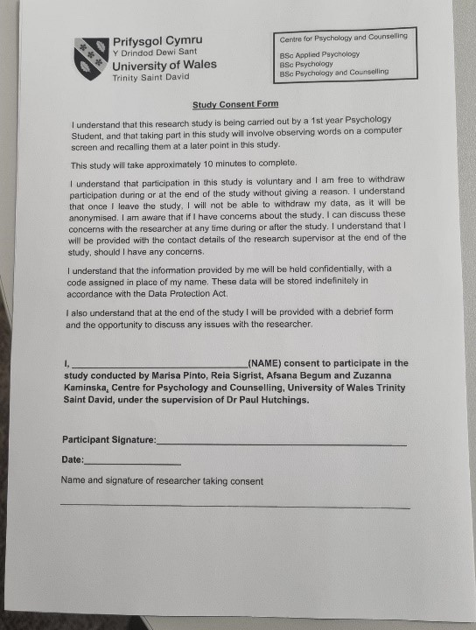

Appendix 2:
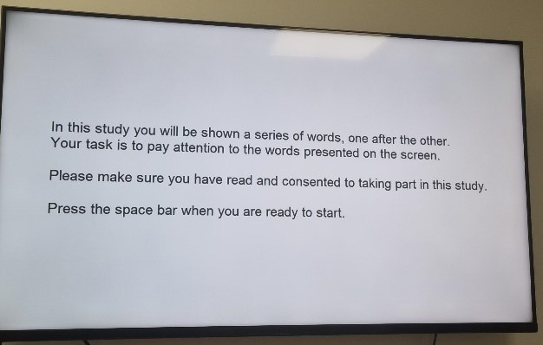

Appendix 3:
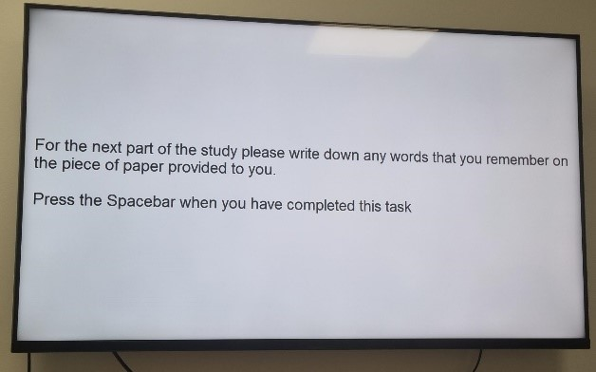

Appendix 4:
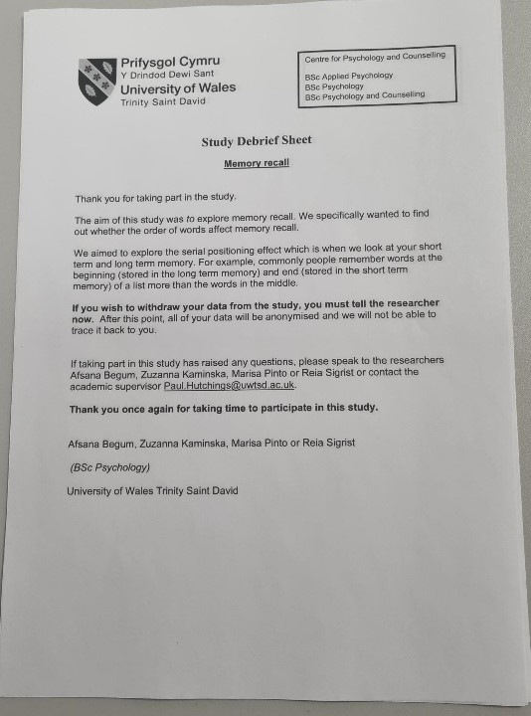

Appendix 5:

Appendix 6:

Appendix 7:

Words | Number of correct recalls (OUT OF 10)
BEHAVE | 5
DIRECT | 4
DEFEND | 6
CALMLY | 3
DEADLY | 2
LOCATE | 1
GENTLE | 0
ADVICE | 1
EXPOSURE | 1
UNLIKELY | 4
HONEST | 3
FORGET | 1
OBTAIN | 6
STUPID | 10

Reference List:

Farr, J. L. (1973). Response requirements and primacy-recency effects in a simulated selection interview. Journal of Applied Psychology, 57(3), 228–232. https://doi.org/10.1037/h0034708

2.Feigenbaum, E. A., & Simon, H. A. (1962). A theory of the serial position effect. British Journal of Psychology, 53(3), 307-320.

3. Kasper, Brueggen, K., Grothe, M. J., Bruno, D., Pomara, N., Unterauer, E., Duering, M., Ewers, M., Teipel, S., & Buerger, K. (2016). Neuronal Correlates of Serial Position Performance in Amnestic Mild Cognitive Impairment. Neuropsychology, 30(8), 906–914. https://doi.org/10.1037/neu0000287

4. Mantonakis, Rodero, P., Lesschaeve, I., & Hastie, R. (2009). Order in Choice: Effects of Serial Position on Preferences. Psychological Science, 20(11), 1309–1312. https://doi.org/10.1111/j.1467-9280.2009.02453.x

5.Roediger, H.L., Crowder, R.G. A serial position effect in recall of United States presidents. Bull. Psychon. Soc. 8, 275–278 (1976). https://doi.org/10.3758/BF03335138

