

Module Code: ECAD5015

Assignment Title: Deepening Practice
ALN – Part 1 Journal / Part 2 Video Reference list and link (delete as appropriate)
Student Name: Megan Howard
Student Number: 2304259
BA Primary Education (QTS)

AI Acknowledgement

I confirm that I have not presented any AI generated materials as my own work.
I confirm that I have copies of my drafts, notes, and other resources I used, which I may be asked to provide in evidence.

I acknowledge the use of chat GBT on [9th of May] to help me find different useful resources in supporting my two strategies I used the prompt(s):
1. find me replacement sources to support my point that visual timetables may be helpful in the classroom.
2. find me relevant sources that can support my point that movement breaks can help a school day

Targets from previous module | How I have worked on these?
Revise harvard refrencing | Looked through the guide to allow me to cite my text correctly.
Countune to develop my critical writing | Researched websites to support my arguments

Additional Learning Needs Journal
Inclusive education is a meaningful approach that reshapes how children learn and grow by ensuring all abilities or needs are met (University of Bolton, 2023). Inclusivity is central to the Curriculum for Wales, reflecting the belief that all learners should access high-quality education in mainstream settings. By adapting the curriculum to meet individual needs, schools ensure every child receives the support needed to reach their full potential (Welsh Government, 2024; Thomas, 2022).
The Additional Learning Needs and Education Tribunal (Wales) Act 2018 is an act that supports children and young people in Wales with additional learning needs. A key feature of the Act is the introduction of Individual Development Plans (IDPs) for all learners with ALN, ensuring their needs are identified early and met through a person-centred approach. The Act also gives families the right to appeal decisions to the Education Tribunal for Wales. (Welsh Government, 2023). The act replaced the former SEN system with a more unified approach, supporting

(Welsh Government, 2024)
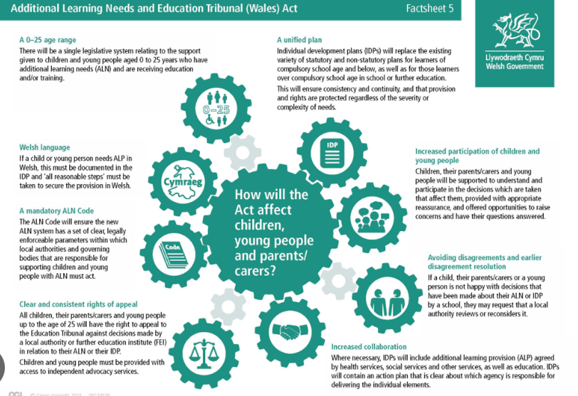
learners from birth to age 25. This reform promotes a person-centred approach, tailoring support to each learner’s unique needs and encouraging inclusion in mainstream education (Welsh Government, 2020; Griffiths & Jones, 2021). The Act also created a new legal framework for supporting children and young people with ALN. While this has been seen as a positive for the Welsh curriculum, Estyn (2024) highlights that there is limited access to equitable support for Welsh-medium ALN provision. This is mainly due to challenges in recruitment and resource availability, which could potentially hinder the development of Welsh-speaking children (Estyn, 2024). Alongside this act, the Additional Learning Needs Code for Wales 2021 provides practical guidance to ensure needs are identified early and addressed effectively, helping all learners achieve their potential (Gowerton School, 2023).
The Well-being of Future Generations (Wales) Act 2015 supports children with Additional Learning Needs (ALN) by encouraging a more inclusive, equal and supportive education system. It promotes long-term planning and early intervention, helping to identify and address the needs of ALN learners as early as possible (Welsh Government, 2015). The Act embeds equality, diversity, and well-being into public decision-making, requiring that the needs of all individuals especially those from disadvantaged backgrounds are considered when shaping policy (Welsh Government, 2024). It’s well-being goals aim to ensure all children could reach their full potential, supported by five keyways of working which include long-term thinking, prevention, integration, collaboration and involvement. To help deliver these aims, the Future Generations Commissioner for Wales has introduced an Equality Strategy to guide inclusive and equitable practices across public services (Future Generations Commissioner for Wales, 2025).
The Welsh Government’s commitment to inclusive practice aligns with Vygotsky’s Zone of Proximal Development (ZPD), where learners receive tailored support to reach their potential (Vygotsky, 1978). The ALN reform in Wales reflects this by removing barriers to participation and ensuring appropriate support. However, ZPD has been criticised for lacking clear classroom guidelines (McLeod, 2014) and potentially limiting independent thinking (Murphy, Scantlebury, & Milne, 2015). In contrast, Piaget’s theory of cognitive development (1952) promotes active learning, which Main (2021) suggests is particularly beneficial for learners with ALN.
It is extremely important for teachers to be educated in promoting equality and fairness so that all children have an equal opportunity to succeed, regardless of ability, gender, or race. While researching my PTE 2 placement school’s most recent Estyn report, I found that 55.6% of students were identified as having Additional Learning Needs. This highlights the importance of inclusive practices. During my time on placement, applying different inclusive strategies helped me grow as a practitioner and allowed me to provide meaningful support to learners. This experience aligns with Article 2 of the UNCRC—the right to non-discrimination—which states that every child should enjoy their rights without discrimination of any kind. I saw this reflected in my placement school, where all children received the support they needed (UNICEF, 2022

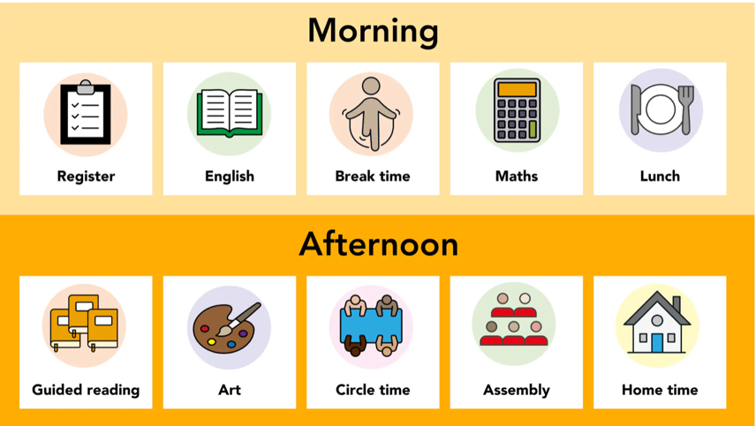
(PlanBee, 2025).
This is a visual timetable. A visual timetable is a tool commonly used in schools to display the schedule of activities, showing what is coming next, how long each activity will last, and the sequence of events (Council for Disabled Children, 2024; NHS Trust, n.d.). This resource is especially beneficial for children with Additional Learning Needs (ALN), such as autism or ADHD, as it provides a clear structure and reduces anxiety by making the daily routine predictable and easy to follow (National Autistic Society, 2018). According to Norfolk Council (2025), visual timetables hold many benefits such as encouraging independence and improving focus and concentration by allowing children to track what they need to get done during the day. During my placement, I used a visual timetable in a Year 3 classroom to support children with ALN, particularly one child with autism. The timetable was displayed at the front of the room, featuring pictures that represented activities and times. I observed that this visual aid helped improve focus, especially during transitions between activities. As a student teacher, I referred to the timetable regularly, involving the children in updating it and discussing the day's events. This approach encouraged routine, promoted independence, and gave learners a sense of control over their day. This can be supported by However, there are some limitations to visual timetables. Not all children interpret visual cues in the same way. Some may need more personalised symbols or require adult support to understand them fully (Hewitt, 2018). Additionally, creating and maintaining visual timetables can be time-consuming for teachers, especially when schedules change unexpectedly (TES, 2020). Another potential challenge is that students may become overly reliant on the timetable, struggling when it’s unavailable or when there are unanticipated changes (Mesibov & Shea, 2010). As a future practitioner, I would continue to use visual timetables as I found them effective in supporting routine, reducing anxiety, and promoting independence, particularly for children with ALN. To ensure they are fully inclusive, I would use clear, age-appropriate visuals, combine both text and images, and actively involve children in updating the timetable. Marshall (2024) supports this, explaining that visual timetables can foster independence when personalised to individual needs.

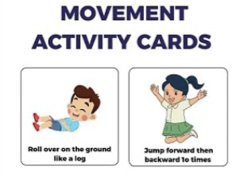
(Tes, 2024)
A movement break is a short, planned activity that allows students to move their bodies and release energy. Typically, it occurs in the middle of a lesson or after a period of focused work (Felder and Brent, 2024). These breaks help children refocus, improve attention, and reduce stress or anxiety. They are particularly beneficial for students who may struggle to sit for long periods, such as those with attention deficit hyperactivity disorder (ADHD) or other Additional Learning Needs (ALN) (Ravizza, 2014). During my time in a Year 3 classroom, I observed how movement breaks were incorporated into the daily routine to help students stay engaged. The teacher scheduled short breaks between lessons, allowing students to stand, stretch, and participate in simple activities like star jumps or quick dances. After these breaks, students appeared more alert and engaged. As a student teacher, I facilitated these breaks by encouraging participation and letting children who showed positive engagement choose the movements. This promoted both independence and leadership. However, movement breaks do have limitations. According to Chorlton et al. (2022), time constraints are a significant barrier, with one Year 1 teacher noting, “there is never enough time.” Fisher and Louw (2023) further explain that crowded curriculums leave little room for movement breaks, making it challenging to fit them in without compromising academic goals. Another challenge is the difficulty of transitioning students back to focused work after the break. While movement breaks increase energy, they can sometimes make it harder for students to settle back into academic tasks (Graham, 2015). Despite these barriers, I believe movement breaks are an effective strategy to support student focus, well-being, and engagement, especially for children with ALN. To ensure they are inclusive, I would provide various movement options, including seated exercises for students with mobility challenges.
In conclusion, being an inclusive practitioner involves valuing all children, regardless of their abilities or backgrounds, and ensuring they receive the necessary support to thrive. Inclusive practice promotes equality and respect, fostering a classroom environment where every child feels they belong. This aligns with the Additional Learning Needs and Education Tribunal (Wales) Act 2018, which emphasizes meeting all learners' needs. It also links to the Welsh QTS standards, which state that “the teacher raises awareness of how high-quality learning experiences and performance outcomes lead to improved learning and improved habits of well-being.”
To improve my future practice, I aim to deepen my understanding of additional learning needs through reflection and continued learning. I plan to further explore the use of visual resources and adapt my teaching to better meet individual needs. I also intend to work more closely with support staff to help create a consistent, supportive, and inclusive classroom environment for all pupils.

Reference list

Additional Learning Needs and Education Tribunal (Wales) Act 2018, c. 2. Availableat: https://www.legislation.gov.uk/anaw/2018/2/contents/enacted (Accessed: 14 May 2025).
Chorlton, R.A., Williams, C.A., Denford, S. and Bond, B. (2022) 'Incorporating movement breaks into primary school classrooms: a mixed methods approach to explore the perceptions of pupils, staff, and governors'. BMC Public Health, 22(1). Available at: https://doi.org/10.1186/s12889-022-14551-5.
Council for Disabled Children (2024) What is a visual timetable? Available at: https://councilfordisabledchildren.org.uk/sites/default/files/uploads/attachments/Visual%20Timetables%20Resource.I%20CAN.FINAL_.pdf.
Estyn (2024). Estyn highlights progress and challenges in implementing Additional Learning Needs reform in Wales. Available at: https://estyn.gov.wales/news/estyn-highlights-progress-and-challenges-in-implementing-additional-learning-needs-reform-in-wales/ (Accessed: 15 May 2025).
Felder, R.M. and Brent, R. (2024) Teaching and Learning STEM. Jossey-Bass.
Fisher, D. and Louw, Q. (2023) 'Primary school learners’ movement during class time: perceptions of educators in the Western Cape, South Africa'. BMC Public Health, 23(1). Available at: https://doi.org/10.1186/s12889-023-17428-3.
Future Generations Commissioner for Wales (2025) Monitoring and Assessing - Future Generations Wales. Available at: https://futuregenerations.wales/do/involvement/monitoring-and-assessing [Accessed 12 May 2025].
Gowerton School (2023) Additional Learning Needs and Education Tribunal (Wales) Act. Available at: https://gowertonschool.com/additional-learning-needs-and-education-tribunal-wales-act/.
Graham, J. (2015) 'The challenges of managing transitions in the classroom: A focus on movement breaks'. Journal of Educational Psychology, 107(1), pp. 15-24.
Griffiths, J. and Jones, H. (2021) The Impact of ALN Reform in Wales: A Comprehensive Review. Cardiff: Cardiff University Press.
Hewitt, D. (2018) Understanding and Supporting Behaviour in the Early Years. London: Routledge.
Home of Dissertations (n.d.) Learning in the Zone: How Vygotsky’s Ideas Support Inclusive Education. Available at: https://www.dissertationhomework.com/samples/assignment-essay-samples/education/lev-vygotsky-and-inclusive-education.
Main, P. (2021) 'Jean Piaget’s theory of cognitive development'. Structural Learning. Available at: https://www.structural-learning.com/post/jean-piagets-theory-of-cognitive-development-and-active-classrooms.
Marshall, H. (2024) How visual timelines can support children’s learning. Available at: https://www.nurtureuk.org/how-visual-timelines-can-support-childrens-learning/.
McLeod, S. (2014) 'Lev Vygotsky'. Simply Psychology, pp. 1-13. Available at: https://www.simplypsychology.org/vygotsky.html [Accessed 12 May 2025].
McLeod, S. (2024) 'Vygotsky’s zone of proximal development'. ResearchGate. Available at: https://www.researchgate.net/publication/383563118_Vygotsky.
Mesibov, G. and Shea, V. (2010) The TEACCH Approach to Autism Spectrum Disorders. New York: Springer.
Murphy, C., Scantlebury, K. and Milne, C. (2015) 'Using Vygotsky’s zone of proximal development to propose and test an explanatory model for conceptualising co-teaching in pre-service science teacher education'. Asia-Pacific Journal of Teacher Education, 43(4), pp. 281-295.
National Autistic Society (2018) Autism support - leading UK charity. Available at: https://www.autism.org.uk.
NHS Trust (n.d.) Children’s Speech and Language Therapy Service Visual Timetables. Available at: https://www.leicspart.nhs.uk/wp-content/uploads/2019/02/Visual-Timetable-ammended.pdf.
Norfolk County Council (2025) Visual timetables - Norfolk Schools and Learning Providers. Available at: https://www.schools.norfolk.gov.uk/article/62813/Visual-timetables.
Ravizza, S.M. (2014) 'Physical Activity and Learning'. Journal of Educational Psychology, 106(1), pp. 1-14.
TES (2020) 'Are visual timetables always helpful?'. Available at: https://www.tes.com [Accessed 12 May 2025].
Thomas, G. (2022) Inclusive Education: A Global Perspective. London: Routledge.
UNICEF (2022) UN Convention on the Rights of the Child (UNCRC). Available at: https://www.unicef.org.uk/what-we-do/un-convention-child-rights/.
University of Bolton (2023). The Impact of Inclusive Education on Society. Available at: https://www.bolton.ac.uk/blogs/the-impact-of-inclusive-education-on-society (Accessed: 15 May 2025).
Welsh Government (2017). Professional standards for teaching and leadership: interactive PDF for PC. Available at: https://hwb.gov.wales/api/storage/19bc948b-8a3f-41e0-944a-7bf2cadf7d18/professional-standards-for-teaching-and-leadership-interactive-pdf-for-pc.pdf (Accessed: 15 May 2025).
Welsh Government (2020) Additional Learning Needs Code for Wales 2021. Available at: https://gov.wales/additional-learning-needs-code [Accessed 5 May 2025].
Welsh Government (2024) Curriculum for Wales: Achieving Excellence in Education for All. Available at: https://gov.wales/curriculum-for-wales [Accessed 5 May 2025].
Welsh Government (2024) Equity and inclusion in the Curriculum for Wales. Available at: https://educationwales.blog.gov.wales/2024/05/13/equity-and-inclusion-in-the-curriculum-for-wales/ [Accessed 12 May 2025].
Welsh Government (2024) Well-being of Future Generations (Wales) Act 2015 Essentials Guide. Available at: https://www.gov.wales/sites/default/files/publications/2024-07/well-being-future-generations-wales-act-2015-the-essentials-2024.pdf.

