Cloud Engineering Principles and Practice

Table of Contents
Introduction 3
Purpose of the Report 3
Why Containerization Matters 3
Virtualisation Principles 3
Reason why Windows the Host OS. 4
System Overview and Practical Environment (Windows Host) 5
windows host system configuration. 5
Practical Aids in the Module. 7
Containerization vs Virtualization 8
Docker Fundamentals 8
Understanding Docker Architecture 8
Docker hub Push 10
Docker REST API 10
Containers, Registries, and Images. 12
Docker Networking 15
Docker Storage and Volumes. 17
Windows Docker Desktop. 18
Practical Docker Operations Summary. 19
Implementation and Installation. 20
Setup of Application Development Environment. 20
The Flask Web Application Development. 20
Writing and Reading the Dockerfile. 21
Building the Docker Image 23
Running the Container Locally. 24
Driving Forces of Cloud Expansion and Serverless computing. 25
Cloud Expansion Driving Forces. 25
Serverless Functions What are Serverless Functions? 26
Serverless vs Containerisation 26
Conclusion 27
References 28

List of Figures
Figure 1: Type 1 and Type 2 Hypervisor Diagram 6
Figure 2: Docker build 7
Figure 3: Docker Git push 8
Figure 4: terminal applications were PowerShell/Windows 9
Figure 5:Docker Daemon 10
Figure 6: Docker initiation 11
Figure 7:Docker REST API 12
Figure 8: Container Push and install 13
Figure 9: Docker container 13
Figure 10: Docker flush and push 14
Figure 11: Docker image push 15
Figure 12: Docker image ls 15
Figure 13:docker push myapp 16
Figure 14: install nginx 17
Figure 15: Docker cross validation 18
Figure 16: Docker final Push 19
Figure 17: Load balancing 22
Figure 18: API routing 22
Figure 19: horizon scaling diagram 24
Figure 20: Docker successful message 25
Figure 21: My app front landing page 26

Introduction

Purpose of the Report
The purpose of this report is to discuss the principles of containerization, and particularly Docker since it is an important component of a cloud computing environment. Discussing theoretical considerations of containerization as well as practical demonstrations based on Docker, the goal is to obtain a complete picture of its use in the contemporary cloud ecosystems. Docker is one of the most popular technologies of containerization, and its practical use is discussed, which can be most advantageous in the cloud-native environment, where its portability, scalability, and resource efficiency are the most useful.

Why Containerization Matters
A key technology in cloud computing, containerization has numerous benefits, such as portability, speed, resource efficiency, and scalability (Chinamanagonda, 2023). Containerization guarantees that the software works identically in various environments by including applications and their dependencies, thus becoming a foundation of DevOps practices and cloud-native architectures. Containers are isolated logically, unlike traditional virtual machines, which use the same kernel as the host machine, resulting in a low resource usage, a shorter startup time, and better application scalability (Al-Said Ahmad et al., 2024).

Virtualisation Principles
The process of developing virtual copies of computing resources like servers, operating systems, storage and networks is called virtualisation. A hypervisor is the software layer which enables several virtual machines to be run on the identical physical machine, by sharing the CPU, memory, storage and network resources of the host. Hypervisors are of two major types namely Type 1 and Type 2. A bare-metal hypervisor (also called a Type 1 hypervisor) is one that is directly running on the underlying physical hardware. A Type 2 hypervisor is implemented on a host operating system, like Windows, Linux or macOS [1].

Hardware virtualisation is based on the principle of isolating the physical resources of the host machine into virtual machines. Processing time is scheduled between different virtual machines, sharing the CPU. Each virtual machine is assigned its own RAM space so that each guest operating system has its own memory space. Virtual disks are used to virtualise storage, and are presented as physical disks to the operating system in the guest, but are stored as files or volumes on the host. This enables multiple operating systems to be used on a single physical machine but they are isolated.
Types of virtualisation technology are VMware ESXi, Microsoft Hyper-V and KVM. Hyper-V is a Microsoft enterprise hypervisor to scale Windows and Linux virtual machines [2]. The open-source Linux virtualisation technology named KVM or Kernel-based Virtual Machine is used to make Linux a hypervisor that can run isolated virtual machines [3].
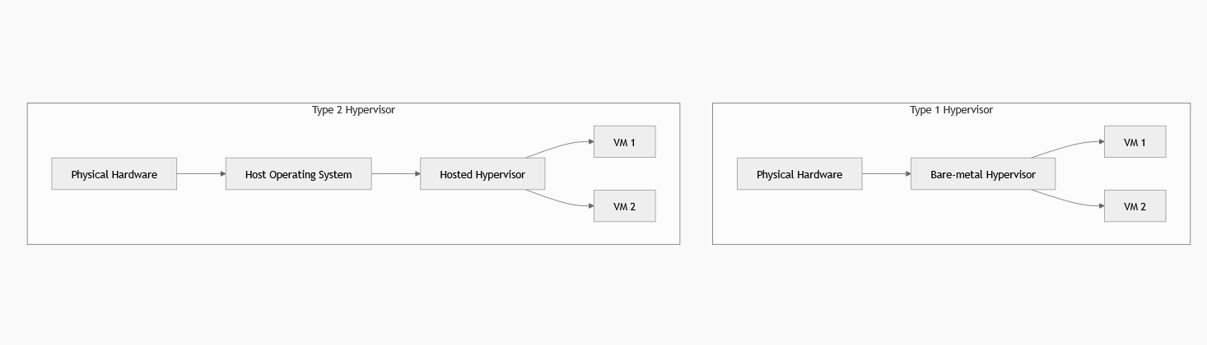
Figure 1: Type 1 and Type 2 Hypervisor Diagram

Reason why Windows the Host OS.
The choice of operating system (Windows) used as the host operating system to containerize Docker in this report is based on the fact that windows is highly used in an enterprise setting where most development and testing processes are launched on windows workstations. Windows now supports Linux containers with Windows Subsystem for Linux (WSL 2), enabling it to become a flexible platform to run container-based workflows without a complete Linux VM. Docker Desktop in combination with WSL 2 allows a container to run smoothly on Windows, powered by Linux, and, therefore, compatible with popular Docker images and making developers more productive (Gangula, 2025).
The use of windows also demonstrates a reflection of the current cloud engineering activity where developers tend to be working in windows environments prior to release their applications into production systems which are Linux server-based. This mixed method, made possible by WSL 2, is such that developers can build and test applications that are cloud-native at the comfort of their own favorite OS without compromising the ability to work with production systems (Sundar, 2023).

System Overview and Practical Environment (Windows Host)

windows host system configuration.
To carry out the practical activities on this report, the system was configured as below:
• OS: Windows 10/11 (64-bit) and WSL 2 installed.
• CPU: Intel/AMD CPU with hardware virtualization.
• Memory: 8GB RAM and above to run Docker containers and other development activities.
• Software Stack:
o Docker Desktop: It is a tool that is used to control Docker images and containers.
o PowerShell or Windows Terminal: To run docker CLI commands.
o Visual Studio Code: Docker integration to develop apps and write Dockerfiles.
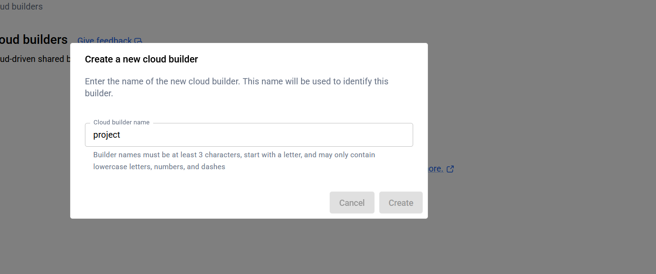
Figure 2: Docker build
The support of WSL 2 in Docker Desktop makes it a lightweight and efficient platform to execute Linux-based containers on windows without having to use virtual machines, allowing developers to develop cloud-native applications in a familiar windows environment (Patil, 2025).
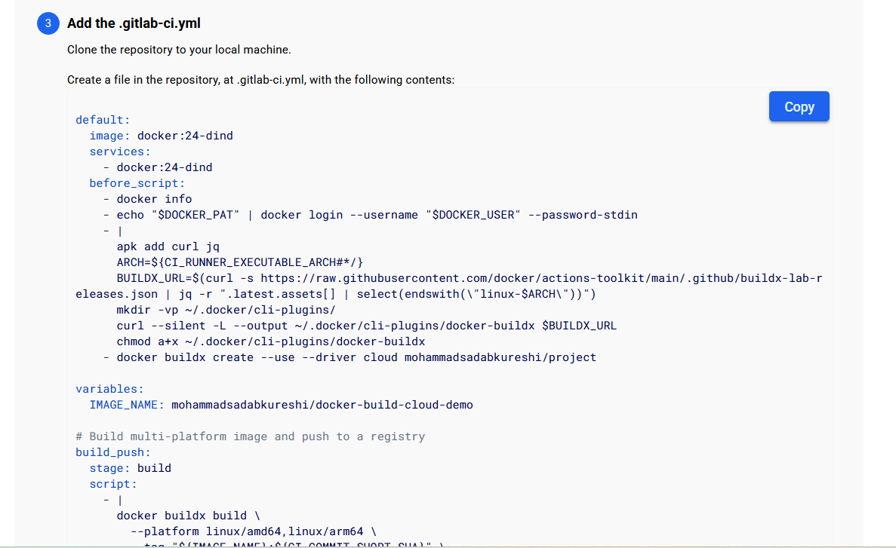
Figure 3: Docker Git push

Practical Aids in the Module.
The practical exercises were accomplished using several tools, such as:
Docker Desktop: The main containerization tool that offers a complete Docker Engine and WSL 2 integration, to run containers.
The terminal applications were PowerShell/Windows Terminal that were used to execute docker run, docker build and docker compose.
Visual Studio Code: An editor that is used to write the Dockerfile, write the web application and organize the project.
These are tools that are part and parcel of cloud-native development practices because they are congruent with best practices in containerized application development, in which code, configuration, and dependencies are closely integrated and interoperable (Sundar, 2023; Kambala, 2023).
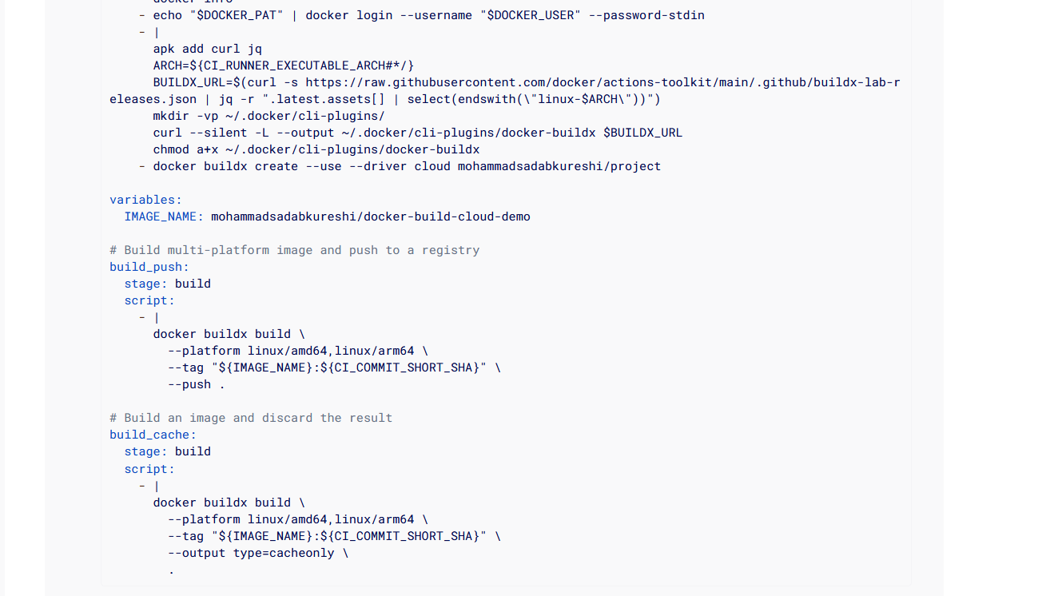
Figure 4: terminal applications were PowerShell/Windows

Containerization vs Virtualization
Containerization and virtualization are technologies that facilitate the ability to have multiple applications on the same physical machine, albeit in fundamentally different ways. The concept of virtualization is to develop complete virtual machines (VMs), which have operating systems. Such an arrangement consumes a lot of resources, with every VM having its own operating system and thus increased overheads and longer boot time. Conversely, containerization, especially using Docker, does not provide operating system virtualization; instead, it just virtualizes the operating system kernel and enables the use of multiple containers running on the same kernel with isolation. (Faruq & Saidur, 2022).
Although the two methods can be applicable to a cloud-based deployment, in a cloud-native setup, containerization is usually a better choice because it provides fast, efficient, and scalable solutions with a low overhead (Oyeniran et al., 2024). Microservice architectures can be best represented using containers, whereby separate parts of an application must be separated but must still be able to interact with each other in a common setting. (Patil, 2025).

Docker Fundamentals

Understanding Docker Architecture
Docker is an open source platform that automates application deployment, scaling and management of applications using containers. It provides a consistent environment for applications from development to production. Docker architecture is important to comprehend the benefits of using Docker and the difference between Docker and the conventional virtualization methods.
Docker Daemon
The most important part of Docker architecture is the Docker Daemon (also referred to as dockerd). It is responsible for managing Docker containers, images, networks, and volumes. The daemon accepts requests of Docker API and takes care of the real implementation of Docker containers. It is a background process on a system running commands which enable users to interact with the containers.
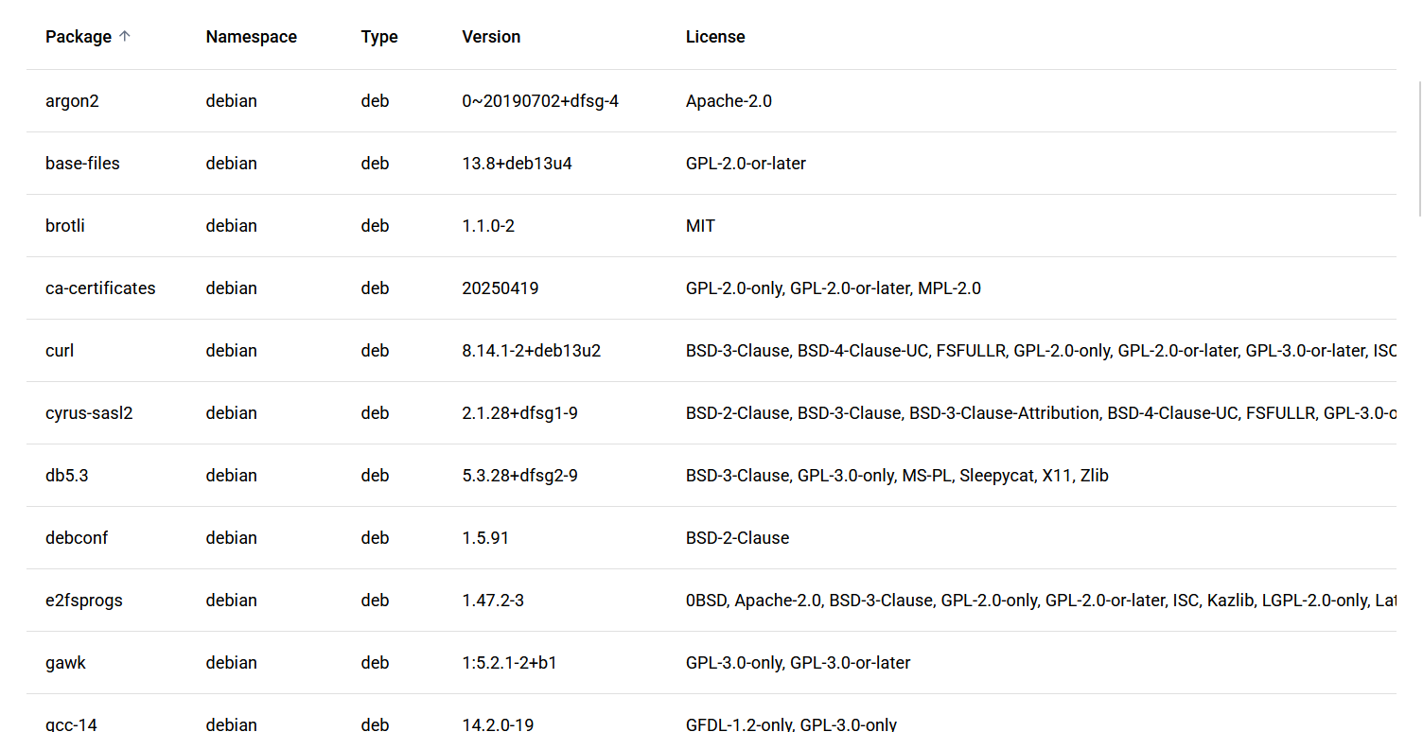
Figure 5:Docker Daemon
Docker CLI (Command Line Interface)
Docker CLI is the interface by which the users communicate with the Docker Daemon. It gives a list of commands that users may enter into a terminal to control containers. The most frequently used commands are:
• docker run: To start and create a container.
• docker build: To build an image from a Dockerfile.
• docker ps: To show running containers.
FROM python:3.13

WORKDIR /app

COPY requirements.txt .

RUN pip install --no-cache-dir -r requirements.txt

COPY . .

EXPOSE 5000

CMD ["python", "app.py"]

Docker hub Push
docker login
docker tag myflaskapp shadab/myflaskapp
docker push yourusername/myflaskapp

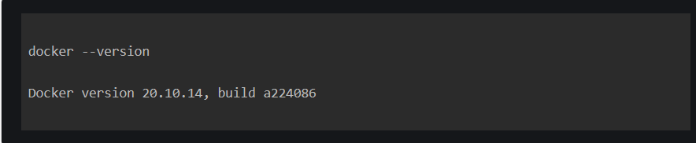
Figure 6: Docker initiation

Docker REST API
The communication layer is the Docker REST API that enables programs and services to communicate with Docker. It allows users to manage Docker remotely via HTTP requests and is a significant capability in terms of integrating Docker with other applications or processes. This API supports such operations as creating containers, managing images, setting up networks and so on. REST API of Docker is used by many current cloud services and tools to automate deployments and operate containers on large scale.
Figure 7:Docker REST API
Containers vs. Virtual machines.
Virtualization of the system is one of the main differences between Docker containers and classical virtual machines (VMs). Although similarities exist in that both technologies can be used to isolate applications; they are differentiated with regards to the way they engage with the resources provided by the host system.
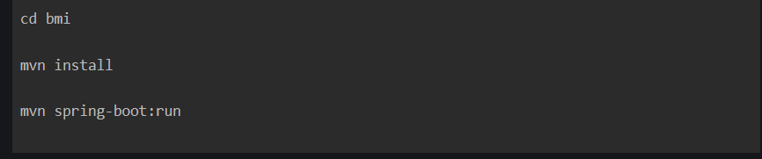
Figure 8: Container Push and install
• Virtual Machines: VMs are virtualizations of the entire hardware stack, i.e. each VM has its own complete operating system, application and dependencies. This leads to a lot of overhead since each VM will require its own instance of the OS, and this makes it resource-intensive and slow to boot.
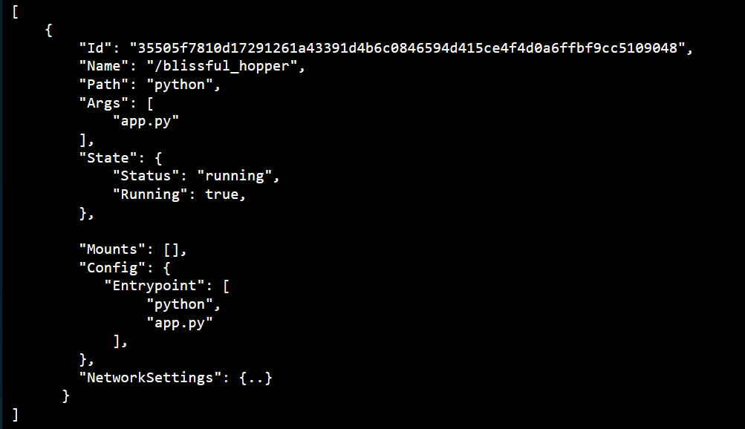
Figure 9: Docker container
Docker Containers: Containers, on the other hand, share the host operating system’s kernel. Containers instead of operating a complete operating system per application bundle the application and its dependencies into a single unit that operates on top of the host operating system. This causes containers to be lightweight, have a quick startup time and low resource usage which is one of the primary reasons as to why they are favored in cloud-native applications.
Containers are more efficient and faster than VMs by utilizing the kernel of the host OS, which makes them ideal in cloud environments, where fast scaling and low overhead are necessary.

Containers, Registries, and Images.
Docker Images
A Docker image is a lightweight, self-contained, executable bundle that contains all the required elements to execute a software: code, runtime, libraries, environment variables, and configurations. Photos are used as guidelines in the development of containers. They are constructed based on special file known as Dockerfile which describes the steps to construct an image based on a base image to the ultimate run environment.
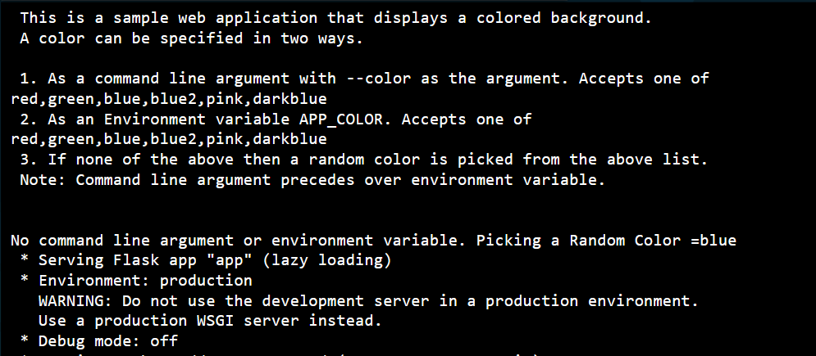
Figure 10: Docker flush and push
Creating Docker Image in Dockerfile.
Dockerfile is a text file which includes a list of commands that Docker is to follow. For example:
FROM python:3.8-slim
WORKDIR /app
COPY . /app
RUN pip install requirements.txt.
CMD ["python", "app.py"]

After writing the Dockerfile, it is possible to build an image with the command docker build -t myapp ., where myapp is the name of the image that will be created.
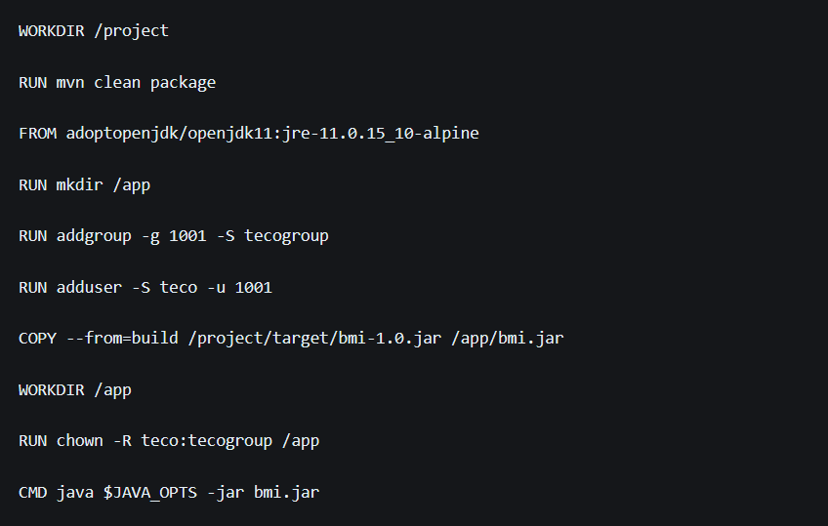
Figure 11: Docker image push
Docker Containers
A Docker image is a container running in a Docker instance. When you run an image with the command docker run, Docker makes a container out of that image, executes it and provides it with an isolated environment to execute in.
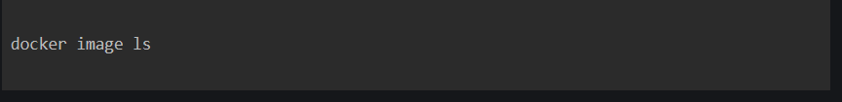
Figure 12: Docker image ls
Docker Registries
Docker registries are repositories, in which Docker images are kept and distributed. The most popular public registry is Docker Hub, but there are also private registries that can be utilized to store images safely. After building a Docker image, it is possible to release it to a registry with the following command:
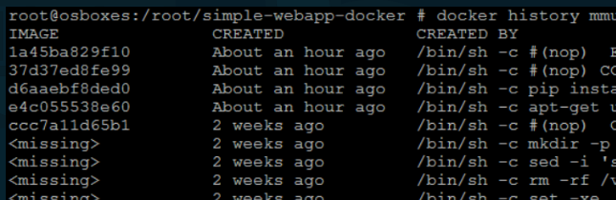
Figure 13:docker push myapp
docker push myapp

Docker Networking
Docker has a variety of network drivers that define how containers will communicate with one another and with external systems. These network drivers play a key role in configuring scalable and reliable cloud-native applications.
Types of Docker Network Drivers
- Bridge Network: It is the default network driver. The containers within the same bridge network are able to access each other through their container names or IP address. It is a network driver normally employed in standalone applications and small scale deployments.

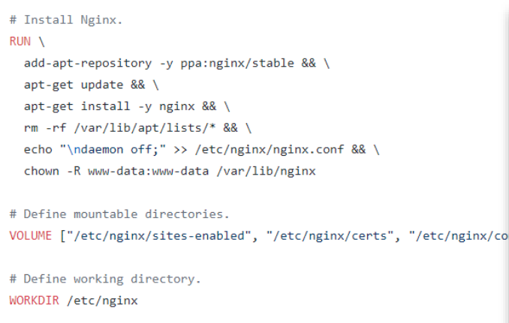
Figure 14: install nginx
2. Host Network: Host Network In this mode, containers share the network stack of the host and thus they share the IP address of the host. Although this provides improved performance as it removes the networking abstraction, it is less secure as the containers are not independent of the host network.
3. Overlay Network: This driver is intended to be used in communication between multiple hosts. Overlay networks allow containers to interact with other Docker hosts in a distributed configuration, like in Docker Swarm or Kubernetes clusters. Big distributed applications rely on overlay networks.
4. None Network: This option turns off networking of the container completely. It is deployed in very secure conditions where access to the network must be strictly regulated.
Docker networking enables flexible communication patterns across the containers, making it possible to design intricate structures, which can be scaled to many nodes.
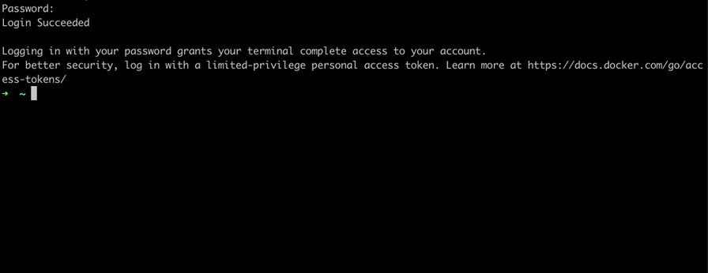
Figure 15: Docker cross validation

Docker Storage and Volumes.
Containers are defaulted to stop and remove the data that is contained in them. Docker resolves this problem by offering a variety of storage options such as volumes, that enable data to persist outside the container lifecycle.
Docker Volumes
Persistent data in Docker are best stored in volumes. Volumes are not a part of the filesystem of the container; they are independent of a container’s lifecycle. It implies that a container can be deleted and the data in the volume will not be destroyed. Docker commands can be used to deal with volumes such as:
docker volume create myvolume.
docker run myvolume:/data mycontainer.
Here, myvolume is the name of the Docker volume and /data is the directory within the container, in which the volume is mounted.
Advantages of Docker Volumes.
Volumes can be used to store databases and other stateful applications.
• Data can be shared among containers using volumes.
• Volumes can be backed and restored, and are important to critical applications that demand high availability.

Windows Docker Desktop.
Docker Desktop/Windows.
Docker Desktop is an efficient application enabling the developers to operate Docker containers on Windows. It is a part of the WSL 2 (Windows Subsystem for Linux), which allows Linux containers to run smoothly on Windows without having to use full virtual machines. Docker Desktop streamlines the process of container management with a graphical user interface and offers added value, including Kubernetes support and monitoring system resources.
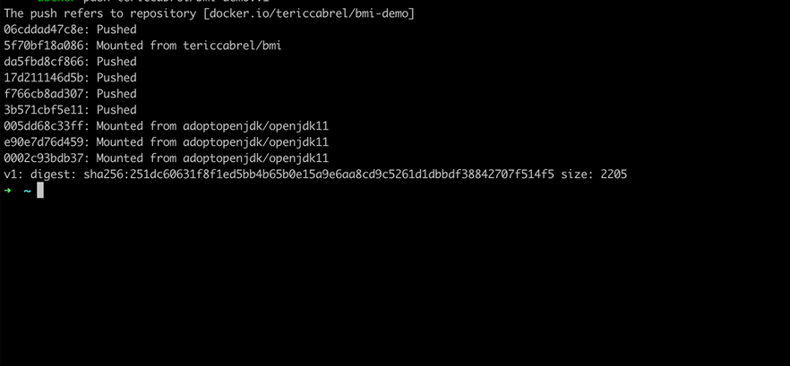
Figure 16: Docker final Push
Integration with WSL 2
WSL 2 is a significant improvement of the Windows Subsystem for Linux which offers a complete Linux kernel. The Docker Desktop uses WSL 2 to execute Linux-based containers on Windows. The integration enables developers to develop, test and run cloud-native applications on Windows with the identical Docker containers that they would in production on Linux servers.
Docker Desktop Features
- Graphical Dashboard: enables users to access running containers, images, and volumes.
- Kubernetes Integration: Kubernetes is directly available in Docker Desktop, and one can orchestrate containerized applications on a local machine.
- Resource Monitoring: Allows seeing CPU, memory, and disk usage of containers, which is essential to optimize performance.
With Docker Desktop on Windows, developers can easily work within their familiar environment yet can be used with cloud platforms based on Linux-containers.

Practical Docker Operations Summary.
These are some of the most important operations conducted in the practical part of this report to show what Docker can do in the cloud-native development:
Creating Dockerfiles: A Dockerfile was created to describe the environment and requirements of a Flask web application.
- Image Construction: The docker build command was used to construct the image, and the image was tested with the docker images command.
  - Running Containers: the docker run command was used to start the container, where the port of the container is mapped to the port of the host system.
  - Creating Docker Networks: A custom Docker network was created to enable communication between containers.
  - Handling Data Persistence: Docker volumes were employed to store data outside of containers so that it is guaranteed that the data is retained across container restarts.
  - Tagging and Posting Photos: The photo was tagged and pushed to Docker Hub to share and deploy.
Pulling and Running Images Pulled and Ran Docker images were pulled and run locally to show that containerized applications are portable.
These real-world operations represent the main functionalities of Docker and its role in the efficient deployment and management of cloud-native applications. Incorporating Docker, developers have an opportunity to develop lightweight, portable, and scalable applications that can be deployed and managed in a simple manner across different environments.

Implementation and Installation.

Setup of Application Development Environment.
The initial action in the practice implementation was to configure the development environment on the Windows host system. This was initiated by installing Python (version 3.x) to host the Flask web application which will be containerized. Flask, a lightweight web framework for Python, is well-suited for this project due to its simplicity and ability to quickly prototype web applications. Visual Studio Code (VS Code) was also included in the environment as the Integrated Development Environment (IDE) which offered an easy interface to edit the code, manage files, and operate with Docker.
The second step was to install Docker Desktop on the Windows machine. Docker Desktop can be used with Windows Subsystem for Linux (WSL 2), which gives Docker the ability to run Linux containers directly and a full Linux kernel on Windows. WSL 2 allows Docker to run without full virtual machines, thus allowing the setup to be lightweight and efficient. Once Docker Desktop was installed, the system was set up to run containers locally and the Docker Engine was checked by running the command docker -version to guarantee its correct installation.
To ensure that Docker was running correctly, the following simple command was used: docker run hello-world, which downloaded a test image on Docker Hub and started it in a container. This established that Docker was working, and was able to handle containers in the Windows environment.

The Flask Web Application Development.
Once the environment was set up, the next step was to develop a simple Flask web application. The application was meant to be a simple Hello World service that will show how a Docker container can execute a Python web application. The code was written in Python and the minimum routing engine of Flask was used to display a plain HTML page to the user when the app was visited using a web browser.
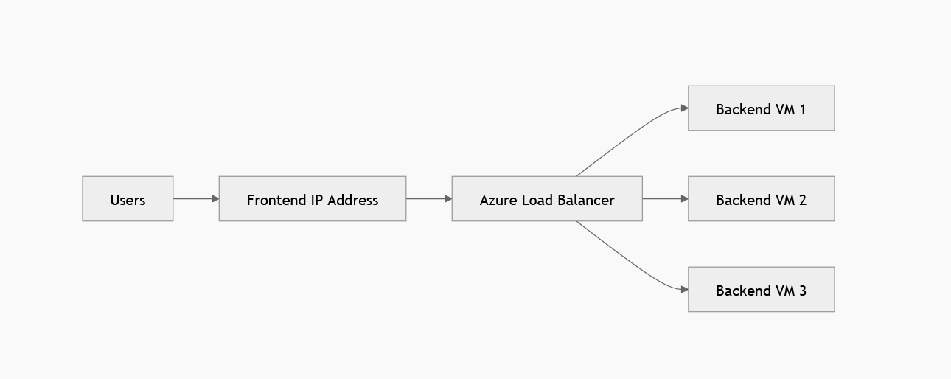
Figure 17: Load balancing
The Flask application code was put in a directory of app, the main script (e.g., app.py) configured the web server and route logic. This application was the essence that was containerized in order to show the power of Docker.
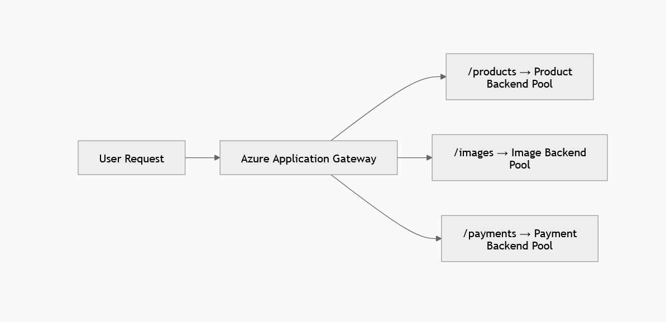
Figure 18: API routing

Writing and Reading the Dockerfile.
An essential task during the containerization of the Flask application was to write the Dockerfile. This is a file that contains the instructions that the Docker will follow to create a custom image of the application. The Dockerfile began with the definition of the base image with the help of the FROM command. A python image (python:3.8-slim) was selected in this case to guarantee a minimal and efficient environment.
FROM python:3.8-slim
WORKDIR /app
COPY . /app
RUN pip install requirements.txt
CMD ["python", "app.py"]

The instructions in the Dockerfile are as follows:

FROM python:3.8-slim: The base image is defined as a line and is a minimal Python environment.
WORKDIR /app: It is used to configure the working directory of the application inside the container.
COPY . /app: This command will copy the application files (including the Python script and any dependencies) inside the container.
RUN pip install -r requirements.txt: Installs the needed Python libraries to run Flask.
CMD [python, app.py]: This is the command to run the Flask application within the container.
The Dockerfile enabled the application to be bundled into a container and thus be portable and can be used in any place where Docker is supported.
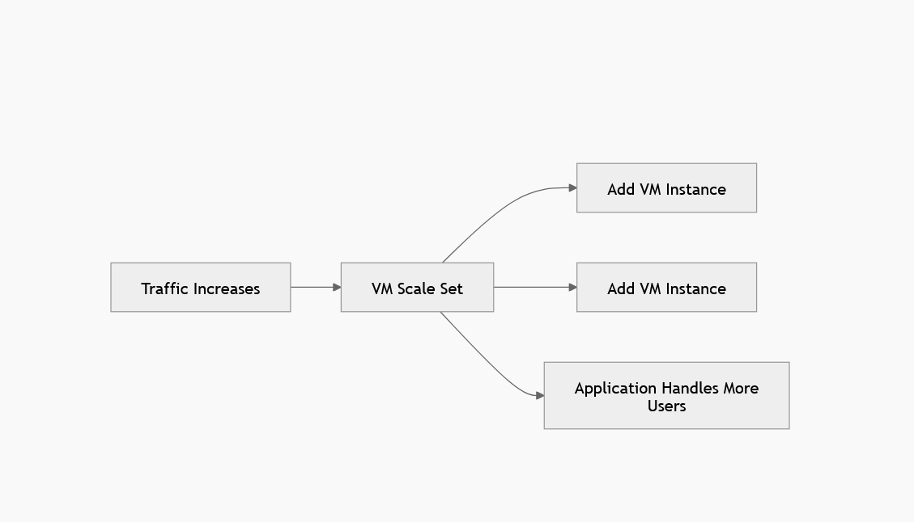
Figure 19: horizon scaling diagram

Building the Docker Image
The second thing to do after writing the Dockerfile was to build the Docker image. With the docker build command, the instructions in the Dockerfile are processed by the Docker engine and the image is assembled.
Docker build -t myflaskapp.
<html>
<head>
<title>Dockerfile</title>
</head>
<body>
<div class="container">
<h1>My App</h1>
<h2>This is my first app</h2>
<p>Hello everyone, This is running via Docker container</p>
</div>
</body>
</html>

This command generates an image in the current directory (indicated by the dot) called myflaskapp and it contains all requirements and settings to run the web application of Flask. Once the image had been built, the command docker images was used to list the image and ensure that the image was built successfully and could be used.
server {
listen 80 default_server;
listen [::]:80 default_server;

root /usr/share/nginx/html;
index index.html index.htm;

server_name _;
location / {
try_files $uri $uri/ =404;
}
}
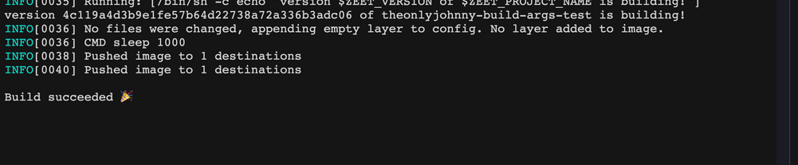
Figure 20: Docker successful message

Running the Container Locally.
After building the Docker image, the program was run in a container with the docker run command. The container was started using the following command:
docker run -d -p 5000:
5000 myflaskapp
In this case, -d will start the container in detached mode (in the background) and -p 5000:5000 will make the port 5000 of the container the same as the port 5000 of the host machine. This allows the Flask application to be viewed in the web browser of the host machine by going to the host machine at port 5000.
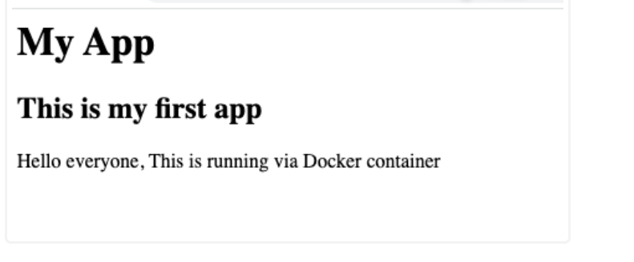
Figure 21: My app front landing page
The container had been successfully started and the Flask web application was now available on the browser of the local machine, which made it possible to practice how Docker can be used to manage and deploy the applications.

Driving Forces of Cloud Expansion and Serverless computing.

Cloud Expansion Driving Forces.
The growth of cloud computing is due to the fact that organisations require technology that is flexible, cost-effective and scalable. Cost is one of the driving forces. Organisations are able to use cloud services and pay only what they use instead of purchasing the costly physical servers. This saves hardware investments, data centre costs and maintenance.
Flexibility is another driving force. Businesses whose workload varies can benefit because cloud resources can be allocated to meet the demand or decreased when the demand decreases. Remote work has also led to the increased demand of cloud services since employees require access to applications and files not only in one place. Large computing powers and storage are also necessitated by big data and artificial intelligence and can be easily supplied by cloud computing compared to on-premises systems. Security and compliance are also significant as the big cloud providers have identity management, monitoring, encryption and compliance reporting tools.

Serverless Functions What are Serverless Functions?
Serverless functions are small programs that execute on event-driven requests without the author of the code having to maintain the servers. In serverless computing, the cloud service provider takes care of the infrastructure, scaling and availability. The programmer simply writes the code of the functions.
One such serverless compute service is AWS Lambda. It enables users to execute code without proving and operating servers and users are charged only by the amount of compute time used [11]. Azure Functions is a serverless solution by Microsoft that enables developers to create applications with reduced infrastructure management and reduced overhead [12].
Serverless functions are event-based. This implies that they execute based on an event like an HTTP request, file upload, database update, queue message or a scheduled timer. They can be used in short-term tasks like image processing, sending notifications, processing form submissions or responding to API requests.
According to AWS documentation Lambda executes code without having to provision or manage servers and only bills based on compute time used. According to Microsoft, Azure Functions is a serverless service that simplifies infrastructure maintenance and is capable of event-based computation [11], [12].

Serverless vs Containerisation
Feature | Containers — Docker | Serverless — Lambda / Azure Functions
Control | Full control over runtime, dependencies and environment | Limited control because the cloud provider manages the runtime
Startup time | Usually seconds | Often milliseconds, although cold starts can occur
Cost model | May cost money while containers or servers are running | Pay per execution or compute time used
Best for | Long-running apps, APIs, microservices and complex environments | Short event-driven tasks and background jobs
Scalability | Manual or automatic depending on platform | Automatic scaling managed by the provider
Server management | Some server or platform management may still be required | No direct server management required
Portability | Highly portable across systems that support containers | More dependent on the cloud provider’s function platform

Conclusion
To sum up, containerization, led by Docker, has substantial benefits compared to the conventional virtualization, particularly in cloud-native and microservices-based systems. Docker is a critical technology to cloud engineers and developers because of its ability to package applications and their dependencies into lightweight, portable containers. The combination of Windows as the host operating system, along with Docker Desktop and WSL 2, offers a natural experience when it comes to containerization, offering the developers to work in a familiar environment, as well as making sure that it is compatible with Linux-based deployments in the cloud.
In this report, the practical and theoretical capabilities of containerization with Docker have been critically examined and its applicability in the current cloud engineering practices identified. This report highlights the importance of Docker in improving scalability, resource utilization, and operational flexibility in the cloud by highlighting the main characteristics of Docker, including container networking, image building and data persistence (Gangula, 2025).

References
Al-Said Ahmad, A., Al-Qora’n, L. F., & Zayed, A. (2024). Exploring the impact of chaos engineering with various user loads on cloud native applications: An exploratory empirical study. Computing, 106(7). https://search.ebscohost.com/login.aspx?direct=true&profile=ehost&scope=site&authtype=crawler&jrnl=0010485X&AN=178046289&h=pAq5VCxAGd6aQAWbGASx697w4sKB3i6EzB58lGEM6%2FMTQwYx3QuhSxlfmYUZ9W2g0pKoejSyHGCQgNu7lpiUqA%3D%3D&crl=c
Bandi, V. D. V. K. (n.d.). Autonomous Data Platforms: Converging AI, MLOps, and Cloud Engineering for Digital. Retrieved April 7, 2026, from https://www.academia.edu/download/131719821/02_2026_Autonomous_Data_Platforms_Converging_AI_MLOps_and_Cloud_Engineering_for_Digital.pdf
Bedoya, M., Palacios, S., Diaz-López, D., Nespoli, P., Laverde, E., & Suárez, S. (2023). Securing cloud-based military systems with Security Chaos Engineering and Artificial Intelligence. Proceedings of the 18th International Conference on Availability, Reliability and Security, 1–9. https://doi.org/10.1145/3600160.3605076
Chinamanagonda, S. (2023). Focus on resilience engineering in cloud services. Academia Nexus Journal, 2(1). http://academianexusjournal.com/index.php/anj/article/view/4
Dalal, A. (2025). Exploring Emerging Trends in Cloud Computing and Their Impact on Enterprise Innovation. Available at SSRN 5268114. https://papers.ssrn.com/sol3/papers.cfm?abstract_id=5268114
Divya, V., & Bandi, V. K. (2023). Cloud-Native Model Lifecycle Management for Enterprise AI Systems. International Journal of Scientific Research and Modern Technology, 78. https://www.academia.edu/download/131794538/Cloud_Native_Model.pdf
Faruq, M. O., & Saidur, M. J. I. (2022). ALIGNING FEDRAMP AND NIST FRAMEWORKS IN CLOUD-BASED GOVERNANCE MODELS: CHALLENGES AND BEST PRACTICES. Review of Applied Science and Technology, 1(01), 01–37.
Gangula, S. (2025). Secure DevOps in retail cloud: Strategies for compliance and resilience. The American Journal of Engineering and Technology, 7(05), 109–122.
Julie, G. (2026). Reinventing Data Pipelines Intelligent Multi Cloud Engineering for Seamless Interoperability and Integration Frameworks. International Journal of Advanced Engineering Science and Information Technology (IJAESIT), 9(1), 52.
Kambala, G. (2023). Designing resilient enterprise applications in the cloud: Strategies and best practices. World Journal of Advanced Research and Reviews, 17(03), 1078.
Li, X., Song, Z., Zhang, M., Pu, J., & Wang, T. (2026). Probabilistic geological body modeling of point cloud based on IMMC-Geo and application. Engineering Geology, 108603.
Meshram, A. (2025). Hybrid Cloud Strategy for Mission-Critical Financial Software Applications. International Journal of Research Publications in Engineering, Technology and Management (IJRPETM), 8(6), 13268–13273.
Nagabhyru, K. C. (2023). Accelerating Digital Transformation with AI Driven Data Engineering: Industry Case Studies from Cloud and IoT Domains. Educational Administration: Theory and Practice, 29(4), 5898–5910.
Okon, S. U., Olateju, O., Ogungbemi, O. S., Joseph, S., Olisa, A. O., & Olaniyi, O. O. (2024). Incorporating privacy by design principles in the modification of AI systems in preventing breaches across multiple environments, including public cloud, private cloud, and on-prem. Including Public Cloud, Private Cloud, and On-Prem (September 03, 2024). https://www.researchgate.net/profile/Oluwaseun-Olaniyi/publication/384703702_Incorporating_Privacy_by_Design_Principles_in_the_Modification_of_AI_Systems_in_Preventing_Breaches_across_Multiple_Environments_Including_Public_Cloud_Private_Cloud_and_On-prem/links/672838845852dd723ca6f875/Incorporating-Privacy-by-Design-Principles-in-the-Modification-of-AI-Systems-in-Preventing-Breaches-across-Multiple-Environments-Including-Public-Cloud-Private-Cloud-and-On-prem.pdf
Oyeniran, O. C., Modupe, O. T., Otitoola, A. A., Abiona, O. O., Adewusi, A. O., & Oladapo, O. J. (2024). A comprehensive review of leveraging cloud-native technologies for scalability and resilience in software development. International Journal of Science and Research Archive, 11(2), 330–337.
Patil, S. P. (2025). Leading Through Innovation: The Evolving Role of the Architect in the Cloud and AI Era. J Artif Intell Mach Learn & Data Sci, 3(1), 3129–3133.
Pillati, L. P. (2025). Enterprise Cloud Infrastructure Evolution: From Manual Operations to AI-Driven Autonomous Systems. Journal Of Engineering And Computer Sciences, 4(8), 715–726.
Stirbu, V., Kinanen, O., Haghparast, M., & Mikkonen, T. (2024). Qubernetes: Towards a unified cloud-native execution platform for hybrid classic-quantum computing. Information and Software Technology, 175, 107529.
Sundar, D. (2023). Serverless Cloud Engineering Methodologies for Scalable and Efficient Data Pipeline Architectures. International Journal of Emerging Trends in Computer Science and Information Technology, 4(2), 182–192.

