
Module Assignment Submission
Student Name: | Emma Louise Stevens
Student Number: | 2025270
Module Code: | BMSK5003
Module Title: | Understanding and Engaging in the Customer Experience

Statement of Confirmation of Authenticity
By the act of making this submission, the student declares that this is the work of the student named above. The work has not, in whole or in part, been knowingly presented elsewhere for assessment, or where assessment has been built on a previous assessment, this has been identified. Where materials have been used from other sources it has been properly acknowledged. If this statement is untrue, the student acknowledges that an assessment offence has been committed.
Attention is drawn to the plagiarism and unfair practice policies of the University.

Contents
Understanding and Engaging in the Customer Experience 1
Introduction 3
Evidence A Critical Understanding of Quality Process Within TSB Bank. 3
Buying Decision Making Process: Ethical Considerations Such as Sustainable Resources. 3
Managing Customer Expectations 4
Appreciation Of the Importance of Quality Control 6
Analyse the Customers’ Experience Within TSB Bank 8
Customer Service, Centrality and Value 8
Critically Evaluate the Benefits and Challenges of Developing and Maintaining Good Customer Relationships. 9
Value and Purpose of Customer Relationship Management (CRM) 9
Buyer Seller Relationships 11
Conclusion 12
References 12
Appendix 1 16

Introduction

Every business wants to succeed and grow, to do this you need a good reputation and to have a good reputation the business must have ethics and a plan on how to achieve their goals behind them. From researching TSB Bank I have found they have a Do What Matters Plan 2025 detailing what they want to achieve for their customer, colleagues, business, communities and environment. This plan is discussed throughout my finding and detailed in the report. For a business to thrive there must be good custom and this is evidenced throughout the report.

Evidence A Critical Understanding of Quality Process Within TSB Bank.

Buying Decision Making Process: Ethical Considerations Such as Sustainable Resources.

TSB Bank have published their achievements throughout 2021 these achievements consist of five categories: Customers, business, colleagues, communities, and environment. These all demonstrate that the business wants to help and grow all aspect of the business while taking ethics and sustainability into consideration.
For the customer: During 2021 TSB Bank reimbursed 98% of customers who were victims of fraud, all customer facing employees where trained in the fraud guarantee and all newly trained as money confidence experts. TSB also teamed with Cogo to help customers reduce their carbon footprint. Cogo is a supplier who support millions of individuals and businesses to be more conscious of the impact of their spend on people and the planet. Customers can track their carbon emissions through their banking experience.
For the businesses: During 2021 TSB Bank have paid 97% of payment to small business in seven days or less. TSB Bank have twenty thousand female entrepreneurs through being provided with access to events, role models and business support and worked with Be the Business to help small business owners improve their business.
For the colleagues: 41% of senior roles are now held by woman and a new equal parental leave has been but in place for both men and woman.
For the communities: TSB Bank has raised over one hundred thousand pounds for charities across the UK and over nine thousand colleague hours have been volunteered to help these causes. There is now one thousand five hundred colleagues Hestia trained so every branch has a safe space for victims of domestic abuse.
For the environment: TSB Bank have launched their first green lending product meaning for every new mortgage customer a tree will be planted and there has been a 74% reduction in operational greenhouse gas emissions vs 2019. (Appendix one).
Focusing on the safe space by providing Safe Spaces can be life changing for victims of domestic abuse TSB Bank is the first high-street bank to offer a Safe Space to victims of domestic abuse in all their branches. As part of the charity Hestia’s Safe Space initiative, support is available in every TSB branch for anyone experiencing domestic abuse, regardless of whether they bank with us. TSB Bank is also soon to launch Digital Safe Spaces – an online place for survivors to visit and seek support, no matter where they live. This is only the start of what TSB Bank want to achieve. TSB Bank are already seeing many people make use of this service and know this will only increase with the cost-of-living pressures.
TSB Bank have given an example of when safe spaces were used recently. A branch colleague was approached by a customer in clear discomfort. He was immediately taken to a private room where he revealed that his wife had been abusing him physically, verbally, and financially. He’d decided to leave the family home with his children, who were also being abused. The colleague, who is trained to help in this type of situation, put the customer at ease and talked through how TSB and partner charities could support. A new account was opened for the customer, so he could access his money. And to keep his location hidden, the account was opened with a special non-geographical sort code. Melanie, the branch colleague who helped the customer, said: “Even though we’ve all been through the Safe Space training, being able to implement this in a real-life scenario and seeing the significant impact it had on the customer made us proud to be part of TSB and the Safe Spaces initiative”.
TSB Bank also want to do better for the planet through helping customers play their part in climate change, empowering workforce to improve sustainability, supporting local communities to drive sustainability and partner with suppliers to drive sustainability through the supply chain. These are clear and achievable goals in the Do What Matters plan 2025.

Managing Customer Expectations

When we refer to customer expectation, we’re talking about everything that a customer expects from a product, service, or organisation. These expectations are formed in the minds of the customer based on their individual experiences and what they have learnt, combined with their pre-existing experience and knowledge.
While there are many common assumptions that customers typically expect businesses to provide from increased personalisation and great customer service to omni-channel availability and low effort experiences, many expectations will be specific to a company. Whatever the mix with the customer, it is important to be able to identify and manage their expectations, otherwise it could damage the customer experience, loyalty and retention as a result.
Given how important customers are to your business success, being able to understand and manage their expectations is crucial.
With today’s customers more knowledgeable and critical than ever before, these expectations and subsequent demands are continually changing. So, ideally if you’re to keep ahead of your competitors you need to find ways of anticipating and exceeding those customer expectations.

Key factors that can influence a customer’s expectations are previous customer experiences, customer communications, reviews through word of mouth and customer experiences with other companies. These are all examples of how a customer or potential customer may view or see your business.
TSB Bank is moving into the digital word whereby mobile banking, internet banking, telephone banking and self-service machines in branch all seem to be doing the jobs of the tellers. Many customers in the older generation or customer who are not digital savy may be struggling with this change. TSB Bank are moving with the times and the digital side of banking is becoming quicker and more confident for customer.
TSB Bank are now marketing online through advertisement using social media. This could impact customer who do not have social media as they could be missing out on new products of bank news.
Definition by David Chaffey of Social Media Marketing –

“Monitoring and facilitating customers interaction, participation and sharing through digital media to encourage positive engagement with a company and its brands leading to commercial value. Interactions may occur on a company site, social networks and other third-party websites.” Chaffey (2002).

TSB Bank may struggle to manage these customers expectations as they expect to be seen by a teller (human) and instead are being met by a machine. The employees are getting round this by helping the customers at the self-service machine, while showing and talking to them.

Every six months TSB Bank take part in a survey helping them know where they stand in the market. As part of a regulatory requirement, an independent survey is conducted to ask approximately 1,000 customers of each of the 16 largest personal current account providers if they would recommend their provider to friends and family. The results represent the view of customers who took part in the survey.

They were asked customers how likely they would be to recommend their personal current account provider to friends and family, how likely they would be to recommend their provider's online and mobile banking services to friends and family, how likely they would be to recommend their provider's overdraft services to friends and family and how likely they would be to recommend their provider's branch services to friends and family.
The results show the proportion of customers of each provider, among those who took part in the survey, who said they were ’extremely likely’ or ‘very likely’ to recommend each service.
Participating providers: Bank of Scotland, Barclays, first direct, Halifax, HSBC UK, Lloyds Bank, Metro Bank, Monzo, Nationwide, NatWest, Royal Bank of Scotland, Santander, Starling Bank, The Co-operative Bank, TSB, Virgin Money.
Approximately 1,000 customers a year are surveyed across Great Britain for each provider; results are only published where at least 100 customers have provided an eligible score for that service in the survey period. 16,061 people were surveyed in total. Results are published every six months, in August and February. (Appendix one).
By taking part and taking feedback from these surveys shows the bank want to manage customer expectations and build on that.

Appreciation Of the Importance of Quality Control

Quality control (QC) is a process through which a business seeks to ensure that product quality is maintained or improved. Quality control requires the company to create an environment where management and employees strive for perfection. This is done by training personnel, creating benchmarks for product quality, and testing products to check for statistically sufficient variations.
By using Goleman’s (1995) emotional intelligence theory of motional self-awareness — knowing what one is feeling at any given time and understanding the impact those moods have on others, Self-regulation — controlling or redirecting one’s emotions; anticipating consequences before acting on impulse, Motivation — utilizing emotional factors to achieve goals, enjoy the learning process and persevere in the face of obstacles, Empathy — sensing the emotions of others and Social skills — managing relationships, inspiring others and inducing desired responses from them TSB Bank are able to really appreciate the importance of quality control.
Creating a product is costly, time-consuming, and can be unsafe without controls in place. Additionally, if a company sends defective products out for purchase, it could be held liable for injuries or issues that arise from using its products. Quality control inspectors ensure that defective or unsafe products are identified, and the causes are corrected. In a non-manufacturing business like TSB Bank quality testing can involve customer service evaluations, questionnaires, surveys, inspections, or audits. A business such as TSB Bank can use any process or method to verify that its end product or service meets the customer's needs and is safe and legal.
There are several methods quality control uses to communicate and track inspections and issues. For instance, a quality control chart is a graphic that depicts whether sampled products or processes are meeting their intended specifications—and, if not, the degree by which they vary from those specifications.
When one chart analyses a specific product attribute, it is called a univariate chart. A chart that measures differences in several product attributes is called a multivariate chart. Tracking differences allows businesses to see how many defects per production unit they produce and what types of defects are occurring. Some methods used are x-bar chart, Taguchi method and 100% inspection method.
An X-Bar Chart randomly selects products and tests for the given attributes the chart is tracking. A common form of a quality control chart is the X-Bar Chart, where the y-axis on the graph tracks the degree to which the variance of the tested attribute is acceptable. The x-axis tracks the samples tested. Analysing the variance pattern on this chart helps you determine if defects are occurring randomly or systematically.
The Taguchi method of quality control is another approach that emphasizes the roles of research and development, product design, and product development in reducing the occurrence of defects and failures in products. The Taguchi Method considers design more important than the manufacturing process in quality control and tries to eliminate variances in production before they can occur.
This 100% inspection method is a quality control process involving looking at and assessing all product parts. This type of quality control is done to rule out flaws in products. This method is often used to evaluate valuable metals and produce. The 100% inspection method calls for data about the manufacturing process and software to analyse inventory.
The challenge of using this method is that looking at every single item used to build a product is expensive and could destabilize or render the product unusable. However, this is the method that TSB Bank use to unsure their products are ready for sale and safe for customers.

Analyse the Customers’ Experience Within TSB Bank

Customer Service, Centrality and Value

To assess the Money Confidence of the nation, TSB Bank conducted a survey on five thousand people asking five questions relating to Brits’ confidence in different aspects of money management. These factors were: 1. Confidence in managing money in general 2. Confidence in making plans for their financial future 3. Confidence in following through on financial goals and commitments they make for themselves 4. Confidence in knowing what different financial products and services there are. 5. Confidence in choosing the right provider for financial products and services.
The TSB Money Confidence Barometer Respondents answered these questions on a scale of 0–10 (from no confidence to high confidence), from which TSB Bank have rated the nation’s average level of confidence in each of these areas. Taken together, these constitute TSB’s Money Confidence Barometer. TSB’s Money Confidence Barometer reveals that Brits are most confident when it comes to managing money in general, averaging at 7.2 out of 10. Brits are least confident when it comes to knowing what different financial products and services are for and choosing the right provider for financial products (6.4 and 6.5 out of 10). On average across all five statements tested, Brits average 6.7 out of 10 for money confidence overall. (Appendix one).
TSB Banks Do What Matters Plan 2025 consistently discusses about doing what is right not only for the customer but also their employees. The plan details simple yet effective statements. These are: Practise good governance, meet all their obligations, be a trusted employer, engage with stakeholders and partner where possible, be transparent, share data and report. These are clear goals which look attractive to both the customer, employees and new employees.
The plan goes into detail about doing what is right for the people – Customers, colleagues, communities, and suppliers.
TSB Bank want to help and nurture their customers financial resilience and support them in tough times. TSB Bank have a vulnerable customer policy and a safe space for customer suffering from any kind of harm or abuse which falls in line with the business ethics also. TSB Bank want their colleagues to continue building a representative workforce where colleagues can thrive, achieve goals, and maintain goals. TSB Bank branches work closely with the local communities and charities to improve money confidence in local communities and give back. By working with suppliers this promotes fair business and shared value.

Critically Evaluate the Benefits and Challenges of Developing and Maintaining Good Customer Relationships.

Value and Purpose of Customer Relationship Management (CRM)

CRM stands for Customer Relationship Management. It is a technology used to manage and record results of customers and potential customers. A CRM system helps organisations build customer relationships and streamline processes so they can increase sales, improve customer service, and increase profitability.
When CRM is discussed, it could be any of these three things:
CRM as Technology – This is a technology product, often in the cloud, that teams use to record, report, and analyse interactions between the company and customers or potential customers. This can also be called a CRM system or solution.
CRM as a Strategy – This is a business’ philosophy about how relationships with customer and potential customers should be managed.
CRM as a Process – This could be a system a business adopts to nurture and manage those relationships.
CRM software records customer contact information such as email, telephone, website, social media profile, and more. It can also automatically pull in other information, such as recent news about the company’s activity, and it can store details such as a client’s personal preferences on communications.
The CRM system organizes this information to give the company a complete record of individuals and companies, so the business better understands the relationships over time.
CRM software can improve customer relationship management by creating a 360-degree view of the customer, capturing their interactions with the business, and by surfacing the information needed to have better conversation with customers and potential customers.
At TSB Bank two types of CRM are used. Within the telephony centre CRM as a technology is used. This is how team leaders can help members of their team improve by providing the customer feedback and or praise the team member. This technology is used to show the team member on a monthly basis during a 1-2-1 or a performance review using the 360-degree feedback appraisal strategy whereby feedback is gathered on an individual from a number of sources. Welch (1980).
However, the TSB Bank branches adopt the CRM as a strategy meaning the manager uses this philosophy to help the team members understand how to build and maintain the customer relationships. My manager has adopted Handy’s (0000) theory of The Task Culture: This culture is small-team-based, results- and solutions-oriented, and marked by flexibility, adaptability, and empowerment.
Although CRM applications have their advantages, they also have some disadvantages. These disadvantages could include lack of human contact, leading to complaints, costs and or profitability, and decrease customer service quality.
One of the disadvantages of CRM is that it eliminates the human factor in the business. For one reason, the business is letting the software deal with some other tasks. By using CRM you could be seen to be turning into a machine, and this is not how a business wants to or should be treating your customers. Also, when a business lets the software deal with the customers, you lessen the human touch, and this is something that brings the business closer to the customers. If the business is taking away the human factor from your business, it is more likely that your customers will complain. And they will do so because they feel overlooked or ignored.

What happens if the customer would like to talk to a human and they are confronted by a machine. The business could in turn be increasing the number of complaints you get in a day, which is not something any company wants to do and could cost the business money in distress and inconvenience costs.

Another one of the disadvantages of CRM is that it might cost the business a lot just to implement it. This might be a problem especially if the business is not sure that it is worth investing in. If the business is not sure if CRM is worth it, then they should explore some other options first.

Sometimes, the software can make too many decisions and assumptions for the workers. So, they will lose their motivation, and productivity levels will be down. Employees benefit from the freedom to make their own decisions and feel like they have an impact on their job, as well as on their company. When they leave work and go home, they want to feel like they have made an impact on their job, not like robots who did nothing but click buttons all day.

CRM can also decrease customer service quality by a lot. This may be something that will bring down the business reputation fast. The reason for this is that customers won’t receive proper treatment from the workers. This is because these workers will spend too much time dealing with systems instead of with their customers’ expectations and needs.

As analysed, there are many pros and cons to CRM and this is a software that the business should research and look into before implementing this into their business.

Buyer Seller Relationships

Establishing a good relationship between the buyer and seller is a most difficult task in the concept of business marketing theory. Within TSB Bank the buyer would be the customer and the seller TSB Bank. By making the seller (TSB Bank) fulfil all the demands and getting the maximum number of customers is the toughest job both must encounter. There are various dimensions in understanding the relationship of customer and TSB Bank. Some of the dimensions are the basic relationship building block between both of them is based on the interactions of the TSB Bank employee and the customer. The perception of the customer towards the TSB Bank employee which is based on the company’s reputation and the behaviour of the TSB Bank employee with the customer which depends on the needs of the company, personal needs of the employees and the social needs.

There are three types of buyers – seller relationships and these are: Transactional (distant) relationship. Value – added (continuing) relationship and Partnering / Collaborative (close) relationship.

All three relationships apply to the relationships between each TSB Bank employee and the customer. This is because even though the sales process is transactional in the sense of the bank needs to sell products to make profit and grow but the relationships between staff and customers also add value to the customer as TSB Bank staff have a responsibility to help the customer with their finances. However, can not give any advice meaning the customer must make an informed choice by having all the knowledge this demonstrates the care TSB Bank have for their customers. TSB Bank staff also have a close relationship with their customers and work collaboratively through the sales process.

Conclusion

Through thorough research into TSB Bank I have been able to come to the conclusion that TSB Bank are delivery a high quality service and doing what they can and what matter for their customers, colleagues and the business. They have a clear plan running up to 2025 and have achieved what they have set out to achieve since 2020. By TSB Bank having a safe space for customers and non-customers this shows compassion and empowerment to do the right thing as a human. By understanding and engaging in the customer experience through critically analysing the quality process, customer experience and critically evaluate the benefits I have been able to have a clear understanding of TSB Bank and how the business has been and will continue to run in the future.

References

Big Think. (2012). Daniel Goleman Introduces Emotional Intelligence [YouTube Video]. In YouTube. https://www.youtube.com/watch?v=Y7m9eNoB3NU
Clear Review. (2020). What is an Effective Performance Management System? (2020 Guide). Clear Review. https://www.clearreview.com/resources/guides/what-is-effective-performance-management/
Deming. (2022). Dr. Deming’s 14 Points for Management - The W. Edwards Deming Institute. Https://Deming.org/. https://deming.org/explore/fourteen-points/
Gartner Glossary. (n.d.). Definition of Customer Centricity - Gartner Marketing Glossary. Gartner. https://www.gartner.com/en/marketing/glossary/customer-centricity#:~:text=Customer%20centricity%20demands%20that%20the
Hanlon, A. (2022, January 11). How to Use the 7Ps Marketing Mix? - Smart Insights. Smart Insights. https://www.smartinsights.com/marketing-planning/marketing-models/how-to-use-the-7ps-marketing-mix/
Holman, V. (2011). The Seven Ps of the Marketing Mix: Marketing Strategies [YouTube Video]. In YouTube. https://www.youtube.com/watch?v=ys7zx1Vc9po
J-P De Clerck. (2018, April 12). Customer-centricity - what it means to be customer-centric. I-SCOOP. https://www.i-scoop.eu/customer-centricity/
Juneja, P. (2019). Charles Handy Model of Organization Culture. Managementstudyguide.com. https://www.managementstudyguide.com/charles-handy-model.htm
Lapaas, T. (2020, November 6). Charles Handy model motivation theory - 4 Culture. Lapaas Digital Marketing Company and Institute. https://lapaas.com/charles-handy-model-motivation-theory-4-culture/
Lysis. (2015). The Disadvantages of CRM Systems | Techwalla.com. Techwalla. https://www.techwalla.com/articles/the-disadvantages-of-crm-systems
Nils. (2013). Creating Customer Value [YouTube Video]. In YouTube. https://www.youtube.com/watch?v=9I2baWR-rqg
odrlwpuser. (2019, December 27). The History of 360 Degree Feedback. ODRL. https://www.odrl.org/2019/12/27/360-degree-feedback-history/#:~:text=The%20proliferated%20use%20of%20360%C2%B0%20feedback%20trickled%20down
Rajakrishnan, B. (2021, June 11). Why is Quality Control Important for a Business? Hurix Digital. https://www.hurix.com/why-is-quality-control-important-for-a-business/
Resilient Educator. (2013, February 27). Daniel Goleman’s Emotional Intelligence Theory: Explanation and Examples | Resilient Educator. ResilientEducator.com. https://resilienteducator.com/classroom-resources/daniel-golemans-emotional-intelligence-theory-explained/
Singh, M. (2019, February 12). Advantages and Disadvantages of 360 Degree Feedback. Mettl. https://blog.mettl.com/advantages-disadvantages-of-360-degree-appraisal/
The Business Mindset. (2020, July 10). How to Add VALUE to Your Product or Service. Www.youtube.com. https://www.youtube.com/watch?v=UpEC-4sQkbA
TSB Bank. (2019). Welcome to TSB | Local Banking for Britain | Personal Banking. Tsb.co.uk. https://www.tsb.co.uk/personal/
TSB Bank. (2020). Do What Matters.
TSB Bank. (2021). TSB Money Confidence Barometer.
TSB Bank. (2022a). Branch Locator. Www.tsb.co.uk. https://www.tsb.co.uk/branch-locator/
TSB Bank. (2022b). The Do What Matters Plan | People | TSB Bank. Www.tsb.co.uk. https://www.tsb.co.uk/do-what-matters/people/
WellExtreme. (2021, September 29). Advantages and Disadvantages of CRM. WellExtreme. https://www.wellextreme.com/advantages-disadvantages-crm/

Appendix 1
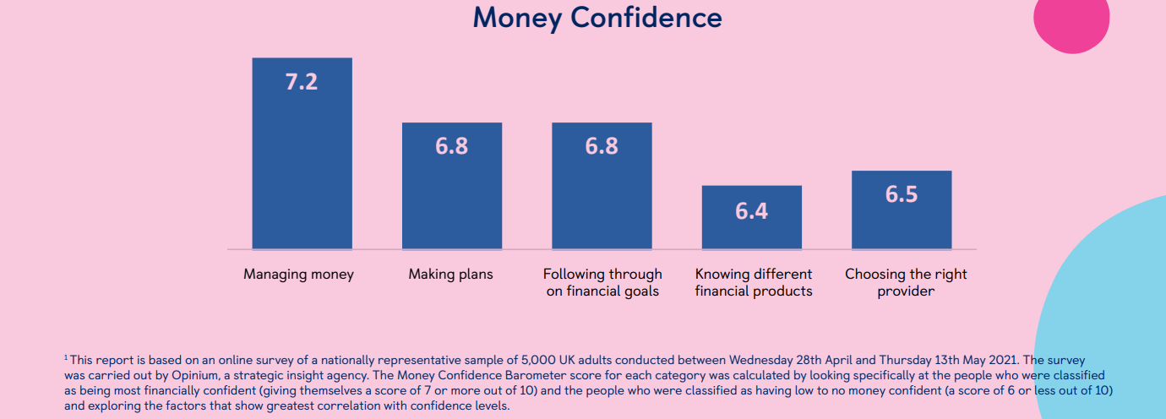TSB Bank (2020)
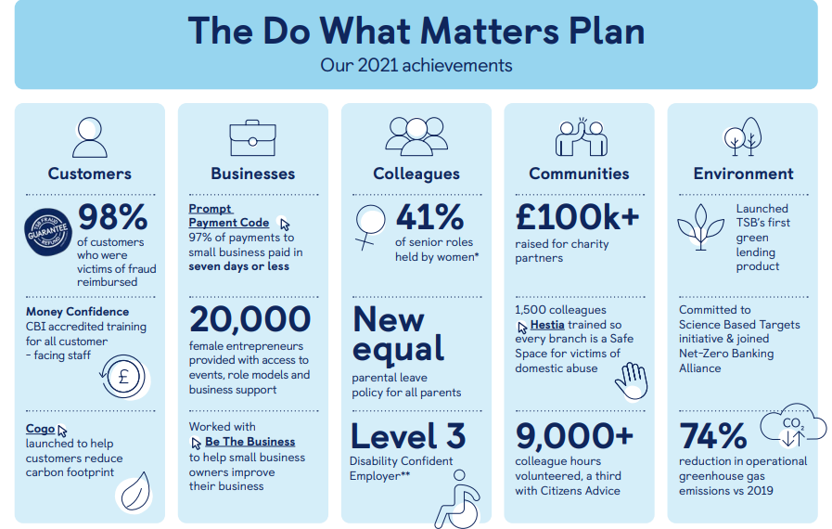
TSB Bank (2020)


