How can writing frames improve the descriptive and explanatory writing in Key Stage 3 Pupils?
Introduction.
The research paper that follows will be carried out within a school situated in West Wales. For the duration of this paper, the school shall be referred to as school A. School A is a mixed gender predominately English medium school for 11-19 year olds. It currently has 1403 pupils on roll, with 17.4% eligible for free school meals (eFSM) (Welsh Government, 2017). The group of pupils that will form the focus of this research will be a class group of Year 8 (13 years old) pupils which are of mixed ability. It is widely accepted that literacy forms an important part of all the curriculum, and with the introduction of specific questions within the GCSE examination papers which assess pupil’s literacy levels, it now forms a more definitive focus of the curriculum in science. The aim of this research paper is to determine if the implementation of a literacy intervention could increase the performance of pupils in PISA- style questions, and the ability to answer appropriately to different command word questions. It is important to stress to the pupils that the tools that they will use in the intervention lesson can and should be applied to all subjects that they study.
The questions to be answered in this research are:
- How can writing frames improve descriptive and explanatory writing?
- How can identification techniques for command words improve descriptive and explanatory writing?
Literature Review.
It is generally expected that teaching professionals critically evaluate their methods of teaching and the effect their lessons have on the learning of the pupils in their classrooms. Additionally, as part of the new teaching standards set out by Welsh Government (2017), which have come into effect for newly qualified teachers, teaching professionals are now required to use additional readings to enhance the learning of pupils, and to ensure that current best practice is being shared amongst colleagues as standard practice. This process will include the implementation of new techniques that have found to be successful in other schools or colleges, due to action-based research. The Welsh Government is an advocate of teaching professionals incorporating others research into their practice as it has been proven to make a substantial difference into how best to meet the learner’s needs, and the addition of interventions to ensure that all pupils receive the best possible education (Welsh Government, 2015).
The education system is under constant scrutiny from all aspects of our society. Much is made in the media regarding the results that our students attain throughout their education. For many people one of the main objectives of our education system is to provide a suitable environment where young people are able to gain the knowledge and experiences to allow them to be successful in the fast changing world that we now live in (National Assembly For Wales Research Paper, 2013, p. 1) (Estyn, 2011, pp. 5-6). Since the devolution of education in Wales to the Welsh Government in 1999, there have been many different incentives to ensure that Welsh students have access to the best possible education. Wales, along with many other countries all around the globe participate in testing of fifteen-year-old pupils in a range of areas covering literacy, numeracy and science. These tests are overseen by the Programme for International Student Assessment (PISA) and run by the Organisation for Economic Co-ordination and Development (OECD). The PISA questions are designed to test the student’s understanding of concepts and be able to relate them to situations that they are aware of (ASE, 2012). Results from the previous years have shown that Wales is dropping behind the rest of the United Kingdom home nations, as well as many of their allies (PISA, 2015). The latest results for Wales show that as a country we are still falling behind in all aspects that are tested, with average scores of 477 in reading, 485 in science and 478 in mathematics against OECD averages of 493, 493, and 490 respectively (Welsh Government, 2016). The Welsh Government have used this data and analysed many aspects of each test to determine where improvements can be made. By looking at the science results it is possible to see that currently Welsh students sit 35th in the countries tested with an average score of 486 out of 1000 for their ability to explain phenomena scientifically, which can also be referred to as scientific literacy. This position puts Welsh students the lowest out of the United Kingdom and Northern Ireland (Welsh Government, 2016).
The Welsh Government has therefore introduced several initiatives to try and improve our standing in the PISA results over pervious years. It was hoped that in the 2015 PISA testing Welsh students would perform better following the implementation of the of the new statutory Literacy and Numeracy framework which was rolled out in 2013 (National Assembly For Wales Research Paper, 2013). However, as the results from the testing in 2015 show, no such improvement was seen (PISA, 2015). The research paper that was published by the Welsh Government (formally the National Assembly for Wales) (2013) also highlighted the possible need for a change within the GCSE examinations to include more literacy and numeracy where applicable. Following on from the continued poor performance in the PISA testing, a review into the entire education system in Wales was organised by the Welsh Government, which resulted in the Successful Futures report (Donaldson, 2015). The results of this review will have a dramatic impact on the way pupils will learn. We will move away from traditional subjects and move towards a more fluid curriculum with areas of learning, focusing much more on a skills-based education. These skills will also include a heavy emphasis on literacy, numeracy and digital competency (Donaldson, 2015). It has also been acknowledged that all teaching practitioners should think of themselves as not only teachers of their chosen subject but also teachers of literacy and numeracy.
The Welsh Joint Education Committee (WJEC) have tried to respond to the demands of the need to improve literacy in the students by including questions which challenge their abilities to respond to questions using correct scientific literacy. These questions are designed to challenge the students to provide more detailed responses to questions, and therefore showing a greater understanding of the chosen topic as well as improving the extended writing skills of the students. However, it is important for pupils to have a firm understanding of what is required of them before they reach their GCSE examinations, and so it is important that literacy is embedded throughout the curriculum, not just an exam-passing technique. Literacy in science is generally considered to be a stumbling block for many pupils due to the nature of the technical language that is used in the subject. This can arise from the use of every-day words being used in a different context (such as “force”) and even the same words having different meanings in the different specialisms (such as molar and nucleus in biology and chemistry) (Kearton, 2011; McKeon, 2000; Wellington & Osbourne, 2001). There are also students that are able to understand the concepts that are discussed in science, but then find the process of explaining what had happened very difficult (Walsh, 2017). This issue is reinforced by details provided by the WJEC in their examiner’s report for 2016 (2017), describes the issues that some students face in examinations. It has been highlighted that pupils do not fully understand the difference between “state” and “explain” and that some pupils failed to plan their answers to the Quality of Extended Response (QER) questions appropriately. The use of command words is common place in everyday teaching, and most pupils will respond correctly when asked questions using these orally and in non-subject specific questions. For example, when asked to ‘list the days of the week’ pupils would not go into detail as to how they know what the days of the week are, and simply list them. As discussed in their article Meyer, Coyle, Halbach, Schuck and Ting (2015) believe that if literacy forms a central part of the subject learning all pupils can obtain a deeper learning across the curriculum.
There is also a difference between the general term literacy, and that of “scientific literacy”. The two are closely linked, however the latter refers to the understanding of the given subject and the ability to respond in a scientific context (Staples & Heselden, 2001). The aim of this research paper is to discuss techniques that could be used to not only improve the scientific literacy of pupils, but also provide them with skills that can be transferred to other subjects and areas of learning.
There are many suggestions which can be used to improve the literacy and scientific literacy of our pupils. Firstly, if we examine techniques that could be used to ensure that pupils are interpreting the question correctly. The WJEC provide information regarding their expectations from questions containing command words such as compare and explain (WJEC, 2014). One technique that has been trialled in a classroom by Adamson (2016) is the BUG technique, which stands for Box, Underline and Glance. This involves the students drawing a box around the command word, underline the key words in the question, and glance at the remaining words. This will help the student to focus on what is required in the question, and make sure that they answer in the correct manner. However, in the study where this was trialled it was found that pupils of lower ability found it difficult to differentiate between what is a key word, and what they could just glance at. It was also found that on occasion where the question contained more than one command word, some students only identified one of the words (Adamson, 2016). This is a point which needs to be carefully addressed with students to make sure that this technique can be carried forward with the students throughout their education. A technique such as this is very accessible by many pupils, mainly due to the simplicity of the method used. Many teachers already encourage pupils to underline or highlight information that is needed to answer the question. The important part of this technique is to identify and understand what the command word in the question, and subsequently provide a suitable response. There is however another literacy skill required to make sure that this technique is used correctly, which is skim reading or scanning text. Adamson (2016) found during his research that many pupils did not posses these skills which meant that some part of his research was taken up by reinforcing these skills. By encouraging pupils to use such a technique it is possible to make sure that they have fully understood what is required of them in their answer.
There is a range of literature available regarding the understanding of command words, however, there is very little research focussing on techniques to assist pupils in identifying them. Both, identifying and understanding the command words causes a range of problems for some students. To combat this, I will aim to use the technique discussed above along with a specifically designed tool for pupils to use to assist in understanding the command words in the questions.
The primary concern of this research is the performance of pupils in the questions which require a more extended response. When looking into the issue with responses to the QER questions, the issue is often a simple one. Toplis (2015, p. 189) states that many pupils simply do not know where to begin when faced with an extended piece of writing. This combined with the pressure of external examinations means that many pupils panic at the sight of the QER questions and either do not attempt them of simply rush an answer.
For a piece of extended writing there are many advocates of the use of writing frames to help pupils to structure their work well (Staples & Heselden, 2001; Strong, 2013; Plamer, 2011). These writing frames can take many forms within the classroom and can also be used across the curriculum. In their book Wellington and Osborne (2001) discuss the use of writing frames for different types of text within science. The frames that they advocate provide scaffolding for pupils on how to structure an extended piece of writing and can be differentiated depending on the pupil’s ability. One interesting way to incorporate the individualism of these frames which has been proven to work is the use of ‘structure strips’. The use of these strips has been proven to be effective when completing extended pieces of writing as they provide a clear guide of what is expected in the work. These scaffolded writing frames not only assist pupils to identify what is needed in their answers, but also acts as success criteria for the pupils. As Hattie and Tipmerley discusses in their article (2007) pupils and teachers need success criteria to have an effective assessment of the work, as well as enhance learning.
With the recent reforms in England at GCSE and A-Level, a revamped method for success at extended writing questions has been promoted by Morrison McGill in his blog. He recommends the use of acronyms to help pupils ensure that when they are responding to the long-answer questions appropriately to obtain maximum marks (2017). The acronym is non-subject specific but does stress the need for pupils to include technical language in their answers, as well as assisting with the structure of the answer. This kind of scaffolding could be advantageous to pupils as it can be utilised in all subjects without the pupils needing to learn many different acronyms.
A different approach is that of ‘Talk for Writing’. The techniques devised by Corrbett and Strong (2011) have been proven to be extremely successful across the primary sector and is now being introduced into secondary school. Strong’s (2013) techniques involve the pupils being more independent in their approach to extended writing. The ideas that are explained ensure that pupils move from talking about what they want to write, to drawing the information and then finally formulating a concise and coherent response in writing. As many pupils find it difficult to think of where to start when looking at a QER question this technique will provide the skills that pupils need without the reliance on the structure strips for guidance. The purpose of this techniques is to get pupils to think about how they wish to structure their answer first, instead of compiling all the information they know in an incoherent answer. Whilst the principles of these techniques can be applied to all subjects, there will be some differences in the phraseology required for different subject areas. To make these techniques applicable to all subjects, it should be the responsibility of the subject areas to develop the literacy skills of pupils in their area. This is an idea supported by Donaldson where all teaching professionals should be teachers of literacy, numeracy and digital competency (Donaldson, 2015).
Whilst the use of writing frames such as structure strips are well matched in descriptive or class-based activities, the aim of this research paper is to ensure that pupils address the command words in a question appropriately. The use of specific success criteria is not possible in terms of preparing pupils for their responses to the QER questions currently in examinations but could be used in a much broader structure as an additional scaffolding for weaker pupils. Based on this it is felt that the use of the BUG technique (Adamson, 2016) combined with the ‘Talk for Writing’ technique (Strong, 2013) is best suited to tackle the current issues that are within scientific literacy.
School Policy.
School A currently uses a range of techniques to improve literacy across the curriculum. Over previous years the standard of literacy has improved across subjects, and this has been accredited to the implementation of the ‘Writing Toolkit’ that is supplied to all staff. The current writing toolkit highlights the importance of success criteria provided to pupils. By using these criteria pupils are able to understand the requirements of the task, and how to achieve the best possible grade. Examples of good practice are provided for teachers in a range of subjects, with different ways to display the criteria. The use of success criteria is particularly helpful for extended pieces of writing such as essays and to a certain extent the quality of extended writing questions that are now included in the examination papers, which supports the work completed by Hattie and Timperley (2007). However, these would have to be very broad in subject to make sure that pupils understand the principles of the structuring. Other strategies that are included in the toolkit are designed for a wider range of questions for example, the use of Venn diagrams for comparing texts, ‘Explosion charts’ and ‘Lotus diagrams’ for consolidating learning. As a school, school A also incorporates the use of ‘What A Good One Looks Like’ (WAGOLL) and ‘What A Bad One Looks Like’ (WABOLL) during a range of literacy-based tasks throughout the curriculum. These are generally used in conjunction with the success criteria, and pupils are encouraged to use the success criteria and the WAGOLL or WABOLL to assess the example given. These WAGOLLs and WABOLLs are an excellent example of getting the pupils to develop skills that can be transferred across the curriculum, and also place an emphasis on the scientific literacy skills of the pupils.
As previously mentioned the WJEC have incorporated questions within their examinations to assess the scientific literacy of pupils. The WJEC are able to provide a breakdown of marks by question, which enables us to analyse the results gained by students in the QER questions. By studying the breakdown of data for each question in both of the Science GCSE qualifications (Double and Triple awards) run by School A it is possible to see that these pupils perform on average better than the national average for each of the QER questions. However, this data also shows that even though School A students are performing above the national average, they are still achieving less than fifty percent of the total marks for this style of question (WJEC , 2018). This information can reinforce the thinking that the current literacy strategies that are in place at school A are effective and are having a positive impact on the student’s results.
All these strategies that have been implemented have had a positive impact of the literacy levels of the pupils within school A and will have had a positive impact on the performance of pupils in examinations. However, some pupils will find the concept of transferring these skills which are based in a classroom environment to the examination room, and therefore still find issues with answering certain questions in a correct manner, as well as fully understanding what the question requires of them in their answers (WJEC, 2017).
Methodology and ethics.
The aim of any form of research is to improve both teaching and learning within schools. The methods that will form the basis of this research paper will all focus on action research. This type of research is well established within the education sector and is considered the most appropriate as the researchers in this case are the teachers (Arthur, et al., 2012). By having classroom practitioners carrying out research, their work can have an impact not only on pre-existing research (either in support of or in contradiction of) but also on new techniques borne from research (Toplis, 2015, p. 289). As this is the initial starting point for this set of research techniques I will be the only researcher involved in the project. The aim of this research is to determine if the introduction of a specific type of writing frame, and the use of the BUG method can improve the responses pupils give, and especially in the quality of extended response questions.
To ensure that this research project conforms ethically several precautions have been put in place, all of which are recommendations by the British Educational Research Association (BERA) (2011). Following the guidelines stipulated by BERA all the pupils and their parents or guardians are fully aware of the research and what it will entail and have signed a consent form. The group of pupils that will take part in this research are a class group of Year 8 pupils who attend School A. Pupils and their carers have been informed of how their data will be stored in total anonymity. Pupils will be able to remove themselves from the study at any point, and their data will be destroyed, however they will still partake in the tasks that are planned for this research as part of their normal classroom lessons. Pupils alone will know which set of data belongs to themselves, as each pupil will randomly pick a number from a box and that is the only identification that they are to put on their papers. All data that is collected in this research will be managed on a password protected USB stick, to which only I will have access. All data will then be archived and destroyed in line with University of South Wales Trinity Saint David’s policy.
As mentioned previously, School A has a well-detailed writing toolkit that is expected to be delivered by all staff, and as can be seen in comparison to the rest of Wales, School A does generally perform better in the QER questions at GCSE. However, as has been outlined by the WJEC examiners reports (WJEC, 2017) there is still some need for improvement in the way that pupils understand how to answer the given question correctly. Based on this information the focus of the research paper will aim to improve a pupil’s ability to understand what type of response the question requires, and therefore be able to answer the question more effectively.
To make this research as applicable as possible, the questions that are asked will be based on the PISA-style questions which will be connected to topics that the pupils have covered whilst try to challenge the more able pupil. The PISA-style of question is structured in a way to challenge pupils with real-life scenarios (Welsh Government, 2012). The pupils will be introduced to the BUG method (Adamson, 2016) as a way to ensure that pupils are fully aware of what is being asked of them, and also encourage the pupils to use ‘Talk for Writing’ skills (Strong, 2013) to help with answering questions which require a more detailed response.
The class in question are of mixed ability with a very wide range of abilities within the group and so the BUG method of identifying what is required from the question was chosen. This was partly due to the simplistic features of the method, as well as the ease that this could be incorporated into all subjects and all future tests. This method also allows for some variation in how it is carried out; for example some pupils have in previous work highlighted key words or command words in the questions, and so this method aligns closely to their pre-existing way of answering questions. In order to ensure that all pupils can access the techniques given pupils will be provided with a range of questions covering different difficulty ranges. Again it will be important to emphasise to the pupils that these techniques can be used across the curriculum in all future examinations. The word wheel is also easily editable for different academic levels, or could become more specific to a given subject.
To assess the effectiveness of the techniques that the pupils will be shown, a baseline assessment will be given to all pupils. This initial assessment will follow in line with a PISA-style question on a topic that the pupils are familiar with. Within this test there will be a range of questions using different command words and therefore requires different response lengths. These tests will be marked and the results shared with the pupils. Pupils will then have a lesson where I will introduce the methods described, along with worked examples. Pupils will each be given a ‘Command Word Wheel’ (appendix 1). These word wheels identify the fourteen most common command words used in examinations and more specifically in science, along with what is required to answer the question. By providing this tool to assist with pupils it is hoped that they find this more engaging than the same information presented in a table format. The second part of the intervention lesson will cover the extended writing questions and the techniques that can be applied to effectively scaffold their responses. Pupils will be able to complete this part in small groups initially to come up with ideas, for a question on the board, and then subsequently individually to answer an exam question. Following on from this, pupils will be given a post-intervention assessment to determine if the intervention techniques had any significant difference in the pupil’s performance at the PISA-style questions.
As this is an action research project which will take place within the classroom, the use of baseline assessment and post-intervention assessment is appropriate. By analysing the results from these tests, it will be possible to determine the effect that the interventions put in place have had. This will then lead onto a period of reflection on the teaching methods used during this project, which will then impact on my own teaching practices in the future. According to the Association for Science Education (ASE) in their guide to research in science education (2012) the use of summative assessment within research has both positives and negative associated with it. One of the major positives that come from summative assessment in research is that all pupils are judged against the same standard. This is ultimately what pupils will be marked against for their qualifications, which is the aim of this research.
Evaluation.
As this intervention was not related wholly to a specific topic I decided to wait until the class had completed their previous module before commencing the intervention lessons. Also, the pupils had end of year internal examination coming up which meant that all pupils were keen to have some additional support in effectively examination technique. However due to the proximity of the examinations there was a maximum of three lessons available for the entire intervention. The first of the lessons that form a focus on this research paper was a full introduction into what the research would involve, the students selecting their numbered tickets to ensure anonymity, and completing the first set of PISA-style questions on acid rain (appendix 2) as their baseline assessment. These questions were answered in the classroom environment with minimal help from myself or their class teacher. Following on from this lesson their work was marked, and the marks were returned to the pupils in the next lesson. This next lesson formed the basis of the intervention for this research paper. Due to time limitations both techniques were taught within one lesson.
Firstly, the class were shown their command word wheels, and how to use them, along with the BUG method as outlined by Adamson (2016). To ensure that pupils were fully aware of the how the technique should be used, a demonstrated question was placed on the board and worked out with the participation of the students. To further assess their understanding pupils were given simple non-subject specific questions to complete based using both the BUG technique and their word wheels. The purpose of using this technique is to ensure that pupils fully understand what the question is asking of them (WJEC, 2017). For the extended responses where pupils are performing poorly in examinations (WJEC, 2017)the ‘Talk for Writing’ techniques (Strong, 2013) was explained in a simplistic step-by-step guide for pupils to follow. Again an example question was placed onto the board for pupils to work through in small groups. During this part of the intervention a WAGOLL exemplar was used to show pupils what was required to gain full marks in the answer. As this is a current school initiative it was felt that pupils would, and did respond well to this addition as it is a common occurrence in School A. Again, after the WAGOLL was shown, pupils were given time to complete a final question following on from the example.
The resources that I crested for the duration of the lessons included two sets of PISA-style questions used for testing (baseline and post-intervention assessment), a command word wheel for the pupils to use during these lessons, a set of example questions which were to be worked through in class and a PowerPoint presentation to accompany the lesson detailing the objectives for these lessons. The pupils found the use of the command word wheel engaging and by using it as a tool throughout the lesson found that on some occasions they were writing too much in response to a question, and on other occasions not enough. The BUG technique (Adamson, 2016) was coherently understood by many pupils, and several of them commented that they already do something similar when answering a question. After the intervention lesson was completed, in the next lesson with the pupils, the post-intervention assessment questions were given to the pupils this time on the topic of Space (appendix 3). Again, there was minimal assistance given from myself to the pupils. To ensure that both the baseline assessment and post-intervention assessment are of equal difficulty the topics that were chosen are ones which the pupils have not been taught explicitly but have been taught lessons around the subject. This will also assess the ability of the pupils to apply knowledge taught to similar situations. This is similar to conditions that pupils will encounter in external examinations.
The sample size for this research was nineteen pupils. The class size of School A is slightly bigger, however as this research was carried out over three lessons, there were some pupils who were not present for all the lessons, and therefore I have omitted any research data that I collected from them. The baseline assessment and post-intervention assessment questions were both marked out of ten, and on both sets of questions the final question was the question designed to assess their extended writing skills. Pupils were given the results from the baseline testing at the start of the intervention lesson. This allowed pupils to understand where marks were lost, before starting the intervention techniques.
The aim of this research and intervention lessons was to increase the literacy skills of pupils before they reach their GCSE examinations. As has been previously mentioned the need for pupils to be literate in all subjects as well as science is paramount (Donaldson, 2015; WJEC, 2017). The research that I have conducted was primarily designed to encourage pupils to focus on what the question is asking of them, and how they formulate their response. By using the baseline assessment and a post-intervention assessment I was able to collect quantitative data from the pupils to analyse and gain and evaluation on the effectiveness of the intervention techniques.
Upon collecting in the post-intervention assessments, the first difference that was noted is that a high proportion of the pupils employed the BUG technique (Adamson, 2016) while answering these questions. Of these pupils many of them showed a greater improvement in answering the question with the appropriate length of response, and therefore answering the questions successfully. An initial analysis of the data collected shows that the average mark out of ten increased between the baseline assessment and the post-intervention assessment, as seen in Figure 1. Whilst this a basic way of analysing the data, it does provide some positive information on the effectiveness of the intervention, as there is a 17% rise in the mean score of the pupils.
Figure 1 Improvement in mean score.
It is possible that this improvement in the mean test results is due to the pupils reading the full question before answering, or simply having an increase in confidence to answer the questions. Many of the pupils in the post-intervention assessment answered the questions based on using the information correct and using the BUG technique (Adamson, 2016) will have assisted pupils in understanding what they needed to do in order to gain full marks on this question.
As this intervention was used with a mixed ability group of pupils there is a wide range of results obtained in both the baseline and post-intervention assessment. This wide range of ability on its one can lead to the average mark out of ten providing potentially unreliable data. In such a case it is more reliable to look at the modal score for this group of pupils. In this research the modal score for the baseline assessment was three, while after the intervention this went up to seven. This again could be due to the pupils reading the question fully, and identifying the command word, and responding in the appropriate manner. To determine which pupil had the greatest response to the intervention the total marks for each individual are compared between the baseline assessment and the post-intervention assessment (these comparisons are shown in Figure 2).

Figure 2 Comparison of total marks between assessments
As can be seen from the data shown in figure 2, most pupils made an improvement in the assessment after the intervention lesson. The biggest improvement in marks gained are by those pupils who appear to be of a lower ability based on the baseline testing. If the pupils involved in the intervention were to be split based on their baseline assessment results it is possible to see that the pupils who scored four or less in the baseline assessment achieved the greatest improvement in results (Figure 3.). As can be seen there is one pupil in this group who gained a mark less in the post-intervention assessment. Those pupils gained an average of 30% in the post-intervention assessment, in comparison to the pupils who scored five or above in the baseline assessment who gained an average of 9% after the intervention lessons. This supports the evidence the any pupils who preform poorly in assessments based on scientific literacy would achieve a greater increase in results with targeted literacy interventions (Adamson, 2016).

Figure 3 Comparison of results of pupils who gained four or less in the initial assessment.
The primary aim of the research conducted was to improve the ability of pupils to respond to questions which require a more detailed answer. The effectiveness of the ‘Talk for Writing’ framework championed by Strong (2013) over one lesson can be analysed by looking at the responses given by pupils to the final question on both sets of assessments. By analysing the raw data from this research is it possible to see that in the post-intervention assessment a greater number of pupils attempted the QER question and scored marks, which would in turn result in an increase in both the modal and mean scores of the assessments. According to Toplis (2015) who suggested that many pupils simply do not know where to start when faced with an extended response question, this intervention seems to have had a very positive effect. The number of pupils obtaining zero marks in the baseline assessment for the extended response question was ten, whereas in the post-intervention assessment this number fell to two, as seen in Figure 4. This equates to approximately a 42% increase in the number of pupils gaining any marks in this style of question. This is quite a remarkable decrease in the number of pupils gaining no marks and could possibly indicate that this intervention has provided pupils with a suitable framework as suggested by Strong (2013), for tackling these questions. Again by comparing the marks gained by pupils who scored four or less marks in the baseline assessment, they obtained an average increase of 11% specifically in the extended response questions. Whilst this is a dramatic and positive improvement, the modal score in the post-intervention extended response question was two out of a possible four marks. Many of the pupils still failed to completely answer the question in regard to providing advantages and disadvantages to the issue in question, leading to a score of one or two marks.

Figure 4 Improvement in responses to QER question
The secondary aim of this research was to improve on the accuracy of the response to certain command words in questions. This has been highlighted as an issue in examinations by the WJEC (2017) as mentioned previously. Again, the techniques that were used to assist with pupils provided some success, as can be seen in figures 1-3. However, as each assessment was marked out of ten, there was limited scope to fully test the techniques on a variety of command words. Also, as the assessments were completed within a relatively short space of time the command words used in the assessments must be different to reduce any bias in the results. To fully assess the techniques described by Adamson (2016) I would need to use a wider range of command word questions with the pupils over a prolonged period of time. Also, to improve the validity of the results obtained in this research it would be beneficial to have an increase in the amount of time in the class spent on scientific literacy. This would allow me to use aa wider range of questions for pupils to try and gain greater experience in understanding what the question is asking of them. In terms of the QER style questions it is important for pupils to spend sufficient time planning their answer carefully, and to develop the thinking strategies required to obtain high level marks. The results from this research do support the findings similar to that of Adamson (2016), where it was found that science and literacy can and should be taught in a joined curriculum. The use of the ‘Talk for Writing’ techniques discussed by Strong (2013) does not provide the pupils with a specific and rigid writing frame, which is to be more beneficial as pupils can utilise the techniques to a number of questions and subjects.
Conclusions
To conclude this research was carried out to determine if additional techniques could benefit pupils when answering both extended response questions and identifying the correct type of response for the given command word. Both issues can be covered under the umbrella of scientific literacy. As can be seen from the data that was collected during this research this short intervention has had a positive impact on the literacy levels of the pupils, and the techniques have been proven successful on this small scale. The use of the tools and resources provided to the pupils has had a positive impact. As the post-intervention assessment was completed in the classroom the pupils were encouraged to use their word wheels to assist with their answers. However, this will only prove to assist the pupils if they are able to identify the correct command word, which is where the BUG technique has proven to be effective.
The dramatic increase in the pupils gaining marks in the extended response questions is very promising. By providing this small group of pupils with a framework to assist with answering this type of question, the pupils seemed to have responded very positively. The supportive framework that is suggested by Strong (2013) provides pupils with a clear and concise way to approach the extended response questions. However as can be seen from the evaluation the majority of pupils still obtain half or less than half marks for this extended response question. This is currently supported by the WJEC in the latest examiner’s report (2017), and by the average marks gained by pupils across Wales (WJEC , 2018). However, this is still a vast improvement based on a single intervention lesson.
To determine if this intervention and the techniques used have been useful in the long term the pupils would need to regularly answer this form of question. From personal experience many of the pupils currently at Key Stage 4 still struggle with the planning for an extended response. To combat this, it could be possible to include more of this style of questioning within the curriculum lower in the school. Currently at School A literacy is incorporated well into all subject areas, with structured literacy tasks within each module. These could be increased to cover a wider range of writing style to encourage pupils to improve their general literacy, and their scientific literacy (Staples & Heselden, 2001). However, it could be beneficial for pupils to have more questions to answer which include a variety of different command words. For pupils that are a lower ability the techniques of ‘Talk for Writing’ (2013) can be adapted towards the primary school focussed frameworks suggested by Corbett and Strong (2011), which encourages pupils to have more discussions about the answer required and the structure of the answer, before any ideas are written down. By encouraging pupils to complete more scientific literacy tasks within the curriculum lower down the school, the pupils will become more familiar with what is expected of them, and therefore perform better in their assessments. This has already happened within School A due to the increased emphasis on literacy across the curriculum which can be seen with their writing toolkits and is evidenced by the marks that pupils of School A obtain in the QER questions in the GCSE examinations (WJEC , 2018).
To ensure that this progress is continued further, I would recommend that the use of the command word wheel and the BUG technique are applied throughout the curriculum. Also, a more focussed initiative for answering the extended response questions is required especially within a scientific concept. Initially this would not have to focus on written responses but could be incorporated into debates and discussions within the classroom. Again, developing these skills in such a manner are similar to that of the ‘Talk for Writing’ frameworks.
Limitations and future development.
Whilst this research has shown positive results, there are many limitations that need to be considered when looking at the findings. As this research has only been carried out with one class in one school it is impossible to say that these results can be repeated with another class within the same school. Also, as the sample size of my research is small in nature, this leads to questioning the reproducibility of the findings. To prove that the results obtained in this research paper are valid, it would need to be repeated over the entire year group, and possibly within different schools.
There are many other limitations to this research including the number of lessons that were allocated for the teaching of the techniques. With an increase in time allocated for the research it is possible that all pupils within the class could have made more of an improvement, simply because they would have been able to practice the technique more before completing the post-intervention assessment. The time spent on this intervention also would have an impact on the progress made by the lower ability pupils, or the pupils with additional learning needs. As this research was carried out on a mixed ability class there was not sufficient time to ensure that all pupils gained enough experience in the example questions before moving on.
As these techniques can be utilised across the curriculum it could be suggested that as with the school-wide implementation of WAGOLLs and WABOLLs, the uses of the BUG technique (Adamson, 2016) and the frameworks suggest by Strong (2013) could be used across the curriculum in School A.
The results that have been collated due to this research are not necessarily conclusive, however as the results show after the intervention lesson a greater percentage of the pupils attempted to answer the extended response question. This can only be taken as a positive after a single lesson, and so I will be incorporating these techniques into my teaching methods. It is possible to see that the majority of pupils know the answers to the questions, but stumble over what exactly the question is asking of them, and so are unsure about what type of answer they need to give. If these small discrepancies could be cleared up early enough, pupils would have a greater confidence in their ability, and have a greater confidence when they need to enter an examination.

Appendices

Appendix 1: Command Word Wheel
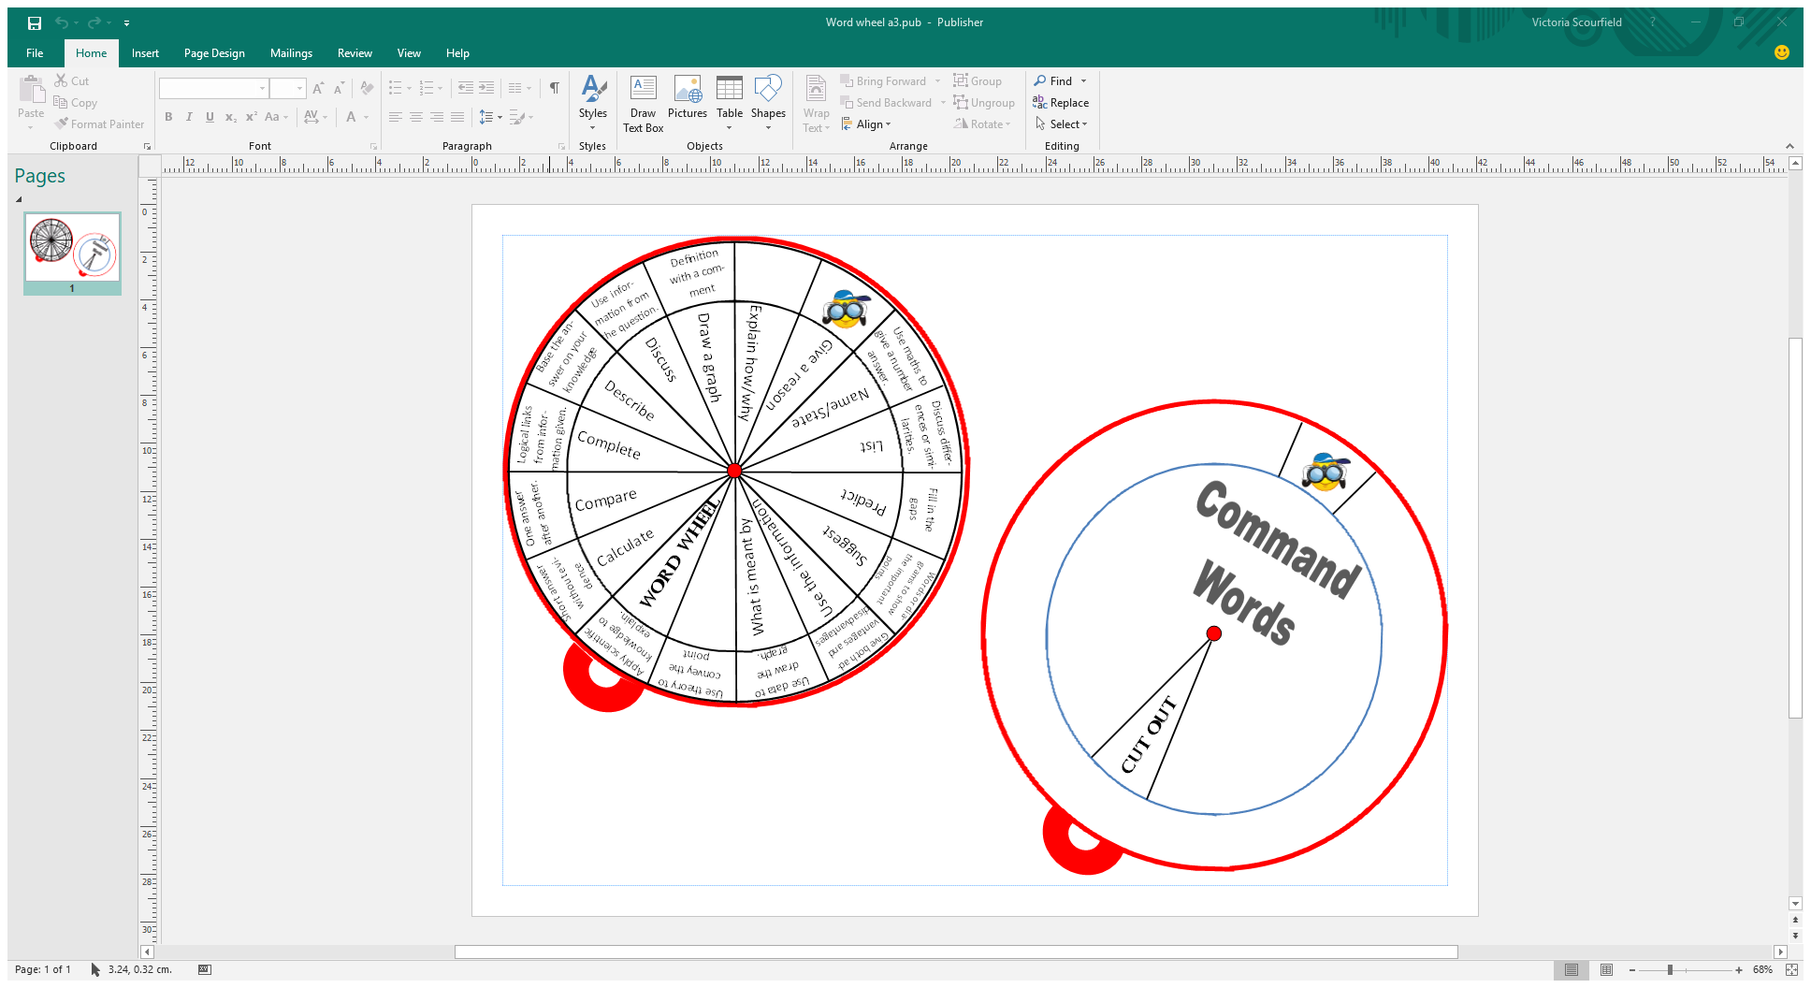
Appendix 2: Acid Rain PISA-Style Questions
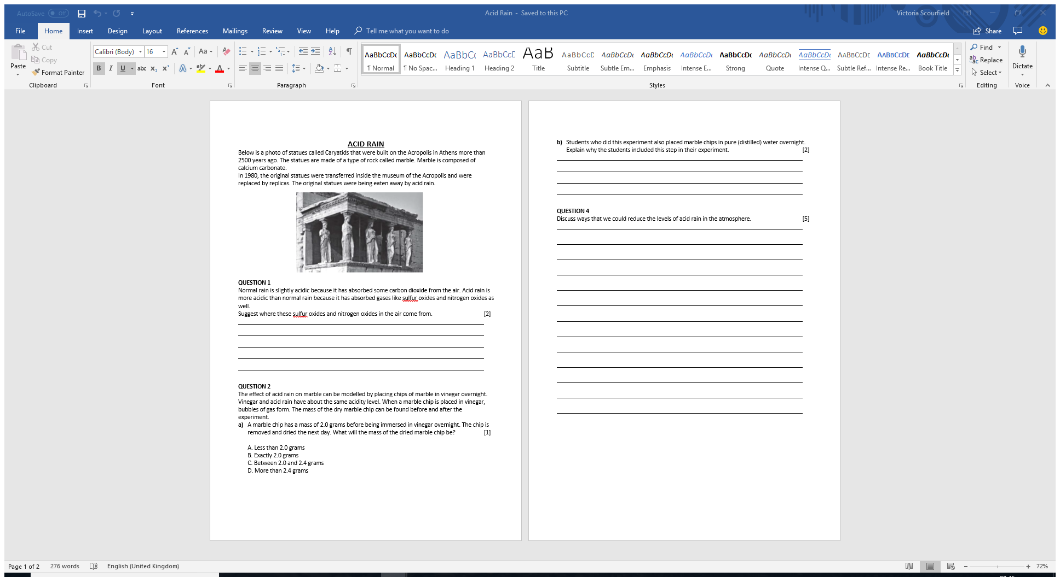

Appendix 3: Solar System PISA-Style Questions
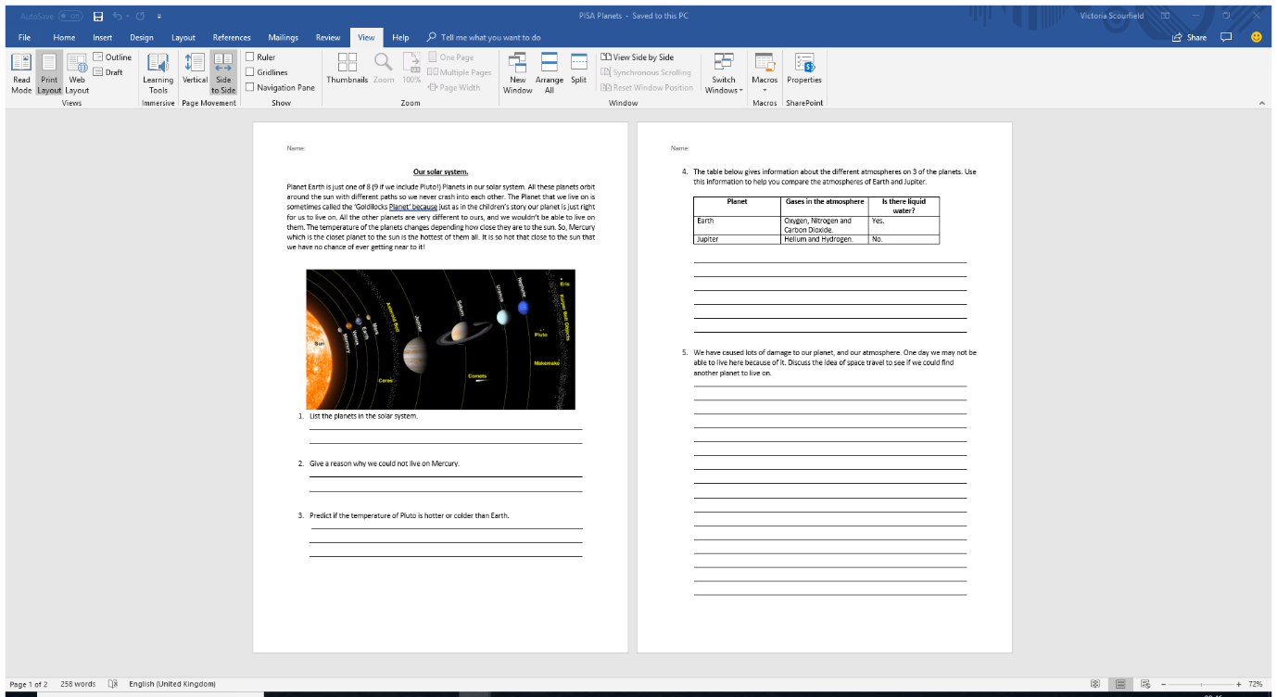

References
Adamson, C., 2016. Improving 15-year-old students' science attainment by raising their science literacy.. School Science Review, pp. 94-102.
Arthur, J., Waring, M., Coe, R. & L, H., 2012. Research methodd & methodologies in education. s.l.:SAGE.
ASE, 2012. ASE Guide to Research in Science Education. s.l.:s.n.
BERA, 2011. Ethical Guidelines for Educational Research, s.l.: s.n.
Corbett, P. & Strong, J., 2011. Talk for writing across the curriculum. s.l.:s.n.
Donaldson, G., 2015. Successful Futures, s.l.: s.n.
Estyn, 2011. Annual Report 2010 - 2011. [Online]
Available at: https://www.estyn.gov.wales/annual-report/annual-report-2010-2011
[Accessed 15 January 2018].
Hattie, J. & Timperley, H., 2007. The Power of Feedback. Reviwe of Educational Research, pp. 81-112.
Kearton, V., 2011. Developing literacy skills within science lessons: what does research say?. Education in Science, February.pp. 26-27.
McKeon, F., 2000. Literacy and secondary scoece - building on primary experience. School Science Review, Volume 81, pp. 41-50.
Meyer, O. et al., 2015. A pluriliteracies approach to content and language integrated learning. s.l.:Routledge.
Morrison McGill, R., 2017. Developing Exam Techniques. s.l.:s.n.
National Assembly For Wales Research Paper, 2013. Literacy and Numeracy in Wales. [Online]
Available at: http://www.assembly.wales/Research%20Documents/Literacy%20and%20Numeracy%20in%20Wales%20-%20Research%20paper-03062013-246762/13-039-English.pdf
[Accessed 15 January 2018].
PISA, 2015. PISA - Programme for International Student Assessment. [Online]
Available at: http://www.compareyourcountry.org/pisa/country/GBR4?lg=en
[Accessed 15 January 2018].
Plamer, S., 2011. How to teach writing across the curriculum. s.l.:Routledge.
Staples, R. & Heselden, R., 2001. Science teaching and literacy, part 1: Writing. School Science Review, Volume 83, pp. 35-46.
Strong, J., 2013. Talk for Writing in Secondary Schools. s.l.:Open University Press.
Toplis, R., 2015. Learning to teach science in the Secondary School. 4 ed. s.l.:s.n.
Walsh, E., 2017. Some thoughts about words and numbers in science. School Science Review, Volume 98, pp. 9-11.
Wellington, J. & Osbourne, J., 2001. Language and Literacy in Science Eductaion. s.l.:Open Universtiy Press.
Welsh Government, 2012. A guide to using PISA as a learning context., s.l.: s.n.
Welsh Government, 2015. Effective use of data and reseach evidence, s.l.: s.n.
Welsh Government, 2016. Welsh Government 2015 PISA National Report. [Online]
Available at: http://gov.wales/docs/statistics/2016/161206-pisa-2015-en.pdf
[Accessed 6 April 2018].
Welsh Government, 2017. My Local School. [Online]
Available at: http://mylocalschool.wales.gov.uk/School/6694063?lang=en
[Accessed 13 February 2018].
Welsh Government, 2017. Professional Standards for Teaching and Leadership, s.l.: s.n.
WJEC , 2018. WJEC Secure Website. [Online]
[Accessed 2018].
WJEC, 2014. WJEC Science Qualifications. [Online]
Available at: http://www.wjec.co.uk/qualifications/science/gcse/16056.pdf?language_id=1
[Accessed 6 April 2018].
WJEC, 2017. GCSE Examiner's Report Chemistry (New), s.l.: s.n.

