

LEVEL 7 ASSESSMENT SPECIFICATION
Programme: Master of Business Administration

Module: Strategic Management
Module code: LCMB7003

Assignment Title: Assessment component - Individual Report

Student Name: Iyappan Balakrishnan
Student ID:2434791

Table of Contents
Section 1: Report 3
1.0 Organisational Context and Overview 3
2.0 External and Internal Environment Analysis 4
2.1 Analysis of External Environment 4
2.2 Identification of success factors and challenges 8
2.3 Analysis of the internal environment 9
2.4 Analysis of Strategic Capabilities 10
2.5 Impact of internal strengths on competitive edge 11
3.0 Analysis of CSR and Sustainability Objectives 11
4.0 Comprehensive and holistic view of the organisation 13
4.1 Financial Perspective 13
4.2 Customer Perspective 14
4.3 Internal Business Processes 14
4.4 Learning and Growth Perspective 14
4.5 Critical Evaluation 14
5.0 Strategic Choices and Implementation 15
5.1 Business-Level Strategy 15
5.2 Corporate-Level Strategy 15
5.3 Recommended Strategic Choices 15
5.4 Change Management Evaluation 16
6.0 Strategic Evaluation and Recommendations 16
6.1 SWOT Analysis 16
7.0 Recommendations (Innovative & Unused by BP) 17
8.0 Conclusion 18
Section 2: Reflection 19
References 23

List of Figures
Figure 1: Global Employee Number at BP 3
Figure 2: Revenue of BP 4
Figure 3: Inflation rate of the UK 6
Figure 4: Increased fuel price in the UK 7
Figure 5: Environmental commitment of the UK 8
Figure 6: Sustainability Objectives of British Petroleum 12
Figure 7: Revenue Generation of BP Plc 13
Figure 8: Gibbs Reflective Model 19

List of Tables
Table 1: VRIO Analysis 10
Table 2: Action Plan 22

Section 1: Report

1.0 Organisational Context and Overview
British Petroleum (BP) is among the largest integrated energy companies in the world, which is based in London, United Kingdom, and has operations in over 60 countries. BP was established in 1909 as the Anglo-Persian oil company. It has grown to be an international energy multinational venturing in oil and gas exploration, oil and gas refining, oil and gas trading, and renewable energy development (BP, 2026). The mission of the company is to provide safe, cheap, and less carbon-intensive energy. In addition, its strategy aims at evolving from an oil company to an integrated energy company and assisting the global process of going net-zero emission (BP, 2026). The business model of BP includes upstream operations, such as production and processing of oil and gas, downstream business, such as refining, retailing, and trading, and increasingly investing in low-carbon and renewable technologies of energy (BP, 2025). BP is a competitor company in the worldwide energy market, which is substantially competitive with other large companies like Shell, ExxonMobil and Total Energies. Enormous production and diversification allow the company to have a high market position globally. It has 93,6700 workers by the year 2025 and it has approximately 21,200 retail outlets (Stock Analysis, 2025). It generates about 2.4 million barrels of oil equivalent daily, which points out large volumes of business and market penetration (BP, 2025).
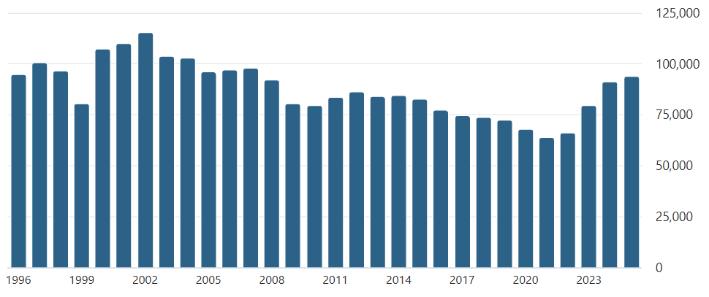

Figure 1: Global Employee Number at BP
(Source: Stock Analysis, 2025)
The period of 2020-25 has noticed a high fluctuation of income in BP as a result of the fluctuation of the oil prices, the geopolitical shocks, and the global transition to the production of energy. After the post-pandemic energy demand, the revenue rose rapidly to about $241 billion in 2022 against about $123 billion in 2020, then stabilised at about $189 billion in 2025 (Companies Market Cap, 2025). This trend is based on the fact that BP is exposed to the dynamics and changes of the global energy market and prices.
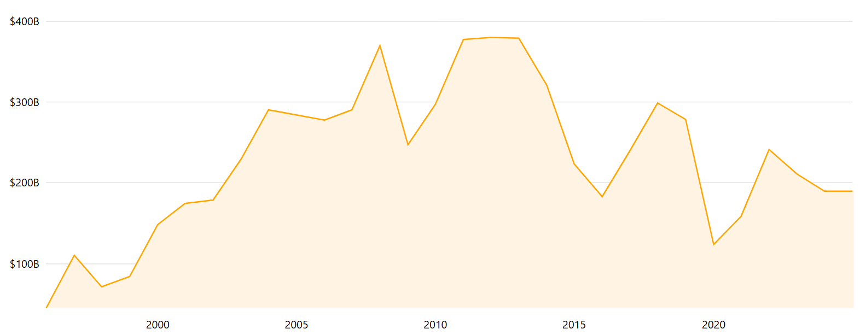

Figure 2: Revenue of BP
(Source: Companies Market Cap, 2025)
The company has reinforced its energy transition plan by further developing EV charging to more than 22,000 locations (BP, 2023) and building 8.2GW of renewable capacity across markets across the world. The BP strategy is based on the priorities of increasing upstream production, downstream operations, and low-carbon energy investments to provide competitive advantage in the global energy market over time in light of its transformation. On the whole, the high global linkage of BP, business model diversification, and strategic shift to integrated energy make the organisation an essential stakeholder of the global energy industry. Yet, it is still struggling with issues of market volatility and sustainability stresses as well as regulatory shifts.

2.0 External and Internal Environment Analysis

2.1 Analysis of External Environment
Political Factors
The UK political decisions have a great effect on the strategic direction of BP. In 2026, the UK government dismissed available calls to increase production of oil and gas in the North Sea in favour of clean energy production (Ambrose, 2026b). This poses a doubt about the domestic upstream investments of BP. Simultaneously, unforeseeable events such as wars in the Middle East have brought about contingency measures such as decreasing the use of oil by restricting transportation (Topham and Partridge, 2026). BP reacts to contradictory cues and pressures to stop its reliance on fossil fuels, and at the same time, it must avoid energy security issues. This has helped BP to remain in the oil and gas investment and not fully invest in renewables.
Economic Factors
These macroeconomic factors have a huge impact on strategies at BP. In the UK and other parts of the world, profitability is decreased due to the fluctuation of oil prices as a result of disequilibrium in supply and demand, OPEC+ production control, and geopolitical uncertainties. Indicatively, in 2025, the global oil prices were valued under $60 a barrel, and the profits of BP reduced to approximately $7.5bn compared to approximately $9bn in 2024 (Ambrose, 2026a). Moreover, the inflation rates and the slow growth rate of the UK economy in the year 2025-2026 will lower the need for energy and heighten the operational expense of the entire industry. The UK Office for National Statistics claimed that inflation was higher than the 2% goal of the Bank of England for the year 2025, which impacted consumer spending and industrial use of energy (ONS, 2025). These outside economic effects compel BP to focus on efficient oil and gas developments of high margins, short-term duration, whereas reducing investment in renewable energy proves more efficient, showing how the global and UK economic environment directly influences business strategy.
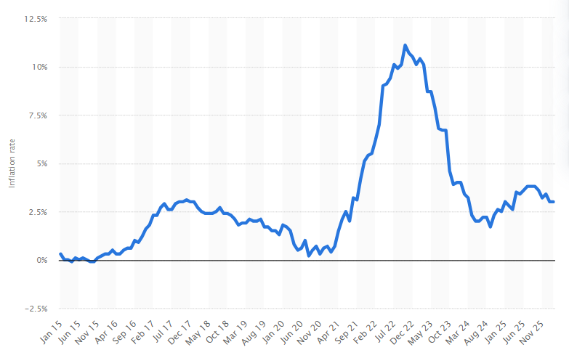

Figure 3: Inflation rate of the UK
(Source: Statista, 2026)
Social Factors
Sustainability and climate responsibility are becoming important in the UK in the eyes of the population and stakeholders. Nevertheless, more than 110 ESG funds would reassess BP in 2025, but some of them left their investments because of environmental issues (Whannell, 2026). Consumer behaviour has also changed, and the increase in fuel costs has stimulated the reduction of car usage and adoption of energy-saving habits in the UK (Topham and Partridge, 2026). BP needs to strike the right balance between reputational risks and the expectations of investors. As much as there are investors who are still in favour of BP, social pressure compels the company to ensure that they commit at least partially towards net-zero objectives.
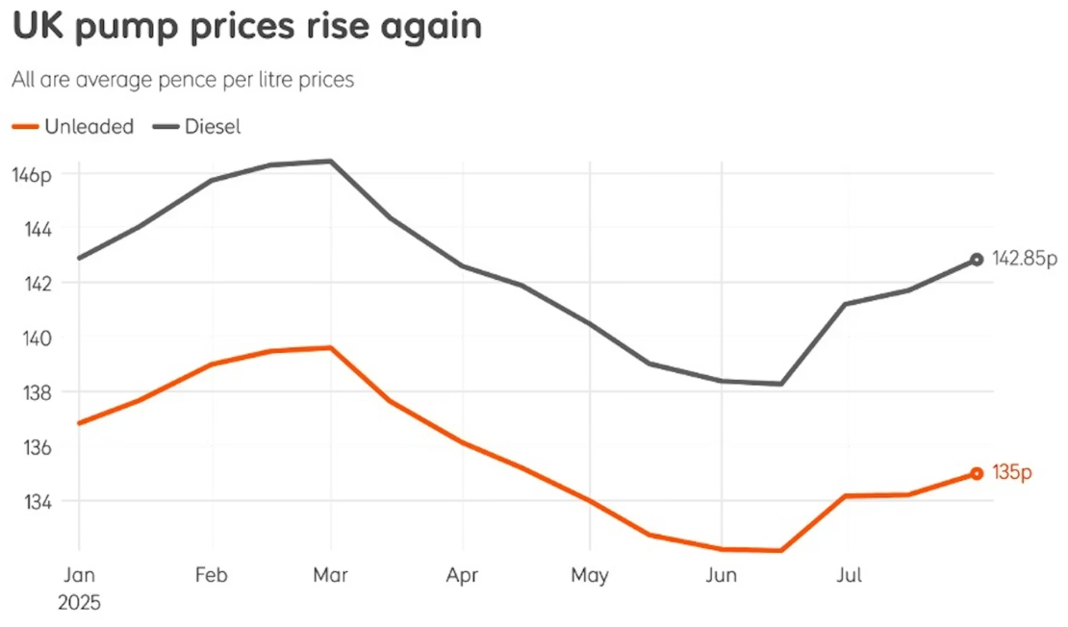

Figure 4: Increased fuel price in the UK
(Source: Doyle, 2025)
Technological Factors
The strategy of BP is majorly affected by external technological advances experienced in the international energy market. The energy transition is accelerated by the rapid innovation in renewable energy, battery storage, and hydrogen which have been triggered by the competition, governments, and research institutions (GOV.UK, 2025). Offshore wind capacity is also growing at a rapid pace in the UK with numerous Contracts for Difference (CfD) schemes sponsored by the government rendering renewables more economically able to compete with fossil fuels (Almeida, 2025). Furthermore, solar and wind technology is becoming increasingly popular in Europe because of the reduced costs in the world. The quick external technological change and developing competition by the renewable energy providers compel BP to act on their part and this will determine the long-term positioning of the firm in the evolving energy market.
Environmental Factors
In the UK, the environmental aspects are exerting pressure, which is greatly influencing the operating conditions of BP. With a strategic aim of reducing carbon emissions by 68% by 2030, and a net-zero carbon emission target of 2050, the UK has made it legally binding to apply pressure on high-carbon-emitting industries (Climate Change Committee, 2025). These trends in the external environment demand that BP employ tools to lower emissions, shift to cleaner energy, and follow the decarbonisation trajectory of the UK, which is accelerating, or may face regulatory and reputational impacts.
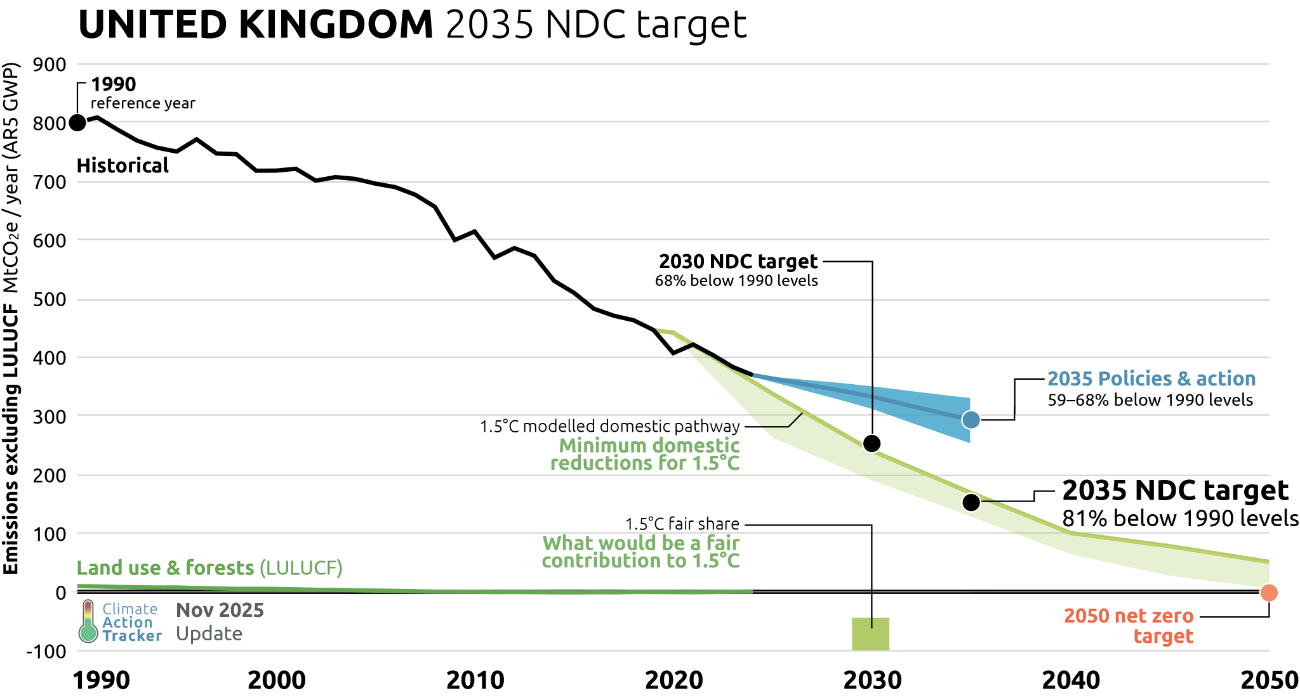

Figure 5: Environmental commitment of the UK
(Source: Climate Action Tracker, 2024)
Legal Factors
The UK has more legal and regulatory frameworks that underpin decarbonisation. BP faces compliance pressures of climate commitments in line with net-zero targets (Burnett and Stewart, 2024). Further, the ESG regulations in Europe could become stricter and this could have an effect on the investor behaviour and reporting standards. BP needs to take control and stay within the law whilst dealing with legal risks related to environmental performance which should affect disclosures and long-term forecasts.

2.2 Identification of success factors and challenges
The external environment in which BP is operating is highly complicated, and the strategic adaptability and orientation toward the energy transition become the critical success factors (CSFs). One of the CSFs is the fact that BP is able to strike a balance between profitability in fossil fuels and renewable investments, which guarantees them a short-term financial stability, whilst keeping them relevant in a decarbonising market (Jamil, Amran and Simarmata, 2023). Its ability to act upon regulatory and political cues in the UK, especially changing energy policies is also important. Also, long-term competitiveness will depend on technological responsiveness, innovation in renewables, hydrogen, and storage (Zeinalnezhad et al. 2020). Being able to maintain investor confidence with the need to address ESG expectations is another key success factor in the continued access of capital.
Nonetheless, there are great strategic challenges that BP is encountering. Politically and legally, there exist competing pressures because of energy security and decarbonisation to confuse the decision-making process of policy-makers, making it difficult to make investments or not (Burnett and Stewart, 2024). Financially, the volatility of the oil price regime, inflation and reduced demand diminish profitability and propel BP to short-term fossil dependence, thereby slowing the transition objectives. Socially, an increased environmental consciousness presents BP with reputational risks and investor drift, mainly with the exit of certain ESG funds. Rapid external innovation in renewables is a competitive threat technologically, which can lead to strategic lag in case BP does not invest enough (Ambrose, 2026a). In environmental contexts, the strict UK net-zero targets put additional pressure and form a structural conflict between the present and future activities and compliance.

2.3 Analysis of the internal environment
Resources | Valuable | Rare | Inimitable | Organised | Outcome
Global Oil and Gas Reserves | Yes | Yes | Yes | Yes | Sustained Advantage
Brand and Market presence | Yes | Yes | No | Yes | Temporary Advantage
Advanced engineering technology | Yes | Yes | Yes | Yes | Sustained Advantage
Financial Strength | Yes | No | No | Yes | Competitive Parity
Renewable Energy Capability | Yes | No | No | Moderate | Temporary Advantage
Table 1: VRIO Analysis
(Source: Self-created)

2.4 Analysis of Strategic Capabilities
The analysis of strategic capabilities of BP in the framework of the VRIO demonstrates mixed results with both durable and structural weaknesses. Its developed oil and gas reserves internationally, and engineering is the fundamental asset of an extended competition. Its developed oil and gas reserves internationally and engineering are the fundamental assets of an extended competitive advantage because they are valuable, uncommon, challenging to follow, and structured (Kang, 2020). These abilities support the scale and efficiency of operations of BP, enabling it to compete with the key players in the industry and take the performance of the upstream, thus remaining at its best.
Nevertheless, not every resource is long-term beneficial. The brand and presence that BP has in the market is valuable and comparatively exclusive, but such a position is not inimitable, which means that the company gains only a transient advantage. This indicates that reputation is not enough in a trade where the rivalry can achieve branding and positioning off the market (Kang, 2020). Similarly, financial strength can only provide competitive parity, which means that capital availability is no longer an aspect of differentiation between large energy companies.
More importantly, the capability of BP in the renewable energy area is poorly placed, valuable but not rare or hard to copy and organised only moderately. This is a strategic weakness, as the shift to energy transition is increasing (Alkaraan et al. 2024). Hence, the competencies of BP are still highly biased in the conventional direction of hydrocarbons, implying that the company has the mismatch between the resources base and the needs of the industry in the long-term perspective, which may impair the future competitiveness

2.5 Impact of internal strengths on competitive edge
To maintain a competitive edge, BP can draw on several internal strengths, although none of them is evenly distributed and shared, becoming more disputed. The most considerable strengths continue to be its oil and gas reserves in the world and its sophisticated engineering capabilities that allow the company to do extensive, cost-effective exploration and production (Alkaraan et al. 2024). These strengths make barriers to entry quite high and enable BP to generate high cash flows and strengthen its leading role in the world energy market. These strengths are especially useful where the profitability is directly proportional to the efficiency of operations and technical expertise in the volatile markets.
Nevertheless, the viability of such benefits is becoming problematic. Although the financial capability allows BP to make big capital investments and absorb market shocks, it does not make the firm stand out from the competition with similar financial power (Kang, 2020). Similarly, it has a small competitive edge in terms of its brand and market position because reputational value is easily broken with environmental accusations and changing social requirements.
More importantly, the tendencies of BP strengths are highly concentrated in the field of fossil fuel activities, which leads to the current structural dependence that is not commensurate with the global energy transition. Its relatively poor renewable energy potential refers to the fact that past strengths may not become future competitors (Melesse, 2025). Thus, although the internal resources of BP are still supporting an advantage, they are likely to evolve into strategic inflexibility unless reconfigured successfully to low-carbon opportunities.

3.0 Analysis of CSR and Sustainability Objectives
The CSR strategy outlined by BP focuses on its net-zero strategy and sustainability, but its correspondence to business goals is highly contradictory. As mentioned in the 2025 Sustainability Report by British Petroleum, the company targets obtaining net-zero emissions by 2050 and has already cut its operational emissions by 37% of the existing level in 2019, which surpasses its 20% goal (British Petroleum, 2025). It has proven to be a step in the right direction, and it is reasonable with regulators and other stakeholders, in line with CSR as a long-term positioning strategy in a low-carbon economy.
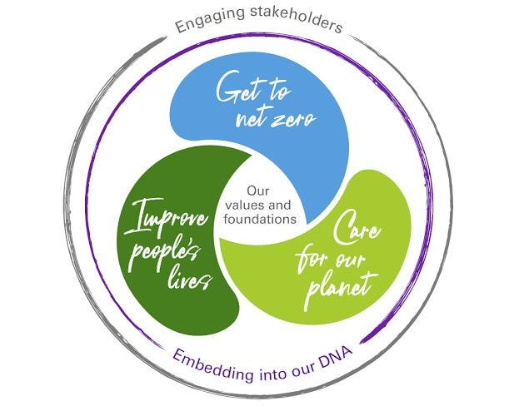

Figure 6: Sustainability Objectives of British Petroleum
(Source: Environmental Action Forum, 2025)
This alignment is, however, compromised by strategic inconsistencies. Although BP is committed to climate, it has cut its intended renewable spending to approximately $1.5-$2.0 billion each year at the same time as spending more on oil and gas (Kumar, 2025). This makes it appear that CSR is, to some degree, fallacious to short-term financial goals, especially the returns to shareholders. Subsequently, BP has already cut down previous emission reduction and production targets and undermined the viability of sustainability as a narrative (Global Witness, 2025).
Most importantly, this tension is reflected in investor and stakeholder responses. On the one hand, as of 2025, more than 110 ESG funds continued to hold BP, and on the other hand, some of the investors have sold off their stakes owing to doubts about diluted climate decisions and possible greenwashing (Whannell, 2026). It means that CSR helps to preserve the attractiveness of investment, but makes the reputation of the firm vulnerable in case inconsistencies are revealed.
Therefore, the CSR approach of BP to business goals is partial in its development of legitimacy and transitioning to the long-term; it cannot fully overcome its fossil fuel profitability, which places a strategic paradox between a sense of sustainability and its business priorities.

4.0 Comprehensive and holistic view of the organisation

4.1 Financial Perspective
The most common goal of BP is profitability and shareholders' return, which is largely oil and gas-based. Oil volatility has led to BP registering revenues of $241 billion in 2022 and stabilising the figure at approximately $189 billion, by the year 2025 (Companies Market Cap, 2025). Among the KPIs are the net profit, ROACE and cash flow. One of the major focuses is to have a good cash-generating process which allows investors to pay dividends and make reinvestment. Nonetheless, there is a paradox in the initiatives, and BP intends to invest more upstream and restrict low-carbon expenditure to about $1.5bn to $ 2bn yearly. Most importantly, this is an indicator that financial priorities prevail and limit real transition alignment.
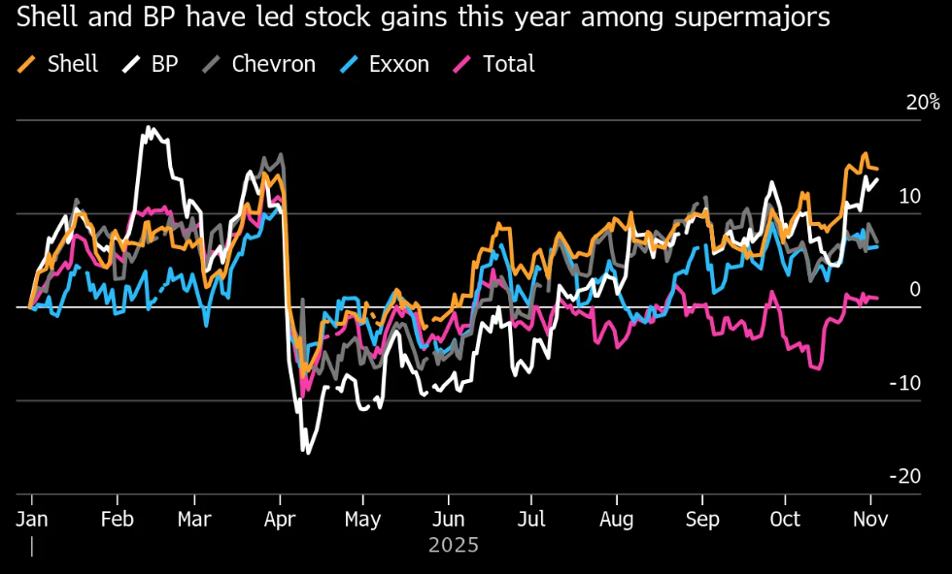

Figure 7: Revenue Generation of BP Plc
(Source: Ferman, 2025)

4.2 Customer Perspective
BP is striving to have access to energy and enhance the perception of sustainable measures among its customers. KPIs are customer reach and EV charging growth, surpassing 22,000 charging units around the world (BP Plc, 2024). Targets work on the development of convenience retail and low-carbon mobility. Nevertheless, an increase in the price of petroleum and a change in consumer trend towards more eco-friendly energy are putting the original model of operation to the test at BP. Although the idea of EV expansion is positive, this is still not a large-scale operation as compared to fossil fuel operations, and this discourages the transformation that is customer-driven.

4.3 Internal Business Processes
The goal of BP is operational efficiency and secure and dependable energy production. The KPIs are production output with approximately 2.4 million barrels per day and emissions reduction by 37% since 2019 (BP Plc, 2024). Some of the efforts are digital optimisation and restructuring of the portfolio. Nonetheless, even the rising oil production objectives with 2.3-2.5 million barrels per day by 2030 are in opposition to internal decarbonisation processes. This becomes a way of showing inefficiencies in coordinating operational activities with sustainability goals.

4.4 Learning and Growth Perspective
BP is also concerned with capability building in the low-carbon technologies and staff transition. KPIs consist of the renewable capacity of 8.2GW developed and the reskilling of the employees. Scaling clean energy and innovation are the targets (Yuriy, 2020). But decreased spending on renewables is an indicator of a lack of commitment, and there may be a risk of technological backwardness. This negates future flexibility with proclaimed aspirations.

4.5 Critical Evaluation
The Balanced Scorecard of BP shows an imbalance in their strategies as the company has a high level of financial and operational performance with a low level of customer and innovation transformation (Elsayed and Ammar, 2020). Although efforts are made to facilitate the gradual shift, the prevalence of KPIs that are fossil fuel-driven indicates that the strategy encounters misalignment to sustainability commitments and thus affects the future competitiveness.

5.0 Strategic Choices and Implementation

5.1 Business-Level Strategy
Traditionally, in upstream oil and gas, BP follows cost leadership, utilising the volume of scale, advanced engineering, and oil and gas reserves worldwide. This has held true especially since it yields approximately 2.4 million barrels of oil equivalent in a daily basis (BP Plc, 2024). Nevertheless, cost leadership is becoming more limited due to unstable oil prices that declined to below $60 per barrel in 2024, decreasing profits to about $7.5bn (BP Plc, 2024).
At the same time, BP tries to differentiate partially by offering low-carbon products like EV charging at more than 22,000 points worldwide or energy capacity powered by renewable energy around 8.2GW (BP Plc, 2024). However, differentiation has been underdeveloped owing to a lowering of annual low-carbon investment. More importantly, BP finds itself in the nebulus position, unable to actually distinguish itself in clean energy but still at risk of being involved in the price competition of commodities in fossil fuels.

5.2 Corporate-Level Strategy
On the corporate level, BP has been diversifying in related areas of renewable, EV infrastructure, and hydrogen. This is in line with its net-zero goal, but it is not scaled, as compared to core operations (Eltweri et al. 2024). Fossil fuels continue to dominate production, generating much energy compared to renewable, which is a reduction of limited diversification.
Large-scaled international expansion is another advantage that BP enjoys as it conducts its businesses in more than 60 countries. The international presence removes risk and the inability to access the market (Araujo et al. 2022). Nevertheless, geopolitical volatiles and regulatory restrictions by the UK on production in the North Sea create strategic doubt thus diminishing the power of internationalisation.

5.3 Recommended Strategic Choices
BP must take a hybrid strategy by clearly prioritising. On the business level, it must shift to low-carbon energy leadership in differentiation, renewable energy scaling, EV charging, and integrated energy solutions (Williamson, Symeou and Zyglidopoulos, 2022). On the corporate level, the rapid diversification of clean energy is necessary with the re-allocation of the capital toward the long-term growth of fossil fuel.
This change is needed due to the fact that the dependence on oil exposes BP to the threat of low demand, regulatory risks, and capital limits induced by ESG (Williamson, Symeou and Zyglidopoulos, 2022). An increased low-carbon orientation would mean more competitiveness in the long term and adaptation to the market trends.

5.4 Change Management Evaluation
The change management in BP has lacked transformational change management, but instead, it has been inconsistent and reactive in nature. However, although Brazil made promises of aggressive emission cuts and renewable expansion, it was later reduced, and more oil and gas investments were made, producing an indicator of a strategic shift (Alm and Brown, 2021). This does not cascade well and invigorates internal non-congruence.
It has a major implementation effect. Conflicting priorities reduce the allocation of resources, hindering innovation and mistrust in stakeholders. Despite some quantifiable improvements on the part of BP, the fact that it is still expanding its fossil fuel consistently portrays progress, but not a radical change.

6.0 Strategic Evaluation and Recommendations

6.1 SWOT Analysis
Strengths:
BP has a high level to perform operational scales and cash generation as they cross 2.3 million barrels/day in recent times and have considerable global assets (BP Global, 2025). The efficacy and price competitiveness are supported by its built-in model and ongoing delivery of the projects which is about 7 large projects in 2025. Additionally, the liquidity and focus are enhanced through portfolio optimisation, for example, sales of 65% stake in Castrol (Gurufocus, 2026).
Weaknesses:
There is an indication of financial instability whereby profits go down to about 7.5bn in 2025 compared to about $9bn in 2024, to leave BP with no choice but to stop share buybacks in 2026 (Ambrose, 2026). More importantly, the demonstration of its low-carbon business in the range of $3-$5bn indicates the poor capital allocation and poor execution in renewables (Partridge, 2026). Strategic consistency is also undermined by the frequent change in leadership.
Opportunities:
Increasing disinvest or demands regarding climate responsibility, which is over 1 trillion in assets to support climate resolutions, provide incentives to reposition strategically to BP (Nasralla, 2026). The need for growth in the global energy demand and the possible technology innovations present a growth opportunity to diversify into scalable low-carbon solutions.
Threats:
BP can expect falling oil prices, below 60/barrel in 2025, geopolitical turmoil, and a growing ESG risk. Increased operational and reputational risk is also an indication of labour disputes and stakeholder activism (Jao and Mukherjee, 2026).
The approach taken by BP for the strategy is a reactive move back to fossil fuels and emphasis is more on the short-term rewards rather than transformation. This is the opposite of its previous net-zero stance and has brought strategic inconsistency, which diminished investor confidence and undermined competitive differentiation.

7.0 Recommendations (Innovative & Unused by BP)
i) Need to develop a “Carbon-as-a-Service” Platform
BP needs to commercialise the emissions management strategy by providing services to industrial clients in the form of carbon capture, offset trading, and decarbonisation advisory. This is in line with the resource-based theory, which would exploit the engineering capabilities of BP even as it generates other forms of revenues other than energy production. For example, Microsoft implements carbon tracking to enterprise services.
ii) Need to Spin-Off a Fully Independent Green Subsidiary
Instead of incorporating renewables in the extensive operations that are dominated by fossil fuels, BP must establish a green arm that has different policies and capital bases. This is a reflection of the transformation in Ørsted, which allowed it to be strategic and investor-friendly.
iii) Need to Adopt “Real Options” Investment Strategy in Renewables
Rather than massive, risky investments, BP ought to engage in gradual investments in new technologies (hydrogen, storage), decreasing uncertainty. This increases the flexibility in fluctuating market conditions.
Therefore, the critical situation that BP is facing at the moment is financially sound yet strategically unsound, as its sustainability credibility drops. Devoid of creative repositioning and structural decoupling of fossil and renewable operations, BP will lose its competitive advantage as an increasing number of energy transitions occur in the long term.

8.0 Conclusion
To conclude, BP functions in a politically and economically tense and ecologically dissonant external environment, where some forces of decarbonisation that are lured by politics and environment, collide with market reality that perpetuates dependence on fossil fuels. Even though BP has maintained excellent internal competencies in the oil and gas sector, its strategic orientation is not harmonious especially in ensuring that sustainability pledges are balanced to its financial interests. The evaluation sheds light on an imbalance in structure between the short-term profitability and the transition preparedness to the long term. In order to be competitive, BP needs to re-organize its resource base, intensify its low-carbon strength and develop a more transparent and regular strategy that brings alignment between external pressures and internal strengths in an ever-changing energy market worldwide.

Section 2: Reflection
The reflective cycle created by Gibbs is a systematic approach to the critical analysis of learning experiences, as it allows identifying six stages, namely, description, feelings, evaluation, analysis, conclusion, and action plan (Praveena et al. 2025). The model promotes increased self-awareness and continuous growth by connecting experience and critical thinking along with the future development in both academic and professional environments.
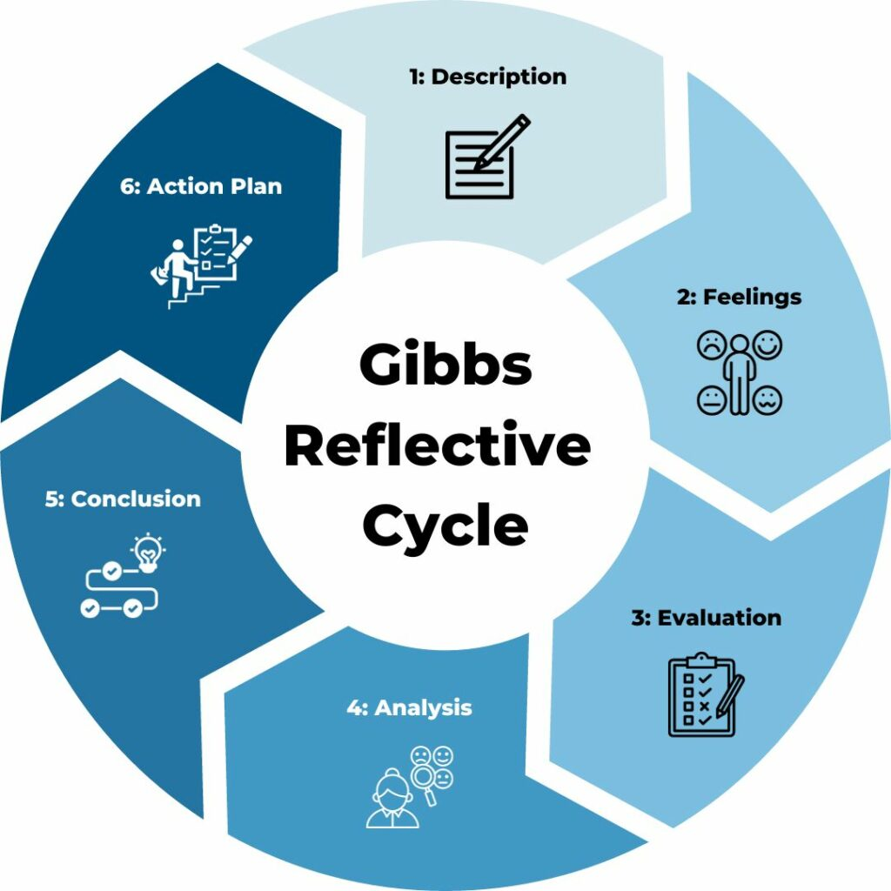

Figure 8: Gibbs Reflective Model
(Source: Channell, 2025)
Description
In the process of preparing the strategic management report, I was conducting a lot of research on a UK-based energy multinational, and its strategic environment, sustainability transition, and the competitive positioning. I have read annual reports and sustainability reports and scholarly journal articles to learn the pressure of external reporting, which include climate regulation, market volatility, and worldwide energy demand. Implementation of strategic frameworks PESTEL, VRIO, and Balanced Scorecard involved structured data interpretation and critical analysis of the theoretical concepts and practices that existed in the theory. According to reflective learning theory, the guided process of reflection can be used to assist learners in bridging the gap between theory and practical activities and enhancing their analytical skills and academic scores (Radović et al. 2023). I also examined financial and operating data over the past five years to learn the development of the strategic decisions in the context of post-pandemic recovery and energy transition issues. This was done in the appraisal of multifaceted and even opposing information, and especially so the sustainability pledges and investments in fossil fuels.
Feelings
I was unsure of how to approach the analysis of a big energy company at the start of this research process due to the complexity and volume of financial data, environmental policies, and strategic frameworks. This amount of information and technical terms at first caused me anxiety and eroded my self-confidence in the ability to construe strategic decisions. But with the help of annual reports and academic literature I felt more controlled and confident with my analysis capacity. I was more at ease with the interpretative sustainability strategies and the connection they have with strategic management theories. Increased emotions enhance reflective learning by facilitating deeper insight and allowing learners to critically evaluate experiences and assumptions to enhance academic judgement and contribute to continuous professional growth and development (Li, 2025). On some occasions, I became frustrated with differences in opinions in journal articles on energy transition and corporate responsibility that needed further critical thinking.
Evaluation
Research process was both rewarding and demanding and provided me with a good learning experience as well as pointing out the areas that needed to be improved. One of the strengths that I had was the possibility of collecting the credible data through the annual reports, industry publications, and academic journals, which contributed to the increase in the reliability of the analysis and evidence-based argumentation. The use of strategic frameworks made me acquire systematic approaches to thinking and obtain a better perspective on sustainability issues and competitive advantage. Yet, I saw time management and data interpretation as weak areas, since the process of analysis of financial and operational statistics took too much effort. It is true that at times, I put extremely much attention on description as opposed to critical analysis, which did not allow an in-depth analysis. To evaluate effectively, distinguishing the strengths and the weaknesses is required to improve a performance in the future and acquire critical thinking skills (Thornhill-Miller et al. 2023). This experience assisted me in realising the necessity of the balance between theory, data and critical analysis.
Analysis
The experience was a big boost to my knowledge on strategic management as well as reflective learning. The implementation of strategic models showed the way theoretical frameworks may be applied to assess actual organisational issues, especially in sectors experiencing environmental as well as technological change. I realised that strategic analysis is not just about model application, but also the critical interrogation of assumptions, critical interpretation of data and the general economic and political situation (Chowdhury et al. 2024). It was also the process that emphasised sustainability and corporate responsibility in contemporary strategic decision-making, which involves the need to bring environmental and financial concerns together. According to the reflective practice theory, critical reflection enables the learner to cease the superficial level of knowing and become able to create deeper thinking and analytical abilities (Aladini et al. 2025). The process allowed me to become a better problem solver and have a more critical response towards the assessment of strategic decisions, which will pay off later in not just my academic but also my professional life.
Conclusion
The reflective experience has enhanced my knowledge about strategic analysis, the methodology of research, and critical thinking. I was able to appreciate the power of credible data, systematic application of theoretical frameworks, and assessing organisational strategies in various ways. It also revealed that the time management is to be improved and the critical attention to the academic literature has to be enhanced. Most significantly, I gained the confidence to analyse intricate strategic problems and to connect the theory and the practical aspects of life. This has enhanced my skills in academic writing as well as making me a critical assessor of organisational performance and is equipping me with postgraduate research writing and professional strategic decisions in the future.
Action Plan
Area for Improvement | Action I Will Take | Timeline | Expected Outcome
Time management | I will organise my research schedule and separate the strategic examination into the weekly tasks to prevent the last-minute rush. | Next assignment | More efficient organisation and less stress in research and writing.
Critical use of literature | I will also lay emphasis on peer-reviewed journal articles and critically compare the various academic views rather than using company reports as a key source of information. | Ongoing | Better critical analysis and enhancement of academic arguments.
Data interpretation skills | I will exercise the skills of analysing the financial and sustainability data through annual reports and strategic plans more often. | 2–3 months | Better confidence of understanding complex strategic information.
Reflective practice | To analyse my learning, I will use the reflection provided by Gibbs following every major assignment to enhance the performance in the future. | Continuous | Constant educational and professional growth.
Table 2: Action Plan
(Source: Self-developed)

References
Aladini, A., Osman Abdul Wahab, M., Ismail, S.M. and Hashemifardnia, A. (2025). Ripples of reflection: how iterative reflective practices shape cognitive flexibility, emotional resilience, and problem-solving skills. Reflective Practice, pp.1-19. https://doi.org/10.1080/14623943.2025.2596423
Alkaraan, F., Elmarzouky, M., Hussainey, K., Venkatesh, V.G., Shi, Y. and Gulko, N. (2024). Reinforcing green business strategies with Industry 4.0 and governance towards sustainability: Natural‐resource‐based view and dynamic capability. Business Strategy and the Environment, 33(4), pp.3588-3606. https://onlinelibrary.wiley.com/doi/abs/10.1002/bse.3665
Alm, K. and Brown, M. (2021). John Rawls’ concept of the reasonable: A study of stakeholder action and reaction between British petroleum and the victims of the oil spill in the Gulf of Mexico. Journal of Business Ethics, 172(4), pp.621-637. https://link.springer.com/article/10.1007/s10551-020-04474-9
Almeida, L. (2025). BP predicts higher oil and gas demand, suggesting world will not hit 2050 net zero target. Available at: https://www.theguardian.com/business/2025/sep/25/bp-oil-and-gas-clean-energy-ukraine-middle-east-tariffs. (Accessed: 25th March 2026)
Ambrose, J. (2026a). BP halts share buy-backs as annual profits slide. Available at: https://www.theguardian.com/business/2026/feb/10/bp-halts-share-buy-backs-profits-fall-chief-executive. (Accessed: 25th March 2026)
Ambrose, J. (2026b). Ministers rebuff trade body’s call to boost North Sea oil and gas production. Available at: https://www.theguardian.com/business/2026/mar/24/ministers-rebuff-call-north-sea-oil-gas-production-offshore-energies-uk. (Accessed: 25th March 2026)
Araujo, C.L., Picavet, M.E.B., Sartoretto, C.A.P.D.S., Dalla Riva, E. and Hollaender, P.S. (2022). Ecocentric management mindset: A framework for corporate sustainability. Critical Perspectives on International Business, 18(4), pp.518-545. https://www.emerald.com/cpoib/article/18/4/518/19756
BP (2023). bp plans to invest $1 billion in EV charging across US by 2030, helping to meet demand from Hertz’s expanding EV rentals. Available at: https://www.bp.com/en/global/corporate/news-and-insights/press-releases/bp-plans-to-invest-1-billion-dollars-in-ev-charging-across-us-by-2030-helping-to-meet-demand-from-hertzs-expanding-ev-rentals.html (Accessed: 24 March 2026).
BP (2025). Annual report 2025 | BP global. Available at: https://www.bp.com/en/global/corporate/investors/results-reporting-and-presentations/annual-report.html#ar-highlights-1-1 (Accessed: 24 March 2026).
BP (2026). Our history | Who we are | Home | BP global. Available at: https://www.bp.com/en/global/corporate/who-we-are/our-history.html (Accessed: 24 March 2026).
BP Global (2025). BP Global. Available at: https://www.bp.com/en/global/corporate/news-and-insights/energy-in-focus/4q-2025-and-full-year-results.html (Accessed: 24th March 2026)
BP Plc (2024). Home. Available at: https://www.bp.com/ (Accessed: 24th March 2026)
British Petroleum (2025). bp Sustainability Report 2025. Available at: https://www.bp.com/content/dam/bp/business-sites/en/global/corporate/pdfs/sustainability/group-reports/bp-sustainability-report-2025.pdf. (Accessed: 24th March 2026)
Burnett, N. and Stewart, I. (2024). The UK’s Plans and Progress to Reach Net Zero by 2050. Available at: https://commonslibrary.parliament.uk/research-briefings/cbp-9888/. (Accessed: 25th March 2026)
Channell, M. (2025). Gibbs Reflective Cycle – A Practical Guide. Available at: https://www.tsw.co.uk/blog/leadership-and-management/gibbs-reflective-cycle/ (Accessed: 24 March 2026).
Chowdhury, S., Budhwar, P. and Wood, G. (2024). Generative artificial intelligence in business: towards a strategic human resource management framework. British Journal of Management, 35(4), pp.1680-1691. DOI: 10.1111/1467-8551.12824
Climate Action Tracker (2024). 2035 NDC. Available at: https://climateactiontracker.org/countries/uk/2035-ndc/. (Accessed: 26th March 2026)
Climate Change Committee (2025). Progress in reducing emissions - 2025 report to Parliament - Climate Change Committee. Available at: https://www.theccc.org.uk/publication/progress-in-reducing-emissions-2025-report-to-parliament/. (Accessed: 25th March 2026)
Companies Market Cap (2025). Revenue for BP (BP). Available at: https://companiesmarketcap.com/bp/revenue/ (Accessed: 24 March 2026).
Doyle, S. (2025). Fuel prices rise again – just as you hit the road for summer. Available at: https://www.carwow.co.uk/news/9339/july-2025-fuel-prices-up (Accessed: 26th March 2026)
Elsayed, N. and Ammar, S. (2020). Sustainability governance and legitimisation processes: Gulf of Mexico oil spill. Sustainability Accounting, Management and Policy Journal, 11(1), pp.253-278. https://www.emerald.com/sampj/article/11/1/253/456786
Eltweri, A., Al-karaki, W.E., Zhai, Y., Abdullah, K. and Faccia, A. (2024). UK Hydrogen Roadmap: Financial and Strategic Insights into Oil and Gas Industry’s Transition. Sustainability, 17(1), p.113. https://www.mdpi.com/2071-1050/17/1/113
Environmental Action Forum (2025). BP PLC Road to Sustainable Future. Available at: https://medium.com/@leaf_33858/bp-plc-road-to-sustainable-future-8058c837f256. (Accessed: 26th March 2026)
Ferman, M. (2025). BP Profit Beats in Sign That Turnaround Is Gathering Pace. Available at: https://www.bloomberg.com/news/articles/2025-11-04/bp-profit-beats-estimates-as-oil-and-gas-production-increases. (Accessed: 26th March 2026)
Global Witness (2025). BP’s climate u-turn set to cause 72,000 extra heat deaths. Available at: https://globalwitness.org/en/press-releases/bps-climate-u-turn-set-to-cause-72000-extra-heat-deaths/. (Accessed: 25th March 2026)
GOV.UK (2025). Government boost for new renewable energy storage technologies. Available at: https://www.gov.uk/government/news/government-boost-for-new-renewable-energy-storage-technologies. (Accessed: 25th March 2026)
Gurufocus (2026). BP (BP) Beats Q4 Revenue Estimates, Adjusts 2026 Strategy. Available at: https://www.gurufocus.com/news/8600524/bp-bp-beats-q4-revenue-estimates-adjusts-2026-strategy (Accessed: 25th March 2026)
Jamil, N.A., Amran, M. and Simarmata, J. (2023). A Study on Critical Success Factors Of Continuous Improvement In Oil And Gas Industries. Malaysian Journal of Industrial Technology, 7(2), pp.17-29. https://ejournal.unikl.edu.my/index.php/mjit/article/view/637
Jao, N. and Mukherjee, A.A. (2026). Union says BP lockout at Indiana oil refinery was unfair, urges return to talks. Reuters. Available at: https://www.reuters.com/business/energy/union-says-bp-lockout-indiana-oil-refinery-was-unfair-urges-return-talks-2026-03-23/ (Accessed: 26th March 2026)
Kang, H. (2020). Competitive Advantage Variations between Strategic Group Members: A Comparison of Global Petroleum Producers. Strategic Management Quarterly, 8(3), pp.8-16. https://smq.thebrpi.org/journals/smq/Vol_8_No_3_4_December_2020/2.pdf
Kumar, A. (2025). BP cuts renewable investment and boosts oil and gas in strategy shift. Reuters. Available at: https://www.reuters.com/markets/commodities/bp-ramps-up-oil-gas-spending-10-billion-ceo-rebuilds-confidence-2025-02-26/. (Accessed: 25th March 2026)
Li, H. (2025). Reflective practice for pre-service teachers’ professional development. SAGE Open, 15(3), p.21582440251363136. https://journals.sagepub.com/doi/pdf/10.1177/21582440251363136
Melesse, H.S. (2025). Strategic Capabilities and Competitive Performance of Firms: Development, Current Themes, and Future Research Agenda. Journal of the Knowledge Economy, pp.1-36. https://link.springer.com/article/10.1007/s13132-025-02708-7
Nasralla, S. (2026). Climate investors give BP until April 1 to include resolution or risk court action. Reuters. Available at: https://www.reuters.com/sustainability/cop/climate-investors-give-bp-until-april-1-include-resolution-threaten-court-2026-03-25/ (Accessed: 26th March 2026)
ONS (2025). Inflation and Price Indices - Office for National Statistics. Available at: https://www.ons.gov.uk/economy/inflationandpriceindices. (Accessed: 25th March 2026)
Partridge, J. (2026). BP to take hit of up to $5bn on green energy as it refocuses on fossil fuels. Available at: https://www.theguardian.com/business/2026/jan/14/bp-hit-green-energy-fossil-fuels-energy-oil-prices? (Accessed: 25th March 2026)
Praveena, K.S., Juslin, F., Patil, C.M. and Bhargavi, K. (2025). Using gibb's reflective model approach for enhancing project-based learning among students through reflective assessment. Journal of Engineering Education Transformations, pp.148-155. https://journaleet.in/index.php/jeet/article/download/2071/2016
Radović, S., Firssova, O., Hummel, H.G. and Vermeulen, M. (2023). Improving academic performance: Strengthening the relation between theory and practice through prompted reflection. Active Learning in Higher Education, 24(2), pp.139-154. https://journals.sagepub.com/doi/pdf/10.1177/14697874211014411
Statista (2026). UK inflation rate 2026| Statista. Available at: https://www.statista.com/statistics/306648/inflation-rate-consumer-price-index-cpi-united-kingdom-uk/?srsltid=AfmBOop4fDWfzD3tH-2uyc5b2gZ_5Ltk9QjY-Zd9b-gAhrn7MDQUiLRg (Accessed: 26th March 2026)
Stock Analysis (2025). BP p.l.c. Employees | Stock Analysis. Available at: https://stockanalysis.com/stocks/bp/employees/ (Accessed: 24 March 2026).
Thornhill-Miller, B., Camarda, A., Mercier, M., Burkhardt, J.M., Morisseau, T., Bourgeois-Bougrine, S., Vinchon, F., El Hayek, S., Augereau-Landais, M., Mourey, F. and Feybesse, C. (2023). Creativity, critical thinking, communication, and collaboration: Assessment, certification, and promotion of 21st century skills for the future of work and education. Journal of Intelligence, 11(3), p.54. https://doi.org/10.3390/jintelligence11030054
Topham, G. and Partridge, J. (2026). Lowering speed limits among contingency plans to curb UK oil demand. Available at: https://www.theguardian.com/business/2026/mar/20/lowering-speed-limits-uk-oil-iea-iran-war (Accessed: 25th March 2026)
Whannell, J. (2026). ESG Funds Still Hold BP Despite Shift Back to Fossil Fuels. Available at: https://born2invest.com/articles/esg-funds-bp-shift-back-to-fossil-fuels/ (Accessed: 25th March 2026)
Williamson, P.J., Symeou, P.C. and Zyglidopoulos, S. (2022). International diversification, legitimacy, and corporate social performance of extractive industry multinationals. Global Strategy Journal, 12(2), pp.359-393. https://sms.onlinelibrary.wiley.com/doi/abs/10.1002/gsj.1405
Yuriy, T. (2020). The analysis of financial stability and profitability of British Petroleum (bp) for the period 2014-2019. Review of Business and Economics Studies, (1), pp.27-33. https://cyberleninka.ru/article/n/the-analysis-of-financial-stability-and-profitability-of-british-petroleum-bp-for-the-period-2014-2019
Zeinalnezhad, M., Chofreh, A.G., Goni, F.A. and Klemeš, J.J. (2020). Critical success factors of the reliability-centred maintenance implementation in the oil and gas industry. Symmetry, 12(10), p.1585. https://www.mdpi.com/2073-8994/12/10/1585

