Guidance for creating an Academic Poster
Academic posters are widely used within the academic community at talks and conferences. Typically, there will be a poster session where you will hang your poster on the wall and stand by it. Other conference attendees can then come and read your poster and discuss it with you. Posters can be used for a variety of purposes. They can act as an advertisement for your area of work, a way of sparking debate/getting feedback or as a tool for raising awareness of an issue.
For this Virtual Conference you will not be able to hang your poster up for reading instead it will be presented on the screen as a PDF so participants can read it as you talk about it for 3-5 minutes (depending upon time constraints). Therefore, you must make is short concise and appealing with a single ‘take home’ message! Below are some hints on how to design it and finally a worked example!
To produce an effective academic poster there are a number of things to be considered.

What is your purpose in creating this poster?
  - Often, the purpose of an academic poster is to grab the attention of your chosen audience and to inspire interest in your area of research. It should convey a strong central message.
  - It is not like an academic essay in this respect as it aims to relate your research project in a brief and concise manner using bold text and colourful graphics to attract attention.

Who is the audience likely to be? Tailor your approach accordingly…
  - Researchers?
  - Students?
  - Peers?
  - Public?
Think about how much existing knowledge your chosen audience has about your research project. It is important to be aware of whether or not they understand your terminology and research practices before thinking about what information to include.

What content needs to be included?
  - Everything you include must relate in some way to your research project including graphics and text.
  - Make sure to include web links, references and contact details for further information.
  - Remember, be selective! Don’t try to cover the entire research project. Focus on those aspects which have most relevance for your chosen audience.

How should your poster be organised?
  - Think about how much text should be given to explaining background information, research questions and results. Think about the visual aesthetics of the poster.

Poster design
It is important that your poster is well designed. Posters are usually A0, A1 or A2 in size but you will only have an A4 sheet.

Layout - The layout of your poster should be both visually appealing and easy to follow. Like other types of academic writing the poster should be well organised with clear headings and subheadings. Depending on your content you might choose to structure your poster in a variety of ways.

Reporting on Research - Similar to a research report, this approach sets out your research according to the order in which it took place.
Reporting on the solution to a problem- Alternatively a poster can be built around explaining how a particular research problem was solved, concerning challenges addressed and barriers overcome. This needn’t be as lineal as a research report and might be more thematic.

Reading order - In the first three seconds of looking at a poster, the reader is deciding whether to stay and explore the poster or move on. The most effective academic posters provide a discernible reading order with a clear sequence of information.
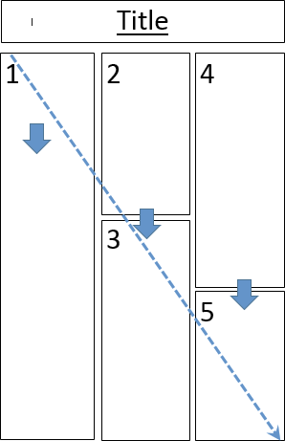
A series of columns can be an effective way of ordering information as demonstrated in newspapers and magazines. In English speaking countries, the way people read a poster is commonly from top to bottom and from left to right.
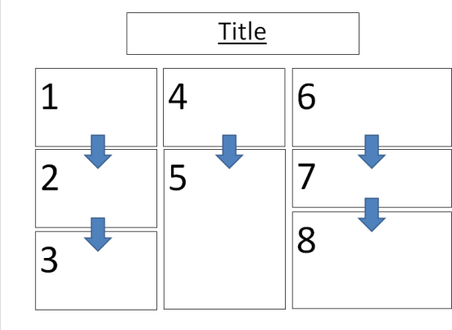

Balance - The best academic posters are well balanced. This means arranging text and images in such a way that both elements are balanced across the poster. Placing illustrations throughout the poster breaks the text up into easily readable chunks and allows for smoother flow.
Balance can also mean ensuring that the poster is not cluttered. Blank space is not the enemy. In fact, like images, it serves to make text easier to read, allowing the reader to pause and take note.

Effective use of Text
  - Total text should be between 300-600 words and should be to the point.
  - Be consistent with style. You should use a maximum of 2 fonts per poster.
  - Try to use Italics, underlining and CAPITALS sparingly.
  - Group text according to subject matter but don’t make paragraphs too long. Break up large paragraphs. Bullet points can be used to define simple statements.
  - The clarity of text can be improved by using increased line spacing.
  - Left justified and not fully justified text is clearest on the eye.
  - Set headings in BOLD and make them concise.

Using Graphs and Images
When presenting numerical data use charts and graphs rather than tables as these can be more effective for illustrating data trends.
When making charts and graphs format them effectively by keeping them simple, enlarging text and thickening lines. 3D graphs can be confusing, 2D are often clearest.
For images try to use a high resolution JPEG (.jpg) with a resolution of at least 300 pixels per sq. inch for sharpness (images copied from internet are usually 72 pixels!).

Include relevant logos of companies/institutions where appropriate.
Series 1
Series 2
Series 3
6
5
4
3
2
1
0
Colour – When using colour ensure that it does not obscure or detract from the text and images used in the body of the poster.
Use subtle background colours and black for small text.
Try not to use too many colours or colours which clash as this can be visually distracting. Think about people who are colour blind and have difficulty differentiating colour.
Check List:
- Read your poster over carefully to check for spelling mistakes.
- Make sure you take home message is clear.
- Show it to someone who hasn’t seen it before and observe their reaction.

Acknowledgements of contributions from colleagues at UWTSD, and University of Manchester

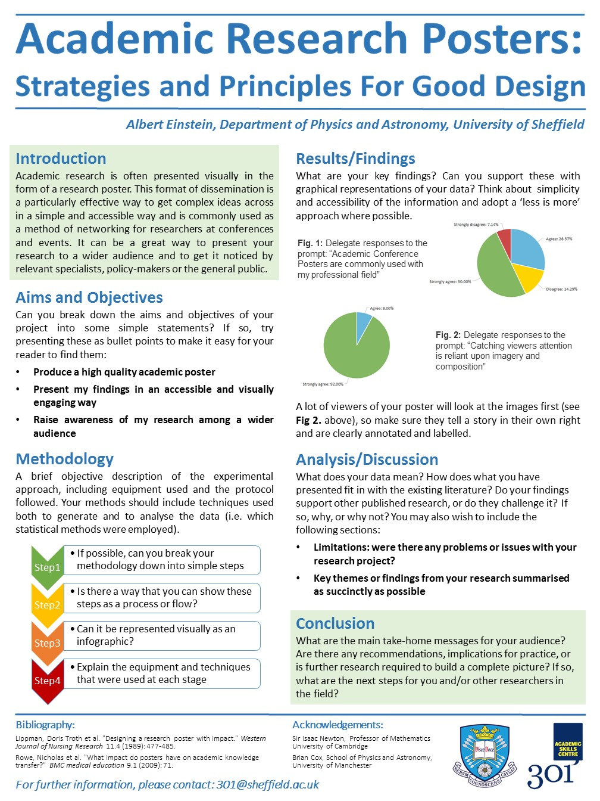
A Spoof Example of an Academic Poster Explaining how to Design an Academic Poster.

(Courtesy of Sheffield University Academic Skills Centre)

