Personal Development Portfolio
Student name | Felix Ojo
Student ID number | 2508025
Programme | Certificate of Higher Education Skills for the Workplace (Health & Social Care)
Module code and title | LCHS4009 Professional Development within Health and Social Care
Lecturer | Odette Jack
Assignment title | Component 2: Personal Development Portfolio
Chosen job role | Care Assistant
Submission date | 21 August 2026

Contents
1. Chosen Job Vacancy 3
Job Advertisement: HC-One Ltd - Care Assistant in Harefield 3
Advertised role and duties 3
Essential qualities and requirements 3
Reason for choosing this vacancy 4
2. Task 1 of 4: Professional CV 5
3. Task 2 of 4: Personal Statement 7
4. Task 3 of 4: SWOT Analysis and Personal Development Plan 8
a) SWOT Analysis - Care Assistant Role 8
b) Personal Development Plan 8
5. Task 4 of 4: Reflection on LCHS4009 Component 1 Presentation 11
Description 11
Feelings 11
Evaluation 11
Analysis 11
Conclusion 12
Action Plan 12
6. Reference List 13

1. Chosen Job Vacancy

Job Advertisement: HC-One Ltd - Care Assistant in Harefield
Job title | Care Assistant
Employer | HC-One Ltd
Home/Department | Handley House - Green Lane, York YO30 6RG
Salary | £14.80 to £15.30 per hour
Job family | Care / Carer
Source | https://apply.hc-one.co.uk/vacancies/72597/care-assistant.html
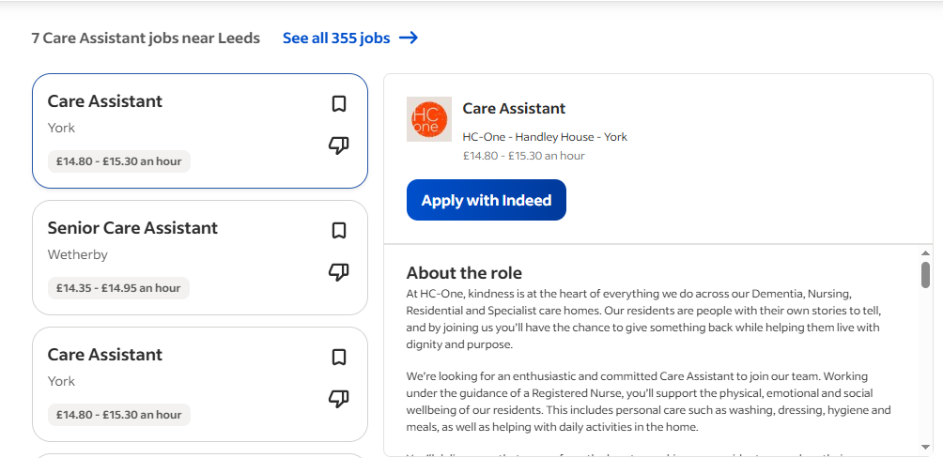

Advertised role and duties
HC-One ("The Kind Care Company") is recruiting a committed Care Assistant to support residents across dementia, nursing, residential and specialist care settings.
Key duties:
- Support residents' personal, physical, emotional and social needs under the guidance of a Registered Nurse and senior staff.
- Assist with personal care: washing, dressing, hygiene, toileting, mobility and mealtimes.
- Encourage dignity, autonomy, choice and respectful living throughout the day.
- Facilitate residents' involvement in social and recreational activities.
- Monitor the wellbeing and report any changes or concerns as soon as possible.
- Follow care plans, safeguarding, infection control, health & safety and confidentiality procedures.
- Collaborate with a team, including nurses, senior carers and relatives.

Essential qualities and requirements
- Compassion, kindness, patience and reliability in assisting older and vulnerable residents.
- Good communication, active listening and teamwork skills.
- Willingness to complete induction, safeguarding training and further role-related learning.
- Commitment to dignity, equality, respect, resident choice and safe working practice.

Reason for choosing this vacancy
I have selected this vacancy as it aligns with my work previously in a care home setting at LIME Social Care and Cedar House Care Home, my degree in BSc (Hons) Health and Social Care and my ambitions of working within the field of adult social care. The role involves person centred communication, safe personal care, safeguarding awareness and team working and I have begun to develop these skills and plan to extend and develop them further through training and supervised practice.

2. Task 1 of 4: Professional CV
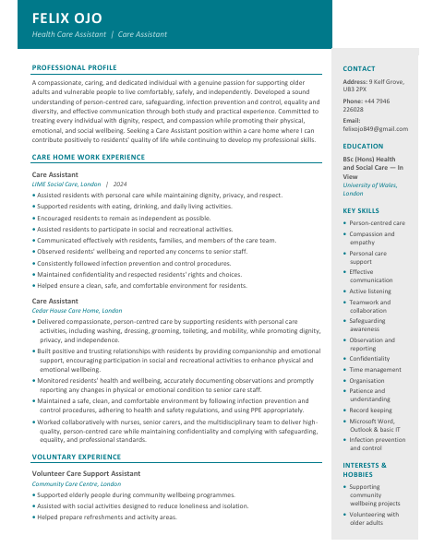
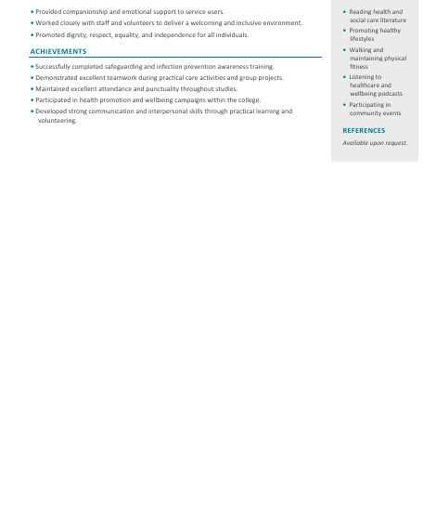

3. Task 2 of 4: Personal Statement
I am applying for the Care Assistant role at HC-One Ltd in Harefield as it aligns with my future career goals of working as a professional in the health and social care sector, supporting older adults and vulnerable people with dignity, patience and respect. Care work is a motivating activity for me because I can make a practical difference in the daily life of someone, not just when caring for them personally, but also helping them to feel safe, listened to and valued. My approach is very person centred; good care should ensure that people are supported to be independent, make choices, and have their physical, emotional and social needs met.
I am currently studying for a BSc (Hons) in Health and Social Care, which has strengthened my understanding of safeguarding, infection prevention and control, equality and diversity, effective communication, mental wellbeing and professional accountability. This academic knowledge supports my understanding of the importance of care plans, accurate records, reporting concerns and working within organisations policies as the role of care assistant. It has also enabled me to see that dignity and safety cannot be distinct, but must be integrated into all interactions with residents.
My practical experience at LIME Social Care and Cedar House Care Home has enabled me to develop hands-on care skills in a residential setting. I have supported residents with washing, dressing, grooming, toileting, mobility, eating and drinking while maintaining privacy and encouraging independence wherever possible. I have also seen residents well-being, I have also observed the wellbeing of residents, reported any changes or concerns to senior staff, followed infection control procedures and communicated calmly and respectfully with colleagues and family.. What these experiences have taught me is that what seems like small things can be large for trust and wellbeing such as explaining what I'm doing before supporting personal care, giving residents adequate time to make choices.
Alongside paid work, my voluntary experience as a Care Support Assistant in a community care centre has strengthened my communication, teamwork and empathy. Assisting older people in wellbeing programmes and social activities provided me with an insight into the consequences of loneliness and the importance of companionship in care. It has also helped me to grow my confidence in communicating with people from diverse backgrounds and tailor my communication style to the needs of each individual, such as those who may require reassurance, patience or additional time to communicate.
My key strengths are compassion, reliability, patience, active listening and a willingness to learn. I work well under pressure, take criticism well, and am aware of the need to keep information confidential, safe, and reported accurately. I will be bringing dedication, experience and a positive mindset to my healthcare providers. I would like to further develop my skills through induction, Care Certificate and training and to support safe, caring and person centred care that enhances the quality of life of residents. I also recognise that care work can be demanding in both physical and emotional ways, and am able to plan my time responsibly and seek advice when necessary, and uphold professionalism even in very busy periods. I believe this role would allow me to use my current skills while continuing to develop towards greater responsibility in adult social care.

4. Task 3 of 4: SWOT Analysis and Personal Development Plan

a) SWOT Analysis - Care Assistant Role
Strengths: Compassionate, patient and able to build trust with residents. Hands-on care experience at LIME Social Care and Cedar House Care Home. Current study in Health and Social Care provides support for knowledge of safeguarding, equality, infection control and person centred care. Voluntary experience demonstrates the commitment to work beyond paid employment, and the confidence in supporting a range of groups.
Challenges: BSc is still in progress so continue to develop formal workplace evidence. Limited experience with more complex needs, such as advanced dementia care or end-of-life care. Not yet authorised to administer medication independently. Still developing confidence with digital care-planning and record-keeping systems.
Opportunities: Care assistants can progress through structured induction, the Care Certificate and further qualifications (Care Certificate standards, n.d.). Employer training can be used to promote awareness, protection and infection control of dementia, and moving and handling skills. Experience in residential care can lead to a job as Senior Care Assistant or Team Leader. Digital records and quality monitoring are becoming important in care, creating opportunities to strengthen documentation skills (Unsworth et al., 2021).
Threats: Care work can be physically and emotionally challenging, and if workload and self-care are not effectively managed, stress can be increased. Some applicants may be more highly qualified or have more experience in care homes. Staffing levels could also lead to increased pressure on shifts and less time for reflection learning. Regulatory expectations around safety, safeguarding and quality improvement require continual updating of knowledge (Grote et al., 2021).

b) Personal Development Plan
The following goals are intended to develop my strengths and mitigate my weaknesses as identified in SWOT analysis. The plan focuses on employability, safe practice and progression within a Care Assistant role over the next two years. As care assistants are regulated services, my development must also include aspects of safe, effective, caring and responsive practice (CQC, 2022).
Goal | Actions | Timescale | Success Criteria
1. Complete care induction & qualification evidence | Complete employer induction and Care Certificate; build evidence toward NVQ/QCF Level 3. Set weekly study time; ask senior carer to review progress. | 0-12 months | Care Certificate (completed); supervision notes; training certificates; quarterly reviews (Care Certificate standards, n.d.).
2. Strengthen safeguarding, dementia & medication awareness | Attend safeguarding, dementia-awareness and medication-awareness training. Observe with the senior staff while medication rounds. Ensure basic life support awareness with evidence that structured training and practice enhances resuscitation skills (Cheng et al., 2020). | 6-18 months | The CPD Log, Manager feedback, Observed competence, Accurate concern reporting – against safeguarding guidance (GOV.WALES, 2026).
3. Improve communication, documentation & digital confidence | Practise short handover; ask for feedback on notes and care record systems; learn about digital record systems. Use active listening and person-centred communication with residents/relatives. | 0-24 months | Enhanced supervision feedback; fewer notes corrections made; confident digital documentation linked to person centred practice (NHS Health Education England, 2022).
4. Prepare for senior care responsibilities | Identify a work mentor; support new staff; undertake leadership CPD; practice calm decision making in stress. | 18-24 months | Mentor feedback, reflective journal, appraisal confirms readiness to become Senior Care Assistant.

Task 4 of 4: Reflection
Description
I use Gibbs' (1988) reflective cycle to critically reflect on Component 1 of the health and social care course LCHS4009, in which I presented teamwork as a fundamental skill in health and social care. I explained how it contributes to safe, person-centred care, applied Tuckman's stages of forming, storming, norming, performing, and adjourning (Tuckman, 1965), and used a scenario of discharge from a hospital setting involving a nurse, physiotherapist, and social worker. I wanted to show theoretical knowledge and practical application. I used healthcare teamwork literature to support the presentation and mentioned that I used AI to organise slides and make them clearer.
Feelings
I was confident before my presentation, since I had prepared the presentation carefully. But the “storming” part was more of an anxiety for me to explain because I had thought of disagreement as a threat to teamwork. I got more comfortable during the presentation as there was a clear context in which to explain the model, the practical discharge example. Then, the lecturer's oral comments contradicted my notion by stating that conflict, when managed positively, can enhance team development as divergent perspectives can contribute to creativity and decision-making.
Evaluation
A key strength was the progression from the importance of teamwork to theory, application and career development. This facilitated good communication and provided evidence that teamwork impacts on the service user, staff and organisations. The same applies to communication, shared goals, conflict management and accountability, which are noted as key factors for the effectiveness of a healthcare team by Zajac et al. (2021). My abstract stages were also converted into professional actions in my discharge example. However, I was simplistic in my approach to conflict. I represented storming as a problem to be solved, but did not separate those times when tasks were disagreeable from when interpersonal conflict was. This limited my analysis to a more shallow level.
Analysis
The feedback from the lecturer was very useful as it altered my perception of effective teamwork. Failure does not always mean that a team is in conflict. Bochatay et al. (2021) demonstrate how professional power structures and hierarchy’s impact healthcare conflict, and Lavelle et al. (2022) illustrate how psychological safety and interpersonal relationships affect team performance in the hospital environment. Hence, disagreement can provide an insight into competing professional views, but only if it is respectful and staff can express their views. This is significant in person-centred care where professional challenge could lead to unsafe consensus and premature decisions. This also reveals one weakness in my use of Tuckman: I thought of it linearly, as a linear progression through team development. In practice, health care teams are flexible and can go back to previous steps if membership, patient needs, or circumstances change. Evidence also shows that interprofessional conflict resolution can enhance collaborative care through constructive conflict and conflict-management training (Orchard et al., 2022).
Conclusion
I discovered that teamwork is not about not having conflict; it's about how a team handles conflict in a way that does not make it personal or destructive. I showed that I know and can apply the concepts, but I could have done more to examine Tuckman and conflict to support my argument critically.
Action Plan
In future presentations, I will go beyond describing models and make explicit assessments of the assumptions, limitations, and applicability of models to practice. I will prepare answers to expected questions, especially in conflict, power and professional disagreement situations. I will also try to minimise text in the slides, be more assertive in source-to-claim matching, and practise more respectful disagreement to engage more confidently in multidisciplinary discussion and learn from disagreement.

6. Reference List
Bochatay, N., Kuna, Á., Csupor, É., Pintér, J.N., Muller-Juge, V., Hudelson, P., Nendaz, M.R., Csabai, M., Bajwa, N.M. and Kim, S. (2021). The Role of Power in Health Care Conflict: Recommendations for Shifting Toward Constructive Approaches. Academic Medicine: Journal of the Association of American Medical Colleges, [online] 96(1), pp.134–141. doi:10.1097/ACM.0000000000003604.
Care Certificate standards. (n.d.). [online] Available at: https://www.skillsforcare.org.uk/resources/documents/Developing-your-workforce/Care-Certificate/Care-Certificate-Standards/Care-Certificate-standards-March-2025.pdf [Accessed 9 July 2026].
Cheng, A., Magid, D.J., Auerbach, M., Bhanji, F., Bigham, B.L., Blewer, A.L., Dainty, K.N., Diederich, E., Lin, Y., Leary, M., Mahgoub, M., Mancini, M.E., Navarro, K. and Donoghue, A. (2020). Part 6: Resuscitation Education Science: 2020 American Heart Association Guidelines for Cardiopulmonary Resuscitation and Emergency Cardiovascular Care. Circulation, 142(16_suppl_2). doi:10.1161/cir.0000000000000903. Available at: https://pubmed.ncbi.nlm.nih.gov/33081527/
CQC (2022). Care Quality Commission. [online] https://www.cqc.org.uk/. Available at: https://www.cqc.org.uk/ [Accessed 9 July 2026].
Gibbs, G. (1988). Learning by doing A guide to teaching and learning methods. Further Educational Unit, Oxford Polytechnic, Oxford. - References - Scientific Research Publishing. [online] Www.scirp.org. Available at: https://www.scirp.org/reference/referencespapers?referenceid=478921 [Accessed 23 July 2026].
GOV.WALES. (2026). Safeguarding guidance | GOV.WALES. [online] Available at: https://www.gov.wales/safeguarding-guidance [Accessed 9 July 2026].
Grote, H., Toma, K., Crosby, L., Robson, C., Palmer, C., Land, C., Ball, J. and Baker, E. (2021). Outliers from national audits: their analysis and use by the Care Quality Commission in quality assurance and regulation of healthcare services in England. Clinical Medicine, 21(5), pp.clinmed.2020–0695. Available at: https://pubmed.ncbi.nlm.nih.gov/34389635/
HC-One Ltd, 2026. Care Assistant in Harefield. Available at: https://apply.hc-one.co.uk/vacancies/72597/care-assistant.html [Accessed 9 July 2026].
Lavelle, M., Darzi, A., Starodub, R. and Anderson, J.E. (2022). The role of transactive memory systems, psychological safety and interpersonal conflict in hospital team performance. Ergonomics, [online] 65(3), pp.519–529. doi:10.1080/00140139.2021.2006771.
NHS Health Education England (2022). Core skills and how they link into person centred care. [online] Health Education England. Available at: https://www.hee.nhs.uk/our-work/cancer-diagnostics/cancer-communications-resource-hub/patient/core-skills-how-they-link-person-centred-care [Accessed 9 July 2026].
Ocampo, F.A., McIntyre, B.G., Massey, D. and Saunders, R. (2025). Nursing Student Reflections on a Research internship: a Reflective Discussion following the Gibbs” Reflective Cycle. Nurse Education Today, [online] 145(1), p.106481. doi:https://doi.org/10.1016/j.nedt.2024.106481. Available at: https://www.sciencedirect.com/science/article/pii/S0260691724003915
Orchard, C., King, G., Tryphonopoulos, P., Gorman, E., Ugirase, S., Lising, D. and Fung, K. (2022). Interprofessional Team Conflict Resolution: A Critical Literature Review. Journal of Continuing Education in the Health Professions, [online] 44(3), pp.203–210. doi:10.1097/CEH.0000000000000524.
Tuckman, B. (1965). Developmental Sequence in Small Groups. [online] Psycnet.apa.org. Available at: https://psycnet.apa.org/record/1965-12187-001 [Accessed 23 July 2026].
Unsworth, H., Dillon, B., Collinson, L., Powell, H., Salmon, M., Oladapo, T., Ayiku, L., Shield, G., Holden, J., Patel, N., Campbell, M., Greaves, F., Joshi, I., Powell, J. and Tonnel, A. (2021). The NICE Evidence Standards Framework for Digital Health and Care Technologies – Developing and Maintaining an Innovative Evidence Framework with Global Impact. DIGITAL HEALTH, [online] 7(7), p.205520762110186. doi:10.1177/20552076211018617. Available at: https://journals.sagepub.com/doi/abs/10.1177/20552076211018617
Zajac, S., Woods, A., Tannenbaum, S., Salas, E. and Holladay, C.L. (2021). Overcoming challenges to teamwork in healthcare: A team effectiveness framework and evidence-based guidance. Frontiers in Communication, [online] 6(1), pp.1–20. doi:https://doi.org/10.3389/fcomm.2021.606445.

