Digital Forensics Investigation
Paul M Lawrence (P152216) Undergraduate Student, Mcomp Computer Networks
University of Wales Trinity St David, Swansea, Mount Pleasant Campus
plawrence.152216@student.uwtsd.ac.uk

Abstract – The aim of this report is to give a general overview of modern digital forensics investigators/incident handlers, the tools that are currently used, the digital forensics methodology that is followed and the strict laws that pertain to today’s digital forensics professionals.

Keywords-component; Forensic Investigator, Incident Handler, Chain of Custody, Digital Laws and legislation, Forensic Catergories, Cyber-crime

Introduction to Digital Forensics
In the world we are currently living in, digital data is integrated into our lives increasingly every day. Modern computing and the Internet has enhanced society significantly; from how people communicate, run businesses, bank, shop, store and access information. Within all aspects of innovation throughout the ages, where great technological advances have been developed to aid humanity for good, unfortunately history records that evidently a minority of people will find a way to exploit these innovations for their own needs and agendas which inevitably leads to criminal activity, this is also true for computing and the Internet. [1][2]

The average criminal’s awareness and knowledge of digital data, how it is stored and transmitted across a network has increased substantially over the last decade, with information readily available on the Internet and pre-made tools easily accessible to help assist criminals to commit digital crimes and disguise their behaviour. Therefore, the field of digital forensics and the sophisticated techniques that are used to locate, recover and analyse criminal digital evidence that may have been encrypted, deleted, altered and/or obscured is required to identify unlawful behaviour and bring criminals to justice. [3][4]

Digital Forensics Tools
There are many tools widely available within the field of digital forensics, each can be categorised to perform specific operations within different aspects of a digital investigation, shown in figure 1.

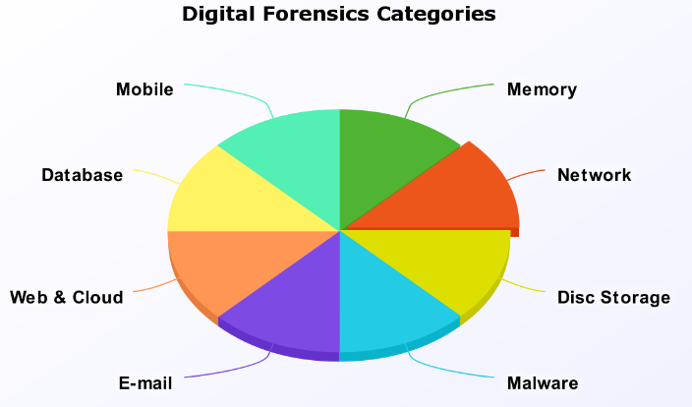
Figure 1: Digital Forensics Categories [5][6]
- Disk forensics: This category of digital forensics focuses on the preservation, recovery and analysis of data from non-volatile storage devices i.e. Hard Disc Drive (HDD), Solid State Drive (SSD), Universal Serial Bus-port (USB) flash drive etc.[7] [8]

- Network Forensics: This category of digital forensics focuses on discovering and analysing log files of end devices and internetworking devices located in a Local Area Networks (LAN) and Wide Area Networks (WAN) to determine how a network has been breached and who may be responsible. Wireless enabled devices are also a specialised sub-category within network forensics.[9][10]

- Malware Forensics: This category of digital forensics focuses on analysing malware i.e. Viruses, Worms, Trojans
found within end devices/servers to determine their implications and origins i.e. author, country etc. [11]

- Mobile Forensics: This category of digital forensics focuses on recovering and analysing digital data from mobile/cell devices and there OS’s i.e. Apple IOS, Android etc. [12]

- E-mail Forensics: This category of digital forensics focuses on extracting and analysing E-mail messages and contacts from E-Mail applications and servers i.e. G-Mail, Outlook etc to determine their content and origins i.e. author, originating country etc. [13]

- Memory Forensics: This category of digital forensics focuses on recovering and analysing raw data stored within volatile Random-Access Memory (RAM) and Read Only Memory (ROM). [14]

- Website, Web Application and Cloud Forensics: This category of digital forensics focuses on retrieving and analysing end user digital information stored on cloud servers and/or websites. [15]

- Database Forensics: This category of digital forensics focuses on recovering, filtering and analysing data stored in various database application or servers i.e. MS Access, Structured Query Language (SQL) etc.[16]

Forensic tools are regularly updated and developed to keep up to date with different technology’s being utilised by end users i.e. device architectures, Operating Systems (OS), data storage.

Frameworks and OS’s have been developed to aid investigators within the digital forensics field, they encompass many tools into one framework or OS for digital investigators to utilise more efficiently. [17][18] [19]

Therefore, digital forensic professionals constantly need to research and keep up to date with tools that have depreciated and tools/techniques that are currently being used. A table containing a variety of the most frequently used tools (research conducted Jan 2018) and a brief overview of these tools can be found in Appendix-A of this report.

INCIDENT HANDLER VS FORENSICS INVESTIGATOR
Digital evidence can be examined by both an incident handler or a forensics investigator, the primary difference between the two is that an incident handler [20] may not have the experience and/or the formal qualifications to examine physical/digital evidence that will be used in a court of law so will typically carry out civil cases for clients. Whereas a digital forensic investigator is considered highly skilled, has formal qualifications and professional certifications such as; Certified Forensic Computer Examiner (CFCE) [21], Computer Hacking Forensic Investigator (CHFI), [22] he/she will also have knowledge of the law pertaining to digital forensics and is also trained to examine criminal evidence to be used in a court of law in which they are qualified to be an expert witness within a criminal case if needed. [23][24]

Laws and Legislation
There are many laws and legislations that must be adhered to within a criminal digital forensics investigation, if a countries laws and legislations are not followed within a criminal case, evidence within an investigation may be deemed inadmissible in a court of law and the investigator could be prosecuted or sued themselves whilst the criminal could potentially go free. [25]

Before an incident handler can work on a case, they must first get written permission from a CEO or manager of a company that’s precuring there services [26]. Within a criminal case a warrant must be obtained by the police or security services before a forensic investigator can examine the evidence [27]. If a warrant has not been procured within a criminal matter and written permission has not been acquired from the owner/company of the digital evidence by an incident handler within a civil case, they themselves could be subject to criminal proceedings for breaking the Data Protection Act 1998 (DPA 1998), UK [28] and the Computer Misuse Act 1990 (CMA 1990), UK [29] or similar laws within other countries.

Laws and Legislation vary from one country to the next so it’s important for a forensic investigator to be aware of all digital laws within the country a case pertains to before proceeding. Even though digital forensics criminal laws may vary within different countries, the methodology often stays the same and a model called: ‘The Four Principles of Digital Evidence’ can be followed, developed by the Association of Chief Police Officers (ACPO) in the UK who are currently called the National Police Chiefs' Council (NPCC) as of 2015, they are the governing body of digital forensics within the UK and there principles state;[30] [31]

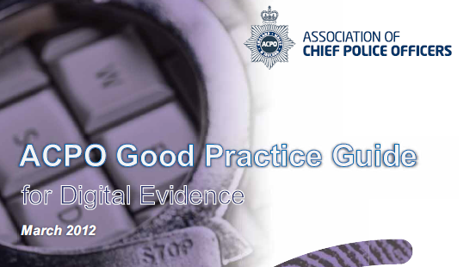
Figure 2: ACPO Digital Evidence Handling Guide [30]

Principle 1: Digital evidence gathered by law enforcement persons or related agencies that may be relied on in a court of law must not be changed/modified by the digital forensics investigator or any other persons handling the evidence.

Principle 2: In the event an investigator must access the original data to obtain evidence, that person must be qualified and proficient to do so. They must also be able to give evidence in a court of law to explain and defend their actions.

Principle 3: A meticulous chain of custody log and audit trail of processes applied to evidence by an investigator or multiple investigators must be kept throughout the processing of all evidence by the person or persons handling the evidence from start to finish. Also, a 3rd party should be able to examine the evidence and achieve the same results.

Principle 4: The overall responsibility of the preservation and handling of the evidence lies solely on the chief investigator or senior person in charge of the case.

As briefly discussed in this section of the report, a digital forensics investigator must adhere to the digital law pertaining to the country in which the case originates and they must keep meticulous records and be prepared to defend and explain the actions that were taken during the investigation in layman’s terms to non-technological professionals i.e. Judge, Jury etc. within court as an expert witness. The ‘four principles’ model can also be followed as a generic guide if the digital law is unclear in a country the evidence pertains to. [32]

Chain of Custody Document
In a case where evidence gathered will be presented in a court of law, chain of custody records is of fundamental importance. If there are incomplete evidence custody records, evidence could be deemed inadmissible in court as discussed earlier in the report. [33]

Example of a ‘Chain of Custody’ document shown in figure 3.

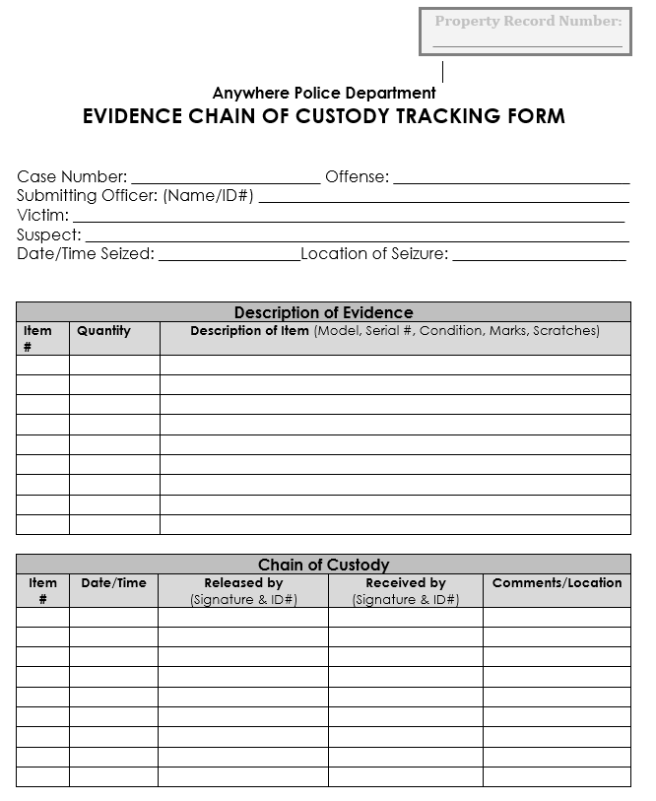
Figure 3: Chain of Custody document example [34]
A ‘Chain of Custody’ document can be broken down into six key questions that an investigator must answer whilst maintaining a ‘Chain of Custody’ document;

- Who? Who handled the digital evidence?
- What? What type of digital evidence has been retrieved? And what’s the physical condition of the evidence at the time it was received?
- When? When was the digital evidence acquired and/or handed over to another investigator?
- Where? Where was the digital evidence collected from and stored during the investigation?
- How? How was the digital and/or physical evidence retrieved and stored after it was acquired?
- Why? For what purpose was the digital evidence acquired?
The ‘Chain of Custody’ document must be updated every time the physical or digital evidence is handled, transported and/or stored. [35] [36]

Methodology of a Digital Forensics Investigation
The methodology of a digital investigation can be broken down into four stages that encompass the ‘four principles’ of digital law previously discussed in the report shown in figure 4.

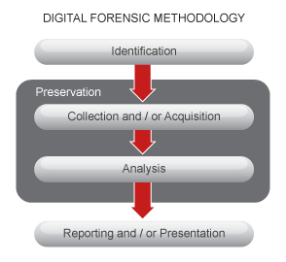
Figure 4: Digital Forensics Methodology [37]
Each stage is just as significant as the next and must be meticulously planned before proceeding with the investigation. Each stage must also be accurately logged within an audit trail document/notebook that chronicles the processes tools used at each stage of the investigation for the investigator to later incorporate into his/her report. These stages are:

Evidence Assessment: At this stage of the investigation an investigator needs to determine the facts about the hardware; i.e. laptop, tablet, computer, camera etc and the Operating System (OS) in use i.e. Windows, Apple IOS, Linux and where the data is stored i.e. HDD, SSD, USB these factors will determine the set of tools that will need to be utilised to acquire the data.

Determining what key data to target is also an important factor within this stage of the investigation i.e. network/system log files, video, E-mail, images, spreadsheets, documents etc this information is usually provided by the client or security services. The nature of the crime i.e. financial, terrorism etc that has been committed will also be a factor within targeting and locating specific data.

The plan formulated from this stage will provide a guided approach to the investigation and govern the tools that will be utilised to preserve, retrieve, sift through, filter and analyse thousands of files to locate the identified target data.

Also, if an investigator is to harness the evidence themselves a physical assessment of the evidence will also be required to determine if the physical evidence has been boobytrapped by the suspect in an attempt to destroy the evidence before it can be investigated. [38] [39]

Evidence Preservation and Acquisition: Data preservation is a very crucial and sensitive step within the acquisition of digital evidence. Operating Systems often write data to disk within background tasks without the user knowing, this could lead to the investigator accidently tainting the evidence if the correct process/tool is not used whilst acquiring the digital evidence.

Therefore, original evidence must not be changed/modified or directly analysed in any way as discussed earlier in the report. Hence, an investigator needs to acquire the data whilst maintaining its integrity by making an accurate image of the entire HDD without writing anything to the disk themselves whilst still creating a 100% accurate copy of the digital evidence.[38] [40] [39]

Also, at this stage it is good practice to make an additional copy of the evidence for future analysis in the event the original copy became corrupt during analysis. [41] [42]

Evidence Analysis: An investigator must be impartial at this stage of the investigation and only scientifically analyse the evidence not form any opinions or make assumptions about data recovered during this stage of the investigation. The content of the data analysed at this stage must only be briefly described in an unbiased context and accompanied with its file name, file path and metadata analysis to be included in the report. [38] [39]

Metadata is data that describes data in which the metadata pertains to i.e. date/time created, size of file, author, most recent date/time accessed etc this information is very important for digital forensics investigators because it reveals hidden information about files that most computer users are unaware of. [43]

An investigator must be aware of and subsequently determine if any data has been concealed within certain files by cyber criminals using steganography techniques at this stage of the investigation. Steganography is a form of cryptography that is sometimes used by criminals to hide data in plain sight within seamlessly innocent files that are most commonly images. The correct tools need to be utilised at this point so that no data is missed. [44]

Also, at this stage an investigator may determine certain evidence recovered that needs to be examined is outside his/her skillset and may have to pass it over to a specialist within the area that pertains to that piece of evidence for analysis [45].The ‘Chain of Custody’ document should be updated depicting the handover of evidence between investigators in this scenario.

Evidence Reporting: Throughout the entire investigation a ‘Chain of Custody’ document and audit trail notes; that contain the name of the investigator(s); processes/software used on the evidence, digital data retrieved and date/time of examination, all need to be recorded as discussed in the ‘Chain of Custody’ section of this report. [46]

Using the ‘Chain of Custody’ document and audit trail notes along with all the digital data recovered from the physical evidence, a formal report will then be created to handover to the client or policing authorities of the case. If it’s a criminal case it is possible the report will be used in court where the investigator may be called as an expert witness to give evidence about his/her findings. [38] [39]

Case Study – An Attempted Terrorist Attack at Mason International Airport
There has been an attempted terrorist attack at Mason International Airport in Fiji, a known terrorist organisation was planning to detonate a bomb at the airport. Fortunately, British security services managed to foil the attack at Heathrow Airport – London, UK before it could take place. The suspected male terrorist; whom matched a list of known terrorists was attempting to board a flight to Fiji. Whilst the security services were apprehending the suspect, he tried to flee and was shot down to prevent him escaping and/or causing harm to civilians at the airport. [42]

A laptop briefcase was retrieved from the suspect that contained a laptop that the suspects fingerprints were subsequently found on. Chief Inspector Mr Mark Wales who is investigating the case contacted ‘John’ an experienced digital forensics investigator and asked him to retrieve digital evidence from the laptop. Mr Wales also provided crime scene photos depicting the laptop briefcase in possession of the suspect to prove the authenticity of the evidence and a warrant to examine the evidence under the Police and Criminal Evidence Act 1984 (UK) [47] so that John can legally investigate the case.

This is a criminal case that involves national security and the attempted murder of innocent civilians. Even though the suspect was shot and may or may not die, the evidence gathered could be used to prosecute other conspirators within the terrorist cell as well as the suspect if he were to live. Therefore, a digital forensics investigator would need to be assigned to the case, any digital evidence retrieved from the laptop would need to be presented in a court of law if the suspect or suspects stand trial for the crime, in this event expert testimony may need to be given by the digital forensics investigator at court.

John, the digital forensics investigator will need to follow the digital forensics laws and methodology discussed earlier in the report whilst investigating this criminal case.

- Evidence Assessment
John prepares a ‘Chain of Custody’ document for the evidence (Laptop), he notes the date/time in which he took custody of the laptop from Mr Wales and the condition of the laptop on delivery from Mr Wales. John notes the laptop was undamaged during delivery because the trained police investigators wrapped it in bubble wrap before transportation, he takes a timestamped [48] photo depicting the physical condition of the laptop using a ‘Cannon Digital Camera’. John and Mr Wales both sign the chain of custody document confirming the evidence handover into Johns possession at the precise date/time, which is then logged within the ‘Chain of Custody’ document.

On first inspection of the physical evidence John notes that the manufacturer and model of the Laptop is ‘Dell – Latitude D630’[49], and the OS installed was Microsoft Windows XP: Service Pack 2 [50] from the display layout of the screen which John was familiar with from his experience, the OS was also observed to be in ‘Standby Mode’ [51] with ‘no logon’ password. John takes a timestamped photo of the laptop screen depicting this, to be used as documentation to prove the logical state the laptop was in when it came into his possession, shown in figure 52.


Figure 5: Dell Latitude D630 Physical Evidence [52]

Further research is also carried out by John regarding the default hardware/software architecture used within the Dell laptop model. [49][50]

John then proceeds to carefully remove the casing of the Laptop that houses the HDD to gain access so that he can inspect if the HDD had been physically boobytrapped [53]. After further physical inspection of the HDD it was determined not to be boobytrapped. John also records this with his digital camera shown in figure 54.

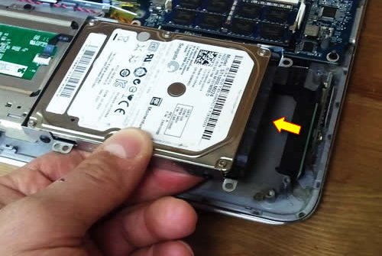
Figure 6: Physical Dell Laptop HDD Evidence Inspection [54]
John also notes from his research into the ‘Dell’ laptop the Seagate HDD’s read speed that was 128MB/s Disk capacity of the HDD was 60GB and the size of the Intel DDR-2 RAM in GB was 6GB for the data acquisition stage of the investigation. The casing of the laptop is then reattached and all of Johns physical analysis up to this point are recorded within the ‘Chain of Custody’ document and audit notes.

- Evidence Acquisition and Preservation
Using the information gathered at the evidence assessment stage of the investigation, John now needs to create an image of the physical evidence whilst also maintaining the HDD’s data integrity. To accomplish this John uses a hardware ‘Write blocker’ [55] tool.

A hardware write blocker is a small device that sits in between the digital evidence HDD and the laboratory workstation, it operates by blocking any write commands to the digital evidence (HDD) from the laboratory workstation whilst only allowing read commands to be sent to the physical HDD.

Using this tool and method allows Johns laboratory workstation to create an image of the laptops HDD whilst also guaranteeing that data will only be read from the laptops HDD and nothing will be written to it. This is crucial in order to maintain data integrity within a digital forensics investigation as discussed earlier in the report.

John must now remove the HDD from the Laptop in order to extract the data from its HDD. Before John proceeds with this he recalls the OS was in standby mode from the evidence assessment stage of the investigation, he recognises that whilst the OS is in ‘standby’ mode power to the HDD has been temporarily suspended, but there may be important data stored within the volatile RAM [56] which still contains data whilst in this state, if the device was powered off (shutdown) at this point all data stored in the RAM would be lost. Knowing this John maintains power to the laptop.

RAM data is important because this data gives an insight into the actions being performed by the suspect directly before the evidence was obtained. Data in RAM is also stored in plain text and could contain passwords, encryption keys etc which would be useful in the data analysis stage of the investigation if certain files/directories were heavily encrypted within the HDD that the investigator couldn’t crack, therefore John will also need to create a secure RAM data dump image after the HDD has been securely imaged. [57][6]

To securely retrieve the HDD data and create an image of the drive John carefully removes the HDD from the laptop whilst maintaining power to the motherboard so not to lose the data stored in RAM. Once the HDD has been retrieved, John attaches a the HDD using a Serial Attachment (SATA) [58] cable connection on one side of the write blocker and then connects his forensics workstation (high performance computer) to the other side of the device using a USB-3 [59] connection cable shown in figure 60.

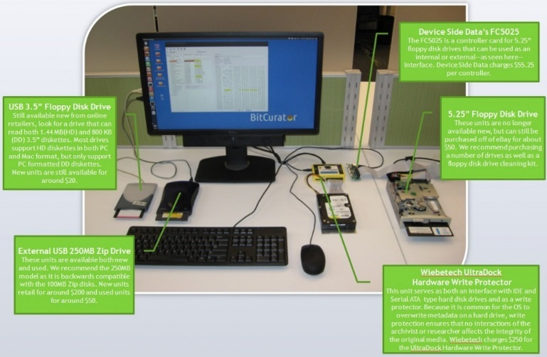
Figure 7Hardware Write-blocker Connected to Lab Workstation [60]
This physical extraction method is the industry standard as it also ensures 100% of the data is captured using file carving techniques [61] as opposed to logical extraction which only copies the primary OS; logical extraction can miss partition storage space, duel boot OS’s and slack space [62] stored within a drive that could contain important digital evidence [63].

John then configures the write-blocker for the correct read/write speeds of the HDD noted at the evidence assessment stage of the investigation so that data is not lost, or the HDD does not break due to running the HDD above its manufacturers recommended read speeds during this delicate stage of the investigation [64].

Once the evidence has been securely connected to John’s workstation containing a Windows OS he starts to configure the Forensics Tool Kit (FTK) imager [65] to create a copy of the drive shown in figure 65.

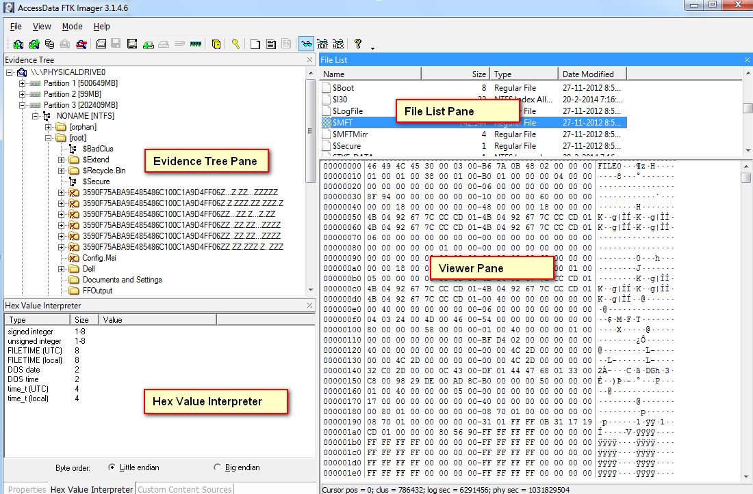
Figure 8: FTK Disk Imaging Software [65]
He first configures the tool to store the drive image in Advanced Forensics Format (AFF) for later analysis. AFF image file format is an open file format within digital forensics, it allows a broad spectrum of tools to read and analyse digital disk images. [66]

John then configures the software to copy the HDD’s data using a methodical bit-by-bit parity [67]cloning method so not to miss any data contained on the drive and/or slack space. This method is the industry standard for maintaining evidence data integrity whilst imaging a physical drive.

John then proceeds to clone the drive after checking his configuration settings are correct. John documents the process took 4.5 hours so that it can be added to his audit notes at the end of this stage of the investigation.

Now that the HDD has been securely imaged John now needs to retrieve and create a secure RAM data dump image [68]. To accomplish this John uses a specialised tool called ‘Helix: Live Response’ [69] that is stored on an 8GB USB flash drive that has enough memory to store all data retrieved from the RAM using the information gathered at the evidence assessment stage of the investigation. Helix is programmed to read raw ‘live’ data stored in the RAM and then create/store an image of this data on the USB storage device for later analysis shown in figure 69.

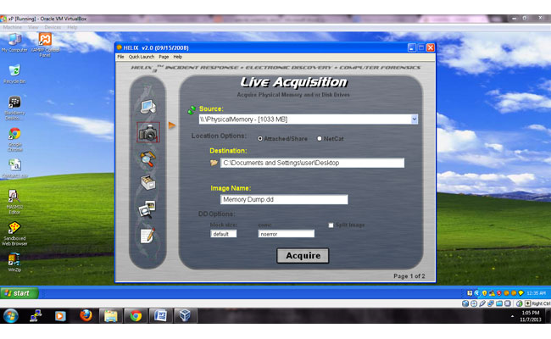
Figure 9: Heli RAM Live Data Acquisition Software [69]
The RAM data retrieval was performed after the HDD was removed to ensure the HDD’s data integrity, even though this process could lose the data stored within the RAM if power was to be lost to the motherboard [70], this decision was taken by John because digital forensics RAM retrieval software is still in its infancy and can sometimes write data to the HDD if it was connected to the device which would destroy the integrity of the digital evidence in the eyes of the law [71]. The HDD is the primary evidence and needs to be protected at all costs, any data retrieved from the RAM would be a bonus. Fortunately, with Johns skills and experience he was successful in retrieving the data from the RAM using the Helix software tool.

Now that the data has been securely retrieved from the laptops HDD and RAM John first makes Message Digest 5 (MD5) hashes [72] of both images to prove their authenticity and integrity in the event another forensic investigator or defence attorney wanted to challenge Johns findings, this process will be discussed in further detail later on in the report.

John notes the hashes to be:

60GB Seagate HDD:
d75f009cd091398830c67147121267e3

6GBIntelDDR-2RAM: d5f80d08e0114687b44fe53e9b71a9c0

John then proceeds to make several clones of the copied HDD and RAM images in the event that during the evidence analysis stage of the investigation the images are corrupted by a tool and/or process used at this point in the investigation. He accomplishes this by using a tool called OSFClone [73] to copy the image files whilst maintaining their integrity shown in figure 73.

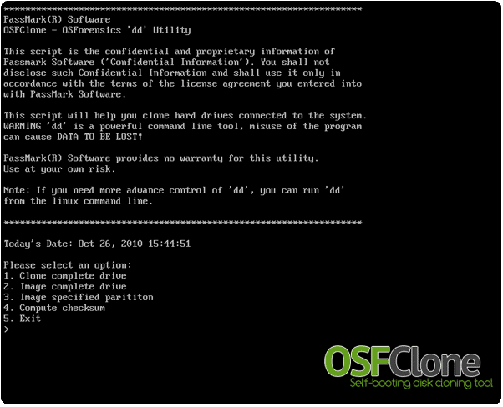
Figure 10: OSF HDD Image Cloning Software [73]
To validate the copied images John uses a Windows OS tool called ‘Hash-My-Files’ [74] to hash the clone of the HDD and the newly created copy, this tool was the same tool used to hash the original RAM and HDD images retrieved from the laptop.
Hashing tools work by creating a mathematically generated alpha-numeric hash value for each file that is referred to as a ‘Check-sum’ which John compares against the original cloned images to mathematically prove the integrity of these logical copies. Both values must be identical if both files are an exact copy of each other, John confirms this to be the case [75].

John then powers off the laptop, reattaches the HDD and locks the physical evidence in a ‘safe’ within a secure location at his laboratory to be returned with the report to Mr. Wales [76].

The ‘Chain of Custody’ document and audit notes are also updated depicting the data/time the evidence was secured and the tools/processes used during this stage of the investigation.

- Evidence Analysis
When Mr Wales asked John to retrieve and analyse the evidence he stipulated what data he was particularly interested in John discovering and analysing:

- MS Word and PDF documents.

- MS Excel spreadsheets.

- Images files (jpeg, giff, bmp, tiff).

- Video files (avi, mpeg, dat, mov).

- Audio files (mp3, wav and rm).

- MS Outlook contacts and E-mail messages.

- Messenger chat history.

- Temporary Internet files.

Clients often stipulate what files to retrieve and analyse within a digital investigation to reduce the workload and the subsequent cost of the investigation. Each item investigated, the hours spent on each file by the investigator, reporting and tools used are all logged and billed to the client which can cost upwards of £10,000 [77] this is why a client stipulates what information the investigator should target to stay within their allocated budget for the investigation. [78]

John mounts the HDD and RAM images procured from the evidence acquisition stage of the investigation into a professional approved Windows OS framework tool (software) called FTK [79] that is installed on his laboratory computer.

John configures the FTK data discovery process for a targeted approach to discover and analyse the data types that MR Wales requested to be investigated shown in figures 11-12.

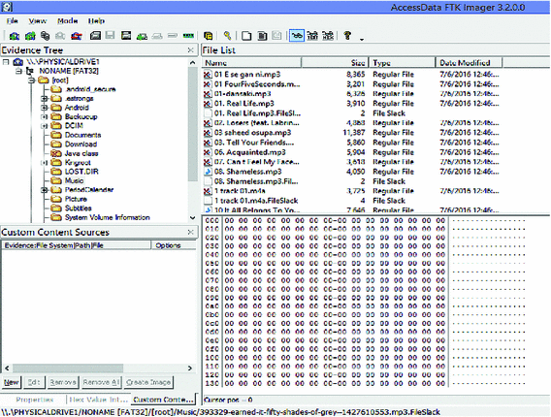
Figure 11: Evidence HDD Image Analysis FTK [80]
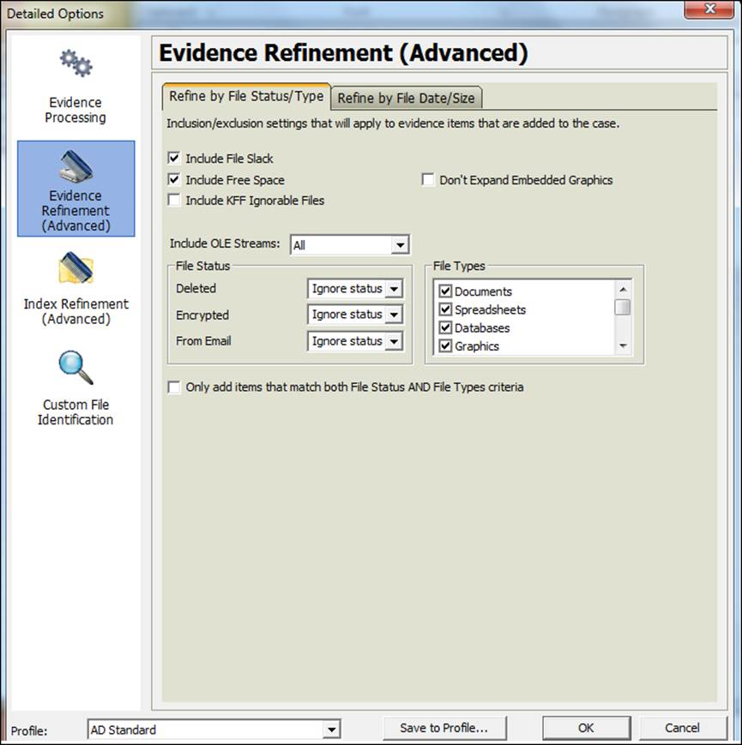
Figure 12: Evidence Refinement Feature FTK [80]
After John runs the FTK evidence refinement search he discovers the file types that Mr. Wales asked him to investigate. The results are shown in figure 13.

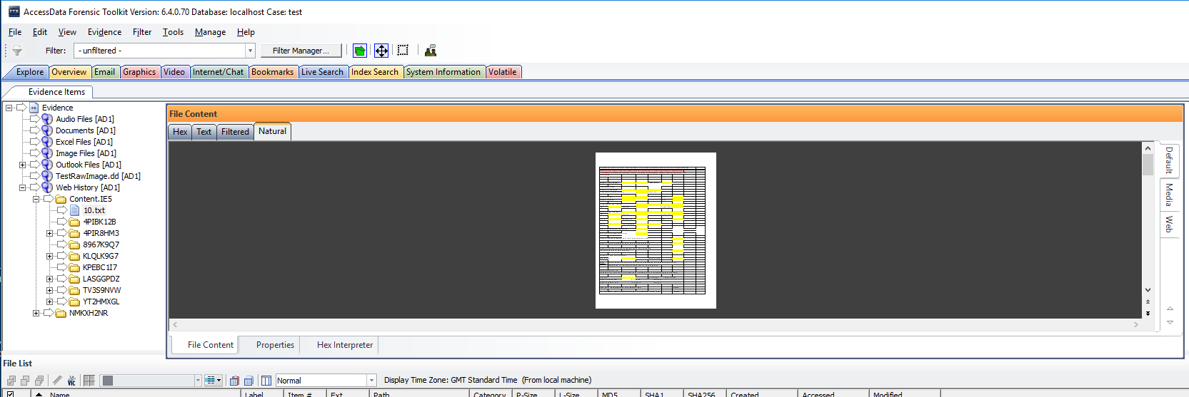
Figure 13: Targeted Files Discovery [80]

John also looked for any deleted files pertaining to the targeted data requested by Mr Wales. No deleted files of this type were found.

John then proceeds to analyse each category of the targeted files discovered within the FTK framework shown in figures 14-19.

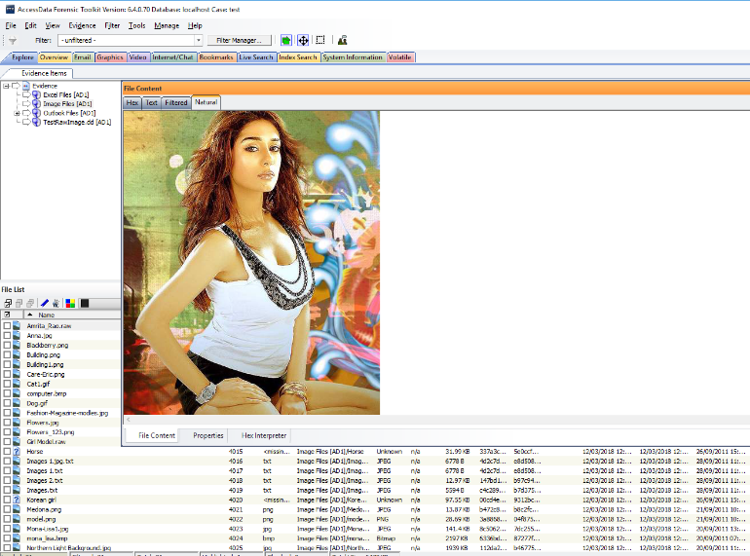
Figure 14: Images Recovered From Evidence [80]
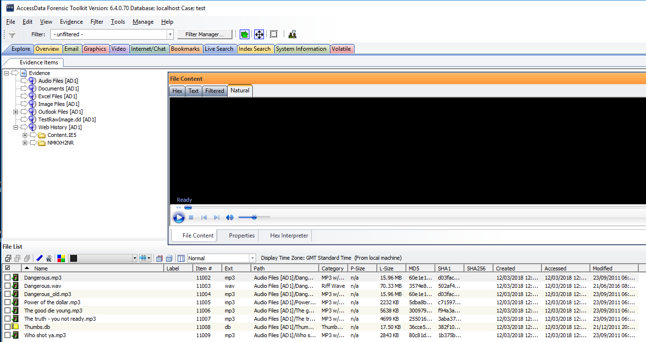
Figure 15: Audio Recovered From Evidence [80]
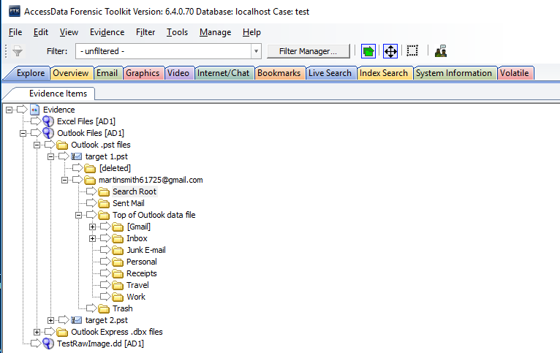
Figure 16: E-mail Contacts and Messages Recovered From the Evidence [80]

Figure 17: Web History Recovered from the Evidence [80]
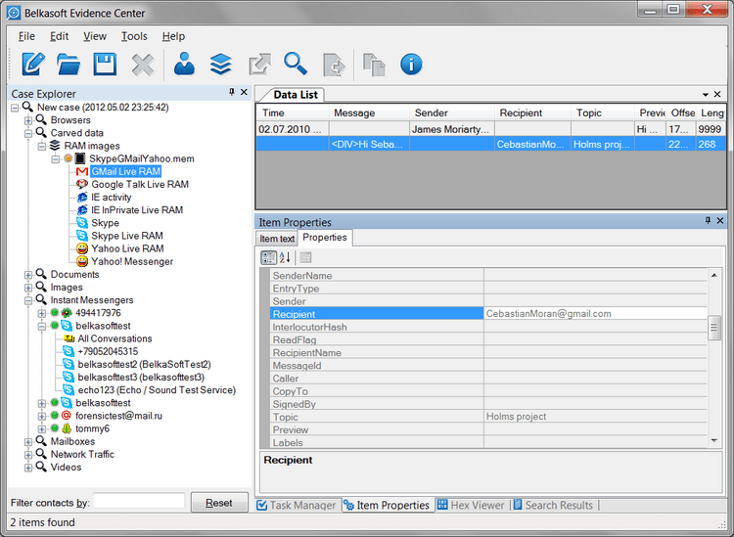
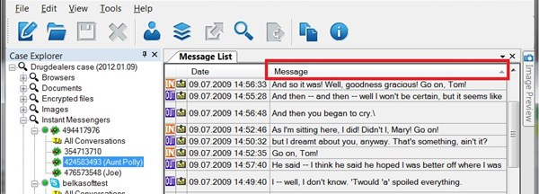
Figure 18: RAM Image Analysis - Instant Messenger Chats Recovered [80]

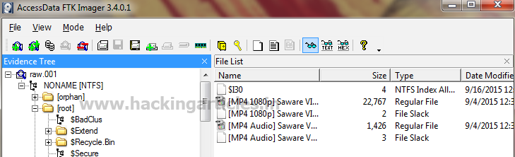
Figure 19: Video Files Recovered from the Evidence [80]
Two file types recovered (MS Word and MS Excel documents) were found to be encrypted shown in figures 20-21.

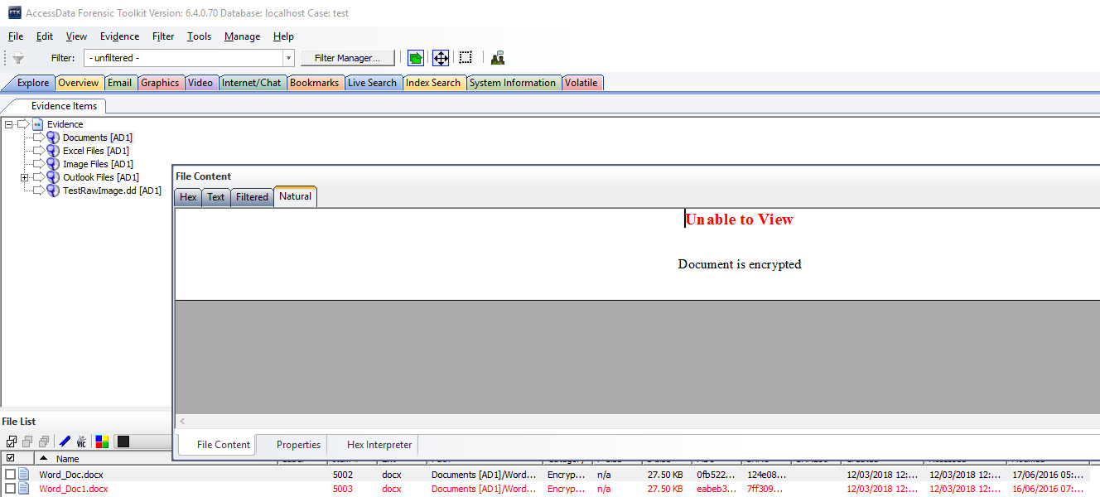
Figure 20: MS Word Documents Retrieved from the Evidence that are Encrypted [80]
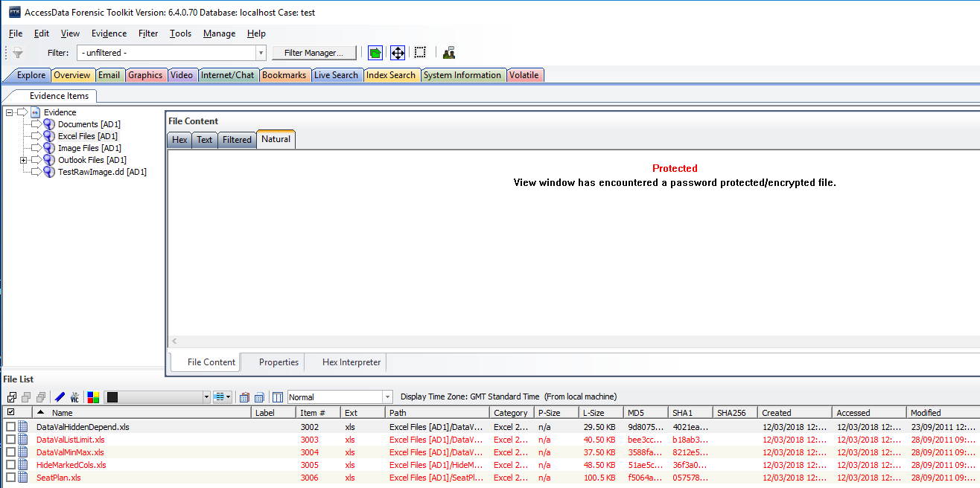
Figure 21: MS Excel Spreadsheets Retrieved from Evidence was Encrypted [80]
John then used a tool called ‘HashCat’ [81] to crack the encrypted files using a dictionary attack method. This password cracking method is accomplished by autonomously trying multiple passwords contained within a .txt file of commonly known passwords used by end users. The crack was successful, and the passwords retrieved for all files were ‘Charley’ shown in figure 22.
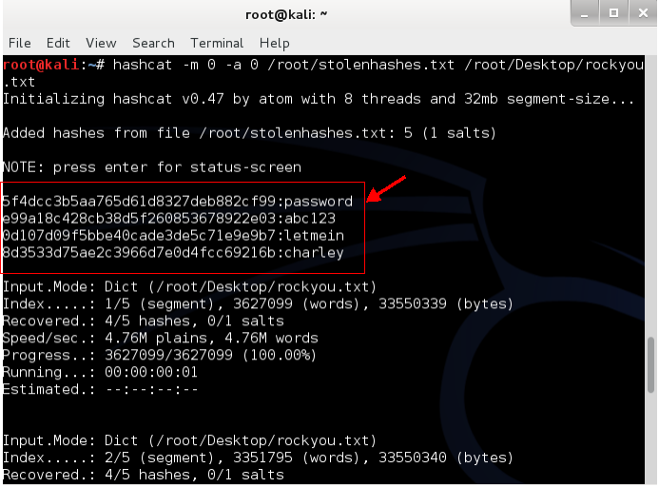
Figure 22: Hash-Cat Linux Password Cracking tool Utilised to Crack Encrypted Recovered Documents [81]
John also looks for hidden data that the suspect may have imbedded within the metadata of the images using a technique called steganography discussed earlier in the report, using the steganography detection feature included within FTK.

After scanning the images using the steganography detection feature John does not find any hidden data obscured using steganography techniques. [82]

Now that all the digital evidence Mr Wales wanted John to investigate has been located and the secure files have been decrypted, John now views and analyses the data recovered in further detail, which includes; the metadata of the digital evidence and an unbiased neutral description of each recovered files contents that will be incorporated within his report to Mr Wales under the ‘Evidence Analysis’ section.

All tools/processes used within this stage of the investigation are documented within John audit notes to be used within his report.

- Video Analysis
During the analysis of the video files, John briefly described the content of each video file that was recovered that included:

- 9/11 Bombings.

- Terrorists practicing at a terror camp.

- Killing of kidnapped hostages.

- Motivational speeches by leaders of various terrorist outfits.

- A 30-minute video of the Heathrow International Airport and Mason International airport at Fiji.

- A Video taken in a hotel room along with 6 other people talking around a table.

The timestamps and dates that these files were created were noted from the files metadata and Windows event logs along with the length of each video. The Windows account user that created and/or accessed these files was also logged.

MD5 hashes were also created of these files to proves their integrity that can be found in the Johns report to Mr Wales.

- Image Analysis
During the analysis of the image files, John briefly described the content of each image that was recovered that included:

- Detailed photographs of Heathrow Airport, London and Mason International Airport, Fiji, that included the layout of corridors, external buildings etc.

- Multiple logos of a well-known terrorist group.

- Images of the suspect and his family having a picnic on an area of grass.

The timestamps and dates that these files were created were noted from the metadata and Windows event logs along with the Windows account user that created and/or accessed these files.

MD5 hashes were also created of these files to proves their integrity that can be found in the Johns report to Mr Wales.

- Document Analyses
During the analysis of the previously encrypted MS word documents material was found and its contents were briefly described that included:

- How to make a chemical bomb

- How to prepare for Jihad

- How to be a suicide bomber

The timestamps and dates that these files were created were noted from the metadata and Windows event logs along with the Windows account user that created and/or accessed these files.

MD5 hashes were also created of these files to proves their integrity that can be found in the Johns report to Mr Wales.

- E-Mail Analysis
During the E-Mail contact and message analysis. John noted an E-mail contact retrieved was a name that was also found within an earlier analysed document.

The timestamps and dates that these E-Mails were received/sent were noted from the metadata, Windows event logs and temporary internet files along with the Windows account user, network information i.e. Internet Protocol version 4 (IPv4) Address, mail server used etc, the name depicted in both documents and E-mail account owner.

MD5 hashes were also created of these files to proves their integrity that can be found in the Johns report to Mr Wales.

- Spreadsheet Analysis
During the analysis of the previously encrypted MS Excel spreadsheet, bank account names and the inflow of a large amount of funds were listed in detail, John notes this.

The timestamps and dates that these files were created were noted from the metadata and Windows event logs along with the Windows account user that created and/or accessed these files.

MD5 hashes were also created of these files to proves their integrity that can be found in the Johns report to Mr Wales.

- Laptop Briefcase Analysis
Whilst removing the laptop from the briefcase, John found documents and immigration visas that were missed by Mr Wales and his team. John photographed this evidence, detailed his findings along with the date/time and securely stored it with the laptop to be given to Mr Wales.

Johns update his audit notes, depicting the processes/tools used to analyse the digital evidence, the file names/format, metadata and date/time that each piece of data was examined to include within his report.

As a digital forensics investigator John will only note the filenames and briefly give an unbiased neutral description of the content/material he has found along with the processes/tools he used to recover and analyse the evidence/metadata within his report to Mr Wales.

All digital evidence retrieved from the laptop will be provided to Mr Wales for criminal analysis because a digital forensics investigator is not qualified in criminal law and is considered an unbiased neutral party who only analyses the evidence scientifically, John must maintain his professional ethics whilst investigating a case with no prejudice or opinion on the content of the files recovered. So, it will be the job of Mr Wales and his team who are qualified detectives to fully analyse and investigate all the data retrieved by John from a criminologists perspective to conclude if the digital evidence contains criminal content or not.[83]

- Evidence Reporting
Now that John has scientifically analysed the evidence from a digital forensics investigators point of view he must now formulate a technical report of his findings to give to Mr Wales containing all the methods/tools used from the start of the investigation until the end.

Professionally approved forensic framework tools such as FTK have a technical reporting function that formats and exports all data recovered and analysed during the investigation, John uses this function to create his technical report. [79]

John creates two reports using FTK;

- Portable Document Format (PDF). [84]

- Hyper Text Mark-up Language (HTML). [85]

He creates the first report in a PDF document because it is considered the most secure form of document since it encompasses a feature in which the author can lock the content within the document then digitally sign it with Adobe sign [86]so that it can only be read and not edited after it has been published, there is also a secure PDF document integrity checker available as a freeware plugin with Adobe Acrobat PDF viewer, [84] these features are important in order to maintain a digital forensic report integrity.

Once John has created the PDF document he digitally signs it, password protects it due to the reports confidential nature and finally E-mails a digital copy to Mr Wales’s government E-mail address from his secure lab E-Mail server.

He creates a second report in Hypertext Mark-up Language (HTML) format so that he can publish it on his secure lab web server so that it can be highly available and conveniently accessed by Mr Wales and his team over the Internet via a secure Virtual Private Network (VPN) [87].

A copy of all digital evidence retrieved from the laptops HDD is also made available on John’s secure webserver. A full copy of these report formats and log files can be found in Appendix-D of this report.

Johns report in a real-world investigation would contain a table of contents and report structure similar to the real-world digital forensics example report shown in figure 23.

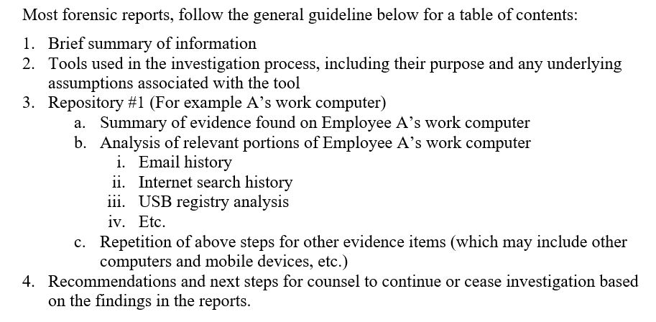
Figure 23: Digital Forensic Report Structure Example [88]
If the case is tried in a court of law, a copy of John’s report and all evidence retrieved during the investigation will be handed to the public prosecutor and defence barrister of the accused to be presented and/or challenged in court.

A copy of all digital evidence recovered during the investigation is returned to Mr Wales by John along with the chain of custody document, audit notes, a printed copy of the PDF report, log files and the physical evidence.

The chain of custody document is then updated by John for the final time depicting the return of the physical and digital evidence to Mr Wales in which they both sign.

John also keeps a digital copy of the evidence, log files, chain of custody document, audit notes and report for his own records in the event he has to give expert testimony in court and/or if the suspect(s) were convicted of the crime and appealed the conviction. Digital evidence recovered during the investigation may be challenged at a later date, so John would need to re-evaluate the report/evidence in this event to defend the actions he took during the investigation. A full copy of Johns technical report can be found in Appendix-B of this report.

Case Conclusion
Now that the digital evidence has been extracted and analysed from the laptop, Mr Wales and his team will methodically assess all the digital evidence retrieved and also use the report formulated by John as a guide; that highlights key areas of the digital investigation i.e. encryption used, hidden files found, deleted files retrieved, metadata analysis of requested file formats, E-mail contacts etc in further detail to determine if the suspect will be prosecuted and/or to identify co-conspirators within the suspected terrorist cell who planned the attack to bring them to justice and prevent further attacks.

John also creates and delivers an invoice for his services to Mr Wales in the form of a MS Excel spreadsheet so that Mr Wales can proceed with Johns payment which can be found in Appendix-C of this report.

Conclusions
Modern day digital forensics is a game of ‘Cat and Mouse’, average criminals are becoming more knowledgeable of their digital footprint and the tools/techniques used by digital investigators to identify criminal activity within the cyber landscape. [89] [4]

Therefore, the skills required by a digital forensics investigator span multiple core computer science disciplines i.e. networking, systems architecture, software engineering, web development etc in order to stay ahead of the criminals to identify and reverse engineer the tools/techniques that they implement to evade prosecution.[90]

These skills are highly sought after within today’s climate by security services and corporations across the globe to identify and prevent criminals costing companies/governments millions in revenue and/or intellectual property. [91] [92]

Due to the highly skilled, multi-disciplined natured role of a digital forensics investigator there is a world-wide skills shortage in this field of computer science in which there is currently a high demand and is very lucrative for experienced investigators.[93]

Digital forensics has grown into a cornerstone of modern law and policing within computer science and the information age we live in today, it has become a highly specialised field that is currently in its infancy.[94]

After reflecting on the case study within this report and digital forensics as an industry, future consideration would be to emulate a real-world investigation by working on evidence from a genuine criminal investigation and applying several forensic analysis tools/techniques to each piece of data obtained from multiple physical devices i.e. Laptop, Mobile Phone, Servers etc to establish if all data could be securely retrieved and analysed to solve the case.

References
[1] C. Colaguori, “Computer crime, investigation, and the law,” Police Pract. Res., vol. 13, no. 6, pp. 539–540, 2012.
[2] B. Akhgar, A. Staniforth, and F. Bosco, Cyber Crime and Cyber Terrorism Investigator’s Handbook. 2014.
[3] G. Gogolin, “The digital crime tsunami,” Digit. Investig., vol. 7, no. 1–2, pp. 3–8, 2010.
[4] S. Garfinkel, “Anti-Forensics : Techniques , Detection and Countermeasures,” 2nd Int. Conf. i-Warfare Secur., pp. 77–84, 2007.
[5] infosec, “Digital Forensics Categories,” infosecinstitute.com, 2016. [Online]. Available: http://resources.infosecinstitute.com/category/computerforensics/introduction/areas-of-study/digital-forensics/#gref. [Accessed: 23-Feb-2018].
[6] H. K. Mann and G. S. Chhabra, “Volatile Memory Forensics: A Legal Perspective,” Int. J. Comput. Appl., vol. 155, no. 3, pp. 975–8887, 2016.
[7] Ninj@S3c, “Linux and Disk Forensics,” InfoSec Institute, 2013. [Online]. Available: http://resources.infosecinstitute.com/linux-and-disk-forensics/.
[8] Dell, “Solid State Drive vs. Hard Disk Drive Price and Performance Study,” dell.com, vol. 1, no. 1, pp. 1–4, 2018.
[9] S. Y. Huang and Y. Huang, “Network forensic analysis using growing hierarchical SOM,” in Proceedings - IEEE 13th International Conference on Data Mining Workshops, ICDMW 2013, 2013, pp. 536–543.
[10] R. Hunt and S. Zeadally, “Network forensics: An analysis of techniques, tools, and trends,” Computer (Long. Beach. Calif)., vol. 45, no. 12, pp. 36–43, 2012.
[11] A. Provataki and V. Katos, “Differential malware forensics,” Digit. Investig., vol. 10, no. 4, pp. 311–322, 2013.
[12] K. Curran, A. Robinson, S. Peacocke, and S. Cassidy, “Mobile Phone Forensic Analysis,” Int. J., vol. 2, no. 2, pp. 15–27, 2010.
[13] G. S. Chhabra and D. S. Bajwa, “Review of E-mail System, Security Protocols and Email Forensics,” Int. J. Comput. Sci. Commun. Networks, vol. 5, no. 3, pp. 201–211, 2012.
[14] L. Cai, J. Sha, and W. Qian, “Study on Forensic Analysis of Physical Memory,” Int. Symp. Comput. Commun. Control Autom., no. 3ca, pp. 221–224, 2013.
[15] Z. Chen, F. Han, J. Cao, X. Jiang, and S. Chen, “Cloud computing-based forensic analysis for collaborative network security management system,” Tsinghua Sci. Technol., vol. 18, no. 1, pp. 40–50, 2013.
[16] K. E. Pavlou and R. T. Snodgrass, “Forensic Analysis of Database Tampering,” ACM Trans. Database Syst., vol. 33, no. 4, p. 30:1--30:47, 2008.
[17] M. S. Bashir and M. N. A. Khan, “A triage framework for digital forensics,” Comput. Fraud Secur., vol. 2015, no. 3, pp. 8–18, 2015.
[18] B. Carrier, “Open Source Digital Forensics Tools,” Analysis, no. October 2002, pp. 1–11, 2002.
[19] S. Jamison, “Is It an Application, a Platform, or a Framework? | Planning Your SharePoint 2013 Solution Strategy | InformIT,” informit.com, 2018. [Online]. Available: http://www.informit.com/articles/article.aspx?p=2130299&seqNum=2. [Accessed: 28-Mar-2018].
[20] EC-Council, “EC-Council Certified Incident Handler (ECIH) | EC-Council,” eccouncil.com, 2018. [Online]. Available: https://www.eccouncil.org/programs/ec-council-certified-incident-handler-ecih/. [Accessed: 28-Mar-2018].
[21] IACIS, “IACIS - CFCE Certification,” IACIS.com, 2018. [Online]. Available: https://www.iacis.com/certification-2/. [Accessed: 28-Mar-2018].
[22] eccouncil, “Computer Hacking Forensic Investigator-CHFI | EC-Council,” eccouncil.org, 2018. [Online]. Available: https://www.eccouncil.org/programs/computer-hacking-forensic-investigator-chfi/. [Accessed: 28-Mar-2018].
[23] G. W. Manes and E. Downing, “Overview of licensing and legal issues for digital forensic investigators,” IEEE Secur. Priv., vol. 7, no. 2, pp. 45–48, 2009.
[24] K. Ryder, “Computer Forensics – We’ve had an incident, who do we get to investigate?,” sans.org, vol. 1, no. 1, pp. 1–12, 2002.
[25] D. J. Ryan, “Legal Aspects of Digital Forensics,” 2011 44th Hawaii Int. Conf., pp. 1–6, 2011.
[26] infosecinstitute, “Computer Forensics Investigation – Written Permission,” infosecinstitute.com, 2014. [Online]. Available: http://resources.infosecinstitute.com/computer-forensics-investigation-case-study/#gref. [Accessed: 28-Mar-2018].
[27] Law Enforcement Cyber Center, “Digital Search Warrants - Law Enforcement Cyber Center,” iacpcybercenter.org/, 2018. [Online]. Available: http://www.iacpcybercenter.org/prosecutors/digital-search-warrants/. [Accessed: 28-Mar-2018].
[28] gov.uk, “Data Protection Act 1998,” legislation.gov.uk, vol. 1, no. 1, p. 1, 2018.
[29] gov.uk, “Computer Misuse Act 1990,” legislation.gov.uk, vol. 1, no. 1, p. 1, 2018.
[30] ACPO, “ACPO Good Practice Guide ACPO Good Practice Guide for Digital Evidence for Digital Evidence,” digital-detective.net, vol. 1, no. 1, pp. 1–15, 2012.
[31] NPCC, “DIGITAL INVESTIGATION AND INTELLIGENCE Policing capabilities for a digital age,” npcc.police.uk, vol. 1, no. 1, p. 24, 2015.
[32] L. Daniel and L. Daniel, Digital Forensics for Legal Professionals. 2012.
[33] J. Ćosić and Z. Ćosić, “Chain of Custody and Life Cycle of Digital Evidence,” Comput. Technol. Appl., vol. 3, no. 2012, pp. 126–129, 2012.
[34] NIST, “Chain of Custody Document example,” nist.gov, vol. 1, no. 1, p. 1, 2015.
[35] informit, “Evidence Collection and Chain of Custody,” informit.com, 2004. [Online]. Available: http://www.informit.com/articles/article.aspx?p=336258&seqNum=3. [Accessed: 28-Mar-2018].
[36] Y. Prayudi and A. SN, “Digital Chain of Custody: State of The Art,” Int. J. Comput. Appl., vol. 114, no. 5, pp. 1–9, 2015.
[37] cubersecurity.my, “CyberSecurity methodology| An Agency Under MOSTI,” cybersecurity.my, 2018. [Online]. Available: http://www.cybersecurity.my/en/services/digital_forensics/services/main/detail/1628/index.html. [Accessed: 28-Mar-2018].
[38] I. O. Ademu, C. O. Imafidion, and D. S. Preston, “A New Approach of Digital Forensic Model for Digital Forensic Investigation,” Int. J. Adv. Comput. Sci. Appl., vol. 2, no. 12, pp. 175–178, 2011.
[39] B. Hitchcock, N. A. Le-Khac, and M. Scanlon, “Tiered forensic methodology model for Digital Field Triage by non-digital evidence specialists,” in Digital Investigation, 2016, vol. 16, pp. S75–S85.
[40] J. L. John, “Digital Forensics and Preservation,” DPC Technol. Watch Rep., vol. 12, no. 3, pp. 1–53, 2012.
[41] S. Harald, “Guidelines on Digital Forensic Procedures for OLAF Staff,” ec.europa, vol. 1, no. 1, p. 2, 2016.
[42] D. C. Cambell, “Course: L5 - Computer Forensics (ACCA5000),” moodle.uwtsd, 2018. [Online]. Available: https://moodle.uwtsd.ac.uk/course/view.php?id=4719. [Accessed: 28-Mar-2018].
[43] NISO, Understanding Metadata, no. MD:NISO Press. 2004.
[44] N. F. Johnson and S. Jajodia, “Exploring steganography: Seeing the unseen,” Computer (Long. Beach. Calif)., vol. 31, no. 2, pp. 26–34, 1998.
[45] K. Ryder, “Computer Forensics – We have had an incident, who do we get to investigate? (specialist investigators),” sans.org, vol. 1, no. 1, p. 3, 2002.
[46] A. M. Neil, “Digital Forensics What, Why, and How OWASP Mansoura Egypt, Chapter leader,” owasp.org, vol. 1, no. 1, 2017.
[47] gov.uk, “Police and Criminal Evidence Act 1984,” legislation.gov.uk, vol. 1, no. 1, p. 1, 2018.
[48] exponent, “Forensic Analysis of Digital Time | Alerts | Knowledge | Exponent,” exponent.com, 2015. [Online]. Available: https://www.exponent.com/knowledge/alerts/2015/04/forensic-analysis-of-digital-time/?pageSize=NaN&pageNum=0&loadAllByPageSize=true. [Accessed: 28-Mar-2018].
[49] Dell, “Dell TM Latitude TM D630 &amp; D630c Impressive, influential and exceptionally smart,” dell.com, vol. 1, no. 1, 2014.
[50] dell, “Windows XP Support | Dell UK,” dell.com, 2014. [Online]. Available: http://www.dell.com/support/contents/uk/en/ukbsdt1/article/product-support/self-support-knowledgebase/operating-systems/windows-operating-systems/windows-xp-support. [Accessed: 28-Mar-2018].
[51] infosec, “Windows Systems and Artifacts in Digital Forensics, Part II,” infosecinstitute.com, 2017. [Online]. Available: http://resources.infosecinstitute.com/windows-systems-and-artifacts-in-digital-forensics-part-ii/#gref. [Accessed: 28-Feb-2018].
[52] lazada, “Dell Latitude D630 14&quot; LCD Laptop / Intel Core 2 Duo / 80GB Hard Disk / 2GB DDR2 Ram / Windows XP / Factory Refurbished | Lazada,” lazada.com, 2018. [Online]. Available: https://www.lazada.com.my/products/refurbished-notebook-dell-latitude-d630-14-lcd-laptop-intel-core-2-duo-80gb-hard-disk-2gb-ddr2-ram-windows-xp-factory-refurbished-i177094476-s210699850.html. [Accessed: 28-Mar-2018].
[53] C. Kleiman, Dave, The official CHFI exam 312-49 study guide : for computer hacking forensics investigators. Syngress Pub, 2007.
[54] insodemylaptop, “How to dismantle Dell XPS 15z (L511z) – Inside my laptop,” insodemylaptop, 2016. [Online]. Available: http://www.insidemylaptop.com/dismantle-dell-xps-15z-l511z-laptop/. [Accessed: 28-Mar-2018].
[55] J. Lyle, S. Mead, and K. Rider, “Disk drive I/O commands and write blocking,” in IFIP International Federation for Information Processing, 2007, vol. 242, pp. 163–177.
[56] Intel, “Laptop RAM - Intel,” intel.com, 2018. [Online]. Available: https://www.intel.com/content/www/us/en/tech-tips-and-tricks/computer-ram.html. [Accessed: 28-Mar-2018].
[57] G. Osborne, “Memory Forensics : Review of Acquisition and Analysis Techniques,” Def. Sci. Technol. Organ., pp. 1–42, 2013.
[58] lifewore, “What Is a SATA Cable or Connector?,” lifewire, 2015. [Online]. Available: https://www.lifewire.com/serial-ata-sata-2626009. [Accessed: 28-Mar-2018].
[59] datapro, “USB-3 specifiactions,” datapro.net, 2017. [Online]. Available: https://www.datapro.net/techinfo/usb_3_explained.html. [Accessed: 28-Mar-2018].
[60] N. Fraistat, “Building a Digital Curation Workstation with BitCurator (update) – BitCurator,” bitcurator.ent, 2015. [Online]. Available: https://bitcurator.net/2013/08/02/building-a-digital-curation-workstation-with-bitcurator-update/. [Accessed: 28-Mar-2018].
[61] D. G. Park, S. J. Park, J. C. Lee, S. Y. No, and S. Y. Shin, “A file carving algorithm for digital forensics,” in Lecture Notes in Computer Science (including subseries Lecture Notes in Artificial Intelligence and Lecture Notes in Bioinformatics), 2009, vol. 5592 LNCS, no. PART 1, pp. 615–626.
[62] Obsidian Forensics, “Slack Space,” Obsidian Forensics, 2011. [Online]. Available: https://www.obsidianforensics.com/blog/slack-space. [Accessed: 28-Mar-2018].
[63] A. Khatri, “The Risk of Logical Data Recovery Explained : Stellar Data Recovery UK,” stelladatarecovery, 2017. [Online]. Available: https://www.stellardatarecovery.co.uk/logical-data-recovery-risks.htm. [Accessed: 28-Mar-2018].
[64] Seagate, “Everything You Wanted to Know About Hard Drives | Seagate,” seagate.com, 2017. [Online]. Available: https://www.seagate.com/gb/en/do-more/everything-you-wanted-to-know-about-hard-drives-master-dm/. [Accessed: 28-Mar-2018].
[65] AccessData, “FTK imager,” accessdata.com, 2018. [Online]. Available: https://accessdata.com/product-download/ftk-imager-version-3.4.3. [Accessed: 28-Mar-2018].
[66] S. L. Garfinkel, D. J. Malan, K.-A. Dubec, C. C. Stevens, and C. Pham, “Advanced Forensic Format: An Open, Extensible Format for Disk Imaging,” In Advances in Digital Forensics II: FIP International Conference on Digital Forensics, vol. 222. pp. 17–31, 2006.
[67] edrm, “Bit-by-Bit Copy | EDRM,” edrm.net, 2015. [Online]. Available: https://www.edrm.net/glossary/bit-by-bit-copy/. [Accessed: 28-Mar-2018].
[68] K. Hausknecht, D. Foit, and J. Burić, “RAM data significance in digital forensics,” in 2015 38th International Convention on Information and Communication Technology, Electronics and Microelectronics, MIPRO 2015 - Proceedings, 2015, pp. 1372–1375.
[69] E-fense, “Helix - Cyber Security &amp; Computer Forensics Software,” e-fense, 2018. [Online]. Available: http://www.e-fense.com/live-response.php. [Accessed: 28-Mar-2018].
[70] D. et al Gaskin, “Dual path memory retrieval system for an interleaved dynamic RAM memory unit,” Dell USA, May 1990.
[71] F. Y. W. Law, K. P. Chow, M. Y. K. Kwan, and P. K. Y. Lai, “Consistency Issue on Live Systems Forensics,” IEEE Futur. Gener. Commun. Netw., pp. 136–140, 2007.
[72] V. Schmitt and J. Jordaan, “Establishing the Validity of Md5 and Sha-1 Hashing in Digital Forensic Practice in Light of Recent Research Demonstrating Cryptographic Weaknesses in these Algorithms,” Int. J. Comput. Appl., vol. 68, no. 23, pp. 975–8887, 2013.
[73] PassMark Software, “OSFClone - Open source utility to create and clone forensic disk images,” OSforensics, 2018. [Online]. Available: https://www.osforensics.com/tools/create-disk-images.html. [Accessed: 28-Mar-2018].
[74] Nirsoft, “HashMyFiles: Calculate MD5/SHA1/CRC32 hash of files,” Nirsoft.net, 2017. [Online]. Available: https://www.nirsoft.net/utils/hash_my_files.html. [Accessed: 28-Mar-2018].
[75] J. Hoffstein, J. Pipher, and J. H. Silverman, An Introduction to Mathematical Cryptography, vol. XVI. 2008.
[76] gov.uk, “Securely Storing Physical Evidence.” p. 13, 2017.
[77] vestige Ltd, “How much does Digital Forensic Services Cost? - Vestige: Digital Forensic Investigator,” Vestige, 2017. [Online]. Available: https://www.vestigeltd.com/thought-leadership/digital-forensic-services-cost-guide-vestige-digital-investigations/. [Accessed: 28-Mar-2018].
[78] T. Moore, “The Economics of Digital Forensics.”
[79] AccessData, “Forensic Toolkit,” accessdata.com, 2018. [Online]. Available: https://accessdata.com/products-services/forensic-toolkit-ftk. [Accessed: 28-Mar-2018].
[80] P. U. Lawrence, “FTK Analasys at UWTSD,” FTK - UWTSD, vol. 1, no. 1, p. 1, 2018.
[81] Hashcat, “hashcat - advanced password recovery,” hashcat.net, 2018. [Online]. Available: https://hashcat.net/hashcat/. [Accessed: 28-Mar-2018].
[82] siliconforensics, “Forensic Tool Kit (FTK),” siliconforensics.com, 2018. [Online]. Available: https://siliconforensics.com/forensic-tool-kit-ftk.html. [Accessed: 28-Mar-2018].
[83] infosecurity, “Computer Forensics: Legal and Ethical Principles,” infosecurity.com, 2018. [Online]. Available: http://resources.infosecinstitute.com/category/computerforensics/introduction/areas-of-study/legal-and-ethical-principles/#gref. [Accessed: 28-Mar-2018].
[84] Adobe, “PDF passwords, protected PDFs, file permissions | Adobe Acrobat DC,” acrobat.adobe.com, 2018. [Online]. Available: https://acrobat.adobe.com/uk/en/acrobat/how-to/pdf-file-password-permissions.html. [Accessed: 28-Mar-2018].
[85] Mozilla, “Introduction to HTML - Learn web development | MDN,” DEVELOPER.MOZILLA.ORG, 2018. [Online]. Available: https://developer.mozilla.org/en-US/docs/Learn/HTML/Introduction_to_HTML. [Accessed: 28-Mar-2018].
[86] Adobe, “What is a digital signature, how it works| Adobe Sign,” acrobat.adobe.com, 2018. [Online]. Available: https://acrobat.adobe.com/uk/en/sign/capabilities/digital-signatures-faq.html. [Accessed: 28-Mar-2018].
[87] F. Chen, K. Wu, W. Chen, and Q. Zhang, “The research and implementation of the VPN gateway based on SSL,” in Proceedings - 2013 International Conference on Computational and Information Sciences, ICCIS 2013, 2013, pp. 1376–1379.
[88] V. D. Crawford, “Example of A Digital forensics Report.” academia.edu, p. 1, 2017.
[89] itgovernance, “The rise of cyber crime – IT Governance Blog,” itgovernance.co.uk, 2018. [Online]. Available: https://www.itgovernance.co.uk/blog/the-rise-of-cyber-crime/. [Accessed: 28-Mar-2018].
[90] C. Grobler and B. Louwrens, “Digital Forensics: A Multi-Dimensional Discipline,” Proc. ISSA 2006, 2006.
[91] Gartner, “Gartner Says Worldwide Information Security Spending Will Grow 7.9 Percent to Reach $81.6 Billion in 2016,” gartner.com, 2018. [Online]. Available: https://www.gartner.com/newsroom/id/3404817. [Accessed: 28-Mar-2018].
[92] Financial Times, “Cost of cyber crime rises rapidly as attacks increase,” ft.com, 2018. [Online]. Available: https://www.ft.com/content/56dae748-af79-11e7-8076-0a4bdda92ca2. [Accessed: 28-Mar-2018].
[93] J. C. Oltsik, “Cybersecurity skills shortage hurts security analytics, operations | CSO Online,” csoonline.com, 2018. [Online]. Available: https://www.csoonline.com/article/3210486/security/cybersecurity-skills-shortage-profound-impact-on-security-analytics-and-operations.html. [Accessed: 28-Mar-2018].
[94] X. Du, N.-A. Le-Khac, and M. Scanlon, “Evaluation of Digital Forensic Process Models with Respect to Digital Forensics as a Service,” IEEE, Aug. 2017.
[95] Guidance Software, “EnCase Forensic Software - Top Digital Forensics &amp; Investigations Solution,” guidancesoftware.com, 2018. [Online]. Available: https://www.guidancesoftware.com/encase-forensic. [Accessed: 28-Mar-2018].
[96] X-ways Software Technology, “Software for Computer Forensics, Data Recovery, and IT Security,” x-ways.net, 2018. [Online]. Available: https://www.x-ways.net/. [Accessed: 28-Mar-2018].
[97] forensicpc, “ForensicPC - Lowest prices on Tableau Computer Forensic Hardware, write blockers, and forensic disk duplicators,” forensicpc.com, 2018. [Online]. Available: http://www.forensicpc.com/proddetail.asp?prod=UWBK-ES&cat=38. [Accessed: 28-Mar-2018].
[98] I. Oxygen Forensics, “Oxygen Forensics - Oxygen Forensic® Analyst,” oxygen-forensics.com, 2018. [Online]. Available: https://www.oxygen-forensic.com/en/products/oxygen-forensic-analyst. [Accessed: 28-Mar-2018].
[99] caine-live team, “CAINE Live USB/DVD - computer forensics digital forensics,” caine-live.net, 2018. [Online]. Available: https://www.caine-live.net/. [Accessed: 28-Mar-2018].
[100] NMAP, “Nmap: the Network Mapper - Free Security Scanner,” nmap.org, 2018. [Online]. Available: https://nmap.org/. [Accessed: 28-Mar-2018].
[101] Xplico, “Xplico - Open Source Network Forensic Analysis Tool (NFAT),” xplico.org, 2018. [Online]. Available: https://www.xplico.org/. [Accessed: 28-Mar-2018].
[102] MailXaminer, “Email Examiner Software &amp; Mail Analysis Program for E-mail Investigations,” mailxaminer.com, 2018. [Online]. Available: https://www.mailxaminer.com/. [Accessed: 28-Mar-2018].
[103] P. U. Lawrence, “Digital Forensics Invoice - MS Excel,” 2018.

Appendix – A: Frequently Used Tools
Tool Name /Type | Category | Manufacturer | Version and Price
SAFE Block  (Windows Software) | Storage – Write blocker | ForensicSoft | Windows 10 and below $549
ForensicPC (Hardware) | Storage - HDD Write blocker | ForensicPC | Ultimate  $1,749.00
Helix  (USB -Software) | Memory - (RAM)  Live Capture | E-fense Ltd | Windows Live Response  $500.00
EnCase  (Windows Software) | Forensics Framework | GuidanceSoftware | V8, $3,594.00
FTK  (Windows Software) | Forensics Framework | AccessData | V6.2, $3,995.00
XWF  (Windows Software) | Forensics Framework | X-Ways | V19.5 £1,789
Oxygen: Analyst  (Windows Software) | Mobile Devices | Oxygen Forensics, Inc | V10.0.3, $2,499
C.A.I.N.E.  (Linux Software) | Forensics OS | Nanni Bassetti et al | V9.0, Freeware
Nmap  (Linux Software) | Network | Gordon Lyon | V7.60, Freeware
Xplico  (Linux Software) | Network | Gianluca Costa et al | V1.2.1 Freeware
HashMyFiles  (Windows Software) | Cryptography | Nirsoft | V2.25 Freeware
MailXaminer  (Windows Software) | E-Mail | SysTools | V4.8.5 $1600
Table 1: Frequently used tools within digital forensics their versions and prices

SAFE Block: Safe block is software that is used to disable write privileges to drives connected to a computer, this method is called ‘Write-blocking’ a write blocker only allows a laboratory terminal to read commands from a storage device that contains the digital evidence, but blocks write ensuring data integrity. This tool can be used in the evidence acquisition stage of the forensic investigation methodology.

EnCase, FTK and XWF: These tools are classed as frameworks because they are software that utilise many forensic tools and techniques within one professional package that can be used for most categories of forensic analysis and OS’s, they are widely used by digital forensics investigators around the world, they have comparative features and primarily aim to do the same job, using one or the other would come down to personal preference (familiarity) and/or budget. EnCase is the most popular of the forensic frameworks and is considered the gold standard within the digital forensic suite of tools. These tools were developed to be used within a Windows OS environment, they can be used in all stages of the digital forensic investigation methodology.[95] [82] [96]

Ultimate Hardware Write Blocker Kit (Forensic-PC): This professional forensic kit contains a small computer device with multiple cables attachments that is portable for write blocking HDD, SSD and USB-3 storage devices so that the storage devices can be forensically imaged. [97]

Helix: Live Response USB: This software product comes pre-installed on a USB-3 flash drive, it is used within the forensics industry to forensically live imaging memory i.e. RAM, ROM. It is the most popular and reportedly forensically reliable live forensics tool currently on the market. [69]

Oxygen: Analyst: Oxygen: analyst is a tool that specialises in digital forensics secure data retrieval and analysis of Mobile devices i.e. Smartphones, tablets and mobile OS’s i.e. Android, IOS. This tool can be used in the evidence acquisition and analysis stage of the digital forensics investigation methodology. [98]

C.A.I.N.E.: Caine is a Debian based Linux OS environment customised for digital forensics professionals packed with pre-installed popular opensource digital forensic tools that can be used within a Virtual Machine (VM) or as a live USB boot. This OS can be used in all stages of the digital forensic investigation methodology which will be discussed later in the report. [99]

Nmap: Nmap is a Linux Command Line Interface (CLI) network analysis tool. It is used to discover layer-3 devices within a Local Area Network (LAN) and information pertaining to the associated device i.e. open ports, OS’s etc. This tool can be used in the evidence assessment and analysis stage of the digital forensic investigation methodology which will be discussed later in the report. [100]

Xplico: Xplico is a Linux tool for live network auditing, it is utilised by listening to the LAN using a MITM attack, the data is then relayed back to the user via an apache webserver that autoconfigures during installation. Xplico can view browser history, Secure Socket Layer (SSL) credentials, live capture emails, browser activity, FTP sessions, SSH sessions and much more. This tool is useful to investigate a suspect whilst he/she is at their workstation connected to the same LAN as the investigator. This tool can be used in the evidence analysis stage of the digital forensic investigation methodology. [101]

HashMyFiles: is a cryptographic hashing tool for Windows OS used to analyse the integrity of files and directories within a system using MD5 and SHA-256 h[101]ashing algorithms. Sha-256 is most frequently used over the deprecated md5 hash algorithm as it is now deemed unsecure by security professionals who have broken the algorithm. This tool can be used in the evidence analysis stage of the digital forensic investigation methodology. [74]

MailXaminer: MailXaminer is a tool used for examining and quickly filtering vast amounts of E-mails, preserving integrity of attachments (files) found within an E-mail inbox for criminal investigations. It supports all popular file formats i.e. Outlook, Gmail, Yahoo. This tool can be used in the evidence analysis stage of the digital forensic investigation methodology. [102]

Appendix-B – Case Study Digital Forensics Report

APPENDIX-C – DIGITAL FORENSIC INVOICE
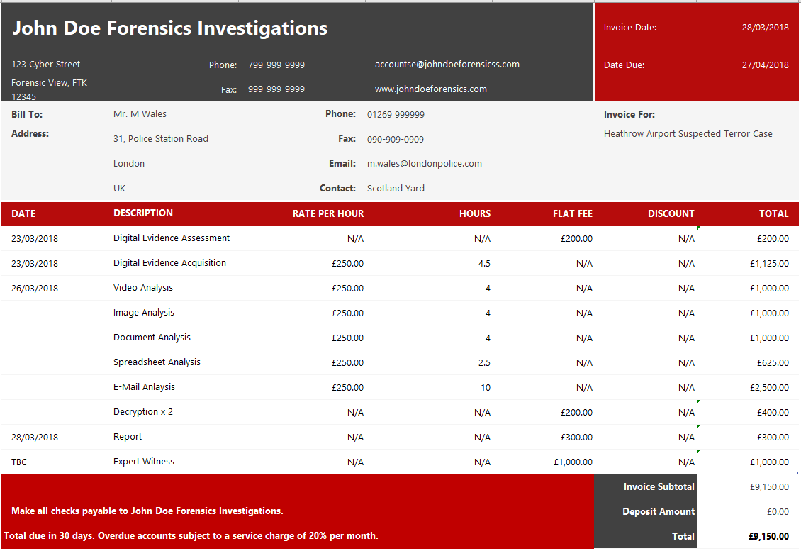
Figure 24: Case Study - Digital Forensics Invoice [103]

Appendix-D – FTK Techincal Reports (HTML, PDF and FTK Log Files)
The reports are missing large amounts of data because within this case study no evidence was provided to carry out a real-world investigation, the reports provided are actual report formats generated by FTK with small amounts of irrelevant data as an example of the reporting function the software provides.

- HTML version of report by FTK

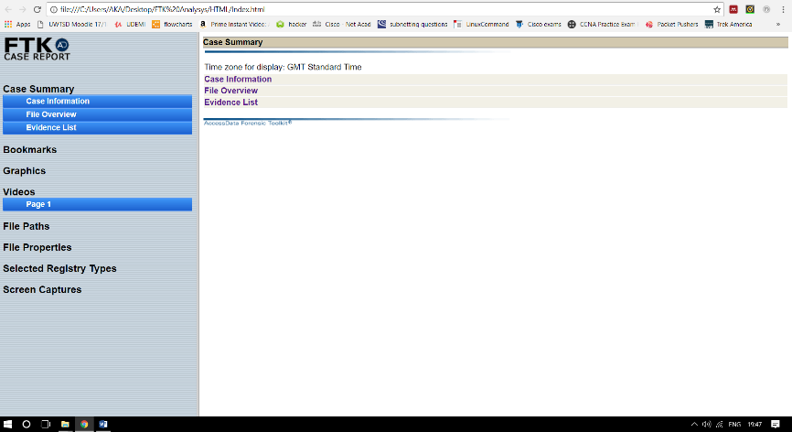
Figure 25: FTK HTML Report Index page within Web Browser [80]
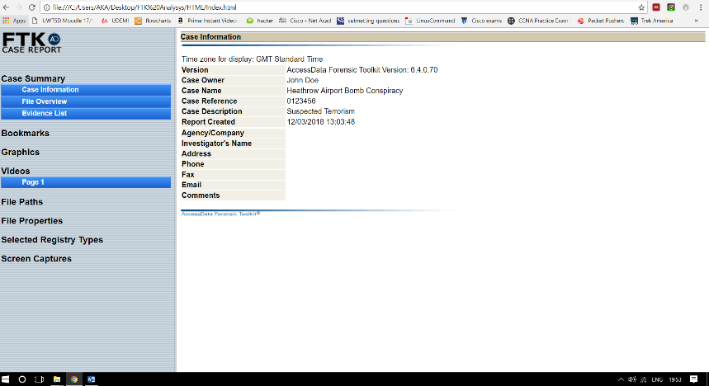
Figure 26: FTK HTML Report Case Information page [80]
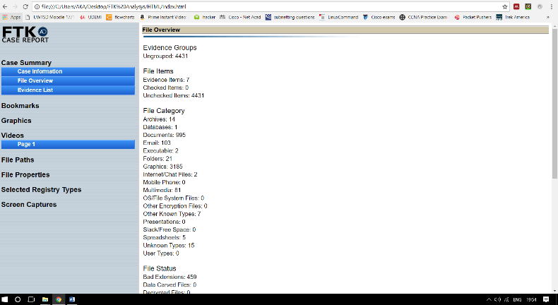
Figure 27: FTK HTML Report File-Discovery Page [80]
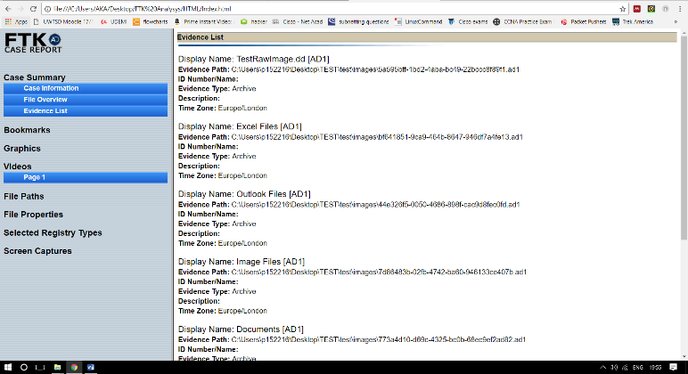
Figure 28: FTK HTML Report Evidence List Page [80]

- PDF Document Generated by FTK

The formatting from the original PDF document is not displayed correctly here. The information contained within the original FTK PDF report is still correct.[80]

Case Information
12/03/2018
Time zone for display: GMT Standard Time
Version: AccessData Forensic Toolkit Version: 6.4.0.70
Case Owner:John Doe
Case Name:Heathrow Attempted Terrorist Attack
Case Reference 012345
Case Description Suspected Terrorism
Report Created 12/03/2018 13:03:48

Agency/Company
Investigator's Name: John Doe
Address:1, Forensics Ave.
Phone: 0779999999
Fax: 01792-123999
Email johndoe@forensicslabs.co.uk
Comments
File Overview
12/03/2018
Evidence Groups
Ungrouped: 4431

Case Summary
Case Information 0
File Overview 0
Evidence List 0
Bookmarks
Graphics
Videos
File Paths
File Properties
Selected Registry Types
Screen Captures

Case Summary
12/03/2018
Time zone for display: GMT Standard Time

File Items
Evidence Items: 7
Checked Items: 0
Unchecked Items: 4431

File Category
Archives: 14
Databases: 1
Documents: 995
Email: 103
Executable: 2
Folders: 21
Graphics: 3185
Internet/Chat Files: 2
Mobile Phone: 0
Multimedia: 81
OS/File System Files: 0
Other Encryption Files: 0
Other Known Types: 7
Presentations: 0
Slack/Free Space: 0
Spreadsheets: 5
Unknown Types: 15
User Types: 0

File Status
Bad Extensions: 459
Data Carved Files: 0
Decrypted Files: 0
Deleted Files: 25
Duplicate Items: 0
Email Attachments: 12
Email Related Items (From Email): 118
Encrypted Files: 8
Flagged Ignore: 0
Flagged Privileged: 0
From Recycle Bin: 0
KFF Alert Files: 0
KFF Ignorable: 0
OCR Graphics: 0
OLE Subitems: 0
Project VIC Matches: 0
User-Decrypted Files: 0

Labels

Email Status
Email Attachments: 12
Email Related Items (From Email): 118
Email Reply: 0
Forwarded Email: 0
Evidence List
12/03/2018
Display Name: TestRawImage.dd [AD1]
Evidence Path: C:\Users\p152216\Desktop\TEST\test\images\5a595bff-1bd2-4aba-bc49-22bccc8f89f1.ad1
ID Number/Name:
Evidence Type: Archive
Description:
Time Zone: Europe/London

Display Name: Excel Files [AD1]
Evidence Path: C:\Users\p152216\Desktop\TEST\test\images\bf641851-9ca9-464b-8647-946df7a4fe13.ad1
ID Number/Name:
Evidence Type: Archive
Description:
Time Zone: Europe/London

Display Name: Outlook Files [AD1]
Evidence Path: C:\Users\p152216\Desktop\TEST\test\images\44e326f5-0050-4686-898f-cac9d8fec0fd.ad1
ID Number/Name:
Evidence Type: Archive
Description:
Time Zone: Europe/London

Display Name: Image Files [AD1]
Evidence Path: C:\Users\p152216\Desktop\TEST\test\images\7d86483b-02fb-4742-ba60-946133ce407b.ad1
ID Number/Name:
Evidence Type: Archive
Description:
Time Zone: Europe/London

Display Name: Documents [AD1]
Evidence Path: C:\Users\p152216\Desktop\TEST\test\images\773a4d10-d69c-4325-bc0b-68ec9ef2ad82.ad1
ID Number/Name:
Evidence Type: Archive
Description:
Time Zone: Europe/London

Display Name: Web History [AD1]
Evidence Path: C:\Users\p152216\Desktop\TEST\test\images\6d1e83a3-ed4a-4eb6-862d-9c9dd8d2f1a0.ad1
ID Number/Name:
Evidence Type: Archive
Description:
Time Zone: Europe/London

Display Name: Audio Files [AD1]
Evidence Path: C:\Users\p152216\Desktop\TEST\test\images\469916ab-6e7b-4710-bb39-0b5811ea85a0.ad1
ID Number/Name:
Evidence Type: Archive
Description:
Time Zone: Europe/London

Graphics
12/03/2018

Videos
12/03/2018
Time zone for display: GMT Standard Time

File Paths
12/03/2018
Time zone for display: GMT Standard Time

File Properties
12/03/2018
Time zone for display: GMT Standard Time

Selected Registry Entries:
12/03/2018

Screen Captures
12/03/2018

Bookmarks, 0-0
Case Information, 0-0
Address, 0
Agency/Company, 0
Case Description, 0
Case Name, 0
Case Owner, 0
Case Reference, 0
Comments, 0
Email, 0
Fax, 0
Investigator's Name, 0
Phone, 0
Report Created, 0
Version, 0
File Overview, 0-0
Email Status, 0
Email Attachments, 0
Email Related Items (From Email), 0
Email Reply, 0
Forwarded Email, 0
Evidence Groups, 0
Ungrouped, 0
File Category, 0
Archives, 0
Databases, 0
Documents, 0
Email, 0
Executable, 0
Folders, 0
Graphics, 0
Internet/Chat Files, 0
Mobile Phone, 0
Multimedia, 0
OS/File System Files, 0
Other Encryption Files, 0
Other Known Types, 0
Presentations, 0
Slack/Free Space, 0
Spreadsheets, 0
Unknown Types, 0
User Types, 0
File Items, 0
Evidence Items, 0
Checked Items, 0
Unchecked Items, 0
File Status, 0
Bad Extensions, 0
Data Carved Files, 0
Decrypted Files, 0
Deleted Files, 0
Duplicate Items, 0
Email Attachments, 0
Email Related Items (From Email), 0
Encrypted Files, 0
Flagged Ignore, 0
Flagged Privileged, 0
From Recycle Bin, 0
KFF Alert Files, 0
KFF Ignorable, 0
OCR Graphics, 0
OLE Subitems, 0
Project VIC Matches, 0
User-Decrypted Files, 0
Labels, 0
Evidence List, 0-0
TestRawImage.dd [AD1], 0
Excel Files [AD1], 0
Outlook Files [AD1], 0
Image Files [AD1], 0
Documents [AD1], 0
Web History [AD1], 0
Audio Files [AD1], 0
File Paths, 0-0
File Properties, 0-0
Graphics, 0-0
Selected Registry Types, 0-0
Screen Captures, 0-0
Videos, 0-0

- FTK – Log Files
The FTK log files were generated using a small amount of example data used within this report. [80]

[12/03/2018 11:40] -
--------------------Starting Batched Jobs--------------------
[12/03/2018 11:40] -
Processing Manager Version: 10.18.0.49
Starting Job: f1d9f876c6e74d399989aef9c81dc8de
Started by SOAC\p152216 on SC-MH509-07
Processing manager: SC-MH509-07
CaseID: 2
CasePath: C:\Users\p152216\Desktop\TEST\test
JobType: AddEvidence
DB System Postgres, Username ADG6x4, Host SC-MH509-07, Port 5432, SID ADG, IntSec False
FTK Username: cisco
Evidence path: C:\Users\p152216\Desktop\TEST\test\images\5a595bff-1bd2-4aba-bc49-22bccc8f89f1.ad1
Evidence type: DiskImage
Evidence codepage: 1252

[12/03/2018 11:40] - Case 2 has changed to CaseProcessing
[12/03/2018 11:40] - Using engine localhost
[12/03/2018 11:40] - Database preparation started
[12/03/2018 11:40] - Database preparation finished
[12/03/2018 11:40] - Processing started
[12/03/2018 11:40] - Processing started (1 of 1)
[12/03/2018 11:40] - Indexing started
[12/03/2018 11:40] - Processing finished
[12/03/2018 11:40] - Processing finished (1 of 1)
[12/03/2018 11:40] - Case 2 has changed to CasePostProcessing
[12/03/2018 11:40] - Database optimization started
[12/03/2018 11:40] - Database optimization finished
[12/03/2018 11:41] - Indexing finished
[12/03/2018 11:41] - Job finished
[12/03/2018 11:41] -
f1d9f876c6e74d399989aef9c81dc8de - AddEvidence job finished with state Finished
Job had 0 failed items
Enumerated: 2
Processed: 2
Indexed: 2
Job time: 00:01:42 = 12/03/2018 11:40:11 to 12/03/2018 11:41:54
Processing: 00:00:13 = 12/03/2018 11:40:12 to 12/03/2018 11:40:25
Postprocessing: 00:00:07 = 12/03/2018 11:40:25 to 12/03/2018 11:40:33
Indexing time: 00:01:37 = 12/03/2018 11:40:16 to 12/03/2018 11:41:54
[12/03/2018 11:41] - Jobs in this batch: 1
Enumerated: 2
Processed: 2
Indexed: 2
Batch time: 00:01:44 = 12/03/2018 11:40:09 to 12/03/2018 11:41:54
Processing: 00:00:13 = 12/03/2018 11:40:12 to 12/03/2018 11:40:25
Postprocessing: 00:00:07 = 12/03/2018 11:40:25 to 12/03/2018 11:40:33
Indexing time: 00:01:37 = 12/03/2018 11:40:16 to 12/03/2018 11:41:54
--------------------Finished Batched Jobs--------------------
[12/03/2018 11:41] - Case 2 has changed to CaseCleared
[12/03/2018 12:13] -
--------------------Starting Batched Jobs--------------------
[12/03/2018 12:13] -
Processing Manager Version: 10.18.0.49
Starting Job: 5884d0225aa246fdb2c1a605771f9168
Started by SOAC\p152216 on SC-MH509-07
Processing manager: SC-MH509-07
CaseID: 2
CasePath: C:\Users\p152216\Desktop\TEST\test
JobType: AddEvidence
DB System Postgres, Username ADG6x4, Host SC-MH509-07, Port 5432, SID ADG, IntSec False
FTK Username: cisco
Evidence path: C:\Users\p152216\Desktop\TEST\test\images\bf641851-9ca9-464b-8647-946df7a4fe13.ad1
Evidence type: DiskImage
Evidence codepage: 1252

[12/03/2018 12:13] - Case 2 has changed to CaseProcessing
[12/03/2018 12:13] -
Processing Manager Version: 10.18.0.49
Starting Job: 278a6b8a252e4392a3c03e29dc4e76e8
Started by SOAC\p152216 on SC-MH509-07
Processing manager: SC-MH509-07
CaseID: 2
CasePath: C:\Users\p152216\Desktop\TEST\test
JobType: AddEvidence
DB System Postgres, Username ADG6x4, Host SC-MH509-07, Port 5432, SID ADG, IntSec False
FTK Username: cisco
Evidence path: C:\Users\p152216\Desktop\TEST\test\images\44e326f5-0050-4686-898f-cac9d8fec0fd.ad1
Evidence type: DiskImage
Evidence codepage: 1252

[12/03/2018 12:13] - Using engine localhost
[12/03/2018 12:13] - Database preparation started
[12/03/2018 12:13] - Database preparation finished
[12/03/2018 12:13] - Processing started
[12/03/2018 12:13] - Processing started (1 of 2)
[12/03/2018 12:13] - Processing started (2 of 2)
[12/03/2018 12:13] - Processing finished
[12/03/2018 12:13] - Processing finished (1 of 2)
[12/03/2018 12:13] - Indexing started
[12/03/2018 12:13] - Processing finished (2 of 2)
[12/03/2018 12:13] - Case 2 has changed to CasePostProcessing
[12/03/2018 12:13] - Indexing finished
[12/03/2018 12:13] - Database optimization started
[12/03/2018 12:13] - Database optimization finished
[12/03/2018 12:13] - Job finished
[12/03/2018 12:13] -
5884d0225aa246fdb2c1a605771f9168 - AddEvidence job finished with state Finished
Job had 0 failed items
Enumerated: 6
Processed: 6
Indexed: 6
Job time: 00:00:30 = 12/03/2018 12:13:09 to 12/03/2018 12:13:39
Processing: 00:00:14 = 12/03/2018 12:13:15 to 12/03/2018 12:13:29
Postprocessing: 00:00:09 = 12/03/2018 12:13:29 to 12/03/2018 12:13:39
Indexing time: 00:00:09 = 12/03/2018 12:13:20 to 12/03/2018 12:13:29
[12/03/2018 12:13] -
278a6b8a252e4392a3c03e29dc4e76e8 - AddEvidence job finished with state Finished
Job had 0 failed items
Enumerated: 122
Processed: 122
Indexed: 122
Job time: 00:00:29 = 12/03/2018 12:13:11 to 12/03/2018 12:13:40
Processing: 00:00:13 = 12/03/2018 12:13:15 to 12/03/2018 12:13:28
Postprocessing: 00:00:10 = 12/03/2018 12:13:29 to 12/03/2018 12:13:40
Indexing time: 00:00:08 = 12/03/2018 12:13:23 to 12/03/2018 12:13:32
[12/03/2018 12:13] - Jobs in this batch: 2
Enumerated: 128
Processed: 128
Indexed: 128
Batch time: 00:00:33 = 12/03/2018 12:13:06 to 12/03/2018 12:13:40
Processing: 00:00:13 = 12/03/2018 12:13:15 to 12/03/2018 12:13:28
Postprocessing: 00:00:10 = 12/03/2018 12:13:29 to 12/03/2018 12:13:40
Indexing time: 00:00:12 = 12/03/2018 12:13:20 to 12/03/2018 12:13:32
--------------------Finished Batched Jobs--------------------
[12/03/2018 12:13] - Case 2 has changed to CaseCleared
[12/03/2018 12:13] - Case 2 has changed to CaseProcessing
[12/03/2018 12:18] -
--------------------Starting Batched Jobs--------------------
[12/03/2018 12:18] -
Processing Manager Version: 10.18.0.49
Starting Job: bbc3a0f4309245afbffa06c7db72c2c1
Started by SOAC\p152216 on SC-MH509-07
Processing manager: SC-MH509-07
CaseID: 2
CasePath: C:\Users\p152216\Desktop\TEST\test
JobType: AddEvidence
DB System Postgres, Username ADG6x4, Host SC-MH509-07, Port 5432, SID ADG, IntSec False
FTK Username: cisco
Evidence path: C:\Users\p152216\Desktop\TEST\test\images\7d86483b-02fb-4742-ba60-946133ce407b.ad1
Evidence type: DiskImage
Evidence codepage: 1252

[12/03/2018 12:18] - Using engine localhost
[12/03/2018 12:18] - Database preparation started
[12/03/2018 12:18] - Database preparation finished
[12/03/2018 12:18] - Processing started
[12/03/2018 12:18] - Processing started (1 of 1)
[12/03/2018 12:18] - Processing finished
[12/03/2018 12:18] - Processing finished (1 of 1)
[12/03/2018 12:18] - Case 2 has changed to CasePostProcessing
[12/03/2018 12:18] - Indexing started
[12/03/2018 12:18] - Database optimization started
[12/03/2018 12:18] - Indexing finished
[12/03/2018 12:18] - Database optimization finished
[12/03/2018 12:18] - Job finished
[12/03/2018 12:18] -
bbc3a0f4309245afbffa06c7db72c2c1 - AddEvidence job finished with state Finished
Job had 0 failed items
Enumerated: 32
Processed: 32
Indexed: 32
Job time: 00:00:23 = 12/03/2018 12:18:03 to 12/03/2018 12:18:26
Processing: 00:00:07 = 12/03/2018 12:18:09 to 12/03/2018 12:18:16
Postprocessing: 00:00:09 = 12/03/2018 12:18:17 to 12/03/2018 12:18:26
Indexing time: 00:00:03 = 12/03/2018 12:18:17 to 12/03/2018 12:18:21
[12/03/2018 12:18] - Jobs in this batch: 1
Enumerated: 32
Processed: 32
Indexed: 32
Batch time: 00:00:25 = 12/03/2018 12:18:01 to 12/03/2018 12:18:26
Processing: 00:00:07 = 12/03/2018 12:18:09 to 12/03/2018 12:18:17
Postprocessing: 00:00:09 = 12/03/2018 12:18:17 to 12/03/2018 12:18:26
Indexing time: 00:00:03 = 12/03/2018 12:18:17 to 12/03/2018 12:18:21
--------------------Finished Batched Jobs--------------------
[12/03/2018 12:18] - Case 2 has changed to CaseCleared
[12/03/2018 12:18] - Case 2 has changed to CaseProcessing
[12/03/2018 12:24] -
--------------------Starting Batched Jobs--------------------
[12/03/2018 12:24] -
Processing Manager Version: 10.18.0.49
Starting Job: 2517011ab5fa4b8fad3e18345166fe50
Started by SOAC\p152216 on SC-MH509-07
Processing manager: SC-MH509-07
CaseID: 2
CasePath: C:\Users\p152216\Desktop\TEST\test
JobType: AddEvidence
DB System Postgres, Username ADG6x4, Host SC-MH509-07, Port 5432, SID ADG, IntSec False
FTK Username: cisco
Evidence path: C:\Users\p152216\Desktop\TEST\test\images\773a4d10-d69c-4325-bc0b-68ec9ef2ad82.ad1
Evidence type: DiskImage
Evidence codepage: 1252

[12/03/2018 12:24] - Using engine localhost
[12/03/2018 12:24] - Database preparation started
[12/03/2018 12:24] - Database preparation finished
[12/03/2018 12:24] - Processing started
[12/03/2018 12:24] - Processing started (1 of 1)
[12/03/2018 12:24] - Processing finished
[12/03/2018 12:24] - Processing finished (1 of 1)
[12/03/2018 12:24] - Case 2 has changed to CasePostProcessing
[12/03/2018 12:24] - Indexing started
[12/03/2018 12:24] - Database optimization started
[12/03/2018 12:24] - Indexing finished
[12/03/2018 12:24] - Database optimization finished
[12/03/2018 12:24] - Job finished
[12/03/2018 12:24] -
2517011ab5fa4b8fad3e18345166fe50 - AddEvidence job finished with state Finished
Job had 0 failed items
Enumerated: 3
Processed: 3
Indexed: 3
Job time: 00:00:15 = 12/03/2018 12:24:35 to 12/03/2018 12:24:50
Processing: 00:00:04 = 12/03/2018 12:24:39 to 12/03/2018 12:24:44
Postprocessing: 00:00:06 = 12/03/2018 12:24:44 to 12/03/2018 12:24:50
Indexing time: 00:00:03 = 12/03/2018 12:24:44 to 12/03/2018 12:24:48
[12/03/2018 12:24] - Jobs in this batch: 1
Enumerated: 3
Processed: 3
Indexed: 3
Batch time: 00:00:17 = 12/03/2018 12:24:33 to 12/03/2018 12:24:50
Processing: 00:00:04 = 12/03/2018 12:24:39 to 12/03/2018 12:24:44
Postprocessing: 00:00:06 = 12/03/2018 12:24:44 to 12/03/2018 12:24:50
Indexing time: 00:00:03 = 12/03/2018 12:24:44 to 12/03/2018 12:24:48
--------------------Finished Batched Jobs--------------------
[12/03/2018 12:24] - Case 2 has changed to CaseCleared
[12/03/2018 12:24] - Case 2 has changed to CaseProcessing
[12/03/2018 12:29] -
--------------------Starting Batched Jobs--------------------
[12/03/2018 12:29] -
Processing Manager Version: 10.18.0.49
Starting Job: 09201f73fbb14a6483bba2b2b0173d2e
Started by SOAC\p152216 on SC-MH509-07
Processing manager: SC-MH509-07
CaseID: 2
CasePath: C:\Users\p152216\Desktop\TEST\test
JobType: AddEvidence
DB System Postgres, Username ADG6x4, Host SC-MH509-07, Port 5432, SID ADG, IntSec False
FTK Username: cisco
Evidence path: C:\Users\p152216\Desktop\TEST\test\images\6d1e83a3-ed4a-4eb6-862d-9c9dd8d2f1a0.ad1
Evidence type: DiskImage
Evidence codepage: 1252

[12/03/2018 12:29] -
Processing Manager Version: 10.18.0.49
Starting Job: 52e4e7c4a3e44be3b8a192372f6d7b7f
Started by SOAC\p152216 on SC-MH509-07
Processing manager: SC-MH509-07
CaseID: 2
CasePath: C:\Users\p152216\Desktop\TEST\test
JobType: AddEvidence
DB System Postgres, Username ADG6x4, Host SC-MH509-07, Port 5432, SID ADG, IntSec False
FTK Username: cisco
Evidence path: C:\Users\p152216\Desktop\TEST\test\images\469916ab-6e7b-4710-bb39-0b5811ea85a0.ad1
Evidence type: DiskImage
Evidence codepage: 1252

[12/03/2018 12:29] - Using engine localhost
[12/03/2018 12:29] - Database preparation started
[12/03/2018 12:29] - Database preparation finished
[12/03/2018 12:29] - Processing started
[12/03/2018 12:29] - Processing started (1 of 2)
[12/03/2018 12:30] - Processing started (2 of 2)
[12/03/2018 12:30] - Processing finished
[12/03/2018 12:30] - Processing finished (1 of 2)
[12/03/2018 12:30] - Indexing started
[12/03/2018 12:30] - Indexing finished
[12/03/2018 12:30] - Processing finished (2 of 2)
[12/03/2018 12:30] - Case 2 has changed to CasePostProcessing
[12/03/2018 12:30] - Database optimization started
[12/03/2018 12:30] - Database optimization finished
[12/03/2018 12:30] - Job finished
[12/03/2018 12:30] -
09201f73fbb14a6483bba2b2b0173d2e - AddEvidence job finished with state Finished
Job had 0 failed items
Enumerated: 4257
Processed: 4257
Indexed: 4257
Job time: 00:00:48 = 12/03/2018 12:29:59 to 12/03/2018 12:30:47
Processing: 00:00:35 = 12/03/2018 12:29:59 to 12/03/2018 12:30:34
Postprocessing: 00:00:12 = 12/03/2018 12:30:35 to 12/03/2018 12:30:47
Indexing time: 00:00:28 = 12/03/2018 12:30:13 to 12/03/2018 12:30:41
[12/03/2018 12:30] -
52e4e7c4a3e44be3b8a192372f6d7b7f - AddEvidence job finished with state Finished
Job had 0 failed items
Enumerated: 9
Processed: 9
Indexed: 9
Job time: 00:00:47 = 12/03/2018 12:30:01 to 12/03/2018 12:30:49
Processing: 00:00:21 = 12/03/2018 12:30:01 to 12/03/2018 12:30:22
Postprocessing: 00:00:13 = 12/03/2018 12:30:35 to 12/03/2018 12:30:49
Indexing time: 00:00:08 = 12/03/2018 12:30:12 to 12/03/2018 12:30:20
[12/03/2018 12:30] - Jobs in this batch: 2
Enumerated: 4266
Processed: 4266
Indexed: 4266
Batch time: 00:00:52 = 12/03/2018 12:29:56 to 12/03/2018 12:30:49
Processing: 00:00:35 = 12/03/2018 12:29:59 to 12/03/2018 12:30:34
Postprocessing: 00:00:13 = 12/03/2018 12:30:35 to 12/03/2018 12:30:49
Indexing time: 00:00:29 = 12/03/2018 12:30:12 to 12/03/2018 12:30:41
--------------------Finished Batched Jobs--------------------
[12/03/2018 12:30] - Case 2 has changed to CaseCleared
[12/03/2018 12:30] - Case 2 has changed to CaseProcessing

marking criteria and Student FEEDBACK

This section details the assessment criteria. The extent to which these are demonstrated by you determines your mark. The marks available for each criterion are shown. Lecturers will use the space provided to comment on the achievement of the task(s), including those areas in which you have performed well and areas that would benefit from development/improvement.

Common Assessment Criteria Applied (Assignment 1) | Marks available | Marks  awarded
1. Research-informed Literature
Extent of research and/or own reading, selection of credible sources, application of appropriate referencing conventions.
Outstanding knowledge of research informed literature. High level of referencing skills consistently applied. (Grade mark: 95.00%) | 20 | 19
2. Knowledge and Understanding of Subject
Extent of knowledge and understanding of concepts and underlying principles associated with the discipline.
High detailed knowledge & understanding of the main theories and concept (Grade mark: 93.33%) | 15 | 14
3. Analysis
Analysis, evaluation and synthesis; logic, argument and judgement; analytical reflection; organisation of ideas and evidence
Very high quality evaluation analysis developed. Some discussion could be in appendix and some appendix could be in the report body. See comments in the report. Overall an excellent job. (Grade mark: 96.67%) | 60 | 58
4. Practical Application and Deployment
Deployment of methods, materials, tools and techniques; application of concepts; formulation of innovative and creative solutions to solve problems.
5. Skills for Professional Practice
Attributes in professional practice: individual and collaborative working; deployment of appropriate media; presentation and organisation.
Can communicate professionally and confident in a suitable format. (Grade mark: 90.00%) | 5 | 4.5

Assignment Mark (Assessment marks are subject to ratification at the Exam Board. These comments and marks are to give feedback on module work and are for guidance only until they are confirmed. ) | Late Submission Penalties (tick if appropriate) |  | 96%
 | Up to four weeks late |  | 96%
 | First Attempt? |  | 96%

