Critical Analysis of Management Behaviour on Employee Engagement.

Name: Lucia Livoti
Student No: 1301299
Word Count: 2,969
Contents Page

- Introduction
- Literature Review
- Methodology
- Findings
  - Poor Management
  - Employee Engagement
- Conclusions
- References

- Introduction

The purpose of this research is to help identify a link between employee engagement and management behaviour.
Previously, Lincoln Electric UK have participated in global discovery surveys run by the international corporation whereby, dissatisfaction from employees was voiced. It has been identified that departmental engagement levels within the organisation vary, factoring in other levels of engagement i.e. absence, disciplinaries, the question was posed whether the reason for employee disengagement is due to poor management?
The focus of the study will help further understanding on how the employees feel about the company and how they feel towards their departmental manager, including the engagement of their manager, not only with the individual, but the entire team. The result of the research will aid LE UK with guidance to enable a strategy that can be implemented to target the levels of engagement on site.
The objectives of the research help us to understand if there are any key trends highlighted relating to the impact of poor management and how it is influencing the employee experience, this will help to establish the management behaviour and influence on the team’s performance, to identify the importance of ideal behaviour and effective communication, lastly, to propose recommendations and guidance on tools to develop management behaviour and conduct.
The value of the research will help identify key areas where LE UK can help support and develop staff, as a result, this will endeavour to lower the overall absenteeism, presenteeism and the ongoing issues within departments. T engage a workforce will help the chances of further future growth for employee engagement as the employee’s performance and output will support the business strategy.

- Literature Review

According to Pettinger (2010), studies show that organisational behaviour is set out and described through six main disciplines that contribute to organisational behaviour. The six key disciplines identified by Pettinger (2010, ch. 1, p. 5) are:
- Psychology
- Sociology
- Anthropology
- Economics
- Ethics
- Mathematics and statistics.

The culture in an organisation is a product of the organisational behaviour, as Buchanan and Huczynski (2019, ch. 4, p. 108) defines organisational culture as the “personality of the organisation”, it affects employees’ performance when conducting their tasks, employee relationships with customers and to their managers. Cunliffe (2008) states the importance of organisational culture by explaining how culture shapes a business’ image, influences organisational effectiveness, provides company direction, and helps to attract, retain, and motivate staff. Research shows that managers who communicate well, do practice good communication skills within their team, their managerial competence will increase the productivity, lower presenteeism and overall, increase the employee’s wellbeing (Kuroda and Yamamoto, 2018). Thus, having an adverse effect on the employee’s engagement and motivation (Cook, 2023).
The organisational behaviour field map helps to achieve two outcomes: organisational effectiveness and quality of working life (Buchanan and Huczynski, 2019). Whilst employees are vital to any business, identifying key employees will make a difference to the success of the business. The implications found through research by Kelloway and Barling (2010) and Kuroda and Yamamoto (2018) suggest that if a business looks to enhance the success of the business, good leadership and appropriate management styles will complement the growth as these play two critical roles when promoting a good working environment. This will link back to Buchanan and Huczynski (2019) organisational field map providing a good quality working life for employee’s and establishing the effectiveness of the business.
A recent poll by CIPD People Management asked 2,100 UK employees, whether they have considered leaving their jobs, 53% of those who responded, said that they would consider leaving their current job, of the results that were displayed, the respondents stated that this was because they had a bad manager (Urquhart, 2022). It is emphasised by Woodruffe (2006) that a sign of poor management is when a manager only provides negative feedback, providing positive feedback will help the emotional benefits of employees and will have a huge effect on engagement.
This helps us to understand further if employee engagement is linked to any of the key six disciplines outlined by Pettinger (2010) specifically to psychology, sociology, or anthropology. Understanding the psychology of managers would help LE UK recognise when leadership failure is about to present itself, this can be seen by managers presenting traits such as the lack of listening skills, exhibiting relationship-based relationships within teams and finally, the lack of leadership skills and authoritative power (Johnson, 2021). Research shows that the most important capability a manager can perceive is their own self-awareness (GreggU, 2018). This means that, if a manager was to have more self-awareness, then they can focus on their weaknesses and build a team to complement each other’s strengths and build upon weaknesses, it will also help a manager respond and manage their emotions and especially, when dealing with difficult situations and conflicts (Arruda, 2023).
Another study conducted by Gallup, looked at what damage is inflicted by poor managers, studies show that “engaged teams show 24% to 59% less turnover, 10% higher customer ratings, 21% greater profitability, 17% higher productivity, 28% less shrinkage, 70% fewer safety incidents and 41% less absenteeism” (Nink and Robison, 2016). The output of an engaged team is far greater than a team who are not engaged (Baldoni, 2013).
As Stein et al., (2021) illustrates how employee engagement can be demonstrated by understanding four key elements, this will allow LE UK insight on their employees and what will make the individuals want to engage more within the organisation, these four key elements are:
- Feeling committed to the organisation
- Identifies within the organisation
- Job satisfaction
- Feeling energised at work

As research suggests, bureaucratic leadership will help the senior management team who encourages communication to flow to employees, it focuses on the culture and can execute operational procedures (Arshad, Ullah and Malik, 2021). This will help with poor management as communication is being processed but also, in relation to employee engagement, the employee will feel a part of the organisation.

- Methodology

To capture and explore primary research at LE UK, a questionnaire was created to collect quantitative data, this was best suited to understand how employees feel, how they engage and how they feel valued by their manager.
Before any primary research was gathered, the implications and concerns that were raised by Senior Management, emphasised that information needed to be anonymous and as Valerio and Mainieri (2008, cited in Acharyya and Bhattacharya, 2020, ch. 2, pp, 168.) expressed how ethical principles needed to be in place to protect individuals’ data, this was due to the potential information and findings that could be highlighted. The responses to the questionnaire were kept anonymous and confidential and were supported through SurveyMonkey, this is an online platform that supports questionnaires.
Exploring primary research through a quantitative measure, helps us understand the findings and how the independent variable effects and influences the dependent variable (McLeod, 2023). The independent variable studies a standalone response that cannot be changed, contrastingly to this, a dependent variable is interchangeable by the effect an
independent variable can cause (Saunders, Lewis and Thornhill, 2009, pp. 367). The disadvantages of looking at the independent variables are impacted and will differ, depending on how the employee is feeling, an example of this would be external factors in the employee’s home life and how this may be presented in the findings of the survey.
Subsequently by using quantitative data, the findings can be converted into statistical data, where feedback from employees can be visually compared (Saunders, Lewis and Thornhill, 2009, pp. 153). As Nawrocka, et al. (2015) discusses the benefits of statistical data, it was expressed that the data can be summarised into graphs and tables. However, it can be argued that the disadvantages of statistical data can be manipulated, and if the systems are used inappropriately, this can present false responses to the research, this could be limited by having time constraints on the questions being asked and limited optional answers (Nawrocka, et al., 2015).
The questionnaire was sent out to all employees within the LE UK network access at Port Talbot, the ethical principles were not a cause for concern. The deductive research method was adopted as the research started with a theory, through the means of quantitative research, the findings will provide specific observations to counteract or counterbalance the purpose of the research topic (Soiferman, 2010).

- Findings

The purpose of the primary research is to understand in greater detail if poor management at LE UK was the effective cause of employees not wanting to engage with the business. A total of 10 questions were asked to employees to gather primary information, out of approximately 60 people who were asked, 36 LE UK employees responded to the questionnaire. All employees who were asked to respond to the questionnaire were briefed that whilst answering the questionnaire, all questions were relating to their managers.

Poor management
The thought process for figure 1 was to gather an understanding of how LE UK employees are treated and how they feel they are treated compared to their peers; this is to help understand their managers behaviour. If an employee feels that they are not being treated fairly, is that due to the individual managers behaviour? The primary research shows that 81% of respondents felt that they were treated fairly, but on the other hand, 19% of respondents felt that they were treated unfairly by management in LE UK.
Similarly, Bhui et al. (2016) demonstrates through research that management practices are a common cause for workplace stress and this includes being treated unfairly. The research was conducted within different types of organisations such as private, public and non-governmental organisations, and the research highlights that unfair treatment is a contributing factor to workplace stress (Bhui et al., 2016). On the other hand, work stressors do differ according to the work environments and the employee’s external factors may have an influence on how they feel and how behaviour is perceived throughout the working day (Dedele et al., 2019).
As Gantt’s scientific management theory discovered, individuals were not given enough consideration through previous management theories, Gantt’s approach to scientific research discovered that an individual’s performance needed incentivising but contrastingly, Gilbreths research discovered that there was not a best way, that feedback and performance measurement could be applied to management to organise and control working methods (Cole and Kelly, 2020, ch.3, pp. 37). This could link with the findings displayed on figure 2 where 25% of those who responded felt that their manager does not lead by example. This could mean that employees do not trust their manager, as Ye, et al. (2022) discovered in their research that managers who lead by example do understand the identity of the organisation and are willing to help develop employees. Do the managers at LE UK need to understand the organisation’s identity so that they can display the acts of leading by example?
The findings in figure 3 have a link to figure 2 as the manager will be setting examples in terms of expectations, 20% of respondents felt that that their ideas, requests and suggestions were not answered in a timely manner. Why do less respondents feel this way, is the managers workload having an impact on their own morale and time being spent with their team members? On the other hand, research suggests that an individual’s work-family life is impacted depending on experiences at home or at work, vice versa will be affected (Goh, Ilies and Wilson, 2015). If LE UK is to overlook the workloads of their managers, this will have a negative effect and will likely, cause issues farther down the line (Faizin, 2023).
The questionnaire discovered that 17% of respondents felt that their manager does not prioritise their wellbeing, this can be seen in figure 4. When prioritising the wellbeing of staff, as 1 in 6 people suffer from mental health illness, the manager would also be decreasing the likelihood of employees taking sickness absence (Mind, 2023).

Employee engagement
Encouraging wellbeing at LE UK will foster a positive environment, where the work culture is open and honest, mental health is not an active result of high workloads and good line management fosters collaborative teams (CIPD, 2023).
To engage a team, the best practice for Managers at LE UK will need to demonstrate the clear and set guidelines, outline what the expectations are and how they can support the organisation will be paramount to an effective team environment (Atkins, 2023), this will help guide managers to understand the expectations of their staff, by carrying out self-appraisals, performance reviews and implementing employee monitoring software so targets can be met, and the expectations are set by both the business and employees. This would lead onto the findings in figure 5 where 22% of respondents felt that their manager does not clearly communicate business expectations. Research suggests that there are four key enablers to a successful employee engagement strategy (MacLeod and Clarke, 2009) these include:
- Leadership – providing a strong strategic ownership and commitment to the organisations aims and values
- Engaging managers – being the heart of the culture, to help facilitate and empower staff
- Voice – to hear the employees voice and make their opinions count
- Integrity – instilling behaviour and conduct throughout the organisation that is consistent with the organisations value.

The onus for employee engagement is placed within the managers roles and responsibilities, they will need to ensure that the core and key skills are protected and that staff opportunities are presented in many ways (MacLeod and Clarke, 2010). Employee engagement can be detrimental due to poor management, managers need to be engaging their top staff, assessing the engagement within their teams and seeking out best practice if they can see areas need boosting (MacLeod and Clarke, 2010). Employees who feel engaged, feel recognised within their team, 14% of people felt that they do not feel recognised within their team (see figure 6). Why do employees feel more recognised within their team but less valued?
Investors in People (2019) explain that an employee will feel valued upon receiving positive responses that confirm the qualities of the employee. This would suggest that it is human behaviour to feel valued through the recognition managers give to employee’s own input, fair pay also makes an employee feel valued as they are paid for their time and skills, in essence this is a psychological contract with the company and demonstrates fair treatment within teams and employees are being managed correctly (Investors in People, 2019).
The effect poor management has on employee engagement, increases the staff turnover, how do LE UK expect to increase the employee engagement when the first important step is, to ensure that senior management and the rest of the management team are engaged? How can managers expect their teams to be engaged when they are not engaged themselves? (Markos and Sridevi, 2010).
It can be seen in figure 7 that 83% of respondents feel proud to work for Lincoln Electric. The level of engagement may be a result of an acquisition of Weartech International by Lincoln Electric, where in most recent years LE UK, formerly known as, Weartech International, have going through change management processes (Lincoln Electric, 2012). Due to the global success of Lincoln Electric, is this why figure 8 displays the findings that 94% of respondents feel that they do contribute to the success of the business? Employees must feel like they belong to a company, this can be proven by eliminating the ‘outsiderness’ feeling within individuals, bringing employees on board by promoting internal growth, hearing the employees voice and then finally, demonstrating the care to employees by the benefits and initiatives set in place (Wiles and Turner, 2022).

- Conclusions

For that reason, it can be determined that poor management does have a key part to play when it comes to employee engagement, Cook (2023) states that poor managers effect employees negatively through performance and engagement. As there do seem to be pockets of unengaged employees within LE UK, helping to understand the reasons behind why employees feel this way would support an action plan where all employees will be engaged.
Bureaucratic management might be the key to effectively engaging employees as this will help with a highly structured, formalised environment and allows the organisation to put the needs of the business first (Project.co, 2023). Interestingly, Project.co (2023) also states that whilst employees and managers have the mindset of processes “as they have always been”, this can lead a team to become unengaged, to go stale and fall behind. Distant leaders may be viewed as disconnected and unapproachable; this will raise the chances of the manager being disliked (Sang and Golan, 2022). Due to the merger from Weartech to Lincoln Electric, is this the likelihood as to why employees are disengaged, seemingly knowing that there are many legacy staff that do not want the business to develop and grow into a bigger corporation?
Adopting the AON Hewitt (2011) engagement theory, investigating 5 key engagement drivers being: career opportunities, managing performance, organisation reputation, brand and recognition. In line with the 5 key drivers, it was found through research employees were positively engaged due to organisations who were focusing on employee success, organisations were proactively responding to the work environment, competition and every changing workforce needs (AON Hewitt, 2011).
As a result of AON Hewitt (2011), LE UK could look to adopt a similar approach to their engagement strategy as the business is a part of a bigger organisation, providing opportunities for staff could be in the long-term plans of the business. The managers should be creating an environment where negative behaviour is non-abundant, this will likely have a beneficial effect, whereby if the manager is providing employees with positive feedback, the output would be that of an engaged workforce.

- Appendix

Figure 1
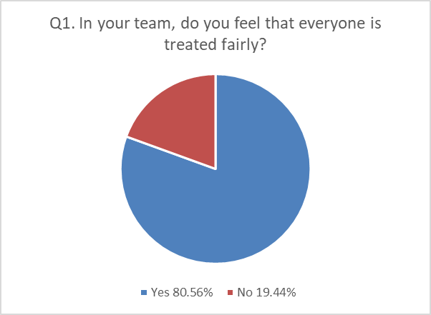
Figure 2
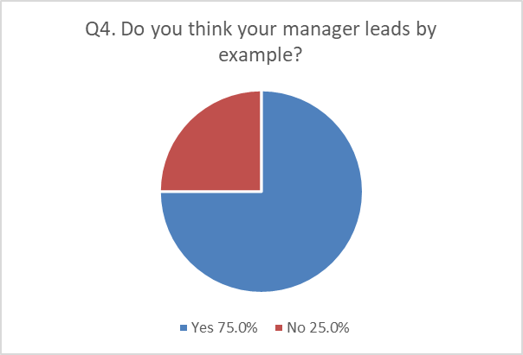
Figure 3
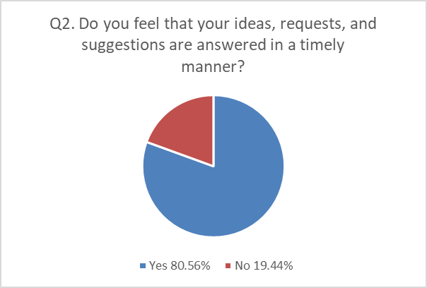
Figure 4
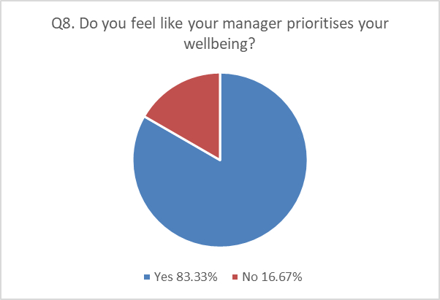
Figure 5
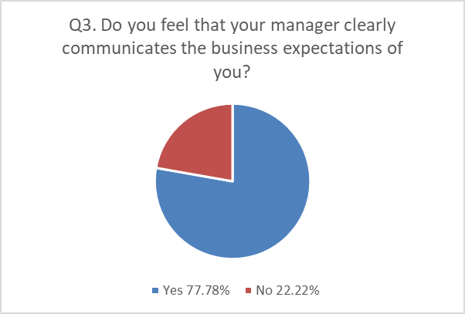
Figure 6
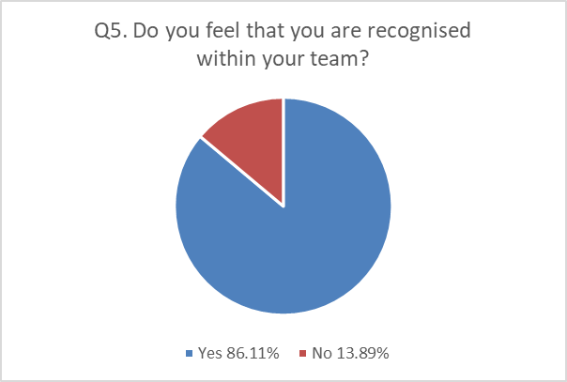
Figure 7
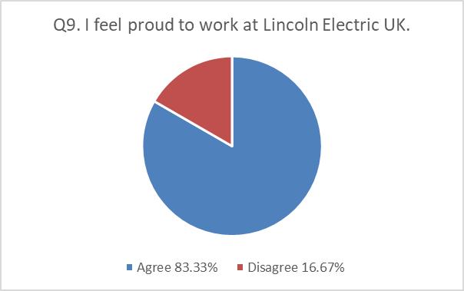

Figure 8
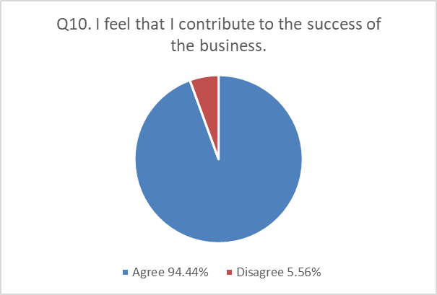

- References
- Acharyya, R and Bhattacharya, N. (2020) Research Methodology for Social Sciences, ch. 2, pp. 168. New York: Routledge.
- AON Hewitt (2011) Trends in Global Employee Engagement. Available at: https://www.aon.com/attachments/thought-leadership/trends_global_employee_engagement_final.pdf (Accessed: 11 September 2023).
- Arruda, W. (2023) Why Self Awareness Is the Most Important Skill for Hybrid Leadership. Available at: https://www.forbes.com/sites/williamarruda/2023/01/10/why-self-awareness-is-the-most-important-skill-for-hybrid-leadership/?sh=1051d6bb654f (Accessed: 25 August 2023).
- Arshad, U., Ullah, O. and Malik, U. (2021) ‘Bureaucratic Leadership Style and Teachers’ Professionalism: A Case Study of Public Sector Universities’, Global Regional Review, 6(1), pp. 211 – 222. Available at: http://dx.doi.org/10.31703/grr.2021(VI-I).23 (Accessed: 12 September 2023).
- Atkins, I. (2023) Setting Clear Expectations for Employees. Available at: https://www.businessnewsdaily.com/9451-clear-employee-expectations.html (Accessed: 4 September 2023).
- Baldoni, J. (2013) Employee Engagement Does More than Boost Productivity. Available at: https://hbr.org/2013/07/employee-engagement-does-more (Accessed: 8 September 2023).
- Bhui, K. et al. (2016) ‘Perceptions of work stress causes and effective interventions in employees working in public, private and non-governmental organisations: a qualitative study’, Work Stress: Causes and Effective Interventions, 40(6), pp. 318 – 325. Available at: https://doi.org/10.1192/pb.bp.115.050823 (Accessed: 31 August 2023).
- Buchanan, D.A. and Huczynski, A.A. (2019) Organizational Behaviour. 10th edn. London: Pearson.
- CIPD (2023) Wellbeing at Work. Available at: https://www.cipd.org/uk/knowledge/factsheets/well-being-factsheet/ (Accessed: 4 September 2023).
- Cole, G.A. and Kelly, P. (2020) Management Theory and Practice, 9th edn. Hampshire: Cengage Learning.
- Cook, G. (2023) Signs of Bad Management and How it Affects Employee Engagement. Available at: https://www.plecto.com/blog/motivation/how-bad-management-affects-employee-engagement/#:~:text=Employees%20who%20are%20encouraged%2C%20or,and%20a%20lack%20of%20motivation (Accessed: 25 August 2023).
- Cook, G. (2023) Signs of Bad Management and How it Affects Employee Engagement. Available at: https://www.plecto.com/blog/motivation/how-bad-management-affects-employee-engagement/#:~:text=Keeping%20an%20eye%20on%20signs,is%20influenced%20by%20their%20manager (Accessed: 11 September 2023).
- Cunliffe, A.L. (2008) Organization Theory. California: SAGE.
- Dedele, A. et al. (2019) ‘Perceived Stress Among Different Occupational Groups and the Interaction with Sedentary Behaviour’, International Journal of Environmental Research and Public Health, 16(23). Available at: https://doi.org/10.3390/ijerph16234595 (Accessed: 2 September 2023).
- Faizin, F.M. (2023) ‘Ignoring Employee Workload: An Expensive Mistake for Company Productivity’[LinkedIn] 15 March. Available at: https://www.linkedin.com/pulse/ignoring-employee-workload-expensive-mistake-company-faizin#:~:text=Employees%20may%20also%20find%20it,and%20affect%20their%20mental%20health. (Accessed: 4 September 2023).
- Go, Z., Ilies, R. and Wilson, K.S. (2015) ‘Supportive supervisors improve employees' daily lives: The role supervisors play in the impact of daily workload on life satisfaction via work–family conflict’, Journal of Vocational Behaviour, 89, pp.65 – 73. Available at: https://doi.org/10.1016/j.jvb.2015.04.009 (Accessed: 4 September 2023).
- GreggU. (2018) ‘Understanding Behavior for Managers’ [YouTube] 27 July. Available at: https://www.youtube.com/watch?v=1hm5N9WwTxs (Accessed: 23 August 2023).
- Investors In People (2019) “Feeling valued:” the dimensions organisations must deliver on. Available at: https://www.investorsinpeople.com/knowledge/feeling-valued-the-dimensions-organisations-must-deliver-on/ (Accessed: 7 September 2023).
- Johnson, R.D. (2021) Leadership Thinking Through Managerial Psychology. Available at: https://doi.org/10.4018/978-1-7998-3811-1.ch001 (Accessed: 23 August 2023).
- Kelloway, E.K. and Barling, J. (2010) ‘Leadership development as an intervention in occupational health psychology’, An International Journal of Work, Health & Organisations, 24(3), pp. 260-279. Available at: https://doi.org/10.1080/02678373.2010.518441 (Accessed: 23 August 2023).
- Kuroda, S. and Yamamoto, I. (2018). ‘Good boss, bad boss, workers’ mental health and productivity: Evidence from Japan’, Japan and the World Economy, 4, pp. 105-118. Available at: https://www.sciencedirect.com/science/article/pii/S0922142518300471#sec0115 (Accessed: 23 August 2023).
- Lincoln Electric (2012) Lincoln Electric Acquires Weartech International. Available at: https://ir.lincolnelectric.com/news-releases/news-release-details/lincoln-electric-acquires-weartech-international (Accessed: 8 September 2023).
- MacLeod, D. and Clarke, N. (2009) Engaging for Success: Enhancing Performance through Employee Engagement. Office of Public Sector Information: London.
- MacLeod, D. and Clarke, N. (2010) ‘Leadership and employee engagement: passing fad or a new way of doing business?’, The International Journal of Leadership in Public Services, 6(4), pp. 26 – 30. Available at: https://doi.org/10.5042/ijlps.2010.0634 (Accessed: 5 September 2023).
- Markos, S. and Sridevi, M.S. (2010) ‘Employee Engagement: The Key to Improving Performance’, International Journal of Business and Management, 5(12), pp. 89 – 96. Ottawa: Canadian Science Publishing.
- McLeod, S. (2023) What Are Independent and Dependent Variables? Available at: https://www.simplypsychology.org/variables.html (Accessed: 8 September 2023).
- Mind (2023) Pause for Work. Available at: https://www.mind.org.uk/get-involved/donate-or-fundraise/pause-for-mind/pause-for-work/?gclid=Cj0KCQjwgNanBhDUARIsAAeIcAuctb5pX5W1vYPM5JrvuyQOFKbl85wUExTMRJy65IPDJ4rdYUm2HHAaAkOFEALw_wcB (Accessed: 4 September 2023).
- Nawrocka, M. et al. (2015) The advantages and limitations of the statistical approach in scientific research. https://doi.org/10.15503/emet2015.58.68 (Accessed: 25 August 2023).
- Nink, M. and Robison, J. (2016) The Damage Inflicted by Poor Managers. Available at: https://news.gallup.com/businessjournal/200108/damage-inflicted-poor-managers.aspx (Accessed: 21 August 2023).
- Pettinger, R. (2010) Organizational behaviour: performance management in practice. 1st edn. Abingdon, Oxon: Routledge. Available at: https://doi.org/10.4324/9780203857595 (Accessed: 19 August 2023).
- Project.co (2023) The 8 Types of Leadership Styles Explained – With Examples. Available at: https://www.project.co/leadership-styles/ (Accessed: 11 September 2023).
- Sang, M. and Golan, O. (2022) ‘Bureaucratic squires: A critical analysis of the construction of charismatic top-leaders’, Sage Journals, 18(3), pp. 427 – 445. Available at: https://doi-org.ezproxy.uwtsd.ac.uk/10.1177/17427150221078442 (Accessed: 11 September 2023).
- Saunders, M., Lewis, P. and Thornhill, A. (2009) Research Methods for Business Students, 5th edn. Essex: Pearson Education Ltd.
- Soiferman, K. (2010) Compare and Contrast Inductive and Deductive Research Approaches. Available at: https://files.eric.ed.gov/fulltext/ED542066.pdf (Accessed: 25 August 2023).
- Stein, D. et al. (2021) How Companies Can Improve Employee Engagement Right Now. Available at: https://hbr.org/2021/10/how-companies-can-improve-employee-engagement-right-now (Accessed: 30 August 2023).
- Urquhart, J. (2022) ‘Two in five employees have quit because of bad manager, study finds’, CIPD People Management. Available at: https://www.peoplemanagement.co.uk/article/1755785/two-five-employees-quit-bad-manager-study-finds (Accessed: 21 August 2023).
- Wiles, J. and Turner, J. (2022) 3 Ways to Build a Sense of Belonging in the Workplace. Available at: https://www.gartner.com/smarterwithgartner/build-a-sense-of-belonging-in-the-workplace (Accessed: 8 September 2023).
- Woodruffe, C. (2006) Employee engagement – the real secret of winning a crucial edge over your rivals. Available at: https://resourcefulentrepreneur.com/wp-content/uploads/2011/06/Ed10_Woodruffe_pg19-22.pdf (Accessed: 21 August 2023).
- Ye, Z. et al. (2022) ‘Impact of Leading by Example on Employees' Organizational and Job Psychological Ownership: A Moderated Mediation Study’, Frontiers in Psychology, 13. Available at: https://doi.org/10.3389/fpsyg.2022.888653 (Accessed: 2 September 2023).

