BMIH5006: Sustainable Hospitality & TourismManagement
Assessment 2
Student Name: Kamran Ahmed
Student ID: 2118921
The future of hospitality and its profitable to be green

Contents
Introduction 2
Importance of social responsibility and sustainability: 2
Doxey’s Irridex model and its importance in environmental sustainability: 3
Butler’s life cycle model: 5
Conclusion 6
References 7

Introduction
According to the studies produced by Legrand (2022), sustainability in hospitality industry can be described as the practice of conducting business operations in such a manner that it reduces the overall environmental and social impact. Many researchers also add that sustainability in hospitality industry refers to proper management of different natural resources like energy, water, waste management as well as to reduce the overall carbon footprint of the business. By encouraging fair labour practises, preserving indigenous cultures, and bolstering local economies, sustainable hospitality also places a strong emphasis on social responsibility (Ghani et al., 2022). In the end, it aims to deliver exceptional visitor experiences while protecting the environment and promoting locals' and tourists' well-being for both the current and next generations. This essay tries to discuss if the statement made by Milton Friedman, “the social responsibility of an organization is to increase profits” is still relevant today in the hospitality industry (Dubey, 2019).

Importance of social responsibility and sustainability:
In modern corporate and social situations, Milton Friedman's claim that "the social responsibility of an organisation is to increase profits" is still up for discussion and close examination. The traditional understanding of business as a profit-driven organisation is reflected in it, but this viewpoint has lost some of its significance over time. Many contend that companies should play a bigger part in society in the modern world. In recent studies it has been seen that there is a growing need among the companies irrespective the industry regarding consideration of environmental, social and governance within the business decision making system. In context to the hospitality industry, it has been seen that there is a growing concern regarding sustainability issues like climate change, social inequality etc. As suggested by Achmad (2022), customers as well as internal stakeholders like employees, investors etc., expect business organizations to be more responsible towards the society and the environment. In a recent report produced by Hotel Tech Report in 2021, it has been seen that 81% of the travellers feel that they would opt for sustainable accommodation for the coming years.
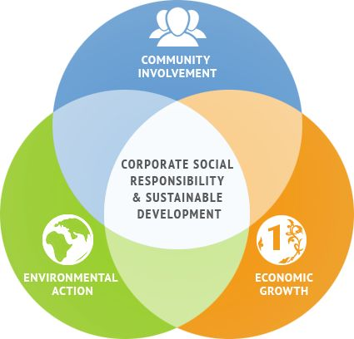
The need for businesses to strike a balance between social and environmental responsibility and profitability has grown as they realise the long-term advantages of sustainability, enhanced public relations, and lower risks related to negative externalities. Certain nations and areas have gone so far as to impose legal obligations on firms to consider their social impact (Tiwari et al., 2023). While pursuing profits is still necessary for businesses to survive in this changing environment, many people think Friedman's claim is no longer valid. In addition to being morally right, modern companies frequently discover that incorporating social and environmental responsibility into their primary goals increases their long-term profitability and competitiveness in a market that is becoming more and more ethically aware. As a result, there is ongoing discussion on the statement's applicability, which is contingent upon the circumstances and values of each individual organisation (Kasayanond, 2019).
According to the studies produced by Jawabreh (2022), it can be said that finance is certainly an important aspect of hospitality business. But it should not be the primary factor that should drive business organizations to operate. Instead, it is suggested that finance should be includes in the broader framework that is critical to the success of an organization. It is expected that hospitality businesses like hotels, resorts must be able to balance the financial aspect of the business with corporate social responsibility. This has compelled many hospitality businesses to adopt the TBL or triple bottom line approach to address all the dimensions of corporate social responsibility. Hospitality businesses frequently take part in social responsibility programmes that benefit the community, encourage ethical hiring practises, and enhance employee wellbeing. For instance, a resort may purchase goods locally to help the neighbourhood’s farmers and craftspeople and boost the local economy. Similarly environmental sustainability has become an important aspect for these businesses as well. Hotels can use water-saving techniques, install energy-efficient equipment, and handle garbage in an ethical manner. Some establishments go so far as to obtain certifications such as LEED or Green Key to show their dedication to environmental responsibility. Lastly, it is suggested that organizations must prioritize on financial responsibility. These organisations make certain they maintain their financial stability and competitiveness while tackling social and environmental issues (Acampora et al., 2022). Marriott International, for example, has implemented a Triple Bottom Line (TBL) strategy by establishing environmental targets, giving back to the community through its "Serve 360" programme, and pursuing financial expansion at the same time. Marriott's strategy serves as an example of how a significant participant in the hospitality sector combines social and environmental responsibility with commercial success (Sarkis, 2020).

Doxey’s Irridex model and its importance in environmental sustainability:
William R. Doxey created the Irridex model, which focuses on how local attitudes towards tourists and the effects of tourism relate to the growth of tourism. This model can clarify the hospitality industry's accountability for environmental sustainability, even though its primary focus is on the effects of tourism on locals. The Irridex model can be used to analyse the complex issue of whether environmental responsibility in this industry is predominantly driven by consumers or the businesses themselves:
The first phase is irritation phase, in which residents may develop negative thoughts about tourism and become irritated. In a similar vein, customers may grow resentful of the hospitality sector if they believe it to be environmentally careless (Fan, 2023). Travellers might steer clear of establishments that have a bad reputation for the environment or that are situated in ecologically delicate locations, for instance. The second phase is resistance phase. People that are in the opposition phase are adamantly against more growth in the tourism industry. Customers may request more environmentally friendly procedures in the hospitality industry and voice their concerns through evaluations, comments, and purchase decisions. Consumer-driven programmes that encourage environmental responsibility in enterprises include eco-certifications and sustainable travel platforms (Fan, 2023). Followed by this is the tolerance phase. The phase of tolerance is reached when tourism development considers the concerns of the locals and becomes more sustainable. Like this, the hospitality sector can cultivate a more favourable and long-lasting reputation by responding to consumer needs for environmental responsibility. Companies that use eco-friendly procedures can draw in and keep clients that care about the environment. Lastly comes the euphoric phase. In this stage, locals and visitors live in harmony with one another. In a similar vein, when the hotel sector completely adopts environmental sustainability, it can provide a euphoric condition that benefits both companies and customers. Cost savings, a rise in client loyalty, and improved brand awareness are all possible outcomes of sustainable business practises.
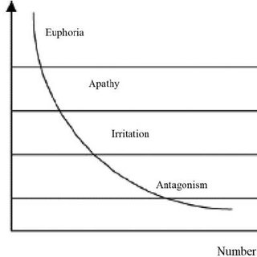
Source: DOXEY, 2015

In this setting, it is evident that environmental responsibility is driven by both customers and hospitality firms. Although customers may first insist on eco-friendly practises, businesses are ultimately in charge of putting these practises into place and keeping them up to date. Furthermore, companies who take the initiative to implement sustainable practises have the power to shape consumer preferences and behaviour, which encourages more environmentally friendly business practises.

Butler’s life cycle model:
According to, there are various steps involved in the development of the hospitality industry, more particularly, a tourist destination. To discuss this development cycle, TALC or Butler’s Tourism Area Life Cycle has been discussed. The Tourism Area Life Cycle (TALC) model developed by Butler is frequently employed for the purpose of analysing the growth and changes in tourist destinations. It has multiple stages, from discovery to decline, and it may also be used to describe how hospitality has changed in various places over time.
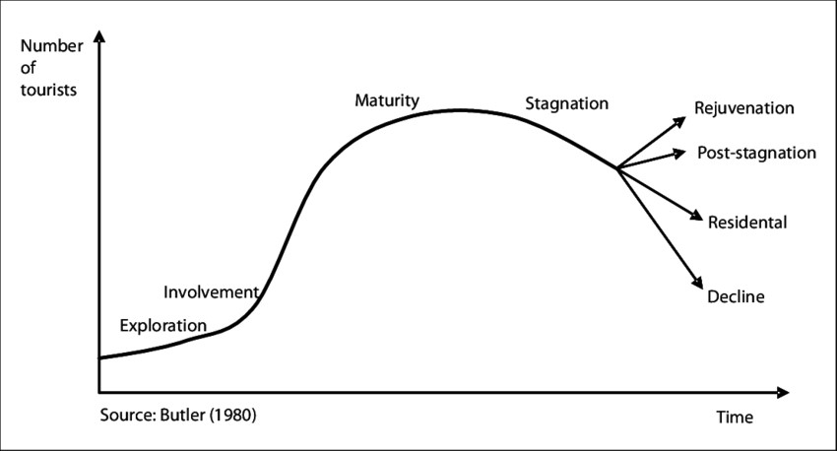
Source: França, 2021
The first stage is exploration stage in which the hospitality organization constructs an establishment in an emerging destination. In this phase the organization tries to cater to the early explorers with basic amenities. The second stage is involvement stage, where the destination gains recognition, and the hospitality business tries to expand its services to cater to a wider group of consumers. In this stage an increase in number of tourists is seen. In the development stage, a significant growth is recorded, and the marketing efforts of the business becomes more significant. Followed by this is the consolidation stage where the hospitality establishment becomes more matured. As suggested by Gore (2022), in this stage the organization also tries to build on customer loyalty. In the stagnation stage, the hospitality establishment might reach a point of stagnation. In this stage the overall competition may increase. In the decline stage some establishment may fail to adapt with the changing business environment and may face complications like decline in the number of visitors etc. Lastly, in the rebirth or rejuvenation stage, a business might make a comeback by introducing new areas of interest for the tourists. It is noteworthy that this cycle is not followed linearly by all travel destinations or lodging places. While some people may go through cycles of decline and rebirth, others may skip stages entirely (França, 2021). The TALC model highlights the significance of innovation and adaptability for long-term success and offers a framework for comprehending how hospitality changes in tandem with destination development.
Undoubtedly, the hospitality industry can aim to be ecologically conscious or "green," but reaching total sustainability can be a challenging task (Oláh, 2020). By putting into practise strategies like energy-efficient lighting, water conservation, trash reduction, and sustainable product procurement, many hospitality firms do a commendable job of lessening their ecological footprint. An eco-friendly endeavour in Mexico is the Sandos Caracol Eco Resort, which features renewable energy sources, a water treatment plant, and wildlife preservation. The usage of single-use plastics, the environmental impact of building and infrastructure development, and the carbon footprint of transport to and from the location are just a few of the difficulties associated with providing truly green hospitality(Isensee,2020). It might take more extensive industry-wide reforms, cutting-edge technology, and increased consumer awareness to become truly green. It also necessitates work beyond the immediate operational elements, such as influencing local policies and pushing for more environmentally friendly transportation options. Even while the hotel industry has come a long way, there is still more work ahead of it in terms of innovation, cooperation, and continual commitment from businesses, customers, and other stakeholders if the industry is to become completely green.
For hospitality enterprises to be sustainable, financial resilience is essential (Chen et al., 2022). It makes it possible to fund environmental projects, staff training, and eco-friendly technology. For example, by drawing environmentally concerned tourists, Marriott International's "Serve 360" sustainability programme has strengthened the chain's financial position. Financial resilience helped businesses weather economic downturns, retain staff, and implement health and safety precautions during emergencies like the COVID-19 pandemic. Sturdy finances enable community engagement and adherence to change environmental rules. Long-term sustainability requires financial stability because it is the foundation for hospitality firms' capacity to adopt, uphold, and constantly enhance sustainable practises (Nguyen et al. 2023).
There are several steps that these hospitality organizations can adopt to achieve sustainability. For example, these businesses can invest more to become energy efficient (Hamsal et al., 2022). Hotels like Marriott have formed energy teams who are responsible for adopting energy conservation practices. One of the most famous projects is Signature Energy Reduction project. Some establishments have also adopted water conservation techniques. Hotel chains like IHG has already committed themselves towards saving water and limiting wastage. The organization has planned to achieve several objectives by 2030. Some include implementing different tools to reduce the water footprint of the establishments throughout the globe. Reducing the risk of water scarcity by collaborating with stakeholders. The organization has also adopted certain UN SDGs like clean water and sanitation, sustainable cities and communities etc.

Conclusion
In conclusion, the data shows that implementing "green" practises and embracing sustainability can be financially advantageous for the hospitality industry. Green efforts can have a direct impact on profitability by lowering operating costs through resource and energy efficiency, drawing eco-aware consumers, improving brand reputation, and decreasing risks related to social and environmental problems. Furthermore, it is becoming a competitive requirement due to the rising consumer awareness and demand for sustainable tourism. The long-term gains in income, cost savings, and enhanced market positioning highlight the financial sustainability and advantages of going green in the hotel sector, even though the early investments may need a financial commitment.

References
Acampora, A., Lucchetti, M.C., Merli, R. and Ali, F., 2022. The theoretical development and research methodology in green hotels research: A systematic literature review. Journal of Hospitality and Tourism Management, 51, pp.512-528.
Achmad, W., 2022. Corporate Social Responsibility and Zakat: A Model of Philanthropy in the Society Era 5.0. Jurnal Scientia, 11(01), pp.565-574.
Chen, C.D., Su, C.H.J. and Chen, M.H., 2022. Are ESG-committed hotels financially resilient to the COVID-19 pandemic? An autoregressive jump intensity trend model. Tourism Management, 93, p.104581.
DOXEY, S., Moore, MA (2015). An essay on Doxey’s (1975) Irridex; Ap’s (1992) Social Exchange Process; and Gursoy and Rurhterford’s (2004) Determinants of Community Support theories. Mphil document, University of Cape Coast, Ghana.
Dubey, R., Gunasekaran, A., Childe, S.J., Papadopoulos, T., Luo, Z., Wamba, S.F. and Roubaud, D., 2019. Can big data and predictive analytics improve social and environmental sustainability? Technological Forecasting and Social Change, 144, pp.534-545.
Fan, D.X., 2023. Understanding the tourist-resident relationship through social contact: Progressing the development of social contact in tourism. Journal of Sustainable Tourism, 31(2), pp.406-424.
França, W.T., Barros, M.V., Salvador, R., de Francisco, A.C., Moreira, M.T. and Piekarski, C.M., 2021. Integrating life cycle assessment and life cycle cost: A review of environmental-economic studies. The International Journal of Life Cycle Assessment, 26, pp.244-274.
Ghani, B., Zada, M., Memon, K.R., Ullah, R., Khattak, A., Han, H., Ariza-Montes, A. and Araya-Castillo, L., 2022. Challenges and strategies for employee retention in the hospitality industry: A review. Sustainability, 14(5), p.2885.
Hamsal, M., Abdinagoro, S.B., Zulkarnain, A., Leonandri, D.G. and Ichsan, M., 2022. The Impact of Organizational Resilience on Hotel Performance during Pandemic COVID-19. Global Business & Finance Review, 27(1), p.1.
Han, H., 2021. Consumer behavior and environmental sustainability in tourism and hospitality: A review of theories, concepts, and latest research. Journal of Sustainable Tourism, 29(7), pp.1021-1042.
Isensee, C., Teuteberg, F., Griese, K.M. and Topi, C., 2020. The relationship between organizational culture, sustainability, and digitalization in SMEs: A systematic review. Journal of Cleaner Production, 275, p.122944.
Jawabreh, O., Shniekat, N., Saleh, M.M.A. and Ali, B.J., 2022. The strategic deployment of information systems attributes and financial performance in the hospitality industry. Information Sciences Letters, 11(5), p.110504.
Kasayanond, A., Umam, R. and Jermsittiparsert, K., 2019. Environmental sustainability and its growth in Malaysia by elaborating the green economy and environmental efficiency. International Journal of Energy Economics and Policy, 9(5), pp.465-473.
Kumar, S., 2022. A quest for sustainium (sustainability Premium): review of sustainable bonds. Academy of Accounting and Financial Studies Journal, 26(2), pp.1-18.
Legrand, W., Chen, J.S. and Laeis, G.C., 2022. Sustainability in the hospitality industry: Principles of sustainable operations. Taylor & Francis.
Nguyen, L.T.M., Le, D., Vu, K.T. and Tran, T.K., 2023. The role of capital structure management in maintaining the financial stability of hotel firms during the pandemic—A global investigation. International Journal of Hospitality Management, 109, p.103366.
Oláh, J., Aburumman, N., Popp, J., Khan, M.A., Haddad, H. and Kitukutha, N., 2020. Impact of Industry 4.0 on environmental sustainability. Sustainability, 12(11), p.4674.
Passer, A., Lützkendorf, T., Habert, G., Kromp-Kolb, H., Monsberger, M., Eder, M. and Truger, B., 2020. Sustainable built environment: transition towards a net zero carbon built environment. The international journal of life cycle assessment, 25, pp.1160-1167.
Sarkis, J., 2020. Supply chain sustainability: learning from the COVID-19 pandemic. International Journal of Operations & Production Management, 41(1), pp.63-73.
Tiwari, M., Tiwari, T., Sam Santhose, S., Mishra, L., Mr, R. and Sundararaj, V., 2023. Corporate social responsibility and supply chain: A study for evaluating corporate hypocrisy with special focus on stakeholders. International Journal of Finance & Economics, 28(2), pp.1391-1403.

