Software Defined Networking
M4X01498
Jack Rout 1802047
Applied Computing Foundation Year

Table of contents
Introduction – page 3
What is software defined networking – page 3
Image of SDN architecture – page 4
How SDN works – page 4
The advantages of using SDN page 5
The problems of using SDN page 6
Conclusion page 7
References page 8

Introduction:
This report will be discussing Software Defined Networking (SDN), how SDN works, the advantages of using SDN, and problems that occur when using SDN.

What is Software Defined Networking (SDN)?
Software Defined Networking can be described as a networking architecture that tries to make a network faster and more reliable. The overall goal of SDN is to improve network control for internet service providers (ISP) so that these service providers can quickly change to their new requirements for the business to run.
There are 3 layers to SDN, the first is the “application layer” [1] and this contains the normal network applications which consists of firewalls and systems that detect hackers from breaking into the businesses secure files.
The next layer is the “control layer” [1], the control layers as it sounds is what makes the network run and without this a network on SDN cannot run This runs in a secure server and controls the flow in which customers use their network.
The next layer is the “infrastructure layer” [1] which controls the use of devices on a network and for this to work it requires the network to made up of network switches.[1]

Below is an image of software defined networking architecture and this shows what these 3 switches would look like:
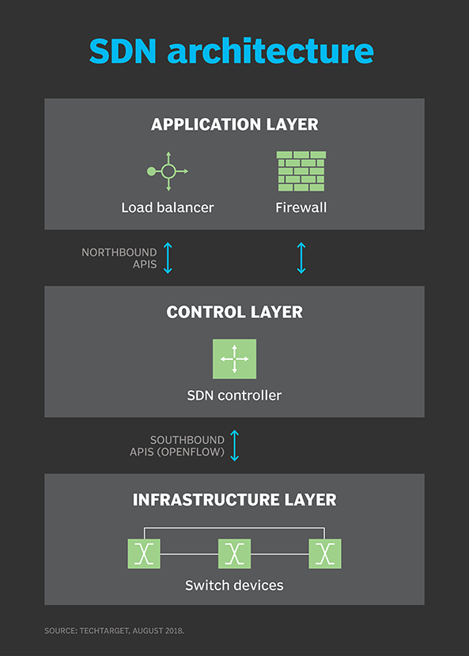
[2]
How SDN works:
SDN has many technologies associated with it such as, the ability to coordinate investment into the service of a network, the ability to see within its own network, and the ability to be automatic so that way it doesn’t have to be done manually.
SDN was originally designed to the network controller from the data streams. The controller on the network decides how data packets on the network should distributed, but the data stream allows these packets to move across the network. [1]

The advantages to using software defined networking:
The first advantage of SDN for businesses would be the “content delivery” [3], content delivery is the controller of the data that flows through a network and this is one of the major advantages as it has the ability to automatically direct data which makes service quality much better for voice over internet protocol(VOIP) as it makes video quality and voice quality better.
The next advantage is “lessen capital expenditure” [3], businesses can make devices on their network better due to software defined networking. Hardware that already exists on their network will be changed to follow instructions of the control layer. This is also good for a business it is compatible with most hardware which makes it more cost affordable and allows them to use the same hardware without having to change it often.
The next advantage would be “centralization” [3], this allows a business to watch their network, which allows a business to manage their network easier, it is also better that the network is in a central location as it allows a network to make network service faster and more reliable for anyone using it in the location.
The last advantage would be “management” [3]. That due to the increase in demand businesses are always creating new software and virtual networks to handle requests from users. Network engineers can change things on a network without it affecting usage on a network. This also allows these network engineers to manage the switches within the network and the equipment on the network and usually you cannot do this without using SDN.[3]

The problems of using SDN:
The only real disadvantage of SDN would be security. This is due to how a network controller is setup and since the network controller is the main thing that keeps the network running, so if someone working on the controller decides they want to be mischievous they will have full control over the network and if they wanted to, they could take down the whole network since they are at the network controller itself. [4]
The next disadvantage is addressing real time changes. Since SDN is automated it allows computers, networks, and storage devices to be ready for use instantaneously but the problem with this is that the controller has to be checked daily for new features and apps that are added to the network, which means real time changes can be slow and are not always there.
The last disadvantage is the increase in demand. Since there are more people joining networks it becomes increasingly more difficult to monitor all platforms across the network, there are other problems such as the inability to add more capacity for devices on the network to the network which means that when a network has maximum devices on it, the networks speed will quickly degrade. [5]

Conclusion:
In conclusion there are a few problems with Software Defined Networking and a few of the problems are unable to be solved as computers need humans in order for them to run at their optimal capacity. The same goes for the software as software gets old and out of date and then comes for people to update this software to make sure it stays optimal. There is one thing that can be solved and that’s the increase in demand for software defined networking and in my opinion the way to fix this increase in demand is by making the software required cheaper or free to everyone and this will fix the increase in demand because it will be available to everyone that way.

References:
[1] Rouse, Margaret(2018), Software-Defined Networking (SDN), Available at: https://searchnetworking.techtarget.com/definition/software-defined-networking-SDN, (Accessed on:18/03/19).
[2] TechTarget(August 2018), Software-Defined Networking (SDN), Available at: https://searchnetworking.techtarget.com/definition/software-defined-networking-SDN, (Accessed on:19/03/19)
[3]Loew, Stacey(September 25, 2017), Advantages of software defined networking, Available at: https://www.fidelus.com/software-defined-networking-advantages/, (Accessed on: 19/03/19)
[4] Nolle, Tom(March 2017), The good, bad and the ugly of software-defined networking security, Available at: https://searchnetworking.techtarget.com/tip/The-good-bad-and-the-ugly-of-software-defined-networking-security, (Accessed on: 20/03/19)
[5] Bakalov, Vess(August 20th,2015), Opportunities and challenges with SDN, Available at: https://www.networkworld.com/article/2973610/opportunities-and-challenges-with-sdn.html, (Accessed on: 20/03/19)

