BMSK5006
Knowledge and Information Management Skills for the Workplace
Submitted by Shekul Islam
ID: 1710629
Date:26/08/2019

Contents
Introduction 1
LO 1: 2
1.1 The ways data, information, and knowledge are related 2
1.2 The way individual knowledge and organisational knowledge are related 3
1.3 The techniques to identify knowledge assets 5
1.4 Evaluating the actual and potential knowledge assets of Barclays Plc 6
LO 2: 7
2.1 The requirement for creating, storing, applying and integrating knowledge 7
2.2 Intellectual Property rights and its importance to Barclays plc 10
LO 3: 11
3.1 Knowledge assets and their contribution on Barclays plc 11
3.2 Evaluating the knowledge requirements for Barclays plc. 12
3.3 The knowledge sharing framework within Barclays plc 13
3.4 Recommendations to improve the framework 14
Conclusion 15
References 16

Introduction
Today, knowledge assets are considered as vital strategic resources which are crucial for an organisation’s overall operation and success. The knowledge assets basically refer to the ideas, information, insights, understanding, learning, and skills and capabilities which are possessed by an organisation and its employees (Harman, 2009). The knowledge possessed by the employees can be defined as individual knowledge whereas the knowledge possessed by an organisation is defined as organisational knowledge. The combination of both knowledge largely help an organisation build a competitive advantage by ensuring superior performance with respect to both routine and non-routine tasks. The knowledge assets can be categorised into actual and potential knowledge assets. The former ones refer to the already existing knowledge assets. On the other hand, the later ones are not currently included in the portfolio of existing knowledge assets but can be included in that portfolio soon. To create, store, share, integrate and apply knowledge, an organisation needs to take into account the knowledge management process. Therefore, the knowledge management process has a significant impact on the creation and application of knowledge by a particular organisation. To learn and understand more about the knowledge assets, knowledge management process, culture, and framework, this report will be prepared based on Barclays plc which is one of the British multinational investment banks headquartered in London, UK. It provides a number of financial services to the customers and clients across the world through its national and international branches.

LO 1:

1.1 The ways data, information, and knowledge are related
The data refers to the observations or facts that have no or little meaning or value until they are processed into information. This indicates that the data is devoid of context, meaning, or intent. As an example of data, we can consider the facts and figures presented in the financial statements of Barclays plc. In contrast, the information refers to the processed data that is meaningful to the people (Maier, 2010). In other words, the information can be defined as a subset of data that is meaningful. For example, the income statement and balance sheet of Barclays plc can be considered as information which is provided to the stakeholders of the company to help them make decisions. The information helps to make decisions or take an action is called knowledge which indicates that the most valuable information generates knowledge. In other words, knowledge is defined as the internalisation of experience, information, and data (Collinson, and Parcell, 2004). For example, the technical know-how and abilities of the employees at Barclays plc to perform their assigned responsibilities can be considered as part of the organisational knowledge of the company.
The above discussion clearly indicates that there is a relationship between the data, information, and knowledge. In fact, they can be arranged in a hierarchy where the data lies in the bottom level, the information lies in the mid-level, and the knowledge lies at the top level. In this hierarchy, the knowledge is generated based on information, experience, and judgment or jurisdiction. Besides, the knowledge helps to make decisions by producing more valuable information from less valuable information or by producing useful and logical information from data (Reddy, 2011). This indicates that the information is produced based on data which actually refers to the facts, figures, or observations. In Barclays plc, to generate and improve organisational knowledge, both tacit and explicit knowledge, relevant, useful, and logical information is used by the management of the company. On the other hand, the company generates the necessary information based on raw data derived from observations and records of the company. So, this is how the knowledge, information, and data are related to each other.

1.2 The way individual knowledge and organisational knowledge are related
In general, individual knowledge can be defied as the knowledge held by the by the people involved in an organisation, such as the employess and staffs. A major part of this knowledge is basically gathered by first-hand observations and experience. The individual knowledge is crucial for the successful operation of an organisation. On the other hand, organisational knowledge refers to the collective abilities and knowledge possessed by the people who belong to a particular organisation. In general, organisational knowledge is prone to waste and difficult to retain and transfer (Kurz, 2010). Though the individual knowledge and organisational knowledge are distinct, they are interdependent which indicates that there is a relationship between them. However, the relationship between them can be identified based on the nature of tasks and interactions that take place in an organisation. So, the relationship between them is explained below from the perspectives of the nature of tasks and interactions that take place in Barclays plc:
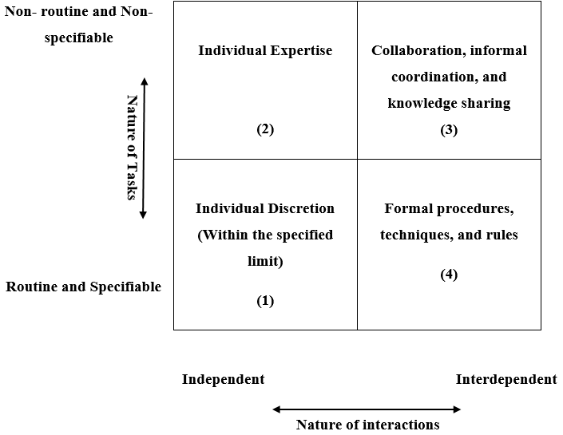
Figure 1: The way organisational knowledge is related to individual knowledge (Schopflin and Walsh, 2016).
The above table shows the extent to which the individual knowledge and organisational knowledge are related to each other. In Cell 1, the relationship between the individual and organisational knowledge is not that much strong because the nature of task and interaction suggest that the employees are empowered to use their expertise and knowledge to solve the problems they encounter. In Cell 2, the nature of task and interaction require the frontline employees to share the non-routine and non-specifiable tasks with the people in the organisation who are expert in those tasks. Therefore, the type of execution of the tasks involved in this cell requires the use of both individuals as well as organisational knowledge. In Cell 3, the nature of tasks and degree of interaction requires the employees to continually share their knowledge and expertise to coordinate their tasks in unison. As the organisation tends to internalise only a part of the tacit knowledge and the employees internalise the other part, the management needs to find a link between the individual knowledge and organisational knowledge while solving difficult and complex tasks. Finally, in Cell 4, the tasks are routine and specifiable but they are interdependent which requires an organisation to devise and implement rules and procedures to align the individual knowledge with the organisational knowledge within a formal organisational structure. So, in all cases, an organisation needs to utilise both the individual knowledge and organisational knowledge to execute its function.

1.3 The techniques to identify knowledge assets
The knowledge assets tend to waste or destroy over time, if they are not properly managed and monitored (Ichijō, K. and Nonaka, 2007). To monitor and manage the knowledge assets of an organisation properly, the management needs to identify them first which requires adopting several appropriate techniques. At Barclays plc, the following technique is considered to identify knowledge assets:
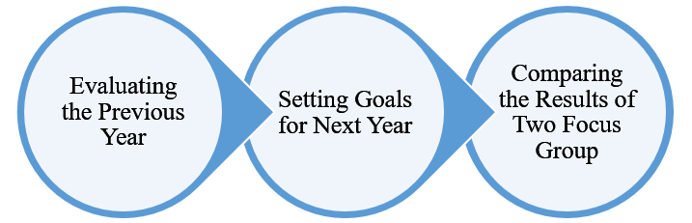
Figure 2: Modelling technique to identify knowledge at Barclays plc (Banksdaily.com, 2019).
- Evaluating the previous Year: In the first phase of the knowledge identification technique, the management of the organisation evaluates the target set in the previous year for various field of knowledge. The idea is to compare the target set by the board of the company with the actual results achieved in the various field of knowledge.
- Setting goals for Next Year: Once the first step is complete, the top management of the organisation attempts to determine what their organisation wants to achieve in the coming year in terms of short-term and long-term goals. The idea is to identify and evaluate the various type of knowledge assets the organisation needs to achieve its goals. In this phase, the management of the company also evaluates the knowledge with respect to the knowledge assets possessed by the competitors to determine the competitive advantage.
- Comparing the results of Two Focus Group: In the third phase, the management of the organisation forms two focus group to practically evaluate the viability of the knowledge assets identified in the previous phase to achieve the organisational goals. The idea is to identify the most effective knowledge assets to reach the goals and beat the competitors in the most effective and efficient manner.
The above technique largely helps Barclays plc to analyse and identify the knowledge assets that it requires to improve its competitive advantages and beat the competitors in the market.

1.4 Evaluating the actual and potential knowledge assets of Barclays Plc
In general, the knowledge assets are crucial for an organisation because they can help to deal with both routine and routine tasks. The knowledge assets can be categorised into actual knowledge assets and potential knowledge assets (Harman, 2009). The actual knowledge assets refer to the already existing knowledge assets. On the other hand, the potential knowledge assets refer to the knowledge assets that are not currently included in the portfolio of existing knowledge assets but can be included in that portfolio soon. The actual and potential knowledge assets of the company can be categorized into four types which are which are evaluated below:
- Experiential knowledge assets: These knowledge assets can be defined as the tacit knowledge which is shared by the employees of an organisation through common experiences (Cokins, 2013). The experiential knowledge in Barclays plc includes know-how and skills of the employees, care and trust among them, and the energy and passion of the employees.
- Conceptual knowledge assets: These knowledge assets are basically explicit knowledge which is transmitted through symbols, language, and images. The conceptual knowledge in Barclays plc includes products concepts, design, and brand equity.
- Routine knowledge assets: These knowledge assets are also tacit knowledge which is reflected through routine, practices, and actions of an organisation (Harman, 2009). The routine knowledge assets in Barclays plc include the organisational routine, know-how in daily operation, and organisational culture.
- Systematic knowledge assets: These knowledge assets are explicit knowledge which is systemized and arranged into specific forms (Kan, 2012). The systematic knowledge assets in Barclays plc include the specification, documents, manuals, database, patent, and license.
These four types of knowledge assets can be considered as the actual knowledge assets of Barclays plc. These knowledge assets help the employees to perform all the tasks of the organisation ranging from a day to day routine tasks to the complex and non-routine tasks. The experiential knowledge assets of Barclays largely help it to create a competitive advantage in the market in terms of the performance. This is because the experiential knowledge assets help the organisation to improve its performance over time by improving the know-how, skills, trust, and passion of the employees through sharing and exchange of these knowledge (Harman, 2009). The conceptual knowledge assets help the organisation to differentiate itself from the competitors in the market through developing and implementing unique products and services. So, the conceptual knowledge assets have also an important role to play in helping the organisation to strengthen its presence in the market. On the other hand, the systematic and routine knowledge assets of the organisation help to carry out its routine tasks and activities and facilitate the control and monitoring of the activities. Therefore, it can be said that all the actual and potential knowledge assets of the organisation have a distinct but crucial role to play in helping it to achieve its goals and generate competitive advantage.

LO 2:

2.1 The requirement for creating, storing, applying and integrating knowledge
As individual knowledge and organisational knowledge play an important role in creating competitive advantages, almost all the organisations pay a great deal of attention on creating knowledge (Ichijō, K. and Nonaka, 2007). Their effort is not limited to the creation of knowledge only, they also take the necessary steps to store the knowledge so that it can be applied and integrated with other knowledge or information conveniently. To create, store, apply and integrate knowledge within Barclays plc, the management of the organisation considers the following knowledge management process:

Figure 3: Knowledge management process (Kan, 2012).
Knowledge Acquisition: The management of Barclays consider the following ways to acquire or create knowledge:
- Creativity and innovation: The first and foremost things to create knowledge are creativity and innovation (Kurz, 2010). The creative and innovative efforts of the management and employees of the organisation play a vital role in recognizing and developing new knowledge.
- New employees: In many cases, the management of Barclays plc recruits new employees with the necessary skills and ability to gather new knowledge from them.
- Analysis of external environment: The existing employees of the organisation in many cases identify and create new knowledge by analysing of the external environment of their organisation (Maier, 2010).
- Merger and acquisition: The management of Barclays plc also create and develop new knowledge through activities merger and acquisition. Over time, the organisation has merged with other organisations and acquired much organisation with an effort to create new knowledge so that it can generate a competitive advantage.
Knowledge Retention: The management of Barclays considers the following ways to retain or store knowledge:
- Written documents: Many of the knowledge assets developed or created by Barclays plc are retained or stored in different types of written documents which can be easily utilised to get the benefits of those knowledge assets when needed.
- Database: The development in the new technologies has made it very easy for Barclays plc to store the knowledge assets in digital storage based databases. However, in some cases, knowledge is also stored in traditional databases.
Knowledge Transfer: The knowledge transfer refers to the share or exchange of knowledge from an individual or a group of individuals to others within an organisation (Collinson, and Parcell, 2004). In order to transfer the knowledge, the management of Barclays plc considers a number of ways such as socialization, education, and learning. The rapid development in the field of technology has allowed Barclays to take advantage of IT to transfer knowledge, especially tacit knowledge. In this case, the organisation uses the teleconferencing, videoconferencing, blogs, information, wikis, social media, and web hosting FAQ pages, etc. to transfer knowledge. The management of the organisation thinks that the transfer of knowledge is not a one-way process rather it is a sharing process that requires sharing and feedback, trial and error, and mutual adjustments.
Knowledge Application: The final phase in the knowledge management process involves the application of the knowledge to make decisions to perform tasks (Griseri, 2002). This is the last stage in the knowledge management process where the newly developed knowledge is applied to generate values from the knowledge. In this stage, the knowledge is also integrated with other information and knowledge to improve the existing knowledge. In order to apply and integrate the knowledge, the management of Barclays plc considers the following systems:
- Decision support system (DSS): The DDS can be considered as a flexible and adaptive information system which is developed to make the management decision-making process more effective and efficient (Wal, 2017). The DDS of Barclays plc combines useful raw data, information, personal and organisational knowledge, as well as the business model in order to find solutions for complex problems.
- Help desk system (HDS): The management of Barclays uses the HDS to apply the knowledge which is particularly created to enhance the customer services. The HDS basically helps the employees of the organisation to provide customer services in a better way by applying appropriate knowledge assets of the organisation.
- Expert system (ES): The ES is considered as an artificial intelligence software which operates on the basis of the inference engine and the knowledge base. The inference systems use the knowledge base and support the decision-making process of the organisation, especially when it deals with non-structured and complex management problems (Swart and Kinnie, 2012).

2.2 Intellectual Property rights and its importance to Barclays plc
In general, intellectual property refers to a category of property which is created by human intellect. The intellectual property has both moral and commercial values that is why it needs to be protected from being stolen or copied by the competitors (Kurz, 2010). The intellectual property basically involves innovation, creative or artistic works, name, symbol, images, trade secrets, and so on. The innovative trade secrets, symbol, and images used by Barclays plc to distinguish itself from the competitors can be considered as the intellectual property of this particular organisation.
As the financial market in the UK as well as all over the world is very competitive, each and every financial institution emphasizes more and more on developing the intellectual property so that they can get one step ahead of the competition. That is why the Barclays plc has also developed a number of intellectual properties over time to outperform the competitors. Once the intellectual property is developed, it needs to be protected from the competitors so that the full benefits of that property can be absorbed (Cokins, 2013). As a result, an organisation needs to have intellectual property rights which give the creator of the intellectual property the exclusive right to reap the benefits of the property. That is why Barclays plc always ensures rights for the intellectual property which have the potential to provide a competitive edge in the market. The protection of the intellectual property also motivates the organisation to focus more and more on innovation and creation of innovative products and processes. Therefore, it can be said that intellectual property rights have a significant positive impact on Barclays plc.

LO 3:

3.1 Knowledge assets and their contribution on Barclays plc
The knowledge assets within Barclays plc can be considered as the accumulated intellectual resources which involve the knowledge possessed by the company itself and its employees in the form of ideas, information, learning, insights, understanding, skills, and capabilities. Barclays plc is an investment bank which provides a range of financial services across many countries. To provide the financial services in a better and a more competitive way than the competitors, the knowledge assets of the company play a vital role. The contribution of the knowledge assets on the company is explained below:
- Develop core competencies: The knowledge assets have played a vital role in creating and developing the core competencies of the company (Kan, 2012). The core competencies of an organisation can be considered as the major means of competitive advantages which means they help to form competitive advantages in the market. Therefore, a part of the competitive advantage of Barclays plc can be attributed to its core competencies which has been formed based on the combination of pooled knowledge and technical skills.
- Enhance operational effectiveness: The knowledge assets of the company such as skills and abilities of the employees, care and trust among them, and the passion of the employees largely helps it to increase the overall operational efficiency and productivity. The increased operational efficiency, in turn, has an important contribution to the growth and profitability of the company over time.
- Strengthen competitive advantage: An organisation is said to have a competitive advantage when it can provide better and superior products and services to the customers than its competitors (Kurz, 2010). Based on this definition of competitive advantage, Barclays plc can be said to have a competitive advantage in the market compared to most other companies in the industry. Behind this competitive advantage, the innovative products concepts, design, brand equity, and the skills and abilities of the employees play a vital role which is considered as knowledge assets. Besides, the knowledge assets also help to improve the core competencies of the company which also strengthen the competitive advantage of the company.
- Facilitate innovation: The innovation basically refers to the creation of new ideas and creative thoughts that helps to develop new products or processes that can meet the market needs in a better way. In this case, to innovate new products and processes both individual knowledge and organisational knowledge play a vital role within Barclays plc. Basically, without the help of the knowledge assets, innovation cannot take place within an organisation.
The overall discussion made above clearly reveals that the knowledge assets of the Barclays plc have a significant contribution to its overall operation and competitive position in the market.

3.2 Evaluating the knowledge requirements for Barclays plc.
Today’s competitive business environment requires an organisation to have adequate knowledge assets to successfully compete in the market (Griseri, 2002). Earlier it has been mentioned that the knowledge assets of Barclays plc can be divided into four categories which are experiential knowledge assets, conceptual knowledge assets, routine knowledge assets, and systematic knowledge assets. Almost all type of knowledge can be categorized under these four categories. However, not all type of knowledge is equally important for an organisation. This indicates that an organisation tends to prioritize some type of knowledge more than others while recruiting or developing employees. Besides, the knowledge requirements tend to vary from organisations to originations as they vary to a large extent with respect to their operations. The knowledge requirements for Barclays plc include the following ones:
- Know-how and skills: To perform regular tasks and functions, Barclays requires the employees to have adequate knowledge and skills in their respective duties and responsibilities. Therefore, the first and foremost knowledge requirement for Barclays plc includes know-how and skills.
- Organisational culture: The employees of Barclays plc also needs to have adequate about the organisational culture because it largely shapes the actions and behaviors of the employees. As the actions and behaviors of employees can largely affect the success of an organisation, having knowledge about the organisational culture is also an important knowledge requirement for Barclays plc (Maier, 2010).
- Conceptual knowledge: The knowledge requirements for Barclays plc also include conceptual knowledge such as products concepts, design, and brand equity. The conceptual knowledge is important for an organisation to generate competitive advantage developing new concepts, product or process design, and brand equity that is why Barclays plc also requires the employees to have conceptual knowledge.

3.3 The knowledge sharing framework within Barclays plc
Knowledge is now considered as one of the most important strategic resources that can help an organisation generate a competitive advantage in the market by outperforming the competitors. That is why the management of knowledge is a crucial task for an organisation (Reddy, 2011). As part of the knowledge management process, an organisation needs to develop a framework that can enable knowledge sharing within the organisation. The framework that Barclays plc has developed to enable knowledge sharing is evaluated below:
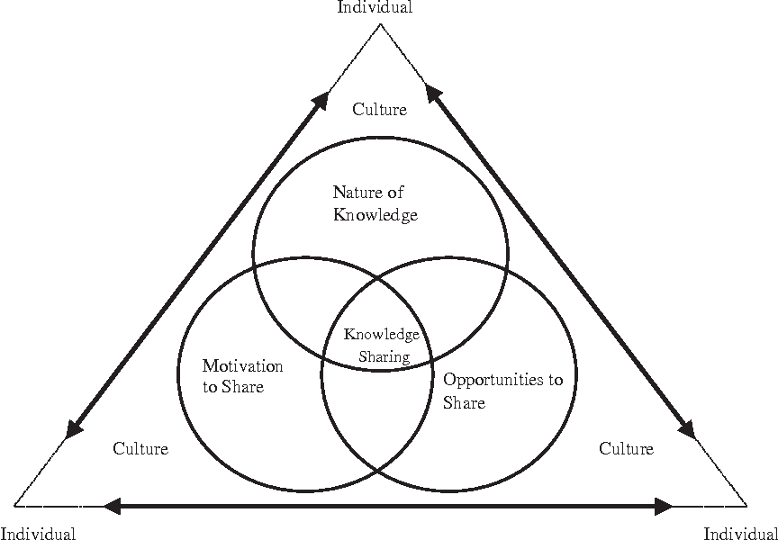
Figure 4: The framework for enabling knowledge sharing within Barclays plc (Schopflin and Walsh, 2016).
The above figure shows that the framework that enables knowledge sharing within Barclays plc depends on a few factors such as the nature of knowledge, opportunity to share knowledge, motivation to share knowledge, culture, and individual. In this framework, the individual refers to the people working within Barclays plc and the culture refers to the organisational culture. The individuals in the framework share knowledge with each other within the organisation where the knowledge sharing process is largely affected by the culture of the organisation. The culture of the organisation motivates the employees to share knowledge with each other to better coordinate their tasks and provides them with the opportunity to share knowledge among themselves. However, the nature of the knowledge sometimes hinder the knowledge sharing process because not all type of knowledge can be shared easily. Therefore, the nature of the knowledge and motivation opportunities to share knowledge largely affects the knowledge sharing framework of the organisation. On the other hand, the culture of the organisation largely determines the type of knowledge that can be shared as well as provides motivation and opportunities to the people of the organisation to share knowledge among them.

3.4 Recommendations to improve the framework
In the prior section, the framework that enables knowledge sharing within Barclays plc has been evaluated. It has revealed that the organisation has a good framework for sharing knowledge among the employees as well as among the departments. However, the framework of the organisation can be improved to some extent to make more effective and successful than it is now. The improvements can be made in the following areas of the framework:
- The framework does not take into account the impact of the organisational structure. As the organisational structure can vary from organisations to organisations, it can have different impacts on the knowledge sharing process (Welbourne, 2014). That is why the organisational structure of Barclays plc needs to be added to the framework in an appropriate manner.
- The framework does not clearly specify how the internal factors such as power and reciprocity can impact the knowledge sharing process within the organisation. Therefore, Barclays should incorporate such internal factors clearly in the framework.
- Besides the internal factors, external factors such as the relationship between the employees and rewards for sharing can also significantly affect the knowledge sharing framework of the organisation. That is why these factors should be clearly defined in the knowledge sharing framework of Barclays plc.
These recommended improvements can make the knowledge sharing framework of Barclays plc more effective and successful in sharing knowledge among its different departments and employees.

Conclusion
The overall discussion leads to the conclusion that an organisation must have adequate knowledge assets to successfully compete in the market and generate a competitive advantage over the rivals. The knowledge assets of an organisation can be divided into four categories which are experiential knowledge assets, conceptual knowledge assets, routine knowledge assets, and systematic knowledge assets. Each category of knowledge assets has different roles to play within an organisation which suggests that an organisation should focus on developing each category of knowledge assets. However, not all type of knowledge is equally important for an organisation. This indicates that an organisation should focus more on developing and creating the knowledge assets which are the most important ones. To create and apply knowledge assets to take advantage of them, an organisation must develop an effective knowledge management process and knowledge sharing framework. This is because an effective knowledge management process and knowledge sharing framework foster the creation and application of knowledge which is necessary to generate competitive advantage.

References
- Banksdaily.com. (2019). Barclays, London, UK | Head office. [online] Available at: https://banksdaily.com/info/barclays [Accessed 1 Aug. 2019].
- Cokins, G. (2013). Knowledge management and organisational performance. Hoboken, N.J.: John Wiley.
- Collinson, C and Parcell, G (2004) Learning to Fly: Practical Knowledge Management from Leading and Learning Organizations, Capstone, England.
- Griseri, P. (2002). Management Knowledge: A Critical View. Houndmills, Basingstoke, Hampshire: Palgrave.
- Harman, B. (2009). A Practical Guide to Knowledge Management. London: Thorogood Pub.
- Ichijō, K. and Nonaka, I. (2007). Knowledge Creation and Management New Challenges for Managers. Oxford: Oxford University Press.
- Kan, S. (2012). Practical knowledge management. 3rd ed. London: Irwin.
- Kurz, H. (2010). Innovation, knowledge and growth. London: McGraw-Hill.
- Maier, R. (2010). Knowledge management systems. 5th ed. Berlin: Springer.
- Reddy, B. (2011). Knowledge Management. 7th ed. New Delhi: Himalaya Pub. House.
- Schopflin, K. and Walsh, M. (2016). Practical knowledge and information management. 3rd ed. London: Pearson.
- Swart, J. and Kinnie, N. (2012). Managing multidimensional knowledge assets: HR configurations in professional service firms. Human Resource Management Journal, 23(2), pp.160-179.
- Wal, P. (2017). Knowledge and Knowledge Assets: Employees Perception. International Journal of Contemporary Research and Review, 08(05).
- Welbourne, M. (2014). Knowledge. Hoboken: Taylor and Francis.

