UWTSD – Birmingham

BMHP5015 – Changemakers: Building Your Personal Brand for Sustainable Employment

Component 2 – Written Report
My Career Goal: Becoming an Occupational Therapist (OT)

Module Code: BMHP5015
Module Title: Changemakers: Building Your Personal Brand for Sustainable Employment
Lecturer: Olufemi Oluranti

Student Name: Mohamad Sediq Ehssan
Student Number: 2017880

Word Count: Approximately 2,000 words

Date: 10/07/2026

Table of Contents
My Career Goal: Becoming an Occupational Therapist (OT) 3
1. Introduction 3
2. Current Occupational Therapist Job Advertisement 3
3. Analysis of Employability Skills Required for an Occupational Therapist 6
4. Evaluation of My Own Skills 8
5. Five-Year Action Plan and Timeline 9
6. Building My Personal Brand 11
7. Promoting My Professional Identity 12
8. Building a Professional Network for Successful Employment 13
9. Conclusion 14
10. Reference List 15

My Career Goal: Becoming an Occupational Therapist (OT)

1. Introduction

Occupational therapy is a healthcare profession that supports people of all ages to overcome physical, mental, cognitive, or social barriers that affect their daily lives. Occupational Therapists help individuals develop or regain the skills needed to live independently and participate in meaningful activities, using evidence-based and person-centred approaches (Stein and Reed, 2021). My ambition is to become a registered Occupational Therapist because I want to make a positive difference to people's health and wellbeing. This report examines the employability skills required for the profession, evaluates my current abilities, and outlines a five-year plan to achieve my career goal and professional development.

2. Current Occupational Therapist Job Advertisement

For this report, I selected a Band 5 Occupational Therapist vacancy advertised on NHS Jobs, as it represents the type of position I intend to apply for after successfully completing an HCPC-approved MSc (Pre-registration) in Occupational Therapy.
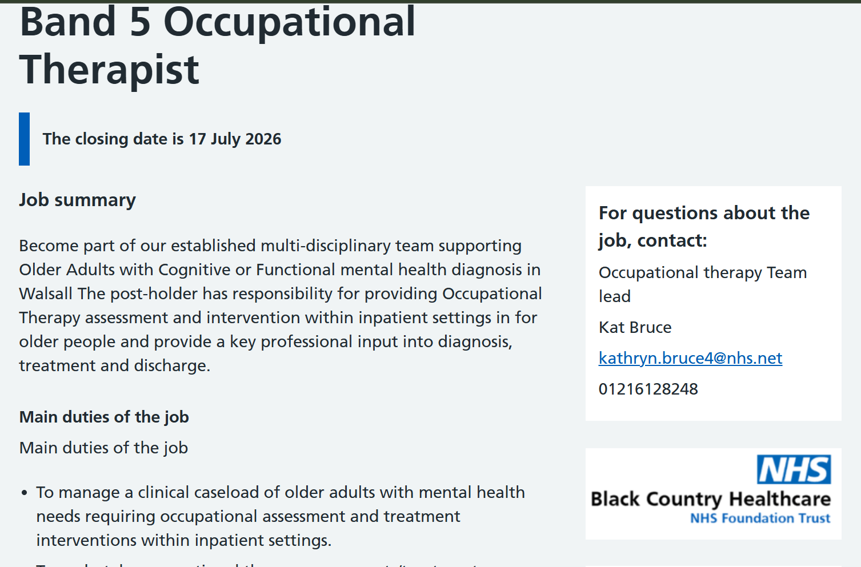
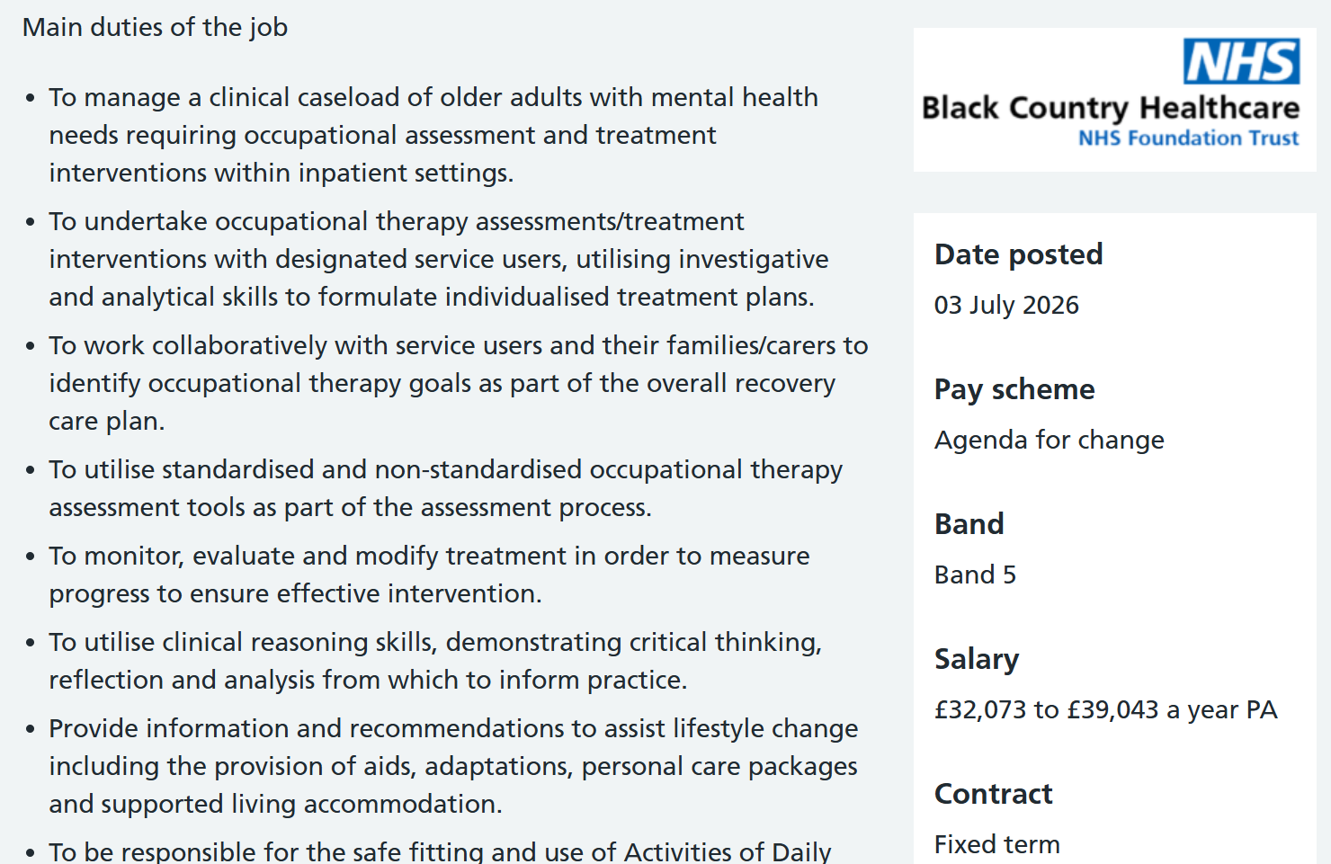

The job description states that the successful Band 5 Occupational Therapist will assess, plan, implement, and evaluate person-centred interventions that promote patients' independence and wellbeing. The role includes managing a clinical caseload, maintaining accurate clinical records, working collaboratively within multidisciplinary teams, and participating in continuing professional development while meeting HCPC professional standards (NHS Jobs, 2026).
The person specification requires an HCPC-recognised Occupational Therapy qualification, excellent communication and teamwork skills, clinical reasoning, organisational ability, digital competence, professionalism, and a commitment to person-centred care (HCPC, 2023). This Band 5 Occupational Therapist role closely matches my career aspirations by providing opportunities to develop clinical skills, gain professional experience, and build a successful career within the NHS.

3. Analysis of Employability Skills Required for an Occupational Therapist
Employability skills combine professional knowledge, practical abilities, and personal attributes that enable individuals to gain and succeed in employment. For Occupational Therapists (OTs), these skills are essential because the role requires delivering safe, person-centred care while working within multidisciplinary healthcare teams. According to the Health and Care Professions Council (HCPC, 2023), Occupational Therapists must communicate effectively, practise safely, demonstrate professionalism, and engage in continuous professional development.
Communication is one of the most important employability skills. Occupational Therapists regularly communicate with patients, families, carers, and healthcare professionals during assessment, treatment, and discharge planning. Effective verbal communication helps practitioners gather information, explain interventions, and motivate service users, while accurate written communication ensures clinical records are clear, confidential, and legally compliant (HCPC, 2023). Strong communication also builds trust, improves patient outcomes, and encourages shared decision-making.
Teamwork is another essential requirement. Occupational Therapists work alongside doctors, nurses, physiotherapists, psychologists, speech and language therapists, and social workers to provide holistic, person-centred care. Collaborative working enables professionals to share knowledge, coordinate interventions, and achieve the best outcomes for service users. Respecting different professional perspectives and contributing positively within multidisciplinary teams are essential for delivering integrated healthcare services (NHS England, 2023).
Critical thinking and problem-solving are equally important. Occupational Therapists assess complex physical, cognitive, and psychological needs before selecting evidence-based interventions. Rather than applying standard solutions, they must consider each individual's goals, abilities, culture, and environment to develop personalised care plans. Clinical reasoning enables practitioners to evaluate progress, adapt interventions, and respond effectively when needs change (Stein and Reed, 2021).
Good organisation and time management are also essential because Occupational Therapists manage diverse caseloads, complete assessments, maintain clinical documentation, attend multidisciplinary meetings, and participate in continuing professional development. Effective prioritisation ensures high-quality care while meeting professional and organisational standards (HCPC, 2023).
In addition, employers value personal qualities such as empathy, resilience, adaptability, professionalism, and cultural competence. Occupational Therapists often support individuals experiencing disability, illness, or significant life changes. Empathy helps establish therapeutic relationships, while resilience enables practitioners to cope with emotionally demanding situations. Adaptability is increasingly important because healthcare services continue evolving through technological innovation and changing patient needs.
Finally, digital literacy and lifelong learning are increasingly important within occupational therapy. Electronic patient records, telehealth, and assistive technologies require practitioners to update their knowledge continuously. Continuous professional development supports competence, safe practice, better patient outcomes, and long-term career progression within the NHS and health and social care.

4. Evaluation of My Own Skills

A critical self-evaluation is an important part of career planning because it helps identify strengths, recognise areas for improvement, and set realistic professional goals. Reflective practice is also a key requirement for Occupational Therapists, who are expected to evaluate their performance and engage in continuous professional development throughout their careers (HCPC, 2023). Comparing my current abilities with the requirements of the Occupational Therapist role has helped me understand my readiness for the profession and the areas I need to develop.
My studies on the BSc (Hons) Health and Social Care programme at the University of Wales Trinity Saint David have provided me with a strong understanding of person-centred care, safeguarding, communication, equality and diversity, leadership, ethics, and multidisciplinary working. I have also developed transferable skills in research, critical thinking, academic writing, and evidence-based practice. Foundation for postgraduate study in Occupational Therapy and future clinical practice (Stein and Reed, 2021).
One of my greatest strengths is communication. Through university studies, presentations, and working with people from different backgrounds, I have developed active listening, empathy, and respectful communication. These skills are essential for building therapeutic relationships, understanding service users' needs, and working effectively within multidisciplinary teams (HCPC, 2023).
Another strength is my commitment to helping people improve their independence and quality of life. I am compassionate, respectful, and motivated to support individuals in overcoming challenges. These personal values closely reflect the principles of person-centred care promoted by the NHS and the Royal College of Occupational Therapists (RCOT, 2024). I am also resilient and committed to lifelong learning.
Despite these strengths, I recognise that I need more practical occupational therapy experience. Although I have strong theoretical knowledge, I need greater exposure to clinical settings where Occupational Therapists assess, plan, and evaluate interventions. Volunteering, work shadowing, or working as a Healthcare or Therapy Assistant will help me gain practical experience and improve my clinical reasoning.
I would also like to strengthen my leadership and digital skills. Developing confidence in leading group activities, making clinical decisions, and using electronic patient records and digital healthcare systems will improve my employability (NHS England, 2023).
My unique selling point is the combination of compassion, resilience, and a strong commitment to continuous learning. With support from university lecturers, practising Occupational Therapists, the Careers Service, and the RCOT, I am confident that I can continue developing the knowledge, skills, and experience required to become a competent and HCPC-registered Occupational Therapist.

5. Five-Year Action Plan and Timeline

Achieving my goal of becoming a registered Occupational Therapist requires careful planning, practical experience, and continuous professional development. A structured action plan will help me identify the knowledge, skills, and experience needed to achieve my career ambition while monitoring my progress over the next five years. Career planning is particularly important in healthcare because professional competence develops through academic study, clinical practice, reflective learning, and continuing professional development (Keep et al., 2025).
My priority is to successfully complete my BSc (Hons) Health and Social Care degree at the University of Wales Trinity Saint David. Achieving a good degree classification will provide the academic foundation required for admission to an HCPC-approved MSc (Pre-registration) Occupational Therapy programme. During my remaining studies, I will continue strengthening my research, communication, critical thinking, and evidence-based practice skills through coursework, independent reading, university workshops, and wider learning opportunities.
Alongside my studies, I plan to gain practical healthcare experience by volunteering or working as a Healthcare Assistant or Therapy Assistant in hospitals, rehabilitation centres, care homes, or community services. This experience will allow me to observe Occupational Therapists in practice, improve my communication and teamwork skills, and develop a better understanding of patient assessment, rehabilitation, and multidisciplinary working. Practical experience is highly valued because it demonstrates commitment to the profession and improves clinical confidence (Stein and Reed, 2021).
After completing my undergraduate degree, I intend to apply for a two-year MSc (Pre-registration) Occupational Therapy programme accredited by the Health and Care Professions Council. The programme will provide the theoretical knowledge, clinical placements, and professional competencies required for HCPC registration. On successful completion, I will apply for HCPC registration and seek employment as a Band 5 Occupational Therapist within the NHS (HCPC, 2023).
Throughout the next five years, I will continue developing my professional skills by completing additional training in safeguarding, dementia care, autism awareness, mental health first aid, manual handling, assistive technology, and digital healthcare systems. These qualifications will broaden my knowledge, strengthen my confidence, and improve my employability. I also intend to maintain a reflective portfolio to record my learning, evaluate my progress, and identify future development needs (RCOT, 2024).
Networking will also remain an important part of my career development. I will build professional relationships with university lecturers, placement educators, practising Occupational Therapists, and fellow students while attending conferences, workshops, and careers events. Becoming a student member of the Royal College of Occupational Therapists (RCOT) will provide access to professional journals, webinars, evidence-based resources, and networking opportunities (Reyes and Brown, 2018). Following this structured five-year plan and reviewing my SMART goals regularly will prepare me for a successful occupational therapy career.

Five-Year Action Plan
Objective | Action Required | Timescale | Expected Outcome
Complete BSc (Hons) Health and Social Care | Successfully complete all modules and assessments | 2026–2027 | Graduate with a strong academic foundation
Gain healthcare experience | Volunteer or work within health and social care services | 2026–2028 | Develop practical skills and strengthen university applications
Improve professional knowledge | Attend Occupational Therapy workshops, webinars and NHS careers events | Ongoing | Enhance professional competence and confidence
Strengthen professional profile | Update CV, LinkedIn profile and reflective portfolio | Ongoing | Improve employability and professional visibility
Apply for MSc Occupational Therapy | Research universities and submit applications | 2027–2028 | Secure admission to an HCPC-approved programme
Complete MSc (Pre-registration) Occupational Therapy | Successfully complete academic modules and placements | 2028–2030 | Meet HCPC registration requirements
Register with HCPC | Apply for professional registration | 2030 | Become eligible to practise as an Occupational Therapist
Apply for NHS Band 5 Occupational Therapist posts | Submit applications and attend interviews | 2030 | Secure employment as a registered Occupational Therapist

6. Building My Personal Brand

Personal branding is the process of developing and promoting a professional identity that reflects an individual's skills, values, and personal qualities. In health and social care, a strong personal brand helps candidates demonstrate professionalism, credibility, and commitment to delivering high-quality, person-centred care (Gander, 2014). As an aspiring Occupational Therapist, I believe building a positive professional reputation will improve my employability and distinguish me from other applicants.
My personal brand is based on compassion, integrity, respect, professionalism, and lifelong learning. These values align with the principles of occupational therapy, where practitioners support individuals to achieve greater independence while delivering safe, ethical, and person-centred care. Through my Health and Social Care studies, I have developed communication, teamwork, critical thinking, problem-solving, and research skills that strengthen my professional identity and prepare me for future practice.
To strengthen my personal brand, I will maintain an up-to-date CV and develop a professional LinkedIn profile that highlights my qualifications, achievements, work experience, and career aspirations. I also plan to create a professional portfolio containing certificates, reflective accounts, and continuing professional development activities. Maintaining a consistent and authentic professional presence can increase visibility, strengthen employer confidence (Szántó, Papp-Váry and Radácsi, 2025).

7. Promoting My Professional Identity

Professional identity is the combination of values, knowledge, behaviours, and attitudes that define an individual within their chosen profession. In occupational therapy, professional identity develops through education, practical experience, reflective practice, and collaboration with service users and multidisciplinary teams (Stead, 2016). A strong professional identity promotes ethical practice, accountability, and confidence while improving employability.
To communicate my professional identity effectively, I will maintain a professional and well-organised CV that highlights my academic qualifications, transferable skills, voluntary experience, and continuing professional development (CPD). I will also tailor every cover letter to match the specific requirements of each Occupational Therapist vacancy, demonstrating my understanding of the organisation and how I can contribute to high-quality patient care.
In addition, I will maintain an up-to-date LinkedIn profile that includes my education, achievements, certificates, healthcare experience, and career aspirations. Engaging with Occupational Therapists, NHS organisations, and professional discussions will strengthen my online presence and expand my professional network (Szántó, Papp-Váry and Radácsi, 2025). I also intend to develop a digital portfolio containing reflective learning, certificates, and evidence of skills development.
During interviews, I will use the STAR technique to demonstrate my communication, teamwork, and problem-solving skills (Davis and Rosee, 2015). By consistently demonstrating integrity, professionalism, respect, and lifelong learning, I will promote a positive professional identity that reflects the standards expected by the Health and Care Professions Council (HCPC, 2023).

8. Building a Professional Network for Successful Employment

Building a professional network is essential for career development because it provides opportunities for learning, mentorship, collaboration, and employment. In occupational therapy, networking enables professionals to exchange knowledge, share best practice, and support continuous professional development (Phillips and Ellinas, 2014). Developing strong professional relationships will enhance my employability and help me progress throughout my career.
During my studies, I will continue building relationships with university lecturers, personal tutors, placement educators, and fellow students. These individuals provide academic guidance, constructive feedback, and encouragement, helping me improve my knowledge and professional skills. I also intend to become a student member of the Royal College of Occupational Therapists (RCOT) to access professional journals, webinars, conferences, and networking events that support career development and evidence-based practice (RCOT, 2024).
Digital networking will also play an important role. I will maintain an active LinkedIn profile to connect with Occupational Therapists, NHS organisations, healthcare recruiters, and university alumni. Sharing my achievements and professional development activities will strengthen my online presence and increase opportunities for placements, mentoring, and future employment.
The BMHP5015 module highlighted the importance of social capital, where strong professional relationships create access to knowledge and career opportunities (Putnam, 1993).

9. Conclusion

This report has examined my ambition of becoming a registered Occupational Therapist by analysing the employability skills required for the profession, evaluating my current knowledge and abilities, and developing a realistic five-year action plan. The analysis has shown that successful Occupational Therapists require excellent communication, teamwork, clinical reasoning, professionalism, cultural competence, and digital literacy to deliver safe, evidence-based, and person-centred care in accordance with HCPC standards (HCPC, 2023).
Reflecting on my own skills has demonstrated that my Health and Social Care studies have provided a strong foundation in person-centred care, communication, safeguarding, equality, leadership, and ethical practice. My compassion, resilience, and commitment to lifelong learning are key strengths that support my future career. However, I recognise the importance of gaining practical experience, developing leadership skills, and improving my digital competence through volunteering, work experience, postgraduate education, and continuing professional development.
The action plan outlined in this report provides a clear pathway towards achieving my career goal by combining academic success, practical experience, professional networking, and personal development. Building a strong personal brand and professional identity will further improve my employability within the NHS.
Overall, I am committed to becoming a compassionate, competent, and HCPC-registered Occupational Therapist. Through dedication, reflective practice, and continuous learning, I am confident that I can make a positive contribution to improving the independence, wellbeing, and quality of life of the people I support.

10. Reference List

- Davis, L. and Rosee, M. (2015) Occupational Therapy Student to Clinician: Making the Transition. 1st ed. Oxford: Routledge. Available at: https://doi.org/10.4324/9781003525363.
- Gander, M. (2014) ‘Managing your personal brand’, Perspectives: Policy and Practice in Higher Education, 18(3), pp. 99–102. Available at: https://doi.org/10.1080/13603108.2014.913538.
- Health and Care Professions Council (2023) Standards of proficiency: Occupational therapists. Available at: https://www.hcpc-uk.org/standards/standards-of-proficiency/occupational-therapists/ (Accessed: 1 July 2026).
- Keep, G. et al. (2025) “Occupational Therapists’ Career Planning, Development, and Progress: An Australian Mental Health Perspective,” Occupational therapy international. Edited by Claudia Hilton, 2025(1), p. 3901634. Available at: https://doi.org/10.1155/oti/3901634.
- NHS England (2023) NHS Long Term Workforce Plan. Available at: https://www.england.nhs.uk/long-read/nhs-long-term-workforce-plan/ (Accessed: 2 July 2026).
- NHS Jobs (2026) Band 5 Occupational Therapist. Available at: https://www.jobs.nhs.uk/ (Accessed: 3 July 2026).
- Phillips, S. and Ellinas, S. (2014) The Complete Guide to Professional Networking. London: Kogan Page.
- Putnam, R.D. (1993) Making Democracy Work: Civic Traditions in Modern Italy. Princeton, NJ: Princeton University Press.
- Reyes, A.N. and Brown, C.A. (2018) ‘Factors affecting occupational therapists’ decision to join their regional professional association’, Canadian Journal of Occupational Therapy, 85(2), pp. 122–131.
- Royal College of Occupational Therapists (2024) Career Development Framework. London: RCOT. Available at: https://www.rcot.co.uk (Accessed: 5 July 2026).
- Stead, J.H. (2016) Becoming an Occupational Therapist: An Interpretative Phenomenological Analysis. Doctoral thesis. University of Brighton.
- Stein, F. and Reed, K.L. (2021) Occupational Therapy: A Guide for Prospective Students, Consumers, and Advocates. Thorofare, NJ: SLACK Incorporated.
- Szántó, P., Papp-Váry, Á. and Radácsi, L. (2025) ‘Research gap in personal branding: understanding and quantifying personal branding by developing a standardized framework for personal brand equity measurement’, Administrative Sciences, 15(4), p. 148.

