Mr. Christion Breeze (1503300).
University of Wales Trinity St David.
Module: BA Music (Performance and Production).
Module Code: M3X8163.
Date: 18.02.18

THE FILM SOUNDTRACK AND NARRATIVE:
The Sound’s portrayal of Reality and Narrative in Movies?

Contents

Introduction - Page 3

Chapter 1: Narrative Elements, Soundscape, Music and Film.

Section 1 Soundscape -Geography and Mapping.

Section 2 The Sound Narrative -Essential Elements, Sound Capture and Functionalities.

- Pages 4-14

Chapter 2: Music and Film: Narrative and Diegesis Emotional Capture

Section 1 Movie Diegesis - Foley, Real Sounds, and Integration.

Section 2 The Underscore Sound Narrative: Emotive, and Psychological. - Pages 15-19

Conclusion - Page 20-21

Bibliography - Page 22-26

Filmography - Page 27

Glossary - Page 28

Word Count - 5119

Introduction

The analysis presented in this dissertation will investigate film sounds’ role in the narrative and realistic aspects of a movie. It explains, in a number of different ways, how the emotional musical techniques and sound effects connect to the audience.

Motion Pictures such as - ‘The Conjuring’ (2013), along with the darkly scripted ‘The Dark Knight’ (2008), and the scary tales of ’28 Days Later’ (2002) will be amongst the questioned listings.

As the main title suggests, the sound narrative discussion will look at the components, tools and strategies involved in creating a foundation for how sound is applied, and why it captures the audience’s attention. The analysis undertaken will highlight suggestions and small arguments from well-known film directors, screenwriters, film analysists, displaying a large emphasis of various types of sound narrative from renowned films and researched books. The theories and arguments will detail where in a film the narrative takes place, whilst the Foley effects, Underscore and Ambient noises become the lead role in other areas, replacing the scripted dialogues.

The chapters will also be discussing the types of sound narrative, how sound design is incorporated into movies to create the realistic sounds, and why it is essential for the sound design teams to use the techniques and tools required.

The crucial point of this analysis is to clarify how sound plays a narrative, and to demonstrate the art of Foley effects and underscore in film.

To close this paper, I will express my opinions to clarify whether the overall dissertation title is true, defining whether sound captures a narrative, and how sound and reality affect movies.

Chapter 1 - Narrative Elements, Soundscape, Music and Film.

Section 1: Soundscape – Geography and Mapping

Soundscape - Design

In movie sound design, the first task once they have received the film footage is to mark and record where and when - in every scene- sound is required.

There will already be diegetic sound and ambient natural sounds recorded on the film, at the start of the Post Audio Production - Production Dialogue editing. This will enable the sound designer to document what sounds are being kept, and what the director has stated to keep. The next stage is to converse with the film director and screenwriter to transition into the planning of the soundscape.

Soundscape - Geography and Mapping

Mapping the areas of scenes, is the primary objective for creating and applying the best sounds to the motion picture.

When filming, due to the increasing noise and ambient sound pollution, it makes the most incredible areas and locations very difficult to capture sound. Depending on the day and location, it may seem impossible to capture quality pieces of ambient sounds. The crucial factors like - filming schedules, budgets, rush-hour traffic, and precipitation – all have to be considered when the screenwriter is planning the film script.

After the movie 28 Days Later was finished, DNA Films (2002) had interviewed the movie director Danny Boyle to understand how the first zombie apocalyptic location was shot. Boyle explains this previous point about the difficulties of filming in this next paragraph. Boyle discussed that his film company had to firstly secure a vintage part of London called Westminster, paying a license to use and shutdown parts of the streets for a short period before rush-hour traffic began.

In the opening scenes of the film you will see the actor Cillian Murphy walking along a desolate Westminster Bridge (see Fig 1).

Figure 1: Cillian Murphy acting on Westminster Bridge ('28 Days Later').
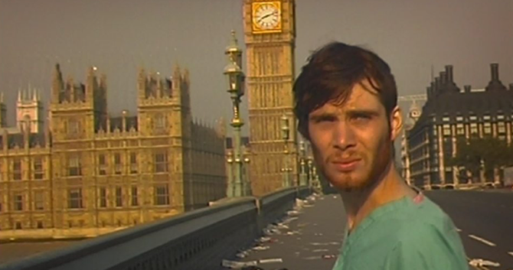

From 3.30 am until 4.00am Boyle could only have certain locations sectioned off, and unfortunately there were ambient noises (of motor vehicles and people) in the surrounding areas, meaning they were not intercepting the shoot and not useable. Boyle later details that it was therefore almost impossible to capture any diegetic onscreen sounds, without external audible interruptions.

Get into Film (2016) talks with Peter Burgis about the cure for these audio interruptions. Burgis discusses adding sound to screen by the use of recording various synthetic sound effects in a studio. The reason this is more convenient is when trying to record a door opening, the specific sound that is required is not always captured. Therefore, Burgis will utilize a prop (such as a wet cassette reel and record it through the enabled microphone ready for the film sound.

When the sound effects team set about making a sound for a certain activity or scene, due to other ambient sounds sabotaging the precise effect they need (when recording the actual item), they cannot seize these effects. The outside ambient sounds like -animals, aircraft, weather, etc. – are also picked up on the field recorder, destroying the main recording.

Also, if the film director wanted an enhanced sound of that steam engine for this to become the lead narrative of the scene, then the sound effects artists can add, reproduce, and alter this sound.

Sound effects artists are the team that bring sound on film to life, and like Boyle suggested about the non-usage of external ambient sounds, this will reproduce the sounds for movie scenes worldwide.

Documenting a planned soundscape, will aid in the creation of a film scene, showing guidelines and paths for the film sound designer to complete the job at hand.

Example: Soundscape Foley mapping details:

-Landscape - where and what?
-Objects that require Foley effects - sizes and what?
-How many sounds - number of sounds?
-Natural sounds or synthetic - edited created sounds or natural (external Ambient) sounds?
-Land mass - where is the location, and how big?
-Weather elements - wind, rain, snow, sun, dry temperature
or atmosphere?
-Acoustic ambient sounds - large echoes (cave, tunnel, house, church?
-Time period - what year or century the film is set in?
-Sound Effects and Reactions - what and how tools are used? (guns,
animals, vehicles, physical actions).

These soundscape maps will also be applied when constructing any musical Underscore, Automated Dialogue Replacement or Foley tasks.

As Ament (2014) states that supporting the reality of a scene is optimum for any film. Ament explains that when the sound effects team will reproduce a sound (e.g. gunshot) they will look at the film scene, and firstly write down where, how long the gunshot has to be, and what other effects are assisting the effect. Then, they will draft a soundscape -similar to the one above- using this as a map for what effects and sounds to make.

For example: If the gunshot is in a small room with the actor firing at a wall, then adding other sounds - the clicking of the gun trigger, the impact of the bullet embedding in the wall, surrounding furniture numbing the sound - will be a large factor. The sounds of echoes and size that the room will make, along with how that fits into the scene (e.g. is there any underscore playing, room noise seeping in from another room or window, etc.). The sound effects team will then try and emulate or create a synthetic sound effect for that activity using the tools and hardware in their sound effects workshop.

Section 2: The Sound Narrative -Essential Foundations, Sound Capture and Functionalities

The Sound Narrative - Explained

Candusso (2012) suggests that the viewing audience has a genuine perception of the sort of sounds that will be included in film that they are watching.

Candusso also states from the moment the soundtrack was introduced into the Movies, the audience has been able to identify the traditional main concepts, ideas, and pre-judged theories.
Certain films are embedded in our audible and psychological senses to accept sound effects for what they are. Knowing that computer technology is enhancing the way sound is shaped and applied to movies, sounds are becoming more realistic by the day.

Some people have visited dark landscapes, cold snowy holidays, foggy and misty harbour scenic places, or even viewed them on television or in the cinema. On the other hand, there are some sounds, actions or activities that the viewing audience have not experienced – like the sounds of gunshots, or the cry of a wild hyena in the jungles of Africa. This then, portrays the question, how is sound captured or even establish a narrative within a motion picture?

Wingstedt (2017) believes there is a system in place that acts as guide for the sound as a narrative. He translates the sound is divided into six functional categories.
These being:

1. Emotive Function

2. Informative Function

3. Descriptive Function

4. Guiding Function

5. Temporal Function

6. Rhetorical Function

The above six sound narrative fundamental factors are structural points for sound effects team to follow when making and mapping out sound for a movie. In some terms it encapsulates what, how and where the sound narrative can be used in movies. For further usage it is an important guide for the soundscape - previously mentioned in Chapter 1.

In the next section I will incorporate the above six functional categories, to detail how, when, and why they are used in films.
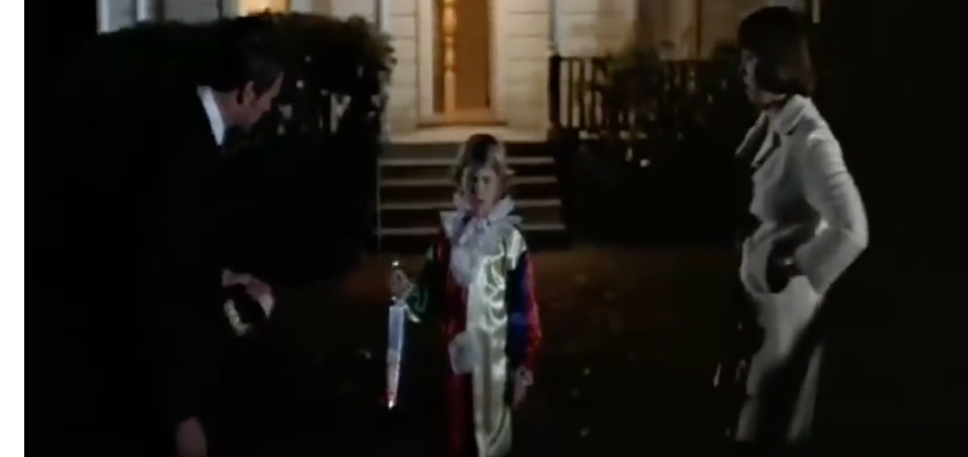


Fig 2: Halloween (1975) -opening scene picture.

Looking at the film Halloween (1978), the opening scene consists of children singing in the background, on Halloween. Instantly, people can relate to the time and date – this is using the Temporal Functions. The function is used to guide the audience directly towards a point in time.

The scene quickly moves to a person, wandering up to a house. The film director has filmed this scene with the intention of synthetically giving the audience the projection, as if you are looking through the visual perception of the actor. Ok, now the film is becoming mysterious due to the cameras visual onscreen viewing angles. Ambient natural sounds can be heard, and slight breathing from the person in the mask. These ambient sounds and the breathing tones create suspense, which take the sound narrative lead roles. The sound team are now using the Emotive Function, creating a psychological suspense to connect with the audience on a scary level. Also, the Guiding Function comes into play, keeping the attention of the viewer by using a high-pitched sound on one musical note of a synthesizer. The musical note is sustained to manipulate the viewer, convincing them to continue watching.

Cutting to the scene where the couple in the house head upstairs, and straight away, a high-pitched noted synthesiser starts playing (Underscore) and taking the lead sound narrative. This first musical note is synchronized with the film footage of the upstairs bedroom light going out. Making a perfect sound and visual match to set the suspense factor rolling within the viewer.
Slightly later, a piano minor-chord sequence begins playing over the top of the synth notes, thus creating the second stage of suspense – with the Guiding and Emotive functions still being used.
As soon as the person grabs the knife from the kitchen, the audience has a good idea of what kind film it is. Here, you can now understand that the three sound functions – Temporal, Emotive and Guiding - have completed their purpose well, setting a fundamental basis for the Introduction of the movie, making the next chapter an easy transition.

Ambient Narrative – Natural Sounds

Looking back at the film Halloween (1975) [opening scene] we can hear the character Michael is roaming around the outside of the house, with the natural ambient sounds playing.

Imagine the actor is standing outside in the street and many sounds can be heard.
The sounds consist of:
- The insects and some small birds chirping.
- The hum of the summer air.
- The slight footsteps of the actor moving around the house.
- The man and woman in the house with the sound of the television playing.

These sounds are significant for the scene and mandatory for the audience to believe it is real, namely termed as the Ambient sounds.

Therefore, when the sound effects team are creating a landscape of sound, they must map out the location, by recording synthetic effects (in their effects studio) to what they believe would fit the scene.

The narrative here takes the effect of two functions in the – the Descriptive and Guiding categories - when married with the outside ambient noises.
The reason this sound narrative works it because it has to have the soundscape -planned and created, and the six functional sound categories - synchronized - before adding sound to film.

Narrative Speech

When a scene requires the speech to tell the story, it relies on the script, and will only contain a small amount of the environmental ambient track and the audio track. The speech (ADR) and conversation that is being announced will lead the scene, along with the quiet or loud ambient sounds (ambient track), this also depends on the motion picture genre.

For a movie scene that is led by speech from the actors, it has to have the correct timing, emotional anticipation, Foley sound effects, sound ambience, dialogue, and connect cognitively.

From the movie ‘Silence of the Lambs’ Clarice arrives at Hannibals cell, visibly nervous as the underscore discontinues, leaving a slight room ambient humming as she greets him. The narrative speech begins when she starts trying to interrogate Hannibal. From this moment forth, there are no other sounds, only very slight Foley effects.
The tones and the dictating voice of Hannibal commands a verbal speech narrative, guiding the audience towards the eerie character. The Emotive sound function here is also capturing how the scene creates suspense.

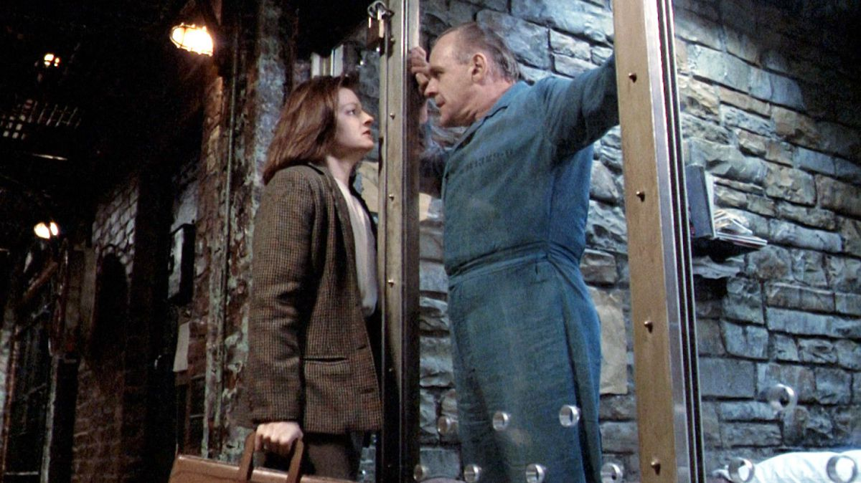

Fig 3: ‘Silence of the Lambs’ Lecter scene image.

There is a clear narrative going on here! The speech narrative begins as soon as she says hello, which also commands the second stage of suspense. The sound narrative has switched from the previous underscore, giving Hannibal, with his authoritative demeanour, the narrative sound in the scene.

Foley Narrative

An accomplished screenwriter or director will produce a film or visual media piece with the sound in mind, as Chion (1994) has said:

“Just as the music will affect how we see things, the visuals will also determine how we hear the music”.

The above quote is so true in many films manufactured from the middle nineteen twenties onwards. Jack Foley was to enhance this process within the film industry, later to be named the main founder for Foley sound effects.

Wolf (2012) believes, Foleys creative talents for extracting and experimentation with realistic sounds, were adapted and applied to the movies, to produce a new era of sound on film. Foley concentrated on all the sounds we would normally hear in a particular scenic place, sounds for various actions to match room ambience, activities, vehicles or other landscape noises. He later developed a system – which is now called Foley Effects or Foley Artistry - to insert sound into movies. From this day forth the film and music industries changed dramatically for the better.

In the next example, Lance (2015) explains the Foley narrative whilst discussing the film ‘Once Upon a Time in the West’.

The concept of the opening scene (first ten minutes) depicts heavy Foley effects mixing cohesively with the ambient sounds. Special room (in the film) has been adapted for these, but the Windmill sound (which is leading the scene), lowers to releases other ambient or Foley effects, such as the footsteps of a cowboy, and the message machine. The windmill sound never dissipates. Later, the scene suddenly introduces the pounding of a steam train (heavy Foley effects). The train creates tension and anticipation which blocks out the other sounds, until the harmonica notes bring the audience into the eerie section where the ADR is relayed from the actors.

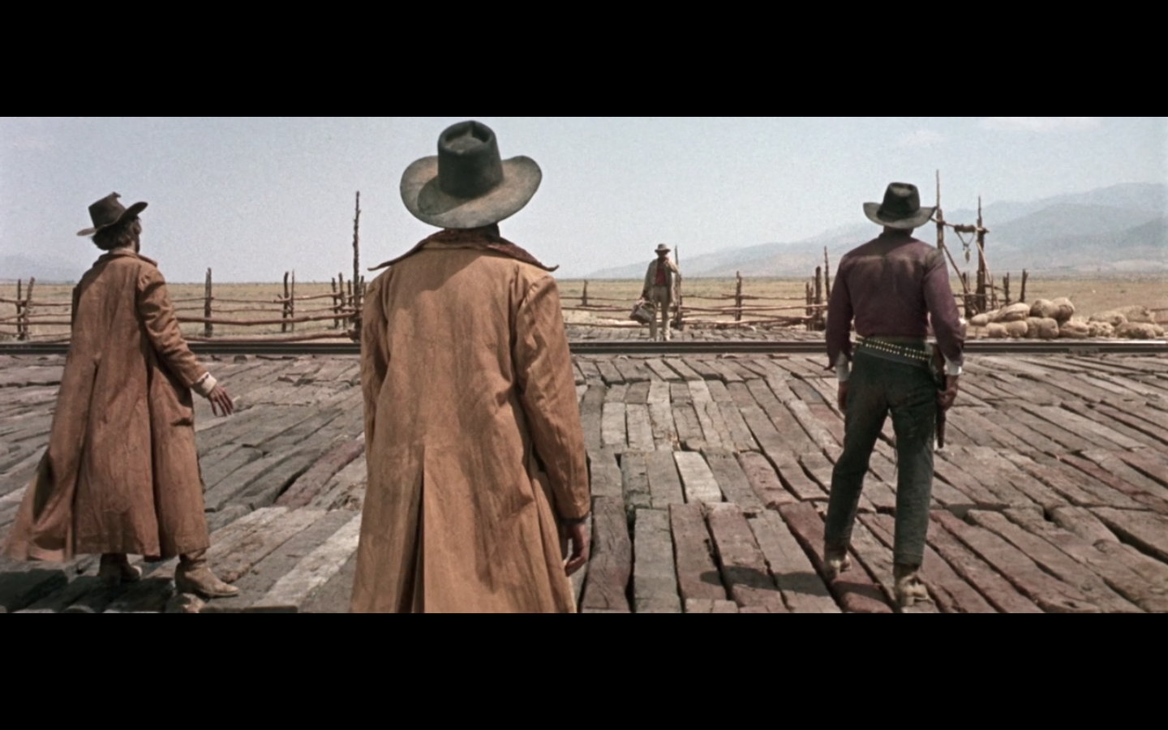

Fig 4: ‘Once Upon a time in the West’ opening scene image.

According to Brand (2013) he argues, in this scene, the sound narrative anchor for the Foley effects is the constant reminder of the windmill turning, acting as a tempo click-track in the composition. This windmill maintains a sense of timing for the musical sound effects, and the other sound is literally layered and created over this windmill.

From my analysis, it implements exactly what Brand suggests, although without the Guiding and Descriptive sound functions - mentioned by Wingstedt (2017) the scene will not work to steer as a Foley effects narrative.
The gunfight commences quickly, with only the gunshots to leave space for the soundscape, and the sound anchor returns (windmill) to end the Foley orientated composition.

Without this special area for the sound, the soundscape would not be so overpowering and unable to impact the Introduction in the motion picture.

Looking at the movie ‘The Conjuring’ (2013), Carolyn Perron (played by Lili Taylor) portrays a great job of being terrified when she checks out the cellar disturbance.

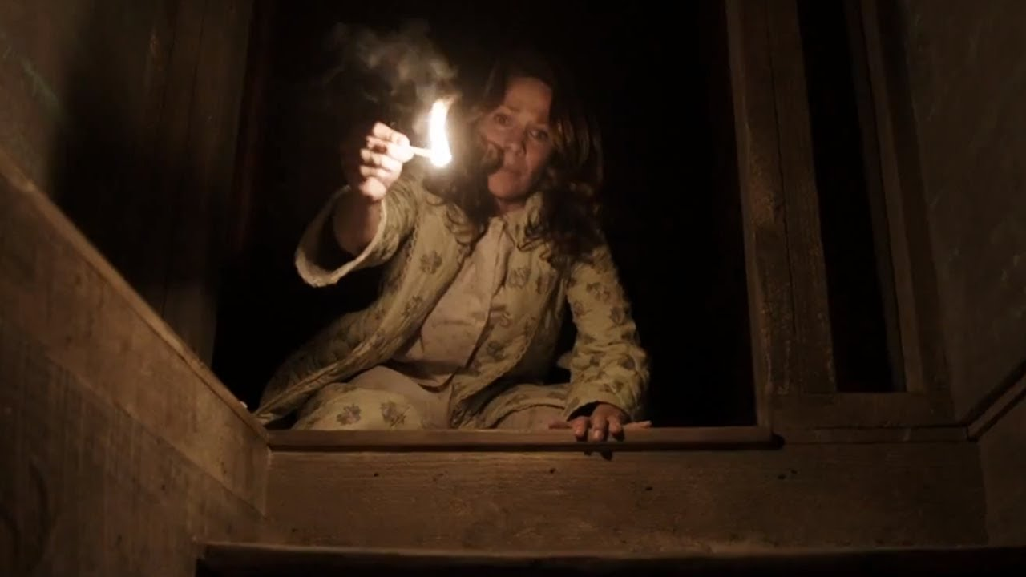

Fig 5: ‘The Conjuring’ movie cellar scene picture

The sound narrative here is the amalgamated mix of Foley effects and musical textures. James Wan (film director) has heavily focused on scary camera angles and great timing. Whilst the sound designer has focused on intense sound effects (using violin strings) highly pitched, in the sixth and seventh musical octaves, for the underscore. Whilst the Foley effects are adding the sufficient musical staccato required.
The capturing of fear and the cliche ‘Jump Scare’ has been doubled.

Narrative Underscore

When you watch a movie scene and the musical underscore enters, if it is playing and the actors and audience cannot see where it is coming from,
then it is non-diegetic. It has been added into the scene by a sound designer, purposely for that narrative sound to command the lead. It is using sound functions, timing and certain style of music to guide the scene and grab the viewers attention.

Looking at the scene from ‘The Conjuring 2’ (Chapter 5 – 45.36 to 47.30 minutes) you can hear the intense underscore playing loudly over the scary scene. The viewing audience cannot see where it is coming from but plays a big part of the sound narrative to enable the scene to work. The timing, sharp staccato musical attacks, choir-lead theme provides a classic example of how the underscore -mentioned earlier -will hit the viewers senses.

Fig 6: ‘The Conjuring 2’ Demon Nun scene picture.

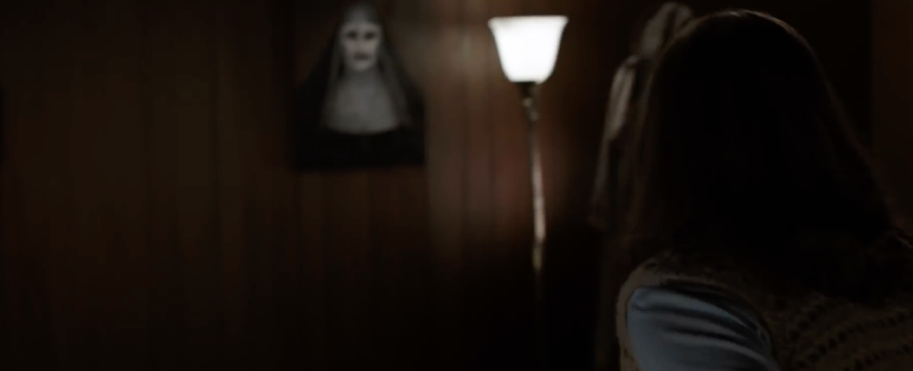

Composers and sound designers will utilise a soundscape mapping system to plot the details and apply what sorts of music to insert.

Looking at the film horror genres, certain musical keys, styling, and textures will be created, tested and used. It is the same comparison as Blues to Heavy Rock genres of music. Each movie genre has a unique type of music.

When playing musical instruments or objects, one of their key factors is that large instruments or objects make deep bass and low-end tones and sounds. Whereas, small objects and instruments create higher-pitched and thinner sounds. This applies to musical octaves on the music scale. Along the musical scale of the piano it has seven octaves (see Glossary -page 28 -for more definition on octaves). In the first to the third octave (above middle C range), most notes or when a Minor chord is played, are very deep with plenty of low-end tones.

In the next original example, Breeze (2018) demonstrates an alternative soundtrack to the trailer for the movie ‘The Evil Dead’, RetroSpectoVideos (2013).
This composition was created and tested with various musical instruments for various affects, to achieve a similar underscore and textured-layered music for horror styling movie genre.

Looking at the whole example underscore, this contains the following musical instruments:
1. Strings - violins, 2nd violins, and violas.
2. Synthesisers - 2 synths.
3. Electronic Drums - 1 hip hop drum kit, and 1 1980’s Pop drum kit.
4. Sound effects - effects made from a 1970’s synthesiser.

The opening musical texture is set in the middle C note range on the musical scale (see Fig 7). Notice that there is a bass clef at the start of the stave, signifying it is using a deep bass pitch, suitable for low end instruments (ie. Bass guitar, piano, etc). Depending on the scene the sound designer will track and allocate appropriate musical rhythm, tempo or texture. The first musical layer (see Fig 7) demonstrates a scary entrance into the film scene, using a patch from the synthesizer (created in Apple Logic) called ‘Event Horizon’.

Fig 7: ‘Event Horizon’ patch -simulated String Instrument in Logic software.

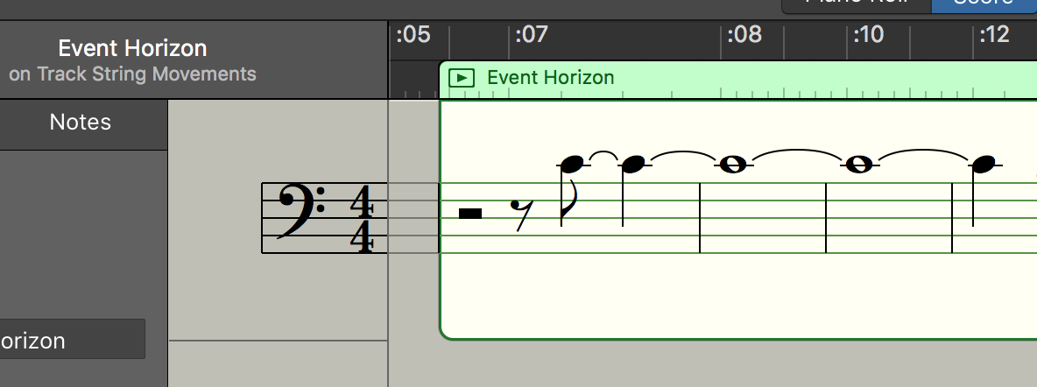


At approximately 1.22-1.28 minutes into the soundtrack you can hear a distinctive high-pitched emulated guitar sustained staccato effect. This was (see Fig 9) created in the D major note, just above the middle C note on the musical scale. With heavily added volume fluctuating effects, sustain, and guitar distortion, this has created a sound worthy of the ‘Jump scare’ it holds.

This depicts and enhances the scene when the zombie first makes her appearance, but it has to be with an impact on the senses for the viewers.

Fig 8: Part of ‘The Evil Dead’ (1981) Trailer where the staccato is designed for.

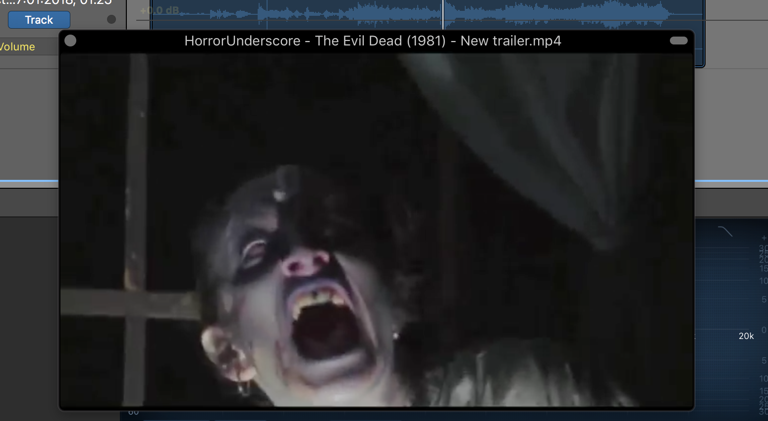


Fig 9: Emulated guitar sustained staccato effect.
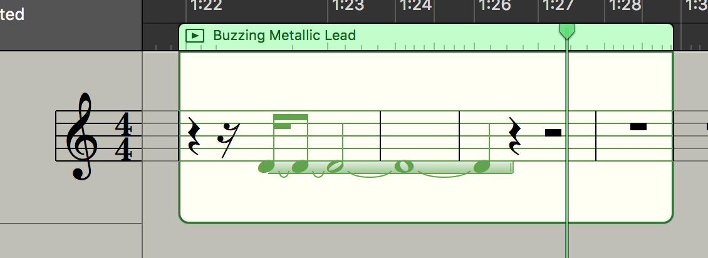


The general idea here is to demonstrate the scary underscore and musical textures, in order for the readers to achieve an understanding of how the narrative and sound design works within films.
The eerie beginning underscore as the trailer is telling the story of the character finding a dagger and a mysterious book.
Later in the trailer, zombies attacking the harmless main characters, the physical stabbing instantly sustained a staccato sound.

Chapter 2 - Music and Film: Narrative and Diegesis Emotional
Capture

Section 1: Movie Diegesis: Foley, Real Sound Integration

Throughout this paper I have mentioned briefly, about the definition of film Diegesis. This section will reiterate and highlight how it works in the soundtrack components, aided by film examples.

Non-Diegetic - Foley Intended enhanced effects

Experienced sound designers can use such mapping (as listed in Chapter two, also see Glossary), to recreate a perfect natural motion sketch, without recording the Foley effects from external natural resources.

Diegetic Ambience

Examining the movie Jaws (1975), [opening scene]: you can hear the sounds of the beach - seagulls, wind and ocean, children playing and shouting, dogs barking, in the background -non-Diegetic. Simultaneously, you hear the sounds of the actors whilst the camera is on them creating the diegetic sounds.

Fig 10: Jaws (1975) Diegetic sounds - Beach scene.

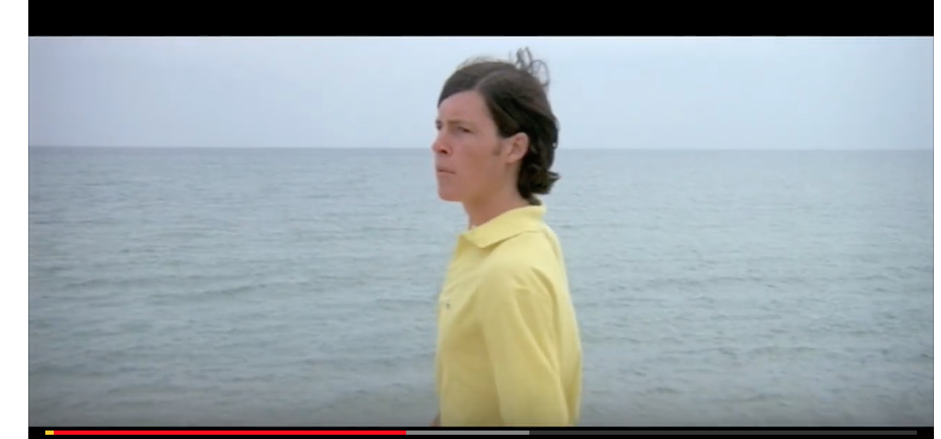


These are the exact sounds that the actors and film crew can hear on set.
Director Steven Spielberg and screenwriter Peter Benchley projected a great job here, giving a natural ambience and suspense to this scene.

Established screenwriters and directors will have already added these effects into the film script, at the writing stages. These ambient effects are used in many suspense and horror movies.
The narrative format here, is - quiet ambient sounds, sad speech and dialogue.

In the next scene the dog has been found dead, here the sharp underscore will intercept with heavy force - orchestral violins in high-pitched notes, creating a sharp blow to the senses.

Section 2: The Underscore Sound Narrative: Emotive and
Psychological

Psychological Interactions

As mentioned previously, special areas in a films script are planned for musical underscore, Foley or natural ambient sounds, to involve and captivate an audience.
As Brown (1994) reiterates, the viewing audience can decipher the story line as the motion picture unravels. It is the combination of visuals and music that will directly excite, sadden, enlighten or create other emotional neurological responses.

In the movie ’28 Weeks Later’ (2007), there is a scene, at the start of the film, when the characters Don and his wife Alice are trapped in a room at the top of their house. Hammering on the bedroom door are zombies trying to get in to attack them. The scene unfolds with ultimate fear, chaos, loud Foley effects, and slowly and quietly in the background, an underscore theme begins to play.
The psychological scene for the viewers is visually is already set - horror, trauma, intense fear, erratic actions and emotions, empathy for the characters who are not zombies.

Fig 10: Opening scenes - Don leaves his wife alone with the Zombies from the movie ’28 Weeks Later’.

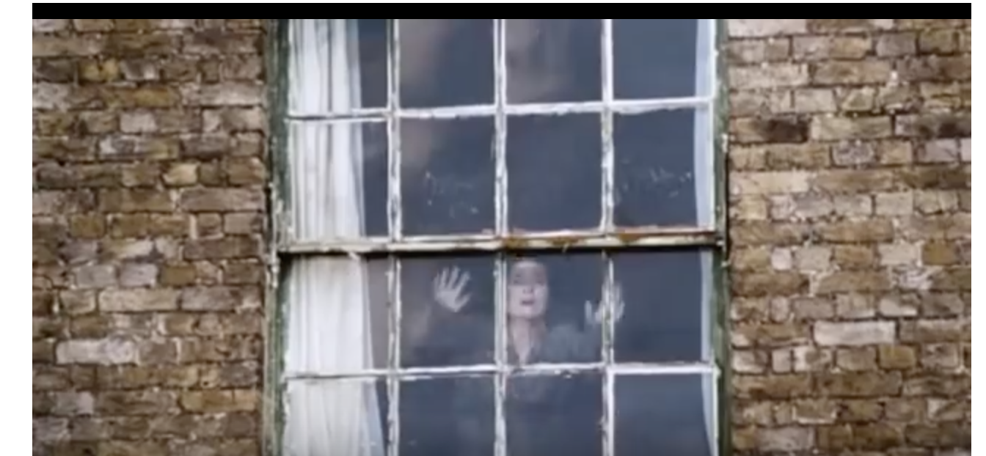


What makes this scene work is the connection between the visual psychological footage linked with the precise and sharp timing of when the Sound Narrative intercepts it.
To simplify this, when Don sees the zombies entering the room you can hear a small underscore playing and increasing in volume slightly. Don panics and very cowardly decides to run from his wife by climbing out the only accessible window. Knowing that Don (from earlier viewing of the film) has been loyal to his wife, the audience believes he should have fought off the zombies and escaped, ensuring the safety of himself and his wife by running for the getaway boat nearby.

The part where the underscore narrative hits the viewers – leaving shock and disgust - is when he leaves his wife with all the zombies and escapes by fleeing out of the window and heading for the boat. The underscore is building in volume, until she leaves the window view, and suddenly the underscore hits full volume, giving the scene perfect impact that it requires.

Fig 11: Opening scenes - Don leaves his wife alone with the Zombies from the movie ’28 Weeks Later’

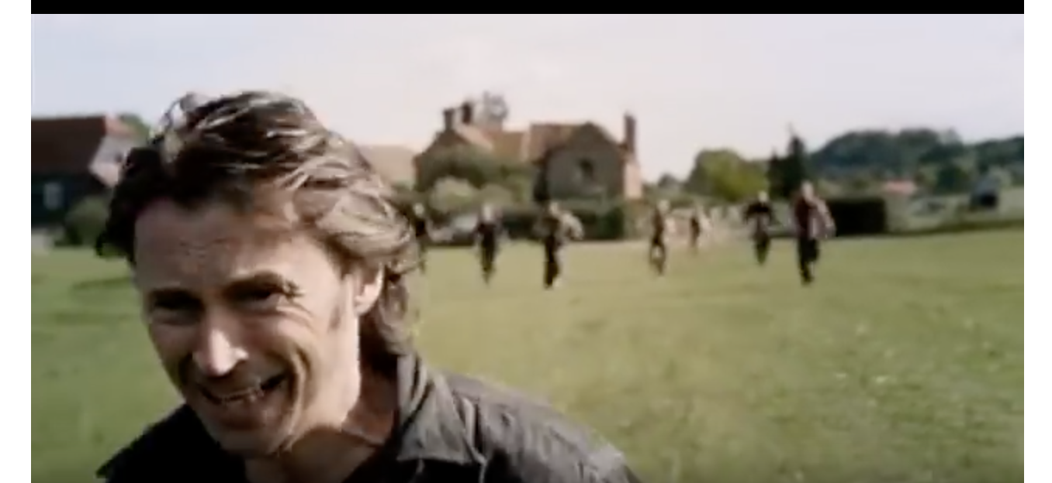


According to MacDonald (2017) the following points suggest a summary of the way a scene works with the Sound Narrative:

1. Film footage - camera angles, dark scenes.
2. Intense acting and action.
3. Foley effects enhanced and added to scene.
4. Timing - the precise points where the Underscore starts and stops.
the suspense and build of the Underscore.
the impact the Underscore has.
the type of Underscore composed and played to the scene.
the volumes of the Underscore.
the mix of the Underscore, and volume of instruments.
5. Emotional connections - the script storyline.
6. Soundscape - locations - Foley sound effects created realistically.
Diegetic underscore mixed for the location.

After researching Hans Zimmers work in the Batman trilogy series, the movie ‘The Dark Knight’ (2008) [ending scene], has a three-step musical underscore plan. This is composed and projected as the sound narrative in a functional way (as described in Chapter 2) and below:

1. Emotive.
2. Directive.
3. Guiding.

All of this functionality works to become an attraction for the viewing audience to fulfil their psychological needs.

The Foley effects are intermingling in certain stages, with intermittent dialogue sitting in where required.

Fig 12: ‘The Dark Knight’ [ending scene] - surprising revelations.
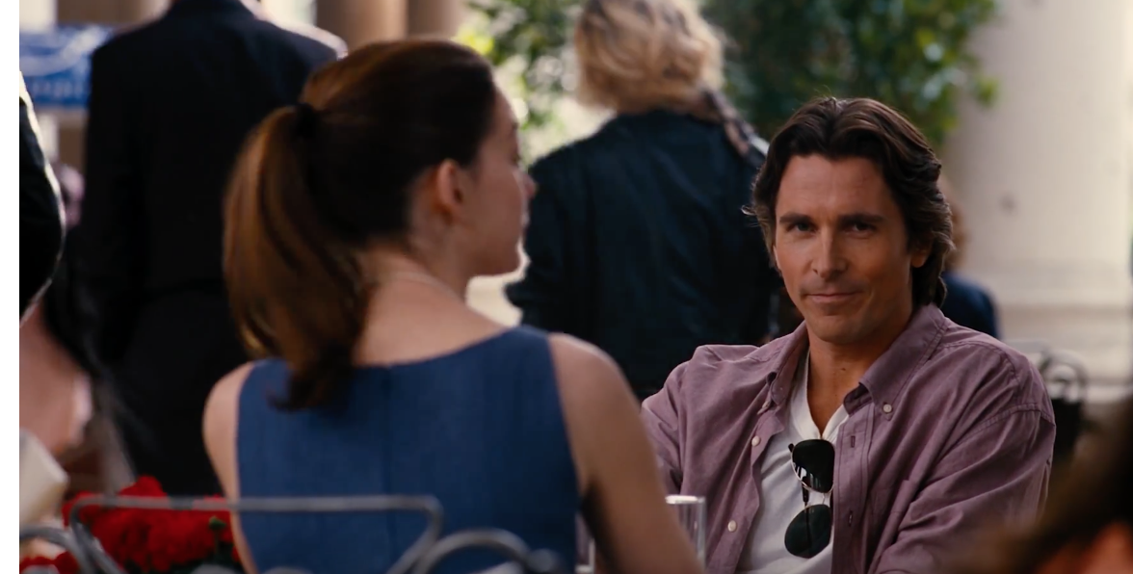


This type of sound narrative is one of the most powerful guides to any film footage, making the power of a film capture the scene completely, and finishing with ultimate cognitive resolution.

Conclusion

The beginning of this document discusses what the soundtrack, and the components include, and how they interact with movies. From the perspective of the viewing audience, it is hard to decipher, and may be totally unnoticeable. Noises and objects, underscores, and Foley effects are things we hear every day, on the radio, on television, in the park, but become concealed without hearing these sounds, and not just listening.
I have determined that in sound design the job is not just to add effects, or construct a musical melody to a film, or a movie. The sound designer has to be creative, inventive, properly organised, and establish a soundscape realistically to give the movie the correct character. Wingstedt (2004) also suggests that although sound design is about being creative and inventive, you also have to have the correct musical notes, volumes and timing to achieve the specific narrative for a film scene.
Any papers, news, tasks, or assignments can seem exciting in the preliminary stages, it is not until the solid research and exploration has taken place the true background and data becomes established.

Wolf (2012) argues Back in the day when Jack Foley, discovered the art of adding and creating sound effects to enhance the movies, it was a world changing turning point. Foley wanted his name artistry to be secret or silent, and never had his name appear on any movie credits. The reason for this is that Foley saw this artistry as an invisible attribute and wanted the viewing audience to believe that the sound in movies was almost natural, not enriched.

Looking deeper into the sound narrative, we have realised, that it takes a good ear, set of eyes, and keen patience to enable and apply great sound effects, or ambient noises. According to a report by Elegyscore (2011), Hans Zimmer was asked by Ridley Scott (film director) to create a cultural and stylistic soundtrack, something that would symbolically define the Japanese civilization. Hans therefore started researching how the Japanese culture acclaimed their historic music, in order to create an artistic characterized composition.
The emotive feeling of sorrow was a defining lead attribute for establishing a melody, and underscore narrative, which was repeated throughout, frequently, played on traditional Japanese musical instruments.
I believe this enforces the idea that screenwriters and directors allow a special area within each of their films for the sound narrative to take the scenes to the audience psychologically and emotionally.

Wingstedt (2004) argues, If the functional sound categories – Guiding, Emotive, etc. - were not implemented for film chapters and scenes, I believe there is no plan, affect or guide, and therefore, no sound narrative.
What I have discovered throughout this analysis, is that for the sound narrative to fully work, it has to have three crucial elements – the soundscape, the six functional sound categories (mentioned in Chapter I-section 2), and the film to be written with room for Sound.

To close this analysis, I believe, the evidence suggests that in the cinema films are written and created with a much larger scope in mind. The scope being the sound and its narrative. Professional and contemporary screenwriters or directors will map their forthcoming motion pictures with large areas for the sound and the sound narrative– Foley effects, underscore, and ambient noises - to forge their presence, by leading, introducing, and ending scenes.

Bibliography

Academy Originals. (2016). Foley Artists: How Movie Sound Effects are Made
https://www.youtube.com/watch?v=U_tqB4IZvMk
[Accessed: 29.12.17]

aisforandrewtoo. (Wood, M.) (2012). Sound Design - Star Wars II (FULL).
https://www.youtube.com/watch?v=5ogCVi0WqrQ
[Accessed: 29.12.17]

Ament, V. (2014). The Foley Grail: The Art of Performing Sound for Film, Games and Animation (2nd Edition). (pp.1-162). Oxford: Focal Press.

Apple Inc. (2009). What is Automated Dialogue Replacement (ADR)?
https://documentation.apple.com/en/soundtrackpro/usermanual/
index.html#chapter=11%26section=1%26tasks=true
[Accessed: 19.12.17]
- 07012018
Brand, N. (2013). The Secret Art of the Film Soundtrack.
https://www.theguardian.com/music/musicblog/2013/sep/12/film-soundtracks-neil-brand
[Accessed: 27.2.18]

Breeze, C. (2018). EVD.Project1 -07012018.
Available at: https://soundcloud.com/search?q=EVD.Project1
[Accessed: 14.3.18]

Brown, R. S. (1994). Overtones and Undertones. (pp. 1-149). CA: University of California Press.

Candusso, D. (2012). Aural Landscapes: Designing a Sound Environment for Screen.
http://www.screensoundjournal.org/issues/n3/11.%20SSJ%20n3%20Candusso.pdf
[Accessed: 19.12.17]

Carpenter, J. (2017). Halloween.
http://www.theofficialjohncarpenter.com/halloween/
[Accessed: 20.11.17]

Chion, M. (1994). AudioVision - Sound on Screen. (pp.1-185). New York: Columbia University Press.

CPPEDRO1. (2015). The Picture Crawler (Short Horror Film) -Sound Design by Duran Daley.
https://www.youtube.com/watchv=Ig0y1AH_1es&list=PLsfydxNDfpIcLQG_0irCmRScLBXkisxNQ
[Accessed: 27.12.17]

Craig, S. (2012). How Music can change a Film.
https://www.youtube.com/watch?v=rn9V0cN4NWs
[Accessed: 27.11.17]

Cross, M. (2017). Audio Post Production for Film and TV.
https://online.berklee.edu/courses/audio-post-production-for-film-and-tv
[Accessed: 21.11.17]

DNA Films Ltd. (2002). 28 Days Later: About the Shoot.
http://cinema.com/articles/1468/28-days-later-about-the-shoot.phtml
[Accessed: 27.02.18]

Dunn, D. (2017). 5 Best Uses of John Williams’ Music in Steven Spielberg Movies.
https://moviepilot.com/p/best-uses-john-williams-music-in-spielberg-movies/4367276
[Accessed: 23.11.17]

Elegyscores. (2011). Making of Black Rain Soundtrack.
https://www.youtube.com/watch?v=S2_I9basZdM
[Accessed: 27.02.18]

Evenant. (2017). Composing & Orchestrating for Dramatic/Emotional Underscoring.
https://www.youtube.com/watch?v=y9nwLAhsPS4
[Accessed: 22.11.17]

Filmmaker IQ. (2014). The Fundamental of Sound in Post Production.
https://www.youtube.com/watch?v=r4791OLkRrs
[Accessed: 12.11.17]

Filmsound. (2017) The Story of Jack Foley.
http://filmsound.org/foley/jackfoley.htm
[Accessed: 29.11.17]

Filskov, D. (2017). The Guide to Sound Effects.
http://www.epicsound.com/sfx/
[Accessed: 29.12.17]

Giardina, C. (2016). Sam Raimi Reveals How He Created the Monster Sound in ‘Evil Dead’.
https://www.hollywoodreporter.com/behind-screen/sam-raimi-reveals-how-he-869649
[Accessed: 15.12.17]

Great Big Story. (2017). The Magic of Making Sound/Thats Amazing.
https://www.youtube.com/watch?v=UO3N_PRIgX0
[Accessed: 18.11.17]

Get Into Film. (2016). How to make your own sound effects with Peter Burgis (interactive on web browser only).
https://www.youtube.com/watch?v=cg_daxoXMaQ
[Accessed: 17.3.18].

Hutchinson, S. (2017). 15 Terrifying facts about John Carpenter’s Halloween.
http://mentalfloss.com/article/59788/15-terrifying-facts-about-john-carpenters-halloween
[Accessed: 15.11.17]

IMDb.com. (2017). Paranormal Activity (2007) – Full Cast and Crew.
http://www.imdb.com/title/tt1179904/fullcredits?ref_=tt_cl_sm#cast
[Accessed: 11.10.17]

John Eye Productions (2017). Mixing Sound for Film - Audio Post Production, An Overview.
http://www.thebeachhousestudios.com/mixing-sound-for-film-audio-post-production-overview/
[Accessed: 11.11.17]

Kay, C. (2016). COMPOSE WITH ME - How to Compose a Dramatic Underscore- Episode 7.
https://www.youtube.com/watch?v=KrauYtMlQbo
[Accessed: 10.11.17]

K. W Audio Productions. (2015). Hoof Steps Foley.
https://www.youtube.com/watch?v=ANbx-lbmRWE
[Accessed: 8.3.18]

Lance, A. (2015). Constructing Narrative through Sound Design.
https://www.videomaker.com/article/c04/18237-constructing-narrative-through-sound-design
[Accessed: 12.11.17]

Lebrecht, J. (2017). In the Mix: A Practical Guide to Navigating the Post-Production Audio Process.
https://www.documentary.org/feature/mix-practical-guide-navigating-post-production-audio-process
[Accessed: 23.12.17]

LilJestrom, S. (2011). Emotional Reactions to Music - Prevalence and Contributing Factors.
http://uu.diva-portal.org/smash/get/diva2:410669/FULLTEXT01.pdf
[Accessed: 2.01.18]

MacDonald, H. (2017). Learn the Definition of Underscore in Film and TV.
https://www.thebalance.com/what-is-an-underscore-2460950
[Accessed: 28.03.18]

May. E. (2015). The Best of Hans Zimmer.
https://www.youtube.com/watch?v=PSeJckOUZrs
[Accessed: 29.12.17]

Mayzes, R. (2016). Order of Operations: The Phases of Audio Post Production for Video Projects.
https://photography.tutsplus.com/tutorials/understanding-the-phases-of-audio-post-production-for-video--cms-26688
[Accessed: 22.12.17]

Modern Film Composer. (2015). How to make Epic Film Music: Getting Started.
https://www.youtube.com/watch?v=5rEVCFDj0JU
[Accessed: 10.12.17]

Murphy, S. (2015). How to Imitate a Whole Lot of Hollywood Film Music in Four Easy Steps.
https://www.youtube.com/watch?v=YSKAt3pmYBs
[Accessed: 12.11.17]

Nazarian, B. (2015). What is Audio Post Production.
http://www.mpse.org/what-is-audio-post-production
[Accessed: 12.12.17]

NOWNESS. (2015). How to Sound Design Your Life.
https://www.youtube.com/watch?v=zoWW2oElGWw
[Accessed: 28.12.17]

Perron, B. & Schroter, F. (2016). Video Games and the Mind: Essays on Cognition, Affect and Emotion. (pp. 1-159). North Carolina: McFarland and Company Inc.

Pomerantz, D. (2012). The Triumph of ‘Paranormal Activity’.
https://www.forbes.com/sites/dorothypomerantz/2012/10/18/the-triumph-of-paranormal-activity/#5acb0ced7b68
[Accessed: 12.10.17]

RetroSpectoVideos. (2013). The Evil Dead (1981) – New Video.
https://www.youtube.com/watch?v=coGH4OaR9hc
[Accessed: 14.2.18]

Robertson, J. (2017). Real-time Music Generation for a Virtual Environment.
https://movingimageeducation.org/create-films/post-production/sound-and-music
[Accessed: 14.12.17]

Schaefer, H. (2017). Emotion and the Film Score.
http://www.e-filmmusic.de/article1.htm
[Accessed: 2.01.18]

Sell, B. (2015). Mixing and Mastering Tips for your Mixes.
https://www.youtube.com/watch?v=h6vRDKw26sY
[Accessed: 7.1.18]

Serafin, S. (2004). Sound Design to enhance Presence in Photorealistic Virtual Reality.
https://smartech.gatech.edu/bitstream/handle/1853/50913/SerafinSerafin2004.pdf
[Accessed: 27.12.17]

Simplythoery.com. (2017). Octave – Definition.
http://www.simplifyingtheory.com/octave/
[accessed: 1.2.18.]

TEDx Talks. (2015). Transforming Noise into Music- Jackson Jhin - TEDxUND.
https://www.youtube.com/watch?v=LadUft_ly50
[Accessed: 17.11.17]

Television Academy. (2015). Crew Call: ‘Back to the Future’ Foley Artist Joe Sabella On Creating Sounds.
https://www.youtube.com/watch?v=B0E0yXp4tEo
[Accessed: 21.12.17]

This guy edits (2017). Audio Design: 70% of what you see.
https://www.youtube.com/watch?v=Jb2RRoEt4_M
[Accessed: 21.12.17]

Thuring, C. (2013). Further thoughts on sound effects.
https://www.beekmanschool.org/articles/further-thoughts-sound-effects
[accessed: 11.10.17]

Video and Filmmaker. (2013). Mastering the Art of Post Mixing.
http://videoandfilmmaker.com/wp/index.php/tutorials/mastering-the-art-of-post-mixing/
[Accessed: 22.11.17]

Wolf, Daphne. (2012). Jack Foley and The Art of Sound.
http://irishamerica.com/2012/01/jack-foley-and-the-art-of-sound/
[Accessed: 21.2.18]

Wingstedt, J. (2004). Narrative Music, Visuals and Meaning in Film.
https://www.diva-portal.org/smash/get/diva2:985329/FULLTEXT01.pdf
[Accessed: 30.11.17]

Wimbledon Sound. (2017). Audio Post Production.
https://www.wimbledonsound.com/audio-post-production/
[Accessed: 22.12.17]

2002 DNA Films. (2002). 28 Days Later: About the Shoot.
http://cinema.com/articles/1468/28-days-later-about-the-shoot.phtml
[Accessed: 28.2.18]

Filmography

Halloween. (1978). [film]. USA. Trancas International Films Inc.

Jaws. (1975). [film]. USA. Universal Pictures.

Paranormal Activity. (2007). [film]. USA. Paramount Pictures.

Once Upon A Time In The West. (1968). [film]. USA. Paramount Pictures.

Silence of the Lambs. (1991). [film]. USA. MGM Studios.

The Conjuring. (2013). [film]. USA. New Line Cinema.

The Conjuring 2 (2016). [film]. USA. New Line Cinema.

The Dark Knight. (2008). [film]. USA. Warner Brothers.

The Exorcist. (2000). [film]. USA. Warner Brothers.

28 Days Later. (2002). [film]. UK. Fox Searchlight.

28 Weeks Later. (2007). [film]. UK. Fox Atomic.

Glossary

Digital Audio Workstation -This a studio set-up specifically created for recording, mixing, editing and mastering music. Digitally arranged with computers and mixing desks, visual and audio monitors, and the appropriate software studio package.

Jump scare -this a part in a film scene, where it designed intentionally to scare and make the audience jump with fear.

Mapping -in general terms this is the practice of planning out the next soundscape, scene of film to add sound, or just creating a planned journey for the application of sound, etc.
Master Mixing and Locking -the whole music track has been equalised, compressed with sound volume parameters, with
all the musical instruments corresponding with each
other. The track is then saved, locked with a password, and ready for distribution onto a film or other musical avenue.

Music Composition and Editing -creation of a musical piece, with the mixing and editing completed on a Digital Audio Workstation,
edited at a later time.

Octaves -think of a piano, at one end there are (left)low-bass notes, and at the (right) other end are high-pitched notes. The musical scale notes start from C, to D, E, F, G, A, B and back to C. If you start at the first C note on the low-bass (left side) of the piano, then you will have the first octave (C, D, E, F, G, A, B) then when you play the next C note it becomes the second octave – which is higher in pitch. The pitch becomes gradually higher all throughout the seven octaves.

Production Dialogue Editing -editing of the film dialogue that has been left on the film after all the visual footage has been completed. The sound designer will use what is required to be used, and later enhance it.

Sound Effects Design and Editing -the process of setting up a Soundscape, adding another plan and timeline, and later adding Foley effects, ADR, editing them, and completing the job.

Spacial Areas -these are the areas in a film where space is deliberately created for the insertion of sound design.
Imagine a scene with no talking, just Foley sound effects, or underscore – like the scene in Part II – Foley Narrative, where I discussed the movie ‘Once Upon A Time in The West’.

