Sports Physical Activity And Society

Contents

Introduction

What is sociological imagination?

Sports Participation

Health Based Sport Intervention

Conclusion

References

In this essay I will be discussing three key topics. The first topic I will be covering is how sociological imagination links to today's current environment. I will also be comparing sports participation statistics. And lastly I will be assessing the outcome of recent health based sports innervation, why it was introduced and what it’s aim of improvement is.

What is sociological imagination?

According to (National university, 2022) “sociological imagination is an ability to connect personal challenges to larger social issues''. It was established in 1959 by C. Wright Mills. The purpose of sociological imagination is to encourage “people to replace the lenses they're currently using to view their own lives and alter their perspectives'' (Your dictionary, N/D). Sociological imagination is important to have because it gives us the chance to “see things socially and how they interact and influence each other” (Ashley Crossman, 2019). In terms of unemployment in sociological imagination some individuals might say that “you need to try harder” and blame it on you. However, to succeed you need to feel positive and think you will get there. Furthermore, linking sociological imagination with our environment and current global problem COVID-19, many people think that they understand the world we live in and why events and global problems like COVID -19 are happening. The saying “The near at hand over the far away” (Ziyad Marar, 2020) connects to our current environment. It indicates that we think it’s easier to care about our current problem COVID-19 rather than thinking about problems further away. As humans we often decide to choose “the simple over the complex '' (Ziyad Marar, 2020) just because it’s the easy option. Sociological imaginations have their pros and cons.

Danielle Rhubart, a university lecturer, had her students share their personal experiences from COVID-19. Financial impacts, lack of opportunities, grief. She described her emotions as being mixed after hearing about their experiences. She found herself “feeling proud of how each of their sociological imaginations have grown” (Danielle Rhubart, 2020) but also said she was upset that through their “circumstances that the sociological imagination has become most alive for them” (Danielle Rhubart, 2020). Unfortunately, through tough, sad, unrenamable personal experiences “sociological imagination has come alive for them - for all of us” (Danielle Rhubart, 2020). Sociological imagination is meant to make people feel empowered and “as an essential tool for social responsibility” (Danielle Rhubart, 2020) however, after experiencing the impacts and effects of COVID-19 it has done the opposite and made people feel powerless.

Sports participation

“Participation rates among women and girls are much lower than among men” (Women’s sports and fitness foundation, 2008). There are several factors that lead to this. The first obvious one is the lack of funding. Unfortunately, female sport doesn’t get as much supported funding as men and due to this they attract less sponsorships from businesses. Between 2006 and 2007 statistics showed that “41% of female athletes were funded through various programmes” (Women’s sports and fitness foundation, 2008).
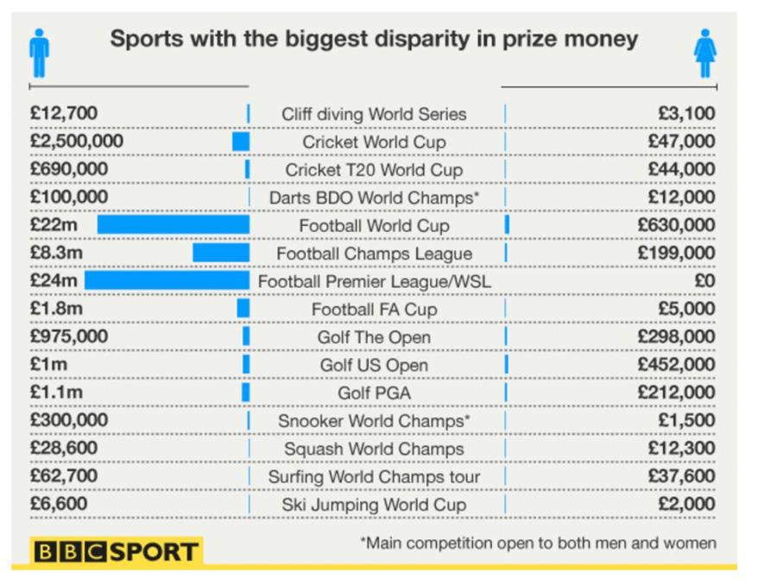
BBC sport, 2014
As shown in the graph above by (BBC sport, 2014), statistics show that in one of the most liked sports, the men’s prize money is £22.37 million more than the women’s £630,000. To add to this, women working full time on average earn “£529 less per month than men” (Women’s sports and fitness foundation, 2008).

Similarly, another money related issue to women in the sporting industry is access to facilities. “Too often, sports halls prioritise male sport when it comes to pitch time” (Women’s sports and fitness foundation, 2008). Because men in the sporting industry are seen to be more successful than women, they get priority in a lot of leisure centres when it comes to their preferred time to practice. Women get no say and must fit around these times. There are clear connections between both points. It is clear that men are more liked in the sporting industry. Men get prioritised when it comes to getting paid like i mentioned in the first point and they also get priority to train.

Equality to people with disabilities in the sporting industry is a major issue. “One third of disabled young people feel excluded from local sports opportunities'' (Women’s sports and fitness foundation, 2008). This is caused by issues such as no access for wheelchairs into the building and also there is a bigger issue for people who are hard of hearing. According to (David Lange, 2018) in 2016 “approximately 1.6 million disabled people in England took part in a sport once a week”. Funding is not only an issue in women’s sports but it is also a problem in the disability sporting industry. However, to try and provide equality for all (Sport England, N/D) have “invested over £1.2 million” into their programme to try and increase the number of disabled people in the sporting industry.

Sadly, age is the leading problem in sports. Very young and talented children and teenagers choose to give up because “Performance pressure is the number one reason why elite participants dropout” (Richard Fryer, N/D). Enjoyment is taken out of sports when children get to the age of it getting serious. For many children their hopes and dreams are taken away from them when they come to the realisation that they will never play professionally and it won’t be a career for them. In America a study by (Roger Wilson, 2019) showed that “0.4% of high school soccer players will play professionally at any level”. Unfortunately, due to the number being so low many children decide their time isn’t worthwhile and would prefer to play Xbox or spend time with friends and family. There are differences between disability in the sporting industry and children not getting many opportunities. There is a small minority of opportunities out there for children who are seen as good at a sport however for children with disabilities the opportunities are even smaller. Although there is more funding being put into disability sport as seen in the paragraph above, more funding is needed for children and teenagers to progress and pursue their dreams to be a professional athlete. There is a similarity which is that sporting opportunities need to be fair for all, whether they be disabled, women, man, everything should be equal.

Health based sport intervention

There are many beneficial health based sport innervations factors. It is known that “sports also have many psychological benefits” (WebMD, 2022). On average the number of doctor visits are due to stress. “Exercise causes your body to release endorphins” (WebMD, 2022) which is a natural pain reliever in your brain that can also boost your mood. “Studies have shown that 20 to 30 minutes of exercise each day can make people feel calmer” (WebMD, 2022) which also lasts hours after completing your exercise. The distraction of dedication and or enjoyment in the gym, outside or from your own home can help you forget about your problems for a while which allows you to relax

In 2015 world rugby introduced some beneficial health rules for all players who had suffered head injuries on the pitch. The HIA’s ( Head injury assessment) purpose was “to assist with the identification, diagnosis and management of head impact events with the potential for a concussion” (World rugby, 2021). Before the HIA was introduced, if the player had a head injury and was bleeding as long as the player did not signal for help from the pitch side paramedics they were allowed to carry on playing however, after 2015 if a player gets hit in the head whether they be bleeding or look okay, they have to be removed from the pitch to have an off field screening to which they would then have to review the video and come to a clinical evaluation. The purpose of the HIA is to help players avoid serious life changing head injuries that they may discover later on in life.

Water is crucial in sports, especially in hot weather. The body needs water to function and in hot weather your body can overheat and lead to problems such as fainting. According to FIFA’s rules if football is being played in a country that has a temperature of 32 degrees Celsius, a water break is allowed “any time after 30 minutes into a game played in extreme heat” (J Athl Train, 2016). If the rules fail to be followed “ FIFA must pay 200,000 reals (about $90,000) for each match in which the ruling isn't enforced” (USA today sport, 2022). The usual water break in football is after 40 minutes however because of the risks like “confusion, irritability, headache, heart rhythm problems, dizziness, fainting, nausea, vomiting” (Mayo clinic staff, 2020), it is crucial that the players have the option to have water sooner because symptoms in the list above will “need immediate medical attention to prevent brain damage, organ failure or even death” (mayo clinic staff, 2020).

To conclude, I have discussed how sociological imagination is linked to our environment today and our current world wide problem COVID-19. I have compared the inequality in the sporting industry between men and women, to people with disabilities and also how the success rate of becoming a professional athlete can leave children feeling uninspired. Lastly I discussed how beneficial sports is to your mental health and I also looked into the new important rules in football and rugby to protect players health.

References:

Crossman Ashley, 2019. Definition of the sociological imagination and overview of the book. https://www.thoughtco.com/sociological-imagination-3026756

Fryer Richard, N/D. Believe perform. Why kids quit sport. https://believeperform.com/kids-quit-sport/

J Athl Train. 2016 Mar. NCBI; 51(3): 264–266. Hydration: the new FIFA world cup’s challenge for referee decision making? doi: 10.4085/1062-6050-51.3.04

Lange David, 2019. Statista. England: number of disabled people who play sport regularly from 2008 to 2016. https://www.statista.com/statistics/572633/number-of-disabled-people-playing-sport-weekly-in-england/

Marar Ziyad, 2020. Why do we need a social imagination. https://blogs.lse.ac.uk/impactofsocialsciences/2020/12/02/why-do-we-need-a-social-imagination/

Mayo clinic staff, 2020. Mayo clinic. Heat and exercise: Keeping cool in hot weather. https://www.mayoclinic.org/healthy-lifestyle/fitness/in-depth/exercise/art-20048167

National university, 2022. What is sociological imagination. https://www.nu.edu/resources/what-is-sociological-imagination/

Sport England, N/D. Mapping disability. https://www.sportengland.org/campaigns-and-our-work/disability

Thompson Anna, Lewis Aimee, 2014. BBC sport. Men get more prize money than women in 30% of sports. https://www.bbc.co.uk/sport/football/29744400

USA today sports, 2022. Court orders FIFA to implement water breaks. https://eu.usatoday.com/story/sports/soccer/2014/06/20/court-orders-fifa-to-implement-water-breaks/11106571/

WebMD, 2022. Benefits of sports for mental health. https://www.webmd.com/mental-health/benefits-of-sports-for-mental-health

Wilson Roger, 2019. Tackle smart. What are the chances of my child becoming a professional athlete? https://www.tacklesmartsports.com/parent-expectations/

Women’s sport and fitness foundation, 2008. Barriers to women and girls’ participation in sport and physical activity. https://www.funding4sport.co.uk/downloads/women_barriers_participation.pdf

World rugby, 2021. HIA protocol. https://www.world.rugby/news/612891

WYSO. Danielle Rhubart, 2020. Commentary: COVID-19 and the sociological imagination. https://www.wyso.org/commentary/2020-05-04/commentary-covid-19-and-the-sociological-imagination

Your dictionar, N/D. Examples of sociological imagination: making connections. https://examples.yourdictionary.com/examples-of-sociological-imagination.html

