Name: Klaudia Csoka
Student number: 2407757
Module code and title: BMHP5023 Introduction to Physiology Case Study Report
Assignment title: Case study Report: Type 2 Diabetes

Introduction:
Type 2 diabetes is a long-term condition that affects how the body manages blood sugar levels. In a healthy person, the hormone insulin helps move glucose from the bloodstream into the body’s cells, where it is used for energy. However, in people with type 2 diabetes, the body either does not produce enough insulin or becomes resistant to it. As a result, glucose builds up in the blood rather than being used properly. Over time, high blood sugar levels can lead to serious health complications, including heart disease, kidney problems, nerve damage, and vision loss. Unlike type 1 diabetes, type 2 diabetes often develops gradually and is strongly linked to lifestyle factors.
There are several important risk factors. Being overweight or obese, particularly carrying excess weight around the abdomen, significantly increases the risk. Other key factors include lack of physical activity, unhealthy eating habits, increasing age, and a family history of diabetes. Some ethnic groups are also more likely to develop the condition. Additionally, high blood pressure and a history of gestational diabetes can further raise the risk.
The purpose of this report is to examine type 2 diabetes in more detail, including its causes, risk factors, and effects on individuals. It will also explore prevention strategies and management approaches used to support those living with the condition.
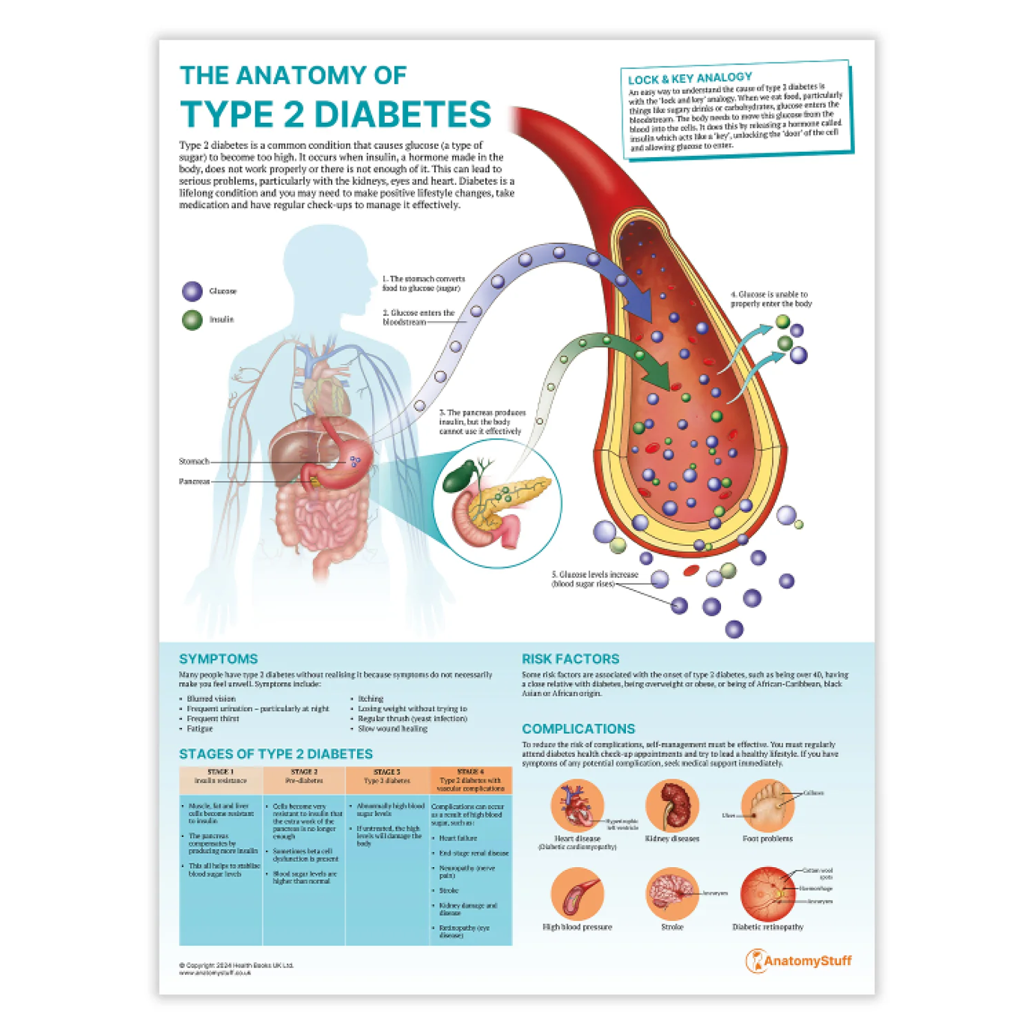
https://www.anatomystuff.co.uk/products/the-anatomy-of-type-2-diabetes-chart-poster?variant=50289975886165

Pathophysiology & Impact

Blood Sugar Regulation and Glucose Control

The body works continuously to keep blood sugar levels within a safe range, ensuring cells have a steady supply of energy. This balance is maintained by hormones, mainly insulin and glucagon, which are produced by the pancreas. After eating, carbohydrates are broken down into glucose, raising blood sugar levels. In response, the pancreas releases insulin. Insulin acts as a key, allowing glucose to move from the bloodstream into the body’s cells, where it is used for energy or stored for later use. As blood sugar levels return to normal, insulin release decreases.

When blood sugar drops too low, such as between meals or during exercise, the pancreas releases another hormone called glucagon. Glucagon signals the liver to release stored glucose back into the bloodstream. This constant adjustment, known as homeostasis, ensures the body has enough energy without allowing blood sugar to become dangerously high or low.

However, when this system fails, blood sugar regulation is impaired. In type 2 diabetes, the body’s cells become resistant to insulin, meaning glucose cannot enter them effectively. As a result, glucose remains in the bloodstream, leading to hyperglycaemia (high blood sugar levels). Over time, the pancreas may struggle to produce enough insulin to compensate. Persistent high blood sugar can damage blood vessels and organs, increasing the risk of heart disease, kidney disease, nerve damage, and vision problems.

Lifestyle factors have a significant impact on glucose control. Diet plays a major role; foods high in refined sugars and processed carbohydrates cause rapid spikes in blood sugar, while balanced meals containing fibre, protein, and healthy fats help stabilise levels. Physical activity improves insulin sensitivity, allowing muscles to use glucose more effectively. In contrast, a sedentary lifestyle increases the risk of insulin resistance. Excess body weight, particularly around the abdomen, also makes it harder for insulin to work properly. Additionally, chronic stress and poor sleep can disrupt hormone balance and negatively affect blood sugar control.

Understanding how blood glucose is regulated highlights why healthy lifestyle choices are essential for preventing and managing type 2 diabetes.
Type 2 diabetes is a long-term condition that affects how the body uses glucose (sugar) for energy. Glucose comes from the food we eat, especially carbohydrates like bread, rice, and fruit. It travels in the bloodstream and needs a hormone called insulin to help it enter the body’s cells.

Insulin works like a key. It unlocks the cell so glucose can go inside. In type 2 diabetes, the body becomes resistant to insulin. This means the “key” does not work properly, so glucose stays in the blood instead of entering the cells. As a result, blood sugar levels rise.

Inside each cell are tiny structures called mitochondria. These are like small power stations. They use glucose and oxygen together to produce energy in a process called cellular respiration. Oxygen comes from the air we breathe and is carried to the cells by the blood.

The basic equation for how cells make energy is:
This means glucose (C₆H₁₂O₆) reacts with oxygen (O₂) to produce carbon dioxide, water, and ATP. ATP is the body’s main energy source. It powers everything from movement and breathing to thinking and the heartbeat.

In type 2 diabetes, because glucose cannot enter the cells easily, the cells do not produce energy efficiently. Even though there is plenty of sugar in the blood, the cells may feel “starved” of fuel. Over time, high blood sugar can damage blood vessels and organs.

In summary, oxygen and glucose are essential for making energy in cells. Type 2 diabetes disrupts this process by preventing glucose from entering cells properly, leading to high blood sugar and reduced energy production.

Monitoring & Data Use
Tracking health data refers to the regular monitoring and recording of specific health measurements to assess how well the body is functioning and how effectively a condition is being managed. Examples include monitoring blood glucose levels in individuals with type 2 diabetes or measuring peak expiratory flow (peak flow) in people with asthma. These measurements provide objective information about a person’s current health status and help detect early signs of deterioration.

In type 2 diabetes, monitoring blood sugar levels is essential for maintaining safe glucose control. Regular testing allows individuals to identify patterns related to food intake, physical activity, medication, stress, or illness. For example, a high reading after a meal may indicate that carbohydrate intake needs adjustment, while consistently elevated levels may suggest that medication requires review. Without monitoring, hyperglycaemia (high blood sugar) may go unnoticed, increasing the risk of long-term complications such as cardiovascular disease, kidney damage, and nerve damage.

Similarly, peak flow monitoring in asthma measures how quickly a person can exhale air from the lungs. Reduced peak flow readings can indicate airway narrowing before the severe symptoms occur. Early detection allows timely intervention, such as adjusting inhaler use, which can prevent asthma attacks and emergency hospital admissions.

Routine health data collection supports effective condition management by providing clear evidence for healthcare professionals to evaluate treatment plans. It encourages patient involvement and promotes self-management, improving confidence and understanding of the condition. Overall, tracking health data plays a crucial role in early problem detection, informed decision-making, and reducing the risk of serious complications in long-term health conditions.

Evidence- Based Lifestyle Recommendations
Type 2 diabetes is a long-term condition where the body does not use insulin properly, causing blood sugar levels to rise. Research shows that lifestyle changes are one of the most important parts of managing the condition. The good news is that changes do not have to be extreme — small, realistic steps can make a big difference to health.

Losing a small amount of weight can greatly improve blood sugar levels. The Uk prospective diabetes study showed that better blood sugar control reduces the risk of complications such as eye and kidney problems. More recently, the DIRECT TRIAL found that losing around 10–15 kg helped many people put their diabetes into remission. Even losing just 5–10% of body weight can help the body respond better to insulin and lower HbA1c levels. In real life, this could mean slightly smaller portion sizes, cutting down on sugary drinks, and swapping white bread or pasta for wholegrain options.

Eating a balanced diet is also important. Studies show that a Mediterranean-style diet can improve blood sugar and cholesterol levels. This means eating more vegetables, fruit, whole grains, beans, nuts and olive oil, and including oily fishlike salmon. These foods help reduce inflammation and protect the heart, which is especially important because people with type 2 diabetes have a higher risk of heart disease. Choosing high-fibre foods can also help slow down how quickly sugar enters the bloodstream, preventing sharp spikes in blood glucose after meals.

Being physically active is another key recommendation. The NATIONAL institute for Health and Care Excellence (NICE) recommends at least 150 minutes of moderate exercise each week, such as brisk walking or cycling, plus some strength exercises twice a week. Exercise helps muscles use glucose for energy, which lowers blood sugar levels. It also helps with weight management and improves heart health. For someone who is not active, even a 10-minute walk after meals can help control blood sugar and feel more manageable than starting an intense workout plan.

Finally, support and education can make lifestyle changes easier to maintain. Programmes such as DESMOND help people understand their condition and build confidence in managing it. Managing stress and getting enough sleep are also important, as poor sleep and high stress can raise blood sugar levels.

Overall, realistic lifestyle changes — healthier eating, gentle weight loss, regular movement, and ongoing support — can improve blood sugar, reduce complications, and help people feel more in control of their diabetes.

Conclusion
In conclusion, type 2 diabetes is a common but serious long-term condition that affects how the body controls blood glucose levels. The key findings discussed show that insulin resistance, lifestyle factors, and genetics all contribute to its development. Evidence clearly demonstrates that healthy lifestyle changes — including balanced nutrition, regular physical activity, weight management, and stress control — can significantly improve blood glucose levels and reduce the risk of complications such as heart disease, kidney damage and nerve problems. Research such as the UK Prospective Diabetes Study and the DIRECT TRIAL highlights that improved blood sugar control and sustained weight loss can even lead to remission for some individuals.

Understanding type 2 diabetes is essential because effective management can greatly improve quality of life and prevent long-term complications. When individuals are informed about how food, exercise, medication and stress affect their blood sugar, they are more likely to make confident and positive choices. Managing diabetes is not about perfection, but about consistency and making realistic adjustments that can be maintained long term.

Health professionals play a crucial role in supporting patients. Nurses, GPs, and diabetes specialists provide education, regular monitoring and emotional support. Programmes such as DESMOND help individuals understand their condition and develop self-management skills. By building trusting relationships and offering clear, practical advice, health professionals empower patients to take control of their health and reduce the impact of type 2 diabetes on their daily lives.

Harvard Reference List

Smith, S-L, Swift, H, Tweddle, S et al. (2024) Peak flow monitoring using digital technology to improve patient self-management and asthma control in primary care: a pilot. Primary Health Care. doi:10.7748/phc.2024.e1833.

Das, S. (2024) The Importance of Regular Blood Glucose Monitoring for Diabetes Management. Journal of Diabetology, 8(6), p.237.

Sly, B. and Taylor, J. (2023) Blood glucose monitoring devices: current considerations. Aust Prescr, 46(3), pp.54-59. doi:10.18773/austprescr.2023.013.

National Institute for Health and Care Excellence (NICE) (2022) Smart Peak Flow for monitoring asthma. NICE MedTech Innovation Briefing MIB282. Available at: https://www.nice.org.uk/advice/mib282/chapter/The-technology (Accessed: 13 February 2026).

Diabetes UK (2025) Continuous glucose monitors and their role in diabetes care. Diabetes UK. Available at: https://www.diabetes.org.uk/about-diabetes/looking-after-diabetes/technology/flash-glucose-monitors-and-continuous-glucose-monitors (Accessed: 13 February 2026).
Lean, M.E.J., Leslie, W.S., Barnes, A.C., Brosnahan, N., Thom, G., McCombie, L., Peters, C., Zhyzhneuskaya, S., Al-Mrabeh, A., Hollingsworth, K.G., Rodrigues, A.M., Rehackova, L., Adamson, A.J., Sniehotta, F.F., Mathers, J.C., Ross, H.M., McIlvenna, Y., Stefanetti, R., Trenell, M. and Taylor, R. (2018) ‘Primary care-led weight management for remission of type 2 diabetes (DiRECT): an open-label, cluster-randomised trial’, The Lancet, 391(10120), pp. 541–551.

National Institute for Health and Care Excellence (2023) Type 2 diabetes in adults: management (NG28). London: NICE. Available at: https://www.nice.org.uk (Accessed: 20 February 2026).

UK Prospective Diabetes Study (UKPDS) Group (1998) ‘Intensive blood-glucose control with sulphonylureas or insulin compared with conventional treatment and risk of complications in patients with type 2 diabetes’, The Lancet, 352(9131), pp. 837–853.

Davies, M.J., D’Alessio, D.A., Fradkin, J., Kernan, W.N., Mathieu, C., Mingrone, G., Rossing, P., Tsapas, A., Wexler, D.J. and Buse, J.B. (2018) ‘Management of hyperglycaemia in type 2 diabetes, 2018. A consensus report’, Diabetologia, 61(12), pp. 2461–2498.

