Influence Maps

Student Name: Mathew Taylor

P Number: 149885

Module Title: Advanced AI and Machine Learning

Assignment Title: Influence Maps

Module Lecturer’s Name: Gordon Dickers

Table of Contents
Table of Figures 2
Introduction 3
Task 1 4
Simple Influence 4
Convolution and Gaussian 4
Task 2 7
The Chosen Algorithm 7
Testing 7
Task 3 8
Game world and AI 8
Testing 9
References 10
Appendix 11
Task 2 11
Influence Map Equation Code Example 11
Task 3 11

Table of Figures
Figure 1 - Influence Map[1] 3
Figure 2 - Rapid initial drop off with a larger range of influence[2] 4
Figure 3 - Plateaus first before rapidly trailing off[2] 4
Figure 4 - Gaussian Convolution Update Matrix[2] 4
Figure 5 - Update Matrix for a corner of a map[2] 5
Figure 6 - Update Matrix for the bottom edge of a map[2] 5
Figure 7 - Equation to calculate the influence on a single point in a map[2] 5
Figure 8 - Red influence source 7
Figure 9 - Green influence source 7
Figure 10 - Two opposite influences next to each other 7
Figure 11 - User selects the map they wish to load 8
Figure 12 - AI in between two different coloured sources 8
Figure 13 - AI moving where it should, towards the green 8
Figure 14 - Implementation of the equation 11
Figure 15 - Green Source is removed when the AI touches it 11

Introduction
Influence maps are grids placed over game worlds that contain values to each square based entirely on some functions which represent spatial features. [1][2] Influence maps are generally used to analyse a map or world by the AI in the game. A common game genre that uses influence maps are RTS (Real-Time Strategy) games, in this example the game might have one influence map for the enemies, one for the allies, and one for resources. The allied AI could find areas on the map with high resource density, low ally density, and low enemy density making a safe, valuable source of resources that nobody is already using. [3][4]
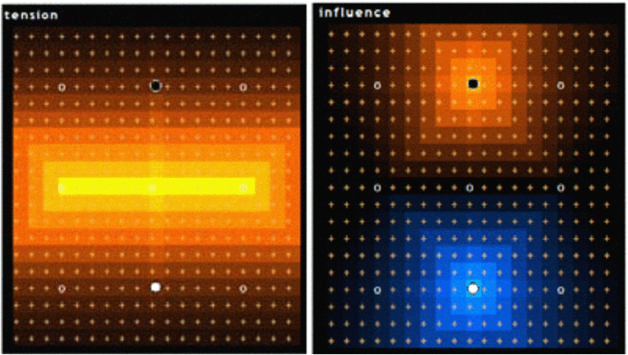
Figure 1 - Influence Map[1]

Task 1

Simple Influence
The equation shown in figure 2 has Id as the influence to be calculated by using the given values of distance, d, and I0 which is the influence at a distance of 0.[2]
Another option is to use a method in which there is a more rapid initial drop off, but has longer range of influence, the equation below in figure 2 will achieve this.
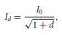
Figure 2 - Rapid initial drop off with a larger range of influence[2]
Another option is to use the equation in figure 3 that maintains influence only close to the influence origin, but then rapidly trails off at a distance from the origin.[2]
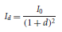
Figure 3 - Plateaus first before rapidly trailing off[2]

Convolution and Gaussian
A popular way of updating analyses’ that involve spreading values out from their source is to use an image blurring algorithm. Convolution filters require a defined update matrix to tell the user how the value of a location on the map will be updated based on the values of its neighbours and its own value.[2]
Example:
Value of a location on the map and its neighbours.
20.0, 20.0, 18.0
22.0, 24.0, 26.0
24.0, 26.0, 30.0
Gaussian filter template (update matrix).
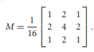
Figure 4 - Gaussian Convolution Update Matrix[2]
Multiply the Location values with the update matrix.
20.0, 20.0, 18.0 1/16, 2/16, 1/16 20/16, 40/16, 18/16
22.0, 24.0, 26.0 X 2/16, 4/16, 2/16 = 44/16, 96/16, 52/16
24.0, 26.0, 30.0 1/16, 2/16, 1/16 24/16, 52/16, 30/16
Add the nine output values together, then divide by the number of values to get the average.
20/16 + 40/16 + 18/16 + 44/16 + 96/16 + 52/16 + 24/16 + 52/16 + 30/16 = 376/16 = 23.5

23.5 / 9 = 2.6111…

If the location on the map being worked on happens to be either in the corner of the map or on the edge, then the update matrix will have to be altered. Instead of using the update matrix used in the previous example one could use the update matrixes shown below.

For a corner.
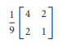
Figure 5 - Update Matrix for a corner of a map[2]
For an edge
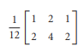
Figure 6 - Update Matrix for the bottom edge of a map[2]
Using a Gaussian convolution template as shown in figure 4 with the value shown above with a location of those values gives an intensity on that point of 2.6111. This process must be completed for each location. This can cause issues, if you run the calculations and change the values on the influence map as you go along then the previous values calculated will affect the new values being calculated. To fix this problem two copies of the map will be needed, one contains the source data that will be read from and as calculations are done the new values are saved to the second map.[2]

The Gaussian filter method is used to blur images and remove noise, so in this scenario it makes the influence area around the source much smoother than the original.

While this method does reduce noise, it is considered to take time to execute and isn’t as detailed as other methods.

The time and memory complexity is determined by using the big ‘O’ notation. The convolution method has a complexity of O(mn), m is the number of points on the map, while n is the number influence sources. In this implementation ‘m’ is 2500 and ‘n’ is 17, giving a complexity of 42500.[2][5]

Another method for determining the influence is the equation shown in figure 7, which calculates the influence, Id based upon the distance, d from an influence source, Io that has an influence range, r.
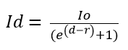
Figure 7 - Equation to calculate the influence on a single point in a map[2]
This method allows for the influence to be flat around a given distance from the centre of influence, but then tail off very rapidly. When it comes to using this method and algorithm two nested loops that loop through for the number of points in the map by the x coordinates and y coordinates will be used. Every time it goes through the second loop it will use the current position on the map being looked at and will grab the details of the sources, perform the calculation above for each source and then add the calculated values together, saving it to the point on the map.

Example using two sources:

Source 1 Source 2
Position = (1,1) Position = (1,6)
Io1 = 3.5 Io2 = 4.3

Cell
Position = (4,5)
Radius = 9

The first step is to calculate the distance between the source and the cell being looked at. There are two methods to figure out the distance between the two points, there’s the Pythagoras method and the trigonometry method. The trigonometry method requires the angles within the triangle that’s made by the difference in the x and y so this method won’t be usable as the angles are not known and would take extra computation to calculate.[6]

The method decided on to calculate the distance is Pythagoras due to familiarity with the method and its ease of use. When using Pythagoras, it might be necessary to work in square space when implementing it to reduce the computational cost, this will not be necessary for the example shown below though.

d = square root of (4 – 1)^2 + (5 - 1)^2

d = 5

Then all the values are put into the actual equation to calculate the influence from that source on the point.

Id = 3.5 / (e^(5 – 9) + 1)

Id = 3.44

Then the same calculations are done for the other source which gave an influence of 4.29

So the total influence on the point from the two source is the two calculated influences added together, giving a total influence of 7.73

Equation 1 isn’t very likely to be used in influence maps due to its high computational cost as the distance check uses a square root and this calculation is done on every point in the map. A relatively simple way to alter this equation to improve its efficiency is to work in square space, so there’s no need for the square root, this will drastically decrease the computational cost.

The complexity of the equation method is given by the square root and the division, which give it a complexity of O(mn).[2][7]

Task 2

The Chosen Algorithm
The chosen algorithm that was implemented is the equation method shown in figure 7, this method was chosen because it provides more detailed influence mappings than the convolution method as the points are not affected by the neighbouring point’s influences. The only down side to using this method is that the distance check used in it is very computationally expensive, but this can easily be rectified by working in square space, so no square roots are used.
To implement this method there will be a two-dimensional array containing the information for the map. A nested for loop will be used to read through the two-dimensional array, and then another for loop will be used to check every source in the scene. Within the third for loop the actual calculations for the chosen method will take place, and the RGB values will bas saved to the array, the RGB values saved represent the influence on that point, please see figure 14 in the appendix for the code detailing this implementation.

Testing
Test | Description | Expected result | Result | Pass?
1 | Placing a red source on the map and displaying its influence. | Will see a red box with more red boxes spreading out from it gradually getting darker. | 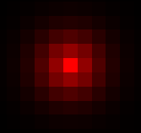  Figure 8 - Red influence source | Yes
2 | Placing a green source on the map and displaying its influence | Will see a green box with more greed boxes spreading out from it gradually getting darker. | 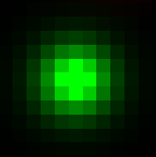  Figure 9 - Green influence source | Yes
3 | Placing a red and green influence source next to each other | The area in between the red and green source should become a yellowish/orange as it will have an influence from both sources. | 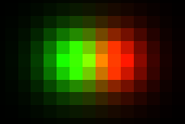  Figure 10 - Two opposite influences next to each other | Yes

Task 3

Game world and AI
When running the developed program, the user will be asked to pick a map to use as shown in figure 8. The map that was chosen map will be loaded uses opengl, and displayed on the screen. The data read from the map file is the location of the player AI, the enemy positions, the goal positions, and the wall positions.
Figure 11 - User selects the map they wish to load
The AI in the game world looks at the point above it, to the right of it, below it, and to the left of it.
The AI looks at the RGB values in the four points it’s looking at, it multiplies the red value by two, add the blue value to it, then subtract the green value, this is because the AI needs to move towards the green influence and it’s set up so it moves towards the smaller value and away from the higher value which will be whichever one has more red in it.
To stop the AI from returning to its last position repeatedly, a blue trail has been placed behind the AI so there’s influence in it. If the AI has to choose between going into blue and going into red then it will go into blue, unless the red is much smaller, this is the reason for multiplying the red value by two.
The last check the AI does before moving is if the position it’s looking at is a wall, if it is then set that value to the max out of the four grabbed values so it’s never chosen.
Figure 9 shows the player AI in between a red point it should move away from and a green point it should move towards. While figure 10 shows the actual result, where the AI moves towards the green and away from the red, while leaving a very slight blue trail behind it.
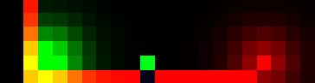
Figure 12 - AI in between two different coloured sources
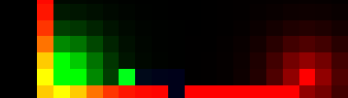
Figure 13 - AI moving where it should, towards the green

Testing
Test | Description | Expected Result | Result | Pass
1 | Check if AI moves towards green. | AI will move towards green. | AI moves towards green sources. See Figure 13. | Yes
2 | Check if the AI moves away from red. | AI will move away from red. | AI moves away from red sources. See figure 13. | Yes
3 | Check if the AI will avoid going on walls. | AI will not move onto walls. | AI doesn’t move onto walls. | Yes
4 | Check if the green source disappears when the AI bot makes contact with it. | Green source will disappear when AI touches it. | Green source disappears when AI touches it. See Figure 15 in the appendix. | Yes
5 | Check if the user can input anything other than the given choices for maps. | The user won’t be able to select anything other than the choices. | The user is only able to input the shown choices. | Yes
6 | Check if the correct map is loaded in when the user selects one. | The correct map will be loaded. | The correct map is loaded. | Yes

References
[1] S. H. Jang and S. B. Cho, “Evolving neural NPCs with layered influence map in the real-time simulation game ‘conqueror,’” 2008 IEEE Symp. Comput. Intell. Games, CIG 2008, pp. 385–388, 2008.
[2] I. Millington and J. Funge, Artificial Intelligence for Games, Second Edition. 2009.
[3] J. Evans, “Influence Maps,” pp. 1–3, 2013.
[4] N. Hansson, “Game School Gems: Influence Maps I.” 2010.
[5] “Analysis of Algorithms: Lecture 7.” [Online]. Available: https://www.geeksforgeeks.org/analysis-algorithms-big-o-analysis/. [Accessed: 22-Mar-2019].
[6] “Measurement Session 5: Measurement and Trigonometry.” [Online]. Available: https://www.learner.org/courses/learningmath/measurement/session5/part_a/measuring.html. [Accessed: 22-Mar-2019].
[7] R. Bell, “A beginner ’ s guide to Big O notation,” A beginner’s Guid. to Big O Not., pp. 1–5, 2015.

Appendix

Task 2

Influence Map Equation Code Example
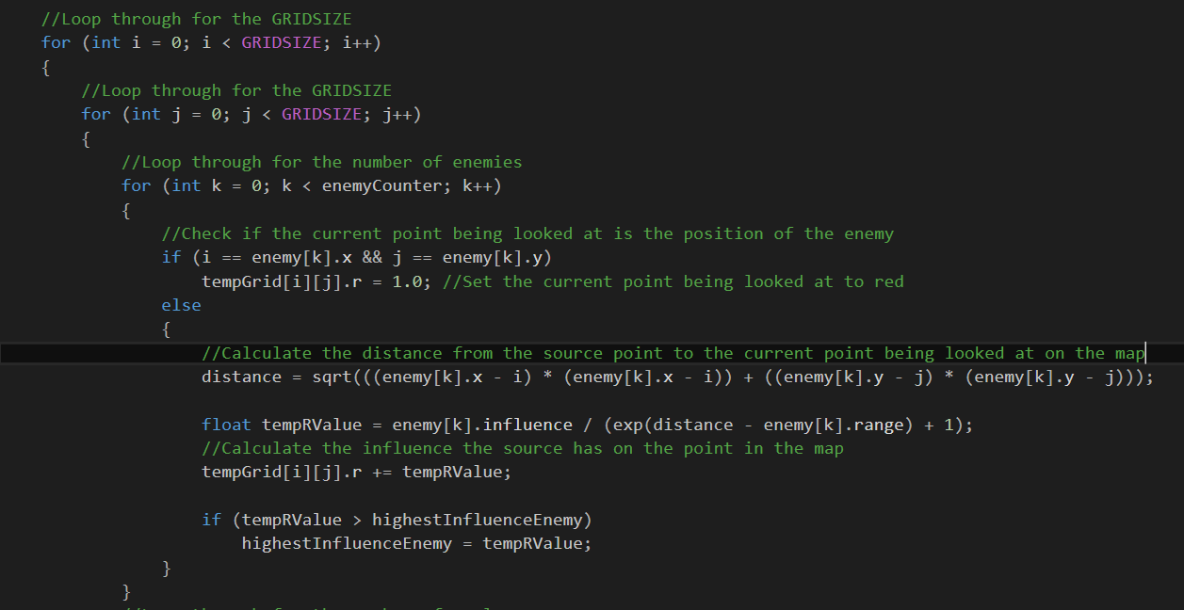
Figure 14 - Implementation of the equation

Task 3
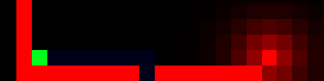
Figure 15 - Green Source is removed when the AI touches it

