Stitching as drawing exploring botanical elements through block and line

Working from the provided studio setup, you are tasked to look, observe and identify emerging shapes and forms.

Working freely, exploring different stitch techniques to produce multiple energetic pieces of work. The session will be led and instructed, allowing you to work through image making and different medias to create a range of ideas.

Additional Tasks: Research (this should be informing your learning, relating to the session, of interest to you and connected to your outcomes).

- Identify and look up at least 4 artists, use the list of names provided on the brief and ensure that you look at the work of Maxine Sutton (mix of stitch and applique techniques), Alice Kettle (textile and stitch as drawing), Tilleke Schwarz (stitched life) and Emily Jo Gibbs (Illustrative and stitch).

- Record your findings and print 3 different images from the 4 artists that you are inspired by, add to your sketchbook.

- Expand on your findings, note key points about the images, colour, process, technique, media used (small notes, no large chunks of text needed). You should be questioning the relevance of the imagery and how it relates to the learning so far.

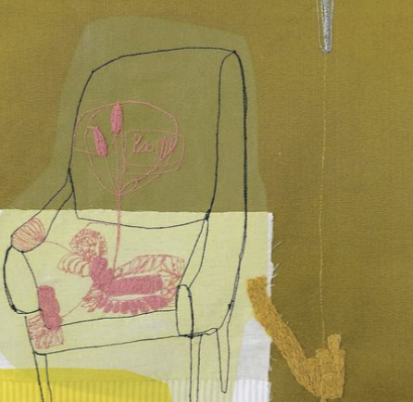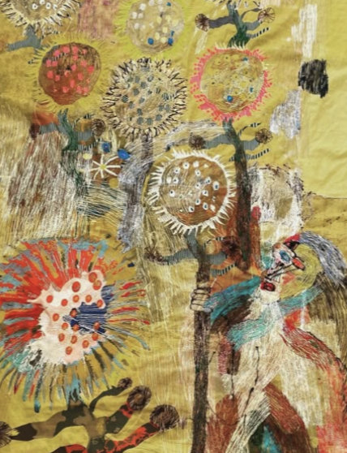
Maxine Sutton. Alice Kettle

To extend the session; continue to work on your drawing and painting, to extend the body of work and find newness, difference and individuality in your imagery. Think about how you may begin to draw within your sketchbook adding in information and ideas from the studio-based sessions. Consider multiple stitched drawings on paper or cloth if this is a way you feel you would like to work.

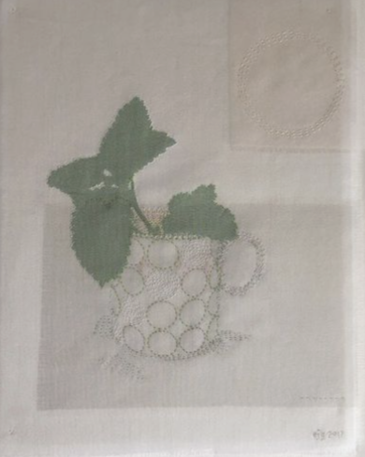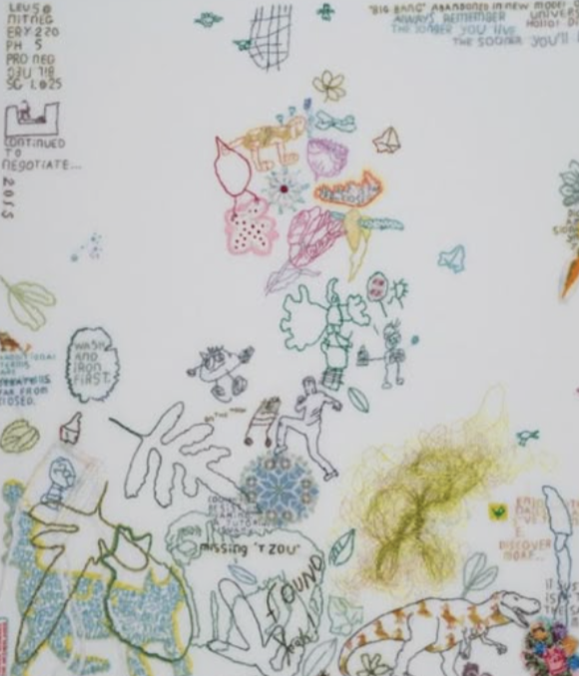
Emily Jo Gibbs Tilleke Schwarz

