
UNIVERSITY OF WALES TRINITY & SAINT DAVID
MODULE CODE: ACCA6026
rajeev nath
Andrey Atanasov
2324732
2324732@student.uwtsd.ac.uk
data warehousing AND DATA MINING (Assessment 2)

BSC applied computing

Contents
Introduction 2
TASK 1: Explore and analyse the dataset. 2
1.1: Purpose and Practice of Data Mining 2
1.2: Dataset Description and Exploration 2
1.3: Data Pre-Processing and Post-Processing 6
1.4: Sample Runs and Analysis Methods 8
1.5: Business Recommendations 10
1.6: Reflective Commentary 11
Conclusion 11
REFERENCES 12

Introduction
This report applies data mining techniques to the Online Retail Customer Churn dataset, a 1,000-record sample of customer demographic, transactional and engagement data. Two objectives, set out in the assignment brief, are addressed: predicting customer churn through classification, and identifying customer segments through clustering. Section 1.1 outlines the purpose and practice of data mining underpinning both objectives. Sections 1.2 and 1.3 use Tableau and Weka to explore and prepare the dataset. Section 1.4 presents sample classification and clustering runs in Weka. Sections 1.5 and 1.6 translate these results into business recommendations and reflective commentary.

TASK 1: Explore and analyse the dataset.

1.1: Purpose and Practice of Data Mining
Data mining is the process of discovering valid, previously unknown and potentially useful patterns within large volumes of data, applying statistical and machine learning techniques to data that has usually already been collected for another operational purpose [1], [2]. It sits within the broader Knowledge Discovery in Databases (KDD) process, which also includes data selection, cleaning, transformation and the interpretation of mined patterns into actionable knowledge [1]. Core data mining tasks include classification, assigning records to predefined categories, clustering, grouping similar records without predefined labels, regression and association rule mining [2].
In a retail context, data mining is applied directly to the kind of customer data collected through every transaction: purchase history, spending, support interactions and engagement behaviour. Two applications are central to this report. First, classification techniques can predict customer churn, identifying which customers are likely to stop purchasing before they actually leave, based on patterns in their past behaviour [3]. Second, clustering and profiling techniques, such as Recency-Frequency-Monetary segmentation, can identify distinct customer segments with different spending habits, loyalty levels and responsiveness to promotions [4].
Both applications feed directly into decision support: rather than treating all customers identically, a retailer can prioritise retention offers toward customers flagged as high churn-risk, and tailor marketing and promotions to the characteristics of each segment [4]. This report applies both techniques to the Online Retail Customer Churn dataset, using classification to predict churn and clustering/profiling to identify customer segments, aiming to produce concrete, data-driven recommendations for retail decision-makers.

1.2: Dataset Description and Exploration
Before any modelling is attempted, the dataset must be explored to understand its structure, quality and underlying patterns; this corresponds to the data selection and cleaning stages of the KDD process [1]. The Online Retail Customer Churn dataset used in this report was explored using Tableau and contains 1,000 customer records across 15 attributes, combining demographic fields (Age, Gender), transactional behaviour (Total_Spend, Num_of_Purchases, Average_Transaction_Amount, Years_as_Customer), engagement indicators (Num_of_Support_Contacts, Satisfaction_Score, Email_Opt_In, Promotion_Response, Last_Purchase_Days_Ago) and the binary target label, Target_Churn.
Checking for missing values and duplicate records is a standard first step before any predictive model is built [3]. A COUNT versus COUNTD comparison was run on the Customer_ID field: both measures returned 1,000, matching the total row count exactly, confirming that every record has a valid, unique identifier with no missing entries and no duplicated customers.
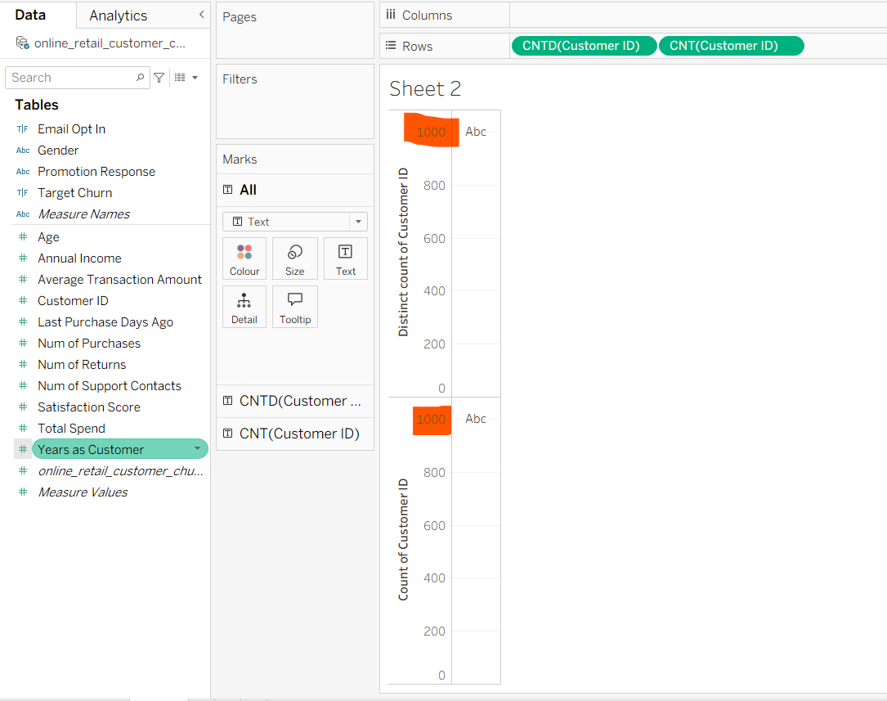
Figure 1: COUNT vs COUNTD check on Customer_ID confirming no missing values or duplicate records.
Summary statistics were then generated for the key numeric fields. Customers average 43 years of age (range 18–69), an annual income of approximately £112,000, and a total spend of around £5,081, made up of roughly 49 purchases at an average transaction value of £267, with a mean satisfaction score of 3 out of 5. Categorical fields were similarly balanced: Gender splits close to evenly across Female (342), Male (334) and Other (324), and Promotion_Response is spread across Unsubscribed (361), Responded (338) and Ignored (301). Critically, the target variable itself is close to balanced, with 526 churned customers against 474 retained, meaning the dataset does not suffer from the severe class imbalance that often complicates churn prediction.
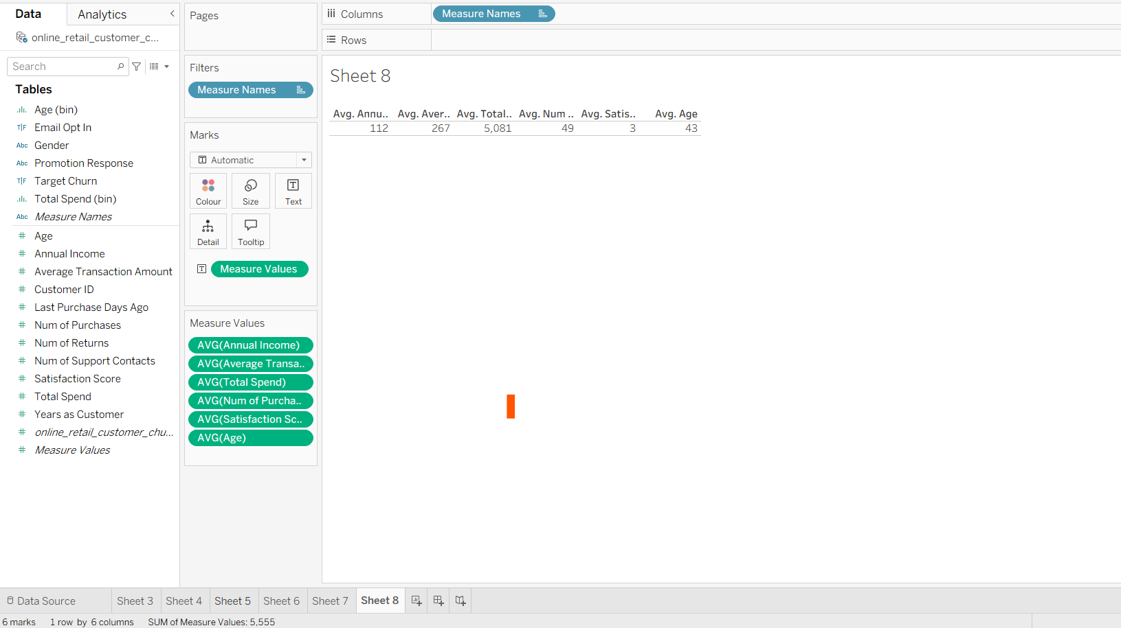
Figure 2: Average values for the key numeric fields.
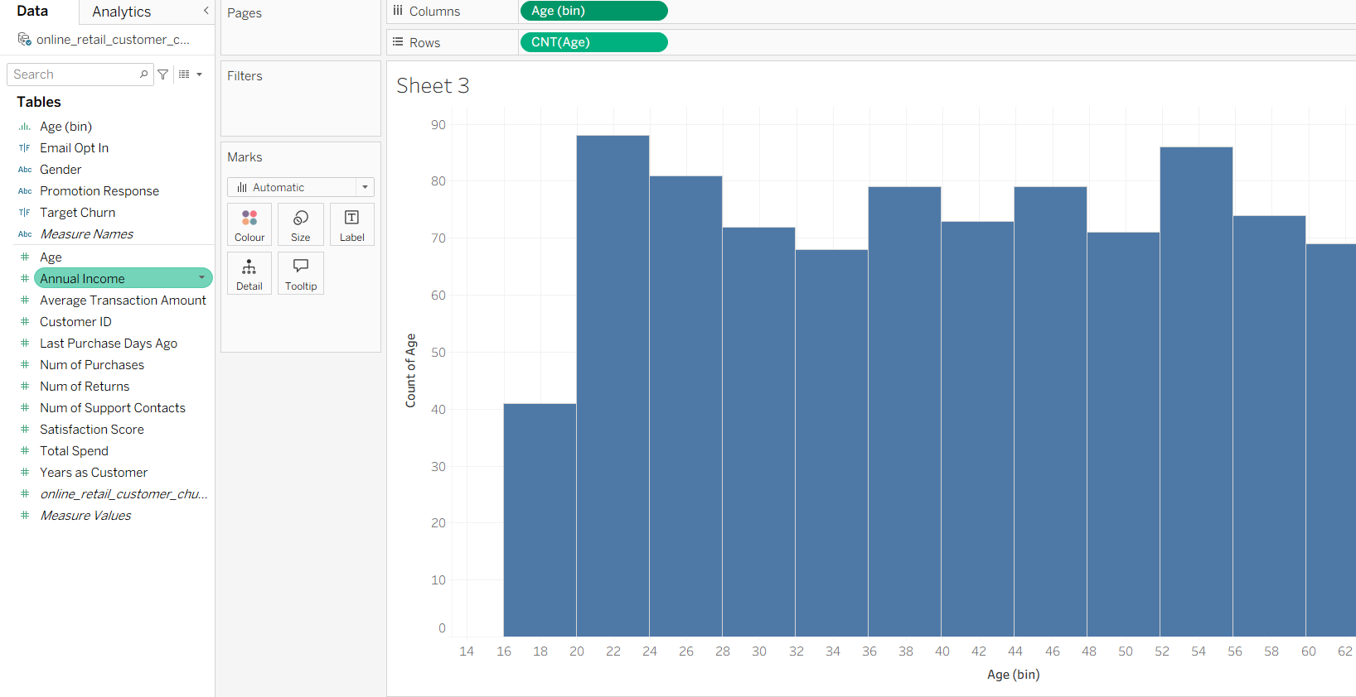
Figure 3: Distribution of customer Age.
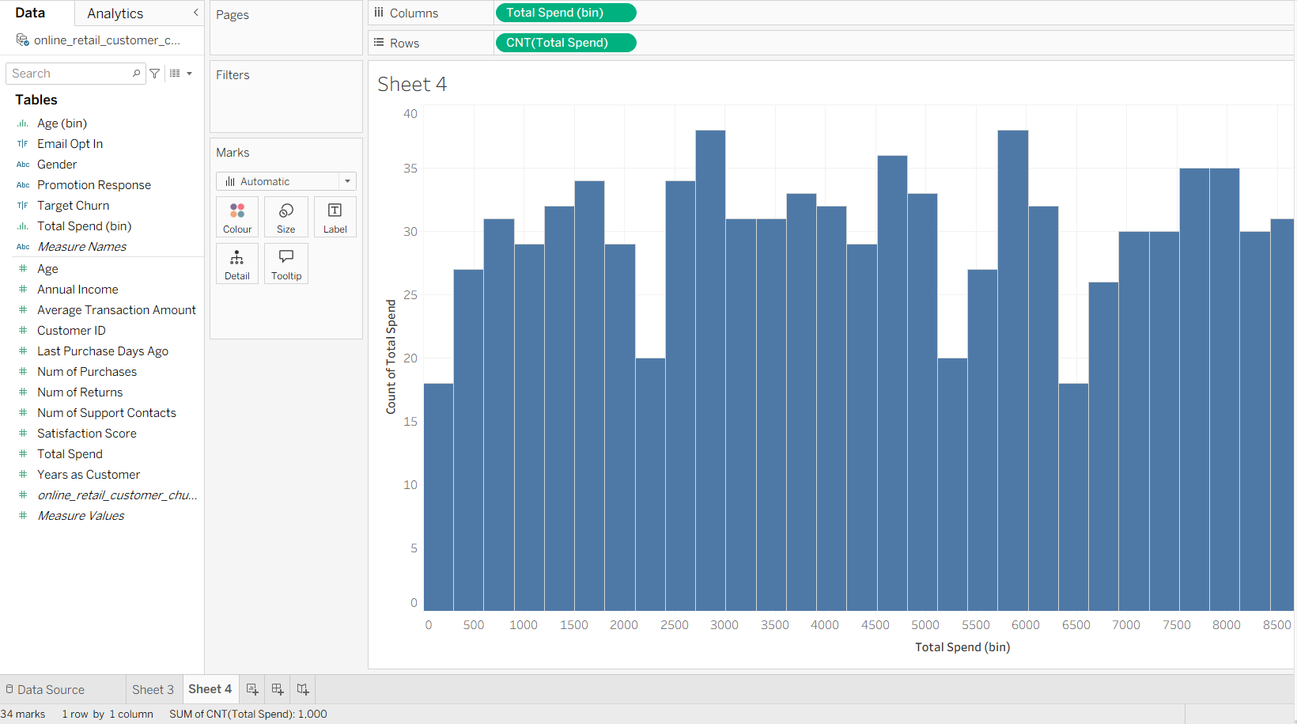
Figure 4: Distribution of customer Total_Spend.
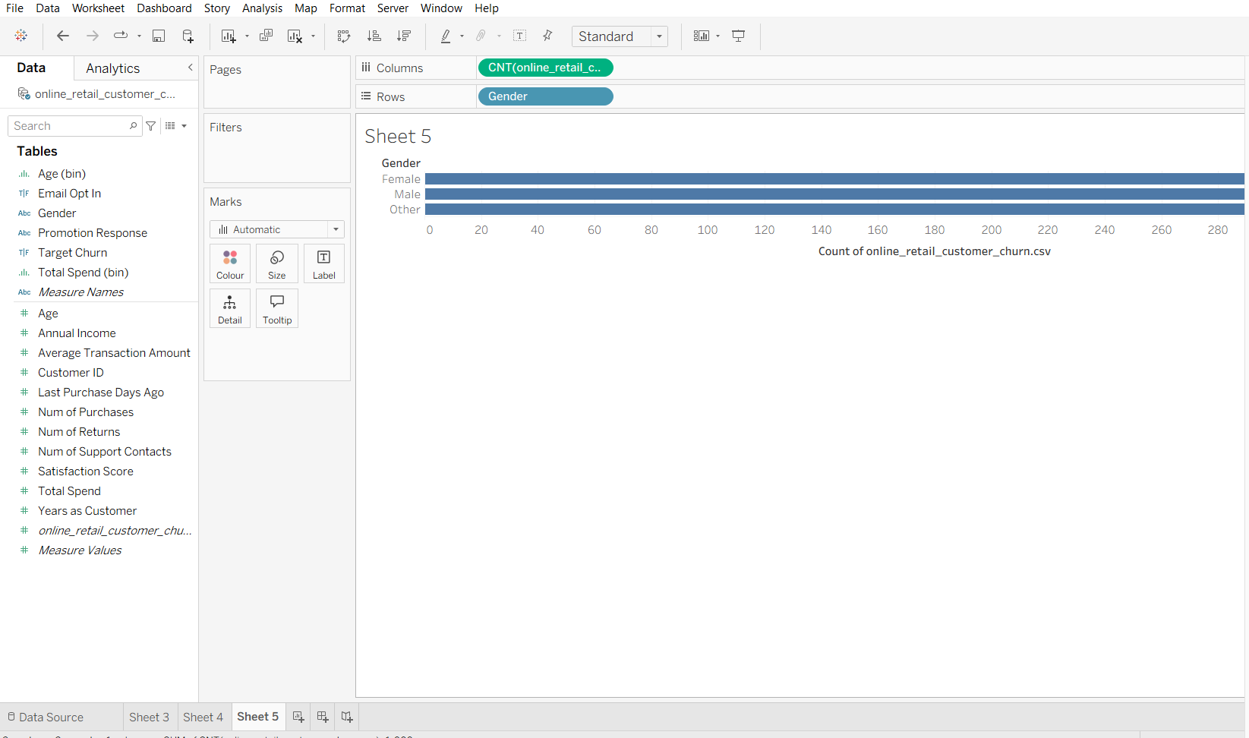
Figure 5: Customer counts by Gender.
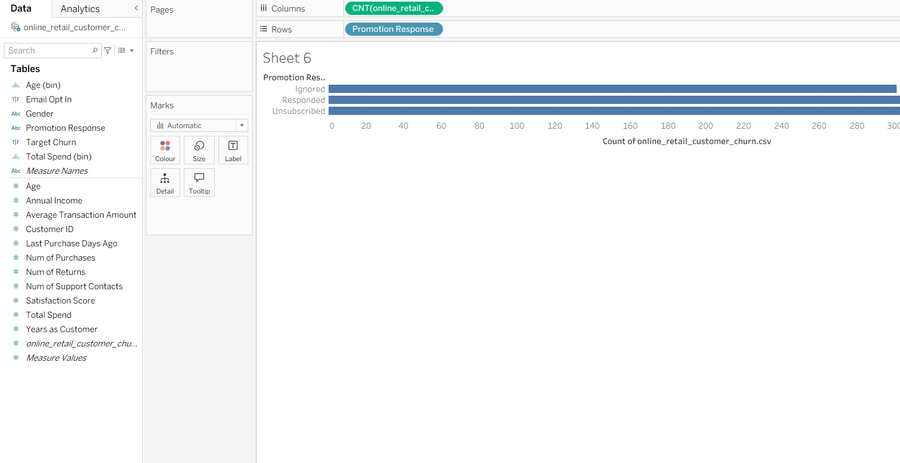
Figure 6: Customer counts by Promotion_Response.
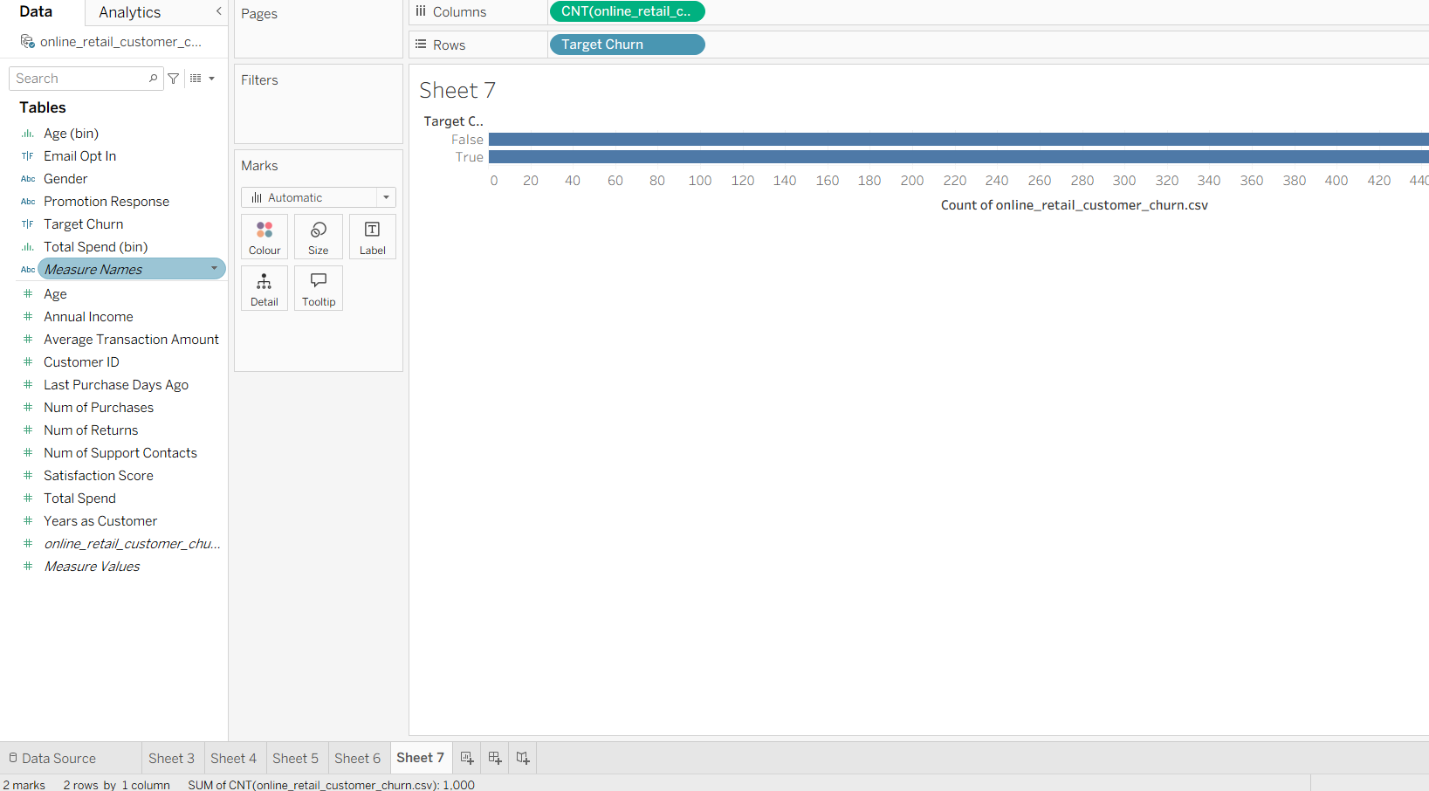
Figure 7: Customer counts by Target_Churn.
Finally, a scatter plot of Age against Total_Spend, coloured by Target_Churn, was produced to look for an obvious visual relationship between these variables and churn outcome. No clear separation emerges: churned and retained customers are distributed across the full range of ages and spending levels rather than forming distinct clusters. This suggests that churn in this dataset is unlikely to be explained by any single demographic or spending variable in isolation, and that a multivariate classification approach, applied in Section 1.4, is required to detect any underlying pattern.
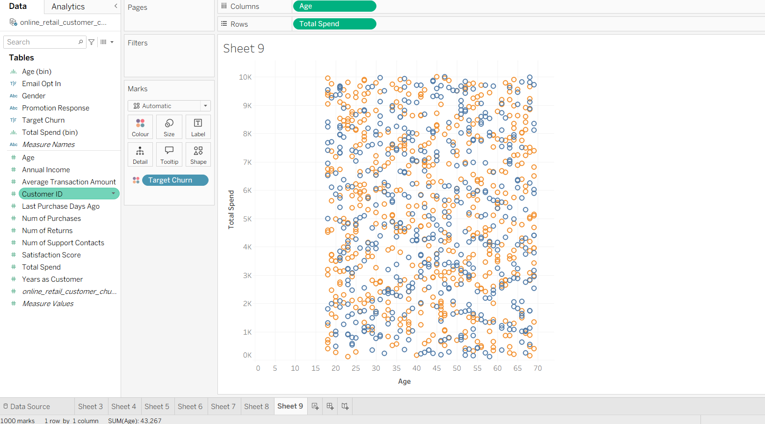
Figure 8: Scatter plot of Age vs Total_Spend, coloured by Target_Churn, showing no clear visual separation between churned and retained customers.

1.3: Data Pre-Processing and Post-Processing
Before a dataset can be mined, it must be transformed into a form suitable for the chosen algorithms; this corresponds to the data transformation and cleaning stages of the KDD process [1]. Although Section 1.2 already confirmed that the dataset contains no missing values and no duplicate records, several further pre-processing steps were required before the data was ready for classification and clustering in Weka.
The raw CSV file was loaded into Weka's Preprocess tab [5], giving 1,000 instances across 15 attributes, with Target_Churn automatically recognised as the nominal class attribute. Customer_ID was then removed using the Remove filter, since it is a unique identifier that carries no predictive information and would only add noise to any model trained on it, leaving 14 attributes for analysis.
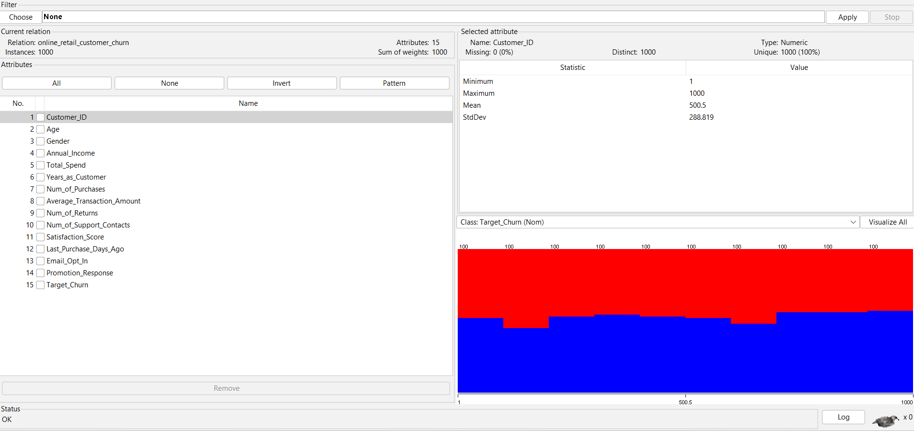
Figure 9: Raw dataset loaded into Weka's Preprocess tab (1,000 instances, 15 attributes).
The remaining numeric attributes, including Age, Annual_Income, Total_Spend, Num_of_Purchases and Average_Transaction_Amount, were measured on very different scales, for example Age ranges from 18 to 69 while Total_Spend ranges into the thousands. Algorithms that rely on distance or gradient calculations, such as logistic regression and k-means clustering [6], can be biased toward attributes with larger numeric ranges unless the data is rescaled first [3]. To address this, the unsupervised Normalize filter was applied in Weka, transforming every numeric attribute onto a common 0 to 1 scale while preserving the relative relationships between values, so that no single attribute dominates a model purely because of its magnitude.
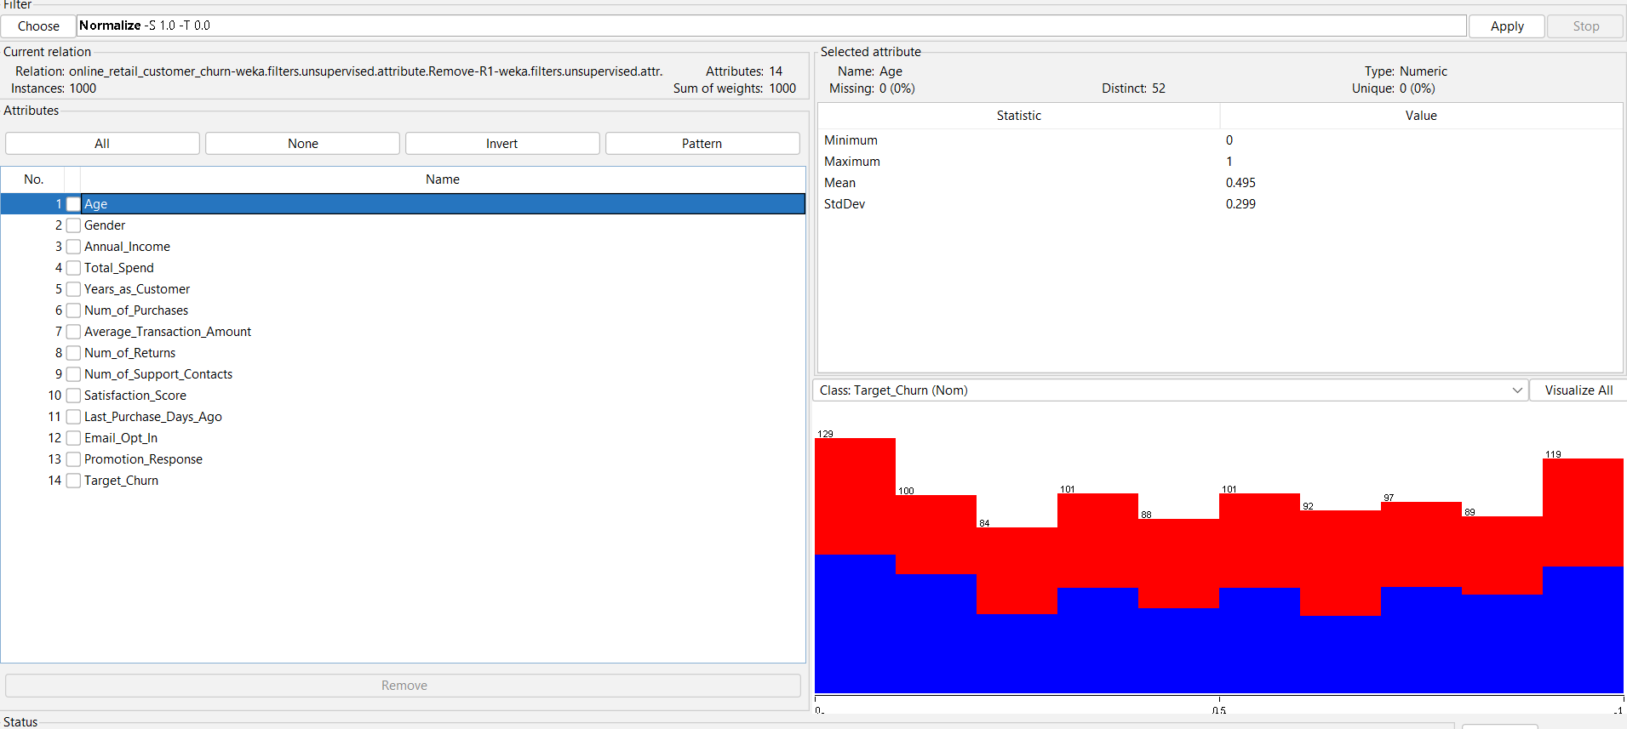
Figure 10: Attributes after removing Customer_ID and applying the Normalize filter (values rescaled to 0-1).
Two further pre-processing considerations were reviewed but judged unnecessary for this dataset. First, outlier removal and missing-value imputation are commonly required in churn datasets [3], but Section 1.2 already established that this dataset has no missing values, and the summary statistics did not reveal extreme or implausible values, so no imputation or outlier-removal filter was applied. Second, class balancing techniques such as oversampling are often needed when churn datasets are heavily skewed toward one outcome [3]; however, Target_Churn in this dataset is close to balanced (526 churned against 474 retained), so no resampling filter was required, and standard evaluation metrics can be used without adjustment for severe imbalance. The preprocessed dataset, with Customer_ID removed and all numeric attributes normalised, was then saved as an ARFF file for reuse in the Classify and Cluster tabs.
Post-processing in this project refers to how the output of the mining algorithms, applied in Section 1.4, will be evaluated and interpreted rather than taken at face value. Because Target_Churn is close to balanced, plain accuracy is a reasonable headline metric, but it will be reported alongside precision, recall and the F1-score, which combines both into a single balanced measure and is considered more informative than accuracy alone when the cost of missing a churner differs from the cost of a false alarm [7]. For classifiers that output a probability rather than a hard class label, the Area Under the ROC Curve (AUC) will also be examined, as it summarises how well a model ranks churners above non-churners across all possible decision thresholds [7]. Where a decision tree such as J48 is used, Weka's built-in pruning is left enabled by default, which is itself a form of post-processing: it simplifies the tree after it has been grown in order to reduce overfitting and improve generalisation to new customers. Comparing these metrics across the different algorithms specified in the brief will determine which model is best suited to predicting churn on this dataset, and this comparison is carried out in Section 1.4.

1.4: Sample Runs and Analysis Methods
This section applies the classifiers and clustering algorithm specified in the brief to the pre-processed dataset produced in Section 1.3, representing the data mining step of the KDD process where patterns are actually extracted from the data [1]. Three classifiers, J48 (a decision tree), Logistic Regression, and Random Forest, were each evaluated using 10-fold stratified cross-validation, a standard evaluation protocol that trains and tests each model on ten different splits of the data and averages the results, reducing the risk of an over-optimistic result from a single lucky train/test split.
The J48 decision tree, run first, produced a tree with 148 leaves and 285 nodes and correctly classified 504 of 1,000 instances (50.4% accuracy). Precision and recall for the True (churned) class were 0.527 and 0.548 respectively, giving an F-measure of 0.537, with a Kappa statistic of only 0.003, indicating almost no agreement beyond what chance alone would produce.
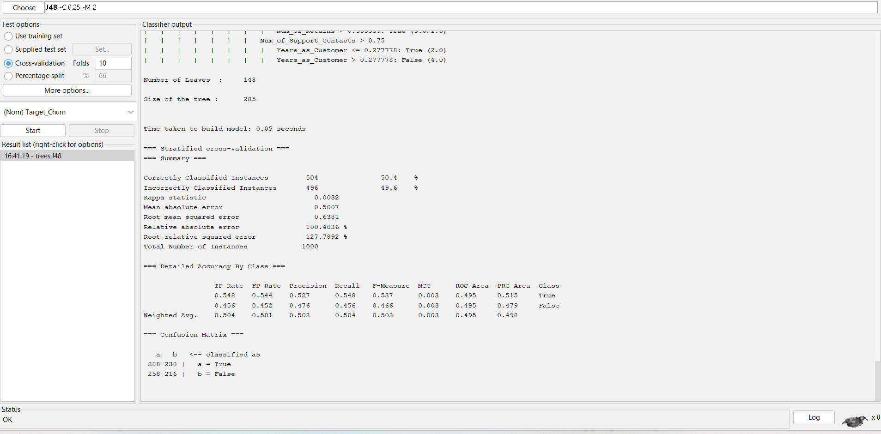
Figure 11: J48 decision tree classifier results (10-fold cross-validation).
Logistic Regression performed worse still, correctly classifying only 469 instances (46.9% accuracy), below the 52.6% that would be achieved by always predicting the majority class (True). Its Kappa statistic of -0.083 confirms the model performs worse than chance, and its ROC Area of 0.448 is below the 0.5 threshold that represents random ranking.
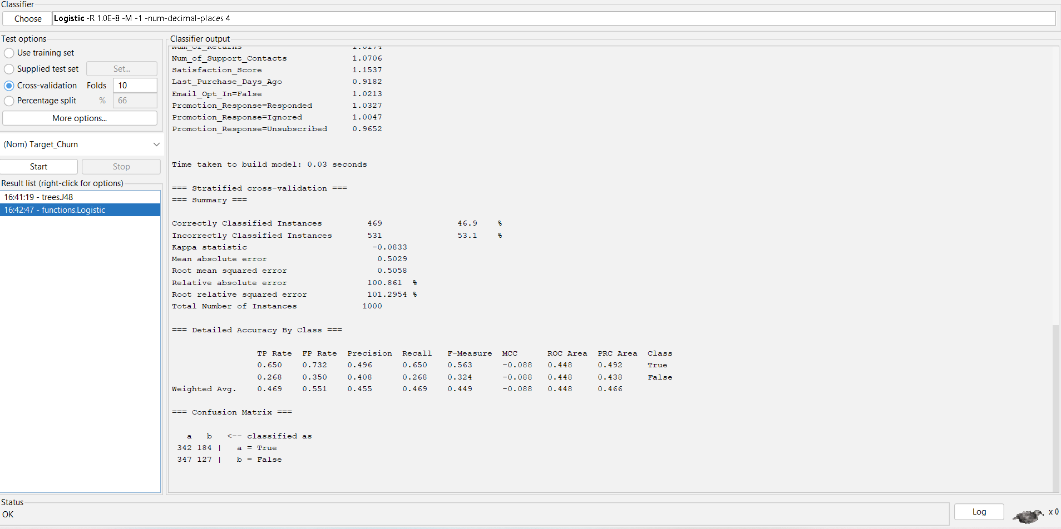
Figure 12: Logistic Regression classifier results (10-fold cross-validation).
Random Forest, an ensemble of 100 decision trees [8], correctly classified 511 instances (51.1% accuracy), with a Kappa of 0.010 and ROC Area of 0.490, essentially matching the performance of a coin flip despite being the most sophisticated of the three algorithms.
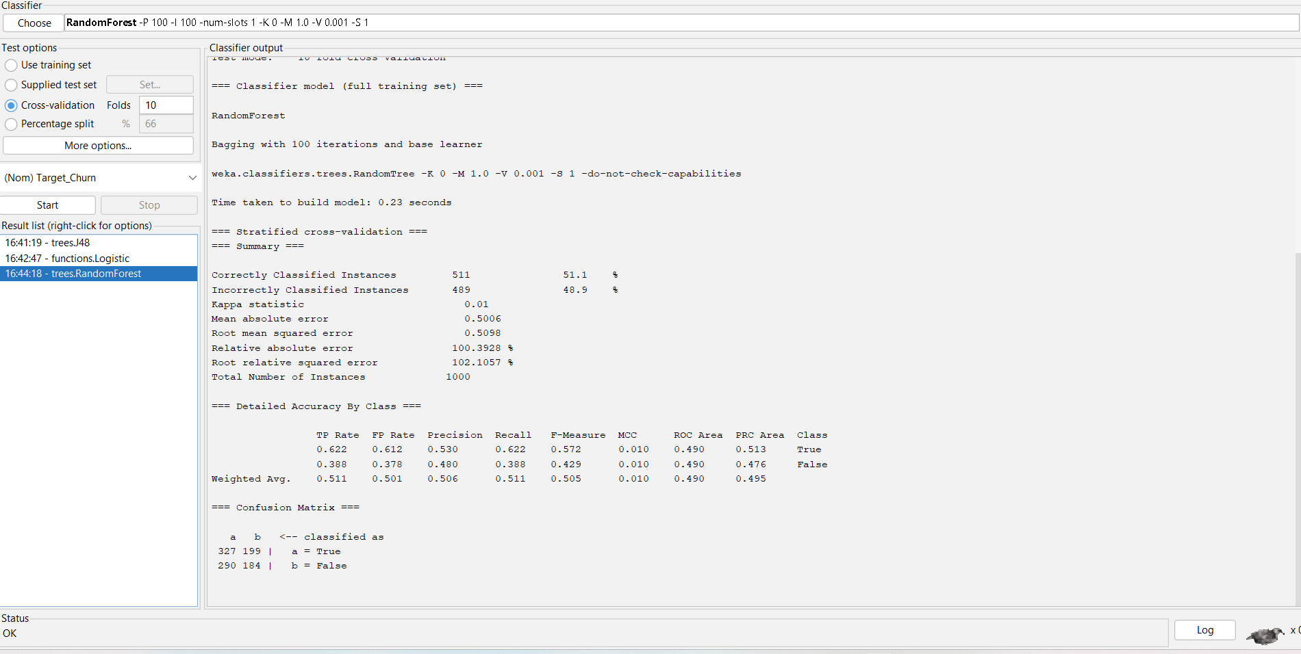
Figure 13: Random Forest classifier results (10-fold cross-validation).
Across all three classifiers, accuracy stayed within a narrow band of 46.9% to 51.1%, none exceeding the majority-class baseline, and Kappa values close to zero confirm that none of the models learned a meaningful relationship between the customer attributes and Target_Churn. This is consistent with the near-zero correlations and the absence of visual separation observed in the Section 1.2 scatter plot, and mirrors a pattern reported elsewhere in the churn prediction literature: models trained on datasets where the dependency between the available features and the churn label is inherently low cannot achieve strong predictive performance regardless of the algorithm used [3]. Rather than indicating an implementation error, this is itself a meaningful analytical finding, and is addressed further in Sections 1.5 and 1.6.
Although classification did not succeed, clustering was used to address the second aim of the brief: identifying customer segments independently of the churn label. SimpleKMeans [6] was run with K set to 4, with Target_Churn excluded from the distance calculation so that clusters reflect behavioural and demographic similarity rather than the outcome itself. The algorithm converged to four reasonably balanced segments of 275, 255, 225 and 245 customers. The clusters show distinguishable profiles: one segment skews male, older, with higher income, more purchases and returns, high satisfaction and a positive response to promotions, resembling an engaged, high-value customer group; another skews younger, with lower income and spend, more support contacts and a lower satisfaction score, resembling a more disengaged, at-risk group. Profiling customers in this way, based on transactional and engagement attributes rather than a single predicted label, is consistent with segmentation approaches used elsewhere in retail churn analytics to prioritise retention effort even when a reliable churn classifier is not available [4].
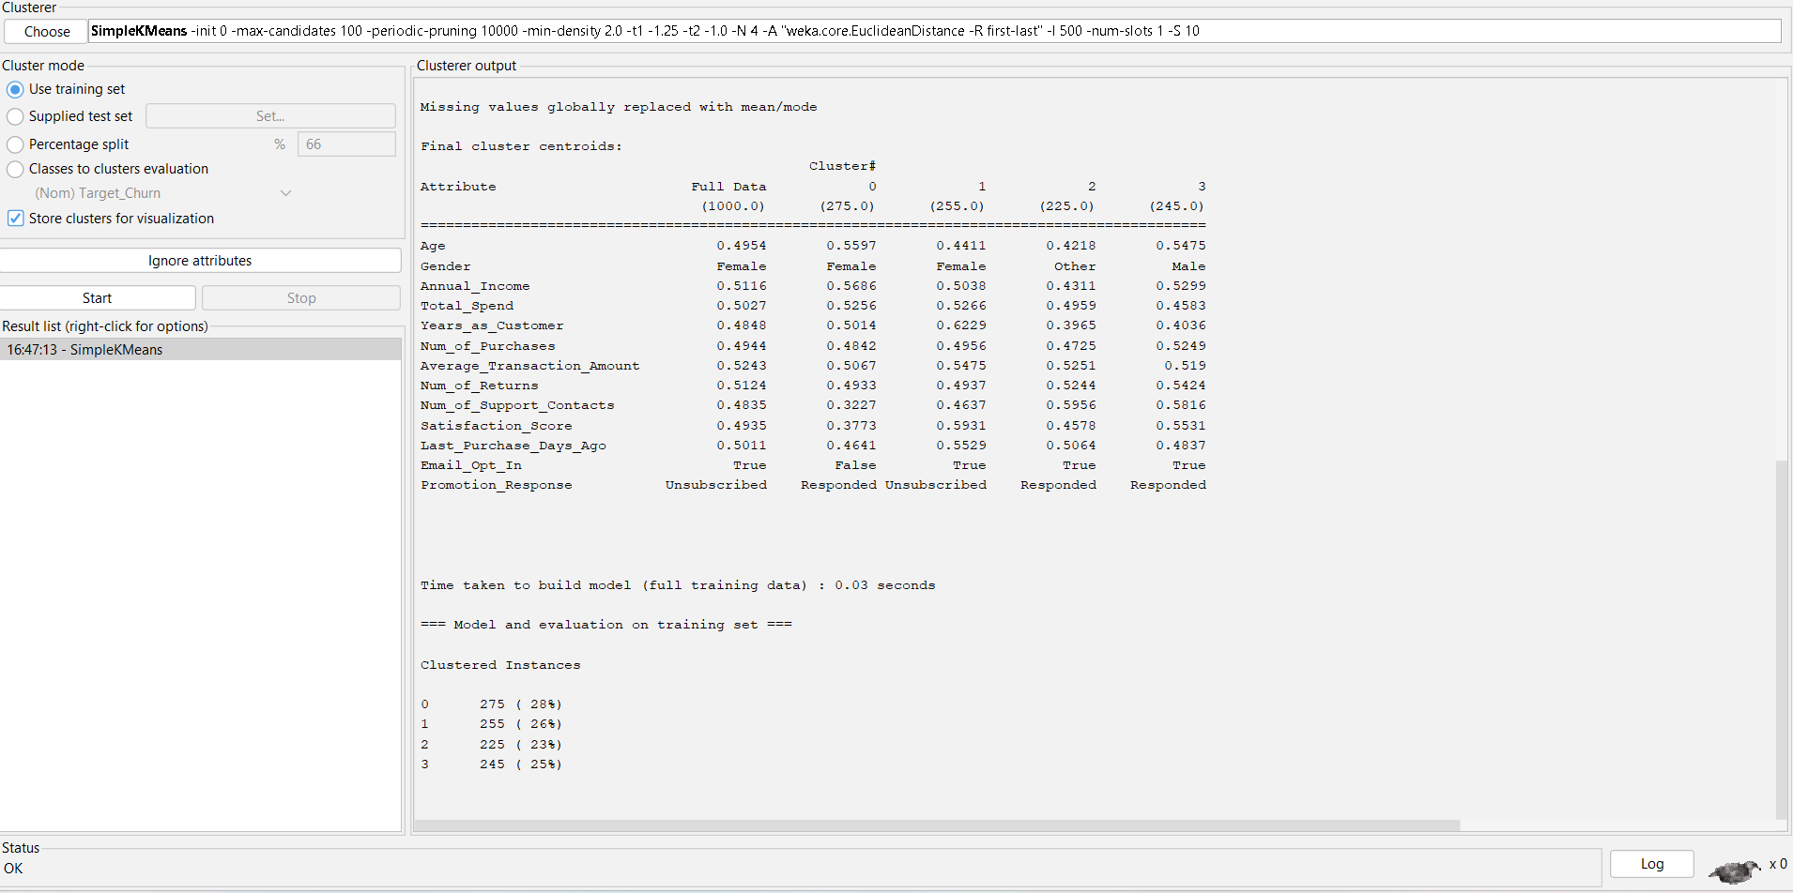
Figure 14: SimpleKMeans clustering results (K=4, Target_Churn excluded from distance calculation).
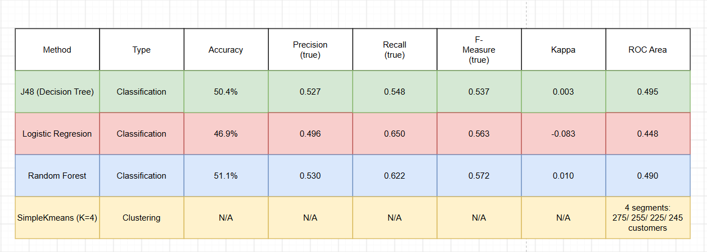Figure 15: Comparison of the four sample runs.
Overall, the sample runs show that this particular dataset does not support accurate churn classification with any of the three algorithms tested, but does support meaningful behavioural segmentation through clustering. Both outcomes carry direct implications for the business recommendations and reflective commentary that follow.

1.5: Business Recommendations
The pattern uncovered in Section 1.4, weak overall classification but clear behavioural segmentation, has direct implications for how the retailer should act. Rather than building a single blanket "churn score" that this data does not reliably support, retention effort should be targeted using the cluster segments identified by K-Means, since these captured genuine behavioural differences even where the classifiers did not [4].
The disengaged, at-risk segment (younger customers, lower income and spend, more support contacts, lower satisfaction) should be the immediate priority. Evidence from churn prediction research elsewhere identifies hidden fees, complicated return processes and low engagement as the strongest drivers of churn in online retail [9]; this points to concrete, low-cost actions: simplifying the returns process, being transparent about costs at checkout, and re-engaging this group through personalised offers or check-in communications rather than generic promotions.
The engaged, high-value segment (older, higher income, more purchases and returns, high satisfaction, responsive to promotions) is already retained; recommendations here should focus on reinforcing loyalty, for example through a rewards or early-access programme, rather than churn-prevention spending that this group does not need.
Finally, because none of the three classifiers extracted a usable signal from the fifteen available attributes, the retailer should not treat the current dataset as sufficient for automated churn scoring. Collecting richer behavioural data, such as browsing activity, delivery and complaint records, or the text of customer support interactions, would give any future model substantially more to work with than demographic and aggregate transaction totals alone.

1.6: Reflective Commentary
Reflecting on this task using Gibbs' Reflective Cycle [10] helps separate what was learned about the dataset from what was learned about the process itself. Descriptively, this was my first time using both Tableau and Weka; the exploration in Section 1.2 and the classification and clustering runs in Section 1.4 were completed without prior experience in either tool. My initial expectation was that the classifiers would achieve reasonably strong accuracy, so the near-random results across J48, Logistic Regression and Random Forest were an unexpected outcome, and it required a deliberate shift in approach to treat this as a finding to be explained rather than an error to be fixed.
On analysis, the weak classification performance is consistent across every algorithm tested, which points to a genuine property of the dataset (the available attributes carry little linear or non-linear relationship with churn) rather than a modelling mistake; this is consistent with findings elsewhere that model performance is fundamentally limited when the dependency between features and the target is low [3]. It also reinforced why evaluation should never rely on accuracy alone: Kappa and ROC Area were what revealed that these models performed no better than chance [7], a distinction I would not have investigated without applying the evaluation methods specified in Section 1.3.
If repeating this task, I would prioritise engineering additional features, such as interaction terms or recency-based ratios, before running classifiers, rather than treating the provided columns as fixed. More broadly, this project reinforced that honestly reporting a negative or null result, supported by clear evaluation metrics, is more valuable to a business stakeholder than overstating a weak model's usefulness.

Conclusion
This report set out to predict customer churn and identify customer segments in the Online Retail Customer Churn dataset. Three classifiers, J48, Logistic Regression and Random Forest, were tested and none exceeded majority-class baseline performance, indicating that the available attributes do not carry a strong signal for churn on this dataset. K-Means clustering, by contrast, revealed two clearly distinguishable customer profiles, an engaged high-value group and a disengaged at-risk group, which supported concrete, segment-based retention recommendations. Together, these results show that data mining outcomes are not guaranteed to be positive, and that a dataset's suitability for a given technique is itself a valid and useful finding. Future work using richer behavioural data would be needed before automated churn scoring could be reliably deployed for this retailer.

REFERENCES
[1] U. Fayyad, G. Piatetsky-Shapiro, and P. Smyth, “From data mining to knowledge discovery in databases,” AI Magazine, vol. 17, no. 3, pp. 37–54, 1996. [Online]. Available: https://www.kdnuggets.com/gpspubs/aimag-kdd-overview-1996-Fayyad.pdf [Accessed Jul. 25, 2026].
[2] T. Silwattananusarn and K. Tuamsuk, “Data mining and its applications for knowledge management: A literature review from 2007 to 2012,” International Journal of Data Mining & Knowledge Management Process, vol. 2, no. 5, pp. 13–24, Sep. 2012. [Online]. Available: https://arxiv.org/pdf/1210.2872 [Accessed Jul. 25, 2026].
[3] M. Chajia, E. H. Nfaoui, and S. Ouali, “Analyzing the impact of feature selection on customer churn prediction in the retail e-commerce industry,” AI, vol. 7, no. 7, art. 244, Jul. 2026, doi: 10.3390/ai7070244. [Online]. Available: https://www.mdpi.com/2673-2688/7/7/244 [Accessed Jul. 28, 2026].
[4] I. Ekanayake and S. De Alwis, “Explainability, risk modeling, and segmentation based customer churn analytics for personalized retention in e-commerce,” in Proc. 2026 6th Int. Conf. Advanced Research in Computing (ICARC), Belihuloya, Sri Lanka, 2026, pp. 1–6, doi: 10.1109/ICARC68737.2026.11454037. [Online]. Available: https://arxiv.org/pdf/2510.11604 [Accessed Jul. 28, 2026].
[5] M. Hall, E. Frank, G. Holmes, B. Pfahringer, P. Reutemann, and I. H. Witten, “The WEKA data mining software: An update,” ACM SIGKDD Explorations Newsletter, vol. 11, no. 1, pp. 10–18, 2009. [Online]. Available: https://www.kdd.org/exploration_files/p2V11n1.pdf [Accessed Aug. 4, 2026].
[6] J. B. MacQueen, “Some methods for classification and analysis of multivariate observations,” in Proc. 5th Berkeley Symp. Mathematical Statistics and Probability, vol. 1, Berkeley, CA, USA: University of California Press, 1967, pp. 281–297. [Online]. Available: https://projecteuclid.org/euclid.bsmsp/1200512992 [Accessed Aug. 4, 2026].
[7] D. M. W. Powers, “Evaluation: From precision, recall and F-measure to ROC, informedness, markedness and correlation,” International Journal of Machine Learning Technology, vol. 2, no. 1, pp. 37–63, 2011. [Online]. Available: https://arxiv.org/pdf/2010.16061 [Accessed Aug. 5, 2026].
[8] L. Breiman, “Random forests,” Machine Learning, vol. 45, no. 1, pp. 5–32, Jan. 2001. [Online]. Available: https://www.stat.berkeley.edu/~breiman/randomforest2001.pdf [Accessed Aug. 5, 2026].
[9] Shanthini B, Subhashini S, Kiruthika S, Yamuna S, Jothi Francina V, and Ramesh V, “Predicting customer churn using artificial neural networks: A data-driven approach to enhance customer retention in e-commerce,” Journal of Information Systems Engineering and Management, vol. 10, no. 41s, pp. 380–388, 2025. [Online]. Available: https://jisem-journal.com/index.php/journal/article/download/7854/3717/13636 [Accessed Aug. 9, 2026].
[10] G. Gibbs, Learning by Doing: A Guide to Teaching and Learning Methods. Oxford, U.K.: Further Education Unit, Oxford Polytechnic, 1988. [Online]. Available: https://radar.brookes.ac.uk/radar/items/a7e1f738-c0a2-47b5-8ab7-95b8973cdbf9/1/ [Accessed Aug. 9, 2026].

