Research Question: How can we improve pupils’ engagement through the use of a traffic light strategy?

 | Targed/Target | Yr hyn yr wyf wedi'i wneud yn yr aseiniad hwn.  What I have done in this assignment.
Targed/Target 1 | Ensure to bring literature into all aspects of your assignment. | I have linked literature into all sections of my assignment where possible.
Targed/Target 2 | Try to make links between theory and practice. | I have made necessary links between theory and practice where possible.
Targed/Target 3

How can we improve pupils’ engagement through the use of a traffic light strategy?

Aims, focus and purpose of research

The topic that interests me is assessment for learning (AFL) within the classroom. This interest arose from watching the documentary ‘The classroom experiment’ by Dylan Wiliam where he introduces new AFL strategies in a school to see what the outcomes are. I was curious to see if an AFL strategy would engage the children in my placement school during lessons.

During placement I was placed in a mixed year group class which consisted of children in years 5 and 6. Whilst being in this class and carrying out observations I recognised that children rarely took part in student self-assessment. The self-assessment they used within the classroom was written feedback at the end of a piece of written work in their books. This led me to discuss with my research partner how we could bring in student self-assessment throughout the lesson. After discussion of different AFL strategies, we decided to base our research study on the use of a traffic light system using coloured fans and exit trays within the classroom. However, other strategies would still need to be incorporated into the lesson in order to assess children’s understanding (Black et al., 2003). These strategies would include our traffic light system, the use of questioning and feedback (Black et al., 2003). The strategy we decided to trial was similar to what Dylan Wiliam tested out in the documentary as he used traffic light cups during a lesson in his experiment.

Our research question is “how can we improve pupils’ engagement through the use of a traffic light strategy?”. In my class were children between the ages of 9 and 11 and in my research partner’s class were children between the ages of 7 and 9. The aim of the research is to investigate how children, in different age groups, will engage with the AFL strategy of a traffic light system to effectively assess their own learning. The objective is for children to be able to independently identify their understanding of the work at the beginning, middle and end of the lesson. Children should feel confident in using the strategy to be able to gain a true reflection of understanding and engagement throughout the lesson. This will link in with the four purposes within the new curriculum to help children to develop as confident individuals (Donaldson, 2015). With the use of the strategy they may become more confident in assessing themselves and their understanding (Donaldson, 2015). For my class this meant that I would be introducing a whole new strategy for them to engage with. At this point, I was unsure how this research was going to go.

Short overview of relevant literature

I looked further into assessment for learning by conducting my own research which consisted of reading books, journal articles, government documents and other online resources. What this showed me is AFL is used to determine where learners are in their learning, where they need to go and how best they can get there (Earl, 2013). AFL is also a useful tool for teachers to identify how a lesson is going and allow for adaptations in the teaching and learning activities (Earl, 2013).

Formative assessment is an informal way of gaining student responses which can be used frequently within the classroom (Popham, 2006). According to Vonderwell and Boboc (2013) formative assessment can support child centred learning where learners can evaluate themselves during lessons. In order to achieve this, children need to be given clear success criteria and expectations to work towards (Tinto, 2012). By giving children clear success criteria, this will help them to be able to evaluate and asses themselves against the criteria (Tinto, 2012). However, students need to be taught how to self-assess and gauge their understanding of what is being taught before this strategy can be successful (Popham, 2006). Bennett (2011) agrees with this and adds that strategies should be well thought out and implemented within the classroom to facilitate learning. When strategies are implemented successfully it can be an ongoing tool for teachers to be able to adapt lessons to maximise student learning and can also help recognise when to put interventions in place (Dixson and Worrell, 2016). The use of mini plenaries can be an useful tool for assessing student understanding in the middle of a lesson and identify if any adaptations or further support is needed (Joyce-Gibbons, 2016). However, Beadle (2013) suggests that students need to be confident to accept they need further support during a mini plenary rather than struggling through a lesson. Otherwise, mini plenaries just become a tick box exercise rather than being an effective strategy for assessment (Beadle, 2013).

Recent research has suggested that teachers have been implementing formative assessment methods in classrooms with a high focus on meeting criteria for tests or qualifications (Hume and Coll, 2009). Wiliam et al. (2004) adds that schools are under pressure to achieve high results in external tests, therefore, formative assessment is not carried out as effectively. During a study on assessment for learning in Canada, some teachers recognised barriers in AFL strategies and transforming classroom practice (Volante, 2010). It has been noted that teachers have not received adequate training to put formative assessment into practice and therefore, have little knowledge or skills on the subject (Moss and Brookhart, 2019).

There is evidence to suggest that formative assessment improves students’ involvement in their learning (Black and Wiliam, 2005). If children understand lesson aims and objectives, and are clear of what the learning should look like, they may be more motivated to take action and want to learn (Black and Wiliam, 2005). This is further backed up by Crawford (2008) who states that self-assessment can lead to pupils developing greater confidence and focus on their learning. Only when children are clear on learning objectives, can they then engage in self-assessment to recognise where they are in their learning (Chappuis, 2005). When it comes to self-assessment, Chappuis (2005) states that children need a simple system in order for them to understand the stages of where they are in their learning. Atkin et al. (2001) suggest that traffic light system can be used for effective feedback. Children can mark their work with a green, yellow or red dot in order to indicate the level of understanding (Atkin et al., 2001). This system can also help teachers gain feedback and recognise which students may need extra support during the lesson (Atkin, 2001).

Lesson study design

The methodology used is lesson study research, which involves a form of action research in order to improve teaching and learning (Dudley, 2014). Lesson study is an effective way for teachers to work collaboratively in planning lessons and implementing new teaching techniques to develop a specific aspect of learning (BERA, 2014). Improving the quality of teaching and learning in the classroom will help to raise standards of achievements within schools in Wales (Hill, 2013). McKinsey and Company (2007) agree with this by stating that the quality of teachers outweigh the quality of the actual education system. Hattie (2009:22) also adds that “…the biggest effects on student learning occur when teachers become learners of their own teaching”. For teachers to do this, it is important for them to complete the cycle to plan, observe and reflect together in order to improve their practice (Rock and Wilson, 2005). This will then lead to increased motivation in student learning (Rock and Wilson, 2005).

The methods of data collection used are non-participant observation, focus group and reflection. The non-participant observations were collected using documents that my research partner and I produced. These observation documents consisted of an observation schedule to help structure what we were looking for and help indicate whether children are engaged in the strategy (Kumar, 2019). The observation will involve the researcher sitting aside in the classroom and having no active part in the lesson itself (Kumar, 2019). The researcher simply observed the selected children while gaining a full perspective of the lesson. The observer will be identifying whether children use the traffic light strategy in an informed way to be able to assess how they have engaged with them throughout the lesson. The traffic light strategy should also identify where children think they are at the beginning of the lesson and where they are at the end, hopefully showing better understanding after the learning has taken place (Black and Wiliam, 2005).

Three children were chosen as a sample for the focus group. These were identified as representing lower, middle and higher attainment across the curriculum from their carousel groups. These children were observed during the lesson in response to questions on our observation schedule which can be referred to in appendices 1 and 2. The Observation schedule also observed each case child’s level of involvement using the Leuven scale (Laevers, 2003). This will help to collect quantitative data by using the scale to recognise children’s level of involvement during the lesson. The scale will be used to identify the level of involvement the child is at (Laevers, 2003). This can then be analysed alongside other data collected. The results can determine what action points to take in order to organise the environment or increase involvement for future lessons (Laevers, 2015). However, the Leuven scale can also produce barriers as a child with low well-being may be less likely to be involved in the lesson (Laevers, 2015). This made me question whether both the involvement and well-being scale should be used within the research project.

The focus group interviews were conducted soon after the lesson observations to ensure children within the sample had fresh thoughts and opinions on the lesson and the use of the traffic lights. The focus group were asked a number of questions which related to the children’s experience in the lesson and their views on the traffic light strategy. The interview was semi-structured and the questions and schedule were planned in advance (Kumar, 2019). This can be referred to in appendix 5. Unstructured interviews allow for qualitative data collection (Kumar, 2019). This method gives scope and flexibility to alter or add questions as necessary (Kumar, 2019), especially useful when working with children as you may not always get a definitive answer from them and may have to re-word questions based on what the children understand. The researchers interviewed the children from their own class to ensure children felt comfortable about giving their views and opinions.

The purpose of the focus group interview also puts children at ease if they are together in a group rather than being questioned on their own (Kumar, 2019). This meant that children could bounce off one another’s answers and add opinions when they felt comfortable. Spratling et al. (2012) state that children may be able to effectively communicate their experiences in interviews. This interview method also allows for pupil voice to be valued, as it will influence and improve future practise (Morgan et al., 2002). However, these need to be conducted using child-friendly techniques involving appropriate vocabulary within questions to encourage child participation (Morgan et al., 2002). At the end of the interview, there was an opportunity to thank the participants and read back their answers to ensure their responses had been accurately captured and to remind them it will be part of my research and no names would be disclosed.

After conducting the observations and focus group interviews there was time set aside to reflect on the experience. The reflections were captured using Gibbs’ reflective cycle which consists of six different stages in order to give structure and make sense of the experience (University of Edinburgh, 2019) (LINK between theory and practice). These six stages include a description of the research and lesson; feelings of both researchers and participants; evaluation of strengths and weaknesses of the strategy; analysis of why something went well or did not go so well; conclusion of the overall findings and finally an action plan to suggest improvements to be made for future research and practice (Markkanen et al., 2020). The reflections are collaborative and shared with my research partner to share good practice and develop any recommendations for the future.

Ethical considerations

There are ethical considerations to consider when carrying out research within a classroom. According to BERA (2018), it is important for researchers to ensure that participants fully understand what is involved in the study and what the data will be used for. It is vital to obtain voluntary informed consent from participants and they must understand that they have the right to withdraw at any time without an explanation (BERA, 2018). To obtain this consent a letter will be sent out to parents outlining the research where they will be required to sign to give permission for their child to take part. Children will also give verbal assent after listening to the research brief. The children will also be made aware that they can approach the researchers at any time to withdraw. This is in accordance with UNCRC Article 12 which states that children should have a say in matters that affect them (UNICEF, no date). When conducting research, it is vital for participants to remain anonymous throughout and any information kept confidential (BERA, 2018). To ensure this in our data collection we will not use any identifying information such as the school or children’s names (BERA, 2018).
Lesson study 1

Lesson study 1 can be referred to in appendix 1. This was carried out in a mixed year 5/6 class of 28 children. At the beginning of the lesson, I made sure to introduce the traffic light strategy clearly to the class and explain how we were going to be using the fans throughout the lesson. This links with the theory that children need to be given clear instructions and expectations for the lesson in order to be successful (Tinto, 2012). All case study children held up a green light using their fans to respond to my question and clarify they understood how to use the fans. With reference to appendix 1, all children held up their fans quickly and confidently showing full engagement. The lesson was clearly introduced, and the aims, which was to create a graph using the data collected from a science experiment from the previous session, were clarified with the children. Success criteria was shared with the children and displayed throughout the lesson so children could refer back to it if they needed to (Tinto, 2012). When the children were asked to hold up their fans to indicate their understanding at the beginning of the session, I had different responses. Child A held up an orange light, meaning they needed a little bit of support to understand. Child B originally held up an orange light, however, the observer had recognised them looking around the room which influenced them to turn to a green light. This may have been because their peers were holding up a green light so they may have felt they needed to be the same. Berndt (2010) suggests that friends can sometimes have an influence on one another and may result in imitating behaviours. This may then be a barrier as it is not a true reflection on their understanding of the lesson.

Halfway through the lesson, I asked children again to hold up their lights to indicate their understanding. All children held up a green light at this point but was interesting to observe that child C took longer to put theirs up. This acted as a mini plenary and gave me the opportunity to use questioning strategies to check individual understanding. According to Joyce Gibbons (2016) mini plenaries can be an effective way to assess whole class understanding and identify if any support or further instructions are needed.

With reference to the observation schedule in appendix 1, it is noted that child C asks for help from their peers throughout the lesson which indicates they may have needed extra support but was reluctant to put up an orange light. It was also recognised that that child A went over to help child C during the lesson. Chid B asks their peers for reassurance throughout the lesson, rather than asking the teacher or teaching assistant for clarification. Whereas, child C always seemed to be asking me to confirm if they had plotted the graph correctly.

I gathered children on the floor area at the end of the lesson for their feedback on what they thought of the traffic light system and if they enjoyed using the traffic light fans. All three children held up a green light for enjoyment. Following this, to end the lesson, children placed their names into coloured exit trays when leaving the classroom. This is an useful tool to identify how the children self-assess their own understanding (Ozan, 2018). Child A and B both placed their names in the green tray, whereas, child C placed theirs in the orange tray. Ozan (2018) suggests that children may become more confident in self-assessing if they do it regularly. Self-assessment can increase attitude and motivation to learning as children can identify where they may need support (Ozan, 2018).

After reflecting with my research partner after lesson study 1, we felt asking children’s understanding of the lesson before the introduction worked well because children could see how they progressed after having the introduction on the lesson. It also indicated children’s understanding on line graphs before having a recap on them. This activated prior knowledge beforehand and is useful for teachers to assess what the children can remember from a previous lesson (Kostons and Werf, 2015).

During the focus group I used the interview questions to gain responses from the three children we chose for the sample. The focus group allowed the participants to express their opinions on the new strategy, whilst adhering to a sequence of questions (Adler et al., 2019). The questions and answers from the interview can be referred to in appendix 5. Child C enjoyed the traffic light system because it was new and explained it can help the shy children within the class to get involved and give an answer. Child A stated they liked the system because of the concept of just holding up a colour and they did not have to talk to express how they were feeling. Child B also stated that everyone in the class was included instead of the same children that always put their hands up. Hearing this opinion made me link to a no hands up strategy from my research (Black et al., 2003). It made me consider using a no hands up strategy as a further AFL strategy and to choose children at random using a randomiser when answering questions (Black et al., 2003). Child C also added that the teacher will know when someone needs help with their work if they hold up a red or orange light.

All three children said there was nothing they disliked about using the fans or the exit trays. I asked the children which traffic light method they liked the most. Child B voiced that they liked the exit trays because it was done individually when leaving the classroom and everyone had a chance to say where they felt they were. They also said that the teacher can gain feedback from this and know which children still think they need a bit more support. Child A enjoyed the fans because they had ownership of them through the lesson and it was interactive. Child C agreed with this and asked if we could use them more often in class. When I asked the children what colour they held up at the start of the lesson, all answers corresponded with the observation schedule of the lesson, showing that they remembered what they had chosen. However, Child B had originally held up an orange but switched to a green after looking around the room. Child A and C both agreed that they were a little unsure at the start of the lesson about how to create their line graphs but after being showed had greater understanding before starting their work. I asked children what exit tray they placed their name into at the end of the lesson. Child A said that they found the work easier than they thought and put theirs in the green exit tray. Child B also placed theirs in the green exit tray and said that if they were asked to do a graph again, they would feel more confident now. Child C said that they put theirs in the orange exit tray because they kept getting confused with the squares on the graph paper. All 3 children agreed that they would like to use the traffic light fans more often in lessons, with child B stating that it helps them think about what they understand in the lesson.

According to Mertler (2009) it is important to reflect on research and identify strengths and areas for development for future research. On reflection, I recognised that the traffic light strategy went well because I had clearly explained to the children how and why we were using them. Children also understood what each colour meant when holding them up. During the lesson some children were drawn to the fans and fussing with them throughout. I come to the conclusion that this was a novelty to them as it was new, however, if we were to use this strategy more in class in the future, they would become used to them. However, I found children were more engaged than usual during the introduction of the lesson. On analysis, this may be because the traffic light fans were something new and this motivated the children to participate and hold up a green light. However, according to Ryan and Deci (2009) it is important for children to use a variety of methods to maintain engagement in lessons and increase student motivation. Although the children enjoyed and engaged in the traffic light strategy it is important to use a variety of AFL strategies within lessons.

Lesson study 2

Lesson study 2 can be referred to in appendix 2. This was carried out in a mixed year 3/4 class of 26 pupils. At the beginning of lesson study 2 the teacher made sure children understood how to use the traffic light fans and what each colour meant. Following this the teacher asked children to hold up traffic lights to show their understanding of them, Child A, B and C all held up a green light. The teacher then went on to clearly introduce the lesson, outlining what they were going to be learning about and clarified the lesson aims. At the start of the lesson, and before the introduction on long division, the teacher asked the children to use their traffic light fan to indicate where they think they are on their understanding of the topic. Child A and C both hold up a green light straight away. Whereas, Child B held up an orange light but then decided to change it to green after looking around the room. This was very interesting as it was similar to what happened in lesson study 1 and refers back to peers influencing decisions within the classroom (Berndt, 2010). During the introduction Child A seemed to be disengaged and was looking down while playing with the traffic light fan. Child C payed attention throughout the introduction and offers answers to the teacher’s questions on long division. The teacher purposely asks child A a question in an attempt to reengage them in the lesson. This made use of other AFL strategies such as questioning techniques to gain futher feedback and identify any support needed (Joyce-Gibbons, 2016). Child A tried to answer the question but needed some support to get the answer. After this, Child A goes back to looking around the room and often not looking at the teacher throughout the lesson. This made me question whether they still did not understand the lesson.

During the main activities the three children were in different groups to suit their abilities. Child C went to their allocated table and started to look at the worksheet, however, then moved their chair to be able to sit by their peers to have a chat. Child B starts working straight away and is engaged in trying to work out the sums. Child A sat ready at the table to work with the teacher for support.
A little while into the lesson, another child who was sitting next to Child B tries to distract them by chatting, but Child B decides to ignore this and carry on with their work. Child C seemed very distracted during the activities and was more interested in chatting to their friends. This is where different AFL strategies may be beneficial such as mini plenaries and questioning for the teacher to assess understanding and remind children of the success criteria (Black and Wiliam, 2005).

To check if the class all understood what they are supposed to be doing, halfway through the lesson the teacher asked the children to hold up the traffic lights to indicate their understanding and check if anyone needed support (Black and Wiliam, 2005). Child A and C held up a green light to show they understood what they were doing. Whereas, child B held up an orange light. The teaching assistant recognised this and went over to give them support. I recognised child C was still chatting to peers and playing with the fan, so I walked over to their table to see how they were getting on. It was apparent that Child C was completing their work but as they were able to work out the sums quite quickly, they were not fully occupied with the task. On reflection, we recognised that Child C may needed to have been challenged further or given an extension task (Donaldson, 2015). Child A was focused throughout the task with support from the teacher and was able to explain the method they were using to work out the answers.
During the plenary all children were asked to hold up their traffic light fans for the enjoyment of the lesson. All children held up a green light to indicate they enjoyed the lesson.
At the end of the lesson children were asked to place their names in a green, orange or red exit tray depending on how they understood the lesson and their competence on long division. Child A, B and C all placed their names into the green exit trays.

Discussion of research findings

Findings from both lesson studies showed a child in each class changing their answer after recognising the answers of their peers. In relation to this, Over and Carpenter (2012) suggest that children may feel social pressures in an experience and want to imitate peer answers in order to be the same. Children may also feel embarrassed to show that they don’t understand or admit they need support (Berndt, 2010). To overcome this, when using the fans next time, answers could be made more anonymous by children closing their eyes or putting their heads down when holding up their fan. This would link with Black and Wiliam (2005) theory of ensuring anonymity and children would feel less pressured. When I carried out my observation in lesson study 2, it was difficult to determine the level of involvement for each child during the lesson using the Leuven scale. A copy of the Leuven scale can be found in appendix 6. This was because I found children had different levels of involvement for different parts of the lesson. For example, one child was engaged for the introduction and then less engaged for the main activity. I would have liked to separate different parts of the lesson in order to use the scale more accurately for each part. Kent (2016) back this up by saying that pupils’ levels of involvement will differ throughout the day, therefore, is unrealistic when observing for short periods of time. If I was to use this scale again, I would split up the lesson in order to give children a level for different stages throughout the lesson. However, Lietart et al. (2015) state that boys may be less engaged than girls and that girls may seek more support from their teacher.

Conclusion

I recognise the importance of ethical considerations and confidentiality. Before starting the research, I made sure that consent was given by all parties involved in the study, no names were recorded, and participants remained anonymous (BERA, 2018).

From carrying out research on AFL I was able to determine that AFL can increase learning gains, engagement and motivation (Black and Wiliam, 2005). By putting a strategy into place, I was able to experience first-hand the effect it had on learning and engagement in the class as a whole. Some children within the class would sometimes be disengaged from the start, however, I observed that during my instructions for the lesson, the introduction of the traffic light fans interested the children and engaged them from the start. This was backed up by feedback from the focus group who indicated that they liked the used of the traffic light fans. They reported that enjoyed the exercise and they felt this was a good way to express their thoughts without speaking out (Adler et al., 2019).

I used a number of different methods in my study lesson. Starting with non-participant observation. The advantage of doing this, is the observer can gain a full perspective of the class while also observing the children selected for the study (Kumar, 2019). This could also have a negative effect as some children may not feel comfortable being observed and, therefore, may react in a way which is not usual for them (Morgan et al., 2002).

Children with a range of attainment levels were selected for this study and the focus group interview. Choosing children with different attainment levels gave a better picture of the class thus strengthening the findings falling out of the study. To ensure the children felt comfortable to express their views, I decided to conduct the focus group interviews myself in the form of an informal chat (Kumar, 2019). As I am known to them, there is the possibility that the children may tell me what they think I want to hear so it was important that I did not guide them in any way. If the interviews were carried out by someone who was not familiar to the children, they may not have given a true account of their views.
For formative assessment to be effective children must be able to assess themselves. To do this, it is important that children understand what the learning goals are (Black and Wiliam, 2005). Teachers need to help the children to understand what this means and how to do it for it to be effective (Tinto, 2012). This was achieved during my lesson study by me first clearly setting out the aims of the lesson. In order for me to gauge whether or not the children understood the instructions, they were asked to use the traffic light fan to indicate their level of understanding.

Gibbs reflective cycle proved to be a useful tool. The six stages helped me to structure my reflection and focus on different elements of the research study (University of Edinburgh, 2019). Reflection is vital in order to improve teaching practice. It highlights areas for improvement and areas of success. It is also best practice to share the findings with others (Kumar, 2019). Everyone in the class benefited from AFL and I would like to test out the theory on other age groups to see if the findings would be similar.

Recommendations

If I was to do lesson study research again, I would carry out a pilot study first. By doing this it can help identify any barriers or limitations to the research beforehand (Kim, 2010). A pilot study can be essential to make modifications to the research plan in order to achieve more accurate results (Kim, 2010). However, Van Teijlingen and Hundley (2001) state that a pilot study may not guarantee the main research study to be a success, but it can increase the chances. Van Teijlingen and Hundley (2001) also state that these pilot studies can be conducted on a smaller scale than the plan of the research and acts as a pre-test. It is also important to discuss with researchers the processes and findings of the pilot study (Van Teijlingen and Hundley, 2001).

Reference List

Adler, K., Salantera, S., and Zumstein-Shaha, M. (2019) ‘Focus Group Interviews in Child,Youth, and Parent Research’, International Journal of Qualitative Methods, Volume 18, Issue 1.

Atkin, J. M., Black, P., and Coffey, J. (2001) Classroom assessment and the National Science Education Standards. Washington: National Academy Press.

Beadle, P. (2013) The Book of Plenary: Here Endeth the Lesson. London: Crown house Publishihg.

BERA. (2014) ‘Research and the Teaching Profession: Building the capacity for a self-improving education system’ https://www.bera.ac.uk/wp-content/uploads/2013/12/BERA-RSA-Research-Teaching-Profession-FULL-REPORT-for-web.pdf?noredirect=1 [Accessed: 11th February 2020].

BERA. (2018) Ethical Guidelines for Educational Research. (4th ed) London: British Educational Research Association.

Berndt, T, J. (2010) ‘Friends’ influence on students’ adjustment to school’, Journal of Educational Psychologist, Volume 34, Issue 1, pp. 15-28.

Black, P., Harrison C., Lee, C., Marshall, B., and Wiliam, D. (2003) Assessment for Learning: Putting it into practice. Berkshire: McGraw-Hill Education.

Black, P. and Wiliam, D. (2005) Changing Teaching through Formative Assessment: Research and Practice. London: OECD.

Chappuis, J. (2005) ‘Helping Students Understand Assessment’, Educational Leadership, Volume 63, Issue 3, pp. 39-43.

Crawford, R. (2008) Understanding and using assessment and delivering feedback. Los Angeles: SAGE.

Dixson, D. and Worrell, F. (2016) ‘Formative and Summative Assessment in the Classroom’, Theory Into Practice, Volume 55, Issue 2, pp. 153-159.

Dudley, P. (2014) ‘Lesson Study: a handbook’ http://disde.minedu.gob.pe/bitstream/handle/123456789/5017/Lesson%20Study%20a%20Handbook.pdf?sequence=1&isAllowed=y [Accessed: 11th February 2020].

Earl, L. M. (2013) Assessment as Learning: Using Classroom Assessment to Maximize Student Learning. (2nd ed) London: SAGE Publications.

Hattie, J. (2009) Visible learning: A synthesis of over 800 meta-analyses relating to achievement. London: Routledge.

Hill, R. (2013) The future delivery of education services in Wales. Cardiff: Welsh Government.

Hume, A. and Coll, R. (2009) ‘Assessment of learning, for learning, and as learning: New Zealand case studies’, Journal of Assessment in Education: Principles, Policy and Practice, Volume 16, Issue 3, pp. 269-290.

Joyce-Gibbons, A. (2016) ‘Observe, interact and act: teachers’ initiation of mini-plenaries to scaffold small-group collaboration’, Journal of Technology, Pedagogy and Education, Volume 26, Issue 1, pp. 51-68.

Kent, J. (ed) (2016) Embracing levels of involvement in the Early Years: Engaging with children’s possibilities. London: Taylor and Francis.

Kim, Y. (2010) ‘The Pilot Study in Qualitative Inquiry: Identifying Issues and Learning Lessons for Culturally Competent Research’, SAGE Journals, Volume 10, Issue 2, pp. 190-206.

Kostons, D. and Werf, G. (2015) ‘The effects of activating prior topic and metacognitive knowledge on text comprehension scores’, British Journal of Education Psychology, Volume 85, Issue 3, pp. 1-28.

Kumar, R. (2019) Research Methodology: a step by step guide for beginners. (5th ed) London: SAGE Publications.

Laevers, F. (2015) ‘Making care and aducation more effective through wellbeing and involvement. An introduction to Experiential Education’ http://citeseerx.ist.psu.edu/viewdoc/download?doi=10.1.1.616.6958&rep=rep1&type=pdf [Accessed: 10th July 2020].

Laevers, F. and Heylen, L. (2003) Involvement of Children and Teacher Style: Insights from an international study on experiential education. Leuven: Leuven University Press.

Lietaert, S., Roorda, D., Leavers, F., Verschueren, K., and Fraine, B. (2015) ‘The gender gap in student engagement: The role of teachers’ autonomy support, structure and involvemnet’, British Journal of Educational Psychology, Volume 85, Issue 4.

Markkanen, P., Valimaki, M., Snttila, M., and Kuuskorpi, M. (2020) ‘A reflective cycle: Understanding challenging situations in a school setting’, Journal of Educational Research, Volume 62, Issue 1, pp. 46-62.

McKinsey and Company (2007) ‘How the world’s best-performing school systems come out on top’ https://www.mckinsey.com/~/media/McKinsey/Industries/Social%20Sector/Our%20Insights/How%20the%20worlds%20best%20performing%20school%20systems%20come%20out%20on%20top/How_the_world_s_best-performing_school_systems_come_out_on_top.ashx [Accessed: 11th February 2020].

Morgan, M., Gibbs, S., Maxwell, K., and Britten, N. (2002) ‘Hearing children’s voices: methodological issues in conducting focus group interviews with children ages 7-11 years’, SAGE Journals, volume 2, Issue 1, pp. 5-20.

Moss, C. and Brookhart, S. (2019) Advancing Formative Assessment In Every Classroom. (2nd ed) London: ASCD.

Over, H. and Carpenter, M. (2012) ‘Putting the social into social learning: Explaining both selectively and fidelity in children’s copying behaviour’, Journal of Comparative Psychology, Volume 126, Issue 2, pp. 182-192.

Ozan, C. (2018) ‘The Effects of Formative Assessment on Academic Achievement. Attitudes toward the Lesson, and Self-Regulation Skills’, Aducational Sciences: Theory and Practice, Volume 18, Issue 1.

Popham, J. (2006) ‘Assessment for Learning: An Endangered Species?’, Educational Leadership, Volume 63, Issue 5, pp. 82-83.

Rock, T. and Wilson, C. (2005) ‘Improving teaching through lesson study’, Journal of Teacher Education, Volume 32, Issue 1, pp. 77-92.

Ryan, R. M. and Deci, E. L. (2009) ‘Promoting self-deterimed school engagement: Motivation, learning and well-being’, Educational psychology, Volume 1, Issue 1, pp. 171-195.

Spratling, R., Coke, S., and Minick, P. (2012) ‘Qualitative data collection with children’, Applied nursing research, Volume 25, Issue 1, pp. 47-53.

Tinto, V. (2012) ‘Enhancing student success: Taking the classroom success seriously’, The International Journal of the First Year in Higher Education, Volume 3, Issue 1, pp. 1-8.

Unicef. (no date) ‘The United Nations Convention on the Rights of the Child’ https://downloads.unicef.org.uk/wp-content/uploads/2016/08/unicef-convention-rights-child-uncrc.pdf?_ga=2.241984196.79056341.1582486793-1845705375.1582486793 [Accessed: 12th February 2020].

University of Edinburgh. (2019) ‘Gibbs’ reflective cycle’ https://www.ed.ac.uk/reflection/reflectors-toolkit/reflecting-on-experience/gibbs-reflective-cycle [Accessed on: 11th February 2020].

Van Teijlingen, E. and Hundley, V. (2001) ‘The importance of pilot studies’, Social Research Update, Issue 35, pp. 1-4.

Volante, L. (2010) ‘Assessment of, for and as Learning within schools: Implications for Transforming Classroom Practice’, Action in Teacher Education, Volume 31, Issue 4, pp. 66-75.

Vonderwell, S. K. and Boboc, M. (2013) ‘Promoting Formative Assessment in Online Teaching and Learning’, TeachTrends: Linking Research and Practice to Improve Learning, Volume 57, Issue 4, pp. 22-27.

Wiliam, D., Lee, C., Harrison, C., and Black, P. (2004) ‘Teachers developing assessment for learning: impact on student achievment’, Assessment in Education, Volume 11, Issue 1, pp. 49-65.

Appendix 1

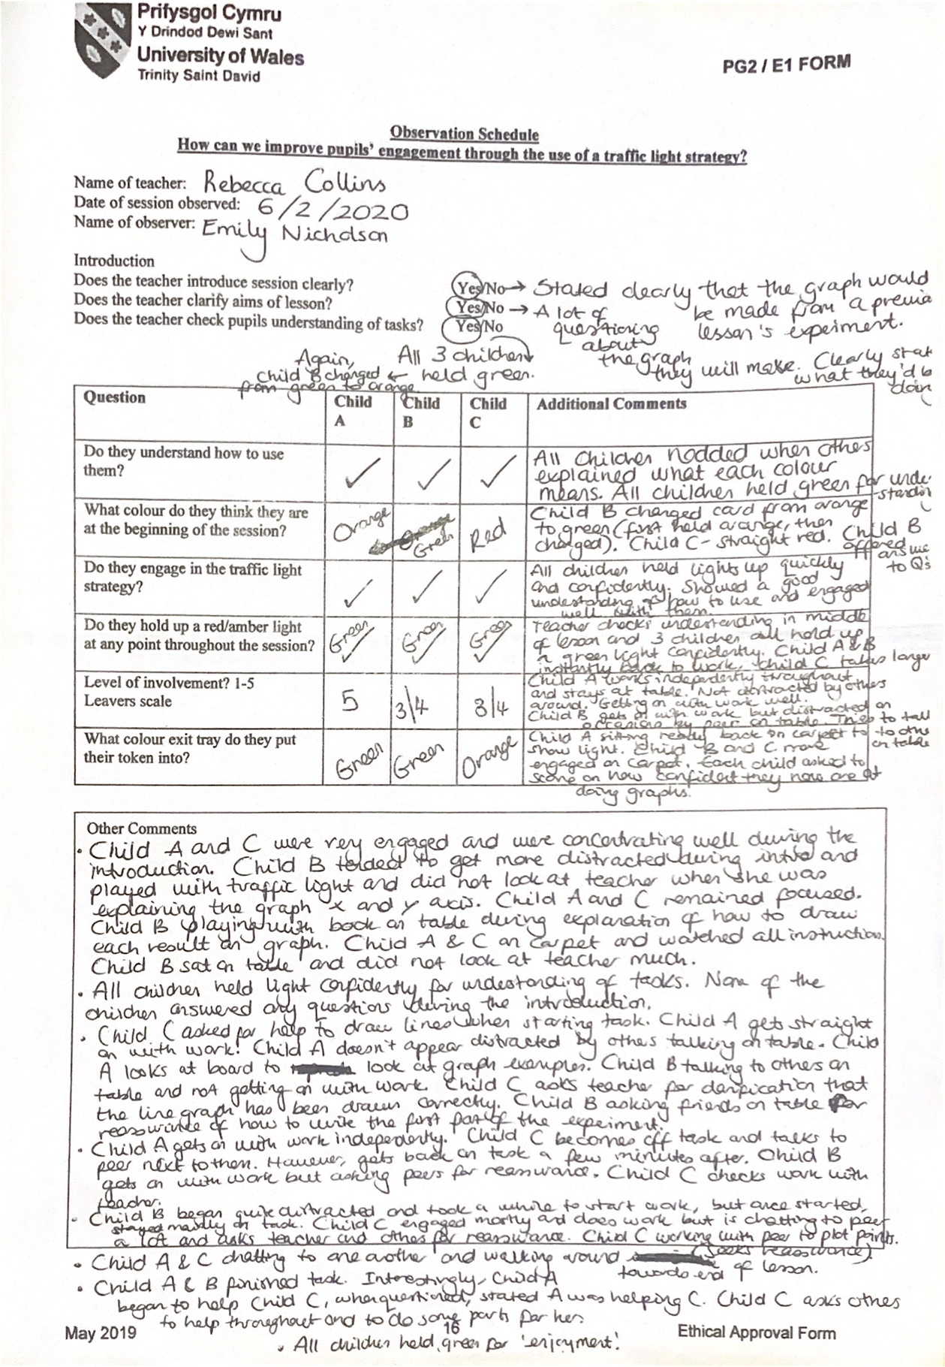
Appendix 2

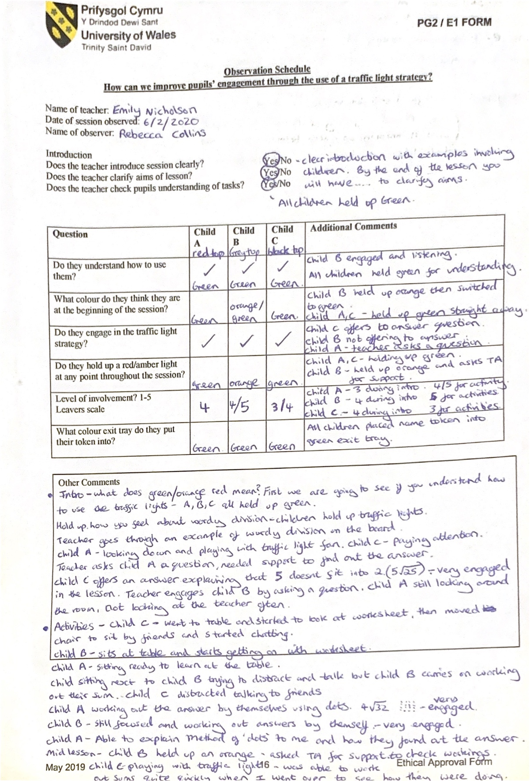

Appendix 2 – continued

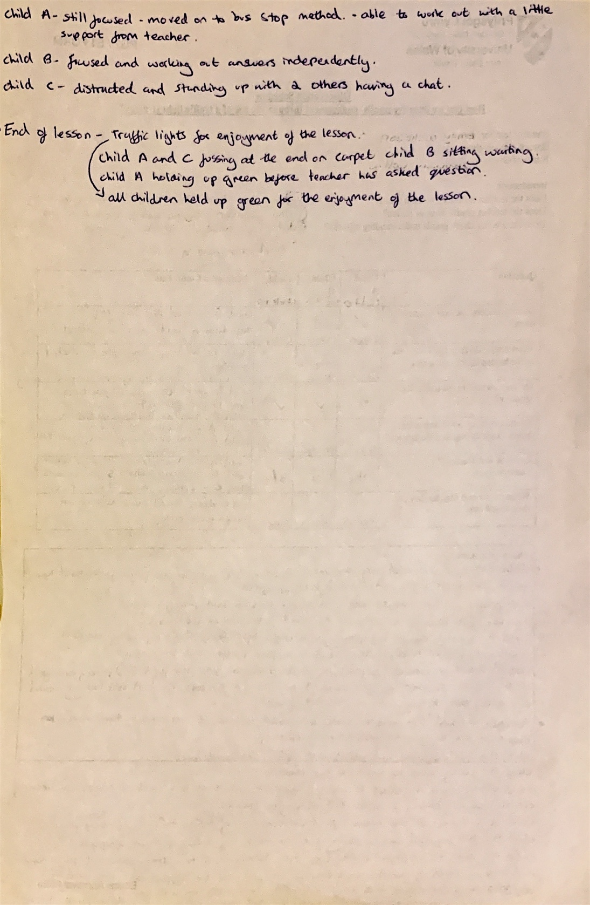
Appendix 3

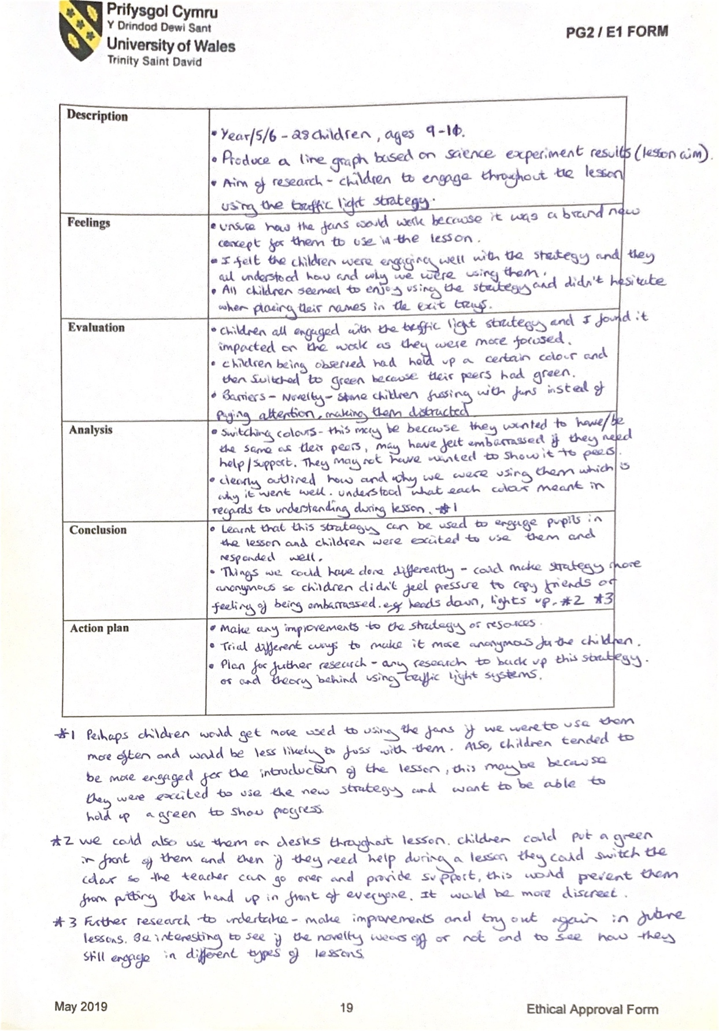
Appendix 4

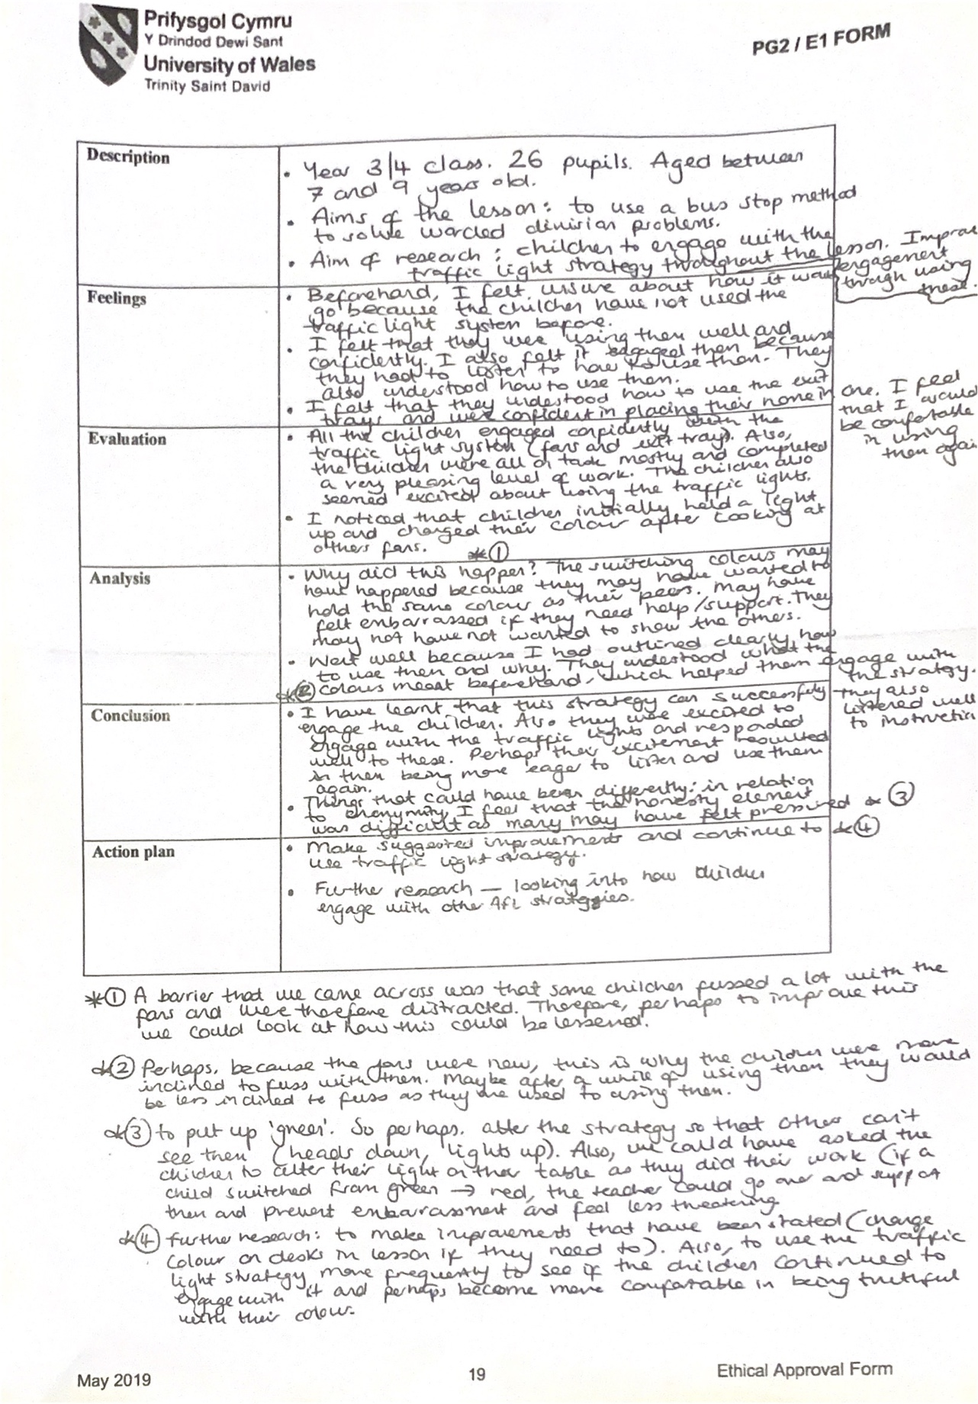
Appendix 5

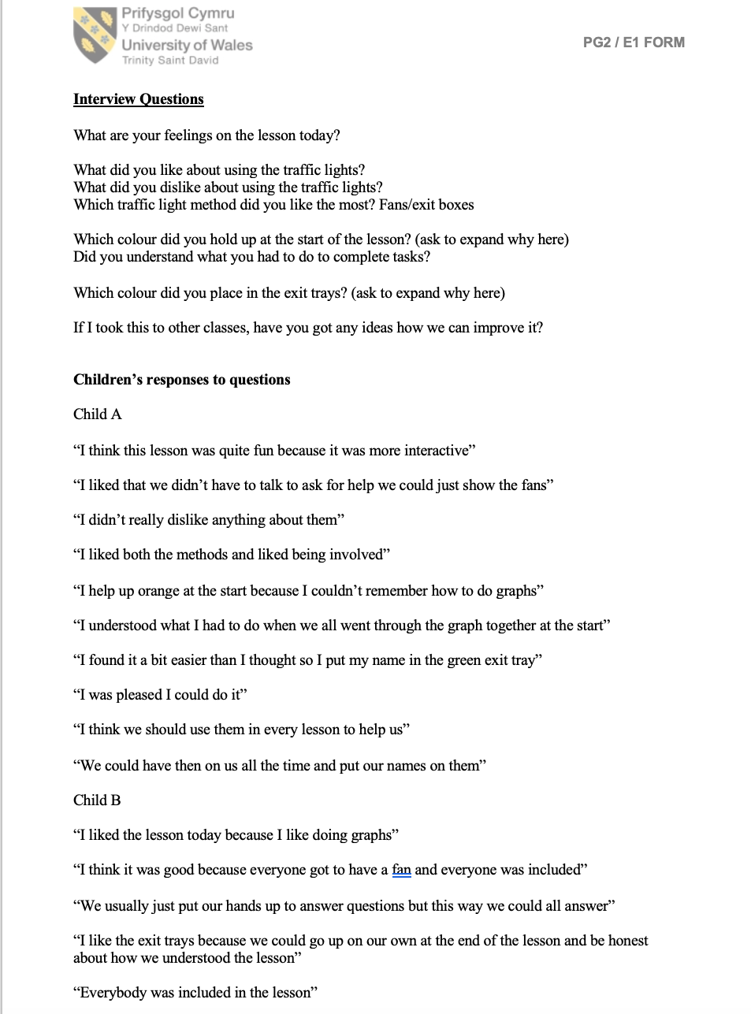

Appendix 5 – continued

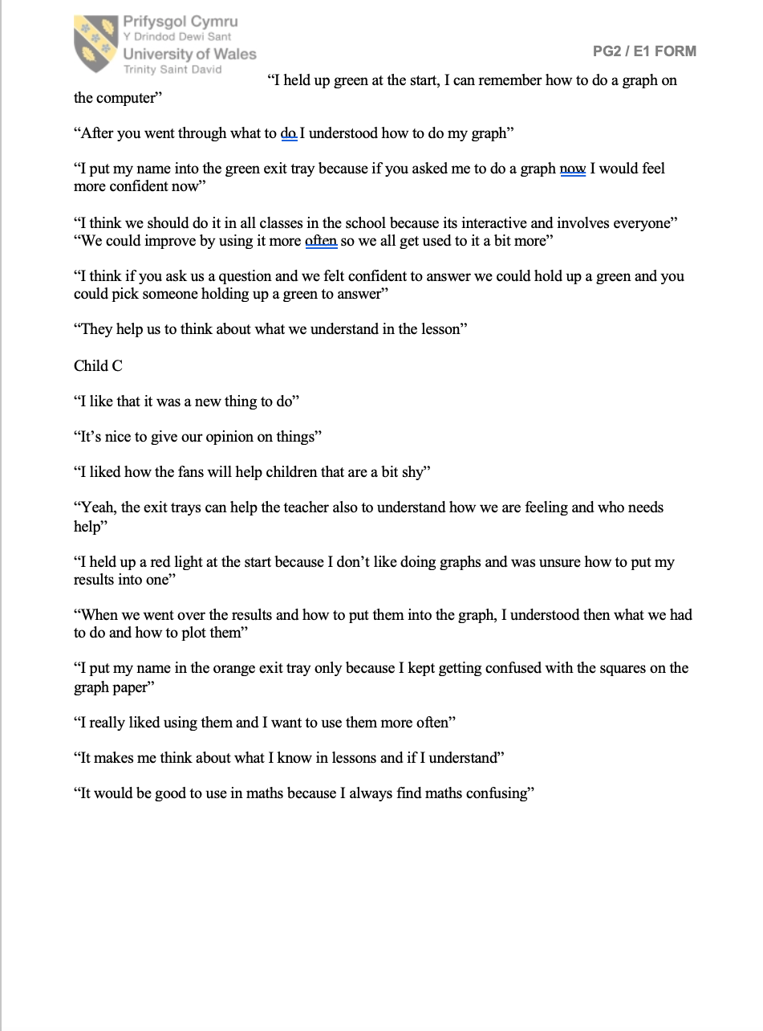
Appendix 6



