Assignment Title: Business report
Comparison of Two Hospitality Organisations

The module title: Financial Management for the Hotel Industry- BMIH5007
Lecturer’s name: Tristan Hawkins
Student name: Anamaria Cristina Salanchi
Student ID: 2206421
Word count: 2160

Executive summary
This report was critically focused on highlighting the comprehensive analysis between two specific hotel businesses which are Corinthia Hotels and Ibis Hotels. The segments of providing services for both the companies are different as Corinthia Hotels only provides luxury services for which their target customers are only those who are looking for quality services without thinking about budget. On the other hand, Ibis Hotel’s target customers are budget-conscious, and they serve way budget services in comparison to the other mentioned companies. Here, the analysis has added the identification of the actual revenue rate that both businesses are earning in order to complete the research it has addressed sources of revenue and revenue trends. Moving ahead, it has also addressed the market position, growth potential, and CSR activities for both the mentioned hotel businesses. Detailed recommendations to the particular companies have been addressed on the basis of the whole analysis.

Table of Contents
Introduction 4
Analysing the total revenue rate of Corinthia Hotels and Ibis Hotels 5
Understanding the market position of Corinthia Hotels and Ibis Hotels 7
Identifying the growth potential for Corinthia Hotels and Ibis Hotels 10
Highlighting the financial commitment to CSR 12
Recommendation to Corinthia Hotels and Ibis Hotels 14
Conclusion 15
References 16
Appendix 18

Introduction
The accurate concept of financial management mainly highlights the process by which a business can monitor, handle, control, protect as well as report all of its financial sources in an effective manner. Managing company finances is one of the most essential tasks that requires to be done in an effective manner for the sake of eliminating any type of errors and mistakes. Therefore, this report aims to produce a detailed comparison between two reputed hotel businesses which are Corinthia Hotels and Ibis Hotel. The discussion will take place by highlighting the comparison including the factors of revenue rate, market position, growth potential as well as CSR activities of both the mentioned companies. Moreover, to develop knowledge regarding the revenue earning capacity, their CSR activities as well as strategies which they are going to apply will be done by thoroughly examining the financial report of both businesses.

Analysing the total revenue rate of Corinthia Hotels and Ibis Hotels
Total revenue
Corinthia Hotels:
Sources of revenue
The revenue of Corinthia Hotels basically comes from the various operational activities of their hotels which include accommodation, services related to food and beverages as well as other types of ancillary services. Moreover, accommodation is the primary source of income for the specific business as the majority of the revenue comes from this particular source.
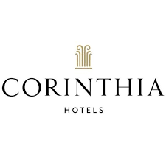
Figure- Corinthia Hotels
Source- (corinthiagroup, 2024)
Revenue trends
The total rate of revenue of Corinthia Hotels has been analysed as € 129.3 million which is half of the revenue in comparison to 2019. However, the owner of the specific hotel business has faced an incline of the revenue rate to 176 %. In the first and second half of 2022, the rate of the revenue has been gathered as € 95.8 million and € 61.2 million (corinthiagroup, 2024).

Figure- Revenue of Corinthia Hotels
Source- by author
Factors impacting the company revenue
The internal factors that boost the revenue of Corinthia Hotels are an increase in the demand for luxury services among the customers which is mainly happening as the disposable income of the individuals is also increasing. The external factors including stability in the economic conditions as well as political factors are the key reason.

Ibis Hotels:
Sources of revenue
On the basis of the company's annual report, it has been detected that there are around 80 % of the total revenue of Ibis Hotels comes from the renting out of the room. Ibis Hotels also earns the rest of the 10 to 15 % of revenue from the hotel's restaurant food and beverages section (ibisworld, 2024).
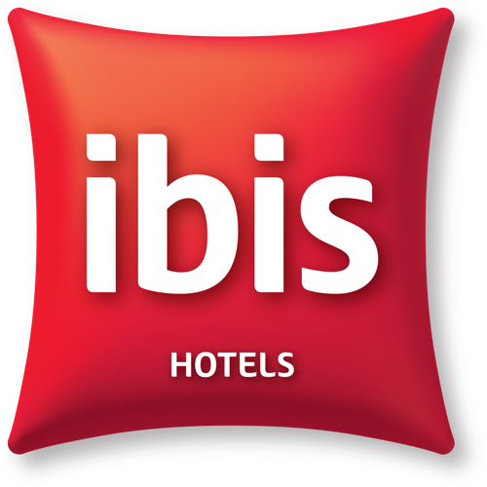
Figure- Ibis Hotels
Source- (ibisworld, 2024)
Revenue trends
The mixed revenue trends have been seen in Ibis Hotels for the past few years. On the basis of the global in 2013 the specific business faced a 4.1 % increase in which the growth was observed as 2.4 %. Moreover, between the years 2014 to 2019, the growth has been seen as 3 to 5 % which was critically reduced in the year 2020 due to the pandemic (ibisworld, 2024).

Figure- Revenue of Ibis Hotels
Source- by author
Factors impacting the company revenue
The budget-friendly services are the key reasons that are helping in boosting the growth of the economy. Apart from this, trends and tourism as well as travel also help in developing the increasing population of certain places. This helps the particular hotel business in boosting its presence and popularity (business-standard, 2024).

Understanding the market position of Corinthia Hotels and Ibis Hotels
Market position
Corinthia Hotels:
Market share
Depending on the collected information of the particular business Corinthia Hotels there are mainly 25 hotels that are owned as well as managed. It has completed stage 7 in the hotel design. The land as well as the commercial properties are 6 and it has a presence in 16 countries. At the present times, the share price of the entity is around 0.454 € in which the issued capital is determined as € 616m and the valuation of assets is € 1.7 bn.
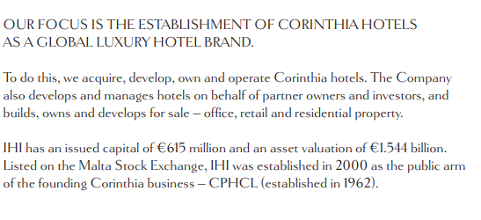
Figure- Market share of Corinthia Hotels
Source- (corinthiagroup, 2022)
Customer demographics
As the particular hotel is famous for its luxurious services it basically attracts affluent visitors who search for sophisticated as well as refined experiences this includes high-end travellers. Apart from this, Corinthia Hotels also has international clientele by having prime locations which include Lisbon, London, St. Petersburg as well as Malta. The age group between 40 to 65 are the main customers of this company.
Brand perception
The positive brand perception involves luxury as well as elegance in their hotels which highlights, spacious rooms, grad architecture, high-end amenities and all. Apart from this, the excellent services of the specific hotel also can be enjoyed in the prime locations (Jagels, 2007). On the other hand, inconsistent quality and limited awareness of the brand.
Ibis Hotels:
Market share
The particular hotel mainly has over 1700 hotels from all over the world. Hence, it has a pipeline of 62000 of the rooms of which 38 % is in Asia Pacific, 30 % in Latin America as well as 27 % in the Europe region. At the current times, Ibis Hotels has over 160000 employees, presented in 93 countries as well as acquired more than 3600 hotels (Bhimani, 2006).
Customer demographics
This specific hotel mainly targets those individuals who seek budget services. Hence, value-conscious travellers are the main target segment. The young generation including Gen Z as well as Millennials also falls into the category that prioritises the experiences beyond the material possessions as well as appreciation which concentrates on the affordability as well as functionality of Ibis.
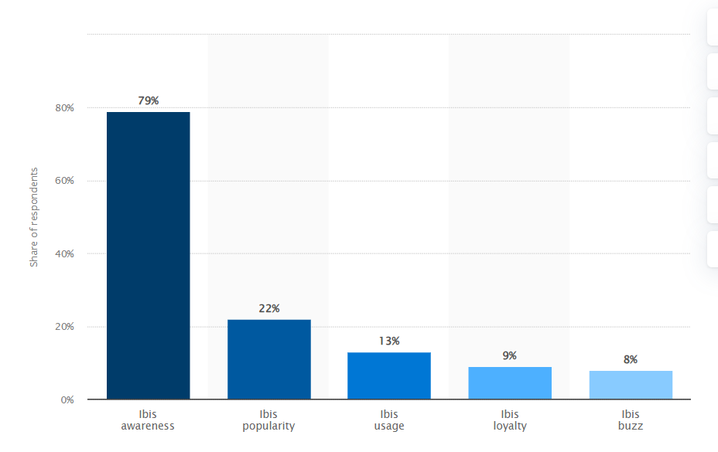
Figure- Ibis brand awareness
Source- (Kunst, 2023)

Brand perception
The positive factors of the brand perception of Ibis Hotels mainly involve affordability, cleanliness and comfort, and convenient locations. However, negative perceptions of the brands also include limited rates of amenities and small and basic sizes of rooms (Walker, 2021).
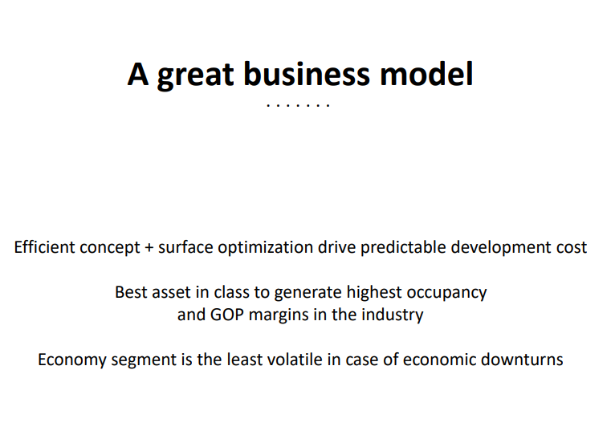
Figure- Ibis Hotels
Source- (ibisworld, 2024)

Identifying the growth potential for Corinthia Hotels and Ibis Hotels
Growth Potential
Corinthia Hotels:
Expansion strategies
Geographical expansion is one of the key strategies for the expansion of the specific business for which it is targeting new segments of markets by prioritising the strong growth of the economy in particularly Asia as well as the Middle East. Curating cultural experiences, and focusing on the wellness of the employees is also one of the top strategies of Corinthia Hotels.

Market opportunities
1. It is possible for the specific business to expand their customer's experiences by integrating technology, customisation of personalised services as well as evolving eco-friendly practices (corinthiagroup, 2024).
2. Moreover, putting more concentration on the business conferences along with events with the state-of-the-art helps with the meetings of the exceptional services and other facilities.

Potential barriers to growth
One of the greatest challenges that can create effective barriers for the specific business is the increasing rate of intense competition among the category of luxury hotel chains (Atrill and McLaney, 2021). The fluctuation in the economic condition is also the reason which may slow down the revenue earning process of the business due to loss of demand in the customers. In addition to this, maintaining service quality as well as brand consistency is also one of the concerning factors.
Ibis Hotels:
Expansion strategies
Ibis Hotels has adopted a multi-pronged method for the sake of expanding as well as establishing its business towards a wide range of locations in an effective manner. Therefore, focusing on the international, developing tiered targeting which can be done by tapping into the major cities. In addition to this, it is also adapting the strategy in developing its brand segmentation by localising and introducing different types of sub-brands (accor, 2024).
Market opportunities
1. Target South America and Southeast Asia where middle-class families are growing as well as the demand for the budget service is also high (accor, 2024).
2. The experiences of the specific business can also be enhanced by introducing personalised services, tech-driven services as well as hygge-inspired design.

Potential barriers to growth
The rise of the competition level in serving budget services within the hotel chain business is considered one of the most concerning factors as hotels like OYO, and FabHotels are giving tough competition by serving a similar range of prices (Seal, 2019). The trends within the hotel industry are constantly changing and shifting which may create challenging situations for the particular business in adapting various strategies in a constant manner. In addition to this, making sure the consistency of the brand around the world is quite challenging as negative experiences of the individuals may tarnish the reputation of the brand (NIKOLSKAYA et al., 2018).

Highlighting the financial commitment to CSR
CSR and Financial commitment
Corinthia Hotels:
Sustainability practices
1. Supporting access for the sake of cleaning water for over 45000 individuals in different countries.
2. Making contributions to the FBF, Ursuline Sisters, potato farmers as well as Christ the King Convert.
3. Fostering initiatives like “Charity begins at home” as well as webinars in order to serve knowledge regarding sustainable factors of the hotels (Drury, 2021).
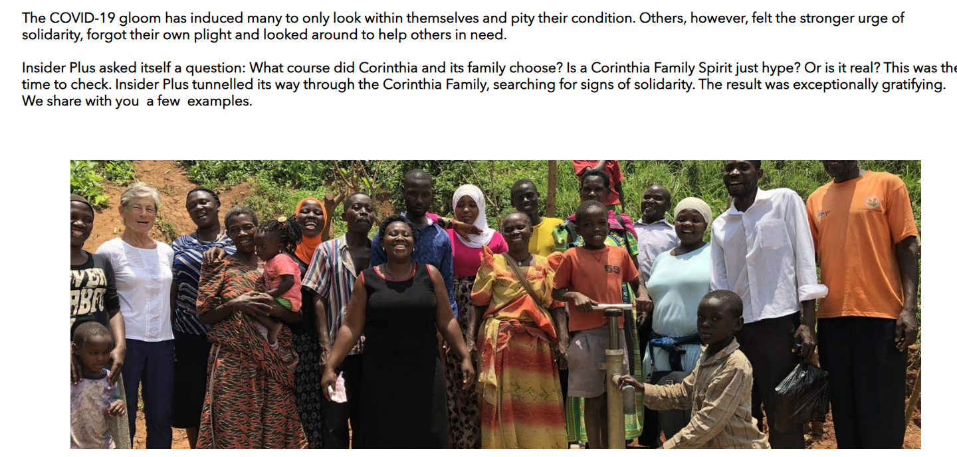
Figure- CSR of Corinthia
Source- (corinthiagroup, 2024)
Community engagement
1. The particular hotel is donating food as well as Christmas gift hampers to the residential home's children. As well as donating masks for disabled and elderly care facilities.
2. Increasing the community space by engaging staff from Radisson Blu St Julian's Park of refurbished.
3. Contributing to the well-being of the community by making donations to the children who have been impacted due to the trauma (Nikolskaya et al., 2018).
Ethical business practices
1. The document of the specific hotels carries detailed information regarding the CSR initiatives and activities which demonstrates the transparency as well as accountability of the company (corinthiagroup, 2024).
2. It also focuses on responsibility along with ethical partnership by conducting a relationship with Just a Drop, Food Bank Foundation.
3. The particular hotel has also mentioned the adherence to the rules and regulations in order to provide the right services to the customers (Ng and Tavitiyaman, 2020).
Ibis Hotels:
Sustainability practices
1. Ibis Hotels is committed to decreasing the consumption of energy by 20% by the year 2025.
2. Apart from this the entity is also focusing on decreasing the consumption of the water by the same target as energy (Guilding, 2014).
3. It is also moving forward with the waste generation of 30 % by avoiding single use of plastics, glasses and food wastage.

Community engagement
1. Supporting local businesses by sourcing local services and foods.
2. Promoting local culture in various destinations.
3. Making investments in the local community to support schools, charity and all (accor, 2024).
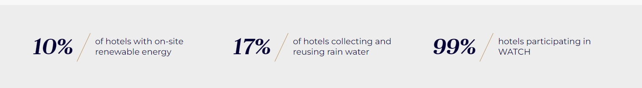
Figure- CSR of Ibis Hotels
Source- (accor, 2024)

Ethical business practices
1. The mentioned entity practices fair labour approaches which include offering benefits and paying fair wages (Miranda et al., 2018).
2. It is also promoting anti-discrimination campaign by putting policies of zero-tolerance in the hotels.
3. The specific business is also committed towards responsible as well as ethical sourcing by changing their business into an ethical one (Seal, 2019).

Recommendation to Corinthia Hotels and Ibis Hotels
Recommendation to Corinthia Hotels
Leveraging technology in the hotels for the sake of developing the luxurious experiences of the visitors is essential. Therefore, it can be recommended that Corinthia Hotels foster AI technologies along with automation for the sake of offering the best services to customers. It will allow the business to curate customised itineraries, increasing the convenience of the guests. Moreover, this can further help solidify their position as one of the most luxurious and leading brands.
Recommendation to Ibis Hotels
On the basis of the analysis, it can be recommended to the specific business to target the markets which have been growing rapidly for the past few years which include Southeast Asia as well as South America. In these particular places, the demand for budgeted services is noticeable as the population of middle-class families is growing. As a result, this will help in expanding the brand awareness of the business to a large population, which will boost the revenue earning capacity of the particular business.

Conclusion
The above report has presented an analysis of two hotel chain businesses based in different places. Hence, Corinthia Hotels, as well as Ibis Hotels, are two hotel businesses that incorporate customer-centric approaches in which one provides luxury services in a higher price range and the other serves comparatively economic service. Now, for the sake of developing the comparison it has addressed various factors of both the businesses that drive success. The effective comparison by detecting the revenue factors of both the specific businesses was addressed. Moving ahead, the actual position of Corinthia Hotels and Ibis Hotels in the marketplace in the current situation was also highlighted. It has also added the type of CSR activities that both organisations are taking into consideration for the sake of evolving their business practices for the long run was also defined in an effective manner.

References
accor, (2024). Ibis family reaches over 1,700 hotels and pursues its pioneering revolution. (Online) Available at: https://press.accor.com/la-famille-ibis-depasse-les-1-700-hotels-et-poursuit-sa-revolution-pionniere_5714_5714/?lang=en (Accessed: 21 January 2024).
accor, (2024). IT Digital. (Online) Available at: https://group.accor.com/en/hotel-development/Optimise-your-costs/IT-digital (Accessed: 19 January 2024).
Atrill P and McLaney E (2021) Management Accounting for Decision Makers, FT Prentice Hall
Bhimani A, (Ed) (2006) Contemporary Issues in Management Accounting , Oxford
business-standard, (2024). Business Standard. (Online) Available at: https://www.business-standard.com/article/companies/ibis-to-add-over-500-more-keys-by-2022-sees-normal-revenues-next-year-121013100313_1.html (Accessed: 20 January 2024).
corinthiagroup, (2024). Corinthia. (Online) Available at: https://www.corinthiagroup.com/ (Accessed: 20 January 2024).
corinthiagroup, (2024). OVERVIEW OF OUR RECENT CSR ACTIVITIES. (Online) Available at: https://www.corinthiagroup.com/insider/overview-of-our-recent-csr-activities/ (Accessed: 20 January 2024).
Drury C (2021) (11th Ed) Management and Cost Accounting, London, Prentice Hall
Guilding,C.(2014) (3rd Edition) Accounting Essentials for Hospitality Managers, London, Routledge
ibisworld, (2024). Global Hotels & Resorts - Market Size, Industry Analysis, Trends and Forecasts (2024-2029). (Online) Available at: https://www.ibisworld.com/global/market-research-reports/global-hotels-resorts-industry/ (Accessed: 19 January 2024).
ibisworld, (2024). Hotels & Motels in the US - Market Size, Industry Analysis, Trends and Forecasts (2024-2029). (Online) Available at: https://www.ibisworld.com/united-states/market-research-reports/hotels-motels-industry/ (Accessed: 20 January 2024).
Jagels,M. (2007) Hospitality Management Accounting, London, Wiley.
Kunst, A., (2023). Ibis brand awareness, usage, popularity, loyalty, and buzz among hotel customers in the UK in 2022. (Online) Available at: https://www.statista.com/forecasts/1335566/ibis-hotels-brand-profile-in-the-uk (Accessed: 26 January 2024).
Ng, A.W. and Tavitiyaman, P., (2020). Corporate social responsibility and sustainability initiatives of multinational hotel corporations. International business, trade and institutional sustainability, pp.3-15.
Nikolskaya, E.Y., Kovaleva, N.I., Uspenskaya, M.E., Makshakova, N.I., Lysoivanenko, E.N. and Lebedev, K.A., (2018). Innovative quality improvements in hotel services.
NIKOLSKAYA, E.Y., LEPESHKIN, V.A., KULGACHEV, I.P., POPOV, L.A., ROMANOVA, M.M. and LEBEDEV, K.A., (2018). Methodological approaches to assessing the innovative potential of enterprises in the hotel business. Revista Espacios, 39(27).
Seal W (2019) (6th Ed) Management Accounting, London, McGraw Hill
Serra-Cantallops, A., Peña-Miranda, D.D., Ramón-Cardona, J. and Martorell-Cunill, O., (2018). Progress in research on CSR and the hotel industry (2006-2015). Cornell Hospitality Quarterly, 59(1), pp.15-38.
Walker J (2021) Introduction to Hospitality, Harlow, Pearson

Appendix
Corinthia Hotels income statement
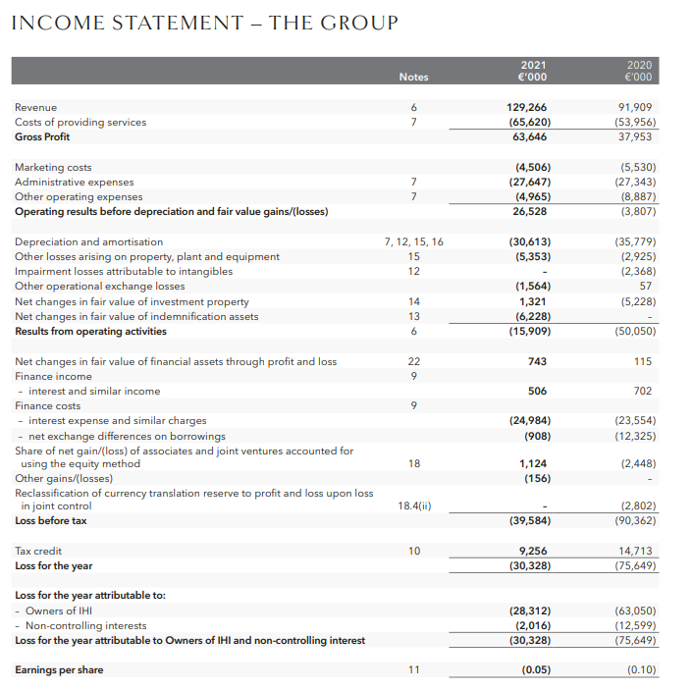
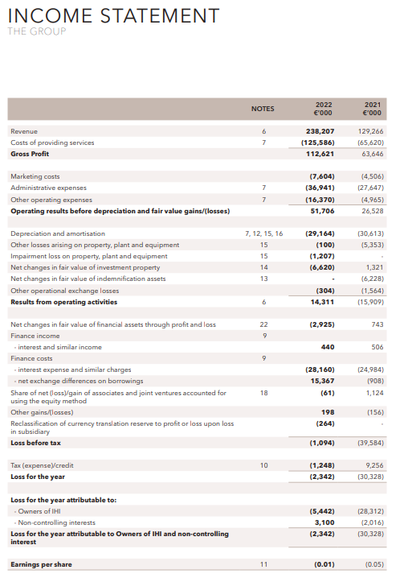
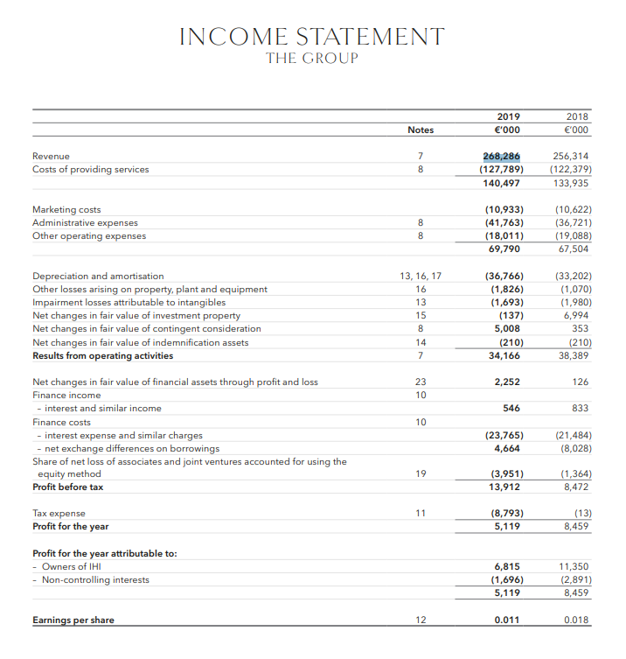

Ibis Hotels income statement


