BMSK4014 PROBLEM SOLVING & DECISION MAKING
Improving the Financial Sustainability
of Renew You Clinic
An evaluation of business growth options and the proposed introduction of Health and Body Assessments
Student: Samantha Jones 2533155]
Module: BMSK4014 Problem Solving & Decision Making
Organisation: Renew You Clinic
Word count: Approximately 3,000 words, including main-text tables; excluding references
Submission date: 30.8.2026

Contents
- Executive summary
- 1. Defining the complex workplace problem
- 2. Analysis of the identified problem
- 3. Alternative solutions
- 4. Evaluation and selection of the preferred option
- 5. Detailed implementation plan
- 6. Communication with relevant stakeholders
- 7. Monitoring and review
- 8. Conclusion
- References

Important case-study note
This report is written as an academic workplace case study. The internal financial figures are realistic planning estimates based on the clinic’s stated overheads and recent trading pattern; they must be checked against the final management accounts before submission or implementation. The proposed service is a private wellness assessment, not an NHS Health Check and not a diagnostic medical service.

Executive summary
Renew You Clinic is a recently established aesthetics and health business in Port Talbot. Its central problem is insufficient and inconsistent income. Estimated monthly revenue of £1,800, direct costs of £1,100 and fixed overheads of £510 leave approximately £190 operating profit. Against a £1,000 minimum owner-return objective, the monthly gap is £810.
Root-cause analysis links the gap to a narrow revenue mix, episodic aesthetic demand, promotional pricing, weak repeat-purchase pathways and limited performance monitoring. Four responses are evaluated: price increases, targeted marketing and partnerships, membership, and Health and Body Assessments. The weighted decision grid favours assessments because they offer strong contribution, low inventory exposure, alignment with the owner’s skills and repeat-review potential.
At a provisional £95 price, less £8 direct cost and £18.75 owner-time allowance, contribution is £68.25 per assessment. Thirteen appointments per month would add about £827 profit after incremental fixed costs and close the gap. An eight-week controlled pilot is recommended, subject to insurance, regulatory-scope, data-protection and referral-pathway checks, with financial, customer, process and safety monitoring.

1. Defining the complex workplace problem

1.1 Organisational context
Renew You Clinic provides non-surgical aesthetic and selected health-related services. As a micro-business, the owner undertakes clinical delivery, purchasing, marketing, administration and quality assurance. This structure keeps staffing costs low but creates a direct relationship between the owner’s available time, booking demand and income. Unlike a larger provider, the clinic has limited financial reserves and cannot spread fixed costs across multiple clinicians or locations.
The clinic’s current recurring overheads are estimated at £510 per month: £400 room rent, £80 insurance and £30 clinical-waste costs. Treatment stock and prescribing or delivery costs vary with activity. Recent profitable weeks demonstrate that demand exists, but performance remains uneven and earlier months generated losses. The actual condition is therefore a business that occasionally produces profit but does not yet generate a stable owner return. The desired condition is reliable monthly profit of at least £1,000, supported by a broader service mix and measurable repeat demand.

1.2 Scope and impact
The problem covers service design, pricing, marketing, capacity, finance, governance and customer retention. It affects the owner most directly through financial uncertainty, pressure to accept additional appointments, difficulty purchasing stock and reduced ability to invest. Clients may be affected if appointment availability or the range of services changes. Suppliers and the landlord depend on timely payment, while referral partners need confidence that the clinic is stable and professionally governed.
The financial impact is demonstrated below. These figures are a baseline for decision-making rather than audited accounts. They deliberately include only routine clinic activity and exclude tax and personal benefits.
Monthly baseline | Estimated amount | Meaning
Revenue | £1,800 | Average client payments received
Direct treatment costs | (£1,100) | Products, prescribing and treatment-related delivery
Fixed overheads | (£510) | Rent £400; insurance £80; clinical waste £30
Operating profit | £190 | Before tax and owner drawings
Minimum owner-return objective | £1,000 | Working sustainability target
Monthly profit gap | £810 | Target less current operating profit

Table 1. Baseline monthly financial position (internal planning estimate).

If the shortfall continues, the clinic risks remaining dependent on personal cash injections and discounted promotions. This restricts investment and increases owner stress. However, any solution must remain achievable within limited time, budget and room capacity. It must also fit the owner’s competence, avoid excessive stock exposure and meet legal, insurance and information-governance requirements.

2. Analysis of the identified problem

2.1 Information sources and method
The analysis combines internal cost and booking estimates, observation of the current client journey, published evidence on preventive health assessments and established problem-solving tools. Tague (2005) recommends structuring quality problems before selecting solutions, while Ishikawa (1986) uses cause-and-effect analysis to separate symptoms from underlying causes. This prevents the conclusion that “more clients” is the only answer.
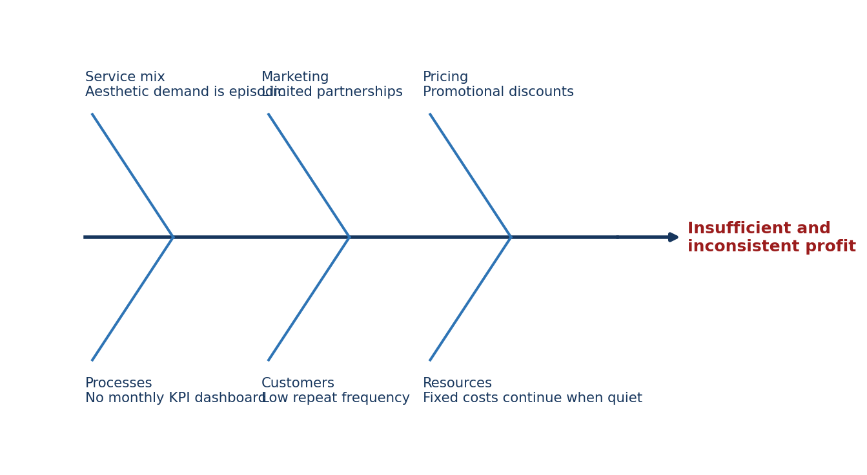
Figure 1. Cause-and-effect analysis of insufficient and inconsistent profit.

2.2 Five Whys root-cause analysis
Stage | Question and finding
1 | Why is profit insufficient? Revenue is too low and variable relative to fixed and direct costs.
2 | Why is revenue variable? Booking levels and average monthly client spend fluctuate.
3 | Why do bookings and spend fluctuate? Aesthetic treatments are discretionary and often purchased episodically or during promotions.
4 | Why is the clinic dependent on episodic demand? The service mix lacks a structured, repeatable health assessment with a planned review pathway.
5 | Why has this not been corrected? The clinic launched around treatment delivery and social-media promotion without a formal monthly revenue-diversification and KPI process.

Table 2. Five Whys analysis.

The analysis identifies five connected causes. First, the revenue mix is narrow. Second, discounted offers may stimulate bookings but compress margin and may train customers to wait for promotions. Third, a client normally returns only when another aesthetic treatment is desired, so there is no consistent review cycle. Fourth, local partnerships with gyms and wellbeing businesses have not yet become a regular acquisition channel. Finally, performance is judged mainly from weekly cash movement rather than a dashboard of revenue, contribution, utilisation and repeat bookings.
The external evidence supports a cautiously designed health-assessment opportunity. Cardiovascular disease remains a major cause of ill health and premature death in Wales, responsible for around one in four deaths (Welsh Government, 2026a). The Department of Health and Social Care (2021) reported that more than three-quarters of NHS Health Check attendees had at least one elevated modifiable risk factor, while Tanner et al. (2022) found that health checks were associated with increased detection of raised blood pressure, diabetes, cholesterol and kidney disease. This evidence demonstrates public-health relevance, but it does not prove commercial demand for Renew You. Local demand must therefore be tested through a pilot rather than assumed.
The assessment should be differentiated carefully. It would include a health and lifestyle history, blood pressure, pulse, oxygen saturation, height, weight, BMI, body-composition measures, a written summary and appropriate signposting. It would not diagnose disease, prescribe medication or be advertised as the NHS Health Check. NICE (2023) provides a framework for cardiovascular risk assessment, while NICE (2025) advises careful interpretation of BMI and central adiposity. These sources should inform protocols without extending practice beyond competence.

3. Alternative solutions
Four complete options were generated from the root causes and available resources. They are not mutually exclusive in the long term, but each is assessed as the primary intervention so that the decision remains transparent.

3.1 Option A: Increase selected prices
A 10% increase on selected aesthetic treatments would improve contribution without major setup cost. It is quick to implement and may better reflect the clinical qualifications and premium products used. However, the estimated gain is only about £180 revenue per month before any fall in demand. It does not diversify the client base or create a new reason to attend, and customers may be price-sensitive while the business is still establishing its reputation.

3.2 Option B: Targeted marketing and partnerships
A monthly campaign focused on social media, local gyms and referral relationships could increase visibility. It supports every service and may strengthen brand awareness. Nevertheless, paid promotion requires recurring expenditure before revenue is guaranteed, and marketing a service mix that remains highly episodic does not fully correct the structural cause. A test budget of £250 per month is assumed, with conversion monitored through trackable links or booking codes (Kotler and Armstrong, 2020).

3.3 Option C: Introduce a membership
A membership could create predictable recurring income through a monthly fee, priority booking, reviews or savings on eligible services. It improves retention but requires carefully costed benefits, payment administration and clear cancellation terms. Demand is uncertain, and a poorly designed discount membership could increase workload while reducing treatment margin. It may become valuable after the clinic has a broader recurring service to include.

3.4 Option D: Introduce Health and Body Assessments
The proposed 45-minute service would convert the owner’s existing health-assessment skills into a low-stock, structured appointment. A provisional price of £95 would include measurements, discussion, a written summary and a review recommendation. It could be promoted to existing clients and through gym partnerships without relying entirely on aesthetic-treatment demand. The service creates scope for repeat reviews at 8-12 weeks and appropriate cross-referral to separately governed clinic services.
The option carries governance requirements. Health information is special-category data, requiring a lawful basis, additional safeguards, secure storage and transparent privacy information (Information Commissioner’s Office, n.d.). The clinic must confirm insurance cover and whether its existing or proposed activities require registration or variation with Healthcare Inspectorate Wales before launch (Healthcare Inspectorate Wales, n.d.). Abnormal results need written escalation thresholds, urgent-care instructions and GP signposting. These controls are included in the implementation plan.

4. Evaluation and selection of the preferred option

4.1 Weighted decision grid
A weighted grid was used because the cheapest solution is not necessarily the best. Ratings run from 1 (poor) to 5 (excellent), and each rating is multiplied by the criterion weight. The method makes trade-offs visible, although the scores remain managerial judgements and should be reviewed after pilot data are available (Saaty, 2008).
Criterion (weight) | Prices | Marketing | Membership | Assessments
Financial impact (30%) | 3 | 3 | 4 | 5
Low setup cost (15%) | 5 | 3 | 4 | 4
Demand/market fit (20%) | 3 | 4 | 3 | 4
Implementation speed (15%) | 5 | 4 | 3 | 4
Strategic fit (10%) | 2 | 3 | 4 | 5
Risk/compliance (10%) | 4 | 4 | 3 | 3
Weighted total / 5 | 3.60 | 3.45 | 3.55 | 4.30

Table 3. Weighted decision grid. Highest score indicates the preferred option.

Health and Body Assessments score highest at 4.30. Their main weakness is governance risk, but that risk can be reduced through scope confirmation, protocols, competency evidence, consent, data controls and referral pathways. Price increases score well for speed and cost but do not resolve the narrow service mix. Membership is potentially useful but should follow, rather than precede, evidence of repeat demand. Marketing remains necessary as an enabling activity but performs weakly as the sole solution.

4.2 Proposed service scope and boundaries
The service must remain a private wellness assessment within the owner’s competence, rather than a diagnostic consultation or an NHS Health Check. Its operational boundaries are incorporated into the main proposal because they affect feasibility, risk and implementation.
- Include: health and lifestyle history, blood pressure, pulse, oxygen saturation, height, weight, BMI, body composition, a written summary and signposting within competence.
- Exclude: diagnosis, treatment of medical conditions, prescribing, promises of disease prevention, and use of the protected NHS Health Check identity.
- Escalate: urgent symptoms or severely abnormal observations according to the approved SOP; direct non-urgent abnormal findings to the client’s GP or an appropriate service.
- Protect information: collect only necessary data, issue a privacy notice, restrict access, retain records securely and maintain documented retention and breach processes.
- Verify before launch: professional indemnity, equipment suitability and calibration, current competence, the HIW position and all advertising claims.

4.3 Cost-benefit analysis and financial ratios
The assessment is modelled at £95. An £8 direct-cost allowance covers payment fees, printing and consumables. Owner time is recognised at £25 per hour; 45 minutes therefore adds an economic cost of £18.75. Contribution is £68.25 per assessment and the contribution margin ratio is 71.8% (£68.25 ÷ £95). Recognising owner time avoids presenting unpaid labour as free and gives a more realistic comparison with other work.
Item | Assumption | Calculation/result
Current monthly operating profit | £1,800 revenue - £1,100 direct costs - £510 fixed costs | £190
Profit gap | £1,000 objective - £190 current profit | £810
Initial setup | Equipment, forms, setup, launch and contingency | £650
Monthly incremental fixed cost | Software, calibration and local promotion | £60
Price per assessment | Provisional launch price | £95.00
Direct cost | Consumables, payment and report allowance | £8.00
Owner-time allowance | 0.75 hour at £25/hour | £18.75
Contribution per assessment | £95 - £8 - £18.75 | £68.25
Contribution margin ratio | £68.25 ÷ £95 | 71.8%
Monthly assessment contribution | 13 appointments × £68.25 | £887.25
Incremental monthly profit | £887.25 - £60 incremental fixed cost | £827.25
Projected total monthly profit | £190 + £827.25 | £1,017.25
First-month break-even | (£650 + £60) ÷ £68.25 | 10.4; therefore 11 assessments
First-year incremental profit | (156 × £68.25) - £720 annual fixed - £650 setup | £9,277
Simple first-year ROI | £9,277 ÷ £650 × 100 | 1,427%

Table 4. Financial assumptions, unit economics and break-even calculation.

At 13 appointments per month, incremental profit is £827.25 and projected total operating profit is approximately £1,017, meeting the objective. At eight appointments total profit is about £676; at 18 it is about £1,359. Demand is therefore the critical uncertainty.
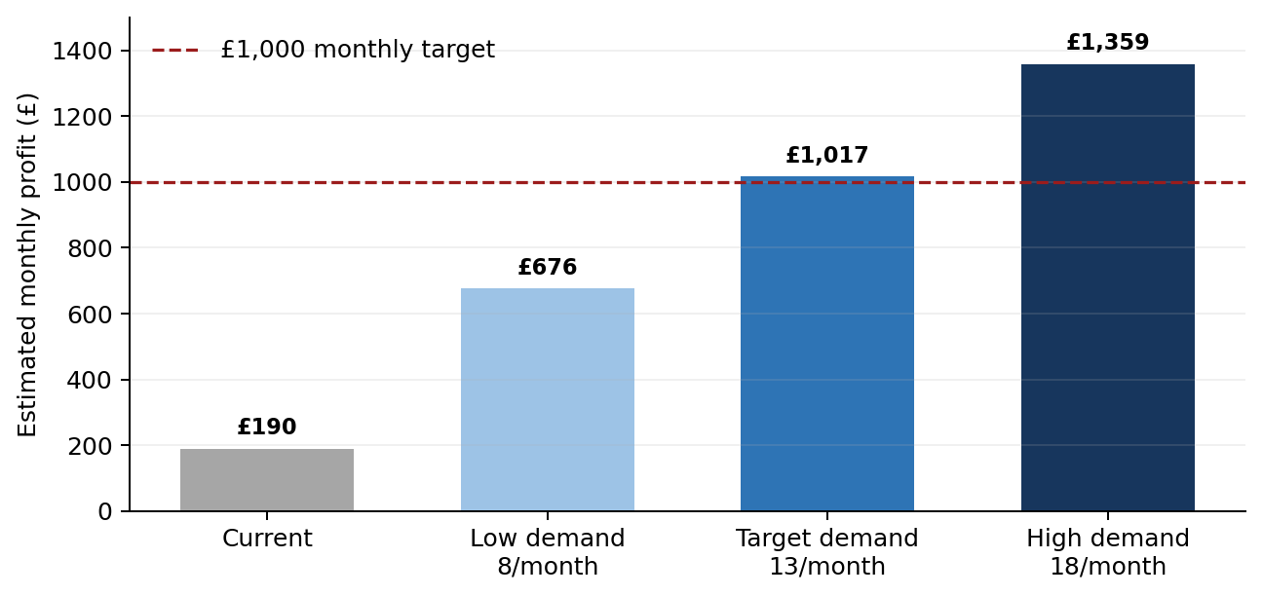
Figure 2. Estimated monthly profit under assessment-demand scenarios.

At 13 appointments monthly, first-year incremental profit after support costs and setup is approximately £9,277, giving a simple ROI of about 1,427%. This is not guaranteed: it depends on sustained paid demand, excludes tax and assumes owner capacity. A stop/go pilot is therefore preferable to immediate full rollout.

5. Detailed implementation plan
The preferred solution will be implemented through an eight-week pilot. The owner is accountable for delivery but will seek external confirmation where specialist authority is required. The plan uses milestones so delays are visible and corrective action can be taken.
Action | Owner | Timing | Output/success measure
Confirm service scope, insurance and regulatory position | Owner; insurer; HIW enquiry if required | Week 1 | Written confirmation or documented advice before advertising
Define assessment content, exclusions and escalation pathway | Owner with clinical adviser/prescriber | Weeks 1-2 | Approved SOP, red-flag thresholds and referral template
Purchase and verify equipment | Owner | Weeks 2-3 | Equipment logged, validated and ready for use
Create consent, privacy, report and record templates | Owner/data-protection lead | Weeks 2-3 | Complete documentation and retention schedule
Competency check and simulated assessments | Owner/peer reviewer | Week 4 | Five satisfactory simulations and signed checklist
Pilot with five consenting clients | Owner | Week 5 | Five completed records; feedback average ≥4/5
Review pilot and amend process | Owner/clinical adviser | Week 6 | Issues log closed or controlled; go/no-go decision
Partner and digital launch | Owner; gym partners | Week 7 | Two active referral partners and trackable campaign
Controlled public launch | Owner | Week 8 | First 13 paid bookings scheduled/targeted

Table 5. Eight-week implementation action plan.

5.1 Gantt schedule
Workstream | W1 | W2 | W3 | W4 | W5 | W6 | W7 | W8
Scope/approval | ■
SOP/referrals | ■ | ■
Equipment/forms |  | ■ | ■
Competency checks |  |  |  | ■
Five-client pilot |  |  |  |  | ■
Review/go-no-go |  |  |  |  |  | ■
Partner launch |  |  |  |  |  |  | ■
Public launch |  |  |  |  |  |  |  | ■

Table 6. Gantt chart for pilot implementation.

The owner will not launch if insurance or regulatory scope is unresolved, the escalation pathway is incomplete, equipment fails verification, or the pilot identifies a safety issue. If fewer than five paid bookings are secured by the end of week 8, the marketing proposition will be tested for a further four weeks before additional investment. This protects cash while allowing evidence-based refinement.

6. Communication with relevant stakeholders
Stakeholders are individuals or groups who can affect or are affected by the decision (Freeman, 1984). Their information needs differ: clients require clear scope and consent; partners require referral criteria; regulators and insurers require accurate service descriptions; and the owner requires timely financial information. Communication will therefore be planned rather than relying on informal social-media posts.
Stakeholder | Interest/expectation | Message and channel | Timing/owner
Owner | Profitability, workload, safety and reputation | Weekly KPI dashboard and implementation log | Weekly; owner
Clients | Benefits, limitations, privacy, price and next steps | Service page, booking information, consent discussion and written report | Before, during and after each assessment; owner
Clinical adviser/prescriber | Safe boundaries and escalation | SOP review and exception discussion | Before pilot and monthly; owner
Gym/wellbeing partners | Suitable referrals and professional service | One-page partner brief, referral code and quarterly feedback call | Weeks 6-7 then quarterly; owner
Insurer/HIW as applicable | Accurate activity description and compliance | Written enquiry/notification and retained response | Before launch and whenever scope changes; owner
GP/urgent-care services | Concise relevant information when a client is signposted | Client-held summary/referral letter; emergency escalation protocol | When clinically indicated; owner

Table 7. Stakeholder communication plan.

Client-facing wording will avoid promises of diagnosis, prevention or guaranteed outcomes. Reports will distinguish measured findings from interpretation and will state when medical assessment is recommended. Health data will be collected only when necessary, stored securely and covered by a privacy notice. The ICO (n.d.) emphasises that special-category health data require greater protection; this supports limited access, secure records, a retention schedule and a documented breach response.

7. Monitoring and review
Implementation will be monitored through a balanced set of financial, customer, process and safety measures. Kaplan and Norton (1992) argue that performance should not be judged by financial results alone. In this case, profitable activity would still be unacceptable if documentation, referral or client-understanding standards were poor.
Measure | Target | Frequency | Corrective trigger/action
Paid assessments | 13 per month by month 3 | Weekly/monthly | <8 for two months: review offer, channels and price
Assessment revenue | £1,235 per month | Monthly | <£760: pause further marketing spend and test demand
Contribution per assessment | ≥£68.25 | Monthly | Lower result: recost time, fees and consumables
Setup-cost recovery | By assessment 11/month 1-2 | At each booking | Not recovered by month 3: formal continuation review
Client satisfaction | Average ≥4.5/5 | After appointment | <4/5: analyse comments and revise pathway
Documentation completeness | 100% | Weekly audit of pilot; 10% thereafter | Any omission: correct, retrain and re-audit
Abnormal-result protocol followed | 100% | Every relevant case | Any failure: pause service and investigate
Incidents/complaints | Zero serious incidents; all acknowledged promptly | Live/monthly review | Clinical incident: immediate escalation and service review
Review/partner conversion | ≥40% book a review or originate through partners by month 3 | Monthly | Low conversion: revise follow-up and partner briefing

Table 8. Monitoring and review framework.

A weekly dashboard during implementation will compare the Gantt plan with actual completion. At the end of weeks 5, 8 and 12, the owner will hold formal milestone reviews. Week 5 tests clinical flow; week 8 decides whether to launch publicly; week 12 evaluates commercial viability. Variance will be recorded with an owner, action and deadline. This converts monitoring into management rather than retrospective description.
At the three-month review, the decision will be to continue, adapt or stop. Continuation requires safe delivery, at least eight monthly assessments with a credible route to 13, positive contribution after owner-time allowance, acceptable satisfaction and full documentation. Adaptation could include a shorter entry assessment, a review package or revised partnership targeting. The service will be stopped or paused if compliance remains unclear, serious incidents occur, or demand cannot support costs. Any decision to add blood testing or medication referral later would require a separate scope, risk and financial assessment.

8. Conclusion
Renew You Clinic’s insufficient income is a complex workplace problem because it arises from interacting financial, operational, marketing and service-design causes. The analysis shows that simply taking more aesthetic bookings or increasing prices would offer only a partial response. A broader, repeatable and lower-stock service is needed alongside disciplined performance monitoring.
The decision grid and cost-benefit analysis identify Health and Body Assessments as the preferred option. At £95 and 13 appointments monthly, the service could add approximately £827 profit and raise total operating profit to £1,017. Because demand remains unproven, an eight-week controlled pilot with clear scope, referral boundaries, data protection, stakeholder communication and milestone reviews is recommended. This addresses the immediate gap while creating evidence for longer-term development.

References
Department of Health and Social Care. (2021). Preventing illness and improving health for all: A review of the NHS Health Check programme and recommendations. https://www.gov.uk/government/publications/nhs-health-check-programme-review/preventing-illness-and-improving-health-for-all-a-review-of-the-nhs-health-check-programme-and-recommendations
Drury, C. (2018). Management and cost accounting (10th ed.). Cengage Learning.
Freeman, R. E. (1984). Strategic management: A stakeholder approach. Pitman.
Healthcare Inspectorate Wales. (n.d.). Register as an independent healthcare service. https://www.hiw.org.uk/register-independent-healthcare-service
Information Commissioner’s Office. (n.d.). Data security advice. https://ico.org.uk/for-organisations/advice-for-small-organisations/information-security/data-security-advice/
Ishikawa, K. (1986). Guide to quality control (2nd rev. ed.). Asian Productivity Organization.
Kaplan, R. S., & Norton, D. P. (1992). The balanced scorecard—Measures that drive performance. Harvard Business Review, 70(1), 71–79.
Kotler, P., & Armstrong, G. (2020). Principles of marketing (18th global ed.). Pearson.
National Institute for Health and Care Excellence. (2023). Cardiovascular disease: Risk assessment and reduction, including lipid modification (NICE Guideline NG238). https://www.nice.org.uk/guidance/ng238
National Institute for Health and Care Excellence. (2025). Overweight and obesity management (NICE Guideline NG246). https://www.nice.org.uk/guidance/ng246
Saaty, T. L. (2008). Decision making with the analytic hierarchy process. International Journal of Services Sciences, 1(1), 83–98. https://doi.org/10.1504/IJSSCI.2008.017590
Tague, N. R. (2005). The quality toolbox (2nd ed.). ASQ Quality Press.
Tanner, L., Kenny, R. P. W., Still, M., Ling, J., Pearson, F., Thompson, K., & Bhardwaj-Gosling, R. (2022). NHS Health Check programme: A rapid review update. BMJ Open, 12(2), e052832. https://doi.org/10.1136/bmjopen-2021-052832
Welsh Government. (2026a). The quality statement for heart conditions. https://www.gov.wales/quality-statement-heart-conditions-html
Welsh Government. (2026b). Healthy Weight: Healthy Wales delivery plan 2025 to 2027. https://www.gov.wales/healthy-weight-healthy-wales-delivery-plan-2025-2027-html

