

DORIN GHEORGHE EPURE - 1912734

EFFECTIVE TEAM WORKING AND COMMUNICATION
BMSW4002
TABLE of CONTENTS

Introduction ……………………….2

Communication ……………………2

Importance of Communication………….3

Importance of effective Communication………..3

Methods of Communication……………4

1. Verbal Communication…………….4
2. Non-verbal Communication………..5

Theories of Communication …………6

- Shannon and Weaver Model of Communication………6

- Schramm Model of Communication…………7

- Berlo’s Model of Communication………..9

My own justification about all the models discussed above…………11

Communication at my work place …………………….11

Conclusions …………………12

References………………….13

INTRODUCTION

Regarding this assignment I’m going to explain about definitions for communication, importance of effective communication and communication methods. I will explain the theories of communication: Shannon and Weaver Model of Communication, Schramm Model of Communication and Berol’s Model of Communication.
Also I will explain how my communication at my work place and finishing with my conclusion about the assignment.

DEFINITIONS OF COMMUNICATION

The communication is transmission of information, ideas, attitudes, or emotion from one person or group to another. (Theodorson, 1969).

Communication is passing the information from sender to the receiver.

The Communication is the transmission of information, ideas, emotions and skills, by the use of symbols. (Steiner, 1964)

Communication is simply the act of transferring information from one place, person or group to another. Please see the communication process in the (Figure 1).

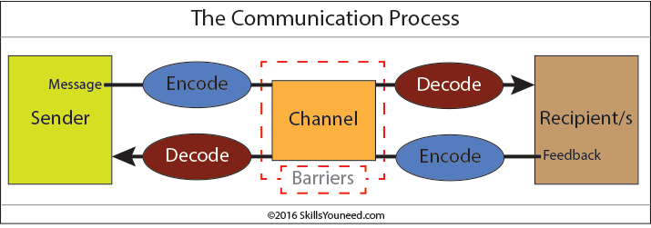
Figure 1.

IMPORTANCE OF COMMUNICATION

The importance of communication is because people can exchange the information or passing the information, ideas or thought from one person to the other person.
Communication it also good because it bridges the gap between individuals and groups through the flow of information and understanding each other much better.

The ramification of communication is the reason why a good communication skills are considered so necessary by employers around the world: accurate, effective and unambiguous communication is actually extremely hard.

IMPORTANCE OF EFFECTIVE COMMUNICATION

For an efficient management and to improve industrial relations effective communication is very important.
A manager must be in a position to communicate effectively with his colleagues in other departments and subordinates. This effective communication will make him perform well and enable him to give his hundred percent to the organisation.
In any working environment, communication can bring high productivity, safety and happy employees. We must understand that the communication is influenced by culture and environment, and is a process which involves the exchange of messages. This messages must have a meaning (Berglund, 1962) and it will be effective if can touch the receptor.
An effective communication must have some characteristics to meet the purpose. It must be clear, correct and precise. If it will met the purpose then can ensure efficient management and the organisation will work as a team. An efficient communication ensure better decision making and the new possibility of growth and development by using the creativity of the employees. A clear and appropriate message can leads to the achievement of company goals and objectives.
Also an effective communication can contains reducing potential of misunderstanding and overwhelming of any barriers to communicate at any stage in the communication method.

Methods of Communication

In the new world, the organisations have many ways of communication. The methods that are used at the workplace are: Verbal and Nonverbal

- Verbal communication - use words to deliver a message. This type of communication can be face to face, by phone, by meetings.
It is a personal communication and to be effective must understand the body language and must contain a clear message. Sometimes the organisation use the social media to communicate directly between different location and divisions.
Is important that verbal communication cannot be totally isolated from nonverbal communication: your body language, tone of voice, and facial expressions.
Simplicity of speech, continuing calm and focused, being polite and following some basic rules of protocol will all help the process of verbal communication.

Nonverbal Communication contain the body languages, the facial expression, dressing code, use of symbols. The nonverbal signals count as more than 50% in the process of communication. We must to remember that “a picture is worth a thousand words”.
It is main to remember that nonverbal signals can be very important, or in some circumstances even more important, than what we say.
Nonverbal communication can take a great impact on the listener and the ending of the communication.

Non-verbal communication supports people to:
- Support or change what is said in words.
- Transfer information about their emotional situation.
- Describe the relationship between people.
- Deliver feedback to the other person.

- Control the run of communication
Another way to communicate is written communication. This method contains letters, e-mails, social media, books, magazines, the Internet and other media.

Theories of Communication

- Shannon and Weaver Model of Communication

Shannon and Weaver (Shannon and Weaver, 1949) consider the communication as a mathematical theory to processed signal. They said that a message is transmitted by a sender to a receiver using a channel and in the process can interfere a noise source. [Figure 2]

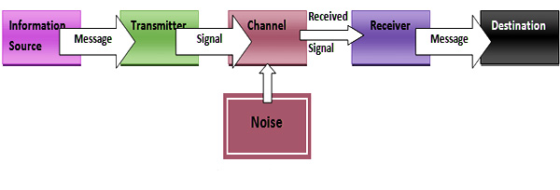
Figure 2.

The Shannon-Weaver model was invented for signal transmission in the middle of different machines.
The decoder receives the signal, converted back into information and pass it to the destination.

Shannon Weaver Model perceptions:
Information source (Sender) – Is the one who creates the message, picks the channel and sends the message.
Transmitter (Encoder)–Is the transmitter who custom the instrument, who adapts message into signals. It might also directly refer to the machine.
Channel –Is the middle instrument to send message.
Receiver (Decoder) - Is the source which is used to exchange signals or dual data into message or the receiver who translates the message from signals.
Destination (Receiver)–Is one who obtain the message or the location where the message should be. The Destination will receive the feedback.
Noise –Noise is the turbulence environment which is not letting the message to arrive to the receiver as what is sent.

Shannon Weaver Model of communication – criticism
- Receiver plays the docile part in the communication process and the sender plays the principal part who send the messages.
- Feedback is less important compare with the messages which are sent by the sender.

- Schramm Model of Communication

Schramm’s model of communication was planned in 1954.
Information are not used until are carefully situate into words and taken to others.
Transmission plays a very important role, as it initiates the process of communication by converting the thought into content.
Encoding and decoding are the most important factors of an effective communication.
Schramm’s model reveals the characteristics of interpersonal communication, particularly face to-face communication, and is not relevant to mass communication. This model is also named “Schramm’s feedback loop”. (Figure 3)
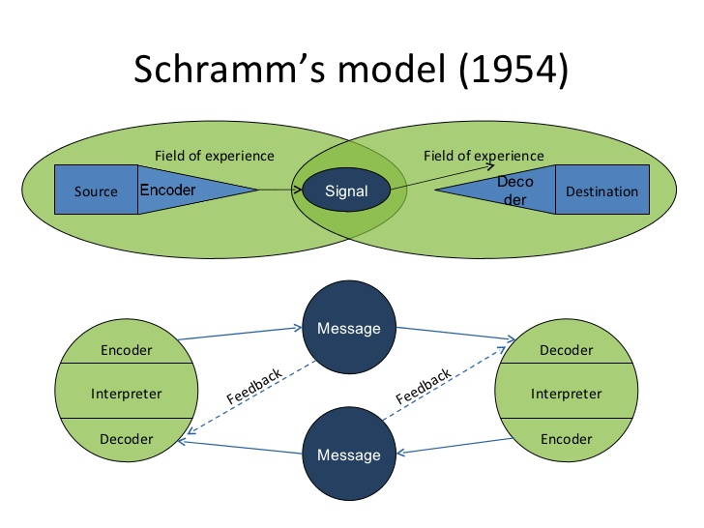

Figure 3

The transmitter has a very important role because is the one who start the process of communication by transforming the concept into matter.
Therefore encoding and decoding are important to have an effective communication.
Schramm said that an individual’s information, knowledge and cultural background they are playing as well an important role in communication. The message can take different ways depending on the cultures, religion.
The conclusion from this model of communication is: when the sender passes the information to the receiver should decode the message and give the feedback.

- Berol’s Model of Communication

Berol (1960) created a model of the ingredients of communication. This model organises controlling aspects for this elements: Source, Message, Channel and Receiver.
Berol’s model of communication is helpful to detect specific factors to use in carrying out tests.
Also this model described factors which affect the individual components in the communication making the message more effective.
Please see the diagram of Berlo’s Model of communication in the Figure 4.

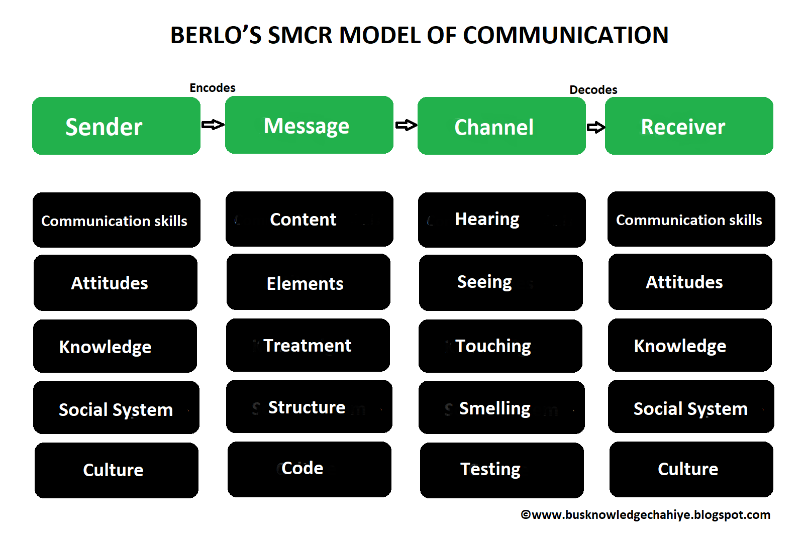
Figure 4

The constituents of Berlo’s Model of Communication are:

SENDER is the person who sends the message to the receiver. The factors who are related to the sender are the same in the case of receiver.
- Communication Skills
- Attitude
- Knowledge
- Social Systems
- Culture

MESSAGE has been sent by the sender to the receiver. The important factors who affect the message are:
- Content
- Elements
- Treatment
- Structure.
- Code
CHANNEL is the middle instrument to send message.
The five perception of a human being for pour communication of the channel who affects the value are: hearing, seeing, touching, smelling and tasting.
RECEIVER is the person who receive the message. The good listening skill for the receiver are: attitudes, knowledge, social system and culture.
The criticism of Berlo’s model of communication:
- No feedback of communication
- No barriers of communication
- No area for noise
- Multifaceted model
- Is a precise model of communication

My own justification about all the models discussed above

I think that the communication models are a useful means to communicate with each other, but also to communicate with public listeners. Is important to know in advance what the message is, how it will been coding, through which channels it will be send to the recipient and what possible kinds of noise might occur, an administration is clever to firmly start a conversation with his target groups.

Communication at my work place

I’m working as a taxi driver at my own Airport Transfers Company. One of my mission is to constantly help improve the quality of minicab services in London for both customers and drivers.
My opinion is that in any working environment, communication can bring high productivity, safety and happy costumer.
Communication is the most important component in my business to avoid confusions (drop off the costumer to a different Airport according to the booking)
The communication with my costumer/operators must be clear, correct and precise. If I will met the purpose then I can be sure that the efficient management and the company will work as a team. An efficient communication ensure better decision which I make, regarding the investment to achieve a higher number of costumers and the new possibility of growth and development by using the creativity of the employees (operators). I’m trying to use a clear and appropriate message who can leads to the achievement of company goals and objectives.
To have a constant communication at my workplace, I can give a significant impact on productivity, employee satisfaction, and income.

CONCLUSIONS

In this assignment I have learnt about how important is to have an effective communication at the work place and also in our life. I understood about the verbal communication when we have to use words to deliver a message and nonverbal communication where the nonverbal signals count as more than 50% in the process of communication.
Also I’ve been learning about the Shannon and Weaver Model of Communication, Schramm Model of Communication and Berol’s Model of Communication.

REFERENCES

Shannon, C.E. & Weaver, W (1971). The Mathematical Theory of Communication. The University of Illinois Press; First Edition (US) First Printing edition (1971).
Croft. R (copyright 2004) Communication Theory - printing paper from the Class

Skill you need (2010-2011) – What is communication [Online] https://www.skillsyouneed.com/ips/what-is-communication.html Accessed on: 15/04/2020 at 21:27.
Maund, A. (2017) Certificate in Higher Education: Skills for the Workplace, Student Yearbook.1st .SAGE, London.

Thompson, N. (2018) Effective Communication: a guide for the people professions, Third edition. Hampshire

Adair, J. (2003) Effective Communication, Pan Macmillan Ltd, London:

