PROFESSIONAL CAREER DEVELOPMENT

PROFESSIONAL CAREER DEVELOPMENT REPORT AND ROLE PLAY

STUDENT ID: 2020570
NAME: JANE ACTOR
MODULE CODE: BMSW4005
LECTURER: Rita Ukachi-Lois

TABLE OF CONTENT
1.0 Introduction………………………………………………………………. 3
2.0 Understanding and Expectation of Employment……………………… 3
3.0 Recruitment and Selection……………………………………………... 4
4.0 Self Evaluation Review…………………………………………………… 5
4.1 Self-Motivation……………………………………………………………. 5
4.2 Kolb’s Learning Styles (1984) …………………………………………… 6
5.0 Personal Development Planning………………………………………… 7
6.0 Conclusion…………………………………………………………………. 7
References………………………………………………………………… 8

- INTRODUCTION
One of the most important decisions we make in our lives when growing up have to do with the career path we choose. This is because whatsoever career we choose tend to show and reflect the kind of person we are, our attitude, personalities, likes and dislikes and so on. It is therefore imperative that we reflect on our skills and strengths when deciding our career path. However, we also need to reflect on our weakness and shortcoming as well as this can also propel a career path thereby turning our weakness to opportunities of becoming a better person. While growing up, I had several careers I was considering, this includes, doctor, banker, an accountant, a consultant and many more. Little did I know that my skills, strength and even weakness were not aligned with any of the careers mentioned above. This report will give full details about my personal reflection on the new career I chose by making use of the Kolb’s reflective cycle as well as the SWOT analysis tools that is used to identify the Strength, Weakness, Opportunities and Threat related to a career path.
In addition, this report will refer to and discuss more on the personal reflection of the role play done in class where I acted as an interviewer as well as an interviewee for a role linked to my personal ambition which is becoming a Nursery Nurse.
2.0 UNDERSTANDING AND EXPECTATION OF EMPLOYMENT
Employment relationship is the connection between employees and employers through which individuals sells their labour (Budd & Bhave, 2010). This implies that the employer pays an employee to use their skills and knowledge to get a particular job done. It could be in form of selling goods or providing services. For this to happen, the employers reach out to people in need of the job and then set up an interview to select the appropriate candidate. Although, there are several reasons for which an employer sets up an interview for prospective employee, however, the most important reason is for the employer to assess the suitability of the candidates for the job. Therefore, as an employee, we need to first incorporate some skills, knowledge, personality and zeal that will attract prospective employers. Other reasons for an employment interview include giving the candidate sufficient information about the job and company, inform candidates about the mission and goals of the company, create a sense of confidence and understanding in selected candidates, test the knowledge and skill of candidates and many more.
The skills employers look out for in prospective employee include analytical skills (ability to confront a problem and create solution), communication skills (ability to communicate effectively both verbally and in writing), interpersonal skills (ability to interact and engage with others), leadership skills, teamwork (ability to cooperate and work well with others), and technical skills (ability to make use of the computer and access social media). In addition, the employers also want an employee who is honest, trustworthy, has integrity, has positive attitude towards work, resourceful, good listener and pays attention to detail, has good time management skills amongst others.
Furthermore, during the recruitment and selection process by the employers, it is imperative for the employers to give each candidate equal opportunity irrespective of their age, disability, gender reassignment, marriage and civil partnership, pregnancy and maternity, race, religion and beliefs, sex and sexual orientation as this is in accordance with the Equality Act (2010).
3.0 RECRUITMENT AND SELECTION
The role play was one of the most exciting and eye-opening time for me during this module. It gave me a deeper understanding into the things employers expects from prospective employees as well as how to stand out from other candidates using the various skills and learning styles taught in class.
I was interviewed on the role of becoming a Nursery Nurse. Becoming a Nursery nurse was a job I recently picked an interest in due to my love for infants and children. I love to provide care for children physically, emotionally, educationally as well as give them guidance. Also, I discovered that Nursery Nurse is also in high demand as little ones continue to need childcare hence the chances of finding and keeping work will be high. The interviewer asked me a range of questions which I answered well to the best of my knowledge but the question I found intriguing was when the interviewer asked me about my strengths and weakness in this job. I emphasized mainly on my strengths as this are much more than my weakness. Some of my strengths includes teaching children general life skills, assisting with potty training, feeding of foods and drinks, patient and ability to remain calm in stressful situations, sensitive and understanding and many more. In other vein, my weakness is that I don’t work well under pressure and during tantrum. Children often display tantrums, and it is sometimes difficult to try and subdue their anger thereby destabilizing me as well. I went further to explain to the interviewer, that although this are my weakness, they won’t hinder me from getting my job done as I have worked on means to keep me stabilized even during pressure and tantrum. Also, am currently working on being certified in first aid as this is a pre-requisite for a Nursery Nurse as children are prone to injury.
I was also privileged to interview another student who wants to be a child psychologist. She explained the role of children psychologist, their duties and responsibilities. According to her, the main duty of a child psychologist is to help diagnose mental health conditions and suggest treatments. Other duties and responsibilities mentioned by the interviewee include assisting affected children and families to realize happiness and fulfilment in their daily lives, providing detailed documentation and records of evaluation and treatments, coordinate with other child health experts like social workers to ensure the psychological development of a child amongst others. I discovered during the interview that the interviewee was well prepared ahead of the interview as she answered all the questions with confidence and accuracy. She also showed that she had great interest in the role and had the skills required for the role. Most importantly she highlighted her strength and weakness and explained in clear terms how she would turn her challenges into opportunities by proffering solution as problem arises. In addition, she also mentioned a few things that helps keep her motivated during the challenging times in her role and that is crucial as all jobs has its difficult times.
4.0 SELF EVALUATION REVIEW
After learning about the various skills employers look out for, it is important for me to reflect on my strengths as well as weakness in all these areas. This will help me build my self-motivation, as well as work on my weakness by using the Kolb’s reflective cycle as my style of learning.
4.1 SELF-MOTIVATION
Self-motivation is the force that drives one to get things done. It is therefore a crucial skill needed for one to be an ideal employee. Self-motivation is what drives us to keep going even in the face of setbacks, to take up opportunities and to show commitment to what they want to achieve. Every career has its difficulties and challenging times hence the need to be self-motivated. There are four elements of self-motivation, this includes the personal drive to achieve such as ambition, commitment to goals, initiative and optimism which is the ability to pursue goals during setbacks. In addition, you need to have a set of goals you desire to achieve before you can be motivated hence the need to leave your comfort zone, look out for opportunities and get ready to create solution as problem arise. This is what makes me stands out from other employees and they are what employers look out for when they are scouting for prospective employees. However, it is not easy to be self-motivated especially when faced with tough and difficult situation with a limited time to create solution. When this happen, I remind myself of other problems I have managed to solve as well as acknowledge my progress in this present challenge, look for another strategy to create solution rather than giving up, think about the people who will benefits from the solution I come up with and will reward myself once am able to finally achieve my goal.
4.2 KOLB’S LEARNING STYLES (1984)
The Kolb’s learning style is based on experiential learning theory and is designed to help individuals identify the way they learn from experience (Kolb & Kolb, 2011). This learning style is represented by a four-stage learning cycle as shown in the diagram below:
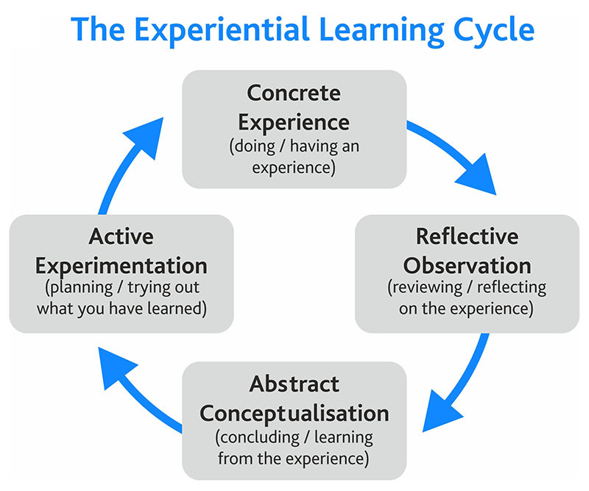
Source: Skillshub.com
The first stage is Concrete Experience which is having a new experience or reinterpreting existing experience. In this stage involvement is the key, that is, it requires me to actively engage in a task. The second stage is Reflective Observation where I reflect on the task carried out. In this stage communication is key because this stage is where I ask questions and discuss the experience with others. This interaction helps to clear any discrepancies between their understanding and the experience itself. The third stage is Abstract Conceptualisation where I begin to draw conclusion of my experience from previous knowledge or ideas incorporated with the ideas that was discussed with my colleagues. The last stage is Active Experimentation also know as the testing stage. This stage is where I apply the conclusion drawn from stage three to the task thereby creating new experience. In this stage, I am now able to make predictions, analyse tasks and make plans for the use of the acquired knowledge in the future. In addition, to develop new knowledge it is essential to complete all the stages in the cycle.
5.0 PERSONAL DEVELOPMENT PLANNING
SWOT is an acronym derived from Strengths, Weakness, Opportunities and Threat. It is a study done by individuals or organisation to identify its internal strengths and weakness as well as its external opportunities and threat. The internal factors (strength and weakness) are those we have control over while those we have little or no control over are the external factors (opportunities and threat) (Sarsby, 2012). My strength are the skills I possess which others don’t and these gives me advantage over other prospective candidates. My weakness are the skills that others possess but I do not possess or have them fully. This can however be controlled and minimised. Opportunities are chances that presents themselves for us to explore and make profit out of them. It is therefore essential for me to recognise and grasp opportunity once whenever it arises. Threats are what could cause damage beyond control. I also need to look out for potential threats to discover them early before they jeopardise everything I worked for.
6.0 CONCLUSION
To conclude, every career has both exciting and difficult times. Therefore, it is important for us to continually work on our strength, weakness and motivational skills as this help to keep us going during difficult times and help us take advantage of opportunities as they present themselves. It is also important for us to continually make use of the Kolb’s learning style to create new ideas and experience which are useful in solving problems as they occur. Lastly, we also need to surround ourselves with people who will add to our knowledge and drives us to become a better person each day.

APPENDIX
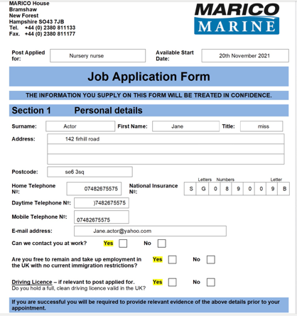
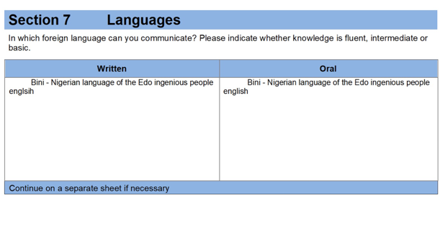
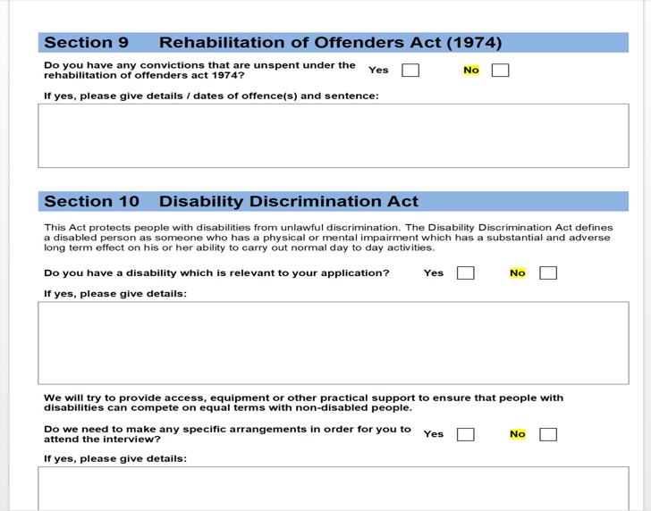
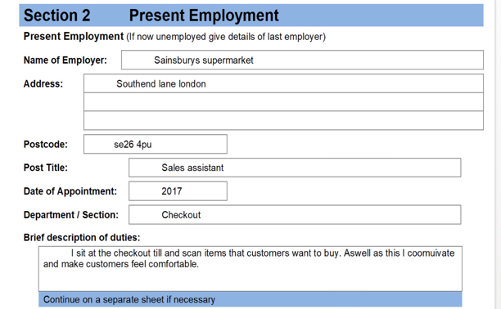
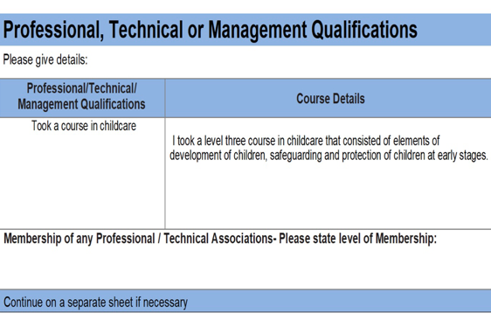
My application form
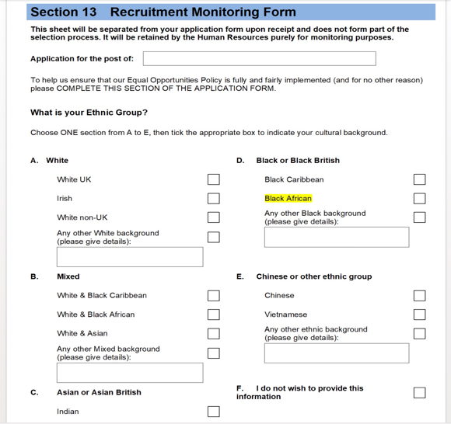
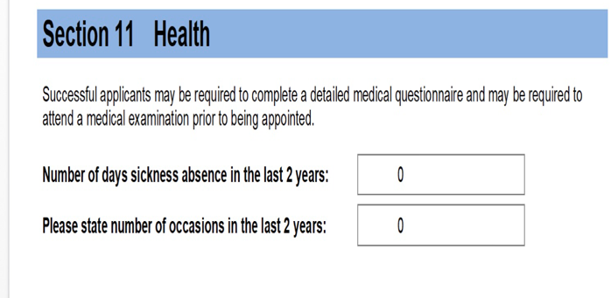
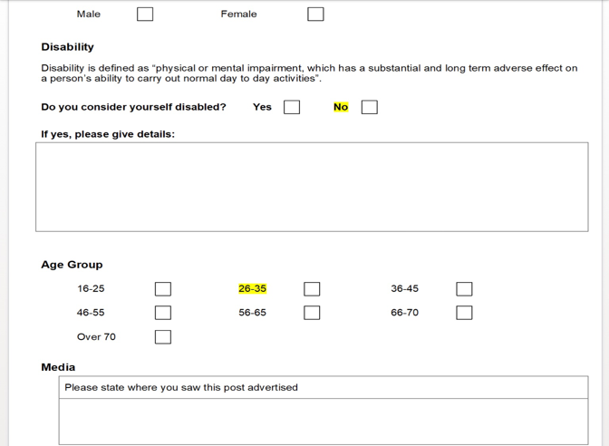
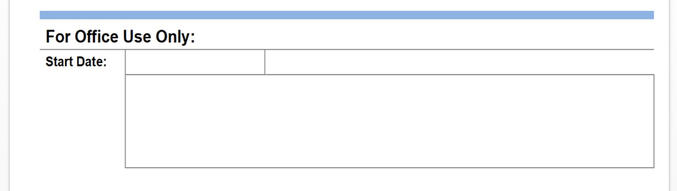
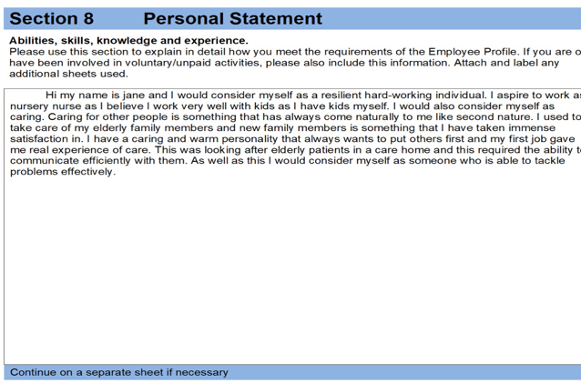

JOB DESCRIPTION

Nursery nurse work description:

Duties and responsibilities of a Nursery Nurse
Nursery Nurses provide care for children up to seven years old. They assist in many aspects of their daily lives, through social, emotional, educational and practical interaction, nurturing and guidance. This is done from a variety of settings, but most often in preschools and nurseries.
Helping to oversee, maintain and organise a clean, tidy, child-friendly environment, Nursery Nurses supervise activities, such as messy play, crafts, cooking, reading and outdoor/physical pursuits.
And because parents may feel like they’re missing out on their young child’s development, Nursery Nurses also plan, observe and keep records that inform parents and carers about their child’s day.
Other duties and responsibilities include:
- Feeding suitable meals, snacks and drink
- Changing nappies or helping with potty/toilet training
- Teaching general life skills, such as basic hygiene and manners
- Working with any health and social care professionals, where necessary, and undertaking any relevant admin/paperwork

Reasons for becoming a Nursery Nurse
It can be fun, flexible and rewarding.
Nursery Nurses will always be in demand as little ones continue to need childcare, so the chances of you finding and keeping work are high. This might be a welcome factor in choosing a career at a time of general employment uncertainty in many commercial and public sector workplaces.
Many office workers would envy painting pictures, baking biscuits and blowing bubbles as part of their day!
If you have kids of your own, it can be slightly easier than other jobs to negotiate your hours around – or they may be able to attend work with you.

Skills needed to be a Nursery Nurse
Energy, organisation, motivation and creativity would suit this role. You need to be practical, patient and enjoy spending time with tots. Skills such as singing, drawing and acting would certainly help. If you exude warmth, compassion and possess a sense of humour this could be the perfect job for you.
You must be dedicated, responsible and able to model appropriate behaviour. You are ideally firm but kind and willing to comply with any rules set by your employer. The ability to communicate clearly, and keep calm and composed in a crisis, is essential.
First-aid training is usually required.
Criminal background checks may be made.
Also you may require:
- sensitivity and understanding
- patience and the ability to remain calm in stressful situations
- the ability to work well with others
- to be flexible and open to change
- excellent verbal communication skills
- customer service skills
- the ability to understand people’s reactions
- active listening skills
- to be able to carry out basic tasks on a computer or hand-held device

JOB ROLEPLAY INTERVIEW QUESTIONS
Questions for Jane Actor
Tell me about yourself.
Why do you feel you are suited for the job of Nursery nurse ?
What are your strengths and weaknesses within this field of work?
Why do you think you're a good fit for our company?
Why did you decide to work as a Nursery nurse?
Would you like to ask me any questions?

References

Budd, J. & Bhave D., (2010). The Employment Relationship. 10.4135/9780857021496.n4.
Doyle A., (2021). Top Skills and Attributes Employers Look For. The best skills to have for your job search. https://www.thebalancecareers.com/top-skills-employers-want-2062481. Updated on July 16, 2021.
Kolb A.Y. & Kolb D.A., (2011). A Comprehensive Guide to the Theory, Psychometrics, Research on Validity and Educational Applications. The Kolb Learning Style Inventory Version 4.0. Experience Based Learning Systems, Inc.
Kurt S., (2020). Kolb’s Experiential Learning Theory & Learning Styles. Educational Technology, last updated December 28, 2020. Accessed at https://educationaltechnology.net/kolbs-experiential-learning-theory-learning-styles/.
Mcleod S., (2013). Kolb – Learning Styles. Published 2010 and updated 2013. Simplypsychology.org/learning-kolb.html.
Sammut-Bonnici T. & Galea D., (2015). SWOT Analysis. 10.1002/9781118785317.weom120103.
Sarsby A., (2012). A Useful Guide to SWOT Analysis. Published by Pansophix Online, ISBN 978-1-906460-89-1.
Skills you need. Self-Motivation. https://www.skillsyouneed.com/ps/self-motivation/hmtl.
What are Kolb’s Learning Style and What do they mean? Skillshub.com. https://www.skillshub.com/what-are-kolbs-learning-styles/.
What is Employment Interview? Types of Employment Interview. https://www.bizcommunicationcoach.com/what-is-employment-interview-types-of-employment-interview/.

