Ref 1:
https://www.technia.co.uk/blog/what-is-solidworks/#:~:text=and%20remote%20working.-,Easily%20Package%20Designs%20in%202D%20and%203D%20Formats,demonstrate%20new%20products%20and%20features.
Ref 2:
https://www.twi-global.com/technical-knowledge/faqs/what-is-3d-printing/pros-and-cons#:~:text=3D%20printing%20allows%20for%20the,the%20use%20of%203D%20printing.
Ref 3:
https://dtsuk.co.uk/uncategorized/milling-machines-what-are-they-and-what-do-they-do/
Ref 4:
https://www.energy.gov/eere/wind/career-map-design-engineer#:~:text=Design%20Engineers%20use%20software%20such,how%20to%20build%20the%20product.
Ref 5
https://www.ametals.com/post/what-is-a-lathe-and-how-does-it-work#:~:text=A%20lathe%20is%20a%20machining,behind%20a%20nicely%20shaped%20workpiece.

Ref 6
https://www.pinterest.com/pin/solidworks-audi-r8-car-complete-tutorial--549368854519611528/
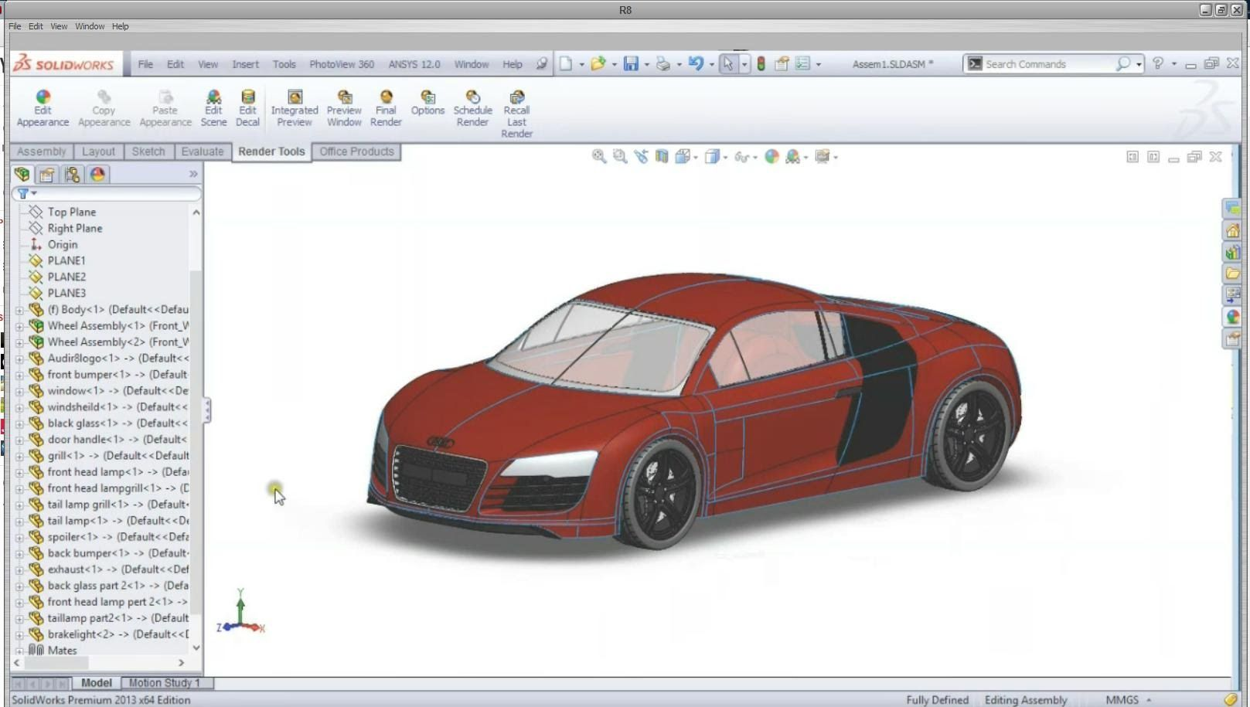
Ref 7
https://www.forbes.com/sites/bernardmarr/2020/07/24/what-can-3d-printing-be-used-for-here-are-10-amazing-examples/?sh=7209eff4d696
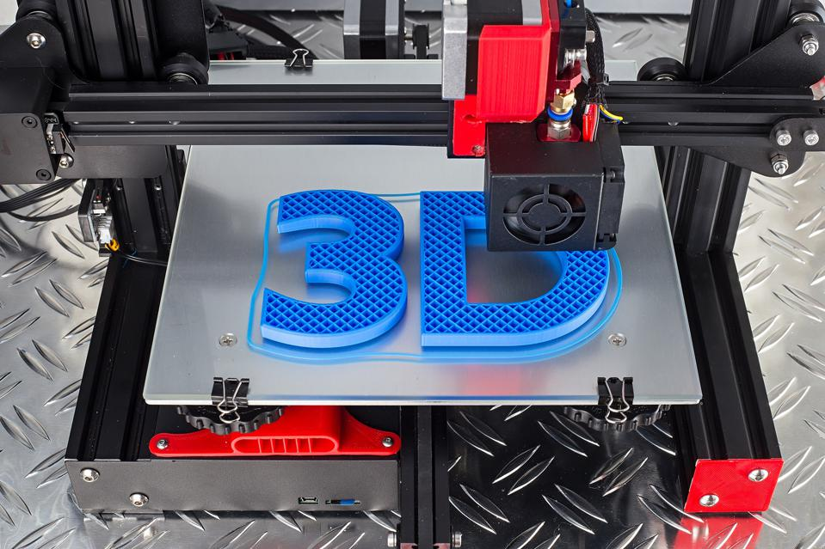

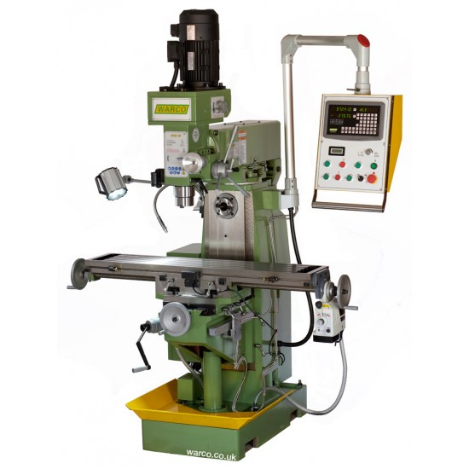
https://www.warco.co.uk/milling-machines/303299-wm-50-horizontal-vertical-milling-machine.html

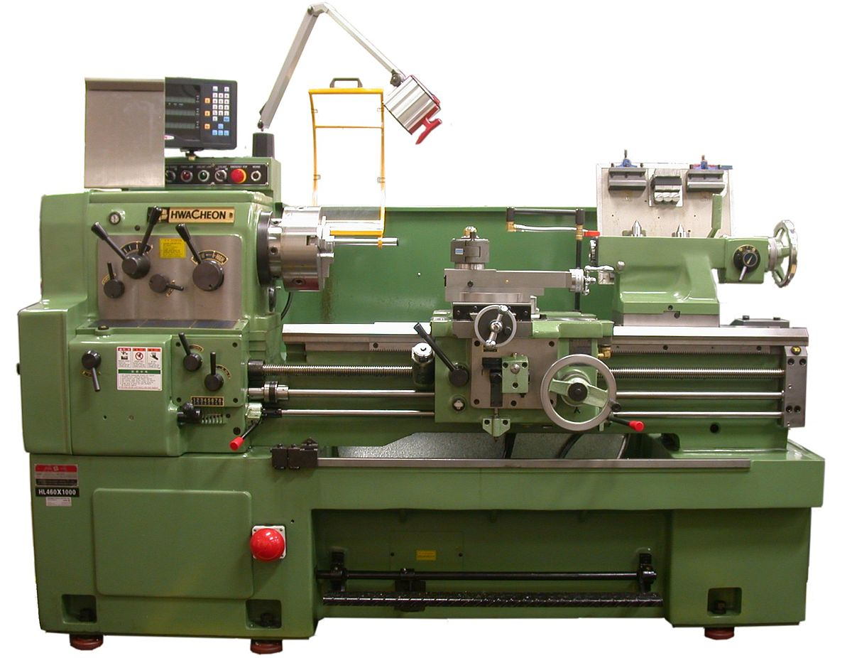

https://en.wikipedia.org/wiki/Metal_lathe

Reference 1 provided information about the utilization of Solidworks. Reference 2 illustrates the pros and cons of using a 3d printer. I used this to provide information on a 3d printers uses and capabilities. Reference 3 was used to give information on what a milling machine is and its capabilities. Reference 4 is used to give a summary on what type of software a design engineer will use. This was important to include as it provides an idea on what an engineer does. Reference 5 provided information on lathe machines.

