MANAGEMENT ECONOMICS – ADIDAS AG
by Anton Mersinkov
ID:2014039

Course: Management Economics LCBB5003
Professor’s Name: Samuel Ze-To
Institution: University of Wales Trinity Saint Daivid
Location of Institution: London Campus

Table of Contents
Company History and Product Description 3
Demand and Market Equilibrium 4
Substitution and Income Effects 9
Price Elasticity 9
Income Elasticity 12
Pricing Policy 13
Government Policy 14
References 15

Company History and Product Description
Adidas AG, is a German-based company that manufactures athletic shoes, clothing, and sporting accessories and is established in the sports industry market. During the early twenty-first century, Adidas became the Europe's leading sportswear producer as well as the second biggest in the entire globe after Nike (Bicho, 2018, p. 264). The company’s products have historically been identified by a three-stripe trademark, which is still used in the company's modern "trefoil" and "mountain" logos. Adidas has its headquarters situated in Herzogenaurach, Germany. Adidas (spelled "Adidas" by the corporation) is an acronym for the name of the company's founder, Adolf ("Adi") Dassler. After the end of world war I, the Dassler family started a shoe manufacturing business. Jesse Owens, an American sprint and world champion, put on shoes that were supposedly a donation from Adi Dassler at the 1936 Berlin Olympics. The athlete's medal-winning feats elevated global recognition of the Dassler product. After World War II, Adi and his brother Rudolf worked hard to reestablish the Dassler corporation, but by 1948, a personal schism between the two had already become irreconcilable. This prompted the division of the company into two: Rudi's business was later known as Puma, whereas Adi's company was named Adidas.
Adidas expanded gradually as football players converted to the corporation's footwear due to the product’s lightweight. The business then made expansions into sports products, floating soccer products in 1963. After four years, Adidas started its cloth manufacturing. Adidas became the leading brand in the sporting shoes market, but the competition intensified in the 1970s, mostly from new manufacturers such as Nike. Adi Dassler died in 1978, and notwithstanding a ground-breaking endorsement arrangement with the rap group Run-D.M.C., authors of the popular track "My Adidas," the brand endured declining market command in the 1980s. Adidas was then forced to sell Salomon in 2005, nonetheless maintaining its TaylorMade brand. The business was renamed back to Adidas AG, the following year. Going forward, Adidas acquired the Reebok firm (2006), that held the Rockport shoe brand, as well as Five Ten (2011), which manufactures outdoor-sports shoes. The company later sold TaylorMade in 2017. Western Europe, North America, and Greater China form the major markets for the company, making up about half of the company's annual sales revenue (Saatchian, Azizi, and Talebpour, 2021, p. 36). Slightly above a third of the company’s sales came from the EMEA region. Although Adidas' target demographic is between the ages of 13 and 40, majority of its clients fall in the middle and luxury class of ages between 15 and 30 (Adidas, 2017). The company's marketing is also built on a user-benefits policy.

Demand and Market Equilibrium
Adidas is concerned about developing strong competitiveness in the modern athletic goods market. Nike and Puma and other smaller companies have increased the market competition leading to several market struggles by the company (Heien and Pompelli, 1989, p. 761). According to Schwarzmayr, (2015, p.876), the market's main players have also chosen to profit from reduced prices in their overseas markets by subcontracting more than half of the production, reinventing themselves as marketing firms instead of producers. Although Adidas presently trails Nike in market share and revenue in world sports shoes, it has established itself as one among Europe's greatest successful companies from the beginning under the oligopolistic market structure.
Adidas' recent successful business operations have been associated with its commitment to technological quality and excellence, which has led to the creation of a tremendous increase in demand that is nearly unbreakable (Andreyeva, Long, and Brownell, 2010, p. 216). Adidas' global demand will be greatly influenced by changing market dynamics, such as the price of substitutes. The presence of new firms in this business demonstrates that the market is not completely inaccessible to fresh competition, shifting the market from oligopoly to monopolistic (Heien and Pompelli, 1989.p.759). These small businesses and substitute products demonstrate the significant threat to Adidas sports footwear alternatives. Because Nike does not offer a perfect substitute for Adidas, the latter is the price maker. Considering Adidas operates in a monopolistic market, it is considered a price maker and confronts a downward-sloping demand curve. With a downward sloping demand curve, the company has to make a trade-off: Adidas may sell extra but must reduce its price to do so. This indicates that its production decision will determine Adidas' marginal revenue.
Figure 1. Six-Year Financial Performance for Adidas AG.
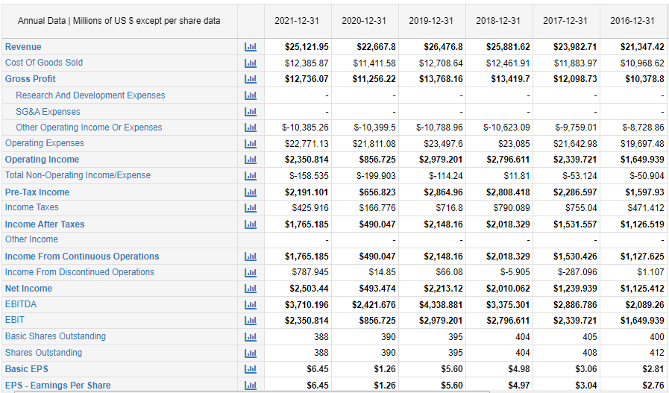
Source: macrotrends.net
Figure 2. Six-Year Financial Performance for Nike Inc.
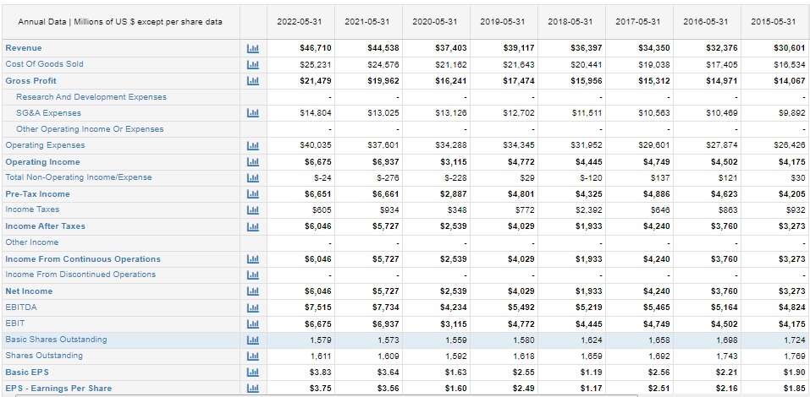
Source: macrotrends.net
Because of their limited income, families must decide about the products and services they buy. The subject of microeconomic consumer theory is the choice of what and how much to purchase by a household. Theoretically, consumer preferences determine the goods and services chosen, intending to maximize utility within the household's income, and the costs of the goods and services (Ellickson, 2013, p.15). The eligible working population's shares (20-64 years) will both decrease by 4.9 percentage points (OECD,2015, Vol 2015/01). Due to income gaps, these changing demographics will not only put the federal pension system to trial and have an impact on the labor market but also on private consumption.
The change in family income after inflation can be used to track the growth of a household's buying power. Recently, household income saw a very slight increase (0.4%) in 2020, after the COVID-19 pandemic, compared to 2019, whereas the average growth in 2021, compared to 2020, was 2.6%. Social income related to pensions expressed in percentage of GDP climbed consistently in the European markets from 11.9% in 2008 to 13.3% in 2013 and then fell to 12.6% in 2019 (OECD, 2015,Vol 2015/01). This trend can be attributed to an aging population. These income fluctuations have a significant impact on Adidas footwear markets. The decrease in working population and incomes means a reduction in total incomes. As income decreases, purchasing power also decreases, leading to a negative impact on the demand for Adidas footwear (OECD, 2015,Vol 2015/01).
Adidas base the design of its footwear on consumer feedback identified shifts in consumer tastes and preferences, and developing market trends. Therefore, consumers in the footwear market have a lot of influence in this area and can easily transfer between companies if they are dissatisfied. Some of the aspects that shoppers consider when choosing a brand are better costs, higher quality, newer styles, and other considerations (Adidas, 2020). The business has developed various techniques to offset the power of the consumer that aims to draw in new clients and maintain a high degree of client loyalty. Adidas strategic plan prioritizes an across-the-board approach of differentiation (Ghauri and Cateora, 2014, p.442).
At the company level, Adidas emphasizes creativity, the manufacture of unique, original products, and effective actions to help the company survive competition. It similarly upholds tight control over its supply model and overseas producers to allow product customization that is appealing to various consumers. Adidas' marketing strategy is centered on displaying its position as a pioneer in developing high performance product positions customized to the individual requirements of consumers and athletes. Additionally, the Adidas STP strategy is based on behavioral, psychographic, and demographic variables (UKFT, 2017). This tactic emphasizes the importance of high-quality products from a reputable brand to construct a distinct impression in the potential customer's mind and ensure a steady growth in demand for Adidas shoes.
Adidas will be raising prices as a result of the increased cost of production, which is disappointing news for customers. Adidas disclosed this in its fourth-quarter and full-year 2021 reports. To maintain their preferred level of financial stability, the German company will increase the price of sports shoes by 5 to 10% this year (Baker, 2003, p.278). This, however, does not impact the demand for Adidas sports shoes because of its strong position in the market. Despite interruptions in the Greater China and Asia-Pacific markets, the global sportswear company reported a currency-neutral sales increase of 16% in 2021 over the previous year, reaching 25.12 billion euros. In line with the footwear trend, buyers choose designer athletic shoes that include aspects of sports design despite higher prices (Baker, 2003, p.278).
Additionally, the ongoing change toward healthier lives is a major driver of running and cycling Adidas shoes in the global market. With the population of women partaking in fitness and sports activities increasing along with the prominence of sports and fitness activities like yoga, running, and aerobics, stylish and comfortable sports shoes are becoming quite famous (Aigner-Walder, 2015, p.33). Because of this, consumers, especially women, are purchasing more sports shoes.
Similar to several developed nations, Europe and other Adidas markets are dealing with an aging population due to a decreasing birth rate and increasing life expectancy (Ellickson, 2013, p.19). Approximately 20.8% of E.U. citizens were 65 or older in 2021. Between 2021 and 2025, there will be a projected 2.5-times increase in the proportion of E.U. citizens 80 years or older, from 6.0% to 14.6%. The proportions of the young population (0–19) will decrease at the same time by 0.8 percent (Statistik Europe, 2013). As members of the household become older, their preferences and needs change, which significantly impacts spending behavior. Foot and Gomez (2006,p.2026) demonstrate that while spending on apparel and footwear, communications, and transportation are higher at younger ages, spending on food and non-alcoholic drinks, alcoholic beverages, tobacco, etc., as well as furnishings and household equipment, increases with age. Since the primary target of Adidas footwear is the young generation, it risks a decreasing demand because of the aging population. However, the effect might not be significant because of the increasing sporting activities, which is the primary target.

Substitution and Income Effects

Price Elasticity
Once the price of a product fluctuates, demand and supply also vary, albeit in a reverse way, keeping other parameters constant. This is how the law of supply and demand operates. The nature of the product in the discussion will determine how much supply and demand will adjust. For example, relative to other products, the demand or supply of specific goods responds more to price fluctuations (McEachern, p.15). This explains the concept of product price elasticity. The amount of change in price's impact on a product depends on that product's price elasticity (Cigliano, 1980, p. 17). Adidas' brand of sports shoes has an elastic price because it is considered a luxury product. Because prospective consumers can forgo luxury goods if it is deemed too expensive, the demand for Adidas sport shoe products is sensitive to price fluctuations (Cigliano, 1980, p.18). Consumers will therefore react to an increase in the price of Adidas sports shoes by purchasing less or moving to ideal substitute products that they perceive to be more reasonably priced.
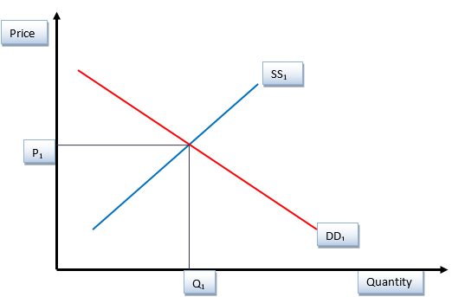
The diagram above demonstrates the initial equilibrium state of the Adidas sports shoe product before the price change. SS1 and DD1 denote the supply and demand curve respectively. P1 and Q1 are the equilibrium price and quantity, respectively.
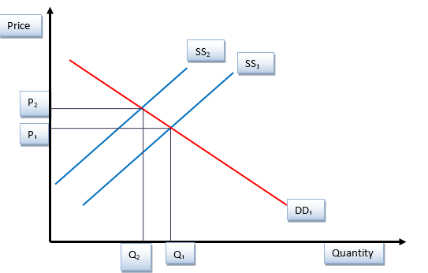
The supply curve shifts inward from SS1 to SS2 as shown in the above figure when the price of Adidas sports shoes increases, compared to other ideal substitute products like Nike sports shoes hence resulting in a new equilibrium position. P1 changes to P2, indicating a rise in price and a decreased customer demand. The overall result of the price increase is a decrease in demand. Guru (2015, p.1132), in his argument, asserts that products that make up a significant amount of disposable income have the disposition to be elastic. This is because customers pay closer attention to modest variations in the prices of expensive products than those of cheap products. Adidas sport shoes, in this instance, are price elastic. Since the pricing of the good dictates how easily it may be consumed in the market, its supply is elastic.
Additionally, the supply adjusts to the market almost immediately when the demand for the same product declines. If the price of an Adidas sports shoe rises, the demand for that specific product will fall by a similar amount, leading to a long-term decline in supply. Contrarily a reduction in the price of good results to an upsurge in demand since more customers will prefer the product.

Income Elasticity
Adidas sport shoes are income elastic since it is a luxurious good. In other words, if a household's income rises, there will be a greater demand to buy the goods because more money will be available (Cigliano, 1980, p.18). The opposite is also accurate. For instance, the demand for Adidas sports shoes will rise as household income rises. As a result, the demand curve for the commodity moves from point D0 to point D1, and a new equilibrium with price P1 and a bigger quantity Q1 is reached at point E1. On the other hand, when income declines, so does people's spending power (Cigliano, 1980, p.19). Considering that Adidas sport shoes are a luxury product, there will be a decline in demand, which will result in a reduction in the quantity needed. From P0 to P2, the comparable price will decrease. At point E2, a fresh equilibrium will be reached. The point is illustrated in the figure below.
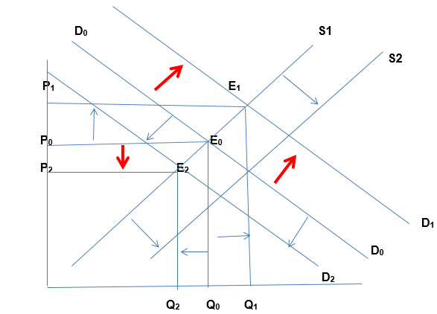
Given numerous substitutes in the market for Adidas sports shoes, the demand curve will be highly elastic due to how quickly customer behavior, such as consumption patterns, changes in response to price changes (Cigliano, 1980, p.19). Because of the presence of substitutes, a slight price change greatly affects demand since consumers have the opportunity to shift to alternatives that are cheaper or those that are affordable in the long term.

Pricing Policy
For the Adidas’ marketing mix, it uses competitive and skimming pricing. Competing with companies such as Nike and Puma, pushes Adidas’ sports products to be sold at competitive pricing, and the company’s recently released products to be sold at skimming prices (Shapiro, M1987, p.2212). Skimming pricing refers to holding on high prices for freshly released products to preserve their exclusivity before slowly decreasing prices over time to the market average (Indounas, 2020, p.1864). Adidas mainly applies a skimming price tactic when selling sport shoes owing to the company’s strong brand. Consequently, both high and upper-middle class customers form part of Adidas' target market. Realistically, Adidas' high price policy uplifts the firm to a premium brand in the market.
To stay competitive in the face of several ideal alternative products in the monopolistic market structure, Adidas must establish strategic limit pricing. Nonetheless, the company is positioned to gain from the functionality of the Sylos-Labini (Shapiro, M1987, p.2212). The simple and detailed assumption behind the Sylos-Labini is that an established company in the market will regularly maintain its pre-entry output levels in the case of a new entrant in that market sector (Shapiro, 1987, p.2212). Following the preceding analysis, the Sylos-Labini limit pricing policy may be considered anti-competitive action in favor of Adidas' potent brand name. The supply and demand factors may control the equilibrium prices for the Sylos-Labini in Adidas before limit pricing. The limit prices that are specified will be inelastic in the short run. The limit pricing, nevertheless, will be elastic in the long run.

Government Policy
Government policies have an impact on consumer consumption and behavior. The primary foundational element upon which the health of an economy is constructed is consumer spending or purchasing power. Whether or not consumer preferences are expressed, the government develops and adopts many policies that must be respected and implemented by an economy. The four primary ways that governments get involved in economies are through the provision of subsidies, the introduction or augmentation of taxes, and the setting, when needed, of price floors or ceilings (Rauch and Schleicher, 2015, p.15-01). Governmental financial aid is given to developing businesses or industries to help keep prices down. This enables these businesses to create more at a reduced cost, raising overall income. Raising consumer income has the impact of increasing demand. To pay for its expenses, the government imposes taxes on certain consumer products and services, as well as incomes and profits. A rise in taxes decreases households' income and, as a result, their buying power, which affects the economy's overall revenue generated by businesses and the demand for the product. The government can set price caps if it thinks the equilibrium price is too high. More critically, price caps are intended to reduce overpriced goods' cost (Rauch and Schleicher, 2015, p.15-01). Government intervention, therefore, is important in helping the smooth operations of Adidas AG.

References
Aigner-Walder, B. (2015) Effects of the Demographic Changes on Private Consumption: An Almost Ideal Demand System Analysis for Austria. Journal of Economic and Social Studies, 5, 1, 33-57
Andreyeva, T., Long, M. and Brownell, K. (2010) The Impact of Food Prices on Consumption: A Systematic Review of Research on the Price Elasticity of Demand for Food. American Journal of Public Health, 100, 2, 216-222.
Baker, J. (2003) Competitive Price Discrimination: The Exercise of Market Power Without Anticompetitive Effects (Comment on Klein and Wiley). Articles in Law Reviews & Other Academic Journals. Paper 278.
Bicho, A. (2018). Adidas AG-sportswear (Doctoral dissertation). Pp. 261-282.
Cigliano, J. (1980) Price and Income Elasticities for Airline Travel: The North Atlantic Market, Business Economics, pp. 17–21
Ellickson, P. (2013) Market Structure, and Performance. International Encyclopedia of the Social & Behavioral Sciences, Forthcoming; Simon School Working Paper No. 13-21
Foot, D. and Gomez, R. (2006) Population aging and sectorial growth: the case study of the U.K., 2006- 2026. OJBE, 5:1
Heien, D. and Pompelli, G. (1989) The Demand for Alcoholic Beverages: Economic and Demographic Effects, Southern Economic Journal, pp. 759–769.
OECD (2015) GENERAL ASSESSMENT OF THE MACROECONOMIC SITUATION. OECD Economic Outlook Volume 2015/1
Indounas, K. (2020). New B2B product pricing. Journal of Business & Industrial Marketing, 35(11), pp.1861-1869.
OECD (2015), OECD Employment Outlook 2015, OECD Publishing, Paris. Available at: http://ifuturo.org/documentacion/Employment%20outlook%202015.pd
Rauch, D. and Schleicher, D. (2015) Like Uber, But for Local Governmental Policy: The Future of Local Regulation of the 'Sharing Economy'. George Mason Law & Economics Research Paper No. 15-01. Available at: http://ssrn.com/abstract=2549919
Saatchian, V., Azizi, B. and Talebpour, M. (2021). ADIDAS Sportswear Brand Popularity Model in Iranian Consumers. Sports Business Journal, 1(1). Paper 36
Shapiro, M. (1987) Measuring Market Power in U.S. Industry, NBER Working Paper, No. 2212.
Schwarzmayr, L. (2015). Adidas AG: sports apparel (Doctoral dissertation). pp.162-169.

