
Skills for the Workplace
Module Assignment Submission

Student Name: | Caroline Smitham
Student Number: | 2011711
Module No: | BMSK4004
Module Title: | Problem Solving and Decision Making

Statement of Confirmation of Authenticity
By the act of making this submission, the student declares that this is the work of the student named above. The work has not, in whole or in part, been knowingly presented elsewhere for assessment, or where assessment has been built on a previous assessment, this has been identified. Where materials have been used from other sources it has been properly acknowledged. If this statement is untrue, the student acknowledges that an assessment offence has been committed.
Attention is drawn to the plagiarism and unfair practice policies of UWTSD.

Table of Contents
Define a complex problem in the workplace, including its scope and impact 16
Analyse information on the identified problem, to help inform the decision-making process 17
Propose a range of alternative solutions to the problem 19
Using a decision-making technique, evaluate a range of solutions to identify the most appropriate option 19
Develop a detailed plan for implementing the solution 22
Communicate the plan to relevant stakeholders 23
References 25
Appendix 1 26

Define a complex problem in the workplace, including its scope and impact

Every workplace faces a daily problem; some could be simple, and others are more complex. In my workplace at the University, we are often faced with a complex problem with a member of staff taking regular sick leave and giving little notice to the department. The university is a public sector organisation, and short notice sick leave can have a massive impact on students, visitors, and deliveries. It also affects the whole department, including management and other staff members. The effect that sick leave has on an entire department include:
- Reduced productivity
- Reduced motivation and morale from other team members
- Reduced customer satisfaction
- The cost of paying the person's salary and finding, training and paying temporary staff.
The impact it has on other employees is the extra workload that they must take on, which can lead to stress and more sickness absence from other team members
According to the Office of National Statistics, the leading causes of sickness absence in the UK are:
- Musculoskeletal conditions, e.g., Neck and back pain
- Minor illnesses like the common cold and, more recently, COVID-19.
- Mental health issues, including depression, anxiety, and stress.
With regular sick leave from the team member, they tend to miss deadlines, team meetings and any training sessions that may occur when they are off. Which can result in poor performance levels and lower productivity in their work.
There could be many reasons this team member is taking frequent sick leave, so it is essential to acknowledge their concerns and be supportive when they are at work.
There are a few options for the department to arrange cover. They include having other staff members cover the building or using agency workers. The course of action required will depend on factors like the length of absence and if the cover will be needed in the future.
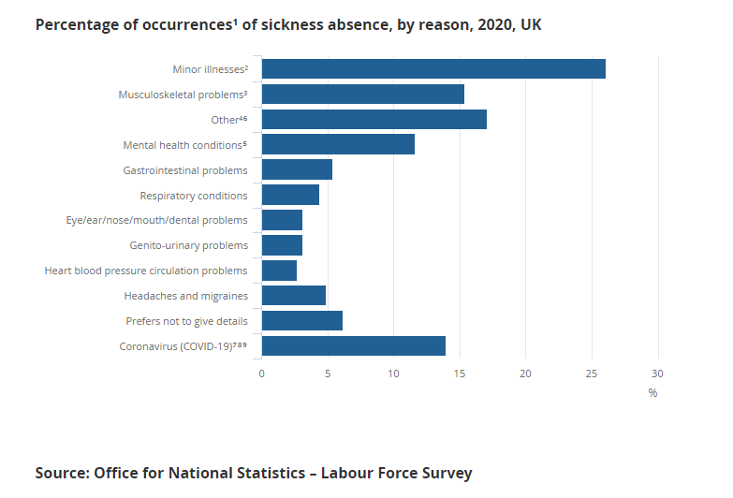

Analyse information on the identified problem, to help inform the decision-making process
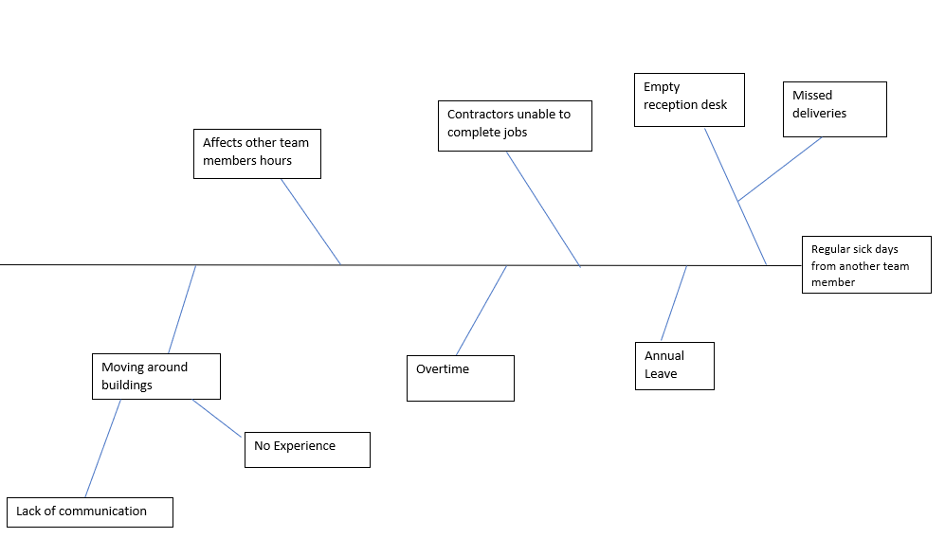

People take time off work for several reasons; when employees book time off for annual leave, it is usually in advance, and prior arrangements can be made. Regular unexpected sickness absence can heavily impact productivity, employee and morale and influence profits. It affects other staff members as they must pick up the absent employees’ work as well as their own. Also, some staff members have no experience in the role they need to cover, affecting customer satisfaction.
There are many ways to reduce regular sickness absences at the workplace. These include:
- An attendance/sickness policy
- Wellbeing programme for employees
- Reduce work-related stress (encouraging staff to take regular breaks)
- Motivate employees by offering incentives for performances
- Flexible working hours
- Provide support for personal problems
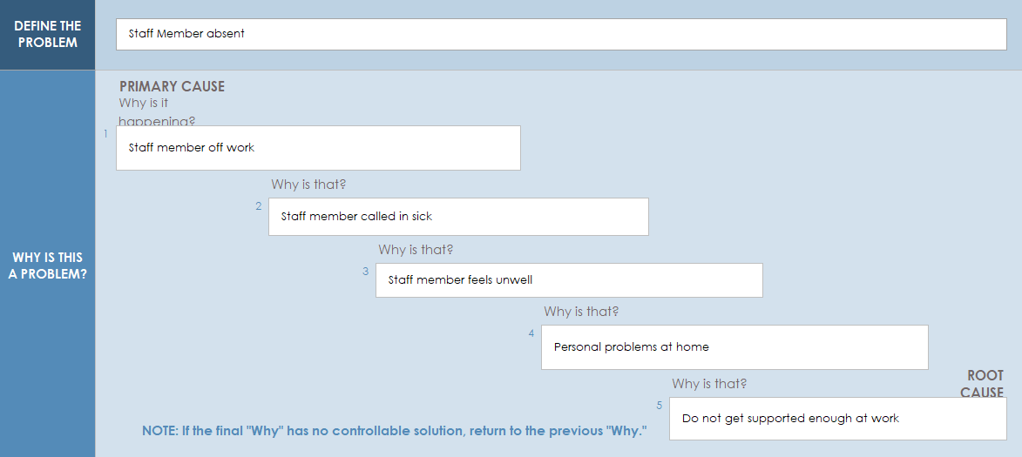
To get to the root of the problem, I have used ‘The five whys’ technique to bring in an in-depth understanding of the situation.

Staff members taking regular absences from work can be challenging to deal with, as there are both genuine and poor excuses for not attending work without prior authorisation. It is important for employers to take an active approach to staff issues and focus on the root cause behind the problem.

There are two main causes of illness-related absences from work: a real illness and system abuse by employees who are healthy enough to work but nevertheless decide to report for sick leave. One or more of the following may be the cause of one or both factors:

- Actual physical or mental illness
- Personal issues in their private life
- An unhealthy lifestyle
- Problems in the workplace, which are causing either short or long-term stress
- The need to care for family members
- Low job satisfaction
- As general unwillingness or want to work

Propose a range of alternative solutions to the problem

There are many ranges to solve the solution of covering an unplanned absent staff member, for short periods of leave the first port of call would be using existing staff members and would unlikely cause much disruption. By creating a clear sickness policy this can help monitor employee’s attendance record for better management and help if the employee needs extra support in work. (Appendix 1).
Employees who are not motivated find ways to miss work, if they are not enjoying their job, or do not feel appreciated or valued. Job satisfaction is essential for employees to succeed in their work, there are a few options that can keep employees motivated
- Hire strong motivated managers – According to survey monkey managers are responsible for at least 70% of the difference in employee engagement levels.
- Providing necessary tools – Keeping up to date with the latest technology and regular training as helps prevent employees from getting frustrated when they know how to do their job.

- Showing appreciation – Acknowledgement by managers builds trust and according to survey monkey research employees who have supportive managers are 67% more engaged and are likely to stay in the company.

- Incentives – Employee incentive programmes help increase productivity and morale and build bonds with other team members. (Top Employee Incentive Programs Examples in Workplace)

- Agency Staff – This can help with cover to relieve the pressure of other team member is there is a long-term absence but there is a disadvantage with this option as recruitment agencies can be expensive.

Using a decision-making technique, evaluate a range of solutions to identify the most appropriate option

OPTIONS | TIME | COST | LOCATION | TOTAL
WEIGHTS | 2 | 3 | 5
Overtime for existing staff | 1 2 | 5 15 | 5 25 | 11 42
Relocating existing staff | 3 6 | 4 12 | 5 25 | 12 43
Recruitment agency staff | 5 10 | 1 3 | 2 10 | 8 23

I have produced two techniques to decide which is the best way to solve my problem. Above is a grid analysis I have produced to decide between several options when factors need to be considered.
Before completing the grid analysis, I thought that employing agency staff would be the best option to the problem. Still, after researching further it, I found that agency staff do have disadvantages, they include the following:
- Lack of communication with other team members can have severe financial repercussions
- Agency staff have less training as work must be completed quickly – Although a temp worker may have some experience in the field of work required, there is still a need to train to complete tasks.
- Agency staff do not have the same bond as long-term employees – It can be challenging to build rapport with colleagues as it is only a temporary arrangement.
- Cost concerns, Agency staff will cost you money in commission or fees.

According to an article (How Much Do Recruitment Agencies Charge?2021) the fees that recruitment agencies charge employers can be significant. A recruitment agency will charge between 10-30% of the base annual salary.
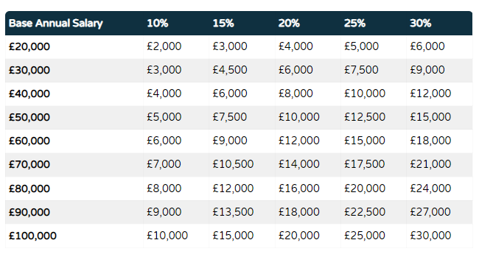
The table above highlights the predicted fees that recruitment agencies charge.
A cost-benefit analysis compares the explicit and implicit expenses of an action against the projected benefits. The process of acquiring that information may be instructive in and of itself, as it may necessitate the firm assigning monetary value to things that do not have explicit costs. The resulting analysis enables decision-makers to assess all available information and make sound decisions.
Cost-benefit analysis are most closely connected with public-sector decision-making as a mechanism for weighing benefits and drawbacks. However, they are also employed in business when it comes to project planning for adding workers, purchasing technology or equipment, expanding facilities, and other activities. Cost-benefit analysis can help a firm weigh the benefits of taking action vs maintaining the status quo, or it can help a corporation compare two or more options to see which one is the most beneficial.
Cost-benefit analysis assist businesses in weighing pros and cons in a data-driven manner so that complex decisions can be made in a systematic manner.
Leaders must identify and project the explicit and hidden costs and benefits of a proposed action or investment for a CBA to be successful.
It is also a good idea to delegate responsibility for making the case for the status quo as a means to evaluate the opportunity cost of doing nothing and investing cash with recommended measures.
Because a cost-benefit analysis is only as effective as the data it is based on, organisations with more mature financial reporting have a better chance of success.

Cost Benefit Analysis Template
 | COST
 | Years
 | 1 | 2 | 3 | 4 | 5 | Cost Total
Recruitment Agency Staff | £6,600 | £7,260 | £7,986 | £8,783 | £9,661 | £40,290
Training | £1,530 | £500 | £1,530 | £500 | £0 | £4,060
Total Costs | £8,130 | £7,760 | £9,516 | £9,283 | £9,661 | £44,350
 | BENEFIT
 | Years
 | 1 | 2 | 3 | 4 | 5 | Benefits Total
Overtime for existing staff members | 6000 | 6600 | 7260 | 7986 | 8783 | 36629
Reduced Training costs | 500 | 500 | 500 | 500 | 500 | 2500
Total Benefits | 6500 | 7100 | 7760 | 8486 | 9283 | 39129
Work out ratios below
Benefit to Cost Ratio = Total Benefits = |  | 0.8:1
Total Costs
Net Annual Benefit = Annual Benefit - Annual Cost
(First year) | £8,130 | minus | £6,500 | = equals | £1,630
Net Annual Benefit = Total Benefits – Total Costs = |  |  | £39,129 | minus | £44,350
5 |  |  | 5
 |  |  | NAB = | -£5,221

The cost-benefit analysis above shows that the cheaper option is not really the best option and does not really benefit cost-wise in the future.
Recruiting agency workers are more costly, but the advantage to this is they have access to the best candidates for the job. The candidates would have basic knowledge of their field of work, and recruitment agencies check references, collect CVs and filter job seekers. (Niamh Keenan,2020). Hiring an agency worker is quicker than trying to find your candidates and will save time and money in the future.
Having existing staff members cover shifts, and extra work can lead to employee burnout as people will take on too much. According to new research, more than three-quarters (79%) of UK workers have experienced burnout with 35% reporting high or extreme levels. (“At a glance: reward and benefits headlines this week 26 November - 2 ...”) (Zoe Wickens, 2021). Human capital management technology business Ceridian’s annual 2022 Pulse of talent report surveyed 1,156 UK members of staff in organisations with at least 100 employees, revealing that the vast majority have struggled with burnout, while 58% are either actively seeking or open to new employment.
The research highlighted that the top three catalysts for this were increased workloads (49%), mental health challenges (34%), and pressure to meet deadlines (32%). (https://employeebenefits.co.uk/79-uk-staff-gone-through-burnout/).

Develop a detailed plan for implementing the solution

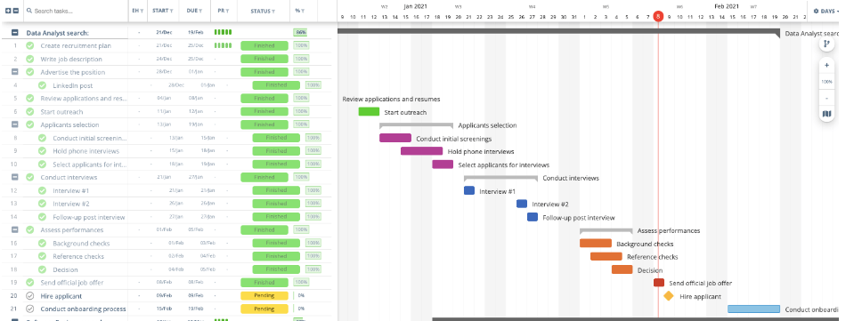
(https://instagantt.com/templates/job-recruitment-template)
Finding an individual to cover a role is not just selecting and hiring a person it is finding a person with the right skills and experience. Recruiting involves an important amount of planning to attract and find the right candidate. The human resources department would help with this process as they are a group who are mainly responsible for training and development; the steps needed to follow in the recruitment process are:
- Identify the hiring need.
- Writing a job description which is specific and attractive
- Advertising the position.
- Recruiting the position.
- Reviewing multiple applications.
- Selecting applicants and conducting initial screenings.
- Interviewing.
- Assessment of applicants and performances.
- Background checks.
- Decision making.
- Checking references.
- Sending official job offers.
- Hiring applicant.
- Onboarding process such as the administration tasks such as bank details, and next of kin information.
There are more scheduling tools besides Gantt charts. However, the following factors will help you manage your project more effectively:
You can design your initial project schedule and process using a Gantt chart. The fact that a Gantt chart is visual is its biggest benefit when used as the basis for project planning. A list or table of chores can be far more difficult to walk through with your team than one that is shown on a large screen in a conference room. A Gantt chart can help you and your team gather all your ideas in one place for an excellent overview, which is the same goal as a mind map. Then, as individuals come up with new needs, dependencies, and milestones, you can drag and drop tasks and reorder them.
Projects can be broken down. You can divide a project into stages or sprints with the use of a Gantt chart while keeping track of the overall project. For instance, you might be working on an Agile project that has three distinct sprints. You may see each sprint independently and concentrate just on the work contained within it by using a Gantt chart. Alternatively, you can see the complete project to keep track of how changes made in one sprint will affect those made in the others.

Communicate the plan to relevant stakeholders

The University has a variety of stakeholders. Stakeholders might come from within the company or from outside. Stakeholders are significant for a variety of reasons. Internal stakeholders are crucial to the business since teamwork is essential to its operations. Indirect effects from external stakeholders may exist on the company. A communication plan for stakeholders is important for several reasons.
- Assists the business in managing customers and other stakeholders - It is crucial that potential project stakeholders are aware of all objectives and checkpoints as well as any modifications to the original schedule. The relationship between the organisation and them can be greatly enhanced by maintaining open lines of communication and regularly updating them on the project's progress.

- A well-crafted stakeholder communication plan informs all stakeholders about project phases, quality, delivery date, and other critical features. Everyone involved is aware of their obligations.

- Helps with overall project planning: Having a communication strategy that expressly outlines how information is being sent, when and how often at each step of the project can help diverse stakeholders be informed about due dates, objectives, budgets, and other project components.

Failure might come from a breakdown in communication. There is a minimal likelihood that the stakeholders who will be touched by the change will be able to successfully embrace the culture, method, tool, etc., required by the project if they are not properly educated and engaged. Effective internal communications improve outcomes by 3.5 times for businesses.
86% of workers attribute business failures to inadequate communication.
Employees that are knowledgeable perform 77% better than their colleagues. (https://www.ocmsolution.com/stakeholder-communication-plan/).

The list of stakeholders and the appropriate channels for informing them of the new strategy are provided below.

Stakeholders | Frequency | Method | Priority
Lectures | Daily | Meetings  Emails | High
Students | Weekly | Bulletins  Email  Posters | High
Admin Team | Monthly | Email | High
Finance Team | Monthly | Email  Phone Calls | Medium
HR Team | When required | Meetings  Phone calls  Email | High

Lectures - Lectures are examples of internal stakeholders as they are the ones who actually carry out the work of educating students. In their classrooms, they have a significant amount of influence over what and how students are educated.

- Students - They are the ones who are learning; students are the most significant stakeholders in the University. Through quality education, students can acquire the knowledge and skills needed to succeed in life. Students should be involved in determining what and how they are taught as they are stakeholders in their education.

- Admin Team - The admin team bear a great deal of responsibility for the efficient and effective operation of the school. They are often persons employed for their profound knowledge of education, meaning they are a respected source of opinion on how The University might be improved. However, for The University to represent the values of their communities, administrators are usually the ones who must listen to other stakeholders and seek their opinions.

Each stakeholder has a distinct role to play in increasing support for educational goals. Stakeholder involvement in education is critical since each stakeholder's goal is to achieve a common educational goal through a collaborative effort. When multiple stakeholders are involved, the team effort increases the likelihood of success in meeting these objectives. As a result, achieving educational goals requires a collaborative effort on the part of stakeholders.

Monitoring

There are a variety of tools available to assist you in planning, monitoring, and reviewing modifications.

- GANTT Charts - Enabling planning, scheduling, and evaluating activities, which visually represent the project for you to readily analyse and ensure its viability.
- SMART (Specific, Measurable, Attainable, Relevant, Time) - Defining these factors in relation to your goal helps guarantee that your objectives are met within a reasonable time frame. This method avoids generalisations and guessing, establishes a defined timeframe, and makes tracking progress and identifying missed milestones easier.

Measuring progress on each work is one of the most critical components of a manager's job. It assists employees in staying focused and meeting goals, as well as project managers in staying on top of what is going on in the workplace. The first step in good leadership is to assist others in staying on track, engaging team members, and holding everyone accountable.

Set goals and milestones.
When discussing how to track the development of a project, it's important to start with a worker's individual skill set. Measuring progress can seem extremely different from one person to the next and from one project to the next. The better a project manager understands each employee's abilities and limitations, the better he or she will be able to keep them accountable. Setting specific goals and milestones for each member of the team also contributes significantly to team happiness. It is critical to emphasise each team member's job and how it will contribute to the overall success of the team. Even when adopting minor goals and points of progress, it is critical to keep the overall picture in mind.

Check-in frequently.
When evaluating how to track a project's progress, never underestimate the value of checking in. A quick, casual talk at the start of each work session can assist project managers and workers create trust and differentiate a key distinction between workers feeling cared for and checked in on versus feeling criticised or checked up on. Communication is always essential in ensuring that a project operates successfully. If a worker is struggling to meet goals or complete time-sensitive activities, it's important to check in and try to figure out why, rather than continuing to develop structures that aren't motivating or helpful.

Establish Specific Deadlines
Keeping the end objective in mind is usually beneficial for tracking progress. Setting clear deadlines can help employees stay on track and accomplish projects without becoming anxious or overwhelmed. When everyone is on the same page about the project timeframe, tracking progress becomes much easier. Some project managers prefer to work with a single final deadline, whilst others prefer to set a timeframe for each milestone or goal. Whatever approach is used, if each deadline is clearly defined and team members understand what they're working towards, keeping track of each project should be as straightforward as sticking to the schedule.

Your communication strategy is about whom you will communicate project progress to, not how you will complete the project. Before you start monitoring your project, you need to be aware of the overall project strategy as well as the communication plan. What you monitor and how frequently you report will be influenced by your methodology in both cases.
Project management is an important but admittedly difficult piece of the puzzle. There are frequently multiple projects to monitor, and each project has numerous sub-levels that must be handled.

References

, How to Effectively Measure Progress on Your Project-08-02T05:00:00+00:00, 2019-last update. Available: https://blog.planview.com/effectively-measure-progress-project/ [Sep 4, 2022].
, Stakeholders in Education | Overview, Types & Examples - Video & Lesson Transcript. Available: https://study.com/academy/lesson/what-is-a-stakeholder-in-education-definition-examples.html [Sep 4, 2022].
HR, C., -07-05T09:38:15+00:00, 2019-last update, Reasons why employees are taking sick days & how you can reduce them. Available: https://www.consulthr.co.uk/reasons-why-employees-are-taking-sick-days-how-you-can-reduce-them/ [Sep 4, 2022].
How To Create an Effective Stakeholder Communication Plan. Available: https://www.indeed.com/career-advice/career-development/how-to-create-stakeholder-communication-plan [Sep 4, 2022].
, Stakeholders in Education | Overview, Types & Examples - Video & Lesson Transcript. Available: https://study.com/academy/lesson/what-is-a-stakeholder-in-education-definition-examples.html [Sep 4, 2022].
, What Are Stakeholders: Definition, Types, and Examples. Available: https://www.investopedia.com/terms/s/stakeholder.asp [Sep 4, 2022].
HR, C., -07-05T09:38:15+00:00, 2019-last update, Reasons why employees are taking sick days & how you can reduce them. Available: https://www.consulthr.co.uk/reasons-why-employees-are-taking-sick-days-how-you-can-reduce-them/ [Sep 4, 2022].
, The Benefits of Using a Recruitment Agency. Available: https://www.cpl.com/blog/2017/07/5-benefits-of-using-a-recruitment-agency [Sep 2, 2022].
, How To Create an Effective Stakeholder Communication Plan. Available: https://www.indeed.com/career-advice/career-development/how-to-create-stakeholder-communication-plan [Sep 4, 2022].
, Job Recruitment | The Ultimate Template. Available: https://instagantt.com/templates/job-recruitment-template [Sep 2, 2022].
, What Are Stakeholders: Definition, Types, and Examples. Available: https://www.investopedia.com/terms/s/stakeholder.asp [Sep 4, 2022].
WICKENS, Z., 2021. 79% of UK staff have gone through burnout.
, What is Employee Absenteeism? Effect, Reasons, Remedies-03-11T10:11:27.000Z, 2019-last update. Available: https://blog.vantagecircle.com/employee-absenteeism-hr-guide/ [Aug 31, 2022].
Grid Analysis to Make Tough Business Decisions. 2018.
What Are The Effects Of Sickness Absence On Your Workplace? | Occupational Health Business Management. 2015.
, 5 simple employee engagement ideas you need to implement. Available: https://www.surveymonkey.co.uk/mp/5-simple-employee-engagement-ideas-implement/ [Aug 31, 2022].
, Effective Problem-Solving Steps in the Workplace | Indeed.com. Available: https://www.indeed.com/career-advice/career-development/effective-problem-solving-steps [Aug 18, 2022].
, How To Manage Sickness In The Workplace. Available: https://www.search.co.uk/blog/2020/02/how-to-manage-sickness-in-the-workplace?source=google.com [Aug 24, 2022].
, Problem solving vs decision making – what is the difference?. Available: https://www.changeboard.com/article-details/16960/problem-solving-vs-decision-making-what-is-the-difference-/ [Aug 31, 2022].
, Top Employee Incentive Programs Examples in Workplace. Available: https://recognizeapp.com/cms/articles/top-employee-incentive-programs-examples-in-workplace [Aug 31, 2022].
JOHNSON, E., -07-31T08:35:38+00:00, 2020-last update, Reducing absenteeism in the workplace. Available: https://cpdonline.co.uk/knowledge-base/business/reducing-absenteeism-in-the-workplace/ [Aug 26, 2022].

Appendix 1

RETURN TO WORK DISCUSSION FORM

Managers must ensure completion of this form for all absences. The form should then be sent under confidential cover to the Human Resources Department to be placed on the employees personnel file and actioned, where necessary. Please refer to the guidelines before conducting a discussion with an employee.

Surname……………………………………… Forename………………………………… Position:………………………………….. Faculty/School/Department………………………………….
The purpose of the return-to-work discussion is to ensure that every employee appreciates that whenever they are absent from work, an important member of the team is missing. The standard questions below are to be used by the manager to guide the discussion. Please refer to the Return-to-Work Discussion Guidelines and the Sickness Absence Management Policy for guidance.

- What was the reason for the absence? ……………………………………………………

- Was this absence related to a previous absence? YES/NO (If YES please give
details) …………………………………………………………………………………………………………
……………………………………………………………………………………………………………

- Is there any likelihood of a reoccurrence? YES/NO

- Did you seek medical advice from your Doctor/Consultant YES/NO
- Do you require further medical treatment?
(If yes please give details) ……………………………………………………………………….
……………………………………………………………………………………………………….…………
…………………………………………………………………………………………….……………………
……………………………………………………………………

- Did the Doctor/Consultant give any advice in respect of your work/work pattern?
…..………………………………………………………………………………………………………………
……………………………………………………………………………………………………………

- Are there any underlying problems relating to the absence that you wish to discuss (personal, work or domestic) and, if so, can any assistance be given to you by your Line Manager or Department?
……………………………………………………………………………………………………………………………
……………………………………………………………………………………………………………………………
……………………………………………………………………………… Was the absence notified in accordance with the correct procedure?

YES/NO

(If not please detail reasons why not)
……………………………………………………………………………………………………………………………
………………………………………………………………………………..…………………………………………
…………………………………………………………………………………

Self certification completed YES/NO

Medical certificate provided YES/NO

OUTCOME OF DISCUSSION

The outcome of the discussion is: (please tick)

  - No further action in relation to this period of absence is required

  - Managerial support to assist employee to achieve better attendance

  - Referral to Occupational Health Advisor/Counselling

  - Progress to more formal procedure

This decision is appropriate for the following reasons:
……………………………………………………………………………………………………………………………
……………………………………………………………………………………………………………………………
……………………………………………………………………………………………………………………………
……………………………………

Manager’s Name ……………………………………………………… Position ……………………………………………………… Faculty/Department ………………………………………………………

Manager’s signature…………………………………. Date………………………….
I acknowledge Return to Work Discussion Forms shall be retained on my personal file

Employee’s signature………………………………. Date…………………………….

THIS FORM SHOULD BE SENT UNDER CONFIDENTIAL COVER TO THE HUMAN RESOURCES DEPARTMENT

