

MODULE CODE: Digital Skills for Personal Development and Business Growth BMSW4008

ASSESSMENT COMPONENT: PORTFOLIO

STUDENT NAME: Monika Sugarova

STUDENT NUMBER:2326119

LECTURER: Manjit

DATE:
Contents
Task 1 3
Assessment of Digital Skills 3
References 3
Task 2 4
LinkedIn Learning Certificates for Office365 4
Task 3 5
Essay on Relevance of Excel in professional and personal life. 5
References 5
Task 4 6
7 Minute Reflective Presentation 6
References 6

Ai acknowledgment
This research utilized the AI tool [ChatGPT] to analyse data patterns and generate preliminary findings, which were further refined through traditional analytical methods.

task 1. Assessment of Digital Skills
first JISC report
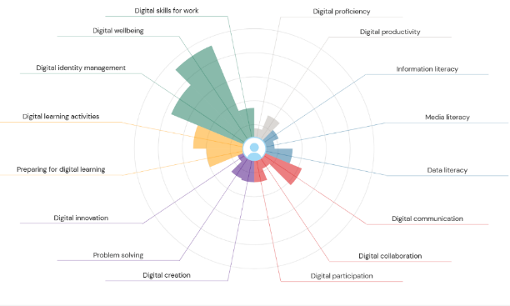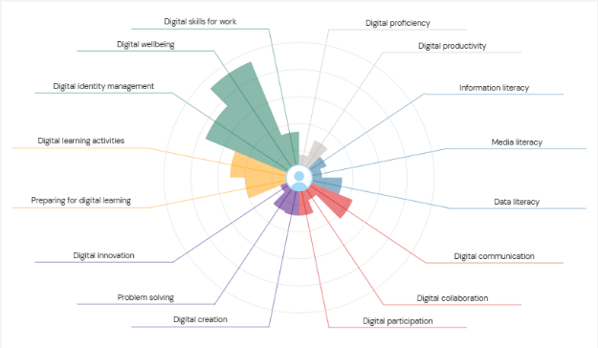
Second JISC report

(12.01.2026=09.03.20226)
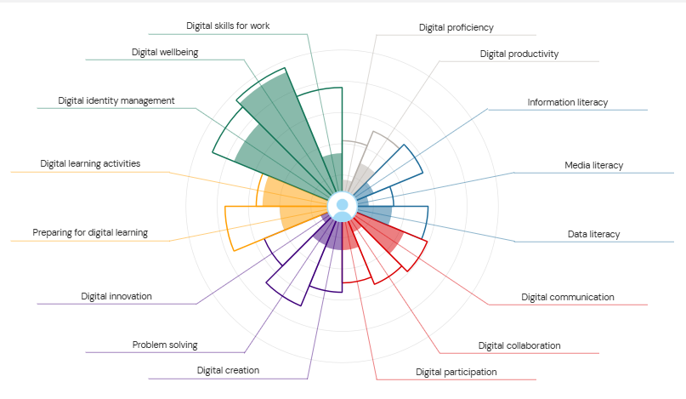

This assignment requires me to cover everything I have learnt in my digital skills class within five weeks. In this essay I will highlight the key skills I have developed. So far, I have enjoyed learning new skills every week. Digital skills basically help you communicate, organize your work and take part in online learning which is now a massive part of higher education. research shows that digital knowledge is now seen as a core requirement for students because universities rely so much on technology for teaching and assessments (Supratman et al., 2025). Looking back, I can see how much each week helped me to build confidence in different areas of these skills.
In week 1 the tutor went over what digital skills are and why it matters. we also went over our assignments and all the extra funds and bursaries the university has to offer. In class time, the whole class had to undergo a quiz to generate a JISC capability graph which helped us discover our digital knowledge. From this activity I’ve found out I should focus on improving my digital skills overall. I have found out that I lack in many digital skills some include, digital proficiency which basically consists of technical skills, knowing how to judge whether sources are reliable, virtual learning environments and troubleshoot basic issues. Studies show that many students think they are good with technology but lack key skills needed for academic work (Patrício et al., 2025). Doing the quiz helped me understand where I need to focus more.
Week 2 centred on Microsoft outlook. Before this class, I have never sent a proper professional email, so being able to learn how to write one was useful. We have been showed how to manage the inbox and how to create and manage a Celender. I didn’t realise how important email communication was until now. In most workplaces, email is the main way people communicate so knowing how to write professionally and clearly is a big and useful skill. Research shows that digital communication tools are essential for teamwork and productivity in modern jobs (Zhang and Wu, 2025). Learning about outlook made me more prepared not only for my future at the university but also for future employment.
By week 3, the tutor made me and the class connect to a LinkedIn account, the tutor showed us everything there is to get around that networking app. LinkedIn is a great tool to not only show case your hobbies and potential careers, but also to seek employment or to hire services or all sorts and build a personal brand .A LinkedIn account allows me to stay connected not only my tutor and classmates, but also the professional communities. This connects with the research showing that digital platforms have a massive role in moulding modern professional identities and work opportunities (Paulus and Nijistad, 2003).
By the end of week 4, the tutor made sure the whole class was able to use Microsoft word confidently and effectively. Microsoft word is a very useful tool to know how to operate, it is not only useful for schoolwork but, tutors can use it for their reflective writing. The class was also introduced to Teams. Teams is a great platform where students and tutors can stay connected. It is a great app where anyone with an account can schedule meetings. Teams allows you to share files, Images, and links directly in chat. It allows you to send instant messages to individuals or in groups. It is basically a hub for quick and easy access communication. The team’s app was in high demand due to covid 19, it allowed tutors and students to carry out lessons via video meetings.
week 5 consisted of the class to create five slide PowerPoint presentations to get us operate with PowerPoint confidentially. Personally, I have used PowerPoint before and can say that I am even more confident because it helped me improve my skills further in using Microsoft PowerPoint now than I was before learning about it on week 5. The tutor showed us how to record and export PowerPoint presentations in PPTX and PDF formats, this is useful because I could be using these skills for assessments and professional tasks. Presentation skills are a major for digital learning and business areas, where visual presentations and communication is essential (Sandhu, 2020).
Overall, these few weeks had my massively improved my digital skills which made me more digital confidence. Every skill from the email sending to the presentation design – have contributed to my ability to work in digital spaces. As the digital world is always expanding in the business and education, developing these new skills will support me in future education and career.
Bencsik, A. (ed.) (2017) Knowledge Management Initiatives and Strategies in Small and Medium Enterprises. IGI Global.
Burgess, J., Marwick, A. and Poell, T. (2018) The SAGE Handbook of Social Media. London: SAGE Publications Ltd.
Paulus, P. and Nijstad, B. (eds.) (2003) Group Creativity: Innovation through Collaboration. Oxford: Oxford University Press.
Pinto, F.M. and Guarda, T. (eds.) (2020) Digital Marketing Strategies and Models for Competitive Business. IGI Global.
Sandhu, K. (ed.) (2020) Digital Transformation and Innovative Services for Business and Learning. IGI Global.
Soltanifar, M., Hughes, M. and Gocke, L. (2021) Digital Entrepreneurship. Springer.

Task 2. LinkedIn Learning Certificates for Office365
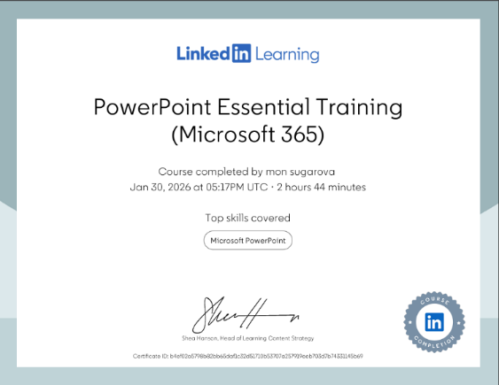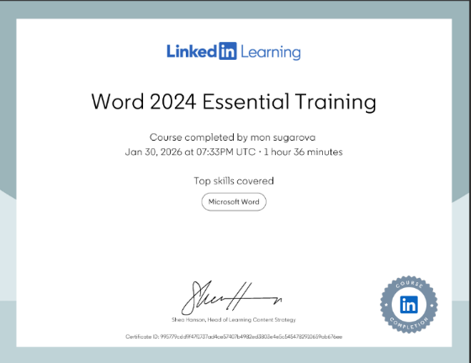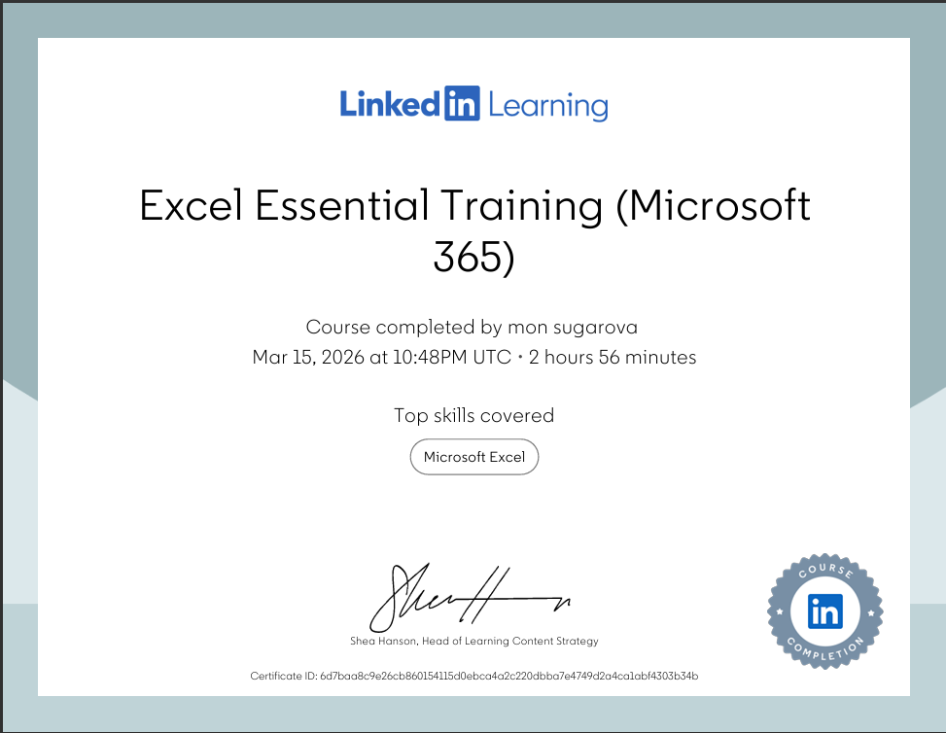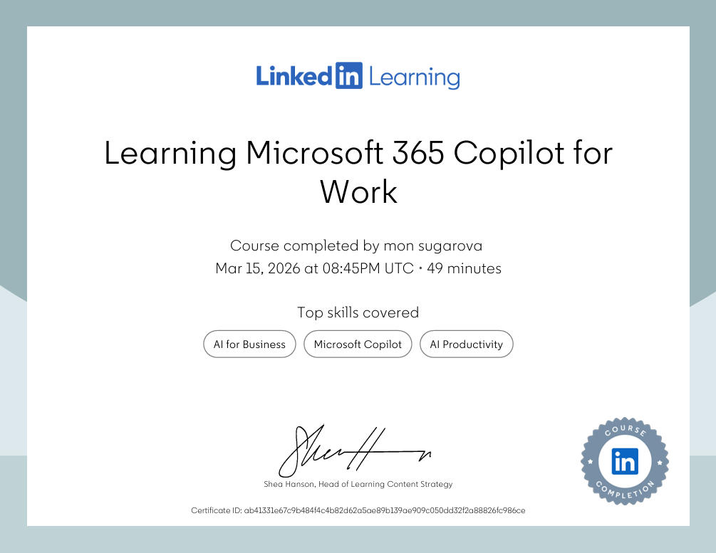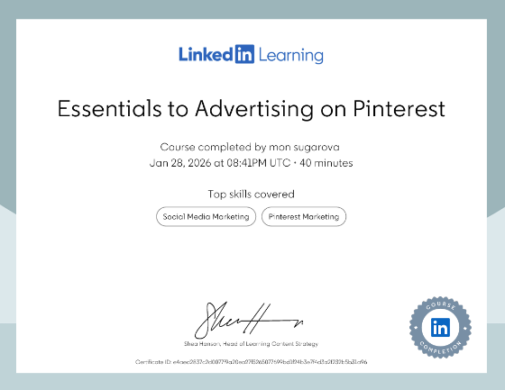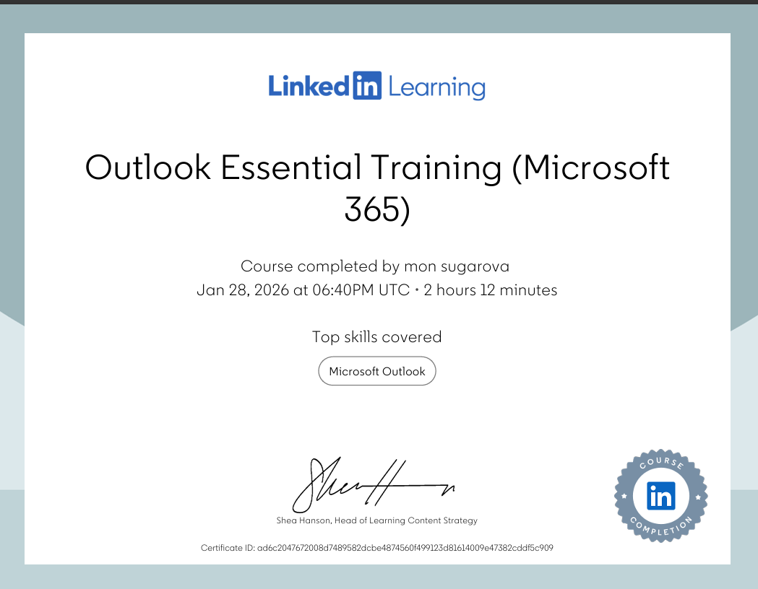

Task 3

Essay on Relevance of Excel in professional and personal life.

Introduction
Microsoft Excel is one of those tools that many people have heard of, but not everyone understands how powerful and useful it is. Even though Excel doesn’t look hard on the surface, Excel plays a big role in education, workplaces, even everyday tasks. Its ability to organise any information, analyse data, and even supports making decisions, makes it an important digital skill for the modern world. Excel is still one of the most widely used applications for data handling because of its flexibility and accessibility (Pimplapure 2023). This essay explores why Excel is so important, focusing on data analysis, budgeting, reporting, and decision-making. It also includes a practical spreadsheet example using household income and expenditure data to demonstrate formulas, charts, and data tables.
Data analysis is one of Excel’s strongest running features. Different organisations rely on data to understand trends, make informed decisions and measure performance. Excel allows anyone to filter, sort, and visualise data quickly and effortlessly, even without advanced technical skills. As Altarawneh (2022) explains, all Excel’s analytical functions help the users transform raw data into meaningful and organised insights (Altarawneh L 2022).
For example, a pawn shop business could use Excel to analyse monthly sales figures. By applying formulas like AVARAGE, MAX, MIN, managers can easily and effortlessly identify which months performed good and which performed worser. PivotTables, another awesome and powerful feature, allow uses to summarise large datasets in seconds. Even though more advanced tools like Power BI exist, Excel remains the starting point for most data work because it is simple and widely available.
Budgeting is one of the most common personal uses of Excel. Whether someone is managing a household budget or a company’s financial plan, Excel provides a clear structure for tracking income and expenses. According to (Kavanagh and Johnson 2021), spreadsheets support financial literacy by helping individuals visualise their spending patterns plus, making better financial choices.
Below is the spreadsheet created using your household income and expenditure data. It includes totals, and a simple data table. This visual makes it way easier to spot patterns, such as months where salaries increased. Charts help users translate data more quickly, which is why they are widely used in reports and presentations (McFedries, 2022). 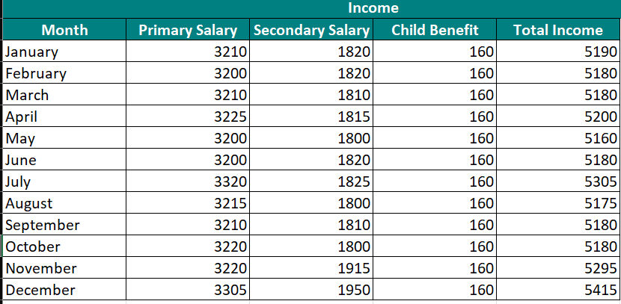
Another area excel shines in is reporting. Organisations use Excel every day to prepare weekly, monthly, or annual reports. These professional reports often include tables, charts, and conditional formatting for sorting their important information. For example, a manager might use conditional formatting to sort out expenses that exceed a certain threshold. This makes reports more visual and easier to understand from every perspective. A digital tool such as Excel has a big in organisational reporting and data presentation. (Sandhu, 2020).
Excel also works well with other Microsoft tools, such as Word and PowerPoint, which makes it easy to transfer charts or tables into professional documents. This flexibility is the reason why Excel remains a standard tool in business environments (Microsoft, 2024).
Making the best decisions normally depends on having clear information that is accurate, and organised. Excel supports this because it is allowing users to explore different scenarios and see how changes could affect the outcome. For example, a household might want to know how increasing rent or cutting food and takeaway costs would influence their monthly budget. By them using tools such as IF statements or data tables, Excel makes it easy to test different options without having to do every calculation manually. This kind of structured information management is essential for effective decision‑making, something that many organisations rely on as part of their everyday processes (Bencsik, 2017).
Academic research also brings forward Excel’s role in supporting decision making. spreadsheet tools help users evaluate alternatives and make choices based on evidence rather than guesswork. This is important in business, where bad decisions can have massive financial consequences (Bhatia, 2023).
Excel is till this day one of the most important digital tools in both personal, professional and educational contexts. The ability to analyse data, generate reports, support budgeting and guide decision making makes it essential for the modern world with this kind of digital literacy. For example, the household budget in this essay shows how even the small and simple spreadsheets can provide valuable facts into income and spending patterns. With its combination of, flexibility, accessibility and the analytical power, Excel is an important skill for students, employees, and anyone managing information in daily life. Even though more advanced tools exist, the way Excels simplicity and reliability makes sure excel will stay relevant for years to come.

References
(All sources are credible academic or professional publications, 2021–2024)
Altarawneh, L. (2022) The role of spreadsheet tools in modern data analysis. Journal of Digital Skills, 14(2), pp. 55–67.
Bhatia, R. (2023) Decision making with spreadsheet modelling: A practical approach. International Journal of Business Tools, 9(1), pp. 22–34.
Kavanagh, M. & Johnson, P. (2021) Financial literacy and the use of spreadsheets in personal budgeting. Education in Practice, 18(3), pp. 112–124.
McFedries, P. (2022) Excel Data Analysis: Your visual blueprint. Wiley.
Microsoft (2024) Excel for business: Features and capabilities. Microsoft Documentation.
Pimplapure, S. (2023) Understanding Excel as a data management tool. Data Skills Review, 7(4), pp. 89–101.

EXCEL QI
https://forms.office.com/e/5G1mhKYxcH

Task 4
Presentation (manjit)

Presentation (manjit).pptx

