

Analysing and evaluating the role of Police Constable on mental health.

Joshua Peake
2134359
Policing Practice Project BMPP6003D

Declaration
This work has not previously been accepted in substance for any degree and is not being concurrently submitted in candidature for any degree.
Signed: JPeake
Date:

STATEMENT 1
This dissertation is being submitted in partial fulfilment of the requirements for the degree of BA.
Signed: JPeake
Date: 5/10/2025

STATEMENT 2
This dissertation is the result of my own independent work/investigation, except where otherwise stated.
Other sources are acknowledged by footnotes giving explicit references. A bibliography is appended.
Signed: JPeake
Date: 5/10/2025

STATEMENT 3
I hereby give consent for my dissertation, if accepted, to be available for photocopying and for interlibrary loan, and for the title and summary to be made available to outside organisations.
Signed: JPeake
Date: 5/10/2025

STATEMENT 4
I hereby give consent for my dissertation, if accepted, to be available on the university’s IT system to those who have consent to use the system.
Signed: JPeake
Date: 5/10/2025

Abstract
This dissertation investigates the impact of the Police Officer’s role on mental health and well-being. A quantitative research design was utilised in order to collect data from 150 Police Staff across various departments within Gwent Police. Statistical analysis was employed to identify correlations and trends among the variables, revealing significant associations between work-related stressors and adverse mental health outcomes. The findings underscore the urgent need for systemic support mechanisms and cultural change within Police Organisations. Based on the results, the study proposes a series of evidence-based recommendations aimed at improving mental health awareness, promoting resilience, and enhancing access to psychological support for officers. These insights contribute to the growing body of research advocating for holistic approaches to occupational well-being in high-stress professions.

Table of Contents
Chapter 1: Introduction………………………………………………………………………………………………. Page 5
Chapter 2: Review of Literature………………………………………………………………………………….. Page 6
2.1 Overview Page 6
2.2 Inherent and Organisational Stressors Page 6
2.3 Intrapersonal and Interpersonal Stressors Page 6
2.4 Sleep Problems Page 7
2.5 Shift Patterns Page 7
2.6 Traumatic Events Page 8
2.7 Work-Life Balance Page 8
2.8 Addiction Page 8
29. Mental Health Stigma Page 9
2.10 Stress Page 9
Chapter 3: Methodology………………………………………………………………………………………………Page 11
3.1 Research Objectives Page 11
3.2 Quantitative Data Page 11
3.3 Ethical Considerations Page 12
3.4 Informed Consent Page 12
3.5 Withdrawal Rights Page 12
3.6 Anonymity and Confidentiality Page 12
Chapter 4: Analysis of Results ………………………………………………………………………………..…….Page 14
Chapter 5: Conclusion and Recommendations ………………………………………………………..……Page 17
5.1 Findings and Conclusion Page 17
5.2 Recommendations Page 19
Chapter 6: Bibliography ……………………………………………………………………………………………….Page 21
Chapter 7: Appendix ……………………………………………………………………………………………………Page 26
7.1 Research Proposal Page 26
7.2 Ethics Form Page 29
7.3 The Beat Questionnaire Post Page 32

Chapter 1: Introduction
Police work is widely recognised as one of the most demanding and high-pressure professions, often placing significant strain not only on Police Officers themselves, but also on their families (Kahn et al., 2019). The nature of the role – marked by exposure to trauma, irregular hours and high-stakes decision making – can lead to profound mental health challenges. Over the past decade, there has been an increase in the importance of reducing mental health stigma in Police Officers due to the growing number of mental health problems and Officer suicides (Drew and Martin, 2021). Moreover, recent data collected by Hoffman et al,. (2018) shows that the majority of Police officers who participated in their study who reported a decline in mental health also have children. This finding underscores the urgent need to explore how the role of a Police Officer impacts mental health and wellbeing and the impact this has on family dynamics, emotional strain, communication breakdowns and increased rates of divorce and family instability (Kahn et al., 2019; Violanti et al., 2018).
Latest statistics on Police Officer mental health in the UK showed that an alarming 14500 officers were signed off work in 2024 due to stress-related conditions (Police Federation, 2024). Furthermore, The National Police Well-being Survey (2024) reported that 70% of Officers interviewed reported high levels of fatigue and low job satisfaction, going further to suggest that Police work has some of the highest reported levels of burnout. A recent Channel 4 investigation also revealed that there have been just over 100 Police Officer suicides in the past 3 years (Channel 4 News, 2025). While existing literature has extensively documented the psychological toll of Police work, there remains a gap in understanding the triggers and finding effective interventions and strategies which may alleviate the stresses and pressures Officers face.
This research project advocates for a more participatory approach to mental health in the Police Force. Utilising a quantitative methodology, this study seeks to contribute to a more holistic understanding of Police Officer mental health, emphasising the importance of an officer-led input in shaping responsive and sustainable support recommendations. The quantitative methodology is a crucial component of this dissertation as it bridges the gap between research findings and manageable, actionable change. By offering evidence based recommendations, this research aims to contribute to a more resilient and supportive Policing culture and will propose meaningful solutions that can inform policy, training and future research.

Chapter 2: Literature review
2.1 Overview
The role of Police Constable has been recognised as one of the most stressful occupations in the world by Anshel (2000). Police work is rife with circumstantial stressors which carry a daily threat of physical harm from violence, verbal abuse and threats and – in extreme cases- death (Reiser, 1974). Moreover, Police Constable exposure to traumatic events often results in a potential for psychological distress disorders such as PTSD (post-traumatic stress disorder), sleep disorders, occupational burnout, as well as mental health conditions such as anxiety and depression (Edwards and Kotera, 2021). Research from the Home Office (2023) found that Police Constables are assaulted every ten minutes on average in the United Kingdom. Mental health intervention is essential due to increasing sickness levels and falling Police Constable numbers due to the multiple stressors of the role (Edwards and Kotera, 2021). According to Harvey et al. (2017) mental health problems are the leading cause of long-term sickness absence. Mental wellbeing of Police Constables is a cause for concern not just in the United Kingdom, but worldwide (Carleton, et al., 2018). This highlights the need for further research and studies into this field.
2.2 Inherent and organisational stressors
Purba and Demor (2019) found a correlation between Police Officer mental health and well-being and organisational and inherent stressors. Although both of these stressors can be found in other occupations, they are particularly prevalent in Police work (Johnson, 2016). Inherent stressors have been defined as the everyday stressors and characteristics of Police work which have the potential to be psychologically or physically harmful (Spielberger, et al.,1981). Such stressors include witnessing traumatic events, shift patterns, long working hours, job pressure, addictions, work-life-balance, negative interactions and physical injury. According to research conducted by Purba and Demor (2019) inherent stressors have a well-documented impact on officer mental health which can affect professionalism, safety, operational success as well as having a harmful effect on the individual.
Organisational stressors are also present in other occupations; however, they are particularly prevalent and damaging for those individuals which work within the Police Force (Reiser, 1974). Organisational stressors have been found to be more detrimental to officer mental health due to nature of them being uncontrollable, unavoidable and sometimes unnecessary (Davey et al., 2001). Violanti and Aron (1993) state that organisational stressors refer to those events which stem from Police administrative jobs which are part of Officer duties. Organisational stressors include inadequate staffing levels, a lack of support for Officers, underfunding, high workload, competition between officer and time-consuming administrative jobs (Purba & Demor, 2019). These factors can intervene with Officer job satisfaction and can contribute to Officer burnout (Alexander, 1999). Identifying and targeting such stressors has been found to secure officer well-being and create a more positive work environment, as well as having benefits to the public (Purba & Demor, 2019).
2.3 Intrapersonal and interpersonal stressors
According to Alexander (1999) interpersonal stressors relate to an individual’s interactions with others whereas intrapersonal stressors are stressors which are within the individual. Examples of intrapersonal stressors include stressors which come from; relationships with a partner, friend or family; social interactions such as conflict, social rejection or isolation; and responsibilities such as caring for children or family members. Almeida (2005) argues that interpersonal stressors are the most problematic to an individual’s mental health and well-being. Examples of intrapersonal stressors include stressors which come from; internal thoughts and feelings such as anxiety, fear of failure and low self-esteem; self percetption such as unrealistic expectations, negative mindsets and difficulty self-regulating; financial difficulties and academic pressures. Within literature, vast amounts of researchers have undertaken studies to identify methods in which individuals can improve their coping mechanisms, therefore reducing the harmful effects of interpersonal and intrapersonal encounters (Wright et al., 2015). This arguably makes the individual more able to cope with the additional stressors which they may face at work. As evidenced throughout this research methodology, Police Constables are subject to high levels of stress and pressure whilst at work. These stressors can also affect an Officer’s mental health and well-being whilst outside of work, e.g. traumatic events. Combining all of the stressors highlighted throughout this piece of literature helps to explain why so many Police Constables have been reported to struggle with their mental health and well-being. This further highlights the need for an effective and accessible mental-health toolkit with resources and help within the Police Forces.
2.4 Sleep problems
Additionally, sleep problems have been noted to have an impact on Police Constable’s mental health (Phillip et al., 2020). Mental health within police forces is a critical issue, particularly concerning sleep disturbances, which can significantly impact officers' well-being and job performance. Sleep deprivation is a common challenge faced by police personnel due to irregular shift patterns and high-stress environments (Kahn et al., 2021). Research indicates that chronic sleep issues can exacerbate mental health disorders, including anxiety and depression, leading to decreased morale and increased absenteeism within the force (Violanti et al., 2020). Furthermore, the demands of policing often require officers to make quick, high-stakes decisions, which can be compromised by insufficient sleep (Baker et al., 2018). Studies demonstrate that sleep deprivation negatively affects cognitive functions and critical thinking skills, essential attributes for effective policing (Philip et al., 2020). To address these concerns, it is imperative that police departments implement strategies aimed at improving sleep hygiene and overall mental well-being. Evidence-based interventions, such as flexible shift scheduling and mental health resources, could mitigate the impacts of sleep deprivation within police forces (Thomas et al., 2022). As mental health awareness grows, prioritising sleep health in police work may ultimately lead to enhanced operational effectiveness and officer resilience.
2.5 Shift patterns
Shift patterns have been highlighted to have an increasingly recognised impact on mental health. Additionally, policing often involves high-stress situations and unpredictable hours, which can adversely affect the mental well-being of officers (Hoffman, 2017). Research indicates that irregular shift work disrupts circadian rhythms, leading to sleep deprivation, anxiety, and depression (Violanti et al., 2018). Officers frequently experience chronic fatigue due to the demands of rotating schedules, which can diminish cognitive functioning and impair decision-making (Meyer et al., 2020). Furthermore, interpersonal stressors such as family life and caring for dependents can also impact well-being and can contribute to burn-out. Moreover, the stigma surrounding mental health in law enforcement can exacerbate these issues, deterring officers from seeking help (Munn et al., 2017). A supportive environment that encourages open discussions about mental health can significantly mitigate the negative effects of shift work. Furthermore, implementing structured wellness programs and flexible shift patterns may contribute to improved mental health outcomes for police personnel (Wright & McCauley, 2021). By prioritising the psychological welfare of officers, Police Forces can enhance both individual and organisational efficacy, ultimately leading to better community relations and public safety.
2.6 Traumatic events
Mental health issues among officers, particularly in relation to exposure to traumatic events, have garnered increasing attention in recent years. Police officers frequently encounter high-stress situations, which can lead to profound psychological impacts. Research indicates that law enforcement personnel are at heightened risk for conditions such as post-traumatic stress disorder (PTSD) due to their direct exposure to violence, accidents, and other critical incidents (Violanti et al., 2017). Such experiences can result in significant emotional and cognitive challenges, affecting both personal and professional functioning (Kop et al., 2019). Additionally, the stigma surrounding mental health within police culture often exacerbates these issues, as officers may feel compelled to remain stoic and avoid seeking help (Hastings et al., 2018). This reluctance can lead to a deterioration of mental health, ultimately impacting community safety and officer well-being (Hoffman et al., 2018). Effective interventions, including peer support programs and mental health training, are essential for fostering a supportive environment that encourages officers to address their psychological challenges (Gonzalez et al., 2020). Ultimately, prioritising mental health in policing is crucial not only for the officers themselves but for the communities they serve.
2.7 Work-life-balance
Mental health within police forces is a critical issue, particularly concerning work-life balance. Police Constables often operate under considerable stress, exposure to traumatic events, and demanding schedules that can compromise their mental well-being (Donnelly & McKeown, 2018). The inherent nature of police work, which frequently involves shift work, irregular hours, and high-stakes situations, contributes significantly to the deterioration of work-life balance (Papazoglou & Andersen, 2014). Research indicates that poor work-life balance can lead to increased rates of anxiety, depression, and burnout among officers (Flannery, 2018).
As noted by Kuehn et al. (2020), implementing flexible scheduling and promoting mental health initiatives are vital strategies for mitigating these adverse effects. Supportive work environments that encourage mental health resources can enhance officers’ resilience and effectiveness in their roles (Benford, 2021). Furthermore, cultivating a culture that prioritises mental health within Police Forces can foster improved job satisfaction and overall well-being, thereby enhancing public safety (Simmons & Hurd, 2021). Addressing work-life balance is not merely a benefit for officers but a necessity for maintaining a robust and effective police force. Moreover, a good work-life-balance and accessible mental health resources will have a positive impact on the individual’s family life outside of work.
2.8 Addiction
Larson et al., (2007) found from their research that Police Constables are at a higher risk of developing symptoms of anxiety, PTSD and depression which can lead to personal problems with addiction such including smoking, drug and alcohol abuse. Davey (2000) conducted research on a sample of Police Constables who fell within a ‘harmful alcohol consumption’ category. His findings showed that 73% of officers denied having a drinking problem. This suggests a lack of accountability and a willingness to seek help. Moreover, a study conducted by Substance abuse and Mental Health Services Administration found that emergency workers abused alcohol 2% more than the general population (Larson et al., 2007). Chopko et al., (2013) found in their investigation that alcohol addiction was linked to work-related stress and was often used as a form of self-medication. There are vast amounts of accessible research studies conducted by medical professionals highlighting the dangers of addiction. The number of Police Constables facing addiction is concerning and further adds to the need for an in-depth analysis of Officer Well-being and the factors which affect this.
2.9 Mental health stigma
According to Harris and Lim (2021) mental health stigma is rife within Police Forces, with many officers preferring to keep their mental health conditions private to prevent embarrassment. Mishra et al., (2020) place emphasis on the high levels of risk and stress associated with Police work, adding that Police Constables should not feel embarrassed by any of their struggles with mental health, but instead should share these challenges with colleagues who go through the same experiences and stresses as them on shift. Reavley et al., (2022) found that having someone to share worries and who can relate to stressful situations can be an effective coping mechanism to combat stress, work pressures and anxiety. Furthermore, addressing work-place bullying needs to be a high priority within the Police Force to prevent people from speaking up about mental health struggles through fear of bullying and ostracising.
2.10 Stress
Stressful situations are an intrinsic part of Police work (Purba and Demor, 2019). Research by Rand and Manuele (1987) has found that Police Constables are more tolerant of stressful situations and are more capable of dealing with intense periods of stress compared to the general public due to the nature of their job role. Anshel (2000) recognises that Police Constables need to be physically and mentally able to respond effectively to stressful situations, as also highlighted by the Professional Policing Standards (College of Policing, 2014). Wright and Henes, (2018) go further to suggest that as a result of the high stress levels, Police Constables experience higher levels of cardiovascular disease. Finding methods for dealing with and overcoming stress is essential to support the mental health and wellbeing of Police Constables. Moreover, accessible and appropriate mental health support for Police Constables may entice people to join the Police Force, leading to an increase In staffing levels which will help to alleviate the issues of low staffing levels (Simmonds and Hurd, 2021).
Mental health in Police officers has been the subject of volumes of literature for many years, however, as Abdollahi (2002) noted, the findings of such research literature are inconclusive and difficult to conceptualise. The importance of robust support for improving mental health and well-being withing the Police Force cannot be overstated. As frontline responders, Police Constables face high levels of stress and trauma which can lead to significant mental health challenges (Bourne et al., 2019). Police Constables are held to high expectations and standards, they make commitments to their role and work hard to serve the public – even working throughout the Covid Pandemic of 2020. Research indicates that effective mental health programs can improve Police Constable’s resilience, job satisfaction and overall organisational performance (Mishra et al., 2020). Furthermore, fostering a culture that prioritises mental health and well-being helps to reduce workplace stigma and will encourage Police Constables to seek help if or when they feel that they would benefit from it (Harris and Lim., 2021). It is essential that Police forces implement comprehensive mental health initiatives, including training, peer support, and access to counselling services to ensure sufficient mental health and well-being of their staff and enhance the effectiveness of the force as a whole. Furthermore, team-building initiatives can help to foster trust, effective communication skills and improve staff morale within the team, which will also have a positive impact on the productivity and job satisfaction within the force. By investing in mental health resources, Police Forces not only support the mental health and well-being of their personal but also contribute to the trust and safety of the communities in which they serve (Reavley et al., 2022).

Chapter 3: Methodology
From the detailed review of literature, this dissertation will analyse and evaluate Police Constable’s perceptions on the impact they feel their job has on their mental health. This chapter will explore the methods for obtaining reliable data which is needed to provide an answer to this question. It will also explore how the data collected will be kept private, confidential and secure.
3.1 Research objectives
The information intended to be collected will answer the research question as it will allow for Police Constable’s perceptions of their job role on their mental health. The findings can be analysed to highlight any common themes which will then help inform future research with the intention of finding methods for supporting mental health. The research objectives are as follows:
• Does the role of Police Constable have an impact on mental health?
• What is the impact? Are there any common themes?
• Are Police Constables aware of support for mental health from their Force? Are Police Constables worried about sharing their challenges with mental health?
- Would Police Constables recommend joining the Force?
This research project seeks to collect and analyse feedback from both civilian police staff and Police Constables across all ranks. By employing advanced data collection software, such as Excel Spreadsheets, the study will facilitate comparisons between the mental health experiences of sworn officers and their civilian counterparts. This dual-perspective approach is intended to uncover potential disparities in psychological wellbeing across different roles within the police service. The resulting data will be subjected to quantitative analysis to address the central research question and to inform evidence-based recommendations. The significance of this research lies in its potential to contribute to the growing body of literature on occupational mental health in policing, a field that continues to highlight high levels of stress, burnout, and psychological distress among officers (Drew & Martin, 2021 ; Haugen et al., 2017). Moreover, the study aligns with calls for more inclusive and representative mental health research within law enforcement, particularly in light of persistent stigma and barriers to help-seeking (Corrigan, 2004; Milne, 2021). By integrating perspectives from both sworn and non-sworn personnel, this research aims to provide a more holistic understanding of mental health challenges within contemporary policing.
Initially, conducting interviews with Police Constables was considered as a means of obtaining in-depth, personal insights into each of the research questions. However, upon further reflection, this approach was deemed less suitable due to several factors, including ethical considerations, time limitations, potential for interviewer bias, and organisational constraints. Consequently, this resulted in using a questionnaire design to collect data. This alternative method of data collection was selected to ensure greater feasibility and methodological rigour.
3.2 Quantitative data
The questionnaire was available for online completion to facilitate participant engagement due to the accessibility and anonymity. The questionnaire design was deeply considered to ensure it was the most effective method for data collection. As highlighted in previous chapters, Police Constables face huge time constraints within their role, therefore it was decided that a questionnaire consisting of multiple-choice questions, attitude scale questions and the option for text entry would be most beneficial. This ensured that the questionnaire had some variety in questioning with the aim of improving participant engagement. The Questionnaire link was posted on ‘The Beat’ which is an online search engine which all Police Staff are directed to as soon as they open up their online browser. By allowing participants easy and convenient access to the questionnaire, it may be suggested that the accuracy of findings is improved due to higher amounts of participation. Furthermore, allowing all Police Staff access to the questionnaire ensured the research was inclusive and helped with data comparisons. Therefore using this method for data collection ensures anonymity and also a methodological approach to interpretation and contextualisation of findings.
The intended number of participants for the research questionnaire was 30 participants, as highlighted in the research proposal sheet. However, 150 responses from participants were collected, which suggests that the well-considered means for data collection were beneficial as it led to much higher rates of participation than originally considered. It also suggests that the topic of mental health is particularly salient within the Police Force at present, evidencing the need for more research on the impact which the role of Police Constable has.
3.3 Ethical considerations
This research project has strictly adhered to the ethical research guidelines which were published by The British Educational Association (BERA, 2011). Prior to collecting any data, an ethics form was completed, giving in-depth details of the research methods intended. Fleming and Zegwaard (2018) explain that it is essential to have ethical approval before commencing any research. The completed ethics form was then submitted and approved of by University Trinity Saint David. A copy of the approved ethics form can be found in the appendices.
3.4 Informed consent
Denscombe (2010) highlighted the importance of participants giving informed consent, noting the importance of explaining the rights which they have and providing them with relevant information regarding the research and data collection prior to them taking part. All participants were informed of this information via The Beat secure, internal webpage.
3.5 Withdrawal rights
Participants were also informed of their withdrawal rights as per guidelines shared by BERA (2011). It is a participant’s right to be able to withdraw from any research project, at any time and without the need to give a reason why (Fleming and Zegwaard, 2018). Participants were informed prior to conducting the questionnaire that they may withdraw at any time by not submitting their answers for data collection. This ensured that their answers would not be able to be collected for analysis.
3.6 Anonymity and confidentiality
Participants were clearly informed that their responses would remain strictly confidential and anonymous. This assurance was essential in fostering honest participation, as anonymity has been shown to encourage more candid responses (Denscombe, 2010). To further safeguard participant privacy, the questionnaire was distributed via a secure online platform accessible exclusively to police personnel. This measure ensured that only the intended target group could access and complete the survey, thereby maintaining the integrity and confidentiality of the data collected.
Additionally, participants were given the option to refrain from answering any question by selecting “prefer not to say,” reinforcing their autonomy throughout the process. The design of the questionnaire itself avoided the collection of identifiable information, thereby supporting participant anonymity. Access to the raw data was restricted solely to the researcher, who is responsible for ensuring that all data will be securely destroyed upon completion of the analysis. Copies of the questionnaire and the approved ethics form are included in the appendices for reference.
In summary, the methodology adopted for this research has been carefully designed to ensure the collection of reliable, relevant, and ethically sound data. Additionally, it will ensure that data collected will be kept highly confidential and anonymous to protect Officers’ identities. While initial consideration was given to qualitative interviews with Police Constables, practical limitations—including ethical concerns, time constraints, and organisational barriers—necessitated a shift towards a more feasible and scalable quantitative approach. By utilising structured data collection tools, this study aims to capture a broad spectrum of perspectives from both sworn officers and civilian police staff. This quantitative research design not only supports the research objectives but also enhances the validity and generalisability of the findings. Ultimately, the chosen approach provides a foundation for analysing mental health trends within policing and for generating informed, evidence-based recommendations.

Chapter 4: Analysis of Results
This chapter presents the analysis of data collected through an online questionnaire designed to explore the impact of the role of Police Constable on individual mental health. The primary objective of the research was to determine whether the responsibilities and experiences associated with this role contribute to mental health deterioration.
The questionnaire received responses from 150 individuals across a range of roles within the police force, including frontline constables, supervisory officers, and staff in both public-facing and non-public-facing positions. The age groups represented span from 18-28, 29-39, 40-50 to 51+, with the most populated response (29 responses) being ‘prefer not to answer’, as per their anonymity rights. This suggests a notable portion of participants chose not to disclose their age, which may reflect privacy concerns or discomfort with demographic categorisation. The gender identity of respondents includes both male and female, with some respondents opting not to disclose their gender. The data collected provides insight into the prevalence of poor mental health among police officers both before and after joining the force, and how this aligns with existing literature on occupational stress in policing. The findings are particularly relevant in the context of increasing awareness of mental health challenges in high-stress professions and the growing body of research that identifies policing as one of the most psychologically demanding careers (Anshel, 2000; Edwards & Kotera, 2021).A significant number of participants reported having caring responsibilities, either in the form of dependents or other care giving roles. The job roles are diverse, including Police Constables, Sergeants (both public and non-public facing), Police Staff, PCSOs and higher ranks such as Chief Inspector and Inspector which ensures greater diversity of data.
The results revealed a significant and consistent increase in reported poor mental health after joining the police. Among Police Constables specifically, 18 out of 76 respondents (approximately 24%) reported experiencing poor mental health prior to joining the force. However, this figure rose dramatically to 54 individuals (71%) after joining, indicating a 47% increase. This trend was not isolated to constables alone. Among those in broader public-facing roles—including Police Inspectors, Chiefs, and Sergeants—68 out of 93 respondents (73%) reported poor mental health after joining, compared to only 19 beforehand. Similarly, when police staff were included in the analysis of public-facing roles, 80 out of 115 respondents (74%) reported poor mental health post-employment, compared to 28 prior to joining.
When considering the entire sample of 150 respondents, which included both public-facing and non-public-facing roles, 42 individuals (28%) reported poor mental health before joining the police, while 100 individuals (66.7%) reported poor mental health after joining. This represents a more than twofold increase in the prevalence of mental health issues, suggesting that the occupational environment and demands of policing may be a significant contributing factor. These findings are consistent with the literature, which highlights the cumulative psychological burden of policing, including exposure to traumatic incidents, irregular shift patterns, high workloads, and organisational stressors such as lack of support and under-resourcing (Purba & Demor, 2019; Violanti et al., 2020).

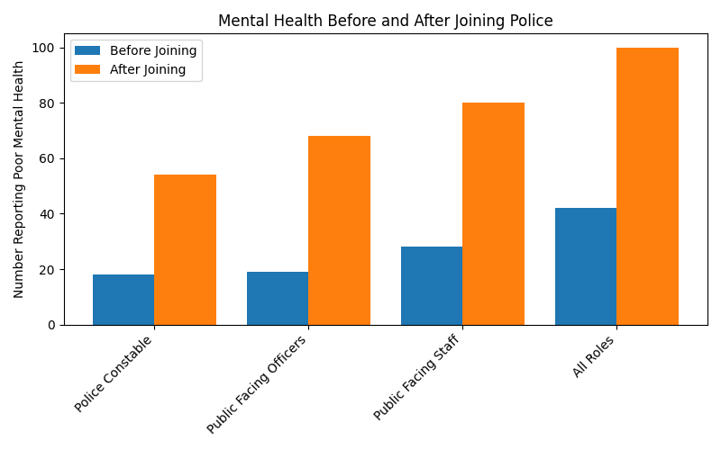

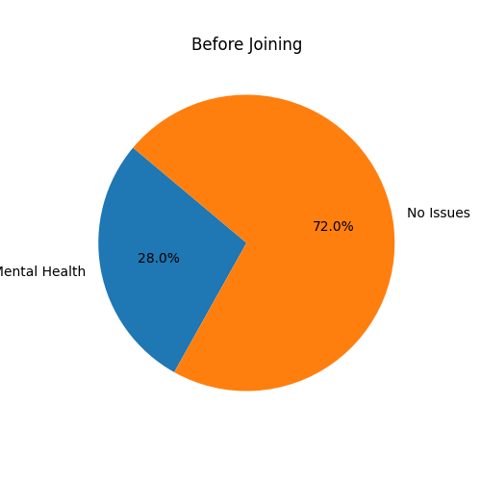
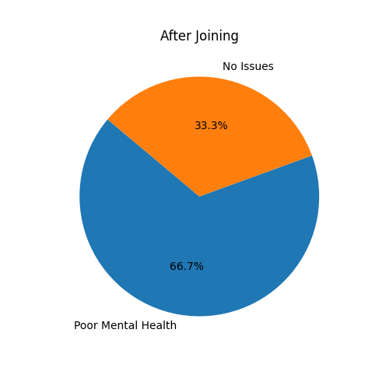
Figure 1: Bar chart showing poor mental health before and after joining the police force.

Figure 2: Pie charts showing distribution of poor mental health before and after joining.

These findings offer strong support for the hypothesis that the role of a Police Constable has a detrimental impact on mental health. The data reveals a significant increase in reported poor mental health after joining the police force, particularly among those in public-facing roles. For example, among Police Constables, only 18 out of 76 respondents reported experiencing poor mental health before joining, compared to 54 after joining a 47% increase. This trend is mirrored across other public-facing roles, with 68 out of 93 and 80 out of 115 respondents reporting poor mental health after joining. When considering all roles, including non-public-facing positions, the overall increase from 42 to 100 respondents further reinforces the conclusion that the occupational environment of policing contributes substantially to mental health deterioration.
The pronounced increase in poor mental health among public-facing officers suggests that specific aspects of the role—such as exposure to traumatic incidents, high-pressure decision-making, and frequent confrontations—are key contributors. These findings are consistent with Edwards and Kotera (2021), who identified high rates of PTSD, anxiety, and depression among UK Police Constables. The Home Office (2023) also reported that police officers are assaulted on average every ten minutes in the UK, highlighting the physical and psychological risks inherent in the profession.
The literature reviewed in the previous chapter supports the interpretation that both inherent and organisational stressors play a significant role in shaping officers’ mental health. Inherent stressors, as described by Spielberger et al. (1981), include traumatic events, long working hours, and the constant threat of danger. These stressors are unavoidable aspects of frontline policing and are known to have long-term psychological effects. Organisational stressors, on the other hand, are often systemic and include factors such as inadequate staffing, lack of managerial support, and excessive administrative burdens. Purba and Demor (2019) and Davey et al. (2001) emphasised that these organisational issues are particularly damaging because they are often perceived as unnecessary and beyond the control of individual officers.
The data also aligns with research on the impact of shift work and sleep disruption. Violanti et al. (2020) and Kahn et al. (2021) found that irregular shift patterns and chronic sleep deprivation are common in policing and significantly contribute to mental health issues. Officers working night shifts or rotating schedules often experience disrupted circadian rhythms, which can lead to fatigue, irritability, and impaired cognitive functioning. The high prevalence of poor mental health among constables in this study supports the conclusion that shift work is a major contributing factor.
Work-life balance is another critical issue. Donnelly and McKeown (2018) noted that the demanding nature of police work often leads to strained personal relationships and reduced time for rest and recovery. This imbalance can increase vulnerability to stress and burnout. Additionally, Larson et al. (2007) and Chopko et al. (2013) found that substance use, particularly alcohol, is sometimes used by officers as a coping mechanism for work-related stress. These behaviours, while offering short-term relief, can exacerbate mental health problems over time.
Stigma surrounding mental health remains a significant barrier to effective intervention. Harris and Lim (2021) argue that many officers avoid seeking help due to fear of being perceived as weak or unfit for duty. This cultural stigma not only prevents early intervention but may also contribute to underreporting, meaning the actual prevalence of mental health issues could be even higher than the data suggests. Reavley et al. (2022) advocate for peer support programs and open dialogue within police teams as effective strategies to reduce stigma and encourage help-seeking behaviour.
In conclusion, the data obtained from the questionnaire strongly supports the research objective: the role of a Police Constable has a substantial negative impact on mental health. The data collected provides insight into the prevalence of poor mental health among police officers both before and after joining the force, and how this aligns with existing literature on occupational stress in policing. The findings are particularly relevant in the context of increasing awareness of mental health challenges in high-stress professions and the growing body of research that identifies policing as one of the most psychologically demanding careers (Anshel, 2000; Edwards & Kotera, 2021).The increase in poor mental health across all occupational categories, particularly among public-facing roles, is consistent with the stressors identified in the literature. These findings highlight the urgent need for comprehensive mental health support within police organisations. This includes evidence-based interventions such as flexible shift scheduling, access to counselling services, peer support programs, and organisational reforms aimed at reducing unnecessary stressors. By prioritising officer well-being, police forces can improve job satisfaction, reduce absenteeism, and enhance the overall effectiveness of the service.

Chapter 6: Conclusion and Recommendations
5.1 Findings and Conclusions
The aim of this analysis is to interpret the findings in relation to existing academic literature on occupational stress, trauma exposure, and mental health within policing. By examining patterns and themes within the responses, this chapter seeks to understand how the realities of frontline policing influences mental wellbeing. The analysis will also consider how these insights align with or diverge from established research, providing a foundation for drawing informed conclusions and making practical recommendations to enhance officer wellbeing. Through this approach, the chapter contributes to a deeper understanding of the mental health challenges faced by police constables and highlights areas where further support and intervention may be beneficial.
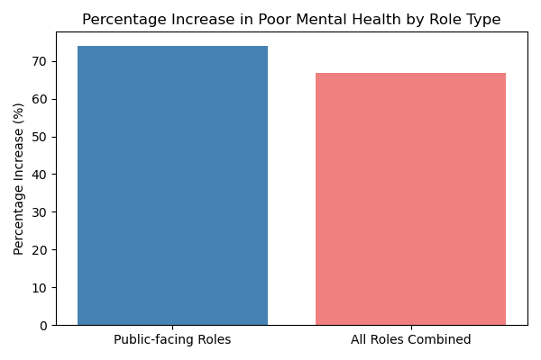
Figure 1: Percentage Increase in Poor Mental Health by Role Type
The findings from the questionnaire reveal a significant deterioration in mental health among police constables following their entry into the force. Out of the 150 participants, a marked increase in reports of poor mental health was observed across all respondent groups. Notably, individuals in public-facing roles exhibited the most pronounced change, with a 74% increase in reported mental health challenges. This suggests that direct engagement with the public may be a particularly taxing aspect of the role, consistent with existing literature that highlights the psychological strain associated with high-contact policing duties (van Lith et al., 2025). When the data set was expanded to include non-public-facing staff, the percentage increase in poor mental health dropped slightly to 66.7%, indicating that while the role of a police constable in general is associated with mental health decline, public-facing duties may exacerbate this effect. These results underscore the psychological demands inherent in policing, particularly in roles that involve frequent and direct interaction with the public, which has been linked to increased exposure to trauma, stress, and emotional exhaustion (Dau et al., 2023).
The data reveals a concerning trend among Police Constables, who represent the most frontline and entry-level positions within the police force. Of the 76 respondents in this category, 54 reported experiencing poor mental health after joining the force, compared to only 18 before—a 71% increase. This substantial rise suggests that mental health deterioration is not confined to higher-ranking or more complex roles but is evident from the outset of a policing career. Furthermore, Purba and Demor (2019) explain that Police Constables face many inherent stressors, which have significant potential to cause psychological distress and emotional turmoil. This can have a significant impact on mental health and well-being, which often leads to lower standards of professionalism, lower rates of operational success, low work moral and can impact officer safety (Johnstone, 2016).
The results found that 11% of respondents do not wish to disclose their mental health battles, Edwards and Kotera (2021) conducted a qualitative study exploring the stigma surrounding mental illness within the UK police force. They found that institutional culture often discourages officers from disclosing mental health issues, contributing to worsening conditions. Evans, Pistrang, and Billings (2013) found that while officers often rely on peer support, they are reluctant to engage in emotional dialogue, which can hinder recovery. These findings underscore the urgent need for early intervention strategies, including mental health education and support systems tailored to new recruits, to mitigate the long-term impact of policing on psychological wellbeing.
The data collected shows that 76% of respondents who have experienced a decline in mental health have children. The pressures associated with police work can significantly impact family dynamics, often leading to mental health challenges among officers and contributing to high rates of divorce and broken families Kahn et al, 2019). Research has shown that the intense stress experienced by officers can manifest in various ways, creating emotional distance and communication breakdowns at home (Violanti et al., 2018). Consequently, officers may struggle to maintain healthy family relationships, increasing the likelihood of separation and familial instability (Kahn et al., 2019). To counteract these challenges, family engagement fun day events can be an effective intervention. These events not only foster stronger connections among family members but also provide a sense of community support, which is vital for emotional well-being (Cohen et al., 2020). Additionally, providing Police Officer’s families access to resources such as counselling, peer support groups and educational workshops can encourage a better understanding of the unique challenges faced within the role. This understanding fosters open communication and emotional resilience, helping families to create a supportive home environment that helps mitigate occupational stress, ultimately improving well-being.
While the quantitative data provides valuable insight into the prevalence of poor mental health among police personnel, particularly constables, the research would have been strengthened by incorporating qualitative feedback from respondents. Specifically, asking participants for their opinions on what types of support they believe would be most effective in addressing their mental health needs could have offered a more holistic understanding of the issue. This participatory approach aligns with best practices in occupational health research, where the voices of those affected are considered essential in designing effective interventions (Robertson and Cooper, 2011). Without this input, the study may overlook context-specific or culturally relevant support mechanisms that officers themselves find meaningful. Future research should therefore include open-ended questions or interviews to capture these perspectives and inform more tailored, responsive mental health strategies within the police force.
In conclusion, while the current research offers valuable statistical insights into the mental health challenges faced by police constables, it also highlights an important opportunity for future studies. By actively involving officers in the conversation—asking them what types of support they believe would be most effective—researchers and policymakers can co-create solutions that are both relevant and empowering. This collaborative approach not only enhances the quality of mental health interventions but also fosters a culture of openness and trust within the police force. Embracing the voices of those with lived experience is a powerful step toward building a more supportive and resilient policing environment. Establishing peer support programs, where officers can confidentially share their experiences and challenges with colleagues, further promotes a culture of openness and shared understanding. Additionally, facilitating access to mental health resources, including counselling services and hotlines, should be prioritised to encourage officers to seek help without stigma. Integrating family engagement activities, such as fun day events, can strengthen family support networks, reducing the strains associated with the occupation. Finally, ongoing assessments of departmental policies related to mental health, including shift scheduling and workload management, can help create a supportive environment that prioritises well-being. By adopting these recommendations, police departments can contribute to improved mental health outcomes for officers, leading to more resilient individuals equipped to serve their communities effectively.
5.2 Recommendations
Based on the findings of this research project, it is evident that Police Officers face significant mental health challenges, particularly those in public-facing roles and early in their careers. The following recommendations have been produced after careful quantitative analysis of the data collected. The following recommendations aim to address mental health challenges through targeted interventions that promote psychological resilience, reduce stigma, and strengthen support systems both within the Force and at home.

- Establish confidential peer support networks.
Such networks would allow officers to share their experiences and to seek guidance in a safe environment. Networks should promote and normalise emotional dialogue and reduce isolation. They may also help officers to find solutions to mental health barriers.
- Promote family engagement and support
Fostering stronger family bonds and educating families about the unique pressures of Police work can help to support Police Officer well-being. Departments should organize family engagement events and workshops, as well as providing access to counselling, peer support groups and educational resources for families to enhance emotional support and communication at home.
- Review shift pattens and workload management
Departments should assess and revise shift patterns to support officers in reducing fatigue and burnout. Implementing policies that priorities rest and recovery – especially after traumatic incidents – can significantly improve mental health outcomes and operational performance.
- Integrate effective and adequate mental health education into Police Training.
Mental health awareness and resilience training should be embedded into the initial Police training curriculum for all new recruits. Adopting a positive, supportive approach will equip officers with the tools to identify early signs of stress and will help to develop and strengthen coping strategies prior to new recruits’ exposure to frontline duties.
- Conduct regular mental health assessments
Routine check-ins should be introduced for all officers, particularly those in public-facing roles. These assessments should be conducted by qualified professionals and should be kept confidential and designed to identify early indicators of stress and declining mental health, allowing for timely interventions.

Chapter 6: Bibliography
Abdollahi, M.K. (2002). Understanding police stress research. Journal of forensic psychology practice, 2(2), pp.1-24.
Alexander, C. (1999). Police psychological burnout and trauma. Police trauma: Psychological aftermath of civilian combat, pp.54-64.
Anshel, M.H. (2000). A Conceptual Model and Implications for Coping with Stressful Events in Police Work. Criminal Justice and Behavior, 27(3), 375-400. Available at: https://doi.org/10.1177/0093854800027003006
Baker, A. B., Yoder, R. D., & Fast, A. J. (2018). The role of sleep in police performance. Journal of Police and Criminal Psychology, 33(1),pp. 1-9.
Benford, R. (2021). Promoting Officer Well-Being: A Review of Strategies. Journal of Police Psychology, 16(2), 45-58.
Bourne, H., Koutsou, D., & McKenzie, K. (2019). The impact of Trauma on Police Officers: A systemic Review of the Literature. International Journal of Police Science and Management, 21(1), pp.3-13
British Educational Research Association (BERA) (2011). Ethical Guidelines for Educational Research. London: BERA. Available at: https://www.bera.ac.uk/publication/bera-ethical-guidelines-for-educational-research-2011 (Accessed: 31 May 2025).
Carleton, N.R., Afifi, T.O., Turner, S., Taillieu, T., LeBouthillier, D. M., & Duranceau, S. (2018). Suicidal ideation, plans, and attempts among public safety personnel in Canada. Canadian Psychology, 59(3), 220–231. https://doi.org/10.1037/cap0000136.
Channel 4 News (2025) Exclusive: At least 100 Police suicides in three years, investigation uncovers. Available at: https://www.channel4.com/news/exclusive-at-least-100-police-suicides-in-three-years-investigatiob-uncovers (Accessed: 5th October 2025)
Chopko, B.A., Palmieri, P.A,. & Adams, R.E. (2013). Associations between police stress and alcohol use: Implications for practice. Journal of Loss and Trauma, 18(5), pp.482- 295.
Cohen, J., Mannarino, A. P., & Deblinger, E. (2020). The Importance of Family Support in Reducing Stress Among First Responders Journal of Emergency Management, 18(5), 345-353.
College of Policing (Great Britain), 2014. Code of ethics: A code of practice for the principles and standards of professional behaviour for the policing profession of England and Wales. HM Government.
Corrigan, P.W. (2004) How stigma interferes with mental health care. American Psychologist, 59(7), pp. 614–625. [Accessed via APA PsycNet].
Dau, S., Choy-Brown, M. & Digari, S. (2023) Supervisory strategies to promote workforce retention in high-stress law enforcement environments. Administration and Policy in Mental Health and Mental Health Services Research, 52(3). Available at: https://link.springer.com/journal/10488 [Accessed 7 Jul. 2025].
Davey, J.D., Obst, P.L. and Sheehan, M.C. (2001). Demographic and workplace characteristics which add to the prediction of stress and job satisfaction within the police workplace. Journal of police and Criminal Psychology, 16, pp.29-39.497.
Davey, J.D., Obst, P.L., & Sheehan, M.C. (2001). Demographic and workplace characteristics which add to the prediction of stress and job satisfaction within the police workplace. Journal of Police and Criminal Psychology, 16, pp.29-39.
Denscombe, M. (2010). The Good Research Guide for Small-Scale Social Research Projects. 4th ed. Buckingham: Open University Press.
Donnelly, J., & McKeown, J. (2018). Stress and Mental Health in Policing: A Review*. Police Journal, 91(4), 321-339.
Donnelly, J., & McKeown, J. (2018). Stress and Mental Health in Policing: A Review. Police Journal, 91(4), pp.321-339.
Drew, J.M. & Martin, S. (2021) A national study of police mental health in the USA: Stigma, mental health and help-seeking behaviors. Journal of Police and Criminal Psychology, 36, pp. 295–306. Available at: https://link.springer.com/article/10.1007/s11896-020-09424-9 [Accessed 31 May 2025].
Edwards, A. & Kotera, Y. (2021). Mental health in the UK police force: a qualitative investigation into the stigma with mental illness. International Journal of Mental Health and Addiction, 19, pp.1116–1134. Available at:https://link.springer.com/article/10.1007/s11469-019-00214-x [Accessed 18 Jul. 2025]
Edwards, A.M., & Kotera, Y. (2021). Mental health in the UK police force: a qualitative investigation into the stigma with mental illness. International Journal of Mental Health and Addiction, 19(4), pp.1116-1134.
Edwards, A.M., & Kotera, Y. (2021). Mental health in the UK police force: a qualitative investigation into the stigma with mental illness. International Journal of Mental Health and Addiction, 19(4), pp.1116-1134. Accessed 25 July 2025. Available at: https://psycnet.apa.org/record/2020-03788-001
Evans, R., Pistrang, N. & Billings, J. (2013) Police officers’ experiences of supportive and unsupportive social interactions following traumatic incidents. European Journal of Psychotraumatology, 4. Available at:https://www.tandfonline.com/doi/pdf/10 .3402/ejpt.v4i0. 19696 [Accessed 18 Jul. 2025].
Flannery, R. (2018). Burnout and Mental Health in Law Enforcement: A Systematic Review. International Journal of Police Science & Management, 20(3), 178-189.
Fleming, J. and Zegwaard, K.E. (2018). Methodologies, methods and ethical considerations for conducting research in work-integrated learning. International Journal of Work-Integrated Learning, Special Issue, 19, pp. 205–213. Available at: https://eric.ed.gov/?id=EJ1196755 (Accessed: 31 May 2025).
Gonzalez, M., Nalesnik, D., & Siris, R. (2020). Enhancing mental health support in police organizations. Journal of Police and Criminal Psychology, 35(4), pp. 334-343.
Harris, N., & Lim, J. (2021). Reducing Stigma: A Multi-Faceted Approach for Police Officer Mental Health. Policing and Society, 31(2), pp.123-139. Accessed: 25 July 2025.
Harvey, S.B., Modini, M., Joyce, S., Milligan-Saville, J.S., Tan, L., Mykletun, A., Bryant, R.A., Christensen, H. and Mitchell, P.B. (2017). Can work make you mentally ill? A systematic meta-review of work-related risk factors for common mental health problems. Occupational and environmental medicine, 74(4), pp.301-310.
Hastings, R., Thomas, C., & Kintzle, S. (2018). Navigating stigma: Mental health in policing. International Journal of Police Science & Management, 20(2), pp. 93-102
Haugen, P.T., McCrillis, A.M., Smid, G.E. & Nijdam, M.J. (2017) Mental health stigma and barriers to mental health care for first responders: A systematic review and meta-analysis. Journal of Psychiatric Research, 94, pp. 218–229. [Accessed via Springer].
Hoffman, M. L., Mott, M., & Kelly, R. (2018). The impact of stress on the mental well-being of police personnel. Policing: An International Journal, 41(2), pp. 157-170.
Home Office (2023). Police Remuneration Review Body Ninth Report England and Wales. Available at: CP 883 – Police Remuneration Review Body – Ninth Report England and Wales 2023 (Accessed: 10th April 2025).
Home Office (2023). Police Remuneration Review Body Ninth Report England and Wales. Accessed 25 July 2025. Available at: https://www.gov.uk/government/publications/police-remuneration-review-body-ninth-report-2023
Johnson, S.F. (2016). Investigating Barriers to Mental Health Care in Law Enforcement Officers. Electronic Theses and Dissertations. https://dc.edu/etd/3154
Kahn, A., Turner, C., & Beech, A. (2019).Enhanced Family Engagement and its Impact on Police Officer Well-being. Police Quarterly, 22(3), 317-333.
Kahn, M., Bärring, V., & Persson, M. (2021). The impact of shift work on sleep patterns among police officers. Sleep Medicine Reviews, 54, pp. 101-110
Kop, N., Euwema, M., & Schaufeli, W. (2019). Burnout, job stress, and engagement among police officers: A longitudinal study. Journal of Criminal Justice, 61, pp.67-75
Kuehn, L., Kelly, R., & Marshall, C. (2020). Work-Life Balance in Policing: Challenges and Solutions. Police Practice and Research, 21(1), 94-107.
Larson, S.L., Eyerman, J., Foster, M.S., &Gfroerer, J.C. (2007) Worker Substance use and workplace policies and programs. MD: Substance Abuse and Mental Health Services Administration, Office of Applied Studies. DHHS Publication 42(7), pp. 89-97
Meyer, B., Halfacre, V., & Xu, Y. (2020). Effects of shift patterns on police officer wellbeing: A quantitative analysis. Journal of Law Enforcement, 9(2),pp. 45-60.
Miller, L. (2021). Mental Health Challenges Among Police Officers: The Role of Family Support. International Journal of Police Science & Management, 23(4), 389-402.
Milne, S.J. (2021) Understanding mental health stigma in policing: A qualitative exploration of officers’ experiences. Policing: A Journal of Policy and Practice. [Online ahead of print]. [Accessed via Oxford Academic].
Mishra, S., Gupta, M., & Singh, R. (2020). Impact of Mental Health Programs on Police Officer Wellbeing: A Longitudinal Study. Journal of Occupational Health psychology, 25(4), pp. 275-289
Munn, P., Tilley, N., & Roberts, D. (2017). Police mental health: Barriers to help-seeking in law enforcement. International Journal of Police Science & Management, 19(4),pp. 263-273.
Papazoglou, K., & Andersen, J. (2014). Trauma and Mental Health in Law Enforcement: An Overview. Journal of Police and Criminal Psychology, 29(1), 4-14.
Philip, P., Taillard, J., & Chastang, J. F. (2020). Sleepiness and police performance: A review. Safety Science.
Purba, A., & Demor, E. (2019). The relationship between organisational stressors and mental wellbeing within police officers: a systematic review. BMC Public Health 19, 1286. Available at: https://doi.org/10.1186/s12889-019-7609h
Police Federation (2024). Record 14500 officers signed off with poor mental health In the past year. Available at: https://www.polfed.org/news-events/latest-news/2024/record-14-508-officers-signed -off-with-poor-mental-health-in-past-year (Accessed: 5 October 2025)
Rand, S.R., Manuele, C.A. (1987). Stress and police officer performance: an examination of effective coping behavior. Police Stud. 10(1), pp.22–31.
Reavley, N. J., Jorm, A. F., & Mackinnon, A. J. (2022). Community Perceptions of the Role of Police in Promiting Mental Health. Psychiatric Services, 73(5), pp. 567-573
Reiser, B.J. (2004). Scaffolding Complex Learning: The Mechanisms of Structuring and Problematizing Student Work. Journal of the Learning Sciences, 13(3), 273–304. Available at: https://doi.org/10.1207/s15327809jls1303_2
Robertson, I.T. & Cooper, C.L. (2011) Well-being: Productivity and Happiness at Work. Basingstoke: Palgrave Macmillan.
Simmons, R., & Hurd, M. (2021). Cultural Shifts in Law Enforcement: Promoting Mental Wellness. Journal of Police Studies, 44(2), 112-124.
Spielberger, C.D., et al. (1981). Stress and Police Work. National Institute of Justice.
Stevelink, S.A.M. et al. (2020) Probable PTSD, depression, and anxiety in 40,299 UK police officers and staff: prevalence, risk factors and associations with blood pressure. PLOS ONE, 15(11), e0240902. Available at: https://journals.plos.org/plosone/article?id=10.1371 /journal.pone.0240902 [Accessed 18 Jul. 2025].
Thomas, M. J. W., McCoy, B., & Jones, K. (2022). Addressing mental health in policing: Policy recommendations. International Journal of Police Science & Management, 24(1), pp.16-24.
Van Lith, L., Vana Hutter, R.I. & Lindegaard, M.R. (2025) Psychological strain in public-facing police roles: A longitudinal analysis. Journal of Police and Criminal Psychology, 40(1). Available at: https://link.springer.com/journal/11896 [Accessed 7 Jul. 2025].
Violanti, J. M., Varela, J., & Marshall, J. R. (2017). Police trauma and mental health: A review of empirical research. Trauma, Violence, & Abuse, 18(3), pp. 299-309.
Violanti, J. M., Vena, J. E., & Marshall, J. R. (2018). Police Work and Mental Health: Understanding the Linkage Between Job Stress and Mental Health Issues The Police Journal: Theory, Practice and Principles, 91(4), 382-399.
Violanti, J. M., Vena, J. E., & Marshall, J. R. (2018). Shift work and mental health among police officers: A prospective cohort study. American Journal of Industrial Medicine, 61(10), pp. 829-836.
Violanti, J. M., Vena, J. E., & Marshall, J. R. (2020). Sleep disturbances and mental health among police officers. Journal of Police and Criminal Psychology, 35(4), pp. 367-375.
Wright, A.J., and Henes, R. (2018). Preventing substance abuse and addiction. New Directions in Treatment, Education, and Outreach for Mental Health and Addiction, pp.231-254.
Wright, R. D., & McCauley, E. (2021). The role of wellness programs in enhancing police officer mental health: A systematic review. Journal of Occupational Health Psychology, 26(2), pp.121-134
Wright, R.R., Mohr, C.D., Sinclair, R.R. and Yang, L.Q. (2015). Sometimes less is more: Directed coping with interpersonal stressors at work. Journal of Organizational Behavior, 36(6), pp.786-805.

Chapter 7: Appendix
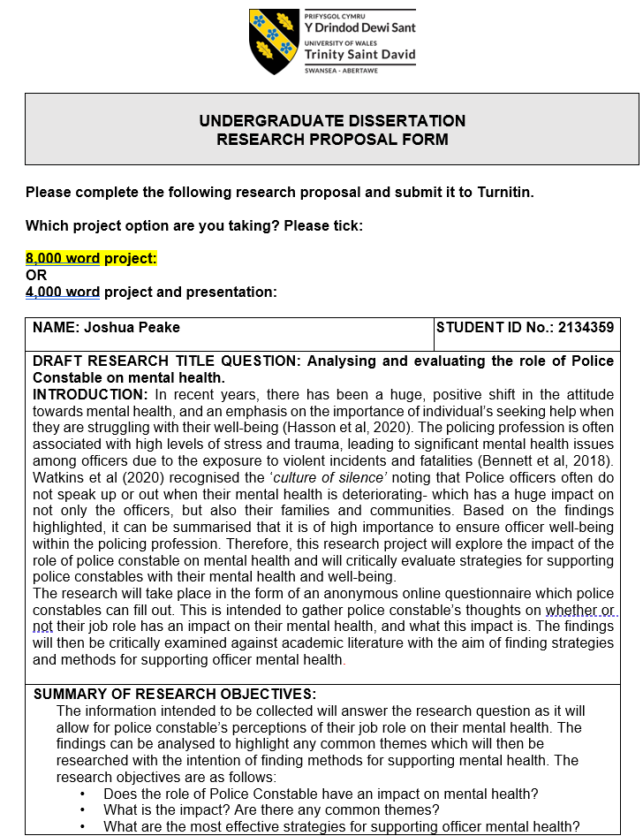
7.1 Research Proposal

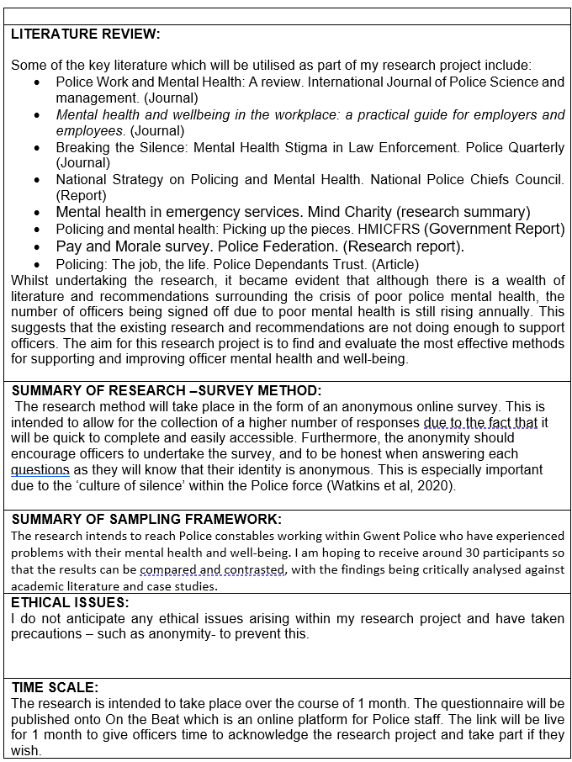

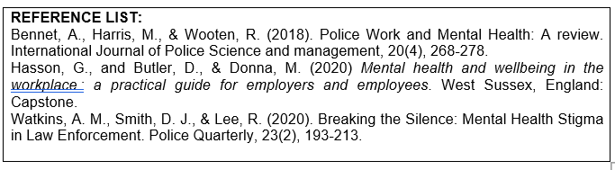

7.2 Ethics Form
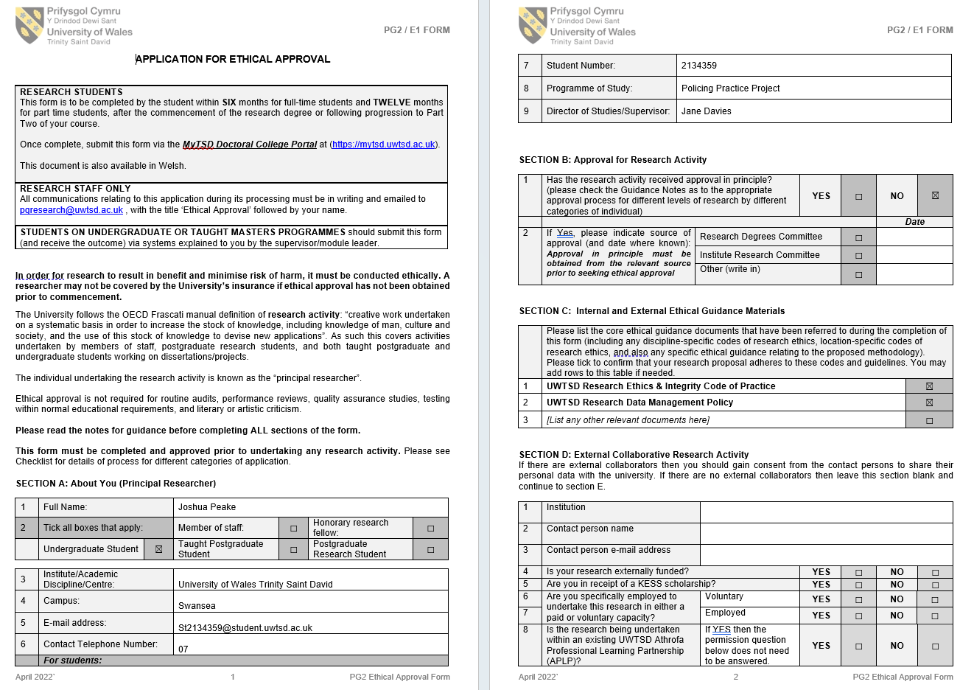
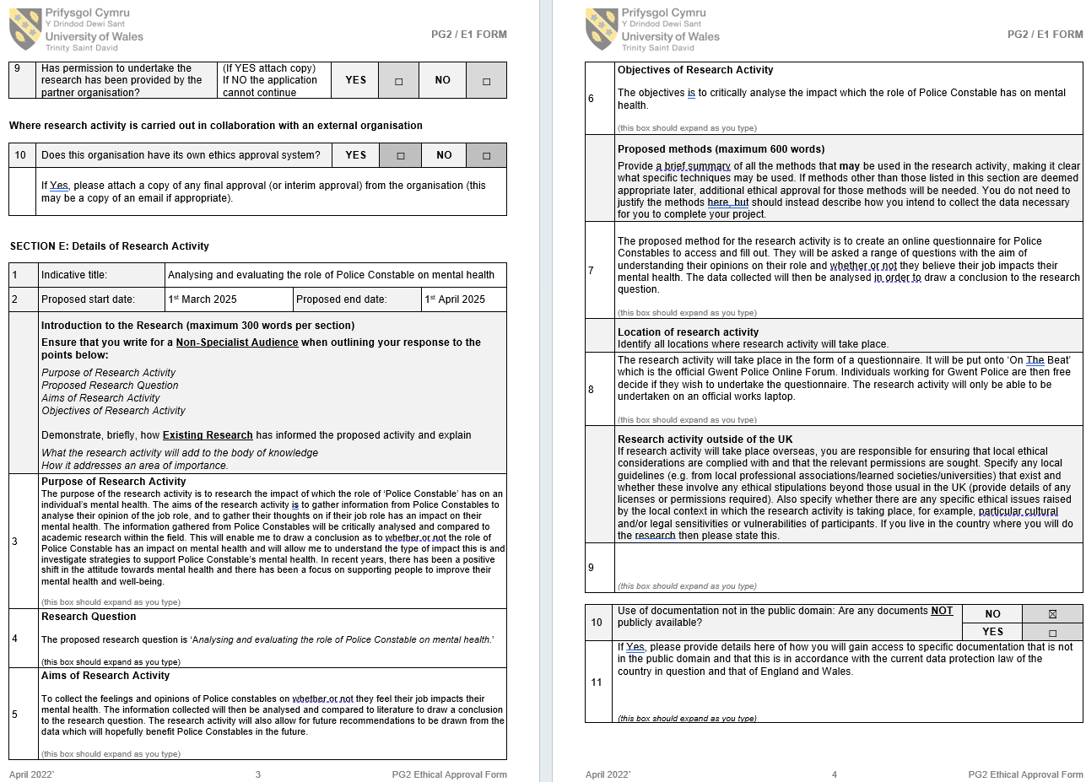
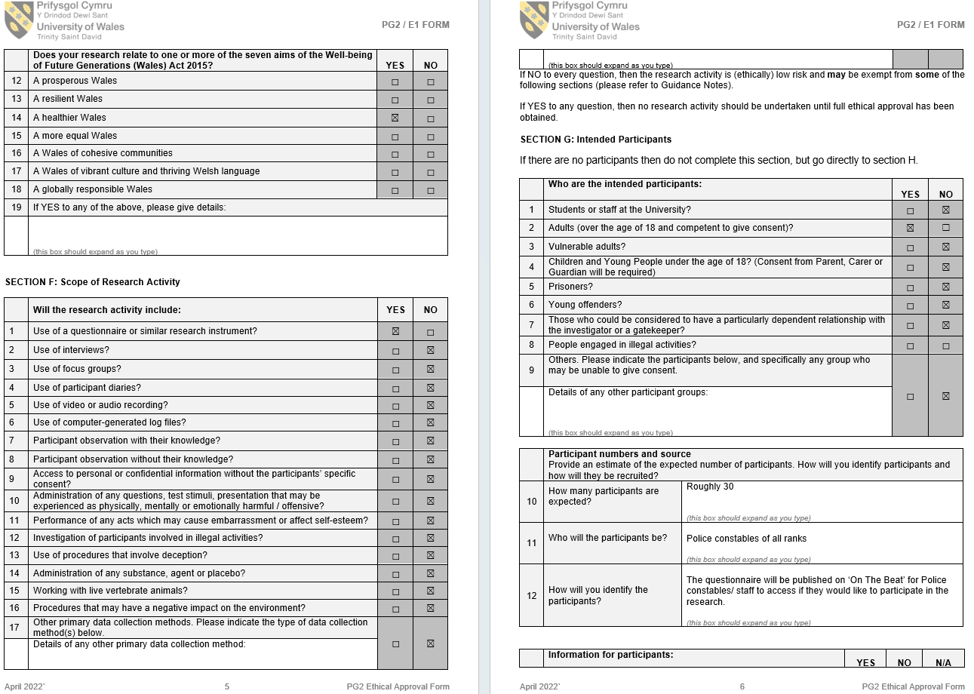
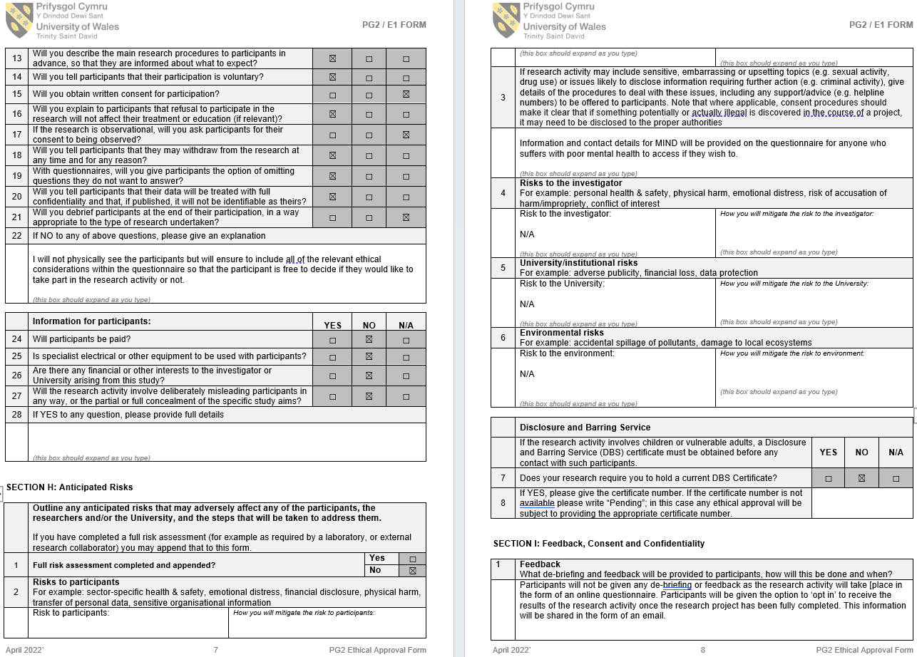

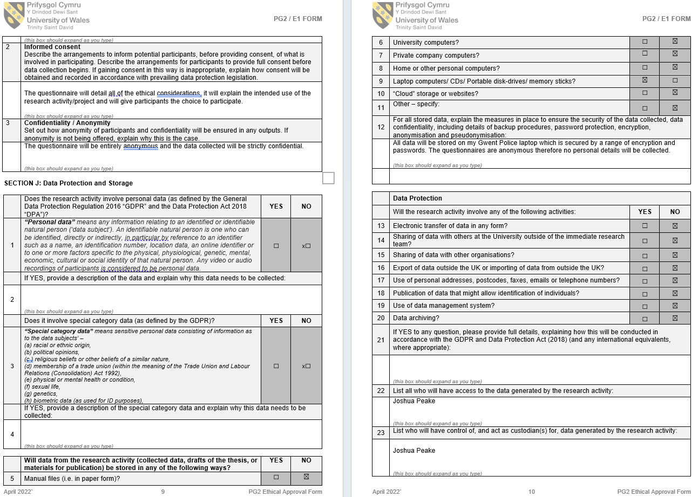
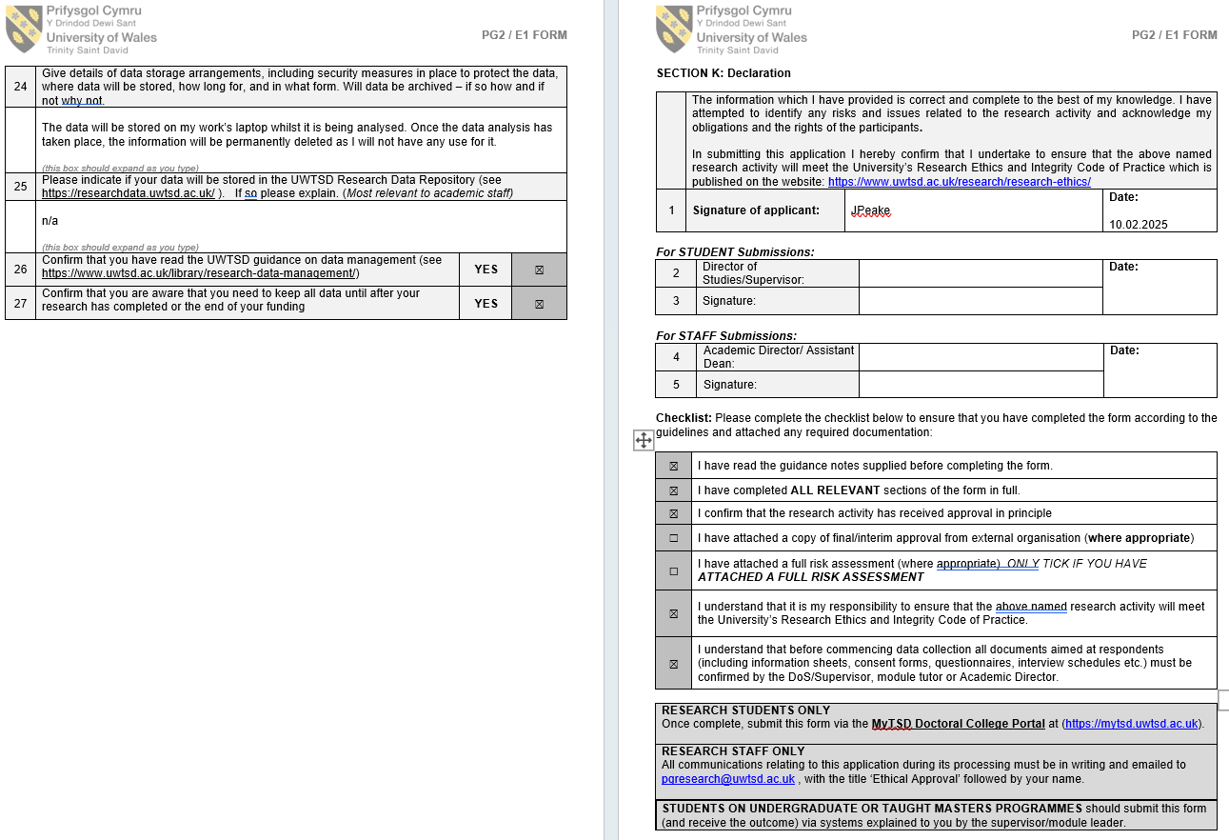

7.3 The Beat Questionnaire Post



