What Is the Relevance of The Conservation Of The Site Of Amarna Undertaken By The Amarna Project?
The short-lived capital, created under the rule of Akhenaten in the fifth year of his tumultuous reign, the site of Amarna, known as the ‘Horizon of the Aten’ is found located on the eastern bank of the Nile, in the modern-day province of Minya. This capital can be identified easily nowadays due its iconic archaeology, most notably, the boundary stelas which encircle the site, which gave modern day scholars the opportunity to learn how the city was founded, and give a cultural, political and religious insight into the lives and everyday administration during this period of Egyptian history. The conservation of this important site is nowadays undertaken by the Amarna Project. With its creation in 1977, this project has, for nearly fifty years held significant relevance in archaeological, cultural and historical fields, dedicating itself to the study of the site of Amarna. This essay will explore the significance of the Amarna Project and its input into the wider understanding of Ancient Egyptian history and how we can in modern times, have a wider comprehension of ancient religions and civilisations.
When Akhenaten relocated the capital from Thebes to Amarna in approximately 1346BC, he disrupted the traditional spheres of religion and the socio-political environment at the time. Akhenaten erected a stela at the Temple of Karnak, before moving to Amarna, denouncing the worship of the numerous deities, and moving to a monolatrous society, in which the Aten was to be worshipped as the sole state-wide god. As a result of this radical move, Amarna represented a pivotal turning point in the history of Ancient Egypt, and thus, the conservation of this site is crucial for scholars to understand the importance of Akhenaten’s place in the Ancient Egyptian timeline. Examples of Amarna’s iconic legacy can be seen through its material culture; the discovery of the Nefertiti Bust is viewed by scholars such as Jung as an ‘icon of Western culture and has since become deeply anchored in our cultural memory.’ This priceless discovery has gripped Western culture since its excavation and is reminiscent of that colourful and illustrious period of history. Even smaller discoveries that the Amarna Project and Egyptian Exploration Society have discovered, such as the head of Akhenaten, to the blue-painted storage jar all emphasise the extravagance and notable art styles in which the Amarna period holds and the importance of the Amarna Project itself.
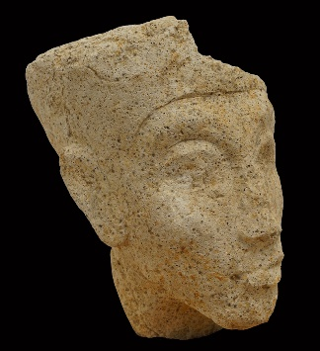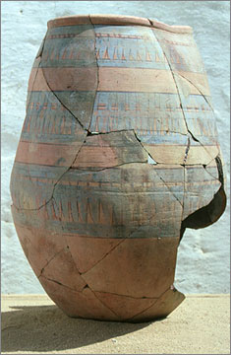
< Figure1 – The Head of Akhenaten, gypsum paste, object number 14130.

Figure 2 – Blue-painted storage jar, clay, object number 14061>
In a cultural sense, the legacy of, and findings in the Amarna site provide a fascinating insight into the everyday lives of both the common folk, and the elite. Van Djik argues that ‘it is perhaps the single most important event in Egypt’s religious and cultural history, and it left deep scars on the collective consciousness of its inhabitants.’ Amarna art notably stands out amongst the whole period of Ancient Egyptian history and has left a lasting legacy on the culture of Egypt itself. Amarna art styles implemented realism and vivid expression to an already rich material culture, exaggerated kingly bodies and displays of affection between Akhenaten and Nefertiti provides a unique insight into the royal family’s personal life, in a way that previous pharaonic families did not illustrate. Another way in which Amarna art challenged the traditional Egyptian style is through the portrayal of its monolatrous deity, the Aten. As most of the Egyptian pantheon was depicted in a semi-anthropomorphic style, like Horus and Serqet, the Aten was instead depicted as the sun disk itself – detaching itself from the human link and becoming wholly divine. With the cultural significance of the Amarna site, The Amarna Project is a cornerstone which can conserve what remains and discover what is still yet to be found.
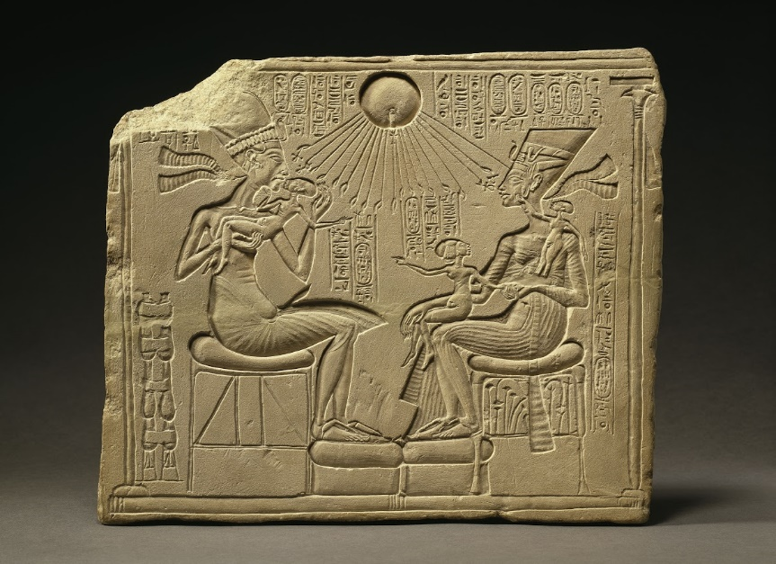
Figure 3 – Akhenaten, Nefertiti and Three Daughters under the Radiation Aten, limestone, ÄM 14145
The Amarna Project works with the Egyptian government and Supreme Council of Antiquities to provide an educational springboard for curious minds to explore and learn about the 30-year period of discord within the 18th Dynasty. The Amarna Visitor Centre, which was opened in 2016 gives visitors the opportunity to interact with all parts of Amarna life. The centre tackles quandaries such as: What did they eat? Why does the site look as it does? What was everyday life like? This gives non-academics a way to further push their knowledge and provide a means for more people to engross themselves in the rich history and culture of the city.
The legacy of the Amarna period is conserved by the outstanding work and exploration of the Amarna Project. The project has been able to provide a significant input into the broader cultural, educational, and historical importance of the site. Providing not just conservation, but continued research into this period, allowing scholars and wider communities a way to engage with the past, present and future of Amarna, ensuring that the chaotic, but beautiful chapter of Egypt’s ancient history remains.
Bibliography
Kemp, Barry, The City of Akhenaten and Nefertiti: Amarna and its People,(Thames and Hudson Ltd, London, 2012)
Seyfried, Friederike, In the Light of Amarna, 100 Years of the Nefertiti Discovery, (Michael Imhof Verlag, 2012)
Shaw, Ian, The Oxford History of Ancient Egypt, (Oxford University Press, 2000)
Stevens, Anna, Amarna: A Guide to the Ancient City of Akhenaten, (The American University in Cairo Press, Illustrated Edition, 2020)
Laboury, Dimitri, Amarna Art, UCLA Encyclopeadia of Egyptology, 1 (1), https://escholarship.org/uc/item/0n21d4bm (Accessed 04/04/2024)
The Amarna Project, https://www.amarnaproject.com/index.shtml, (Accessed 04/04/2024)

Figure 1
The Head of Akhenaten, gypsum paste, object number 14130, 2017, https://www.amarnaproject.com/pages/recent_projects/material_culture/statuary/akhenaten.shtml (Accessed 04/04/2024)

Figure 2
Blue-painted storage jar, clay, object number 14061, 2017, https://www.amarnaproject.com/pages/recent_projects/material_culture/new_kingdom.shtml (Accessed 04/04/2024)

Figure 3
Akhenaten, Nefertiti and Three Daughters under the Radiation Aten, limestone, Ägyptisches Museum und Papyrussammlung (Egyptian Museum and Papyrus Collection), ÄM 14145, https://www.smb.museum/en/museums-institutions/neues-museum/online-offers/detail/looked-at-house-altar-featuring-akhenaten-nefertiti-and-three-of-their-daughters-under-the-solar-aten/ (Accessed 04/04/2024)

Anna Stevens, Amarna: A Guide to The Ancient City of Akhenaten, 2020, p.20
Barry Kemp, The City of Akhenaten and Nefertiti: Amarna and its People, 2012, p.8-10
Anna Stevens, Amarna: A Guide to The Ancient City of Akhenaten, 2020, p.13
Friederick Seyfried, Michael Imhof Verlag, Mariana Jung, In the Light of Amarna: 100 Years of the Nefertiti Discovery, 2012, p.426
Figure 1, The Amarna Project, The Head of Akhenaten, object number 14130, 2017
Figure 2, The Amarna Project, Blue-Painted storage jar, object number 14061, 2017
Ian Shaw, Jacobus Van Djik, The Oxford History of Ancient History, ‘The Amarna Period and later New Kingdom’, 2000, p.279
Michael Imhof Verlag, In the Light of Amarna: 100 Years of the Nefertiti Discovery, Fig.2, Family Altar with Amenhotep IV/Akhenten, Nefertiti and three daughters, limestone, Ägyptisches Museum Berlin, ÄM 14145, 2012, p.426
Dimitri Laboury, Amarna Art, UCLA Encyclopaedia of Egyptology, 1 (1), p.3
The Amarna Project, The Amarna Visitor Centre, 2017

