GUS. (2023) ‘Informacja o rozmiarach i kierunkach emigracji’ [Online] Available: https://stat.gov.pl/obszary-tematyczne/ludnosc/migracje-zagraniczne-ludnosci/informacja-o-rozmiarach-i-kierunkach-emigracji-dlugookresowych-w-latach-2017-2022,18,1.html, Accessed 2024, June, 20th

Migration Observatory. (2023) ‘EU Migration to and from the UK’ [Online] Available: https://migrationobservatory.ox.ac.uk/resources/briefings/eu-migration-to-and-from-the-uk/, Accessed 2024, June, 20th

Talbot, D. (2024) ‘Languages Spoken In UK’ [Online] Available: https://wordsrated.com/languages-spoken-in-uk/, Accessed 2024, June, 20th

Byczek, R. (2014) ‘Emigration of Poles to the United Kingdom and the impact on the development of the inbound tourism amongst british citizens visiting Poland’ [Online] Available: https://cejsh.icm.edu.pl/cejsh/element/bwmeta1.element.cejsh-c489f68a-2428-4f50-a8af-98aa42f17fce, Accessed 2024, June, 20th

Kowalczyk, B. (2014) ‘Polish one of the most entrepreneurial Community in the UK’ [Online] Available: https://business.pblink.co.uk/news-news/polish-one-of-the-most-entrepreneurial-community-in-the-uk, Accessed 2024, June, 20th

PBLINK. (2023) ‘Is Britain Great again? Future of Polish-British business relationship’ [Online] Available: https://business.pblink.co.uk/is-britain-great-again, Accessed 2024, June, 20th

Wire, C. (2024) ‘How to Start a Business in the UK for Foreigners’ [Online] Available: https://wise.com/gb/blog/how-to-start-a-business-in-the-uk-for-foreigners, Accessed 2024, June, 20th

Tracy, B., Chee, P. (2013) ‘12 Disciplines of Leadership Excellence: How Leaders Achieve Sustainable High Performance’ [Online] Available: https://books.google.co.uk/books?id=DH4dZZJRdFgC&pg, Accessed 2024, June, 20th

CIPD. (2023) ‘Coaching and mentoring’ [Online] Available: https://www.cipd.org/uk/knowledge/factsheets/coaching-mentoring-factsheet, Accessed 2024, June, 20th

Mundey, M. (2023) ‘Mentoring vs Coaching: The Key Differences and Benefits’ [Online] Available: https://www.think-learning.com/employee-engagement/mentoring-vs-coaching/, Accessed 2024, June, 20th

OED. ‘Coach’ [Online] Available: https://www.etymonline.com/word/coach, Accessed 2024, June, 20th

Whitemore, J. ‘Coaching for Performance: The Principles and Practice of Coaching and Leadership’ Boston: Nicholas Brealey Publishing
Stanier, M. (2016) ‘The Coaching Habit: Say Less, Ask More & Change the Way You Lead Forever’ Toronto: Box of Crayons Press

Franklin, M. (2019) ‘The Heart of Laser-Focused Coaching’ Kansas City: Thomas Noble Books

Hughes, G. (2022) ‘Why (most) Business Coaching is a Waste of Time…’ [Online] Available: https://www.linkedin.com/pulse/why-most-business-coaching-waste-time-gareth-hughes/, Accessed 2024, June, 20th

IOC. ‘Benefits of Coaching’ [Online] Available: https://instituteofcoaching.org/coaching-overview/coaching-benefits, Accessed 2024, June, 20th

Brinkley, M., Roux, I. (2018) ‘Coaching as a support function for potential entrepreneurs’ [Online] Available: https://sajesbm.co.za/index.php/sajesbm/article/view/99, Accessed 2024, June, 20th

Przybylo, J., Vasan, N. (2013) ‘Seven Habits of Highly Effective Mentors’ [Online] Available: https://ssir.org/articles/entry/seven_habits_of_highly_effective_mentors, Accessed 2024, June, 20th

Starr, J. (2014) ‘The Mentoring Manual: The Mentoring Manual: Your Step by Step Guide to Being a Better Mentor’ London: Pearson UK

Maxwell, J. (2008) ‘Mentoring 101: What Every Leader Needs to Know’ Nashville: HarperCollins Leadership

Say, M. (2014) ‘Why You Shouldn't Look For Mentors’ [Online] Available: https://www.forbes.com/sites/groupthink/2014/03/17/why-you-shouldnt-look-for-mentors/, Accessed 2024, June, 20th

Comaford, C. (2019) ‘76% Of People Think Mentors Are Important, But Only 37% Have One’ [Online] Available: https://www.forbes.com/sites/christinecomaford/2019/07/03/new-study-76-of-people-think-mentors-are-important-but-only-37-have-one/, Accessed 2024, June, 20th

Serrat, O. (2009) ‘Coaching and Mentoring’ [Online] Available: https://www.adb.org/sites/default/files/publication/27568/coaching-and-mentoring.pdf, Accessed 2024, June, 20th

Garvey, B. (2018) ‘Mentoring and coaching’ London: Routledge

Phair, D., Warren, K. (2021) ‘Saunders’ Research Onion: Explained Simply’ [Online] Available: https://gradcoach.com/saunders-research-onion/, Accessed 2024, June, 20th

BRM. ‘Interpretivism (interpretivist) Research Philosophy’ [Online] Available: https://research-methodology.net/research-philosophy/interpretivism/, Accessed 2024, June, 20th

Jansen, D. (2023) ‘Research Philosophy & Paradigms’ [Online] Available: https://gradcoach.com/research-philosophy/, Accessed 2024, June, 20th

BRM. ‘Positivism Research Philosophy’ [Online] Available: https://research-methodology.net/research-philosophy/positivism/, Accessed 2024, June, 20th

Ikram, M., Kenayathulla, H. (2022) ‘Out of Touch: Comparing and Contrasting Positivism and Interpretivism in Social Science’ [Online] Available: https://myjms.mohe.gov.my/index.php/ajress/article/view/17935/9693, Accessed 2024, June, 20th

Pressbooks. ‘Inductive and deductive reasoning’ [Online] Available: https://pressbooks.pub/scientificinquiryinsocialwork/chapter/6-3-inductive-and-deductive-reasoning/, Accessed 2024, June, 20th

Thomas, D. (2003) ‘A General Inductive Approach for Qualitative Data Analysis’ [Online] Available: https://www.researchgate.net/publication/228620846_A_General_Inductive_Approach_for_Qualitative_Data_Analysis, Accessed 2024, June, 20th

Streefkerk, R. (2022) ‘Inductive vs Deductive Reasoning | Difference & Examples’ [Online] Available: https://www.scribbr.co.uk/research-methods/inductive-vs-deductive-reasoning/, Accessed 2024, June, 20th

Noble, H., Heale, R. (2019) ‘Triangulation in research, with examples’ [Online] Available: https://ebn.bmj.com/content/22/3/67, Accessed 2024, June, 20th

Oncol, J. (2015) ‘Understanding and Evaluating Survey Research’ [Online] Available: https://www.ncbi.nlm.nih.gov/pmc/articles/PMC4601897/, Accessed 2024, June, 20th

StudySmarter. ‘Interview in Research’ [Online] Available: https://www.studysmarter.co.uk/explanations/marketing/marketing-information-management/interview-in-research/, Accessed 2024, June, 20th

Melnikovas, A. (2018) ‘Towards an Explicit Research Methodology: Adapting Research Onion Model for Futures Studies’ [Online] Available: https://jfsdigital.org/wp-content/uploads/2019/01/03-Melnikovas-Onion-Research-Model.pdf, Accessed 2024, June, 20th

YEC. (2023) ‘The Dynamic Terrain Of Entrepreneurship: Navigating Challenges And Revealing Rewards’ [Online] Available: https://www.forbes.com/sites/theyec/2023/12/01/the-dynamic-terrain-of-entrepreneurship-navigating-challenges-and-revealing-rewards/, Accessed 2024, June, 20th

IBM. ‘IBM SPSS Statistics’ [Online] Available: https://www.ibm.com/products/spss-statistics, Accessed 2024, June, 20th

CFI. ‘Excel Definition’ [Online] Available: https://corporatefinanceinstitute.com/resources/excel/excel-definition-overview/, Accessed 2024, June, 20th

KSU. ‘Statistical & Qualitative data analysis software: About Nvivo’ [Online] Available: https://libguides.library.kent.edu/statconsulting/NVivo, Accessed 2024, June, 20th

University of Oxford. ‘Informed consent’ [Online] Available: https://researchsupport.admin.ox.ac.uk/governance/ethics/resources/consent, Accessed 2024, June, 20th

Research Integrity. (2024) ‘Consent and Early Withdrawal or Cessation of Participation’ [Online] Available: https://www.unr.edu/research-integrity/human-research/human-research-protection-policy-manual/346-consent-and-early-withdrawal-or-cessation-of-participation, Accessed 2024, June, 20th

GOV. ‘Data protection’ [Online] Available: https://www.gov.uk/data-protection, Accessed 2024, June, 20th

UWTSD. ‘Research Integrity and Ethics’ [Online] Available: https://www.uwtsd.ac.uk/research/research-integrity-and-ethics, Accessed 2024, June, 20th

Gantt. ‘What is a Gantt Chart?’ [Online] Available: https://www.gantt.com/, Accessed 2024, June, 20th

Vasanthakumari, S. (2021) ‘Writing research proposal’ [Online] Available: https://wjarr.com/content/writing-research-proposal, Accessed 2024, June, 20th

Nundy, S., Kakar, A., Bhutta, Z., ‘Writing the Research Proposal: The Art and the Science’ [Online] Available: https://link.springer.com/chapter/10.1007/978-981-16-5248-6_12, Accessed 2024, June, 20th

Melnikovas, A. (2018) ‘Towards an Explicit Research Methodology: Adapting Research Onion Model for Futures Studies’ [Online] Available: https://jfsdigital.org/articles-and-essays/2018-2/towards-an-explicit-research-methodology-adapting-research-onion-model-for-futures-studies/, Accessed 2024, June, 20th

GOV. (2024) ‘Population of England and Wales’ [Online] Available: https://www.ethnicity-facts-figures.service.gov.uk/uk-population-by-ethnicity/national-and-regional-populations/population-of-england-and-wales/latest/, Accessed 2024, June, 20th

Saunders M., Lewis, P., Thornhill, A. (2019) Research Methods for Business Students. New York: Pearson

Introduction

Writing a research proposal is a crucial step in preparing to write a dissertation. It lays the foundation for the entire research project. It clearly outlines the research question, objectives, and the methodology that will be used to investigate the topic. This structured plan helps to ensure that the research is focused and coherent, providing a guideline that guides the researcher through each stage of the process (Vasanthakumari, 2021). Additionally, it helps in identifying potential challenges and limitations, allowing for better preparation and risk management. By presenting a well-structured research proposal, the researcher can also demonstrate the study's value and significance (Nundy, 2022).

Writing a dissertation highlighting the value of mentoring and coaching for the success of Polish entrepreneurs in the United Kingdom could be interesting. The study may explore how these support systems help immigrant entrepreneurs succeed. Polish entrepreneurs, a significant group in the United Kingdom, face various challenges as they need to adapt to a new business culture. Investigating the impact of mentoring and coaching on their personal and professional growth can provide valuable insights, which could lead to practical advice on supporting immigrant entrepreneurs and encouraging more inclusive business communities.

For this research proposal, the Saunders Research Onion model has been used to provide a clear and structured framework for planning and conducting research. The model breaks down the research process into manageable layers, ensuring each step is carefully considered and aligned with the overall research objectives. By addressing all layers from philosophies and approaches to strategies, choices, time horizons, and techniques and procedures, it helps to achieve comprehensive coverage, leaving no critical aspect of the research design overlooked (Melnikovas, 2018).

Research Rationale

The United Kingdom is well known for its cultural diversity, seen in its population that includes people from many different backgrounds (GOV, 2024).
According to data from the Central Statistical Office of Poland (GUS), the number of Polish emigrants in the United Kingdom in 2002 was 24,000. Since Poland joined the European Union in 2004, this number had increased to 150,000 and continued to rise (GUS, 2023).
Despite a decline from previous years, Poland remains the leading country of origin for foreign nationals residing in the United Kingdom. As of the latest data, there are approximately 696,000 Polish citizens in the United Kingdom, making up 12% of the non-UK citizen population. This number represents a decrease from the estimated 905,000 Polish nationals living in the country in 2018 (Migration Observatory, 2023).
In England, Wales and Northern Ireland, Polish is the second-most spoken language while in Scotland, Polish is the fourth-most spoken language (Talbot, 2024).
The primary reasons motivating people to emigrate to the United Kingdom were often better salaries, a higher standard of living, improved working conditions, good job prospects, the opportunity to gain experience and meet new people, positive experiences of others and better career opportunities than in their home country. However, these motivations vary significantly with the age of the emigrants. While the younger segment seeks better life prospects, the older group, often with families to support, aims to earn money and return home (Byczek, 2014).
As a result, Poles have come to dominate the British labour market among immigrants and have started to play a significant role in the country's economy. According to the statistics, approximately 22,000 Polish nationals have chosen to start businesses in the United Kingdom, establishing themselves as one of the largest groups of migrant entrepreneurs in the country. Additionally another 65,000 Poles are self-employed (Kowalczyk, 2014). Their enterprises operate across diverse industries, including construction and real estate, manufacturing and heavy industry, and consumer goods and services with a two-thirds of them being established by men (PBLINK, 2023).
Despite the fact that the United Kingdom is an attractive destination for foreign entrepreneurs because of its large economy, diverse market, and generally favourable business environment (Wire, 2024), Polish entrepreneurs in the United Kingdom may face many challenges as they start and grow their businesses. They potentially need to adapt to a new market, understand different cultural expectations, and compete in a busy and competitive environment. To succeed, they often need more than only business skills. They must overcome probably their biggest challenge. The challenge which is based on their own limitations.

Mentoring and coaching have long been recognised as effective tools for professional development and business success. Brian Tracy highlights that the world's top leaders rely on advisors and collaborators for strategic planning and personal development initiatives. (Tracy, Chee, 2013). Although both terms are related to the development of individuals and organisations, they differ from each other.
Business coaching involves a skilled professional providing guidance and training to an individual with the aim of enhancing their skills, performance, and career progression. This personalised process usually takes place one-on-one over a set period, targeting specific business goals (CIPD, 2023).
Mentoring, on the other hand, is a career development approach where an experienced professional supports a less experienced one, either through formal or informal arrangements. Mentors share their knowledge, skills, and experiences to guide mentees in their career paths, fostering growth and development by passing on expertise from one generation to the next (Mundey, 2023). For Polish entrepreneurs in the United Kingdom, these support mechanisms may be especially helpful in navigating a foreign business landscape, overcoming cultural barriers, and achieving personal and professional growth.

The concept of coaching has roots that go back to the ancient Greeks, but it was formally introduced in the modern sense in the 20th century. The term "coach" was originally used in the 1830s at Oxford University to describe a tutor who helped students prepare for exams. Modern coaching, particularly in the context of personal and professional development, began to take shape in the 1960s and 1970s with the emergence of life coaching and business coaching practices (OED).
Sir John Whitmore emphasises that effective coaching is not about giving advice or solutions but rather about helping individuals find their own solutions through deeper self-awareness, reflection, and goal-setting. The coach role is to ask powerful questions, actively listen, provide feedback, and support the coachee in their journey of growth and development. (Whitemore, 2017). Michael Bungay also promotes a coaching style that is less about providing answers and more about empowering others to find their own solutions. He states that effective coaching doesn't necessarily require long, formal sessions. Instead, it can be integrated into daily interactions through asking the right questions (Stanier, 2016). Marion Franklin encourages coaches to use a focused approach that targets specific goals and outcomes. She recommends asking insightful questions, listening actively, and following a structured coaching method. The author stresses the importance of emotional intelligence in coaching which helps coaches understand and address their clients' emotions effectively, leading to deeper insights and breakthroughs (Franklin, 2019).

On the other hand, Gareth Hughes points out that many business coaching programs fail to improve business performance. He argues that effective coaching should be results-oriented and based on proven best practices, rather than focusing solely on motivation and emotions. Although effective coaching has the potential to transform businesses and individuals, it sometimes devolves into therapy for entrepreneurs (Hughes, 2022).

According to a survey by the International Coaching Federation, coaching in organisational and leadership contexts is valuable for addressing various developmental needs. The results showed that 80% of participants experienced increased self-confidence, and over 70% saw improvements in work performance, relationships, and communication skills. Additionally, 86% of companies reported a return on their coaching investment (IOC)

This shows that entrepreneurial skills are increasingly critical for business viability, growth, and job creation, especially in today's competitive markets. Coaching serves as a valuable support and development mechanism for entrepreneurs. However, there is limited research on their perceived benefits within small-to-medium enterprises (SMEs). Academic exploration of coaching often remains theoretical rather than empirical, highlighting the need for further research to assess its effectiveness specifically in SME and entrepreneurship contexts (Brinkley, Roux, 2018).
The concept of a mentor first emerges in Homer's "The Odyssey." Before embarking on his journey, Odysseus entrusts his son Telemachus to a friend named Mentor, who is later revealed to be the goddess Athena in disguise. Although pinpointing the exact time when "The Odyssey" was written is challenging, most historians estimate it was composed between 750 and 650 BCE. Since then, numerous publications have explored the concept of mentoring, and the term remains relevant today (Przybylo, Vasal, 2013).
Julie Starr states that mentoring provides a structured environment for individuals to develop their skills, knowledge, and confidence. This growth benefits both the mentor and the mentee, fostering a culture of continuous learning and development. She emphasises that mentoring is a mutually beneficial process that drives personal development for both parties (Starr, 2014). John C. Maxwell also underscores that mentoring is a critical tool for personal and professional growth for both the mentor and the mentee. He highlights the long-term impact of mentoring and its significant influence on achieving success within an organisation (Maxwell, 2008). Conversely, Bobby Campbell argues that not having a mentor may contribute significantly to business success. Contrary to popular belief in entrepreneurial circles, he believes that relying heavily on mentors can hinder a business by weakening decision-making skills and fostering dependency. He emphasises the importance of self-reliance, using his own experiences and instincts to navigate business challenges successfully (Say, 2014).
Mentoring programs are common among top corporations, with 84% of U.S. Fortune 500 companies implementing them. A survey by Olivet Nazarene University revealed that despite 76% of people believing mentors are crucial, only 37% currently have one, highlighting a gap in adoption. The results show that individuals with mentors tend to report higher job satisfaction compared to those without mentors, and only 14% of mentoring relationships begin with a formal request, with most of them evolving naturally (Comaford, 2019).
Therefore, high performance modern organisations recognise that their success depends on the capabilities of their employees. They prioritise personal qualities in recruitment and staff development. However, this approach presents challenges such as gaps in experience, knowledge, skills, attitudes, aspirations, behaviours, and leadership required for demanding roles. While formal training programs aim to bridge these gaps, individuals often require personalised guidance to maximise their potential. In the contemporary era, effective coaching and mentoring are recognised as essential tools for improving self-direction, self-esteem, efficacy, and accomplishment through meaningful dialogue (Serrat, 2009).

Despite the general recognition of coaching and mentoring benefits (Garvey, 2018), the impact of these programs on Polish entrepreneurs in the United Kingdom remains largely unexplored. Existing literature reviews suggest a lack of direct research on how coaching and mentoring affect this demographic. Understanding this impact could lead to the critical collection of data and development of more targeted support programs tailored to entrepreneurs.

The primary aim of this research is to evaluate the impact of mentoring and coaching on the success of Polish entrepreneurs within the UK business environment. Specifically, this research will seek to determine the effectiveness of these programs in improving personal success, to explore how mentoring and coaching contribute to the professional growth and success of business owners, and to identify potential challenges and limitations associated with these practices.The findings might be valuable not only for the entrepreneurs themselves but also for organisations supporting entrepreneurship and for coaches and mentors seeking to optimise their support strategies.

This research will include four main objectives that will help assess the impact of mentoring and coaching on Polish entrepreneurs in the United Kingdom.

- Identification of the key benefits of mentoring and coaching for individuals in a business environment.

This objective focuses on exposing the primary advantages of mentoring and coaching. It aims to reveal why these programs could be valuable for personal satisfaction and performance, highlighting their potential to enhance personal growth and improve business performance.

- Assessment on how mentoring and coaching contribute to career and skill development.

This objective involves measuring the tangible outcomes of mentoring and coaching, such as business expansion, skill acquisition, and professional achievements. The focus here is on understanding how these developmental tools aid in career progression and the acquisition of crucial business skills.

- Examination the perceptions of business professionals on the effectiveness of mentoring and coaching.

The objective seeks to gather insights from business professionals regarding their views on the effectiveness of mentoring and coaching programs. By understanding their perceptions, the research can provide a comprehensive look into the perceived value of these programs and identify areas for improvement.

- Analysis of the challenges and limitations associated with implementing mentoring and coaching programs in businesses.

The final objective is to identify obstacles and limitations that may hinder the success of mentoring and coaching initiatives. This includes exploring barriers such as cultural differences, accessibility issues, and the relevance of available programs to the specific needs of Polish business owners in the United Kingdom.

Research Methodology

The "Research Onion" is a metaphorical framework introduced by Saunders et al. in their book "Research Methods for Business Students." It is used to illustrate the layers of complexity involved in conducting research, guiding researchers through the various stages and decisions they need to make.

- Research Philosophy
- Research Approach
- Research Choice
- Research Strategy
- Time horizon
- Techniques and Procedures (Phair, Warren, 2021).

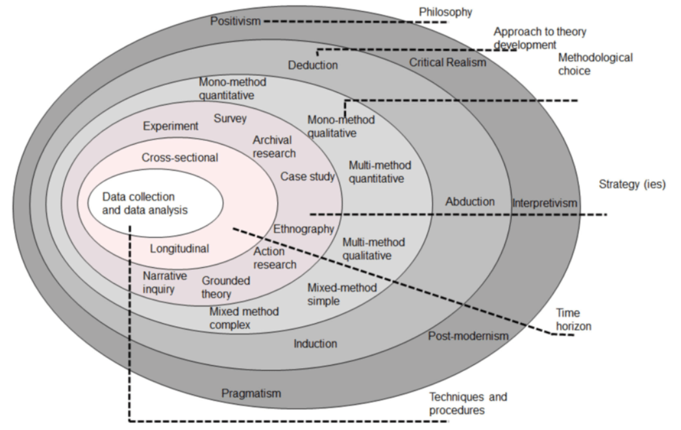
Source: Research onion (Saunders et al., 2019).

Research Philosophy

For the research question "Is mentoring and coaching valuable for success in the business environment for Polish entrepreneurs in the United Kingdom'', an appropriate research philosophy would be pragmatism. This research philosophy allows combining elements of interpretivism and positivism to gain a comprehensive understanding of experiences (Jansen, 2023) of mentoring and coaching practices.

Interpretivism acknowledges that individuals construct their own subjective realities and meanings. In the context of mentoring and coaching for personal success, this philosophy would be helpful to assess how Polish entrepreneurs perceive and interpret the impact of these practices on their business and personal growth. It encourages qualitative methods such as interviews or focus groups, which are ideal for capturing detailed narratives and contextual insights from participants. Interpretivism focuses on the importance of context and social interactions in shaping individuals perceptions and behaviours (BRM). This aligns well with understanding how mentoring and coaching relationships influence Polish entrepreneurs operating within the business environment of the United Kingdom.

Positivism, as a research philosophy, would also offer certain advantages for proposed research. This research philosophy emphasises objective measurement and quantitative data. For the research, this could involve measuring specific outcomes of mentoring and coaching programs, such as financial growth, business performance metrics, or career advancements among Polish entrepreneurs in the United Kingdom. This approach provides clear, measurable results that can be analysed statistically, offering strong evidence of the impact of mentoring and coaching (BRM).

However, it is important to note that positivism may not fully capture subjective experiences and interpretations of individuals, which are crucial in understanding how mentoring and coaching influence personal success in a diverse and multicultural business environment. Therefore, while positivism offers strengths in terms of objectivity and generalisability, interpretivism remains a strong foundation for studies where understanding individual perceptions and meanings is central to the research question (Ikram, Kenayathulla, 2022).

Research Approach

For evaluating the impact of mentoring and coaching on the success of Polish entrepreneurs in the United Kingdom within a business environment, an inductive research approach would be appropriate. This approach is particularly suitable when exploring new or emerging circumstances where there is limited existing theory or research (Pressbooks). In this case, the impact of mentoring and coaching may not have been extensively studied before, especially within this specific cultural and business context.

Inductive research allows for the collection of detailed qualitative data through methods like interviews or case studies. These methods might reveal new insights and patterns in the experiences and perceptions of the entrepreneurs. Inductive research involves gathering data, identifying patterns, and generating theories or hypotheses based on those patterns (Thomas, 2003). The experiences of Polish entrepreneurs and how mentoring and coaching impact their success can contribute to developing theoretical frameworks in this area.

Inductive approaches are flexible and adapt to the data collected, letting findings emerge naturally instead of forcing them to fit pre existing theories or hypotheses that may not suit the context of Polish entrepreneurs in the United Kingdom. This flexibility is crucial for capturing diverse experiences of the participants. In contrast, a deductive approach would start with established theories about mentoring and coaching and test specific hypotheses derived from these theories (Streefkerk, 2022).

However, since the proposed research appears to be more exploratory in nature and aims to build understanding from the ground up, an inductive approach aligns better with the proposed research objectives and the complexity of the phenomena being studied.

Research Choice

Applying a mixed methods approach to assess how mentoring and coaching influence the personal success of Polish entrepreneurs in the United Kingdom provides a comprehensive understanding by integrating quantitative and qualitative data. This approach enables exploring various dimensions of success, including financial outcomes, personal satisfaction, and professional growth. By triangulating findings from both types of data, the study enhances the validity and reliability of its conclusions. This approach also allows to contextualise findings within the cultural and social contexts that influence Polish entrepreneurs (Noble, Heale, 2019).

Research Strategy

Combining surveys and interviews offers a comprehensive approach to evaluate the impact of mentoring and coaching on the success of Polish entrepreneurs in the United Kingdom. Each method brings visible strengths, and their combination ensures a thorough understanding of the research problem.

Surveys reach a large number of respondents, providing a broad quantitative overview of the impact of mentoring and coaching. They allow for statistical analysis to identify trends, correlations, and patterns among variables. Surveys can be distributed and collected quickly and cost effectively. They offer respondents anonymity, leading to more honest and open responses (Oncol, 2015). Surveys are important for establishing general trends and obtaining quantifiable data on business success metrics and experiences with mentoring and coaching among a large group of Polish entrepreneurs in the United Kingdom.

Interviews, on the other hand, can provide detailed data about personal experiences, perceptions, and the impacts of mentoring and coaching. They allow for follow-up questions revealing deeper insights and clarifying responses. Interviews explore the context and specific circumstances that surveys might miss. Semi-structured interviews complement surveys by providing deeper, qualitative insights, helping to understand the personal and emotional aspects of mentoring and coaching that quantitative data alone cannot capture (StudySmarter).

Combining surveys and interviews gives a strong and thorough way to assess how mentoring and coaching affect the success of Polish entrepreneurs in the UK. This mixed method ensures the research covers the topic well and provides reliable and useful insights.
Research Time Horizon
The time horizon in Saunders’ Research Onion is typically categorised into two main types: cross-sectional and longitudinal. Given that the data will be collected from various stages in the lives of the individuals being interviewed, a longitudinal time horizon is most appropriate for this research. A longitudinal study involves repeated observations of the same variables over long periods, allowing the researcher to detect developments or changes in the experiences and outcomes (Melnikovas, 2018).

In this context, a longitudinal approach will enable to capture the changing influence of coaching and mentoring on the success of Polish entrepreneurs in the United Kingdom. By tracking the participants over an extended period, the research will provide understanding into how these development programmes impact their entrepreneurial journey, including the initial phase of setting up their businesses, the growth and scaling stages, and any challenges they encounter.

Furthermore, using a longitudinal time horizon fits well with the dynamic nature of entrepreneurship, where success is an ongoing process influenced by many factors over time (YEC, 2023). This approach will help understand how coaching and mentoring contribute to long-term entrepreneurial success and adaptation in a foreign business environment.

Adopting a longitudinal time horizon for this research allows for a deep exploration of the impact of coaching and mentoring on Polish entrepreneurs in the United Kingdom, providing valuable insights into their development and long-term success.

Techniques and Procedures

For this proposed research several techniques and procedures will be applied to collect comprehensive data.

- Surveys
An online survey will be created using Google Forms. This survey will consist of structured questions designed to gather quantitative data on various aspects of coaching and mentoring. Questions will cover dimensions such as business performance, personal development, network expansion, and specific benefits received from coaching and mentoring relationships. The survey will have a mix of multiple-choice, Likert scale, and open-ended questions to capture a range of responses and insights. The survey link will be distributed through targeted online platforms including social media channels (Facebook, LinkedIn) and email lists.

- Interviews
One-on-one semi-structured interviews will be conducted to gather qualitative data. These interviews will look into individual experiences and perceptions regarding coaching and mentoring. An interview guide will be developed with open-ended unbiased questions focusing on topics such as the nature and duration of coaching relationships, specific benefits gained, challenges faced, and perceived impacts on business success. Participants will be initially identified through personal and professional networks, with snowball sampling techniques applied to expand the participant pool. Interviews will be conducted either in person or via video conferencing tools such as Zoom or Skype, based on participant preferences and logistical considerations. Each interview will be recorded with consent and transcribed verbatim to assist thorough analysis. The translation will be done with another bilingual person to ensure validity of reliability of data.

A balanced and unbiased perspective will be achieved by using various research methods in the study. Qualitative methods, like interviews, are essential for gaining deep insights into the topic but can be influenced by personal opinions. To minimise bias, the study will carefully design non-leading questions and select a diverse group of interviewees, including individuals of different ages, sexes, types of businesses, and durations of mentoring/coaching programs
.
By applying these data collection methods, this research aims to provide a comprehensive understanding of how coaching and mentoring impact the success of Polish entrepreneurs operating in the United Kingdom. The combination of quantitative insights from the survey and qualitative depth from the interviews will contribute to valuable insights.

To effectively analyse the data collected from surveys and interviews a combination of software tools will be used for both quantitative and qualitative analysis.

For the quantitative data from survey responses, software tools like SPSS and Excel will be supportive. SPSS (Statistical Package for the Social Sciences) is an effective software tool used for statistical analysis in social science research. It simplifies data manipulation and performs complex statistical tests like correlations (IBM). Excel, while more basic, is highly accessible and useful for initial data cleaning, organisation, and performing simpler descriptive statistics. Its pivot tables and chart functions are practical for quick insights and presentations (CFI).

For the qualitative data obtained from interviews, software tools such as NVivo will be applied. NVivo is particularly effective for managing large volumes of text data and supports complex coding, querying, and visualisation of qualitative data. It will allow categorisation and code text segments systematically, clearing the way for thematic and content analysis (KSU).

In addition manual coding methods will be applied, especially in the initial stages of qualitative analysis. This involves reading through the transcripts and manually highlighting and categorising text segments, which can provide a deep understanding of the data before it is further processed with software tools.

By leveraging these software tools, the research will provide comprehensive analysis of both quantitative and qualitative data. This approach will help in triangulating findings and providing a good understanding of how coaching and mentoring impact the success of Polish entrepreneurs in the United Kingdom.

Ethical Considerations

Participants must be fully informed about the nature, purpose, and potential impacts of the research before they consent to participate. This includes providing detailed information about what the study requires, how their data will be used, and any potential risks or benefits. Consent should be obtained in writing (University of Oxford).

Participation in the study must be entirely voluntary. Participants should be informed that they have the right to withdraw from the study at any time without any negative consequences (Research Integrity, 2024).
The research must avoid causing harm to participants. This includes considering the psychological impact of discussing personal and professional challenges faced by Polish entrepreneurs in the United Kingdom.

Compliance with the General Data Protection Regulation (GDPR) is essential. This involves ensuring that data is collected, stored, and processed in a manner that protects participants' privacy (GOV). Also the research will be subject to guidance from the University of Wales Trinity Saint David' code of ethics (UWTSD).

Time Management

A Gantt chart is an important tool in preparing a dissertation as it provides a visual representation of the entire project timeline, highlighting deadlines for each of the tasks. The chart allows for the breakdown of complex tasks into manageable ones, ensuring proper prioritisation and efficient scheduling. By tracking progress and showing how tasks depend on each other, it helps keep the project on schedule and identifies the most important tasks (Gantt).

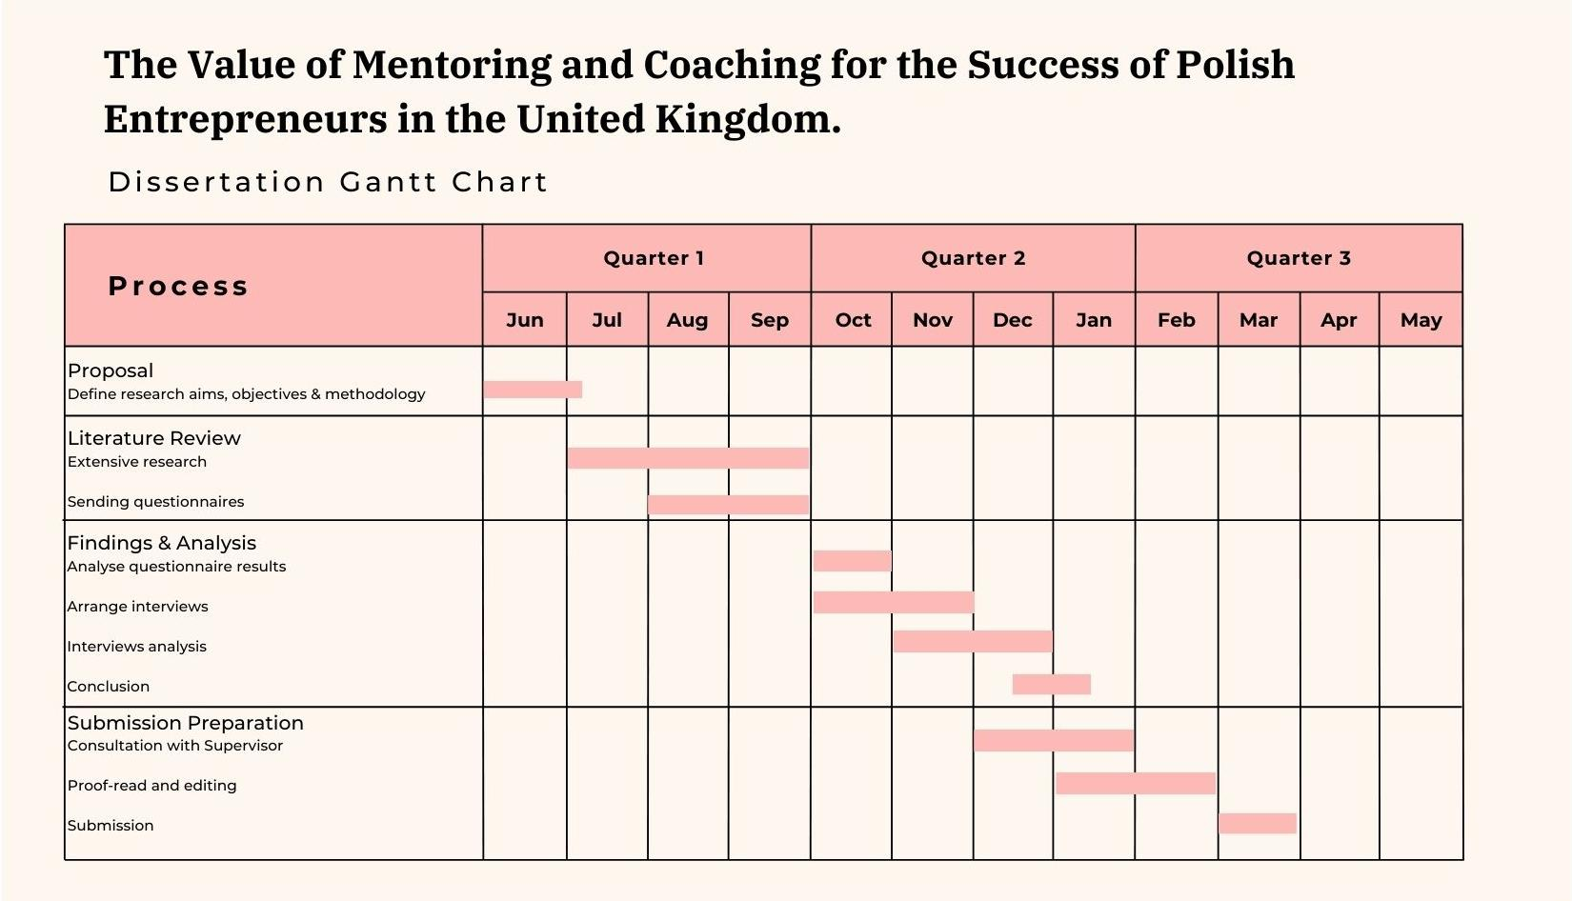
Figure 2. Dissertation Gantt Chart

The above Gantt chart shows a detailed schedule for a dissertation project on the value of mentoring and coaching for Polish entrepreneurs in the United Kingdom. It shows ten months of action tasks and is divided into four phases: Proposal, Literature Review, Findings & Analysis, and Submission Preparation. Each phase includes specific tasks with defined start and end dates, ensuring a structured approach to completing the dissertation.
This timeline allows the researcher to manage time effectively, ensuring that each part of the dissertation process is completed in a logical and timely manner.

Conclusion

Coaching and mentoring are valuable tools for professional development, helping entrepreneurs navigate their businesses, overcome cultural barriers, and achieve growth. Effective coaching emphasises self-awareness and goal-setting, while mentoring focuses on sharing knowledge and skills. Despite their recognised benefits, the impact of coaching and mentoring on Polish entrepreneurs in the United Kingdom remains underexplored. This research aims to evaluate these programmes effectiveness in enhancing personal and professional success for the business owners, addressing benefits, career development, professional perceptions, and implementation challenges.

The research philosophy of pragmatism is chosen for investigating the value of mentoring and coaching for Polish entrepreneurs in the United Kingdom, blending elements of interpretivism and positivism to capture both subjective experiences and measurable outcomes.
An inductive research approach is considered appropriate to explore this relatively under researched area, allowing for the collection of qualitative data through interviews to explore insights into how mentoring and coaching impact entrepreneurial success. Employing a mixed methods approach, the study integrates quantitative surveys for broad quantitative insights and qualitative interviews for deeper understanding, ensuring a comprehensive exploration of the research question.

With a longitudinal time horizon, the research will track changes over time in the impact of coaching and mentoring on entrepreneurial journeys, aligning with the dynamic nature of business development. Ethical considerations include informed consent, voluntary participation, participant welfare, and GDPR and UWTSD compliance, while effective time management is shown through a structured Gantt chart outlining key phases from proposal to submission preparation. This timeline enables the researcher to manage time efficiently, ensuring that each stage of the dissertation process is completed systematically and punctually.

