
Applied Leadership and Management in the Workplace
Module Assignment Submission
Student Name: | Siam Rahman
Student Number: | 1710176
Module No: | BMSK4009
Module Title: | Learning in the Digital Era
Statement of Confirmation of Authenticity
By the act of making this submission, the student declares that this is the work of the student named above. The work has not, in whole or in part, been knowingly presented elsewhere for assessment, or where assessment has been built on a previous assessment, this has been identified. Where materials have been used from other sources it has been properly acknowledged. If this statement is untrue, the student acknowledges that an assessment offence has been committed.
Attention is drawn to the plagiarism and unfair practice policies of both the University and of ILM.

Table of Contents
Introduction 3
Studying in Higher Education 3
Mind Map 5
Personal Development Plan 6
References 10

Introduction

I'll be discussing ways to get ready for learning in the digital age in higher education in this project. I'll create a mental map and a personal growth strategy. I'll be writing about topics including how technology plays a significant role in today's academic system, how to develop digital skills, and how to get familiar using online resources relevant to your subject of study.

Studying in Higher Education

How to prepare for studying in higher education entails many aspects and avenues for example due to recent pandemics, learning has taken place digitally rather than in a face to face environment.
Learning in the digital world, technology can provide students new ways to investigate complicated phenomena and to develop interactive digital representations of their ideas, educational technologies have the potential to revolutionise the way that students learn. To be active and independent users of technology for tackling open-ended, real-world problems, however, students must develop the fundamental abilities and attitudes that need to be taught.
There are two competencies that are quintessential learning with technologies in the digital era
- Self-regulated learning- which relates to managing and researching of ones behavioural, cognitive, metacognitive, motivation and measure progress whilst learning
- Computational practices- which relates to the ability to study systems, represent concepts, and solve problems using computational logic.
It is important for students to flourish and to be successful learners in the digital world because as technology develops, it becomes more crucial than ever for young people to be ready to participate in a workforce where computers play an ever-increasing role and to decide how to use technology to learn new information and skills. While not everyone will become software engineers, professions in the future will demand more interaction with computational models and simulated realities as well as the use of digital tools to address problems. Today's students need to acquire a broad set of abilities and perspectives that support lifelong learning in innovative and foreign digital contexts because of the speed at which technology is changing. (Learning in the Digital World - PISA, 2023)
Preparing for higher education for a student leaving school or college and going in to University can be daunting and difficult for a student to adapt to. There are many ways for a student to prepare, adjust and adapt to new surroundings for example, when learning digitally it is essential to have reliable internet connection, bad internet can interfere with you being taught and learning what is required of the course the student is studying which will ultimately result in failure or difficulties understanding what was taught in the lecture or class. Poor connection will also prevent the student from carrying out any research online. It is fundamental to minimise distractions by creating a conducive learning environment, it will be good practice to set up a designated study space that is quiet, comfortable and free from distractions and interruptions. Avoid listening to the radio or watching TV whilst studying as this will prevent the student from adsorbing any information and can be a detrimental disturbance. (30 Ways to Prepare for University Studies | Oxbridge Essays, 2019)
It will be prudent and wise, in my opinion, to become familiar with online learning platforms, get to know the platforms the institution uses for online classes such as Moodle. Take time to explore the features and tools available to you on Moodle. Doing this will help the students navigate through material that are online. Furthermore it will be beneficial to engage with online resources and take advantage of the vast array of online resources available to supplement the students learning, for example exploring e-books, online libraries, academic journals and educational websites related to the students field of study. (Welcome to the Online Library | the Online Library, 2023)
Keeping track of time and managing your time will help you get prepared for higher education in the digital world, for example try establish a study routine. In the digital age, it's critical to establish a study habit, just like in conventional classrooms. Set aside time specifically for studying, completing assignments, and attending classes via the internet. It will also be of benefit to work on your self-discipline. Digital learning necessitates self-motivation and self-control. Set goals and objectives, create study routines, and hold yourself accountable to stay on task.
Communication is key, staying in touch and communicating with professors or tutors via email, virtual office or discussion boards is extremely important. When a student requires clarification on course material or has questions about an assignment that is due, they should not hesitate to contact their tutor or professor. Given that meeting tutors digitally are more and more accessible rather than face-to-face meetings and because meetings online can be scheduled more quickly, they can be contacted sooner. Participating in online discussions or forums with classmates will enhance understanding of the subject matter and foster a sense of community, sharing thoughts, stay current with the latest advancements in the field you are studying by following relevant blogs, subscribing to newsletters, attending webinars, asking questions and contributing to conversations can only benefit the student as continuous learning is key in the digital era.
My belief is being organised is paramount for studying in higher education for example use digital tools such as calendars to set reminders for when you have lectures so you cannot forget to attend your class additionally set a reminder for important deadlines that need to be submitted on its due date, task management apps or note taking apps is also advantageous, create to-do lists and keep a record and track your progress.
Developing digital literacy skills improves by learning how to effectively use online research databases, presentation software and citation tools, these particular skillsets will be extremely valuable throughout the students’ academic journey. (A Quick Guide to Referencing | Cite Your Sources Correctly, 2019). A student should always recognise areas for improvement and identify skills that they need to improve on and put a plan in to place to increase knowledge and enhance skillset, on the whole it will benefit the student academically for the future and for the present. All students have the opportunity to take advantage of multimedia resources such as videos, podcasts and interactive simulations, these sources can be incorporated in to their learning to make it more engaging and interactive.

“By failing to plan, you are preparing to fail”.
Quote by Benjamin Franklin
(Green, 2018)

Mind Map

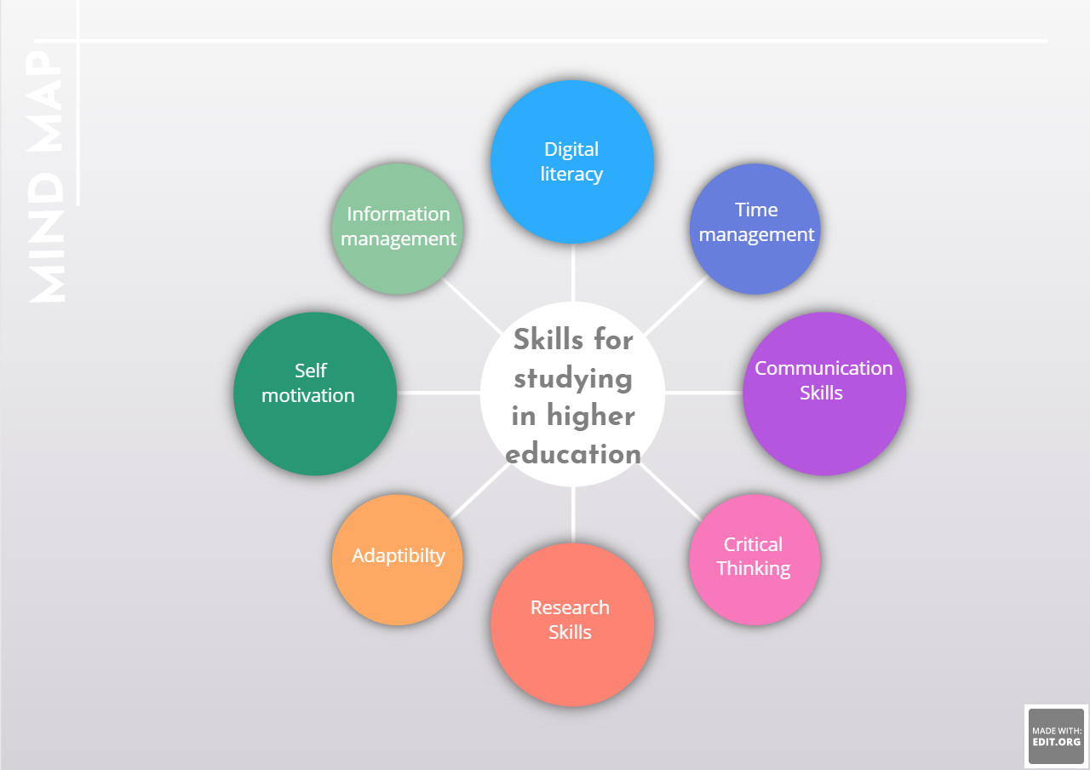
(EDIT.org - Online Editor, 2023)
A diagram of a mind map identifying skills required to study in higher education in the digital era.
Digital literacy - Being able to navigate online resources, use digital tools and evaluate information
Time Management – Balancing virtual classes, completing assignments and personal commitments
Communication Skills – Engaging in online discussions, sharing and presenting ideas,
Critical Thinking – Analysing and evaluating information, solving problems and finding solutions
Research Skills – Conducting online research, finding credible sources and citing them correctly
Adaptability – Being open to new technologies, learning numerous platforms in a digital learning environments
Self-Motivation – Staying focused, setting goals and targets, minimising distractions
Information Management – Organising and effectively storing digital files, notes, assignments and resources for easy access and retrieval

Personal Development Plan

What do I want to do? | How can I do it? | What resources will I need? | How will I measure success? | Target Date for review
Enhance Digital literacy | Take online courses or tutorials to improve my proficiency in using digital tools and navigating online resources. Stay updated with the latest technology tends and platforms relevant to my field of study. | Online digital platforms that offer specific courses on digital skills. | Test my knowledge after learning a particular skill. | 1 month
Time Management Mastery | Develop effective time management strategies to balance online classes, assignments and personal commitments. Utilise digital calendars, task management apps, set realistic goals and targets to stay organised and meet deadlines. | Google calendar, Microsoft outlook to schedule tasks and to set reminders. | Monitor the ability to meet deadlines consistently and track the completion of tasks within designated timeframes. | 1 Month
Communication Skills Boost | Engage actively in online discussions, participate in virtual group projects and practice effective written and verbal communication. Seek opportunities to collaborate with peers and utilise digital platforms seamless communication. | Join online discussions forums provided by my educational institution. Practice written communication by participating in online forums, writing clear and concise. | Evaluate my improvement in written and verbal communication via feedback from tutors, professors and classmates. | 1 month
Cultivate Critical Thinking | Sharpen my critical thinking skills by analysing and evaluating information from various online sources. Practice problem solving, logical reasoning and decision making to develop a strong analytical mindset. | Online digital platforms that offer specific courses on enhancing critical thinking skills. | Asses my ability to analyse and solve problems effectively by measuring my performance in critical thinking exercises or assignments. | 1 month
Research Excellence | Improve my research skills by utilising online databases, academic journals and credible sources. Learn the correct citation techniques and develop a systematic approach to conducting comprehensive online research. | Online databases and my educational institutions library, Learn about proper citation techniques through resources like APA style websites. | Monitor the quality of my research papers or projects as well as the use of proper citation techniques. | 1 month
Embrace Technological Adaptability | Stay open and adaptable to new technologies, learning platforms and digital tools. Explore different software apps and online resources that can enhance my learning experience and productivity. | Stay updates with technology trends by following tech news websites and blogs. Explore new software and tools by visiting websites. | Asses my ability to adapt to new software or tools in my field of study. | 1 month
Foster Self-Motivation | Develop self-motivation and discipline to thrive in a digital learning environment. Set clear goals and targets, create a study schedule and minimise distractions to stay focused and productive. | Use productivity apps to minimise distractions and to remain focused. Set clear goals and track my progress. | Set goals and track my progress towards them, monitoring my consistency and motivation levels along the way. | 1 month
Information Management Mastery | Organise digital files, notes and resources systematically for easy access and retrieval. Make use of cloud storage, note taking apps and file organisation techniques to maintain an efficient and clutter free digital work space. | Use cloud storage services such as Google drive to store and organise my files. Note taking apps can help me keep my digital notes organised. | Evaluate the organisation and accessibility of my digital files and notes ensuring efficient retrieval when needed. | 1 moth
Cultivate Online Collaboration Skills | Actively participate in virtual group projects, utilise digital platforms for teamwork and practice effective virtual communication. Develop skills in remote collaboration, active listening and conflict resolution. | Use collaboration tools like Microsoft Office 365 for real time document editing and virtual team work. Use of communication platforms can help facilitate effective communication with tutors, professors or class mates. | Asses my ability to work effectively in virtual teams considering factors like communication, contribution and teamwork. | 1 month
Continuous Learning | Embrace a growth mindset and commit to lifelong learning. Stay curious, explore new subjects and seek opportunities for personal and professional development in the digital era. | Explore online learning platforms for courses and certifications in various subjects. Follow education channels or podcasts related to my field of interest to continue learning outside of my formal education. | Track the number of courses, certifications or new skill acquired over time as well as my engagement with educational resources. | 1 month

References

Learning in the Digital World - PISA. (2023). Oecd.org. https://www.oecd.org/pisa/innovation/learning-digital-world/

30 ways to prepare for university studies | Oxbridge Essays. (2019, September 27). Oxbridge Essays. https://www.oxbridgeessays.com/blog/30-ways-prepare-university-studies/

Welcome to the Online Library | The Online Library. (2023). London.ac.uk. https://onlinelibrary.london.ac.uk/

A Quick Guide to Referencing | Cite Your Sources Correctly. (2019). Scribbr. https://www.scribbr.co.uk/category/referencing/

Green, N. (2018, June 21). Failing to plan is simply planning to fail. | Perspectives. https://senateshj.com/perspective/failing-to-plan-is-simply-planning-to-fail/#:~:text=The%20title%20is%20a%20modern,plan%20is%20planning%20to%20fail%E2%80%9D.

EDIT.org - online editor. (2023). Edit.org. https://edit.org/edit/my/5mwqwreo33ga

