
Student name: Lucrezia Nappi (23122484)
Programme: BA (Hons) Leadership and Management Skills for the Workplace
Module: Research Methods for Business
Lecturer: Rameses Manalang
Digital Transformation on Employee Burnout and Staff Retention within an NHS Imperial Trust

Business Research Proposal

Table of Contents
2
1. Identification of a Business Problem 3
1.1 Organisational context and background 3
1.2 The business problem 3
1.3 Why the problem is significant 3
1.4 Problem framing 4
2. Research Aim, Objectives and Questions 4
2.1 Research aim 4
2.2 Research objectives (specific and measurable) 4
2.3 Research questions 4
3. Critical Literature Review 5
3.1 Digital transformation as organisational change 5
3.2 Burnout frameworks and the JD-R model 6
3.3 Culture, leadership and change management 7
3.4 Retention, turnover intention and workforce outcomes 8
3.5 Gaps and how this study addresses them 8
4. Research Methodology and Design 9
4.1 Research philosophy 9
4.2 Research approach and justification 9
4.3 Research design 9
4.4 Data collection methods 10
4.5 Sampling strategy 10
4.6 Data analysis 10
4.7 Ethics, reliability and validity 10
5. Business Relevance and Practical Implications 11
6. Conclusion 11
Reference List 11

1. Identification of a Business Problem

1.1 Organisational context and background
Digital transformation is a strategic priority for many organisations, including public sector services, as it can improve efficiency, data quality and service outcomes (Vial, 2019; Westerman, Bonnet and McAfee, 2014). However, it is not only a technological change but also an organisational one, requiring cultural alignment, behavioural change and effective leadership (Bharadwaj et al., 2013; Kotter, 1996).
In healthcare, particularly within NHS Trusts, digital initiatives such as Electronic Patient Records (EPR) are often introduced under operational pressure (Cresswell and Sheikh, 2013). This can lead to unintended consequences, including increased workload, stress and reduced staff morale (Tarafdar, Cooper and Stich, 2015). Therefore, workforce experience has become a key factor influencing the success and sustainability of digital transformation (Westerman, Bonnet and McAfee, 2014).

1.2 The business problem
The specific business problem addressed in this proposal is:
Rising employee burnout and declining staff retention during digital transformation within an NHS Trust.
Burnout is commonly conceptualised as a syndrome involving emotional exhaustion, depersonalisation and reduced personal accomplishment. In healthcare environments, burnout is associated with reduced engagement, lower perceived quality of care and increased turnover intention. Digital transformation may amplify these risks because implementation phases often involve additional training demands, process disruption and heightened performance monitoring
This is a “messy” management problem because it is not explained by a single cause. Instead, it reflects the interaction of multiple variables, including organisational culture, leadership, job demands, employee resources, perceived support and the implementation approach used

1.3 Why the problem is significant
Operational performance: Staff turnover and reduced workforce stability can disrupt continuity of care and operational reliability, especially where clinical and administrative processes depend on experienced staff and coordinated teams
Financial impact: Turnover creates direct and indirect costs through recruitment, onboarding, training, and reliance on temporary staffing. Turnover intention is a strong predictor of actual leaving behaviour, making it a key management indicator
Strategic impact: Digital transformation investments only deliver value when the organisation achieves adoption, routinisation and sustained use. If workforce wellbeing declines during implementation, transformation benefits may be delayed, reduced or undermined
Reputational and governance impact: Reduced staff morale and high sickness absence can influence patient experience, service outcomes and perceptions of organisational effectiveness, creating broader strategic risk

1.4 Problem framing
Existing management responses often focus on technical training or system features. However, evidence suggests that organisational and human factors (culture, leadership, resources, job design) may be equally or more influential in determining outcomes (Kotter, 1996; Schein, 2010). Therefore, a systematic research study is required to generate evidence-based insights rather than relying on assumptions or isolated operational indicators (Saunders, Lewis and Thornhill, 2019).

2. Research Aim, Objectives and Questions

2.1 Research aim
To examine the relationship between digital transformation, employee burnout and staff retention within an NHS Trust, and to identify organisational factors that influence these outcomes (Demerouti et al., 2001; Leiter and Maslach, 2009).

2.2 Research objectives (specific and measurable)
- To assess employees’ perceptions of digital transformation implementation (Vial, 2019).
- To measure burnout levels among staff using validated burnout indicators (Maslach and Jackson, 1981).
- To analyse the relationship between perceived digital transformation demands and burnout using a job demands perspective (Demerouti et al., 2001).
- To examine whether burnout predicts turnover intention as a proxy for retention risk (Tett and Meyer, 1993; Leiter and Maslach, 2009).

2.3 Research questions
RQ1. How do employees perceive the implementation of digital systems within the Trust (e.g., workload impact, usability, support)?
RQ2. What are the current levels of burnout among staff during/after digital implementation?
RQ3. Is there a significant relationship between perceived digital transformation demands and burnout?
RQ4. Does burnout significantly influence turnover intention (retention risk)?
RQ5. What organisational practices (e.g., leadership communication, training, support) mitigate negative outcomes?

3. Critical Literature Review

3.1 Digital transformation as organisational change
Digital transformation is often defined as the integration of digital technologies into organisational processes to create value and enable new ways of operating (Vial, 2019). Bharadwaj et al. (2013) argue that digital transformation reshapes strategy, capabilities and operating models; therefore, success depends on organisational alignment rather than technology alone. Westerman, Bonnet and McAfee (2014) similarly emphasise “digital maturity”, which combines technology adoption with leadership, culture and governance.
In healthcare, the literature highlights that implementation often produces short-term disruption, including workflow fragmentation, documentation burden and “workarounds” when systems do not align with practice (Cresswell and Sheikh, 2013). A key critique is that many studies evaluate adoption through technical metrics (usage rates, system uptime) rather than workforce wellbeing and sustainability outcomes (Vial, 2019).
Figure 1: Kotter’s 8-Step Change Model

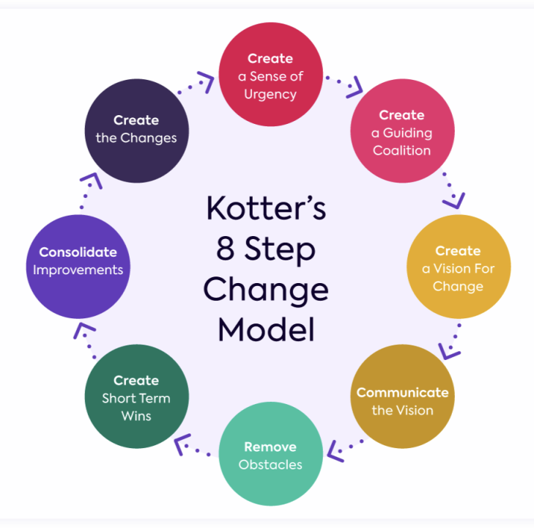
Figure 1 illustrates Kotter’s (1996) eight-step model, highlighting the importance of leadership and communication in successful digital transformation.

3.2 Burnout frameworks and the JD-R model
Maslach and Jackson (1981) provide a foundational conceptualisation of burnout, which has been widely applied in healthcare contexts. The Job Demands–Resources model proposes that burnout emerges when job demands (pressure, complexity, workload) exceed job resources (support, autonomy, training, feedback) (Demerouti et al., 2001). This model is particularly relevant to digital transformation because digital implementation can increase cognitive and time demands (learning new workflows, dual-running paper/digital systems) while resources may lag (training, support capacity) (Tarafdar, Cooper and Stich, 2015).
Technostress research further explains how ICT-related demands (overload, complexity, uncertainty) can negatively affect employee wellbeing and performance, especially when implementation is rapid and ongoing (Tarafdar, Cooper and Stich, 2015). However, an important nuance in the literature is that technology can also function as a resource—improving information access and reducing errors—when systems are user-centred and supported effectively (Westerman, Bonnet and McAfee, 2014). This suggests the relationship between digital transformation and burnout is contingent on organisational context and implementation quality.
Figure 2: The Job Demands–Resources (JD-R) Model

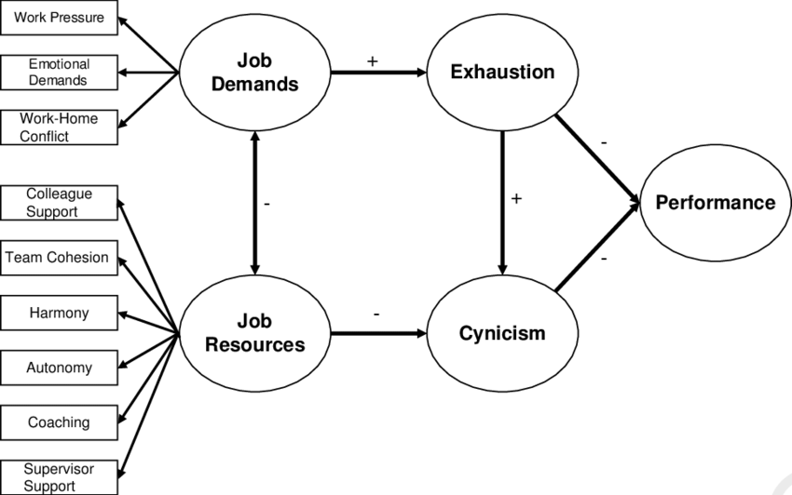
As illustrated in Figure 2, the Job Demands–Resources (JD-R) model demonstrates how increased job demands during digital transformation may lead to burnout when organisational resources are insufficient (Demerouti et al., 2001).

3.3 Culture, leadership and change management
Schein (2010) argues that culture shapes how employees interpret change and what behaviours are normalised. In many large public sector organisations, structural characteristics may resemble role cultures where formal procedures and accountability dominate (Handy, 1993). While this can support governance, it may reduce flexibility during innovation and increase resistance if change is perceived as imposed rather than co-designed (Handy, 1993; Schein, 2010).
Kotter’s (1996) change model emphasises creating urgency, building coalitions, communicating vision and enabling action. Where these elements are weak, transformation may generate uncertainty, reduced trust and disengagement (Kotter, 1996). In digital contexts, leadership capability is often linked to employee engagement and adoption outcomes, reinforcing the argument that “digital is people” as much as technology (Westerman, Bonnet and McAfee, 2014).

3.4 Retention, turnover intention and workforce outcomes
Turnover intention is strongly associated with actual leaving behaviour and is commonly used as a predictor of retention risk (Tett and Meyer, 1993). In healthcare settings, burnout has been identified as a significant predictor of turnover intention, suggesting that wellbeing is a key lever for retention strategy (Leiter and Maslach, 2009).
A limitation in current literature is that many studies examine burnout or retention separately from digital transformation, or treat digital transformation as a background condition rather than a central explanatory factor (Vial, 2019). This proposal positions burnout as a mechanism linking digital transformation pressures to retention risk, consistent with JD-R logic (Demerouti et al., 2001).

3.5 Gaps and how this study addresses them
• Limited integrated research linking digital transformation, employee burnout and turnover intention, particularly within NHS contexts (Cresswell and Sheikh, 2013; Leiter and Maslach, 2009).
• Limited empirical quantitative research examining measurable relationships between digital transformation demands and employee wellbeing outcomes (Saunders, Lewis and Thornhill, 2019).
• Under-exploration of organisational resources, such as support, training and leadership communication, as factors that may mitigate the negative effects of digital transformation (Demerouti et al., 2001; Kotter, 1996).
This study addresses these gaps by applying JD-R theory and incorporating organisational change perspectives, while using a quantitative approach to provide measurable and evidence-based insights.
Figure 3: Conceptual Framework for This Study
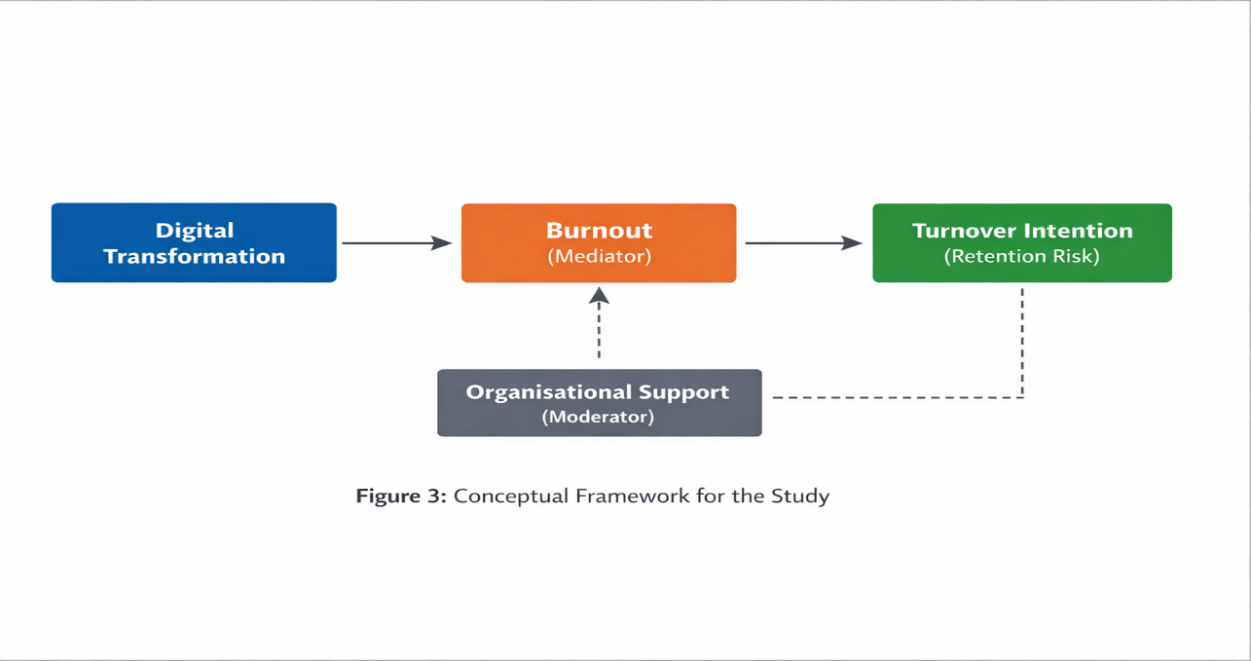
The conceptual framework visually represents the relationships between the key variables and guides the research design.

4. Research Methodology and Design

4.1 Research philosophy
A positivist research philosophy will be adopted, as it focuses on objective measurement and the use of quantitative data to examine relationships between variables (Saunders, Lewis and Thornhill, 2019). Positivism is appropriate for this study because it allows for statistical analysis and supports a deductive approach, where existing theory is tested using empirical data.

4.2 Research approach and justification
A quantitative research approach is adopted, as the study aims to measure burnout levels and examine the relationship between digital transformation and staff retention. Quantitative methods allow for the collection of numerical data and enable statistical analysis to identify patterns and relationships between variables (Saunders, Lewis and Thornhill, 2019). This approach is appropriate as it provides objective and measurable evidence to support organisational decision-making.

4.3 Research design
A cross-sectional survey design will be used to collect data at a single point in time. This design is suitable for examining relationships between variables such as digital transformation, burnout and turnover intention. It allows for efficient data collection from a relatively large sample and supports statistical analysis of trends and correlations (Saunders, Lewis and Thornhill, 2019).

4.4 Data collection methods
The survey will include measures of:
- Burnout indicators (Maslach and Jackson, 1981)
- Turnover intention (Tett and Meyer, 1993)
- Perceived job demands and resources (Demerouti et al., 2001)
- Perceived organisational support (Demerouti et al., 2001)
This method enables efficient data collection from a large number of participants and supports statistical analysis.

4.5 Sampling strategy
A stratified sampling approach will be used to ensure representation across different staff groups, including clinical, administrative and managerial employees. This is important as the impact of digital transformation may vary depending on job role and level of system interaction (Cresswell and Sheikh, 2013).
The target sample size is approximately 50 respondents, which is sufficient to identify patterns and relationships within the data (Saunders, Lewis and Thornhill, 2019).

4.6 Data analysis
Quantitative data will be analysed using descriptive statistics to assess burnout levels, as well as correlation analysis to examine relationships between variables. Regression analysis may also be used to identify the extent to which digital transformation predicts burnout and turnover intention (Saunders, Lewis and Thornhill, 2019).

4.7 Ethics, reliability and validity
Ethical considerations are central to this research. Participants will be fully informed about the study’s purpose, and participation will be voluntary. Confidentiality and anonymity will be ensured, with all data securely stored in line with data protection requirements (Saunders, Lewis and Thornhill, 2019).
As the study addresses sensitive topics such as stress and burnout, participants may skip questions or withdraw at any time without consequences. Reliability and validity will be supported through the use of established measures of burnout and turnover intention (Maslach and Jackson, 1981; Tett and Meyer, 1993). The combination of surveys and interviews will provide both quantitative and qualitative insights, enhancing the credibility of the findings (Creswell, 2014).

Business Relevance and Practical Implications
This study is relevant to managerial decision-making as it provides evidence on whether digital transformation is linked to increased burnout and retention risk, and identifies the organisational resources that can mitigate these effects (Demerouti et al., 2001).
Key practical implications include:
- Reducing job demands during implementation (e.g., protected learning time, phased rollout)
- Strengthening job resources such as training, “super-user” support and responsive helpdesks (Demerouti et al., 2001)
- Enhancing leadership practices through clear communication, engagement and empowerment (Kotter, 1996)
- Promoting a supportive organisational culture focused on learning, psychological safety and collaboration (Schein, 2010)
Overall, the research supports strategies that ensure digital transformation delivers sustainable value while maintaining workforce stability (Westerman, Bonnet and McAfee, 2014).

Conclusion
This proposal investigates the relationship between digital transformation, employee burnout and staff retention within an NHS Trust. Digital transformation is conceptualised as an organisational change process involving strategy, culture and leadership, rather than purely technological implementation (Bharadwaj et al., 2013; Vial, 2019).
Drawing on the Job Demands–Resources model, the study examines how increased job demands during digital transformation may contribute to burnout when organisational resources are insufficient, and how burnout may subsequently influence turnover intention (Demerouti et al., 2001; Maslach and Jackson, 1981; Leiter and Maslach, 2009; Tett and Meyer, 1993).
Adopting a quantitative research approach, the study aims to generate measurable evidence through statistical analysis to support evidence-based managerial decision-making (Saunders, Lewis and Thornhill, 2019).
The findings are expected to inform organisational strategies that reduce burnout, strengthen employee support and improve staff retention, ultimately contributing to more effective and sustainable digital transformation within the public sector (Westerman, Bonnet and McAfee, 2014).

Reference List
Bharadwaj, A., El Sawy, O.A., Pavlou, P.A. and Venkatraman, N. (2013) ‘Digital business strategy: toward a next generation of insights’, MIS Quarterly, 37(2), pp. 471–482.

Braun, V. and Clarke, V. (2006) ‘Using thematic analysis in psychology’, Qualitative Research in Psychology, 3(2), pp. 77–101.

Briner, R.B. and Denyer, D. (2012) ‘Systematic review and evidence synthesis as a practice and scholarship tool’, in Rousseau, D.M. (ed.) The Oxford Handbook of Evidence-Based Management. Oxford: Oxford University Press, pp. 112–129.

Creswell, J.W. (2014) Research Design: Qualitative, Quantitative, and Mixed Methods Approaches. 4th edn. Thousand Oaks, CA: SAGE.

Cresswell, K. and Sheikh, A. (2013) ‘Organisational issues in the implementation and adoption of health information technology innovations: an interpretative review’, International Journal of Medical Informatics, 82(5), pp. e73–e86.

Demerouti, E., Bakker, A.B., Nachreiner, F. and Schaufeli, W.B. (2001) ‘The job demands–resources model of burnout’, Journal of Applied Psychology, 86(3), pp. 499–512.

Handy, C. (1993) Understanding Organizations. 4th edn. London: Penguin.

Kotter, J.P. (1996) Leading Change. Boston, MA: Harvard Business School Press.

Leiter, M.P. and Maslach, C. (2009) ‘Nurse turnover: the mediating role of burnout’, Journal of Nursing Management, 17(3), pp. 331–339.

Maslach, C. and Jackson, S.E. (1981) ‘The measurement of experienced burnout’, Journal of Occupational Behaviour, 2(2), pp. 99–113.

Saunders, M., Lewis, P. and Thornhill, A. (2019) Research Methods for Business Students. 8th edn. Harlow: Pearson.

Schein, E.H. (2010) Organizational Culture and Leadership. 4th edn. San Francisco, CA: Jossey-Bass.

Tarafdar, M., Cooper, C.L. and Stich, J.F. (2015) ‘The technostress trifecta—techno eustress, techno distress and design’, Information Systems Journal, 25(2), pp. 103–132.
Tett, R.P. and Meyer, J.P. (1993) ‘Job satisfaction, organizational commitment, turnover intention, and turnover: path analyses based on meta-analytic findings’, Personnel Psychology, 46(2), pp. 259–293.

Vial, G. (2019) ‘Understanding digital transformation: a review and a research agenda’, The Journal of Strategic Information Systems, 28(2), pp. 118–144.

Westerman, G., Bonnet, D. and McAfee, A. (2014) Leading Digital: Turning Technology into Business Transformation. Boston, MA: Harvard Business Review Press.

