Determining if there is a need to improve generational diversity consciousness within SALT of Palmar and LUX* Belle Mare.

Participant Name Student ID: Marie Sheila Malloo 1715710 Asha Domun 1715705 Frederic Legris 1715708 Devesh Chatoo 1715702 Viswanand Venkatasami 1715881

Module Number: BMPF4010
Module Name: Work-Based Learning Project
Words count: 7382
Date of Submission: 5 November 2019

PROJECT REPORT
Table of contents
Content Page Number

Section 1 – Project Report
1.1 Introduction 2
1.2 Literature Review 3
1.3 Methodology 6
1.4 Findings 9
1.5 Conclusion and Recommendations 21
1.6 References 24

Section 2 - Appendices
2.1 Generational differences chart 26
2.2 Survey 27
2.3 Questions for focus group managers 28
2.4 Mindset quiz and results 29

Section 3 – Approved Ethics Form
3.1 Ethics Form 31

Section 1 – Project Report
1.1 Introduction
Mauritius is a multicultural island and well known for its hotel industry around the world, with diversity in culture reflected in its service’ philosophy.
As it is a fast developing sector with more than 190 star rated hotels in Mauritius, more and more young people are attracted in the hotel industry where each one envisages a clear development and career path.
Unfortunately, in reality turnover is increasing in the sector which also causes a strain on recruitment resources, onboarding and training that in turn has an impact on the stability of a company. This impact can also be cascaded to the family life of an employee.
When we look at LUX* Belle Mare and SALT of Palmar, the two hotels of The Lux Collective group, the turnover data of both hotels suggest a higher turnover among the younger employees. We observed that mostly millennials are leaving the company within 6 months to 2 years of their employment. The analysis of the exit interviews of those millennials showed that the latter are leaving to join other organizations mainly because of conflicts between team members and managers. It is interesting also to note that the managers in these two hotels are mainly from the generation X and they have many years of service in the company. Another important factor cherished by the millennial team members is their personal life that generates frustration at the workplace since the hotel industry is known for its long working hours.
When the various departments were segregated based on the age group of team members, the research showed that the workforce of the hotel is in fact constituted of a mixture of generations.
Taking into consideration those factors, it was important to first understand if there is a need to improve generational diversity consciousness and secondly research on ways to create a stronger bonding among all the generations with the aim of creating a more pleasant working environment and mitigating the high turnover among millennials.

1.2 Literature Review
Worldwide there are theories and discussions based on generational problems in the work place. Experts’ opinion varies slightly, especially in the definition of millennials and Generation Z. The below chart provides a clear categorization of generations by age as per West Midland Family Center. (2008). Generational differences chart. 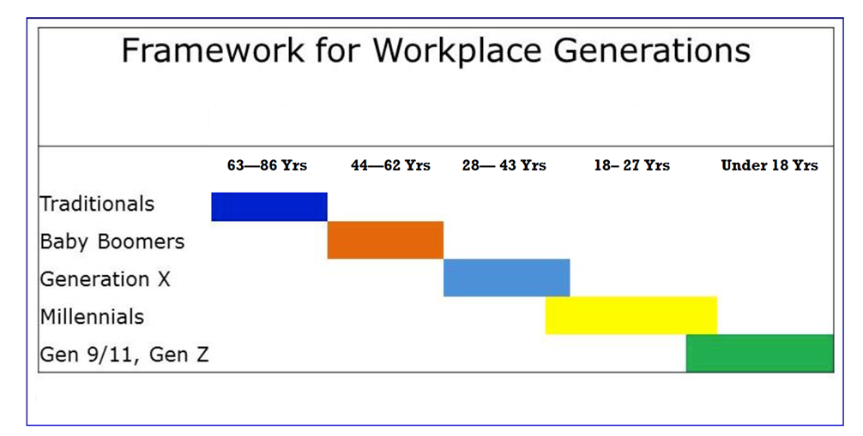
Figure 2.1: The generations defined
Critical reviews are being presented by scholars and other researchers. Research of Twenge (2008) refers to generational differences in psychology and the impact on organizations which will lead to a major problem if not taken into consideration and acted upon.
Diversity can be perceived as a “double-edged sword”. In an academic context, diversity encompasses different dimensions including origin, race, gender, ethnic group, language, color, attitude, values, beliefs and religion. A similar list, provided by Kearney et al., (2009) relates diversity to minorities comprising of; elderly and disabled people and women.
Bentley CWB (2017), has done research on multi-generational impacts on the workplace, whereby the university found that millennials have a preference to work with managers that recognize and assist them in both their personal and professional goals in an optimistic and structured approach. A global study on work-life challenges across generations performed by Twaronite (2015) found the 5 most common reasons why millennials are quitting their company are:
• Salary 76%
• Promotion 74%
• Long working hours 71%
• Lack of Team Spirit, no teamwork 71%
• No flexibility from superiors 69%

Smith et al, (2012) concluded that a generation problem should be considered at an early stage and there needs to be a culture where managers adjust themselves to the millennials.
Having referred to turnover data of the two resorts (LUX* Belle Mare and SALT of Palmar) and taking into consideration the hotels’ exit interview forms, at a first glance it seems that there is also a need to consider generational diversity consciousness in the hotels.
Since the last five decades, there has been much debate on the theory of labor force diversity and organizational performance. Shani and Lau, (2005) perceived organizational culture and labor force diversity to be the main reason of positive and negative impacts in an organization. To have better performance and solve problems, employees in an organization need to have clear understanding of the concept. Due to a rise in differences in the population of many countries, diversity issues are now regarded as important and are expected to become even more important in the future. Nowadays most companies are laying emphasis on diversity as it has a great privilege of providing high productivity and competitive advantage. Rau and Hyland, (2003), mentioned that managing and valuing diversity are key components of effective people management and can improve workplace productivity. Unmanaged diversity in the workplace might become an obstacle for achieving organizational goals.
Conversely, studies by Melisa et al, (2008) shows that in reality most of the differences observed during their studies revealed that the differences are better explained by individuals, rather than generational differences. It has been pointed out that there is more likely to be differences between people of the same age group. The result of this research highlights the importance for Managers and HR professionals to attend to individual differences, regardless of Generations.
Rodrigues & Dias, (2019) hi-light retention of employees as one of the biggest threats that most companies are facing. The two major facts is that most employees in the hospitality sector have the tendency to leave their jobs are:
- 67% are looking for more exciting work,
- 65% leave for a better work/life balance, Witts, (2015).

The topic of multigenerational co-existence in the workplace has intrigued numerous scholars who have investigated the topic from an array of different perspectives. It is found in personal, group or organizational interaction. Conflict is either “good or bad” and “sinful or immoral”. It assumes significance, once it is dealt intelligently. When conflict is handled unskillfully and badly, it becomes detrimental and when it is handled morally and creatively, it ceases to be frightening or incapacitating, and results in growth, maturity, and empowerment for individual, group and organization. Conflict occurs due to differences of perception, ideas, behaviors, interest, attitudes, religious differences, political differences and unjustified distribution of national resources. So it affects quality, performance and profit of organization. Conflict is essential for life and dynamic for team performance Medina et al. (2005).
Capelli, (2019), mentioned that there is no generational stereotypes and that organizations must not dwell on differences. He believes that people misinterpret the concept of “age effect”. The “age effect” is the fact that people of different ages would act in a particular way depending on where they stand in the course of their life. There is nothing that can prove the difference between a 35 year old manager today from a 35 year old manager a generation ago. It appears that there is a lot of variation within people of the same generation. Hence, the way forward is to understand individual needs.
Good workforce diversity practices in the area of human resources are believed to enhance employee and organizational performance Adler (1986). Managing diversity involves leveraging and using the cultural differences in people's skills, ideas and creativity to contribute to a common goal, and doing it in a way that gives the organization a competitive edge Morrison (1992).
Summarizing the above research, it seems obvious that before taking a decision in the way to proceed for the benefit of the team in the two resorts, the researchers need to really understand which path to take. The research will indeed need to determine if there is a need to improve generational diversity consciousness within the resorts. On the other hand, the research may guide them and highlight factors other than a generational problem. In the resorts we have witnessed a trend where managers tend to complain about millennials. The research will help to determine the most appropriate approach. Either we must find strategies to encourage managers to adjust their way of work to meet the demands made by today’s millennial employees as stipulated by Smith et al, (2012) - or, concentrate on adopting an individual approach, taking into consideration their personal and professional inclinations as suggested by Cappelli (2019).
1.2.1 Personal/Professional Learning

With reference to the studies by Melisa et Al, 2008 on generational differences, same shows that in reality most of the differences observed during their studies revealed that the differences are better explained by individuals, rather than generational differences. From my personal learning, I can say that Mauritius being a multicultural island we do have different cultural origins where everyone has learnt over the years to live peacefully together in the same community.
This diversity is visible in the daily activities of an individual when it comes to serving others and the modesty in their approach compared to other countries. In other words, someone showing respect, dedication to his work, centered on achieving personal and professional goals, expects the same in return from his employers.

1.2.2 Personal contribution
My contribution to the group was to help in conducting research on generational differences in order to see if those differences were a source of conflict pushing more and more new comers to leave their workplace within a short period of six months to two years.

1.3 Methodology
To understand if there is a need to improve generational diversity consciousness within The LUX* Belle Mare and Salt of Palmar, the researchers have chosen three methods and the methodology cascades down in three phases using a funnel approach where one leads to the other. The methods used are surveys, followed by focus groups and finally interviews. The three methods have been chosen because they are more practical and do not involve high costs.
The first phase that is the survey consisted of a paper-based questionnaire with approximately 20 questions including some with comments field allowing participants to express their own opinion. A set deadline of one week was given for the submission of questionnaire. Having a comments section in the questionnaire allowed the participants to give more detailed answers that helped the researchers to gather both quantitative and qualitative data. The questions were based on what Team Members value at the workplace and in their personal life. 100 Team Members were targeted for this survey, out of which 60 Team Members from LUX* Belle Mare and 40 from SALT of Palmar.
Voice recording was not selected as participants may have been reluctant to express their views. Keeping the survey anonymous helped participants to express themselves freely. Email was not considered as it could have been easily ignored. Besides, the researchers have also considered the fact that not all participants have access to emails. Also the deadline set allowed the participants to fill in the survey at the own pace.
The survey analysis provided us with important information on Team Members’ challenges and preferences. The researchers also gained further insights with regards to the positive and negative views of the team members.
The survey has been compiled and analyzed by the researchers. Based on the survey analysis, researchers have designed relevant questions for the focus group which has been the second phase of the research.
One focus group was conducted with managers and one with the Team Members at each hotel. It consisted of open-ended questions with answers recorded in writing by the researchers. The focus groups consisted of 10 participants in each group where everyone had the opportunity to express themselves freely with regards to the set questions. For focus group with managers, six managers were selected from LUX* Belle Mare and 4 from SALT of Palmar. For focus group, the managers and team members of LUX* Belle Mare and SALT of Palmar were interviewed separately. These focus groups took approximately 30 minutes each.
Researchers from the two resorts interchanged resorts to conduct the focus group in order to avoid conflict of interest between focus group participants and researchers. This also allowed the participants to express their feelings openly.
Focus group methodology was chosen for three main reasons - i) to understand the various generations’ point of view, ii) to understand the challenges they could be facing and how we can create better bonding between them, iii) it provided a platform to probe further on the comments shared by the participants while also identifying the specific root causes of a challenge.
The outcome from the focus group was analyzed and compared with the survey which helped researchers to formulate suitable interview questions for the Human Resources Managers (HRM) for LUX* Belle Mare and SALT of Palmar.
We proceeded with the interview with HRMs in two stages. First, they were asked generic questions pertaining to generational differences and after getting their responses, we shared the survey results and sought a second opinion. It was interesting to note how the survey results had an influence on their perception.
The Human Resources Managers from LUX* Belle Mare and SALT of Palmar belong to different age groups and they were likely to have a specific point of view with regards to the subject. This helped the researchers to gather further information and as a result get a better overview of the responses analyzed. The same questions were asked to both Human Resources Managers as it helped us determine whether with an age gap there is a different pattern of thinking - one HRM belongs to Generation X and the other HRM is a millennial.
It was important to gather information from Human Resources Managers from different generations in order to understand how to deal with different generations’ employees and managers. The interviewer strived to remain impartial towards both the interviewees and the topic under discussion. Face to Face and telephone calls helped to gain better idea of the context of discussion and measures to be taken in order to be successful.
Finally, the General Managers of both resorts were interviewed separately to understand their mind-set and beliefs with regards to generational challenges as well as the outcome of Team Member’s survey, focus group of managers and the interview with the Human Resources Managers.

1.3.1 Ethics Consideration
The purpose of the survey was clearly explained to Team Members and they were assured of full confidentiality and anonymity. Facts and figures collected was only used for the purpose of the study. Moreover, information related to LUX* Belle Mare and SALT of Palmar Team Members was not mixed nor manipulated with other resorts historic data.

1.3.2 Adverse Outcome
As the participants interviewed and those that participated in the survey were Team Members of the 2 resorts, it was not an issue to obtain the relevant data. It was explained to the interviewees that the research was for the benefit of the team and resorts.
In case the targeted number of responses to the survey would be insufficient for an accurate analysis, we would use secondary data such as team member survey of 2018 conducted by Great Place To Work for The Lux Collective resorts.

1.4 Findings
1.4.1 Findings from the survey questionnaire
The main findings that came out from the survey with the team members of LUX* Belle Mare and SALT of Palmar were:
• Differences do exist amongst the different generations; baby boomers, X and Millennials in the hospitality workplace.
• The majority of the interviewees perceived that these differences are translated into a generational ‘gap’ within each generation.
• The analysis of the responses to the different questions by the different generations clearly revealed no coherence to the generational difference chart by West Midland Family Center (2008) except when it relates to technology. Indeed the analysis revealed that the majority of millennials are aligned to the generational difference chart with regards to technology.
• The need to improve on generational diversity consciousness dissolves as within each generational group the responses are relatively different.
The above main findings have been derived from analyzing each of the questions from the survey as per below. The survey questions were derived from a generational differences chart (appendix 1) introduced by West Midland Family Center (2008) whose mission is to enhance the quality of life for each generation by providing growth and achievement opportunities within a caring environment. It has enabled the researchers to understand the similarity and differences in the behavioral pattern of people from different generations. Each question characterized a particular generation and we were expecting to have a particular response which is related to the generational stereotype the respondent falls into. However, respondents were not made aware of this so as to ensure non-biased reflection and response.
Understanding the respondents’ profile is paramount to capture the generation in which the respondents fall in. Hence question 1 helped us to understand the age distribution of the sample population surveyed which is as follows:
• Traditionalist (63yrs-86yrs)
• Baby Boomer (62yrs-44yrs)
• Generation X (43yrs-28yrs)
• Millennial (27yrs-18yrs)
Analysis showed no respondents belonged to the Traditionalist age group.
Questions 2 and 3, were to understand the current position and length of service consecutively in order to know if it bears an incident to the survey.
Analysis of question 4 (Appendix 2), was about what best matches your personal values. As per the chart Baby Boomers are characterized as being competitive and creative, Generation X as being practical, independent and highly productive and Millennials are concerned with what is happening worldwide. Out of 13 respondents from the baby boomers, only 2 responded as being competitive and creative, out of 55 respondents from the generation x, 23 responded as practical, independent; highly adaptive and out of 32 respondents from millennials only 5 responded as being concerned about what is happening worldwide. It means that the participants did not respond as per their generational stereotypes as expected by the West Midland Family Center (2008) Generational Chart. We were expecting the millennials to be concerned about what is happening worldwide, however their response to this question remained widely distributed among different generational traits. Most of the participants responded like traditionalists and Generation X. Surprisingly, very few survey participants are concerned about what is happening worldwide.
Question 5, referred to how you best describe your time at work and here even not a single match was observed. We can analyze from the graph that most of the generations have chosen their response like that of baby boomers, i.e., they all like to create good relationships with colleagues, achieve good results together and be flexible with working hours. Out of 13 respondents from the baby boomers generation, 10 responded as expected by a baby boomer. Millennials were expected to be working efficiently within fixed hours with results not being the focus. However out of 32 respondents only 1 has responded according to the generational stereotype. We can conclude that in this question as well, there was no generational pattern observed. Majority of the respondents from all the generations have responded as a baby boomer, which is a good sign for the resorts.
As regards how comfortable they are with technology in question 6, although a trend could be seen in reference to what majority of respondents have chosen for each generation, we still have gaps in percentages that were expected for each generation. Millennials are expected to be very advanced with smart phone technology; however from the survey, it was found that out of 32 respondents (millennials), only 11 respondents were very advanced on technology, 10 respondents were pre-advanced and 11 respondents were not versatile with phone technology. Overall responses were quite near to what was expected. However, some of the millennials do not like to venture much into technology. For generation X, it was indeed a great result as out of 55 respondents, 23 responded being pre-advanced and 19 responded being advanced that makes a total of 42 which means that they are quite advanced with technology. Knowing that nowadays we are having tremendous technological advancement and everything is connected with social media and audio-visual, appropriate training could be provided with the assistance of those with advanced skills. This will also enable team members to follow in the new trend and be more connected.

Question 7, was about preferred approach to communication. Effective communication is a key factor for the success of a company; therefore effective communication is critical to avoid generational conflict. Observation of results obtained demonstrates that people of the same generation have different preferences in communication. The results obtained reveal that the best way to communicate is to understand individual preferences. It is imperative to accommodate people’s differences by learning their unique style and serving them accordingly. Out of 13 Baby Boomers that were expected to answer as being diplomatic, speaking openly using casual language - none of them responded as such. Instead 10 Baby Boomers responded as millennials – choosing polite, respectful and in-person conversations. Generation X were expected to choose as being direct, state facts and use e-mail as a number 1 tool as per the generational differences chart; however only 18% responded accordingly. 20 Gen X respondents responded like Baby Boomers and strangely 9 responded like Traditionalists who prefer being discreet while showing respect and using formal language.
Motivation factors were probed in question 8, with a view to knowing the phrases which best motivate each generation. Traditionalists are motivated when their opinion is respected. Having no traditionalists as per the age group analysis, 0 responses were expected. However, 7 Baby Boomers, 9 Generation X Team Members and 4 Millennials chose the Traditionalist phrase. The generational differences chart states that a Baby boomer is motivated when he is needed in the company but 0% responded likewise. As for Generation X, only 15% responded as per their generational stereotype preferring to do things in their own way. For the Millennials, 41% responded that they are motivated when working with other bright and creative people. Therefore, the above analysis reveals a need to understand individual motivations as there is no obvious trend or generational way of thinking.
Question 9, was about their description of training and development. Training and development has a very important role in the success of a company, knowing how each generation describes same contributes to understanding their way of thinking. From the analysis the most obvious nonconformance was seen in Generation X. The latter typically considers training and development as an investment for future opportunities irrespective of the employer, however, only 5 respondents responded likewise which represents 9% of survey participants. Astonishingly, majority of Gen X responded like baby boomers mentioning that training contributes to the organizational goals and is also a path to promotion and additional compensation. From the analysis we found that 31% of millennials believes that training is a learning opportunity and it is ok to make mistakes in the learning process. Analysis reveals a mix of opinion within each generation pertaining to description of training and development.
Question 10, was about feedback and recognition. It is an important factor to know how to motivate team members, understanding the preferences of each generation and working towards same. Here as well, analysis reveals a distortion amongst each generation. None of the baby boomers responded that they enjoy public recognition, which presumably is characterized as a baby boomers trait. However, we see that majority of the baby boomers chose constructive feedback to be more effective, which is presumably a Gen X trait. Analysis also shows an incoherence in regards to the millennials as we had only 28% that chose the millennial trait of preferring being given feedback often. Therefore, generational stereotyping cannot be considered as an approach to give feedback or recognition.
In Question 11, respondents were asked about their point of view on building skills at their workplace. None of the Baby Boomers responded as per their generational stereotype, instead majority of the baby boomers have responded like millennials meaning they opted for training as being important and they are motivated by learning and want to see immediate results. For Gen X only 24% responded like the Gen X trait choosing multiple skills which will lead to the next job, the more they know the better. Work ethic is important, but not as much as skills. Majority of the Gen X, have chosen like a millennial as well. Eventually, analysis proves that there is discrepancy within the likes of each generation regarding their point of view on building skills.
Question 12 reveals how concerned the Team Members are about their social gathering. Majority of them strongly agree /agree with the fact that social gathering is very important and is something they value. For them they believe that they will be more productive and effective if they have time to socialize. This can enable them to cut off from their work life. Only a few disagree on this question indicating that participant’s value having a social life.
To sum up - the data collected and analyzed from the survey does not show a clear trend of adherence to the generational pattern / traits expect the question on technology which shows some degree of conformance.

1.4.2 Findings from Focus group with team members
The main findings from the focus groups with the team members are:
• There exist diverging opinions on generation.
When asked whether there is a generational problem within the work place the answers were very diverse, as some team members feel that the fact of having millennials in the team creates conflicts since they lack experience and are not supportive enough. On the other hand, researchers find that the opinions vary. For others the fact of having a mix of different generations seems to be very beneficial. By combining individual strength and ability through good communication and working environment, productivity can be improved.
• Clear understanding of expectations leads to good working environment
Regardless of the generation the team falls into, adopting a more casual approach and providing a good understanding of what is expected from team members in the workplace is important to create better bonding and avoid conflicts. What is often interpreted as generational conflicts is only a question of understanding others and being understood. Team spirit, sharing of ideas and discovering at the same time a more realistic picture in order to create a stress free atmosphere seems to be the appropriate approach.
• It is more of an individual approach than a generational dilemma
Millennials believe that generation X has a fixed mind-set and consequently are not open-minded. However during the focus group it was observed that there was a reluctance from the participants to talk about mind-set as a generational dilemma. They believed that mind-set is more of individual approach.
Team members’ focus group reveals a preference in being valued, having a human touch, showing respect, adopting fairness and more collaborative approach. Team members revealed a sense of engagement in contributing to more innovative ideas. Team members feel valued by contributing to the organizational growth by participating in several tasks and implementation of innovative ideas.
• Communication style should be individual based
During the focus group it was revealed that communication does not have anything to do with age or generational preferences but rather on how someone interprets the point of view received from their interlocutor. Hence, adopting an individual approach to preferred way to communicate is important.
Observation was also made on the fact that young team members, so called millennials didn’t have any issue in sharing their daily workloads with elderly colleagues meaning Gen X and baby boomers. They seemed to enjoy as they benefit a lot from their experience and they feel comfortable when they know those people are around to guide them in any worrisome situations that they encounter during their day to day task.
However, team members’ focus group also determined that though millennials do not foresee issues working with older generations, in certain situations difference of age group and comprehension may lead to challenges. Mostly misinterpretation in the way that the young generation expresses themselves despite the fact that they don’t have any work experience also contributes to conflicts and challenges.
In general, the focus group session with the team members proved to be very fruitful. It revealed the importance of studying our employees and creating opportunities for cross generational mentoring. The outcome also showed that team members need a lot of attention, like to be valued and have the willingness to contribute more in sharing their ideas regardless of their generation.

1.4.3 Findings from focus group with managers
The main finding from the focus group with managers was that that the managers were convinced that there is generational problem.
The focus group for managers comprised of five questions derived from analysis of our survey questions (Appendix 3) which was also filled by the managers. In understanding the managers’ point of view in regards to generational problem, it seems obvious Managers perceive Millennials to be team members that do not show ownership and dedication in their work. Millennials will come to perform their shift and will refuse working overtime. Millennials were characterized to be the generation that have a lack of discipline. Conversely, one manager did not share the same point of view. He defined generational problem to be a myth created by individuals by generalizing issues or conflicts. Moreover it was felt that generations above millennials, mostly baby boomers need to adapt to the millennials as it seems that baby boomers are more reluctant to millennials approach.
Manager’s focus group revealed that there is no mechanism in place to create a better bond between the generations and that there is a need to improve generational diversity consciousness in the resort. Managers felt that diversity consciousness would help to better understand each other and most importantly would benefit managers to cope with different generations.
Majority of managers declared that different generations have different mind-set and that fixed mind-set or, fixed with some growth mind-set are mostly baby boomers.
In regards to how team members view time spent at work, managers expressed that generation X and millennials does not have the same pattern of thinking. Managers declared that generation X would create good relationships with colleagues, want to achieve good results together that they are flexible with working hours whereas millennials work efficiently within fixed hours only - the results are not the focus.
Above statement obtained from the focus group clearly reveal that managers are convinced that there is a generational problem within the resort.
Following the above discussion with the managers, the survey analysis results were revealed to them clearly indicating that there was non-conformance to stated generational traits and the survey tabulated does not show a generational problem.
Thereafter, a complete change of perception was noticed whereby managers were seen to be perplexed by the results obtained from survey. A sudden change of opinion on what actions are needed was observed from the managers. They seemed to no longer feel the need of creating generational diversity consciousness. Instead, they felt the need to understand people’s individual needs and have a strategy where supervisors and managers are being actively prepared on how to handle each team member by considering their individual values.
The question pertaining to point of view for time spent at work, results were shared with the managers. Whereby, majority had chosen to create good relationships with colleagues and achieve good results together, flexible with working hours. Generally, it is a baby boomer pattern of thinking. Analysis showed to managers reinforced that there are no generational problem. Manager’s focus group ultimately determined generational attributes to be a wrong approach and agreed that the goal is to help team members to move forward and not waste time on stereotype problem.
Researchers have also shared with Managers the mindset quiz survey (Appendix 4) which reveals that from the 21 supervisors that filled the survey, 19% have a strong growth mindset, 67% growth with fixed mindset, 14% fixed with some growth mindset and 0% strong fixed mindset.
From the 5 Shift leaders 40% a strong growth mindset, 20% growth with some fixed mindset, 40% fixed with some growth mindset and 0% strong fixed mindset.
From 59 Team members, 27% a strong growth mindset, 49% growth with some fixed mindset, 22% fixed with some growth mindset and 2% strong fixed mindset.
Managers revealed a certain satisfaction for the results obtained. It reveals that managers would have been more concerned if there was a higher percentage of strong fixed as well as fixed with some growth mindset.
Moreover, having 5 shift leaders, showing 40% of them having a fixed with some growth mind-set seems to be an opportunity to address. It is important to consider same in the future, to provide appropriate training and support. Shift leaders are usually groomed to become future supervisors and it is important that they are coached to develop a higher growth mindset.

1.4.4 Findings from interview with the Human Resources Managers (HRM)
The main finding from the interview with the HRMs from both resorts was similar to the finding from the managers. The HRM of both resorts also thought that there is a generational problem in the resort.
The questions of the 2 focus groups were elaborated and used for the interview with the Human Resource Managers (HRM) of both resorts done separately. From the interview it was noted that HRMs also shared the same point of view as the managers, before knowing the survey analysis. Stereotypes about generations seemed to be present. HRMs seemed to define Baby Boomers as non tech savvy and generation X Team Members as just wanting to get ahead and witness success in a short lapse of time. On the other hand, Millennials were defined by HRMs to be sluggish Team Members with lack of interpersonal skills. Analysis of the interviews at first revealed that from the HRMs perspective, a combination of generations often leads to unpleasant and unproductive work environment and eventually, this hinders teamwork.
Interviewees defined Baby Boomers as those who prefer long workdays at the office, while millennials usually prefer flexible hours and work-from-home options. It was revealed that from the interviewees’ perspective having both generations on a project seems to be challenging due to difficulty in collaborating because of difference in working styles.
Findings of the interview from HRM of SALT of Palmar revealed his opinion of Baby boomers as a generation that have shown less interest in technology, software and applications. Baby boomers seem to be reluctant to accept new technology as a tool for improvement. Millennials are presumably keener to use new technology. However, millennials are quite on the move and less patient to share their knowledge with Baby Boomers, which tends to generate frustration and disconnected teams.
Following the interviews it was revealed that there is no official strategy in place to overcome the generational concern. However, HRMs of both resorts use current HR practices to work collectively with all the different generations. HRMs focus on combining different generations in projects hence enhancing the team bonding.
When Analysis of the survey was disclosed to the HRMs revealing no pattern of generational problem, HRMs showed an interest in reviewing their approach to questions asked before the survey results were disclosed.
Analysis of the interviews revealed that training targeting individual development and understanding might be the appropriate strategy or approach to address HRMs struggles concerning team members’ conflict. From shift leaders to managers, providing a training or workshop to understand the importance of tackling people individually and valuing people at work is of paramount importance. More leadership training would also appear to contribute in understanding individual values.

1.4.5 Findings from the Interviews with the General Managers (GM)
The main findings from the interviews with the GMs of the two resorts were:
• The interview with the GM of LUX* Belle Mare revealed that the GM was 50:50 on the question pertaining to generational trend in the resort. He believes that the results obtained contribute toward people’s individual rather than generational approach. Company wise, it reveals that through trainings that have been done, the group is heading in the right direction focusing on leadership and people.
• The interview of the GM of Salt of Palmar also reported that generational problem does not exist. However, he believes that generally older work force is not too keen to adapt to changes and prefer normal routine of work. As perceived by the GM, people from the younger generation are hyper about situations and tend to be reluctant to cope with the older generation.
The outcome of the surveys and focus groups were shared in the interview with the General Managers of both resorts as represented in the picture below. The survey analysis, followed by focus groups with Managers and Team Members, then interview with the Human Resource Managers of both Hotels.

From GMs’ interview we noticed that youngsters, so called millennials ought to be given enough freedom of doing their task in their own ways. Knowing that nowadays college environment involves more discussion and engagement and the young people that have just finished college are used to an engaging and collaborative culture.
From the interviews, it has been perceived that the way of delivering communication is important. Regardless of the generation there should be a good plan for personal and professional growth, which proves to be an element to feel valued and appreciated.
Daily training is an utmost important tool. This will make the generations feel at ease in their workplace and make them willing to work and deliver exceptional service to our guests. With training, Team Members will be more prepared for the next level.
The result of the mindset quiz was also shared with the GMs. From the interview it can be concluded that the responses obtained were gratifying as majority of team members which represent 49% have a growth with some fixed mindset and that 30% have a strong growth mindset.
1.4.6 Personal/Professional Learning

As a group we did a survey with a series of questions derived from a generational differences chart which was introduced by West Midland Family Centre.(2008), whose mission was to enhance quality of life for each generation by providing growth and achievement opportunities within a caring environment.
The use of such a tool enable us as a group to view and extrapolate the similarities and differences in the behavioural pattern of people from different generations.
Personally I learnt through the surveys that despite the young age group of team members, their way of thinking was similar to older team members and therefore was contrary to the general opinion that there were generational problems, where millennials were too young to understand or have the willingness to achieve their goals.

1.4.7 Personal contribution

Similarly, my participation in both the focus groups of Team Members and Managers was very inspiring to me as during these sessions divergent views were abundant,. In other words, there was not a big gap in the opinions of the two mentioned groups. Both agreed that with better communication and individual efforts greater things could be accomplished.
On a more professional point of view, the result from the interview with the Human Resources Managers of the two hotels was practically similar to the Managers focus group. Both see in millennials an inconsistency in their approach towards attaining personal or even professional goals and they treated the subject in a broader context comparing to all generations. As a final point when the results of the survey were disclosed, mentioning that the results showed no generation problem and that it was rather a mindset concern, which in general contributes to a bad working environment, the HRMs were instantly willing to look at different strategies to deal with the mindset issues. I realized that they were very flexible in their approach and keen to take action where it matters most. This was a good learning for me and showed the importance of leaders being flexible and ready to adapt to change.
Pertaining to the GM interviews, both of them mentioned we are on the right direction as a group and that we are adopting the right approach, which is, focusing on leadership and people which is one of the most important assets in our industry.

1.5 Conclusion and Recommendations
From the findings, it can be concluded that overall team members including managers have agreed that there is no generational dilemma. However, there are conflicts which need to be addressed. Those conflicts could be mitigated by determining strategies that would motivate team members. For this to happen, understanding team member’s individual needs and values is of utmost importance. Following recommendations are made to address conflicts:
1. Improving communication leading to increase in trust and decrease in conflict
Although mostly everyone acknowledged that differences do exist, only few relate this to specific workplace conflicts. Causes of conflicts are generally more related to personal differences than workplace issues. The cause of conflict often cited as miscommunication and lack of trust towards the competencies of younger employees as major problem areas.
2. Develop strategies to improve work-life balance
It can also be determined that the overall team is concerned about their social life. As Mauritius is a multi-cultural island, it seems that to have all generations motivated to work, we need to have a work life balance. Hospitality industry is known for its irregularity of working hours due to 24 hours way of life, very often team are requested to work longer hours disturbing their personal commitment.
It is important to have an insight of mixed age group and reverse monitoring program that enables older, skilled team members to network and learn from younger recruits. Very important not to consider generational based employee groups as same generally enforces labelling of team by generation. As per Capelli, (2019) people tend to behave differently because of what has happened to them and not because of who they are.
Career prospects, training and better communication flow are recommended to assist in reducing conflicts between all the generations and promote a happy working environment and a great place to work. Also, human resources survey seems important to be conducted regularly to get an idea on Team Members demographic and needs.
Insights derived from this study might be of value to correlate with country statistics or other Industries, to determine if there is a generational concern.
3. Focus on personal and professional growth
To help team members to continue to learn and to enhance their skills and knowledge, it is essential that:
• Managers & Team members learn to focus on what is important in order to fulfil set objectives.
• Create a win-win environment where everyone is at ease and performing optimally.
• Instill passion for change in order to break monotonous and repeated daily tasks.
4. Training is crucial for organizational development and success.
It benefits both the company and the Team Members. Training helps to improve morale of Team Members. The more satisfied the employees are the greater is the morale, the more they will contribute to organizational success and the lesser will be the absenteeism and turnover.
5. Provide continuous and concrete Feedback
It has been noted that younger generation are keener to get direct feedback in order to feel more confident in their day to day work. Therefore, leaders should constantly look for opportunities to approach team members about their performance so as to create that positive bonding which will enhance the work environment and help them to take their own decisions.
1.5.1 Personal/Professional Learning

As a group we concluded that there is no generational problem affecting the working environment but purely a mindset issue as each person is different and in order to have good synergy ,the approach should be more focussed on individual needs rather than englobing all the different generation altogether.
The key learnings for me is that:
- Good communication plays an important role in the smooth running of an industry and must be done in a way that prevents any discrimination.
- Show respect to others and others will show respect to you.
- Learn to listen to others.
- As managers, adapt ourselves to millennials.
- Praise Team members for their good work.
1.5.2 Overall View:
Moreover in my experience, I have seen that despite we do have different ways of thinking, different generations, status, backgrounds ,we all are human beings and therefore must treat each other with due respect. Therefore, each manager must try their upmost to adapt himself or herself to any individual that they come across during their daily task, to create a better working environment.

1.6 References
Adler, N. J. 1986. "Cultural synergy: Managing the impact of cultural diversity." The 1986 annual: Developing human resources: 229-238.
Bentley CWB Fall, 2017. Generational impacts research report
Gary Connor, 2016, Medp Spark, Volume 1, issue 3
Jean M. Twenge, Stacy M. Campbell, 2008. Generational differences in psychological traits and their impact on the work place Journal of Managerial Psychology, Vol. 23 Issue: 8
Karyn Twaronite, 2015. EY A global study on work-life challenges across generations.
Kearney, E., Gebert, D. and Voepel, S.C, 2009. When and how diversity benefits teams: The importance of team members’ need for cognition. The Academy of Management Journal, Vol .52 No3
Medina J. Francisco, Munduate. L, Miguel, A. Dorado, Martínez Inés, Guerra, M. José, 2005. Types of intragroup conflict and affective reactions. Journal of Managerial Psychology, Vol. 20, No. 3/4, pp. 219-230
Melisa Wong, Elliroma Gardiner, Whitney Lang, Leah Coulon, 2008. Journal of managerial Psychology, Vol 23 Issue: 8, pp.878-890
Morrison, A. M, 1992. The New Leaders: Guidelines on Leadership Diversity in America. Jossey-Bass Management Series, ERIC
Peter Cappelli, 2019. Here’s why Millennials aren’t that different
Rau, B.l., & Hyland, M.M, 2003. Corporate and Hyland
Rodrigues & Dias, 2019. Determinants of employee retention, A Study of reality in Brazil
Shani A.B and Lau, J.B, 2005. Behaviour in Organizations: An Experiential Approach. (8th Ed), New York: McGraw-Hill Irwin
Smith, S.D., Galbraith, Q, 2012. Journal of Academic Librarianship Volume 38, Issue 3. Pages 135-144
Witts, 2015. High staff turnover
West Midland Family Center. (2008). Generational differences chart. Retrieved from http://www.wmfc.org/uploads/GenerationalDifferencesChart.pdf

Section 2 – Appendices
2.1 Generational Difference Chart
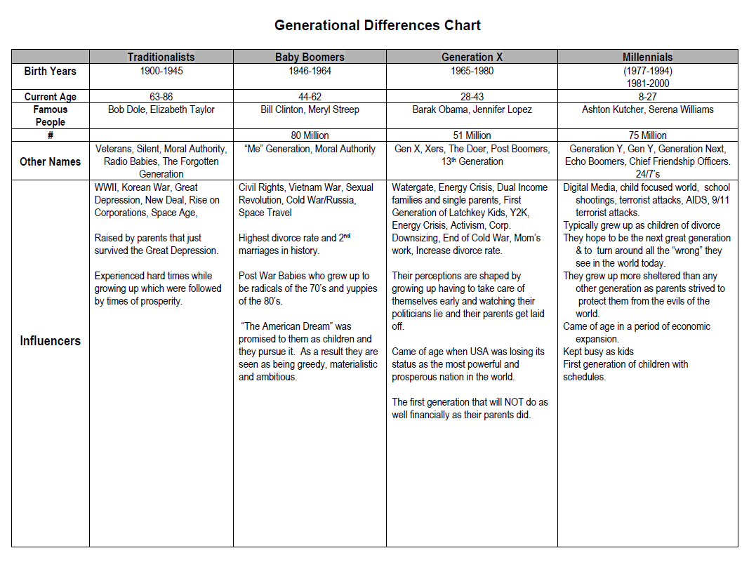

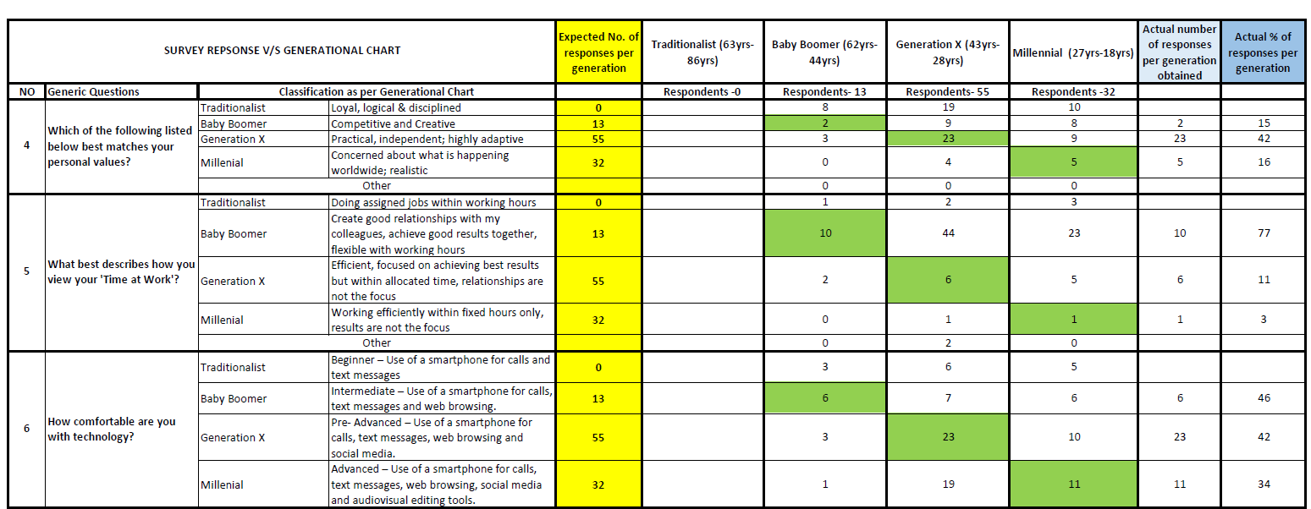
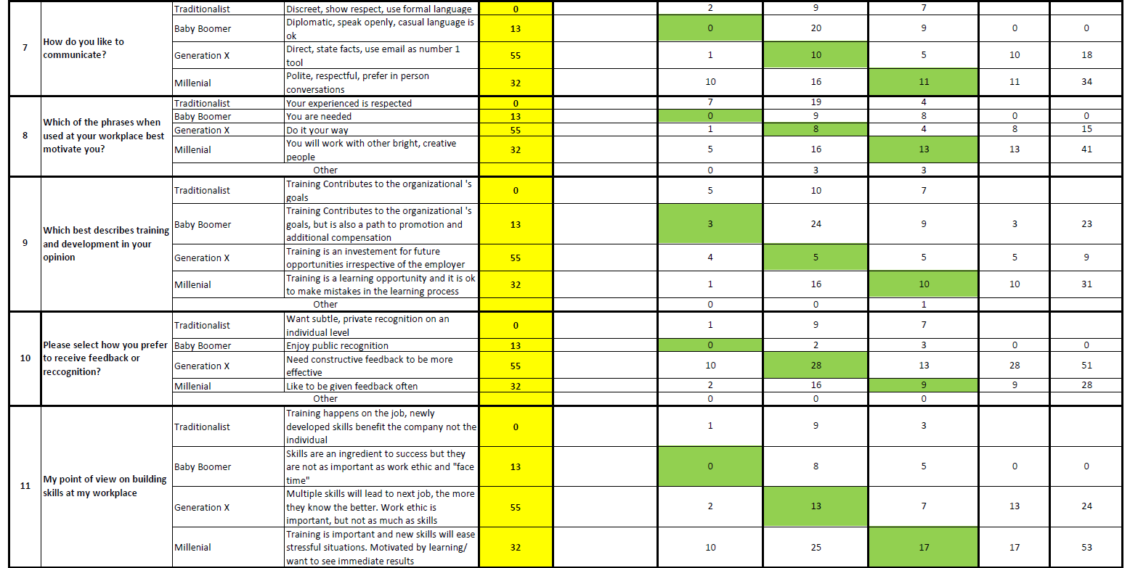
2.2 Survey

2.3 Questions for focus group with Managers
- Do you think that we have a generational problem in the hotel? Why?

What kind of work environment and practices do we have in place or we need to create a better bond between all generations and have a pleasant working environment?
- Do you think that people from different generation have different mind-set? Why?
- Does millennials share that same pattern of thinking as a generation X, in terms of their time at work? Explain why
- Majority of supervisor have a growth with some fixed mind-set do you think that same impact on your operation? How?

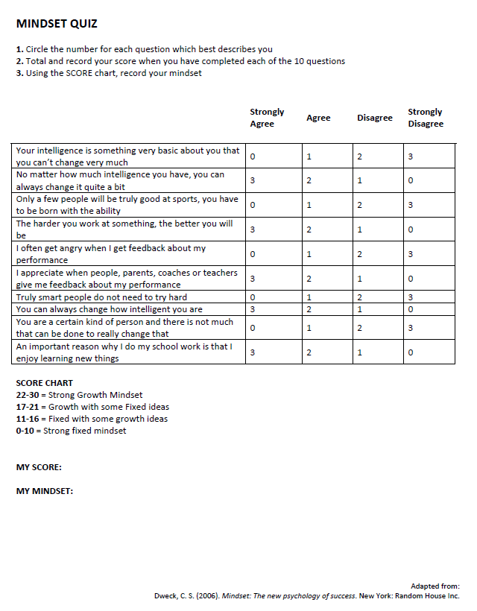
2.4 Mindset Quiz & results
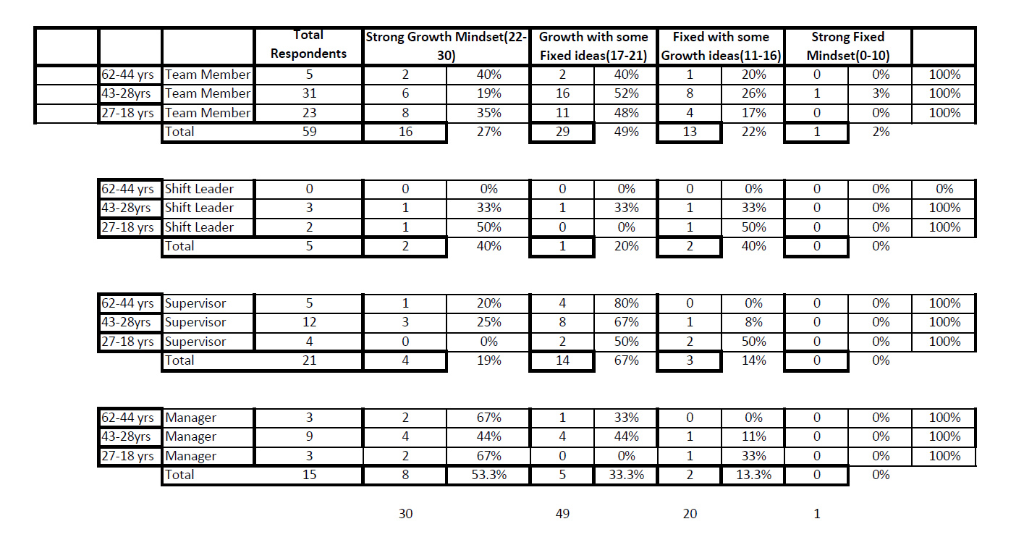
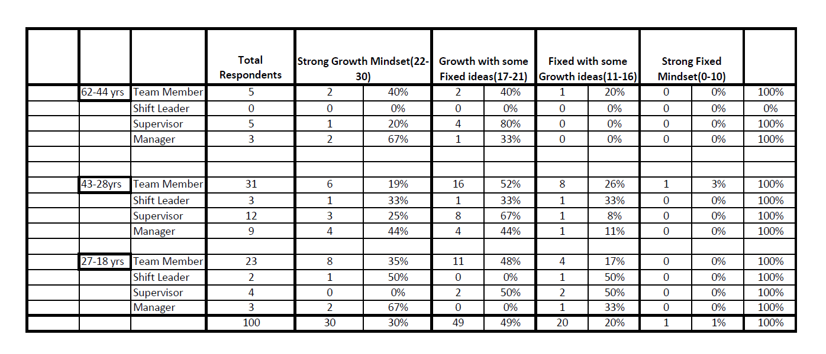

Section 3 - Approved Ethics Form
3.1 Ethics Form
APPLICATION FOR ETHICAL APPROVAL

In order for research to result in benefit and minimise risk of harm, it must be conducted ethically. A researcher may not be covered by the University’s insurance if ethical approval has not been obtained prior to commencement.

The University follows the OECD Frascati manual definition of research activity: “creative work undertaken on a systematic basis in order to increase the stock of knowledge, including knowledge of man, culture and society, and the use of this stock of knowledge to devise new applications”. As such this covers activities undertaken by members of staff, postgraduate research students, and both taught postgraduate and undergraduate students working on dissertations/projects.

The individual undertaking the research activity is known as the “principal researcher”.

Ethical approval is not required for routine audits, performance reviews, quality assurance studies, testing within normal educational requirements, and literary or artistic criticism.

Please read the notes for guidance before completing ALL sections of the form.

This form must be completed and approved prior to undertaking any research activity. Please see Checklist for details of process for different categories of application.

SECTION A: About You (Principal Researcher)

Full Name: |  |  | - Marie Sheila Malloo  - Asha Domun  - Frederic Legris  - Devesh Chatoo  - Viswanand Venkatasami
Tick all boxes which apply:
Member of staff: | ☐ | Student: |  | ☒ | Honorary research fellow: | ☐

Faculty/School/Centre: | WIWBL
Campus: | Carmarthen
E-mail address: | - sheila.malloo@luxbellemare.com  - asha.domun@luxbellemare.com  - frederic.legris@luxbellemare.com  - kunal.chatoo@saltofpalmar.com  - vish.venkatasami@saltofpalmar.com
Contact Telephone Number: | - 59197139  - 59435789  - 59191740  - 59441018  - 59441016
For students:
Student Number: | - 1715710  - 1715705  - 1715708  - 1715702  - 1715881 | Undergraduate | ☒
Programme of Study: | Cert HE in Professional Practice | Taught Postgraduate | ☐
Director of Studies/Supervisor: | Tessa Oosthuizen | Research | ☐

SECTION B: Approval for Research Activity

Has the research activity received approval in principle?  (please check the Guidance Notes as to the appropriate approval process for different levels of research by different categories of individual) |  | YES | ☒ | NO | ☐
 |  |  |  | Date
If Yes, please indicate source of approval (and date where known): | Research Degrees Committee |  | ☐
 | Faculty Research Committee |  | ☐
 | Other (write in)  WIWBL Ethics Board Representative |  | ☒
Approval in principle must be obtained from the relevant source prior to seeking ethical approval.

SECTION C: External Ethical Guidance Materials

Please list the core ethical guidance documents that have been referred to during the completion of this form (including any discipline-specific codes of research ethics, and also any specific ethical guidance relating to the proposed methodology). Please tick to confirm that your research proposal adheres to these codes and guidelines.
Guidelines Revenue Report; Guidelines Annual report of Hotels 2017 | ☒
LUX Code of Ethics | ☒
 | ☐

SECTION D: External Collaborative Research Activity

Does the research activity involve collaborators outside of the University? |  | YES | ☐ | NO | ☒
If Yes, please provide the name of the external organisation and name and contact details for the main contact person:
Institution
Contact person name
Contact person e-mail address

Where research activity is carried out in collaboration with an external organisation
Does this organisation have its own ethics approval system? | YES | ☐ | NO | ☐
If Yes, please attach a copy of any final approval (or interim approval) from the organisation

SECTION E: Details of Research Activity

Indicative title: | Determining if there is a need to improve generational diversity consciousness within SALT of Palmar and LUX* Belle Mare.
Proposed start date: | June 2019 | Proposed end date: | October 2019
Purpose of research activity (including aims and objectives)
Outline the purpose, aims and objectives of the research activity, including key research questions. Show briefly how existing research has informed the proposed activity and explain what the research activity will add and how it addresses an area of importance. (Maximum 300 words)
Background

Referring to turnover data of the hotels we have noticed a trend where youngsters, which is mostly generation Y, are leaving the organization within 6 months to 2 years of their employment.
Taking into consideration the hotel exit interview forms, it appears that most of the youngsters are leaving to join other organizations because of these two reasons:
- Conflict between Team Members and Managers
- Team members valuing more their personal life which creates frustration at work.

Through further investigation, we found that we have a mixture of generations, whereby majority of leavers are generation Y and majority of supervisors and managers are generation X. Our research will focus on understanding generations and analyse how to create a stronger bond between the generations.

Aims
The aims of this research will therefore be:
- Understanding if there is a pattern of behaviour associated with different generations
- Understand if generational behaviour patterns can result in conflict
- Understand if there is a co-relation between generations and type of mind-set adopted by people (growth Vs. Fixed)
- To identify ways to create a better bond between all generations and have a pleasant working environment.

Previous Research

Baby Boomers appear to be more reluctant to move from one organisation to the other compared to Generations X and Y employees. Job satisfaction and organisational commitment seems to have a much lower importance among younger generations so, career mobility seems much higher. Younger generations tend to have the desire for a leadership style which is individual-focused, more competitive and show case more self-reliance. Therefore, teamwork approach turns to be lower.

Behaviours change when it applies to different generations and this creates a different workplace performance which transforms the requirements for talent management.

People from different generations reflect differently and make alternative choices from other generations because what they value is not the same. Organisational leaders and Human Resource Professionals should be cautious in implementing Human Resource Strategies that recognise the unique values and the characteristics of each generation because what they value is not the same.

The generational differences have both positive and negative influences on the day-to-day operations, and often lead to challenges. Different generations can perform well and if they are being provided and motivated according to their needs so that they will work more efficiently.

References:

- Angeline, T. (2011). Managing generational diversity at the workplace: expectations and perceptions of different generations of employees.
- Becton, J. B., Walker, H. J., & Jones-Farmer, A. (2014). Generational differences in workplace behaviour.
- Lyons, S., & Kuron, L. (2014). Generational differences in the workplace: A review of the evidence and directions for future research.
- Roberts, F. (2000). From wedding rings to nose rings… generational differences in the workplace and in the practice setting.
- Tiwari (2016).India’s New HR Challenge: Managing a Multi-Generational Workforce.

Group Learning Outcomes:

- Understand if there is a correlation between generations and behavioural pattern
- Based on the above understand generational needs and preferences
- Adapt leadership style based on an understanding of generational differences
- Develop effective strategies in consultation with the HR managers to deal with team members belonging to different generations.

Proposed methods
Provide a brief summary of all the methods that may be used in the research activity, making it clear what specific techniques may be used. If methods other than those listed in this section are deemed appropriate later, additional ethical approval for those methods will be needed. (Maximum 600 words)
Methodological Position:

This research entails others input and opinions which are mainly Team Members, colleagues and peers. Their output will be both qualitative and quantitative information which will help for better decision making.

Secondary data will also be taken into consideration to understand international trends.

Participants:

Will be mostly team members of the company & Managers (Approx. 100 participants)

Methods:

- Survey: The purpose of the survey is to gather information from our Team Members in order to understand the differences between generations, taking into consideration Mauritius, which has a multi-cultural context and a high social focus mind-set. The survey will help us to better understand the conflict between the generations. Results will be compiled on a feedback sheet.
We will use approximately 20 questions including few open ended questions.
The questions will be based on what Team Members value at the workplace and in their personal life.

- Focus Group: We shall conduct group sessions focusing on challenges that our generations are facing. This will be done at managerial and Team member level. It will be open ended questions and answers which will be recorded. The group will consist of 10 people and group session will take approximately 30 minutes.

- Interviews: Responses obtained from survey and focus group will be utilised with the Human Resource Managers of the two resorts to identify generational differences and similarities in order to understand how to enhance leadership strategies and management style. The interview will be approximately 15 minutes either face-to-face or by telephone.

Also, the General Manager of both resorts will be interviewed separately to understand their mind-set and beliefs with regards to the outcome of team member’s surveys, focus group of managers and interview of Human Resource Manager.

Analysis

Survey: The findings from the survey will provide us with information on Team Members preferences and mind-set. Following the analysis of the survey we will be able to understand the generations better.

Focus Group: To understand the generations’ point of view and how we can create a good bonding between them.

Interview: Gathering information from different HR Managers in order to understand on how to deal with all generations’ employees.

Before making recommendations, indicative costs will be investigated.

Location of research activity
Identify all locations where research activity will take place.
This will be based in the company’s office LUX* Belle Mare and SALT of Palmar. All research will be conducted by telephone, survey questionnaire and face to face.
Research activity outside of the UK
If research activity will take place overseas, you are responsible for ensuring that local ethical considerations are complied with and that the relevant permissions are sought. Specify any local guidelines (e.g. from local professional associations/learned societies/universities) that exist and whether these involve any ethical stipulations beyond those usual in the UK (provide details of any licenses or permissions required). Also specify whether there are any specific ethical issues raised by the local context in which the research activity is taking place, for example, particular cultural sensitivities or vulnerabilities of participants.
In Mauritius

SECTION F: Scope of Research Activity

Will the research activity include: | YES | NO
Use of a questionnaire or similar research instrument? | ☒ | ☐
Use of interviews? | ☒ | ☐
Use of diaries? | ☐ | ☒
Participant observation with their knowledge? | ☐ | ☒
Participant observation without their knowledge? | ☐ | ☒
Use of video or audio recording? | ☐ | ☒
Access to personal or confidential information without the participants’ specific consent? | ☐ | ☒
Administration of any questions, test stimuli, presentation that may be experienced as physically, mentally or emotionally harmful / offensive? | ☐ | ☒
Performance of any acts which may cause embarrassment or affect self-esteem? | ☐ | ☒
Investigation of participants involved in illegal activities? | ☐ | ☒
Use of procedures that involve deception? | ☐ | ☒
Administration of any substance, agent or placebo? | ☐ | ☒
Working with live vertebrate animals? | ☐ | ☒
Other primary data collection methods, please explain in this box | ☐ | ☒

If NO to every question, then the research activity is (ethically) low risk and may be exempt from some of the following sections (please refer to Guidance Notes).

If YES to any question, then no research activity should be undertaken until full ethical approval has been obtained.
SECTION G: Intended Participants

Who are the intended participants: | YES | NO
Students or staff at the University? | ☐ | ☒
Adults (over the age of 18 and competent to give consent)? | ☒ | ☐
Vulnerable adults? | ☐ | ☒
Children under 18? | ☐ | ☒
Prisoners? | ☐ | ☒
Young offenders? | ☐ | ☒
Those who could be considered to have a particularly dependent relationship with the investigator or a gatekeeper? | ☐ | ☒
People engaged in illegal activities? | ☐ | ☒
Others (please identify): | ☐ | ☒

Participant numbers and source
Provide an estimate of the expected number of participants. How will you identify participants and how will they be recruited?
- Team Members of the resort: 60 participants from LUX Belle Mare and 40 participants from SALT of Palmar
- 6 Managers of LUX Belle Mare and 4 managers of Salt of Palmar – 10 participants
- Human Resource Managers of The LUX Collective
- General Managers of both resorts

Information for participants: | YES | NO | N/A
Will you describe the main research procedures to participants in advance, so that they are informed about what to expect? | ☒ | ☐ | ☐
Will you tell participants that their participation is voluntary? | ☒ | ☐ | ☐
Will you obtain written consent for participation? | ☐ | ☐ | ☒
Will you explain to participants that refusal to participate in the research will not affect their treatment or education (if relevant)? | ☒ | ☐ | ☐
If the research is observational, will you ask participants for their consent to being observed? | ☐ | ☐ | ☒
Will you tell participants that they may withdraw from the research at any time and for any reason? | ☒ | ☐ | ☐
With questionnaires, will you give participants the option of omitting questions they do not want to answer? | ☒ | ☐ | ☐
Will you tell participants that their data will be treated with full confidentiality and that, if published, it will not be identifiable as theirs? | ☒ | ☐ | ☐
Will you debrief participants at the end of their participation, in a way appropriate to the type of research undertaken? | ☒ | ☐ | ☐
If NO to any of above questions, please give an explanation

Information for participants: | YES | NO | N/A
Will participants be paid? | ☐ | ☒ | ☐
Is specialist electrical or other equipment to be used with participants? | ☐ | ☒ | ☐
Are there any financial or other interests to the investigator or University arising from this study? | ☐ | ☒ | ☐
Will the research activity involve deliberately misleading participants in any way, or the partial or full concealment of the specific study aims? | ☐ | ☒ | ☐
If YES to any question, please provide full details

SECTION H: Anticipated Risks

Outline any anticipated risks that may adversely affect any of the participants, the researchers and/or the University, and the steps that will be taken to address them.
Risks to participants
For example: emotional distress, financial disclosure, physical harm, transfer of personal data, sensitive organisational information
None anticipated

If research activity may include sensitive, embarrassing or upsetting topics (e.g. sexual activity, drug use) or issues likely to disclose information requiring further action (e.g. criminal activity), give details of the procedures to deal with these issues, including any support/advice (e.g. helpline numbers) to be offered to participants. Note that where applicable, consent procedures should make it clear that if something potentially or actually illegal is discovered in the course of a project, it may need to be disclosed to the proper authorities
Not applicable

Risks to investigator
For example: personal safety, physical harm, emotional distress, risk of accusation of harm/impropriety, conflict of interest
None anticipated

University/institutional risks
For example: adverse publicity, financial loss, data protection
No risks are anticipated

Adverse outcomes
List measures put in place to limit any adverse effects or outcomes of research activity where appropriate. Include any emergency protocols.
As the people we are going to interview and do survey are mostly team members of the resort, it will not be a problem to have the required information. The interviewees will be briefed that the research is for the betterment of the team and resort.

Disclosure and Barring Service
If the research activity involves children or vulnerable adults, a Disclosure and Barring Service (DBS) certificate must be obtained before any contact with such participants. | YES | NO | N/A
Has a DBS certificate been obtained? | ☐ | ☐ | ☒

SECTION I: Feedback, Consent and Confidentiality

Feedback
What feedback will be provided to participants, how will this be done and when?
Participants of both resorts will be updated on the outcomes upon request.

Informed consent
Describe the arrangements to inform potential participants, before providing consent, of what is involved in participating. Describe the arrangements for participants to provide full consent before data collection begins. If gaining consent in this way is inappropriate, explain how consent will be obtained and recorded.
Participants are team members of the resorts and they will be advised that by taking part they are giving their consent.
Confidentiality / Anonymity
Set out how anonymity of participants and confidentiality will be ensured in any outputs. If anonymity is not being offered, explain why this is the case.
For both survey and interviews, only information data related to what Team Members value at their workplace.

SECTION J: Data Protection and Storage

In completing this section refer to the University’s Research Data Management Policy and the extensive resources on the University’s Research Data Management web pages (http://uwtsd.ac.uk/library/research-data-management/).
 | YES | NO
Does the research activity involve personal data (as defined by the Data Protection Act)? | ☐ | ☒
If YES, provide a description of the data and explain why this data needs to be collected:
Does it involve sensitive personal data (as defined by the Data Protection Act)? | ☐ | ☒
If YES, provide a description of the data and explain why this data needs to be collected:

Will the research activity involve any of the following activities: | YES | NO
Electronic transfer of data in any form? | ☒ | ☐
Sharing of data with others at the University? | ☐ | ☒
Sharing of data with other organisations? | ☐ | ☒
Export of data outside the European Union or importing of data from outside the UK? | ☐ | ☒
Use of personal addresses, postcodes, faxes, emails or telephone numbers? | ☐ | ☒
Publication of data that might allow identification of individuals? | ☐ | ☒
Use of data management system? | ☒ | ☐
Data archiving? | ☒ | ☐
If YES to any question, please provide full details, explaining how this will be conducted in accordance with the Data Protection Act (and/or any international equivalent):
The data below will be in line with our resort policy of data protection act – Information gathered will only be in conjunction of responsible party

Will the research activity involve storing personal data on one of the following: | YES | NO
Manual files (i.e. in paper form)? | ☒ | ☐
University computers? | ☐ | ☒
Private company computers? | ☒ | ☐
Home or other personal computers? | ☐ | ☒
Laptop computers/ CDs/ Portable disk-drives/ memory sticks? | ☒ | ☐
“Cloud” storage or websites? | ☐ | ☒
Other – specify: | ☐ | ☒
For all stored data, explain the measures in place to ensure data confidentiality, including details of password protection, encryption and anonymisation:
The company database ensures client confidentiality via the use of specific operator passwords. No data is shared. All client-related email correspondence requires a specific operator password. The data generated by the research, will not include any guests data but only figures by Data Protection Act 2017 and LUX Code of Ethics.

List all who will have access to the data generated by the research activity:
Researchers and mentors

List who will have control of, and act as custodian(s) for, data generated by the research activity:
The researchers only

Give details of data storage arrangements, including where data will be stored, how long for, and in what form. Will data be archived – if so how and if not why not.
Data generated by this research will be stored on company computers which are password-protected. Data will be anonymous, and used only for the research purposes outlined. All data will be erased/ destroyed once analyses are complete.

SECTION K: Declaration

The information which I have provided is correct and complete to the best of my knowledge. I have attempted to identify any risks and issues related to the research activity and acknowledge my obligations and the rights of the participants.

In submitting this application I hereby confirm that I undertake to ensure that the above named research activity will meet the University’s Research Ethics and Integrity Code of Practice
Signature of applicant: |  | Date:

For students:
Director of Studies/Supervisor: | Tessa Oosthuizen
Signature:
Date: | 31.05.19

For staff:
Head of School/Assistant Dean: | Pp Dr A Fillery-Travis
Signature: | 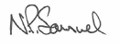
Date: | 5/7/2019

Checklist: Please complete the checklist below to ensure that you have completed the form according to the guidelines and attached any required documentation:
☒ | I have read the guidance notes supplied before completing the form.
☒ | I have completed ALL RELEVANT sections of the form in full.
☒ | I confirm that the research activity has received approval in principle
☒ | I have attached a copy of final/interim approval from external organisation (where appropriate)
☒ | I understand that it is my responsibility to ensure that the above named research activity will meet the University’s Research Ethics and Integrity Code of Practice.
☒ | I understand that before commencing data collection all documents aimed at respondents (including information sheets, consent forms, questionnaires, interview schedules etc.) must be confirmed by the DoS/Supervisor, module tutor or Head of School.

RESEARCH STUDENTS AND STAFF ONLY
All communications relating to this application during its processing must be in writing and emailed to pgresearch@uwtsd.ac.uk , with the title ‘Ethical Approval’ followed by your name.
You will be informed of the outcome of your claim by email; therefore it is important that you check your University and personal email accounts regularly.

STUDENTS ON UNDERGRADUATE OR TAUGHT MASTERS PROGRAMMES should submit this form (and receive the outcome) via systems explained to you by the supervisor/module leader.

This form is available electronically from the Academic Office web pages: http://www.uwtsd.ac.uk/academic-office/

Application Process

All staff research projects and all research students must submit the Ethical Approval Form to the University Ethics Committee via the Postgraduate Research office (pgresearch@uwtsd.ac.uk). Staff research directly in relation to personal study for taught undergraduate or Masters programmes should be submitted via the Faculty procedures explained below.

Taught masters and taught undergraduate research Ethical Approval Forms are considered within Faculties. Faculties will provide details of the specific processes for this. Where the Ethical issues within any single ethical application are of particular concern the Faculty will refer these to the University Ethics Committee. Any student activity that involves the collection of primary data needs to undergo Ethical approval, this includes assignment work as well as dissertations.

Notes for guidance in completion of this form

Section A: About You
Please complete all relevant sections

Section B: Approval for research activity
Research proposals must be approved in principle before applying for Ethical Approval. The proposal approval only becomes final when the ethical approval is received.

The process for proposal approval varies according the individual and programme of study:
- Research students, by application on form PG1 to the Research Degrees Committee
- Taught students by review of research proposal within Faculties (Faculties provide specific details of these processes)
- Staff, by agreement by the Head of School/Assistant Dean

Section C: External Ethical Guidance materials
Many discipline areas are required to operate with the discipline specific codes of research ethics (for example health, psychology, education etc.), any such codes must be listed and you must tick to confirm that you have consulted with these.

Section D: External Collaborative Research Activity
Provide details of the external collaborative partners, where appropriate you might want to submit a copy of the external collaboration agreement with the Ethical Approval Form. If the partner requires the research to be subject to its own internal Ethical approval process then please provide details of that process and a copy of any final (or interim) approvals received from the organisation.

Section E: Details of Research Activity
Remember that the individuals reviewing this Ethical Approval Form may not have seen your research proposal, and also may not be experts in the specific area of your research. The information provided should therefore be jargon free and clearly stated.
Indicative Title: please use the same title as used on the research proposal.
Purpose: the Ethical approval process will want to ensure that the methods you propose are adequate and appropriate to address the research aims and objectives. Excessive additional data collection can be seen as unethical.
Proposed Methods: the Ethical approval process seeks to ensure that you understand the methods that are intended, and that the implementation of those methods will be appropriate and without unnecessary impact on respondents. Please be specific.
Location: this needs to mention geographical location and also local situation (for example, within Local Authority Offices in Cardiff, using a private room but close to other individuals). If you are collecting data within an organisational setting then you need to explain the permissions that you have obtained to do this.
Research Activity outside of the UK: please complete this section in detail, and note any guidance you have received. Also describe your own familiarity (or not) with the location that you will be utilising.

Section F: Scope of Research Activity
Please tick ALL of the research activities that might be undertaken. If any additional types of activity are intended then please add an extra box and describe these.
If you have answered no to all questions in F then sections G and J do not need to be completed. Section H should be considered, and may be completed. Signatures are still required in section K.

Section G: Intended Participants
Please tick all categories that might apply.
Numbers & Source: if you are using a series of different methods or research activities please list numbers for each stage/phase. Be clear about how you will find respondents. Will you use intermediaries, and if so how? How will you ensure compliance with your sampling strategy?
Information for participants: all participants should be appropriately informed about the research, what is expected of them and what will happen to the information that they provide. The Ethical review process does not ask to see this documentation, but requires this to be reviewed and approved by the Director of Studies in the case of research students, the supervisor/module tutor in relation to students on taught programmes and the Head of School/Assistant Dean in relation to staff research.

Section H: Anticipate Risks
All research carries some level of risk. The answers you provide to questions in this section will be reviewed to ensure that you have an appropriate understanding of the type of risks involved and how you can mitigate against these risks.
Risk to participants Think very carefully about how your actions/questions/discussions might affect the people you are involving as participants. You might identify the risk as small but it would still be a risk. Many types of question have the potential to make respondents less content with their life / job; you need to recognise and try to ameliorate any such effects
If these are business owners, time with you may reduce profit.
In some locations physical risk is very real to both participants and yourself, please consider this.
Risk to you, the researcher Think about where you will meet people, if there are any dangers involved in the location. If you are meeting people as individuals think about using a public place. In general do not visit people in their own homes or remote locations. If you are talking to individuals about certain issues think about how their responses might affect you emotionally. What about the risk of collecting insufficient data?
Risk to the University When undertaking your research, you are acting as a member of the University (student or staff). Professionalism is important, so it is important to be well organised and well prepared. Punctuality, clarity etc. are all part of this. What will you do to ensure this? You must ensure you do not harm the good name of the University in any way and do nothing to undermine the reputation of the research it conducts and sponsors. Upholding high standards of conduct and integrity are vital in this regard. You must also conduct the research in such a way to minimise the potential for claims of negligence made against the University, its researchers and any collaborating individual or organisation. In this respect you should always comply with ethical, legal and professional frameworks, obligations and standards as required by statutory and regulatory authorities, as well as the university’s Research Integrity and Ethics Code of Practice. Research misconduct in this respect can take many forms, including:
- fabrication: making up results or other outputs (eg, artefacts) and presenting them as if they were real
- falsification: manipulating research processes or changing or omitting data without good cause
- plagiarism: using other people’s material without giving proper credit
- failure to meet ethical, legal and professional obligations: for example failure to declare competing interests; misrepresentation of involvement or authorship; misrepresentation of interests; breach of confidentiality; lack of informed consent; misuse of personal data; and abuse of research subjects or material
- improper dealing with allegations of misconduct: failing to address possible infringements such as attempts to cover up misconduct and reprisals against whistle-blowers

Adverse Outcomes. Think carefully about the possibilities, and cover here

Section I: Feedback, Consent and Confidentiality
Feedback to participants: outline your approach. Will interview transcripts be shared with respondents to check accuracy? Will summaries of questionnaire analysis be made available to respondents in some way? Will an overview report be provided? How and when?
Informed consent: Draft letter / e-mail / or heading (or footer) section of questionnaire must be approved by DoS/supervisor (if research student), supervisor/module tutor if taught student, or Head of School / Assistant Dean if a member of staff.
Confidentiality/Anonymity. Explain clearly how you will ensure confidentiality and anonymity.

Section J: Data Protection and Storage
Before completing this section it is necessary to read the University’s Research Data Management information. The questions that follow are designed to ensure compliance with the Data Protection Act as well as established research protocols.

Many research activities will involve electronic transfer of data and use of data management systems in the summarisation and analysis of data. You will need to explain these in relation to compliance with the Data Protection Act.
Think carefully about who will have access to your data, this will include supervisors and examiners. Also that a thesis will be made available via the University library and the British Library system. If you are seeking an access bar for a period of time after completion then mention it here. If you will provide a copy of your findings, or intend to give a presentation, to a facilitating/ supporting/accessing organisation then explain that in this section. But also think about the general principle of data sharing, as explained in the Research Data Management information.
In terms of storage of data please ensure security, and also mitigate against loss of data.

Section K: Declaration
Ensure the appropriate countersignatures have been provided
Look carefully at the checklist and ensure that you comply with and tick all that are relevant to your research.

