University of Wales Trinity Saint David


Wales Institute of Science and Art

Torsion of Shafts

Mechanics and Dynamics (ACHA4026)

Dafydd Pughe
2401243
Date (12/2025)

Word Count : 1448
Contents
1. Introduction: 1
2. Experimental Procedure: 2
3. Results 4
4. Analysis 5
4.1: Brass 5
4.2: Aluminium 6
4.3: Steel 7
4.4 Equations 7
5. Conclusion 8
5.1. Brass Results 8
5.2. Aluminium Results 8
5.3. Steel Results. 9
6. Evaluation 10
7. Further Work 11
8. References &/or Bibliography 12
8.1 Figures 13
8.2 Tables 13

Introduction:
In this report, the task was to see how different materials would twist with weight added to the scale. By adding weights varied from 100g to 500g to 3 different materials which were brass, aluminium and steel. The experiment that was chosen was a torsion test to se the reaction of adding weights to the material rods and see what was the angle the rods rotated. This experiment was from a booklet that was provided by TecQuipment 2012. The purpose of a torsion test mechanical test that evaluates the properties of the material while undergoing stress from a angular displacement. (Instron, 2015). The aims of this experiment was to see the shear modulus of very material that was tested and determine that the results that was measured was similar to other measured experiments. Graphs were made to calculated the shear modulus of every material, while spreadsheets were made to calculate the results that was measured. Another calculations needed to be done to help create the graphs needed for the experiment.

Experimental Procedure:
The procedure of this experiment was to configurate the kit that was needed for the experiment. The kit that was used by the group was a TecQuipment Torsion of Circular sections kit. There were 2 key parts that were needed to be added onto the vertical metal wall, and those were the specimen, which held the metal rods in place. Also, the rotating chuck needed to be fitted to provide a reading of the rotation when the weights were added. To change the rods after 500g of reading, the group had to loosen the grubscrews with a hexagon tool. Every time the group had to change the material that had to be tested, also had to make sure that the material wouldn’t slip from 0 degrees so that was an essential part of the procedure. If the material would slip while it was being measured, that would cause inaccurate data reading which meant the group had to review if the material was tight. After aligning the rotating chuck to 0, as it defined if the results would be accurate or not, the kit was ready to be used. The group followed the step by step progress to configurate the kit that was found in the booklet provided to us. (TecQuipment, 2012). By following these steps, it kept the group on track to get the kit built in the correct form.
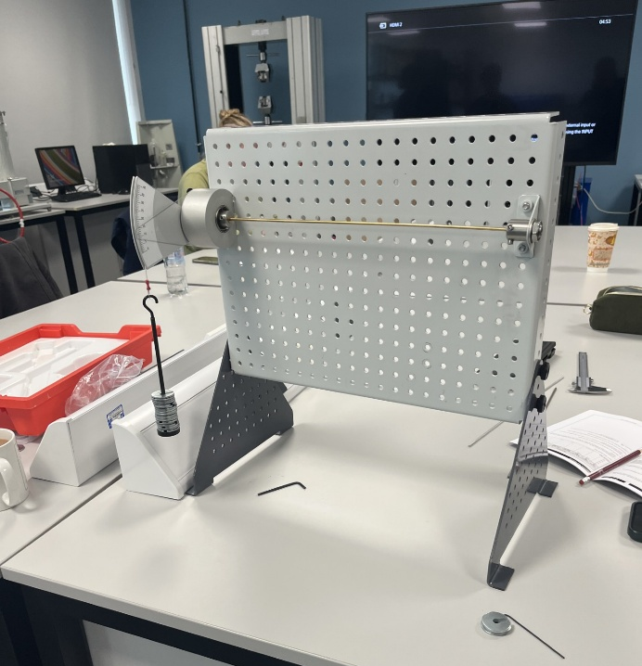
Figure 1 - Completed Assembly of Torsion Kit
In the figure above, its shows how the kit looked after assembling it together and was ready to start measuring the angle. Reading the rotating chuck was easy as there was 5 students in the group which helped with communication and also verification on reading the measurements and to assure that the kit was ready to be used. Changing the material rods was a simple procedure as there was only 4 grubscrews to be loosened and taking the rod out of the specimen and rotating chuck.
The group had to measure the torsion of 3 different materials, Brass, steel and aluminium. Due to aluminium having a smaller elastic limit, the group could only measure using a constant 100g load change from 100 to 400. Where with brass and steel, they can measure the load up to 500g. Using 10g plates, the group could measure the load by adding 10 plates for every reading by placing on a plastic hook that could be connected to the rotating chuck.

Results
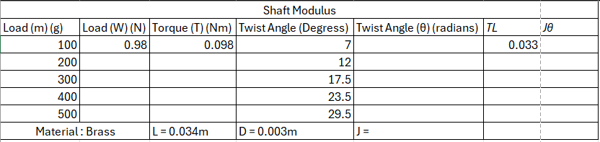
Table 1 - Raw test results (Brass)
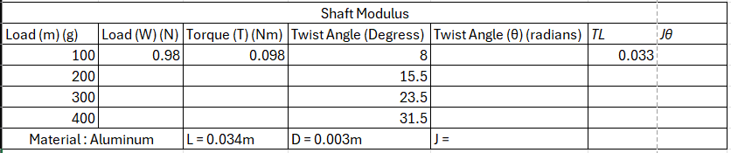
Table 2 - Raw test results (Aluminium)
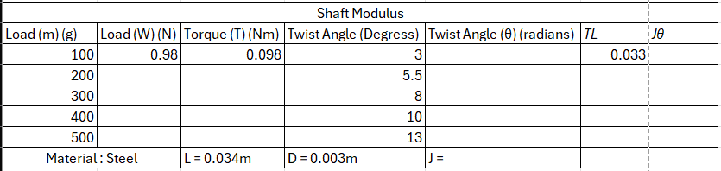
Table 3 - Raw test results (Steel)
The tables shown above are from the booklet, Torsion of Circular Section Kits ES5, (TecQuipment, 2012). By looking at the table above, the group collected the twist angle (degrees) and have to follow equations to fill out the table.

Analysis

4.1: Brass
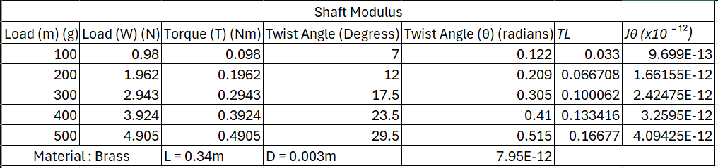
Table 4 - Calculated Results (Brass)
Calculations needed to be done to fill out the table above to complete the set of figures needed for the experiment. The table above shows the tests for the brass experiment.

Figure 2 - Graph showing shear modulus of Brass
The graph above shows the test results for Brass. To draw the graph, the value of Jθ was draw on the X axis while the value of TL was draw on the Y axis. By looking at the graph above it shows that the value of GPa of the material brass came to 40 GPa. This value would an important one as that is the value that would be used for comparison.

4.2: Aluminium
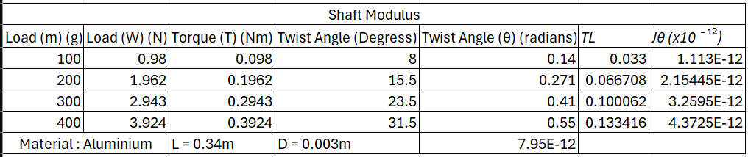
Table 5 - Calculated Results (Aluminium)
The table above shows the full calculated results for the aluminium results.

Figure 3 - Graph showing Shear Modulus of Aluminium
The graph above shows the results for aluminium experiment. By looking at the equation of the graph following the trendline, the GPa for the aluminium results came to 30 GPa which in comparison to the booklet it isn’t in the 10%.

4.3: Steel
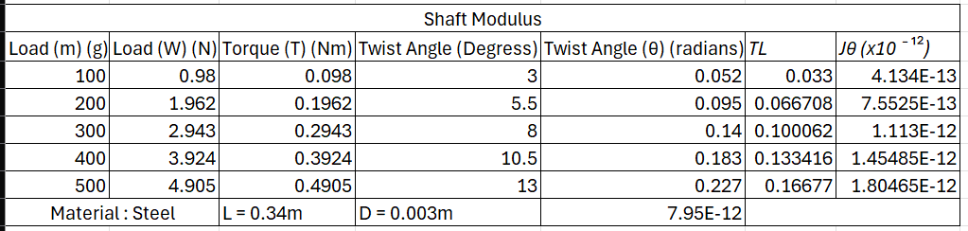
Table 6 - Calculated Results (Steel)
The table above shows the full test results for the steel results.

Figure 4 - Graph showing shear modulus of Steel
The graph above shows the results for the steel experiment, by following the trendline and looking at the equation on the graph it shows the GPa is 100 which is also outside the 10% of the compared data.

4.4 Equations
Load (w) (N) | Torque (T) (Nm) | Twist Angle (θ) (radians) | TL | Jθ
Load (m)(Kg) x 9.81 | Load (w) (N) x 0.2 | Twist Angle (degrees) x (ϖ/180) | Torque x Length of the shaft | Twist Angle (radians) x J (7.95x10¯¹²)
Table 7 - Equations needed for results
These were the equations needed to complete the table of the results. By using collected data from the lab, It helped to calculate some of the figures needed. All these equations were essential towards the experiment as it helped to draw a scatter graph to use as a comparison to determine if the experiment went to plan or not.

Conclusion
By researching different recourses of results of shear modulus for the 3 type of materials that was measured in the lab. Comparing the groups calculated results was important to see if the results match and see if there was any errors while measuring.

Brass Results
By comparing results found in the Engineering Guidance Notes Booklet from TecQuipment, the results found in the booklet indicates that the measured results are inside the 10%. The measured and calculated results from the UWTSD lab came to 40.7 GPa. In the booklet, the results shown are 38.0 GPa, which shows that the brass experiment went as planned and was followed well by the group.

Aluminium Results
The results for the aluminium experiment, the measured results came to 30 GPa which is just outside the 10% of the results in the booklet which came to 25.5 GPa. The difference between the 2 sets of results could occur due to a measuring fault from the group.

Steel Results.
The results of the steel experiment also wasn’t in the 10% of the comparison set of results. The results that was done in the lab came to 100 GPa which is quite different in comparison. The results that are on the booklet is 79.6 GPa which the group`s results aren’t in the 10%.
As a whole, the brass experiment went to plan as it was in the 10% region of the results I the TecQuipment booklet, but the aluminium and steel results weren’t in the 10%. This could be due to an error made by the group measuring or a calculation error.

Evaluation
To eliminate any error that can occur in this procedure, working in a group was a key part for this. Group member could review and validate decisions such as reading the rotating chuck, to insure that the chuck and specimen is tight on the work panel. Communication was a key part in the group as students were helping each other with reading and sharing the test results, knowing how to assemble the kit correctly. One factor that we checked throughout the test, was if the group was adding the correct amount of mass onto the hook. The group doubled checked every step as the experiment was happening to ensure that nothing would go wrong, the reading of the rotating chuck as checked by multiple group members to make sure that the reading was correct, this step was an essential one as it would go on to affect the rest of the experiment results if there was an error.

Further Work
If this test was to be run again, there could be some changed that could be done to make this test better. With unlimited time and resources this experiment could do with changes. Such as a digital rotating chuck so provide a solid figure instead of group members having to read and could cause inaccurate readings. Making the experiment a bigger scale could improve the results by improving the material behaviour with having a bigger chunk of material to test with. Having a bigger scaled experiment would also reduce the risk of making some measuring errors. By scaling the experiment to become bigger, a bigger load weight can be used to see how the different materials react with a bigger load to twist.
Another aspect of the experiment that can be changed with unlimited time and resources is testing other sets of material to compare the results with. This can determinate which type of material has a higher twist angle and lower twist angle.
Also, with unlimited time and resources, the experiment can be based around a motorsport part. One example that could be used is a driveshaft. Experimenting different driveshaft materials can be done such as steel and aluminium. This is to see the torque and angle of the twisting motion, also to determine the shear modulus of the shaft.

References &/or Bibliography

Engineers Edge, 2025. Engineers Edge. [Online]
Available at: https://www.engineersedge.com/materials/shear_modulus_of_rigidity_13122.htm
[Accessed 16 12 2025].
Instron, 2015. Intron. [Online]
Available at: https://www.instron.com/en/resources/test-types/torsion-test/
[Accessed 16 12 2025].
TecQuipment, 2012. Engineering Science Guidence Notes Torsion Kit ES5. In: Engineering Science Guidence Notes Torsion Kit ES5. s.l.:s.n., pp. 9-10.
TecQuipment, 2012. Torsion of Circular Sections Kit ES5 2.Specimen Rod Material. 2.Specimen Rod Material ed. s.l.:s.n.

8.1 Figures
Figure 1 - Completed Assembly of Torsion Kit 2
Figure 2 - Graph showing shear modulus of Brass 5
Figure 3 - Graph showing Shear Modulus of Aluminium 6
Figure 4 - Graph showing shear modulus of Steel 6

8.2 Tables
Table 1 - Raw test results (Brass) 4
Table 2 - Raw test results (Aluminium) 4
Table 3 - Raw test results (Steel) 4
Table 4 - Calculated Results (Brass) 5
Table 5 - Calculated Results (Aluminium) 5
Table 6 - Calculated Results (Steel) 6
Table 7 - Equations needed for results 7

