BMIH5007, BMIH5002

Financial Management for the Hotel Industry

Module Lecturer:
Tristan Hawkins

Student:
Nisipeanu Denisa Elena
2234127
Executive.Summary
Urban Heights Hotel has encountered significant financial challenges in the last three years, marked by a decrease in revenues and an increase in operating expenses. The hotel's revenue has declined from £2,500,000 in 2021 to £1,800,000 in 2023, while operating costs have increased from £1,800,000 to £2,300,000, leading to a substantial decrease in net income from a positive £700,000 to a loss of £500,000. The reduction can be attributed to internal issues such as operational inefficiencies, excessive worker turnover, inadequate training, and poor cost management. Externally, the hotel's financial woes have been worsened by Brexit, competition from other accommodation providers such as Airbnb, and inflation.
To tackle these problems, it is crucial to implement a comprehensive improvement plan. This involves optimising the usage of the hotel's bar and event areas by arranging themed evenings and special events to appeal to various consumer categories and implementing happy hour discounts and seasonal promotions to boost the number of visitors. In addition, by marketing the event space for corporate and community events and promoting the hotel as a place for weddings and private parties, it is possible to create substantial extra income. Implementing cost reduction strategies, such as investing in energy-efficient technologies and streamlining procurement and inventory management, is crucial.
Enhancing client experience through tailored service and loyalty programs while also maximising operational efficiency through task management systems are vital measures. Utilising digital marketing strategies to focus on specific market segments and offering distinctive experiences can effectively draw in a more significant number of customers. Executing a comprehensive financial restructuring plan, which involves negotiating more favourable terms with creditors and executing measures to reduce costs, will help to alleviate financial stress. By implementing these tactics, Urban Heights Hotel may improve operational efficiency, boost revenue, and reclaim its competitive advantage in the hospitality industry, paving the way for a successful recovery.

Introduction
Situated in the city's heart, the Urban Heights Hotel offers several services, such as a restaurant, bar, and event spaces. However, despite its excellent location and extensive amenities, the hotel has experienced severe financial difficulties over the last three years, as seen by falling revenues, rising operational costs, and sharply diminishing customer satisfaction. The owner, staff, investors, and the community are among the many stakeholders for whom the hotel's performance is critical since it directly affects their social and financial well-being.
This report's primary goals are to thoroughly examine the Urban Heights Hotel's financial performance, pinpoint the leading causes of its downfall, and create a complete turnaround plan. This research offers practical suggestions to improve the hotel's competitive standing in the market and restore its financial health by addressing internal and external challenges.
Financial Performance Analysis
Overview of Financial Trends Over the Past Three Years
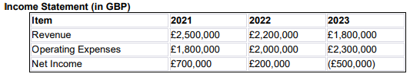
Urban Heights Hotel has had serious financial difficulties during the last three years, with diminishing revenues and rising operational costs. Revenue decreased from £2,500,000 in 2021 to £1,800,000 in 2023, while operating costs rose from £1,800,000 to £2,300,000 during the same period. As a result, net income fell from a profit of £700,000 in 2021 to a loss of £550,000 in 2023.
Identified Risks and Risk Management Strategies (CFI, 2023)
1. Revenue Trends and Patterns
- Analysis: Revenue has steadily fallen due to increased competition from Airbnb and changing consumer preferences (Borovčanin, 2015).
- Risk: Market hazards include rising competition and shifting consumer preferences.
- Risk Management Strategy:
  - Mitigation: Target specific markets and promote unique experiences using digital marketing methods. Collaborate with local companies to create comprehensive packages highlighting the hotel's distinctive advantages (Hameed et al., 2021).
2. Operating Expenses and Their Impact on Profitability
- Analysis: Operating expenses climbed considerably due to manpower, maintenance, and utility. expenses (Santoso & Supatmi, 2021).
- Risk: Operational hazards stem from inefficiency and high expenses.
- Risk Management Strategy:
  - Mitigation: Implementing a cleaning and maintenance task management system can significantly improve operating efficiency. Use economic techniques to improve scheduling and keep a consistent maintenance schedule to avoid unexpected breakdowns. (Vladimirov & Williams, 2018).
3. Net Income Trends and Implications
- Analysis: Net income dropped from £700,000 in 2021 to £200,000 in 2022, followed by a £500,000 loss in 2023, showing severe financial difficulties (Babajee et al., 2021).
- Risk: Financial concerns arise from deteriorating profitability.
- Risk Management Strategy:
  - Mitigation: Financial restructuring entails negotiating with creditors for better terms for current obligations. Collaborate with financial advisors to lower interest rates and relieve financial stress (Turner et al. 2017).
4. Liquidity and Cash Flow Analysis
- Analysis: The hotel's liquidity and cash flow have deteriorated, with cash and equivalents dropping from £300,000 in 2021 to £100,000 in 2023. Accounts payable increased from £250,000 to £300,000, indicating a constrained cash flow situation (Botta, 2018).
- Risk: Financial hazards arise from liquidity restrictions.
- Risk Management Strategy:
  - Mitigation: Increase liquidity by introducing cost-effective solutions such as energy-efficient lighting and water-saving systems. Prioritise low-cost adjustments initially, then seek financial incentives or grants for larger investments (Botta, 2018).
5. Solvency and Long-Term Financial Stability
- Analysis: The Urban Heights Hotel's financial situation has deteriorated, with total liabilities remaining stable at £3,300,000 and equity declining from £2,200,000 in 2021 to £1,380,000 in 2023. The company's debt-to-equity ratio has deteriorated, leading to greater financial leverage and potential insolvency (Jakaša, 2017).
- Risk: High debt levels cause long-term financial instability.
- Risk Management Strategy:
  - Mitigation: Engage in financial restructuring to lower your financial leverage. Consider renegotiating debt terms and improving cash flow management to improve financial stability.
Financial Ratios Analysis
- Profit Margin Ratio: Fell from 28% in 2021 to -28% in 2023.
  - Risk Management: Implement cost-cutting initiatives to improve profit margins.
- Current Ratio: Deteriorated significantly, indicating liquidity issues.
  - Risk Management: Enhance liquidity through improved cash flow management and cost-effective strategies.
- Debt-to-Equity Ratio: Increased from 1.5 in 2021 to 2.4 in 2023.
  - Risk Management: Reduce financial leverage through debt restructuring.
- Return on Assets (ROA): Dropped from 15% in 2021 to -10% in 2023.
  - Risk Management: Improve asset utilisation and operational efficiency.
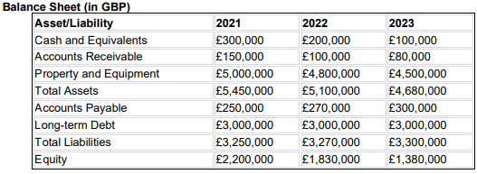
By incorporating risk management into all aspects of financial performance analysis, Urban Heights Hotel can efficiently limit potential risks and improve its financial stability. This complete approach guarantees that the hotel handles current financial and operational challenges and prepares for future uncertainties.

Graphical Representation of Financial Trends
The following are graphical representations of Urban Heights Hotel's important financial trends from 2021 to 2023:
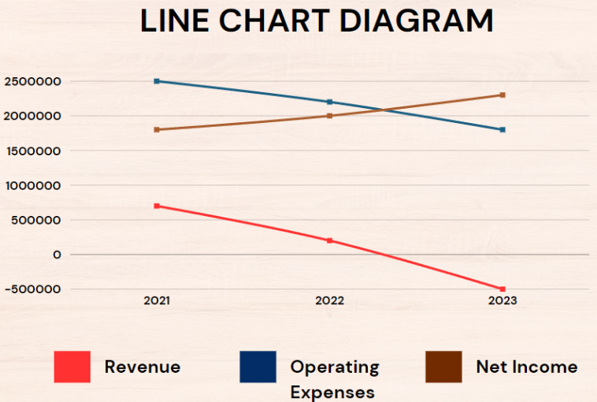

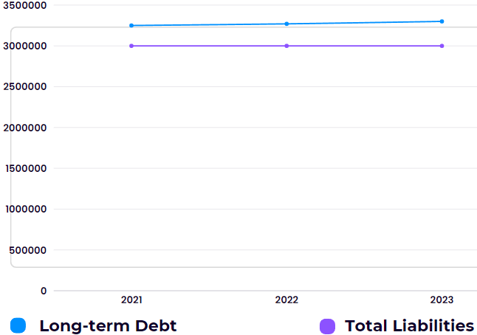

Implications and Limitations
The research reveals major financial issues that require prompt response. High operational costs, diminishing income, and insufficient liquidity contribute to the hotel's financial difficulties. The rising debt-to-equity ratio emphasises the need for financial restructuring to reduce leverage and strengthen stability.
Limitations include the possibility of unpredictability in market conditions and consumer behaviour, which could impact the viability of recommended tactics. Furthermore, the correctness of the financial ratios depends on the integrity of the financial data supplied.
Urban Heights Hotel must take smart steps to overcome its financial problems. The hotel can improve its financial performance and recover stability by increasing operational efficiency, improving cost management, and targeting certain market segments with targeted marketing tactics.
Identifying the Causes of Decline
Internal Factors
Operational Inefficiencies: Operational inefficiencies can significantly affect hotel performance. Ineffective procedures can lead to higher operational expenses and diminished service quality, which might discourage customers. Tavitiyaman et al. (2016) found that internal factors, such as hotel ownership and management methods, significantly influence operational efficiency. Joint-venture hotels typically outperform state-owned hotels in terms of operational efficiency thanks to their more effective management procedures.
Staffing Issues and Impact on Service Quality: Personnel matters are paramount in the hospitality sector. High turnover rates, insufficient training, and low employee morale can significantly impact service quality, reducing customer satisfaction. Vladimirov and Williams (2018) highlight the significance of staff-related innovations in enhancing hotel performance. Their research revealed that the innovations introduced by the staff had the most significant and immediate influence on performance, underscoring the importance of implementing efficient human resource procedures.
Customer Satisfaction Trends and Feedback Analysis: A hotel's success is heavily influenced by customer happiness. Negative feedback and diminishing satisfaction ratings can indicate fundamental difficulties in service delivery and operational management. Al-Ababneh et al. (2018) found that internal service quality (ISQ) considerably impacts employee job satisfaction, subsequently affecting overall customer satisfaction. Enhancing client experiences requires improving ISQ (Information Security and Quality) through implementing better management systems and increased employee engagement.
Cost Management Issues: Efficient cost control is crucial for sustaining profitability. Inadequate cost management can increase expenses, as evidenced by the notable increase in operational costs at Urban Heights Hotel over three years. A study by Guetat et al. (2015) revealed a direct correlation between effective cost-management methods and enhanced hotel performance. Enforcing rigorous cost management measures can alleviate financial pressure and improve profitability.
External Factors
Economic Impacts, Such as Brexit and Its Influence on Tourism: The hotel business is significantly impacted by economic changes, such as Brexit. The occurrence of Brexit has resulted in economic ambiguity, variations in currency exchange rates, and alterations in immigration regulations, all of which have the potential to impact the movement of tourists. Babajee et al. (2021) found that macro-contextual elements such as foreign appeal and market competitiveness substantially impact hotel efficiency. Brexit's economic and tourist repercussions may decrease international visitors, impacting hotel profits.
Competition from Platforms Like Airbnb: The emergence of platforms like Airbnb has brought about substantial competition for conventional hotels. These platforms provide versatile and frequently more cost-effective lodging choices, which appeal to a significant customer demographic. Hameed et al. (2021) emphasise that the presence of competing platforms compels conventional hotels to innovate and adjust their service offerings to maintain competitiveness.
Regulatory Changes Affecting the Hospitality Industry: The hospitality business can face difficulties due to regulatory changes. Modifications in labour legislation, health and safety regulations, and environmental policies can raise operational expenses and make compliance endeavours more intricate. Maté‐Sánchez‐Val and Teruel-Gutiérrez (2022) state that location and regulatory context factors greatly influence the application of sustainable management methods and the overall performance of hotels.
Trends in Consumer Behavior and Preferences: Changes in consumer attitudes and behaviours might affect hotel demand. Contemporary tourists increasingly seek distinctive experiences, customised services, and environmentally friendly methods. Mohsin and Lengler (2015) discovered that there frequently exists a substantial disparity between guests' expectations and their actual experiences, which might impact customer satisfaction and loyalty. Adjusting to current trends to stay relevant and appeal to new clients is crucial.
Aviation Regulations and Their Impact on International Tourism: Aviation rules, which encompass alterations in flight paths, safety protocols, and environmental limitations, can impact international tourism. These restrictions can affect expenses and ease of travel, influencing the number of tourists visiting a destination. According to Arbelo-Pérez et al. (2017), hotels need to make quality improvements and strategically position themselves to mitigate the negative impact of external influences on their performance.
Broader Market Conditions Affecting the Hospitality Sector: The hospitality sector is influenced by general market factors, such as economic cycles, political stability, and technological improvements. In their study, González‐Rodríguez et al. (2018) argue that a company's assets and strategies have a considerable influence on its performance, often surpassing the impact of industry factors. Strategic innovation and investment can improve hotels' ability to withstand and perform well in the face of broader market shifts.
Conclusion
Upon analysing the financial performance of Urban Heights Hotel, it becomes evident that there has been a substantial decrease in income, a considerable increase in operating expenses, and a transition from being profitable to incurring losses over the last three years. The reduction can be attributed to internal factors such as operational inefficiencies, workforce problems, and inadequate cost management. Externally, the issue is worsened by economic factors such as Brexit, competition from platforms like Airbnb, and regulatory changes. It is imperative to address these concerns promptly to avert any additional financial decline. After a thorough review, it is possible and essential to develop a well-organized plan to turn around the hotel's economic health and regain its place in the market. This plan should prioritise operational improvements, cost control, and strategic marketing.

Turnaround Strategy Development
The Urban Heights Hotel faces substantial financial and operational difficulties, requiring a thorough yet economical plan to reverse the situation. Considering the existing budgetary limitations and available resources, the following measures are suggested to rejuvenate the hotel's operations:
1. Enhancing Customer Experience through Service Innovation
Implementation: Implement a customer loyalty program and provide tailored service offerings.
Details:
- Create a loyalty program incentivises frequent consumers by offering reduced prices, special promotions, and complimentary upgrades. This can be accomplished using a straightforward digital platform, or if financial constraints exist, it can be done manually. Tailored services, such as individualised room arrangements according to guest preferences (e.g., desired room temperature, pillow selection, minibar choices), can greatly enhance the overall guest experience.
- Instruct employees to identify and recall frequent patrons, providing them with customised salutations and amenities.
Function: This strategy promotes client loyalty, leading to repeat visits and favourable word-of-mouth referrals. These factors are essential for maintaining and growing occupancy rates. Hameed et al. (2021) assert that personalised service and customer involvement are crucial in enhancing customer satisfaction and hotel performance.
2. Optimizing Operational Efficiency
Implementation: Optimize cleaning and maintenance operations by implementing a task management system.
Details:
- Deploy an uncomplicated, economic task management system to enhance the efficiency of organising cleaning and maintenance schedules. This can be accomplished using preexisting resources such as Google Sheets or cost-free task management applications.
- • Implement a consistent maintenance schedule to avoid unforeseen malfunctions and maintain efficient hotel operations proactively, minimising expenses in the long run.
Function: Enhanced operating efficiency minimises periods of inactivity and guarantees a continually excellent level of service, which is crucial for ensuring visitor contentment. Vladimirov and Williams (2018) highlight the importance of operational improvements in improving hotel performance considerably.
3. Strategic Marketing Initiatives
Implementation: Utilize digital marketing strategies to target specialised markets and advertise distinctive experiences.
Details:
- Use social media networks and targeted internet advertising strategies to effectively contact potential guests. Emphasise the hotel's distinctive features, such as its prime urban location, proximity to popular local attractions, and exclusive events organised inside the premises.
- Collaborate with nearby enterprises and tourism authorities to develop comprehensive packages encompassing lodging, dining, and authentic local activities.
Function: Precision marketing strategies can effectively appeal to specific client segments and enhance the number of reservations, especially during periods of low demand. These findings are consistent with the research conducted by Mutavi and Gichinga (2019), which emphasised the importance of service innovation and market entry tactics in attracting and maintaining customers.
4. Financial Restructuring and Cost Management
Implementation: Negotiate with creditors to secure an extension of payment terms and a reduction in interest rates.
Details:
- Collaborate with financial advisors to initiate discussions to reevaluate the conditions of current loans, obtain extensions, and reduce interest rates to alleviate the present financial strain.
- Employ cost-effective strategies, such as utilising energy-efficient lighting, installing water-saving fixtures, and implementing improved waste management techniques to decrease utility expenses effectively.
Function: Efficient financial restructuring can relieve cash flow constraints, enabling the hotel to dedicate additional resources to crucial areas that directly influence guest experience and satisfaction. According to Turner et al. (2017), strategic financial management is critical to enhancing hotel performance and maintaining long-term sustainability.
5. Enhancing Facility Utilization
Implementation: Maximize the potential of unused areas by implementing new activities that generate income.
Details:
- Convert areas with low utilisation into co-working spaces or small event venues, explicitly targeting local firms and freelancers. Reusing and adapting preexisting furniture and decorations can accomplish this with little financial outlay.
- Organize frequent community events, workshops, or pop-up markets in the hotel's event rooms to attract local people and visitors.
Function: Optimizing the utilisation of existing space can create extra sources of income and enhance the hotel's prominence within the local community. According to Gorondutse and Hilman (2019), differentiating and creatively utilising facilities substantially impact hotel performance.
By implementing these cost-effective and targeted methods, Urban Heights Hotel can strengthen its operational efficiency, boost client happiness, and stabilize its financial situation. This will pave the way for a successful recovery.

References
- Al-Ababneh, M., Masadeh, M., Al-Shakhsheer, F., & Habiballah, M., 2018. The impact of internal service quality on job satisfaction in the hotel industry. Research in Hospitality Management, 8, pp. 55 - 62. https://doi.org/10.1080/22243534.2018.1501182.
- Arbelo-Pérez, M., Arbelo, A., & Pérez-Gómez, P., 2017. Impact of quality on estimations of hotel efficiency. Tourism Management, 61, pp. 200-208. https://doi.org/10.1016/J.TOURMAN.2017.02.011.
- Babajee, R., Seetanah, B., Nunkoo, R., & Gopy-Ramdhany, N., 2021. Corporate social responsibility and hotel financial performance. Journal of Hospitality Marketing & Management, 31, pp. 226 - 246. https://doi.org/10.1080/19368623.2021.1937433.
- Borovčanin, D., 2015. A comparative analysis of hotel financial performance. In SITCON 2015-Singidunum International Tourism Conference (pp. 198-201). Singidunum University. https://doi.org/10.15308/sitcon-2015-198-201
- Botta, M., 2018. Financing Decisions and Performance of Italian SMEs in the Hotel Industry. Cornell Hospitality Quarterly, 60, pp. 335 - 354. https://doi.org/10.1177/1938965518816948.
- González-Rodríguez, M.R., Jiménez-Caballero, J.L., Martín-Samper, R.C., Köseoglu, M.A. and Okumus, F., 2018. Revisiting the link between business strategy and performance: Evidence from hotels. International Journal of Hospitality Management, 72, pp.21-31. https://doi.org/10.1016/j.ijhm.2017.11.008
- Gorondutse, A., & Hilman, H., 2019. Testing the Effect of Business-level Strategy on Performance of Hotels. Global Business Review, 20, pp. 1141 - 1154. https://doi.org/10.1177/0972150919846799.
- Guetat, H., Jarboui, S. and Boujelbene, Y., 2015. Tourism Management Perspectives. Tourism Management, 15, pp.128-136. httpps://doi.org/10.24244/0223405003220504
- Hameed, W., Nisar, Q., & Wu, H., 2021. Relationships between external knowledge, internal innovation, firms’ open innovation performance, service innovation and business performance in the Pakistani hotel industry. International Journal of Hospitality Management, 92, pp. 102745. https://doi.org/10.1016/j.ijhm.2020.102745.
- Jakaša, P., 2017. Financial determinants of hotel performance. International education and research journal, 3(12), pp.62-64. https://www.academia.edu/download/65803483/21_Petra_Jakasa.pdf
- Maté-Sánchez-Val, M. and Teruel-Gutierrez, R., 2022. Evaluating the effects of hotel location on adopting green management strategies and hotel performance. Journal of Sustainable Tourism, 30(8), pp.2029-2052. https://doi.org/10.1080/09669582.2021.1995397
- Mohsin, A., & Lengler, J., 2015. Service experience through the eyes of budget hotel guests: Do factors of importance influence performance dimensions? Journal of Hospitality and Tourism Management, 23, pp. 23-34. https://doi.org/10.1016/J.JHTM.2015.03.001.
- Mutavi, I., & Gichinga, L., 2019. INFLUENCE OF TURNAROUND STRATEGIES ON ORGANIZATIONAL PERFORMANCE OF HOTEL INDUSTRY IN COAST REGION, KENYA. Strategic Journal of Business & Change Management. https://doi.org/10.61426/sjbcm.v6i3.1335.
- Santoso, T., & Supatmi, S., 2021. Financial Ratio Analysis to Assess Financial Performance of the Hotel Industry. International Journal of Social Science and Business. https://doi.org/10.23887/ijssb.v5i3.37003.
- Tavitiyaman, P., Zhang, H., Law, V., & Lin, P., 2016. Exploring the Environmental Scanning of the Hotel Industry in China. Journal of China Tourism Research, 12, pp. 313 - 330. https://doi.org/10.1080/19388160.2016.1263264.
- Turner, M., Way, S., Hodari, D., & Witteman, W., 2017. Hotel property performance: the role of strategic management accounting. International Journal of Hospitality Management, 63, pp. 33-43. https://doi.org/10.1016/J.IJHM.2017.02.001.
- Vladimirov, Z., & Williams, A., 2018. Hotel innovations and performance – The mediating role of staff-related innovations. Tourism Management Perspectives. https://doi.org/10.1016/J.TMP.2018.08.010.

