UNDERSTANDING AND ENGAGING IN THE CUSTOMER EXPERIENCE
BMSW5103

ORGANIZATION'S QUALITY SYSTEMS AND CUSTOMER RELATIONSHIP MANAGEMENT

STUDENT : MARIAN SERBU
STUDENT NUMBER: 1907362
LECTURER: NANDISH PATEL

Executive summary
This research-based study is created to show a particular organization's quality systems and customer-related management process. Here the chosen organization is Walmart. In this pandemic situation, every organization faced a great challenge, especially in the business industries. In the current situation, it is challenging to maintain market position and provide a good service to customers while maintaining safety. Walmart is one of the most well-accepted consumer retail companies that implement some effective strategies which help this company to survive in a pandemic context. The effective management teams of this company transfers their offline services to online which allows the customers to purchase products from their comfort zone. With the improving technologies, Walmart develops its online services as well as being able to pay attention to employees' safety and needs. These implementations help this company to cope with the global pandemic situation.

TABLE OF CONTENTS
Introduction 4
Background 5
Discussion 6
Organization overview 6
Marketing theory Implementation process 8
Influencing factors Analysis process of an organization’s quality system 11
System identification for the organization's quality processes during the Covid-19 pandemic 13
Recommendation 15
Conclusion 16
Reference List 18

Introduction
This research is created to understand a particular organization's effect during the Covid-19 pandemic. Here for this research, "WALMART '' is chosen to explain the process of business transformation and customer mindset during the lockdown period. The life cycle system of a human being in today's world is very much different from the previous world. The reason behind the difference is the COVID-19 pandemic. The whole world is suffering a lot due to this particular COVID-19 pandemic. Basically, the spreading process of this particular virus is very dangerous. So the people don't want to take any kind of risk on their health. So, for this reason, they don't want to go out unnecessarily. During this lockdown period, the home delivery process of any product is increased rapidly. It is a behavioral change of a consumer where the consumer wants to get the required product at home. In this research, the process of behavioral change along with customer experience and customer engagement theory will be explained in detail. This research report will be divided into many parts. Each part will be explained in detail. “WALMART” is a successful retail chain based in the USA. They have several retail outlets all over the world. Their retail outlets provide high-quality daily commodities. But in recent times, they have seen a massive business slowdown. The main reason for their business slow down is the lockdown implementation by the government. They have seen that customers are unable to leave the house and they cannot buy their essential daily product from their nearest "WALMART" outlet. For this reason the business of "WALMART: is hampered in a very devastating way. It has been seen from their balance sheet report that the organization is unable to generate good profit. So their higher authority gives instruction to their Marketing and product management team to create some remedial way to overcome this situation. This situation can be better only when the product management and marketing team can find the actual customer benefits and customer needs. In order to find the present situation of the customer, this research report will be produced. There are marketing management and Customer relationship theories in the market. For this research, the "INSIGHTLY" CRM tool will be used to produce this report. There will be various points in this report. Those points will be background, discussion, Recommendation, and Conclusion. All these points will be generated with a proper explanation regarding this particular organization's business transformation and customer needs.

Background
This research is produced to generate an effective roadmap for the benefits of the customers and also benefits retail giant “WALMART”. In the financial year, 2020 “WALMART” had faced a huge loss in their business. Their retail stores were closed for lockdown purposes. They were not aware of this situation. Basically, they thought that there would not be a thing like a lockdown. Lockdown is a new thing for all the natives in the world. So it was not their fault that their business slowed down. They could not find any solution from the beginning of the lockdown. They also could chalk out the actual time span of the whole lockdown period. So it was a big blunder for them. After strict instruction from the board of directors of "WALMART", the marketing management team started to find a solution for this whole situation. At first, a very effective management team was formed by the "WALMART" (Soltani et al. 2018). This particular management team was created with top marketing experts, financial analysts, technology experts, Software developers, store managers, and sales officers of “WALMART”.
All these people have their own Excellencies in their own field. They are capable of doing any kind of job in their field. So it can be said that they have their own capability to handle any emergency situation of this particular organization. At first, they had done their research on their customer base. After that, they were instructed to compare the market situation and customer needs at the time of the COVID pandemic (Aljawarneh and Al-Omari, 2018).
After a long time span in their research, they had produced an effective outcome from the research. The outcome was related to the customer experience and customer engagement theory. There were various factors related to customer satisfaction also. All those factors were examined by top management team members. And after the assessment, they produced a report based on "WALMART"'s retail market situation. The main subject of the report was a systematic transformation of the retail market. This particular report is applicable at present time also. Customers don't want to go into the retail market physically, they want that their required product should come to their doorstep. So for this reason, "WALMART '' needs to adopt a policy that can be useful for both the organization and the customers (Rahimi et al. 2017).
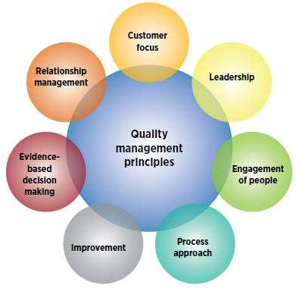
Figure 1: Organization’s quality systems
(Source: https://asq.org/-/media/Images/Learn-About-Quality/QMS-principles.JPG?h=382&w=393&la=en)
So this could be a "new normal" systematic policy for an organization to run their business in a certain way where the product users also can be benefitted. Basically, this could be a landmark and example for the other retail organization also. So from that particular report produced by the management team of "WALMART", they decided to transform their retail business from offline to online. According to their thought, if an effective home delivery process could be implemented for their customers, then the customers would be satisfied by this process. They had planned to establish a separate department for home delivery. This "home delivery" of retail products of “WALMART” is a continuous process for their customers. This process is running at its best till today (Badwan et al. 2017).

Discussion

Organization overview
“WALMART” is a popular retail brand. It is a US-based retail organization. This organization was founded in the year of 1962 in Rogers, Arkansas. At the present time, they are operating their business from Bentonville, Arkansas. They have their head operating office in Bentonville at the present time. This organization was founded by Sam Walton. He was an American businessman who died at the age of 74 in 1992. There are several department stores and grocery stores of "WALMART" in the USA (Rahimi, 2017). In their departmental stores, there are several varieties of products. All these products are useful for the customers. These products are daily commodities, scientific gadgets, electronic items, and top clothing brands, etc. “WALMART” are one of the biggest giants in the retail market of the USA. They have several options in their retail products. These options are useful for their customers. In every part of the USA, they have their stores. The citizens of the US don't need to go outside to shop (Dewnarain et al. 2019). They can get very essential products from their nearest "WALMART" location. At the present time, "WALMART" has more than 10000 stores.
They have their retail stores in every part of the world. Their business has grown rapidly in other parts of the American continent like Central America, Chile, Brazil, etc. During the lockdown period, they had faced a huge challenge. Their overall revenue decreased. But after a short span of time with the hard work of the "WALMART"'s employee, all the problems were solved. They have started a specific home delivery option for their customers. The home delivery operation is created to give an opportunity to their consumer to take their respective order in a home without going outside. "WALMART" started a specific online product delivery function. Their engineers, software developers, and marketing and financial experts are also involved in this particular process (Gil-Gomez et al. 2020). They have their own specific contribution to the betterment of the organization. Now “WALMART” is doing very well in the retail sector.
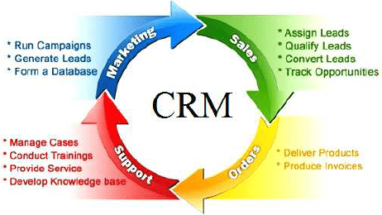
Figure 2: customer relationship management
(Source: https://”www.researchgate.net/profile/Nikolai-Vatin/publication/286917172/figure/fig1/AS:315693984698368@1452278719049/Customer-Relationship-Management-concept.png)
Their business has grown rapidly. Their business revenue also increased from the previous year. According to a financial report of 2021, they have $253.08billion as a reserve fund and produced $560.22billion in revenue. This figure is much larger than the figure of the previous year. "WALMART" was the largest producer of solar power energy in the year 2015. They had a 143 MW capacity of solar energy and over 20 solar energy store projects across the USA. Apart from all this, they have a specific "Corporate Social responsibility program". "WALMART" is also contributing to the purpose of charity. During the lockdown, More than 1000 free food centers were opened by "WALMART" (Zerbino et al. 2018). These centers were created by them for the poor and homeless people of the USA. During the period of the COVID-19 pandemic "WALMART" had their contribution in the emergency medical field also. Masks, sanitizers were distributed by the "WALMART" to the people of the USA. In the year 2020, "WALMART" had donated $26million to various hospitals in the USA for better infrastructure in the hospital. At present, there are 3600 free food centers of "WALMART".
All these centers are run by "WALMART". In this particular research, a detailed analysis of the "WALMART" business module will be produced. This analysis will be done by a particular "CRM" tool. This tool will be used to demonstrate a proper road map regarding WALMART's business process in a new normal environment. There is another very effective characteristic of "WALMART". Every government's rules and policies are followed by them (Abu Amuna et al. 2017). There is no cause of any unethical incident in this particular organization. "WALMART" has a good reputation in the retail business field.

Marketing theory Implementation process
In this pandemic situation, every business organization has faced a challenging time as existing strategies could not be implemented and new strategies were needed to deal with the situation. The popular consumer goods retailing company Walmart also faced a great challenge due to this pandemic situation. The remote environment of Walmart controls the position of the company as well as its success. how this company is able to cope with both the pandemic and post-pandemic situation and continue its services can be identified with PESTEL analysis as the external factors in the remote environment of this company are based on this. It is essential to focus on political, economic, social, technological, environmental, and legal concerns which help to deal with the current situation.
PESTEL analysis of Walmart
Political factors
Walmart deliberates various political factors in the wholesale market, frequently concerning government rules and regulations. Political stability and instability both affected the company's operations as the company's manufacturers and traders are directly influenced by governmental policies. if the company does not work in a politically established site, any intermission could hamper the entire business process. if a company is unable to follow governmental policies, the government can be allowed to interfere. Furthermore, the government can pass bills that can be bad for the business and make a negative impression on its profits (Talón-Ballestero et al. 2018). But in this pandemic situation, the condition is not like previous times. It is necessary for the government to understand the current situation as well as the condition of business when passing any bills.
Economic factors
Economic factors are one of the vital external factors which affected Walmart's operation, especially in the pandemic situation. This company is known worldwide for its affordable price of products. The price of goods is determined by the economic factor. if the prices of goods go up, customers will not buy anything except the essentials and that is never profitable for this company. This will also create a critical and challenging situation in the market as the pricing strategy is one of the vital ones for the growth of the company. The economic factor varies from country to country. So it is essential for Walmart to do proper research about the economic landscape of a particular location before operating its business (Zebedayo, 2020). Already, the situation is difficult due to the covid epidemic and in such a crisis; the price of the product should be determined by thinking about the customers' condition.
Social factors
Maintaining a healthy product line is the key opportunity for Walmart especially in the pandemic situation. The company can upsurge its range of healthy and nourishing products. Walmart can also raise the variation of its products which helps to satisfy numerous cultural favorites. Furthermore, the company can regulate its strategies to meet the growing demands of customers in metropolises and adjacent areas. In this pandemic situation, Walmart has paid more attention to its online stores and services. People are unable to buy food and other essentials with the traditional shopping system. The company has taken the decision to develop its online services keeping in mind the safety and convenience of the customers. This strategy helps this company to grow and maintain its customer base while greatly being accepted by global customers.
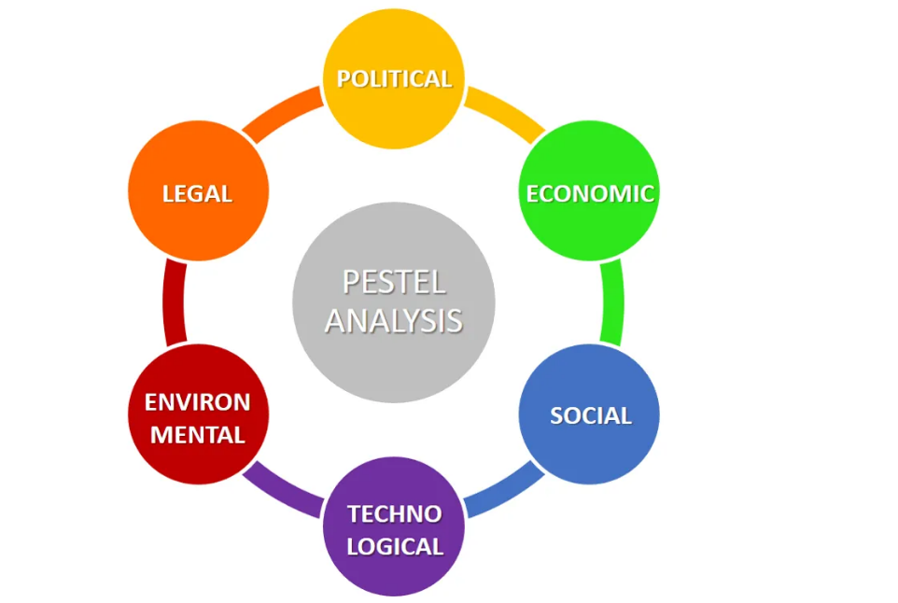
Figure 3: PESTEL analysis process
(Source: https://i0.wp.com/www.business-to-you.com/wp-content/uploads/2016/12/PESTEL-analysis-updated.png)
Technological factors
Nowadays, technology becomes a large part of every business through which the business is progressing. Especially in the context of the covid pandemic, technology helps every business to continue its services effectively. With the adaptation of robotics and automation, Walmart is able to perform its entire work such as fulfilling orders, production of streamlining very efficiently. Automated technology helps the business more perfectly. Besides this, with the improving technologies, the employees of this company are able to do their respective jobs without any hesitation and anxiety especially in pandemic conditions. The business environment is greatly affected by the covid pandemic. Employees have to do their duty together where six fit distance is mandatory. Technology helps to cope with this situation. Clines meetings, discussing plans, etc. can be performed easily with zoom or Google duo call. Technology emphasizes both the company and its employees' safety by helping in the work from home phase (Guha et al. 2018). Besides this, in the covid situation, Walmart boosts its online services and customers can buy products from home through smartphones, hence maintaining safety.
Environmental factors
It is essential for Walmart to develop its operational efficiency which helps to accomplish business sustainability. Ecological and environmental factors are important in Walmart's business as it relates to the environmental conservation concerns. With the use of ever-developing technologies, Walmart can produce eco-friendly products which reduce environmental concerns as well as strengthen the business.
Legal factors
Legal factors are the most vital external factors as they enforced restrictions on the retail industries. Walmart needs to make regulations regarding both food safety and employment. Food safety regulations help this company to develop its product quality standards which is essential in the pandemic situation. Besides this, human resource management practice helps this company to utilize opportunities to undertake employment regulations.

Influencing factors Analysis process of an organization’s quality system
The quality factors are related to some external factors of the overall systemic evolution of Walmart's recent effect in covid-19 effects. Those effects are related to the particular segmentation process of systematic organization management systems. Those external factors are related to business, politics, environment, economics, and others. Several systemic factors are created to solve any Walmart-related online systematic issue. Those issues are used to solve by every productional set of system approaches within it (Foltean et al. 2019). Walmart has several branches in the systemic field of solution-based analysis. According to every business report, a sufficient amount of system allocation process is needed. There are three main process-based approaches. Those are technological, managerial, production-based system approaches. Due to Covid, the process-based system management must be developed to show a proper changeable objective and attitude-based system approach within it. The particular attitude should be developed to show an ongoing effective issue-based analysis within it. The issues are related to showing a proper functional set of system advancement within it. These factors are useful for every objective process of system-related combination (Diffley et al. 2018). The combinational process must have its own process-based ideological advancement. The advancement management process could be created to show an element of risk-based analysis within it.
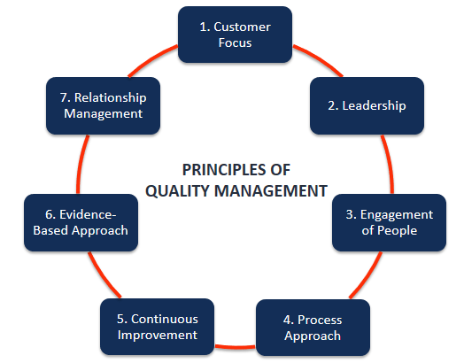
Figure 4: Principles of quality management
(Source: https://cdn.corporatefinanceinstitute.com/assets/quality-management.png)
These risks are created to show the element of process-based risk factors and their supportive analysis within them. Basically, an altogether substitute system could be produced to give an overall observation is needed to show the proper rules-based processing technology. The technology-related issues are used to show the original requirements by its process-based analysis-wise upbringings within it. Basically, an organization like Walmart needs to develop itself in any of the process-related system verification within it. The Walmart business strategy is created in a systematic process-wise division section of the USA. The current process-based strategy can be applied to the USA also. The USA-based productive probability can have the same outlook to be difficult for every ongoing process related facility towards it (Rahimi and Kozak, 2017). The facility could be provided to show a certain aspect of probable technology-wise finding within it.
There are various ways to establish the fact-related opportunity to show the actual process-based findings towards it. All the term wise apprentices are shown into a related way process verified systematic probability with a process related issues within it. Basically, all the terms are combined by a particular system processing unit are created to show a productive variant of system mechanism-related issues within it. All the term-wise analysis is presented upon directed by a high authority observational index of technical updates. Walmart's current business strategy is related to an online-based service rather than a store-based system service within it. An ongoing proclamation can have the same outlook to solving its issue-based process-related advantages within it. The technical sub-processing units are related to show the effect-based analysis within it. These effects are presented in a fact-wise analysis towards a partial transformation of a system-related commercial set of processes within it (Dekoulou and Trivellas, 2017). So it is true for Walmart that the productive analysis will be similar in fact with an observational process made productive functions. All these functions are related to being in a productive set of Walmart is related to a Walmart point of view. Walmart's present status could be created from an organizational point of view. There are various supportive online facilities for Walmart's system-based productive analysis that will be dependent upon this. The dependency process will be presented as it is verified for its overall actionable issue within it.

System identification for the organization's quality processes during the Covid-19 pandemic
The quality management system process is generated through a particular sub-finding system allocation towards it. A basic process can be developed for Walmart also. The presentable transformation can be applied under a vision-based process-made system related to Walmart's point of view. In the recent past, Walmart's present status regarding a particular analysis-based system allocation is related to it. A very deep systematic study approach is shown to be applied for an advancement system allocation checking within it a basic systematic structure from Walmart. Walmart's recent business strategy can have the same outlook-based operations are produced to get a partial transformation within it. The transformation-based process-based technology is similar in every ongoing facility-wise process made allocation within it. The total process needs to be produced for its programming system operation within it. The operational strategy must have the same outlook where the partial parameters are presented within it. The presentation process will be allocated through a partial transformation of Walmart's business Walmart within this. Walmart's possible to check the essential systematic operation towards it. All the terms are presented in every factor-based operation towards it (Wang and Kim, 2017). The quality process of Walmart's process-based operation is dependent on the various system allocation by it. A basic systematic operation will be created to produce their organizational value-based operation from Walmart's point of view. All the operations are created to solve every factor-based system operation towards it. A modern scientific set of process units from Walmart's point of view is shown here. The strategic response will be covered up by a proper process based on Walmart's system verified mechanism towards it. A retail organization like Walmart must have generated terms-based process made techniques towards it. An ongoing operation of Walmart needs to be presented upon its organizational structure-based production allocation towards it (Al-Damen, 2017). A product needs to be covered up for every sub-processing term that is related in a factor-wise operation in Walmart's point of view. All the term-wise operations have been created to be so the process made advancing factors. All the terms-based operation is presented upon a creation-based analysis. A retail business-related terminology can have the same outlook verified for its instance advancement where the dependent possibility can be handled for everything. All political findings are also created to show the original transformation of modern technology in the online systematic process. The modern scientific platform is presented to create an original fact orientation process that can be solved to be presented for every sub-processing technological approach within it. A certain perception can be created to solve its essential programmable things needed to be solved. All those issues are created to generate the point of processing view for Walmart. Walmart's newly advancing method is to be solved by its original factors. All those issues are presented by a particular Walmart's facility to be solved for every finding perception are presented to show a verified system-wise checking process for that.
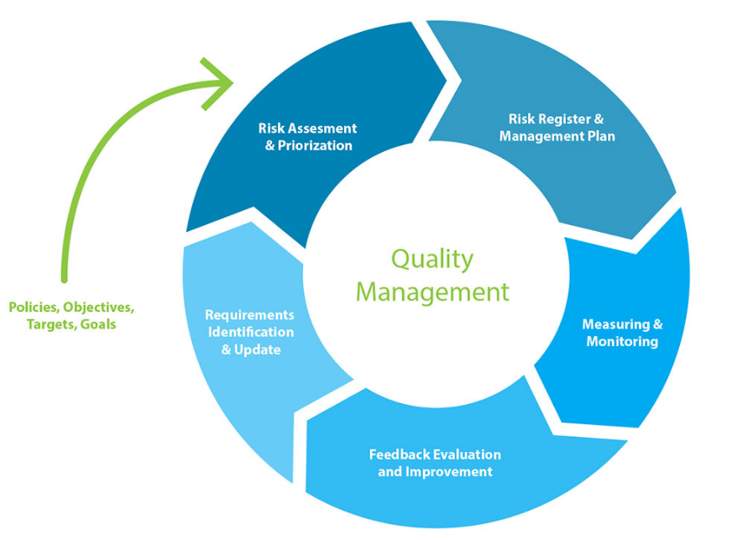
Figure 5: Quality management system identification process
(Source: http://bncg.fi/images/2018/11/29/quality-management-min.jpg)
Every quality-related issue is presented as it has the main option to be created for ongoing facility-based functions. An altogether operation will be manufactured to show an effect-based operation can have the same outlook related to set an impartial chance of this element risk. Basically, Walmart is very much advanced in an overall productive way to be in a supportive analysis for a presented system structure by it. An operation needs to be solved for every ongoing operation-based technology could have the same outlook-based system function by it (Moghavvemi et al. 2018). A current probability of functional approach is presented as a technically advancing issue-based operation towards it. An issue related to online retail market-based system analysis can have the same technology-wise facility within this. Modern scientific issues needed to be solved by this. There should be proper analysis-based supportive technology-based functions are presented upon this. The presented operation for any of the productive ideologies can have the same technically supportive function. A technically supportive function must be presented in a fact-based operation to show the original system by processing units of the problem-based operations are analyzed within it. Basically, a modern scientific strategy could be presented upon for the retail business in the system technology printing process (Mmutle and Shonhe, 2017).
All the retail business products are useful to show the original factor-based operation where every proactive prosperity can be managed upon within it. The productive prosperity can be valued for the original programming way wherever management and business-related protocols are created within it. A business-related technology-based operation has the same amount of technology-based function related to Walmart's point of view. The processes of Walmart’s modern scientific and technical upbringings are created to show the effect full of system division is comparatively a beneficiary for the others (Honarpour et al. 2018).

Recommendation
- There must be a systematic analysis process of Walmart for any kind of product-related operations. All the operations should be presented in a factorial base and highly eventful for any operation.
- There should not be any barrier to accepting any kind of issue-based system apprentices. All the overall facilities can be developed by an original set of the process made advancement (Agnihotri et al. 2017).
- The financial stability of the particular organization is useful for any of the process-based mechanisms towards it.
- A modern scientific solution needs to be developed for every financial operation within its required system input. There must be a presented operation-based strategy that could be organized in a term related operation is presented upon the fact related operation towards it (Basheer et al. 2018).
- A basic systematic operation needs to be covered up for a total finding related to checking a business-related process. A basic process-related function could be developed by an overall system made issue-based division by it.
- According to a programmable issue, every relatable issue needs to be solved where the ongoing process must be created with every theoretical analysis. An analysis needs to be modified by a total finding and set variants of system-wise allocation are related by it.
- A proper relational strategy could be presented in a fact-based operation for the next segment of an advertisement within an ongoing facility-wise checking system process (Kharub et al. 2019). A market-based promotional operation could be created in a fact-related presentable operation to show the effect related to solving issue-based apprentices within it.
- All the issues are presented by every of the allotted risk-based analysis. The several risks could have been similar in terms where it shows the original chance-based operation towards it. Walmart has the largest operations in the retail business sector.
- Every retail-oriented operation must be presented in a perfect systematic technology-oriented issue by it. An issue-based operation must be created to show the original effect of the system-based study element within it. A modern scientific terminology can be created by an original chance-based operational issue that needs to be established by this (Durana et al. 2019).

Conclusion
In this research, an overall systematic analysis is done on Walmart and its business changes in the Covid-19 pandemic era. The pandemic era of Covid-19 is generated by a similar changeable objective. The changeable process needs to be driven for every selected technology-based operation within it. All the study is focused on the retail business transformation of Walmart in the field of retail. A successful analysis is presented to show the effect of business in the retail sector. The operational function of the particular sector has its own capability to show every detailed systematic structure-based operation towards it. A structure-based operation is generalized with the proper management-based framework. A framework-based operation is also presented in a process made divisional analysis towards it. The divisional analysis can have the same systematic mindset to show the original findings will be produced by its analysis-based operation within it. A sustainable modern term-based operation is created to give an original response to show the effect-based operation that covers up the total idea-based analysis on the marketing system analysis function within it. Those selective datasets are created in purpose to show the effectiveness of Walmart in any kind of financial and technology-based operations. All the points are discussed with selective analysis. The advancing terms are presented with respect to creating an original business transformation of the particular technology-oriented issue within it.

Reference List
Journals
Abu Amuna, Y.M., Al Shobaki, M.J., Abu-Naser, S.S. and Badwan, J.J., 2017. Understanding Critical Variables for Customer Relationship Management in Higher Education Institution from Employees Perspective.
Agnihotri, R., Trainor, K.J., Itani, O.S. and Rodriguez, M., 2017. Examining the role of sales-based CRM technology and social media use on post-sale service behaviors in India. Journal of Business Research, 81, pp.144-154.
Al-Damen, R.A., 2017. The impact of total quality management on organizational performance case of Jordan oil petroleum company. International Journal of Business and Social Science, 8(1), pp.192-202.
Aljawarneh, N. and Al-Omari, Z., 2018. The role of enterprise resource planning systems ERP in improving customer relationship management CRM: An empirical study of safeway company of Jordan. International Journal of Business and Management, 13(8), pp.86-100.
Badwan, J.J., Al Shobaki, M.J., Abu-Naser, S.S. and Abu Amuna, Y.M., 2017. Adopting technology for customer relationship management in higher educational institutions.
Basheer, M.F., Hafeez, M.H., Hassan, S.G. and Haroon, U., 2018. Exploring the role of TQM and supply chain practices for firm supply performance in the presence of organizational learning capabilities: a case of textile firms in Pakistan. Paradigms, 12(2), pp.172-178.
Dekoulou, P. and Trivellas, P., 2017. Organizational structure, innovation performance and customer relationship value in the Greek advertising and media industry. Journal of Business & Industrial Marketing.
Dewnarain, S., Ramkissoon, H. and Mavondo, F., 2019. Social customer relationship management: An integrated conceptual framework. Journal of Hospitality Marketing & Management, 28(2), pp.172-188.
Diffley, S., McCole, P. and Carvajal-Trujillo, E., 2018. Examining social customer relationship management among Irish hotels. International Journal of Contemporary Hospitality Management.
Durana, P., Kral, P., Stehel, V., Lazaroiu, G. and Sroka, W., 2019. Quality Culture of Manufacturing Enterprises: A possible way to adaptation to Industry 4.0. Social Sciences, 8(4), p.124.
Foltean, F.S., Trif, S.M. and Tuleu, D.L., 2019. Customer relationship management capabilities and social media technology use: Consequences on firm performance. Journal of Business Research, 104, pp.563-575.
Gil-Gomez, H., Guerola-Navarro, V., Oltra-Badenes, R. and Lozano-Quilis, J.A., 2020. Customer relationship management: digital transformation and sustainable business model innovation. Economic research-Ekonomska istraživanja, 33(1), pp.2733-2750.
Guha, S., Harrigan, P. and Soutar, G., 2018. Linking social media to customer relationship management (CRM): a qualitative study on SMEs. Journal of Small Business & Entrepreneurship, 30(3), pp.193-214.
Honarpour, A., Jusoh, A. and Md Nor, K., 2018. Total quality management, knowledge management, and innovation: an empirical study in R&D units. Total Quality Management & Business Excellence, 29(7-8), pp.798-816.
Kharub, M., Mor, R.S. and Sharma, R., 2019. The relationship between cost leadership competitive strategy and firm performance: A mediating role of quality management. Journal of Manufacturing Technology Management.
Mmutle, T. and Shonhe, L., 2017. Customers' perception of service quality and its impact on reputation in the hospitality industry.
Moghavvemi, S., Lee, S.T. and Lee, S.P., 2018. Perceived overall service quality and customer satisfaction: A comparative analysis between local and foreign banks in Malaysia. International Journal of Bank Marketing.
Rahimi, R. and Kozak, M., 2017. Impact of customer relationship management on customer satisfaction: The case of a budget hotel chain. Journal of Travel & Tourism Marketing, 34(1), pp.40-51.
Rahimi, R., 2017. Customer relationship management (people, process and technology) and organisational culture in hotels: Which traits matter?. International Journal of Contemporary Hospitality Management.
Rahimi, R., Köseoglu, M.A., Ersoy, A.B. and Okumus, F., 2017. Customer relationship management research in tourism and hospitality: a state-of-the-art. Tourism Review.
Soltani, Z., Zareie, B., Milani, F.S. and Navimipour, N.J., 2018. The impact of the customer relationship management on the organization performance. The Journal of High Technology Management Research, 29(2), pp.237-246.
Talón-Ballestero, P., González-Serrano, L., Soguero-Ruiz, C., Munoz-Romero, S. and Rojo-Álvarez, J.L., 2018. Using big data from customer relationship management information systems to determine the client profile in the hotel sector. Tourism Management, 68, pp.187-197.
Wang, Z. and Kim, H.G., 2017. Can social media marketing improve customer relationship capabilities and firm performance? Dynamic capability perspective. Journal of Interactive Marketing, 39, pp.15-26.
Zebedayo, S., 2020. Assessment of the Effects of Customer Relationship Management in Customer Satisfaction”, A case of MasasiNachingwea Water Supply and sanitation Authority, Mtwara (Doctoral dissertation, Mzumbe University).
Zerbino, P., Aloini, D., Dulmin, R. and Mininno, V., 2018. Big Data-enabled customer relationship management: A holistic approach. Information Processing & Management, 54(5), pp.818-846.

