
Master of Business Administration

Module Code: LCMB7023
Module Title: Human Capital Management

Lecturer: Gladius Kulothungan Ejike Udeogu
Student Name: Shariara Mahmud Rafat
Student ID: 2521546

Word Count: 2635
Submission Date: 20th March 2026

Table of Contents
1. Introduction 1
2. Current Talent Ecosystem in the Technology Industry 1
3. Strategic Build vs Buy Talent Model 2
4. Talent Development and Retention Framework 3
4.1 Mentorship Programmes 3
4.2 Leadership Development Pathways 4
4.3 Lifelong Learning and Continuous Development 5
5. Impact on Organisational Performance 5
6. Reflection (Gibbs Reflective Cycle) 6
7. AI and the Future of Work 9
8. Conclusion 9
9. References 10

1. Introduction
Human capital is significant in the technology industry as it promotes the performance and innovation in organisations. The Aether Innovations is a 300 employee technology firm that is already experiencing some issues such as stagnant growth, high employee staff turnover and customer dissatisfaction. Subsequently, it is necessary to build a proper talent ecosystem to enhance workforce potential and competitive edge. The current report discusses the practice of talent management in tech companies and offers an innovative strategic build-versus-buy talent model to recruit and retain employees with high potential (Collings et al., 2022).

2. Current Talent Ecosystem in the Technology Industry
The tech sector is a very competitive talent ecosystem that is fuelled by the rising demand of specialised digital skills. The presence of the rapid technology development in fields like artificial intelligence, cloud computing and data analytics has increased competition of the professionals worldwide requiring a high level of skills. Such aggressive recruitment by technology companies has contributed to high levels of talent mobility between organisations as they all vie to secure software engineers, data scientists and AI specialists. The major companies (the likes of Google, Microsoft, Amazon and Apple) invest in the talent acquisition strategy, competitive pay rates and innovative workplace to attract and retain highly skilled workers (Cappelli and Keller, 2021). Such a high rivalry puts a strategic emphasis on the human capital in the knowledge based industries where employee skills have a direct impact on the innovation and performance of the organisation.
Nevertheless, technology firms are experiencing a number of challenges in their talent systems. High turnover of the employees is a significant concern because professionals with talent often transfer to other organisations in search of improved job prospects and remuneration. Moreover, the speed of technological evolution demands constant training of skills and it may be impossible to keep up with the latest capabilities of organisations in their staff (Deloitte, 2023). The workload and pressure to innovate experienced by employees in technology companies are also highly likely to cause burnout and job dissatisfaction in case they are not managed (World Economic Forum, 2023). With these challenges, high-potential employees are especially challenging to retain.
In a bid to overcome these challenges, most technology firms have adopted elaborate talent management strategies to help them build and sustain skilled employees. These are graduate development programmes, internal innovation labs, leadership development pathways and on-going professional training opportunities. These strategies correspond to the Resource-Based View, according to which the distinctive human resources are able to create the sustainable competitive advantage of organisations (Barney, 2021). Moreover, the problem of the War For Talent emphasises that organisations must take strategic steps to recruit and keep high-potential employees in labour markets (McKinsey & Company, 2022).

3. Strategic Build vs Buy Talent Model
An effective solution to the talent challenges encountered by Aether Innovations can be offered with the help of a strategic Build vs. Buy talent model. The technology organisations are increasingly becoming aware that sustainable competitiveness lies in creating internal capabilities and at the same time obtaining expertise in specific fields through the labour market.
The build strategy is aimed at internal employee development based on training programmes, skills development programmes, leadership development programmes, and structured career development programmes. The Human Capital Theory goes in great support of this method stating it is more productive and long-term when an organisation invests in employee knowledge and skills (Becker, 2022). Talent management can also help organisations to enhance the commitment of the employees, cut down the turnover and come up with a stable workforce which can facilitate long term innovations. Organisational agility in fast changing technology environments also comes through internal development programmes where organisational capabilities are matched with strategic goals to enhance employee capabilities (Garavan et al., 2022). Nevertheless, the build strategy is not flawless as employee development takes a lot of time and money and before real performance gains can be achieved.
Contrary, the buy strategy aims at contracting very qualified external individuals with specialised knowledge that would not be available in the organisation. This is also a common hiring practice in technology firms to hire seasoned software engineers, artificial intelligence experts and heads of innovation who can quickly help an organisation scale up. Expert recruitment allows organisations to receive the latest knowledge directly and contributes to the introduction of new perspectives and the rapid progress of the innovation process (Cappelli and Keller, 2023). However, external hiring may also pose such challenges as high expense involved in the hiring, integration problems and possible culture clashes among the new hires and the current workforce. Too much reliance on the outside talent could also undermine the internal career developmental opportunities, which can probably lower the motivation of employees and the Organisational commitment (World Economic Forum, 2023). This means that organisations need to have a balanced build and buy approach to talent management, whereby internal talent development can be used to enhance long term organisational capacities and external recruitment can be used to fill essential skill shortages. This strategic mix can help technology companies to remain innovative, have highly-potential staff and stay competitive in competitive labour markets (McKinsey & Company, 2024).

4. Talent Development and Retention Framework

4.1 Mentorship Programmes
Mentorship programmes are a relevant employee development and knowledge transfer system in organisations. Experienced staff members in technology firms tend to coach junior workers in order to guide them on skill acquisition, career counseling and networking. Mentoring relations transfer knowledge and expertise between teams and departments, and through such relations, organisations retain institutional knowledge and reinforce learning cultures based on collaboration. Mentorship is also quick to develop employees as it offers them practical guidance to supplement training programmes. Theoretically, the Social Learning Theory proposes that people learn new behaviours and acquire new knowledge through observing and engaging with more experienced role models (Bandura, 2022). As a result, mentorship programs may play an important role in increasing employee engagement, organisational learning and long-term career development. The studies show that employees engaged in mentoring relationships tend to report increased job satisfaction and better organisational commitment that leads to increased retention rates in knowledge-intensive industries (Allen et al., 2023).

4.2 Leadership Development Pathways
Effective leadership development tracks are also significant in retaining high-potential employees as well as creating future organisational leadership capacity. Career development systems enable the employees to know that they can be developed in the organisation hence augmenting motivation and dedication. An average career in leadership of a technology company can be through the rank of junior employee to senior specialist, team leader, department manager up to the positions of executive leadership. These are structured development programs where organisations are able to develop leadership competencies in a systematic manner and continuity in the management of organisations.
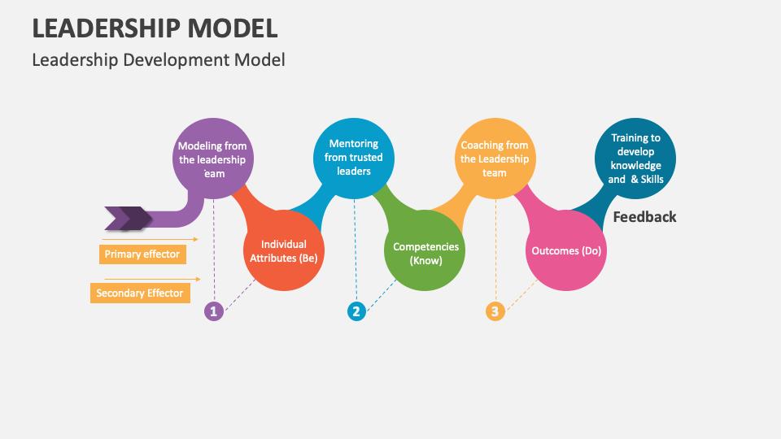
Figure 1: Leadership Development Theory (Collidu, 2024)
Leadership Development Theory focuses on effective leadership skills as a result of exercised training, mentoring, and other experiential learning as opposed to being a natural development of experience (Day and Dragoni, 2023). Organisations investing in leadership development programmes are able to empower their leadership pipeline, boost employee motivation and organisational stability in volatile business environments.

4.3 Lifelong Learning and Continuous Development
Technology organisations have become highly dependent on continuous learning because of the high rate of changes in technology. Staffs need to keep updating their skills frequently in order to stay productive and innovative in the digital working environments. This makes several companies invest in lifelong learning programs like professional training programs, industry certification, innovation training programs, cross-functional learning and online learning programs. Such programs help employees to gain greater knowledge as they are adjusting to the new technological changes. The Learning Organisation comes along with the idea that organisations that enhance learning are in a better position to respond to the change in the environment and maintain the innovation in the long run (Ortenblad, 2023). The integration of the lifelong learning culture will help technology companies to become more flexible and promote the levels of employee innovation and engagement, as well as raise the level of organisational performance and retainment (Noe et al., 2024).

5. Impact on Organisational Performance
An integrated talent ecosystem can be of great benefit to organisations in terms of employee engagement, retention, innovation capability and productivity. Employees would feel valued and aided in their professional development when organisations invest in structured talent management practices including internal development, mentoring, leadership pathways and continuous learning. This heightened commitment enhances the engagement of employees and lowers turnover intentions which is of great significance in technology sectors where the skilled employees are very mobile (Jiang and Messersmith, 2023). Moreover, an effective talent ecosystem will motivate knowledge transfer and cross-team interactions, thus bettering the capacity of innovation and allowing organisations to be more responsive to technological change. Employees who are promoted via developmental opportunities also have high chances of showing increased productivity and also help in enhancing good organisational performance. High-Performance Work Systems (HPWS) model describes the combination of complementary HR practices, such as training, development and performance management, to improve the employee capabilities and motivation of a staff that eventually results in high organisational performance (Posthuma et al., 2022). Through such integrated HR practices organisations are able to come up with highly skilled and motivated workforce that leads to innovation, enhanced operational efficiency and customer satisfaction due to improved products and services. As a result, a good talent ecosystem can help organisations like Aether Innovations to build competitive edge and maintain organisational growth in the long run (Boxall and Macky, 2023).

6. Reflection (Gibbs Reflective Cycle)
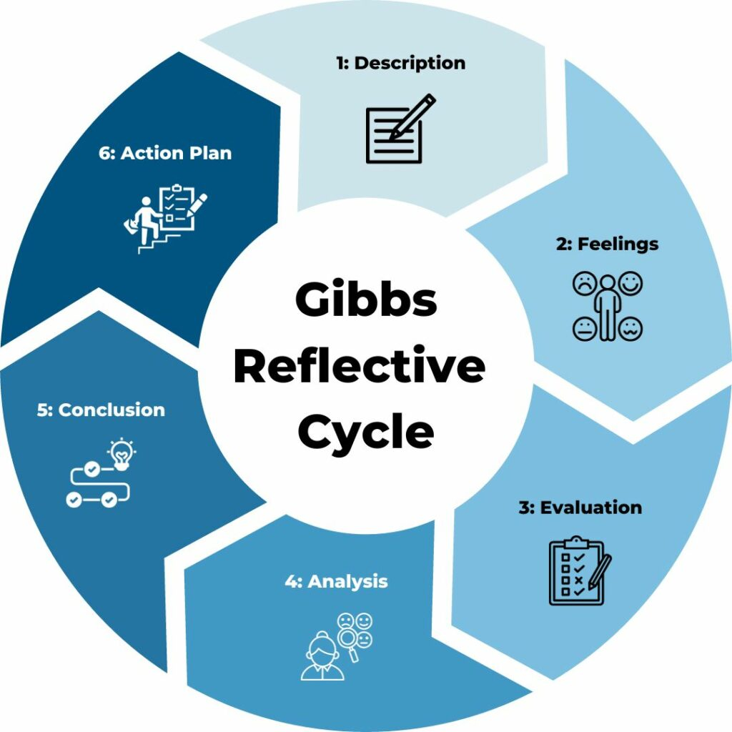
Figure 2: Gibbs Reflective Cycle (Channell, 2023)
Description
The HCM module has given me important knowledge of the strategic position of human resource management in contemporary organisations. During the course, I learned such critical areas as HR strategy, talent management, employee engagement and leadership development. The module has highlighted the need to have organisations ensure their human capital strategies are aligned with the business objectives so to attain sustainable performance and competitive advantage. One of the greatest concentrations of the module was how organisations attract, develop and maintain talented employees in highly competitive sectors like technology. Also, the module discussed the impact of HR practices on organisational culture, motivation and productivity of the work force. The knowledge about the modern HR frameworks also allowed me to understand the need to align people management practices with organisational strategy to enable innovation and long-term organisational success (Reiche et al., 2022).
Feelings
When I was starting the module, my concept of HR was mainly one of a functional department of recruitment, administration and employee relations. Nevertheless, my attitude changed significantly as the module developed. I learned that the role of HR is much more strategic in influencing the performance of organisations and directing the development of workforce. The reading on strategic HRM and talent management made me realise the value of human capital choices in organisational competitiveness. This change of perception drew me more to the strategic nature of HR and motivated me to perceive HR practices as major drivers of organisational development instead of the operational work.
Evaluation
Among the greatest things that the module taught me was the role of HR strategies in organisational innovation and employee development. The module presented a number of talent management models that explain how organisations realise and develop high potential employees. I worked with it especially productively to consider actual organisational cases in which HR strategies have been applied to drive business performance. Moreover, the module also showed the power of leadership and employee involvement in the creation of high-performing organisations. These themes showed the usefulness of HR practices in enabling organisations to build favourable work conditions that foster teamwork and constant innovation (Marchington et al., 2021). In general, the module enabled me to gain a deeper insight into the role played by HR policies in organisational effectiveness.
Analysis
The study of the ideas discussed in the module made me realise how closely the practices of HR are connected with the outcomes of the organisations. Good HR practices would help greatly in enhancing motivation among employees through development, leadership and meaningful working experiences. Employees that feel appreciated and encouraged will tend to exhibit dedication and increased levels of output. Furthermore, innovation in organisations can be improved through the HR practices that promote the sharing of knowledge and collaboration. In industries that require a lot of knowledge, the expertise and creativity of employees are key factors that contribute to organisational success. Studies have shown that in organisations where the development of talent and employee engagement is performed, the high probability of sustainable performance increases (Paauwe and Boon, 2020). Consequently, HR professionals are of great essence in the development of the people management systems that not only increase the workforce capability but also contribute to the organisational strategy.
Conclusion
Looking back at this learning experience, I realise that the main success of an organisation lies in the good management of human capital. The module has made a substantial contribution to my knowledge about strategic HRM and illustrated how HR practices determine the behaviour of employees, organisational culture and long-term results. I now understand that human capital is an important organisational strength that should be strategically handled to facilitate innovation and competitive edge.
Action Plan
In the future, I would use the experience of this module in my practice. The enhancement of my knowledge of HR analytics and workforce planning is one of my primary priorities to be able to contribute to the data-driven HR decision making. My area of focus is also leadership and communication skills, which will make me successfully work and lead various teams. Moreover, I would like to keep on learning about the talent management strategies and organisational culture to facilitate the engagement of employees and innovation in organisations. Mastering these competencies, I will be able to work in those organisations where employee development and sustainable growth are the priorities (Lengnick-Hall et al., 2020).

7. AI and the Future of Work
Artificial intelligence (AI) is playing a significant role in the modern workplace, automating mundane processes and allowing organisations to make more informed decisions with more information. AI technologies may also help organisations enhance the efficiency and productivity of many of the most common administrative tasks, such as data processing, recruitment screening and workforce analytics. With the further advancement of digital technologies, experts will need to adjust to the working environment where analytical skills and technological literacy are becoming more significant (Brynjolfsson and McAfee, 2022). Nonetheless, even with the increasing power of AI, there are numerous things about work that cannot be handled by machines due to their specific human skills.
Such human competencies as creativity, emotional intelligence, leadership and ethical judgement are still needed to manage people and resolve difficult organisational issues. These are especially necessary in jobs that require making of decisions, as well as collaborative and organisational leadership. Instead of applying AI to fully substitute human workers, they are to be regarded as an aid in the improvement of professional performance. As an example, AI can be used by HR professionals in assisting HR analytics, enhancing the effectiveness of recruitment and helping with workforce planning through analyzing the large volumes of data. With the integration of technology expertise coupled with excellent interpersonal and strategic abilities, experts can be highly relevant in the dynamic workplace and play a role in facilitating organisations that work within an increasingly digital setting (Autor, 2023).

8. Conclusion
To sum up, strategic talent ecosystem should be developed in order to deal with the workforce challenges presented in Aether Innovations. Employee ability and retention can be reinforced through a balanced build-versus-buy talent strategy that is facilitated by mentorship programs, leadership development and lifelong learning programs. Through integrated HR practices, the organisation will be able to boost innovation, employee engagement and eventually it would lead to the sustainable organisational performance.

9. References
Allen, T.D., Eby, L.T. and Lentz, E. (2023) ‘Mentorship and career development: contemporary perspectives’, Journal of Vocational Behavior, 142, pp. 1–11.
Autor, D. (2023) ‘The impact of artificial intelligence on jobs and skills’, Journal of Economic Perspectives, 37(4), pp. 3–30.
Bandura, A. (2022) Social learning theory. New York: Routledge.
Barney, J.B. (2021) Gaining and sustaining competitive advantage. 5th edn. Harlow: Pearson.
Becker, G.S. (2022) Human capital: A theoretical and empirical analysis, with special reference to education. 3rd edn. Chicago: University of Chicago Press.
Boxall, P. and Macky, K. (2023) ‘High-performance work systems and organisational performance: a review and research agenda’, Human Resource Management Journal, 33(2), pp. 259–275.
Brynjolfsson, E. and McAfee, A. (2022) The second machine age: Work, progress, and prosperity in a time of brilliant technologies. Updated edn. New York: W.W. Norton & Company.
Cappelli, P. and Keller, J.R. (2021) ‘Talent management: conceptual approaches and practical challenges’, Human Resource Management Review, 31(2), pp. 1–12
Channell, M. (2023). Gibbs Reflective Cycle – How to Learn from Experience and Become a Better Leader. [online] TSW Training. Available at: https://www.tsw.co.uk/blog/leadership-and-management/gibbs-reflective-cycle/ (Accessed: 9 March 2026).
Collidu (2024). Leadership Model. [online] Collidu.com. Available at: https://www.collidu.com/presentation-leadership-model (Accessed: 9 March 2026).
Collings, D.G., Mellahi, K. and Cascio, W.F. (2022) ‘Global talent management and performance’, Journal of World Business, 57(2), pp. 1–12.
Day, D.V. and Dragoni, L. (2023) ‘Leadership development: an outcome-oriented review based on time and levels of analyses’, Annual Review of Organizational Psychology and Organizational Behavior, 10, pp. 41–67.
Deloitte (2023) Global human capital trends 2023: New fundamentals for a boundaryless world. Available at: https://www2.deloitte.com/global/en/insights/focus/human-capital-trends.html (Accessed: 9 March 2026).
Garavan, T., Carbery, R. and Rock, A. (2022) ‘Mapping talent development: definition, scope and architecture’, European Journal of Training and Development, 46(3/4), pp. 310–335.
Jiang, K. and Messersmith, J. (2023) ‘On the shoulders of giants: a meta-review of strategic human resource management’, Human Resource Management Review, 33(1), pp. 1–15.
Lengnick-Hall, C.A., Beck, T.E. and Lengnick-Hall, M.L. (2020) Strategic human resource management: Theory and practice. 3rd edn. London: Routledge.
Marchington, M., Wilkinson, A., Donnelly, R. and Kynighou, A. (2021) Human resource management at work: People management and development. 7th edn. London: CIPD.
McKinsey & Company (2022) How companies can win in the seven tech-talent battlegrounds. Available at: https://www.mckinsey.com/capabilities/mckinsey-digital/our-insights/how-companies-can-win-in-the-seven-tech-talent-battlegrounds (Accessed: 9 March 2026).
McKinsey & Company (2024) Tech talent trends: How companies compete for digital skills. Available at: https://www.mckinsey.com/capabilities/people-and-organizational-performance/our-insights (Accessed: 9 March 2026).
Noe, R.A., Clarke, A.D.M. and Klein, H.J. (2024) ‘Learning in the twenty-first-century workplace’, Annual Review of Organizational Psychology and Organizational Behavior, 11, pp. 45–72.
Örtenblad, A. (2023) The learning organization: exploring the concept and its applications. 2nd edn. Oxford: Oxford University Press.
Paauwe, J. and Boon, C. (2020) ‘Strategic HRM: A critical review’, Human Resource Management Journal, 30(1), pp. 4–22.
Posthuma, R.A., Campion, M.C. and Campion, M.A. (2022) ‘High performance work practices and organisational effectiveness’, Journal of Management, 48(6), pp. 1462–1495.
Reiche, B.S., Harzing, A.W. and Tenzer, H. (2022) International human resource management. 6th edn. London: Sage.
World Economic Forum (2023) The future of jobs report 2023. Available at: https://www.weforum.org/reports/the-future-of-jobs-report-2023 (Accessed: 9 March 2026).

