A Report Focussing On:

Development Plan

Module Code – ACBA6010

Word Count Required – 2500 (+/- 10%
Word Count: 2554

Prepared for:
I. Brown

Created By:
E. Evans (2211009)

Submission Deadline – 8th May 2026

Contents
1. Introduction 3
1.1 Site Location 3
2.0 Existing Site Considerations 5
3.0 Proposed Development 6
4.0 Capital Expenditure associated with the acquisition and development (GDV) 7
4.1 Build Cost Calculations & Associated Costs 7
4.2 Budget calculation 8
5.0 Case Studies of Existing Projects 9
5.1 Higher Lane, Mumbles, SA3 4PD 9
5.2 Long Park, Manorbier, Pembrokeshire, SA70 7SX, Pembrokeshire (Key example) 10
6.0 Risk Register 12
7.0 Return on Investment 13
8.0 Recommendations 14
References 15

Table of Figures
Table 1:Comparison of surrounding area property values 4
Table 2: Development & Build cost calculations 9
Table 3: Risk Register for proposed development 12

Photo 1: Aerial view of proposed development land (Zoopla, 2026) 3
Photo 2: Existing structure to be demolished on land (Zoopla, 2026) 4
Photo 3: Aerial view of surrounding area of the plot (Zoopla, 2026) 5
Photo 4: Block plan of proposed 2x residential development 6
Photo 5: Elevation & floor plan of proposed build 7
Photo 6: 75 Higher Lane, Mumbles, SA3 4PD (Zoopla 2025) 9
Photo 7: Long Park Manorbier (Country Living Group 2026) 10
Photo 8: Long Park, Manorbier. Similar location to proposed build (Country Living Group 2026) 11

1. Introduction
This report development plan is designed to assess the feasibility of the proposed construction of two luxury houses within the Slade area of Swansea. This project will aid in the decision of the director to become a developer and has placed the responsibility of the project manager to oversee the development plan and derive the overall costs for the works, land acquisition, meeting planning obligations and a market-risk adjusted return. The report will contain an introduction to the scheme along with its location, historical and current uses, condition and the surrounding areas requirements. There will be assessment of costings for land acquisition and development (GDV) as well as calculations of the return on investment (ROI) with reviewing of case studies and existing projects to support the feasibility of the proposed project.

1.1 Site Location
Haere-Mai, Slade, Oxwich, Swansea, SA3
0.42 acre plot (1699 m²),
The proposed development that has been accepted at pre application stage by Swansea City Planning Department is located in Oxwich, within the Gower Peninsula. This location is part of an Area of Outstanding Natural Beauty (AONB) while being surrounded by well valued properties in a sought-after area that can influence potential house prices. Oxwich is attractive to buyers seeking luxury coastal homes due to being in the vicinity of Oxwich bay and a short trip to Swansea and other facilities such as shopping/amenities, essential highway networks and schools. (Zoopla, 2026) (The GreenRoom Estate Agency, 2025)
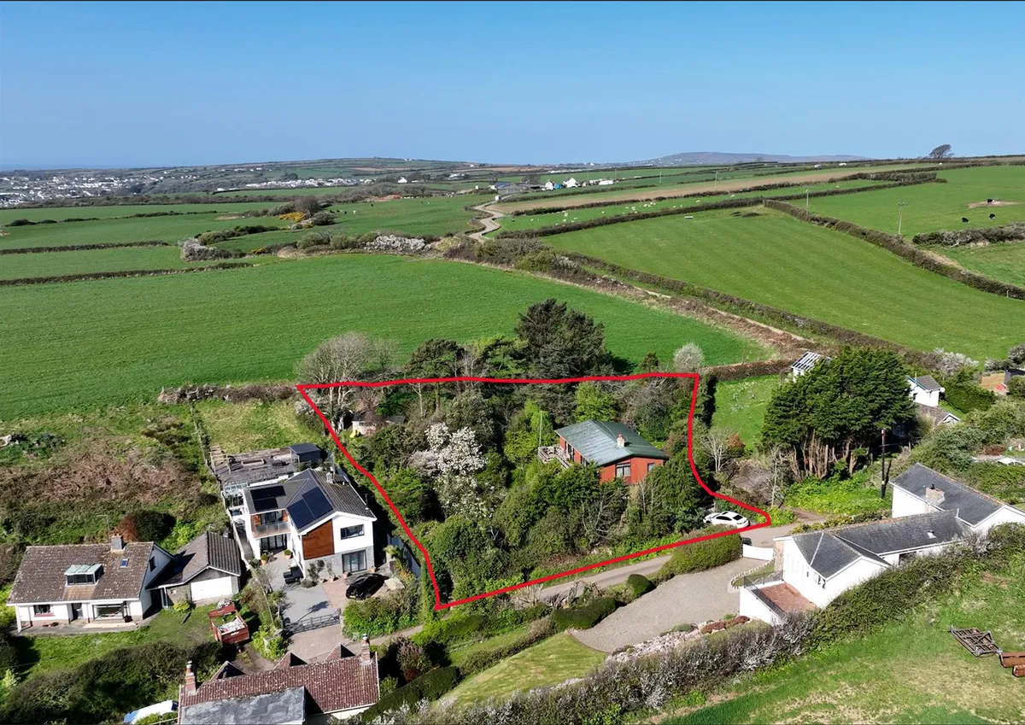
Photo 1: Aerial view of proposed development land (Zoopla, 2026)
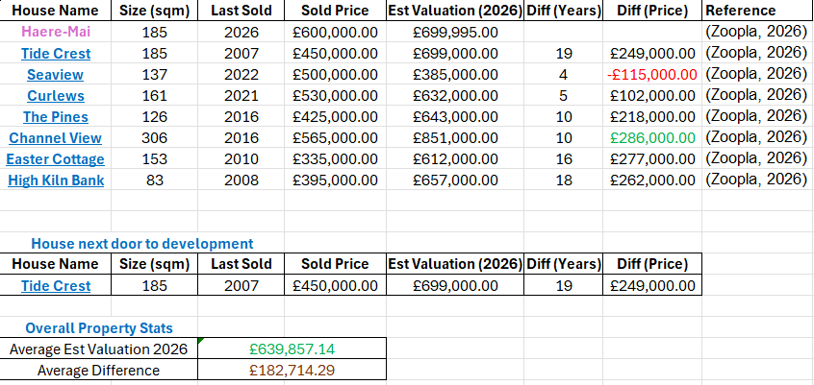
Table 1:Comparison of surrounding area property values
This table displays records of properties in the vicinity of the proposed development that include the size, date last sold/how much for, estimated value for 2026 and a price difference between when they were last sold and the 2026 valuation. This can help outline trends in house prices in the area dependant on their size so that an ideal calculation for the development can be made. Viewing the table, it is noted that Haere Mai is the structure currently on the proposed plot and next door to this property is ‘Tide Crest’ which is similar size to the properties of the developments (2 no. 200sqm plots) with a valuation of £699,000 in 2026 this property can be an ideal marker for the developer as it is a modern build and will influence the yield price for the proposed works. The average valuation prices in 2026 comes in at almost £640,000 and an average increase of just over £180,000 which displays growth and continued influx of pricing in the area. The property we are interested in purchasing started at £699,000 but is now listed to us at £600,000 and is reflected in the costings.
On the 0.42 acre plot there is an existing residential structure that will be demolished as part of the associated works for the two residential plots.
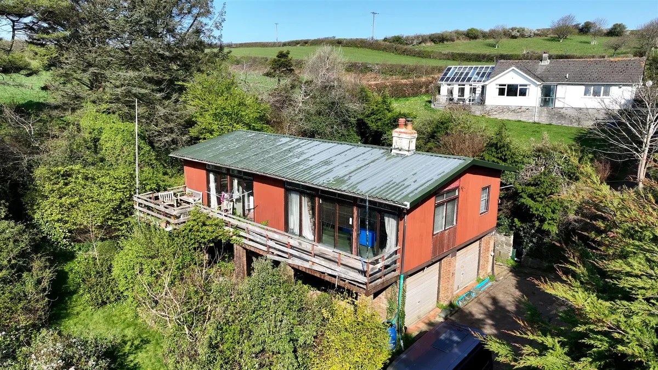

Photo 2: Existing structure to be demolished on land (Zoopla, 2026)

2.0 Existing Site Considerations
- Current condition of land and structure is poor with intensive work needing to be carried out to bring up to building standard
- No beneficial scope to salvage materials from existing structure
- Services on site including water, electricity, sewerage and oil heating
- Possibility of asbestos within existing structure
- Invasive weeds and heavy overgrown landscape
- Ground conditions – Flooding/contamination/radon/mining
- Lack of drainage – Consult SUDS/SAB
- No offroad parking on site
- Rural location could be housing protected species
- Farming land in vicinity
- Access requirements – Swept path analysis
- Area of Outstanding Natural Beauty (AONB) (Swansea Planning App, 2026)
- Does not have a tree preservation order = Tree removal in AONB is okay (swansea.gov, 2026)
- Not a Site of Special Scientific Interest (SSSI) (datamap.gov, 2026)
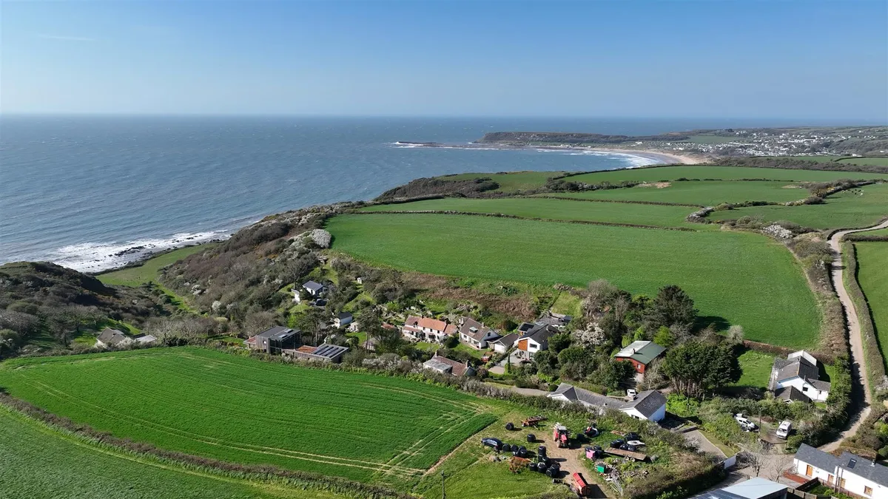
Photo 3: Aerial view of surrounding area of the plot (Zoopla, 2026)

3.0 Proposed Development
- Demolition of existing structure
- Accepted at pre-application stage for erection of two new dwellings
- Construction of contemporary style two storey dwellings with pitched roof at 200sqm each
- Associated landscaping including retaining walls
- High end finishes such as timber cladding, slate roof and aluminium window frames to preserve character of the area
- Sustainable building design with updated energy sources
- Two detached single storey outbuildings/workshops
- Upgrading of existing services to more efficient and sustainable options
- Private offroad parking
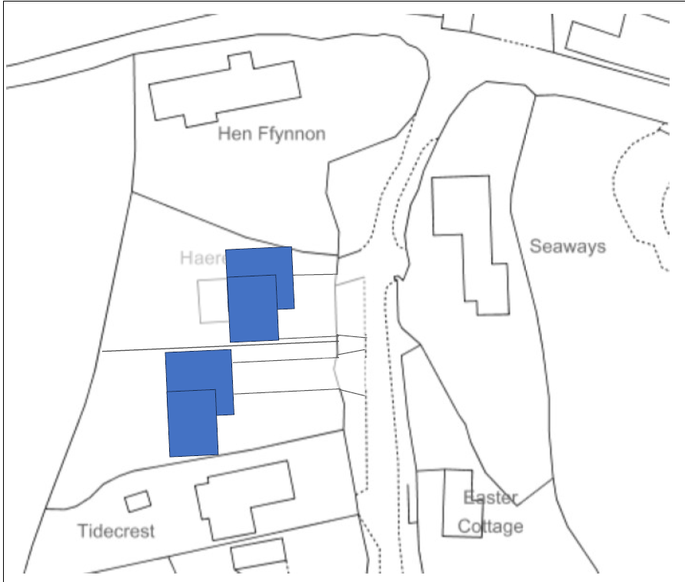
Photo 4: Block plan of proposed 2x residential development

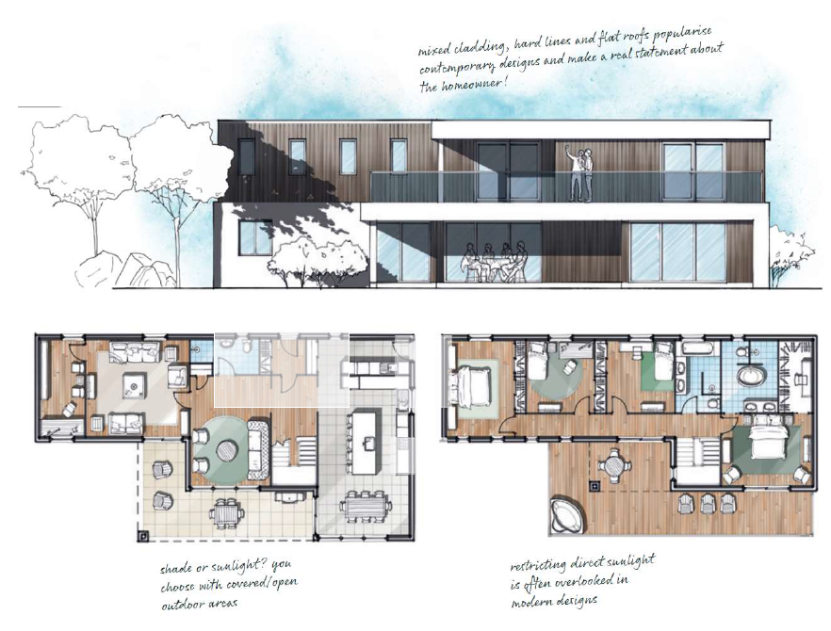
Photo 5: Elevation & floor plan of proposed build

4.0 Capital Expenditure associated with the acquisition and development (GDV)

4.1 Build Cost Calculations & Associated Costs
To put together a detailed project appraisal there will need to be focus on the associated works and costs that will derive from different tasks such as initial site surveys, site setup, land acquisition and legal fees. Once there are some accurate costs assigned the project manager can then calculate the capital expenditure which is defined as the money spent to purchase the land/property and develop it, including acquiring the land, construction, professional fees and infrastructure (Designing Buildings Wiki, 2021).
Once there is an idea of what the total build cost is, we can determine the Gross Development Value (GDV) which is the estimated market value of the completed project when it is leased or sold, this will help understand the scope of the project and identify if the project is financially viable and profitable (UK Property Accountants, 2024).

To calculate the build costs, we will outline the project and assign costs such as:
2x Two storey dwellings proposed at 200sqm each
Obtaining the costs from Page 79 of SPONS Architects and Builders Price List 2023 for the cost of private development two storey houses can range from £2050 - £2650 per sqm. This figure will need to be adjusted for regional cost variations and is based on a current tender price index 226 (3Q 2025 – Year 2000 = 100) this states that Wales index is calculated as 98 and can be added to the price per sqm formula, £2650 x 0.98 = £2597 per sqm (Cost Modelling, 2025).
Inflation needs to be calculated within the cost and will be as follows.

4.2 Budget calculation
Building works cost (BWV factor of 1.00) > 400m² x £2597 m² = £1,038,800
Adjustment for building works value (Cost Factor for £1,038,800 = 1) (Cost Modelling, 2025)
£1,038,800 x 1 = £1,038,800 \\
Adjusted for location (Swansea = 98)
£1,038,800 x 0.98 = £1,018,024
Adjustment for tender inflation
Current tender price index 2026 = 229
Forecasted tender price index 2027 = 235 (Cost Modelling, 2025)
Adjustment 235 – 229 = 2.55% (Estimated rise per annum) > £26,000
£1,018,024 + £26000 = £1,044,024
Adjustment for construction inflation
Current building cost index 2026 = 246
Forecasted building cost index 2027 = 252 (Cost Modelling, 2025)
Adjustment 252 – 246 = 2.4% (Estimated rise per annum) x 50% > £13,000
Updated cost £1,044,024 + £13,000 = £1,057,024
Allowance for external works > say 15% > £158,553 = £1,215,577
Allowance for risk > say 12% > £145,869 = £1,361,446
Indicative total construction works cost = £1,361,446
Excluding land acquisition, fees, VAT, fittings and furnishings
Total cost all in = £2,166,254
Using the total construction works cost and factoring in the expenditure we can gauge a total build cost for the project and determine how feasible it will be, this will help decision making into whether the project needs adjustments, how the company will fund it and more.
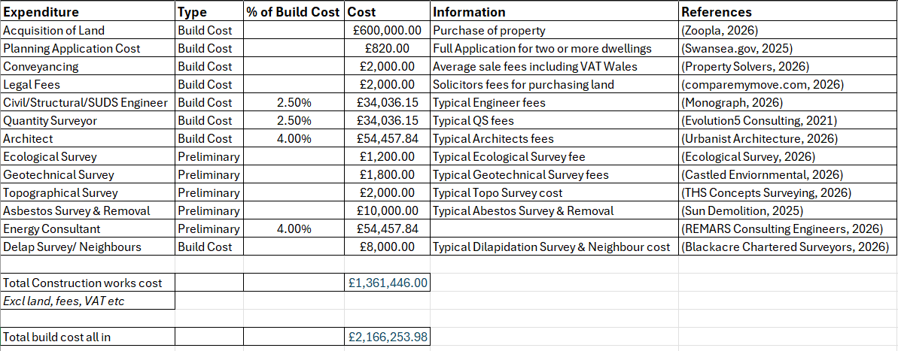
Table 2: Development & Build cost calculations

5.0 Case Studies of Existing Projects
Analysing comparable properties in the Swansea area to gauge a full scope of what kind of market and property value the scheme can achieve is crucial to reinforce the overall margins of the project and maximise return on investment. This project will be self-funded by the company through bank loans and collateral, so it is very important to gather information about similar property builds according to their size, quality and sold prices. This will achieve a realistic Gross Development Value (GDV) assumption for the scheme.

5.1 Higher Lane, Mumbles, SA3 4PD
309 m² 4 Bedroom Detached
Original Listing 2019 - £475,000
Last sold June 2025 – £1,050,000 (132% increase in 6 years)
Latest valuation - £1,130,000
(Zoopla, 2025)
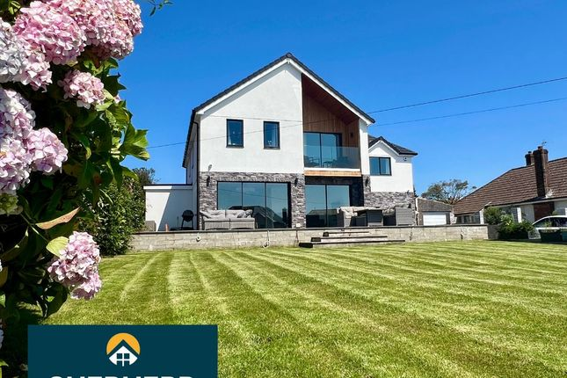
Price per sqm with current valuation = £3,656.96
Photo 6: 75 Higher Lane, Mumbles, SA3 4PD (Zoopla 2025)

Comparison between scheme and this property, the scheme would for example accumulate upwards of £1,200,000 each for a 200 m² plot and the price per sqm would be around £6,000 (Proposed sold price of 1 build = £1,200,000 ÷ floor size = 200 m² > £6,000)
This property benefits from a recent renovation that added floor space for a new bedroom, bathroom and receptions. It is a premium coastal location that features high quality architectural design and modern internal and external specification. This example while originally was closer to the same floor plan size as one of the proposed plots, allows the company to scope where to get the upper range of quality and price within the market. This property demonstrates that builds close to the quality and size of the scheme can achieve £1 million + pricing especially with updated materials, efficiency and services as well as quality and setting. From 2019 the price has increased 132% showing a consistent and very healthy pricing growth that could see more in the future, this can further influence the scheme as it will display the level of build that is going to be achieved and justify the overall end pricing for a high quality, modern property (Zoopla, 2025)

5.2 Long Park, Manorbier, Pembrokeshire, SA70 7SX, Pembrokeshire (Key example)
287 m² 4 Bed detached house currently listed
Previous sold price 2014 - £950,000 (Land Registry, 2026)
Current list price 2026 - £1,600,000 (Rightmove, 2026)
Price per sqm with current valuation - £5574.91
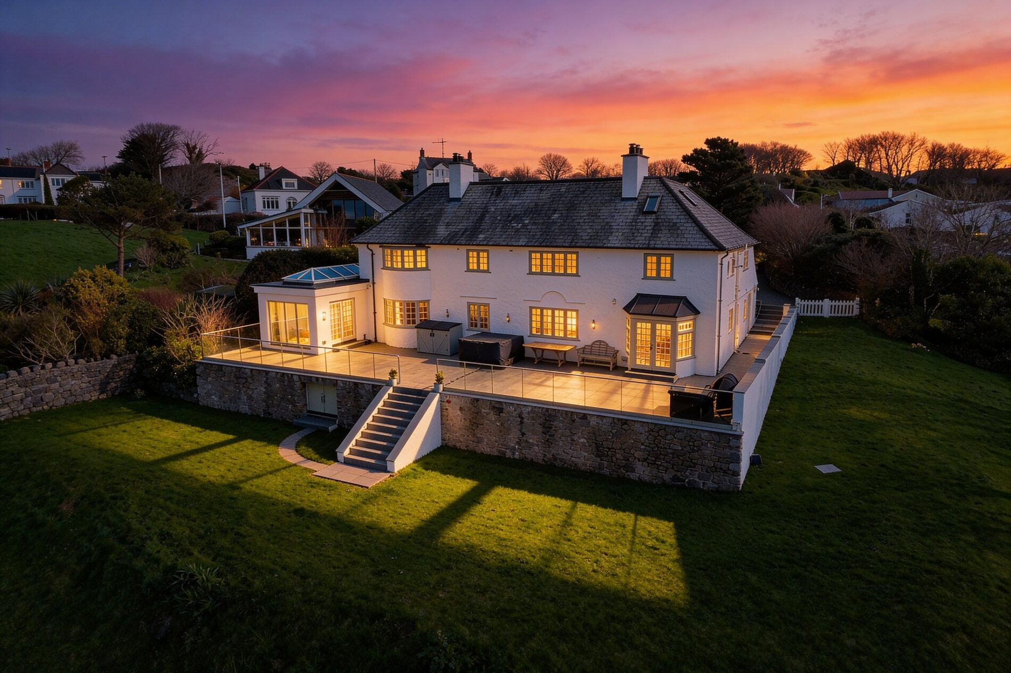
Photo 7: Long Park Manorbier (Country Living Group 2026)

This property is a high specification detached 4 bedroom house with a 287 m² floor space that is just over what the proposed scheme will be at 200 m² but aligns greatly with the location and modernisation. This property is located near a well-known beach that attracts holiday makers, while being close to shops, transport and schools. With the comparable scale this property can be used to benchmark the proposed build and help justify the upper range price per sqm. The modern build that boasts rare location and opportunity, as well as the fact that the proposed scheme will feature enhanced technology for energy, materials, luxury and comfort which can reinforce the uplift for such commodities. The correlation between long park and the proposed scheme are very similar with location (albeit Pembrokeshire not as busy as Swansea) but it is very rare cove near a popular beach, modern design techniques with open plan rooms and luxury finishes as well as privacy and outdoor fixtures with stunning views. The newer build can boast higher EPC ratings, reduced energy consumption, solar panels and higher end design to bring the higher property value in line with the case studies.
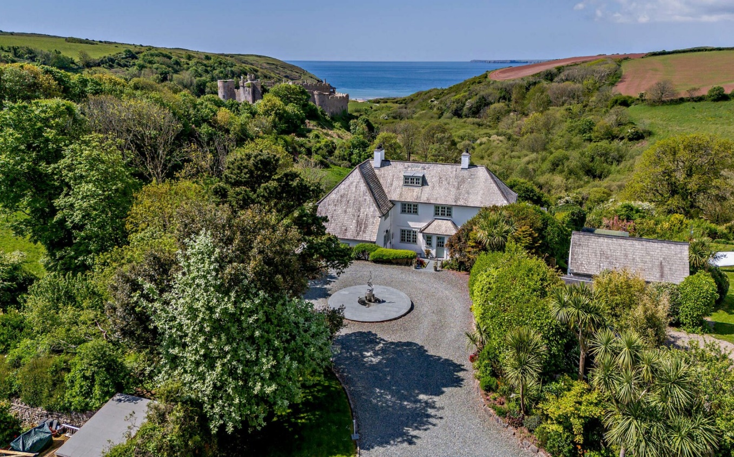
Photo 8: Long Park, Manorbier. Similar location to proposed build (Country Living Group 2026)

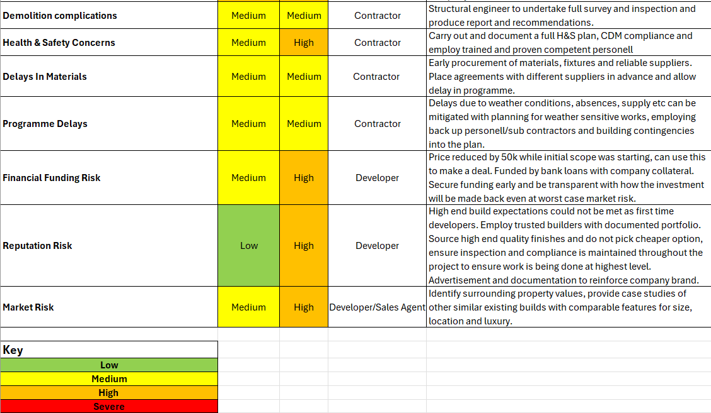
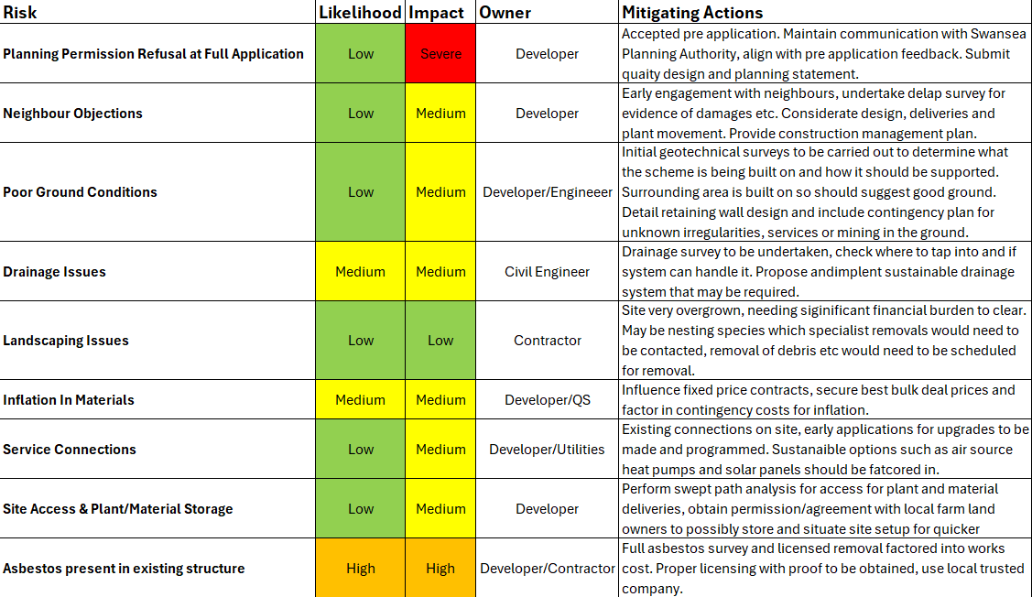
6.0 Risk Register
Table 3: Risk Register for proposed development

7.0 Return on Investment
The proposed development is in the initial planning stages of construction and requires a return on investment (ROI) calculation as the main factor in justifying the works that are proposed. The company is thinking of branching out into being a developer and will learn a lot with its first build, money and reputation will be affected and it is crucial to make sure funding is secured and paid back with maximum profit to be made as this will fund other projects and good reputation will bring more schemes to be involved with and therefore increased capital. The ROI can influence decision making for feasibility, alternative methods of construction or funding, identify and attract potential investors to be involved and manage budgets.
7.1 ROI Calculation
Formula for ROI = $\frac{Gain from Investment - Cost of Investment}{Cost of Investment}$
Given the proposed scheme aligns closely to the case studies that have been presented albeit this new build is 2x properties that will feature high end energy sources, luxury finishes and prime sought after location. It is partial to a valuation of around £1,200,000 for each property which equals £2,400,000 sold together.
The cost of investment has been calculated above which is:
Indicative total construction works cost = £1,361,446
For the total build cost all in with all the fees it is:
Total cost all in = £2,166,254
$\frac{£2,400,000-£2,166,254}{£2,166,254}$ = £233,746 Investment Gain > 10.79% ROI
The project shall be completed within 2 years from start to finish so an annualised ROI would be 5.26%.
Taking into account that this is the companies first residential build as a developer there is not huge gains to be had and more of an establishing reputation through proven track record of build quality, efficiency, project delivery and communication (MN Vision, 2026). Large scale developers with established records and systems quote target rates of return to around 10-20% annually, residential developers with planning risks and alike often seek 20% per annum with likely drop to 15% if planning is secured already. These are quotes from experienced companies that have secured trustworthy relationships, reduced rates of materials and contractors to bring down costs and maximise their potential. There is also the option of retained investments where properties are built and held (build to rent) and see returns of 10-12% per annum, although funds can be held up and not moved across to pay the outstanding loans the company has acquired to fund the project (RICS, 2019).
The rate of 5.26% annually can be seen as low in the grand scheme of big developers but it can be a pivotal experience for the company to establish experience, expertise, managing construction projects, controlling costs, coordinating between contractors and navigating the sales processes. On this scheme the original listing for the land was £699,000 which would have left the company with a return of £133,746 and an annualised return of 2.91% which may have not been worth the effort and capital invested for so little return. Successfully delivering this scheme can help establish credibility with investors, lenders and future clients that can help secure better financing terms in future projects.

8.0 Recommendations
To improve the return of investment margins and improve the overall build the scheme can adapt low carbon technologies and boast modern systems to gain access to the higher asking prices.
Options such as:
- Air source heat pumps
- Solar panels
- Underfloor heating systems
- Electric/Hybrid charging points
- Target higher energy efficiency banding
The combination of low carbon energy efficient and sustainable systems can increase their Energy Performance Certificate (EPC) ratings which will in turn attract buyers due to the rising energy costs and regulatory pressures while increasing sale values, reduce time on the market and greater appeal to environmentally conscious buyers. Improving thermal performance of the builds by implementing enhanced insulation techniques, airtight construction and tripled glazed windows will reduce the energy demand as well as providing long term value. Future proofing the builds with smart energy systems, EV chargers, high speed broadband connections as well as maximising design by open plan living spaces with sea views and outdoor features. With the combination of these adaptations and features there build can reduce development risk through sustainability and increase overall ROI, while also establishing the business as strict for compliance and attention to detail.
(gov.uk, 2024) (MCS, 2026) (LSE, 2025)

References
Blackacre Chartered Surveyors, 2026. Dilapidations Survey. [Online]
Available at: https://blackacresurveyors.com/2026/02/28/dilapidations-survey/
[Accessed 12 03 2026].
Castled Enviornmental, 2026. Survey & Reporting Costs. [Online]
Available at: https://www.castledineenvironmental.co.uk/costs
[Accessed 11 03 2026].
comparemymove.com, 2026. Solicitors' Fees for Buying a House. [Online]
Available at: https://www.comparemymove.com/guides/conveyancing/solicitor-fees-when-buying#:~:text=Most%20buyers%20spend%20between%20%C2%A3,how%20complex%20the%20transaction%20is.
[Accessed 11 03 2026].
Cost Modelling, 2025. Comparative Construction Costs According to Project Size. [Online]
Available at: https://costmodelling.com/project-size
[Accessed 24 03 2026].
Cost Modelling, 2025. Tender Price and Building Cost Indices. [Online]
Available at: https://costmodelling.com/construction-indices
[Accessed 24 03 2026].
Cost Modelling, 2025. UK Construction Cost Regional Variations. [Online]
Available at: https://costmodelling.com/regional-variations
[Accessed 24 03 2026].
Country Living Group, 2026. Long Park, Manorbier for sale advert. [Online]
Available at: https://countrylivinggroup.co.uk/property/tenby-2/
[Accessed 02 04 2026].
datamap.gov, 2026. Sites of Special Scientific Interest (SSSI). [Online]
Available at: https://datamap.gov.wales/layers/inspire-nrw:NRW_SSSI
[Accessed 11 03 2026].
Designing Buildings Wiki, 2021. Capital expenditure for construction. [Online]
Available at: https://www.designingbuildings.co.uk/wiki/Capital_expenditure_for_construction
[Accessed 12 03 2026].
Ecological Survey, 2026. Ecological Survey. [Online]
Available at: https://ecological-survey.co.uk/#:~:text=Find%20More%20Info-,How%20Much%20Does%20an%20Ecological%20Survey%20Cost?,Our%20Team%20For%20Best%20Rates
[Accessed 11 03 2026].
Evolution5 Consulting, 2021. Quantity Surveyor Fees. [Online]
Available at: https://evolution5.co.uk/how-much-do-quantity-surveyors-charge/
[Accessed 11 03 2026].
gov.uk, 2024. low carbon technologies in English homes - fact sheet. [Online]
Available at: https://www.gov.uk/government/statistics/english-housing-survey-2023-to-2024-low-carbon-technologies-in-english-homes-fact-sheet/english-housing-survey-2023-to-2024-low-carbon-technologies-in-english-homes-fact-sheet#heating-and-types-of-fuel
[Accessed 02 04 2026].
HouseMetric, 2025. 75, Higher Lane, SA3 4PD Property Data. [Online]
Available at: https://housemetric.co.uk/30688827/SA3-4PD/75+Higher+Lane#epc-section
[Accessed 26 03 2026].
HouseMetric, 2025. House prices in SA3 Mumbles. [Online]
Available at: https://housemetric.co.uk/analysis/sector/SA3-4/Mumbles
[Accessed 26 03 2026].
Land Registry, 2026. Deed search. [Online]
Available at: https://eservices.landregistry.gov.uk/eservices/ECBD_RegisterViewPDF/RegisterViewSubmit.do
[Accessed 26 03 2026].
LSE, 2025. UK home buyers are overpaying for properties with higher energy efficiency rating bands. [Online]
Available at: https://www.lse.ac.uk/news/latest-news-from-lse/b-february-25/uk-home-buyers-are-overpaying-for-properties-with-higher-energy-efficiency-rating-bands
[Accessed 02 04 2026].
MCS, 2026. The 2026 Low Carbon Landscape. [Online]
Available at: https://mcscertified.com/the-2026-low-carbon-landscape/
[Accessed 02 04 2026].
MN Vision, 2026. What makes a real estate developer trustworthy?. [Online]
Available at: https://mnvision.co/trustworthy-real-estate-developer-property-investment/
[Accessed 02 04 2026].
Monograph, 2026. Structural Engineer Fees: Complete Cost Breakdown. [Online]
Available at: https://monograph.com/blog/structural-engineer-fees-cost-breakdown#:~:text=protect%20your%20margins.-,How%20Structural%20Engineers%20Price%20Their%20Services,change%20becomes%20a%20negotiation%20point.
[Accessed 11 03 2026].
Omni Calculator, 2024. Price per Square Meter Calculator. [Online]
Available at: https://www.omnicalculator.com/finance/price-per-square-meter
[Accessed 26 03 2026].
Omni Calculator, 2024. Price per Square Meter Calculator. [Online]
Available at: https://www.omnicalculator.com/finance/price-per-square-meter
[Accessed 26 03 2026].
Property Solvers, 2026. Average Conveyancing Fees (2026). [Online]
Available at: https://www.propertysolvers.co.uk/homeowners-hub/conveyancing/conveyancing-fees/#:~:text=Average%20Conveyancing%20Fees%20(2026),782.94%20(inclusive%20of%20VAT).&text=Please%20note%20the%20following%20regarding,for%20disbursements%20and%20supplementary%20f
[Accessed 11 03 2026].
REMARS Consulting Engineers, 2026. M&E Fee Percentages. [Online]
Available at: https://remars.co.uk/me-consultant-fees/
[Accessed 12 03 2026].
RICS, 2019. Performance metrics, required returns. [Online]
Available at: https://www.rics.org/news-insights/research-and-insights/rics-research-trust-performance-metrics-report
[Accessed 02 04 2026].
Rightmove, 2026. Long Park Manorbier advert. [Online]
Available at: https://www.rightmove.co.uk/properties/173358593#/?channel=RES_BUY
[Accessed 26 03 2026].
Sun Demolition, 2025. How much does asbestos removal cost? Pricing explained. [Online]
Available at: https://sundemolition.co.uk/blog/how-much-does-asbestos-removal-cost/
[Accessed 12 03 2026].
Swansea Planning App, 2026. App No. 2020/1841/PRE. [Online]
[Accessed 10 03 2026].
Swansea.gov, 2025. Planning Application Costs. [Online]
Available at: https://www.swansea.gov.uk/makingaplanningapplication
[Accessed 11 03 2026].
swansea.gov, 2026. Tree Preservation Order map. [Online]
Available at: https://www.swansea.gov.uk/tpomap
[Accessed 11 03 2026].
The GreenRoom Estate Agency, 2025. Haere-Mai, Slade. [Online]
Available at: chrome-extension://efaidnbmnnnibpcajpcglclefindmkaj/https://alto2-live.s3.amazonaws.com/N1_WCcmWLM4K1syqq9gDYuzSsH8/_CN9iVngM1UBC7hcw9xGpG_zERA/Brochure/[0]/hJQfbJeeq0CWNDHvBkgRdg.pdf
[Accessed 10 03 2026].
THS Concepts Surveying, 2026. How Much Does a Topographical Survey Cost in 2026?. [Online]
Available at: https://www.ths-concepts.co.uk/how-much-does-a-topographical-land-survey-cost/
[Accessed 11 03 2026].
UK Property Accountants, 2024. What is Gross Development Value (GDV)?. [Online]
Available at: https://www.ukpropertyaccountants.co.uk/understanding-gross-development-value-gdv-in-property-development/
[Accessed 12 03 2026].
Urbanist Architecture, 2026. Architects fees in the UK. [Online]
Available at: https://urbanistarchitecture.co.uk/how-much-architects-charge/
[Accessed 11 03 2026].
Zoopla, 2025. 75 Higher Lane, Langland, Swansea, SA3 4PD. [Online]
Available at: https://www.zoopla.co.uk/property/uprn/100100338367/?referer=home-values
[Accessed 26 03 2026].
Zoopla, 2026. Channel View Advert. [Online]
Available at: https://www.zoopla.co.uk/property/uprn/10011727646/
[Accessed 10 03 2026].
Zoopla, 2026. Curlews. [Online]
Available at: https://www.zoopla.co.uk/property/uprn/10010032172/
[Accessed 10 03 2026].
Zoopla, 2026. Easter Cottage Advert. [Online]
Available at: https://www.zoopla.co.uk/property/uprn/10011727573/
[Accessed 10 03 2026].
Zoopla, 2026. Haere-Mai Advert. [Online]
Available at: https://www.zoopla.co.uk/for-sale/details/70042485/?search_identifier=7ad016ce9e3b3a396173bb741614fd3d14d4a867d58bec852bf61f1974819fba
[Accessed 10 03 2026].
Zoopla, 2026. High Kiln Bank Advert. [Online]
Available at: https://www.zoopla.co.uk/property/uprn/10011727576/?referer=home-values
[Accessed 10 03 2026].
Zoopla, 2026. Seaview Advert. [Online]
Available at: https://www.zoopla.co.uk/property/uprn/10011727701/
[Accessed 10 03 2026].
Zoopla, 2026. The Pines Advert. [Online]
Available at: https://www.zoopla.co.uk/property/uprn/10011727581/
[Accessed 10 03 2026].
Zoopla, 2026. Tide Crest Advert. [Online]
Available at: https://www.zoopla.co.uk/property/uprn/10011727582/?referer=home-values
[Accessed 10 03 2026].

