Module BMSW 4003_BIRM Digital Skills and Research Methods
Student Name/Student ID: Iulian Dumitru/ 2122387

Table of Contents

Introduction 3
Research Design 3
Research Question 3
Method 4
Ethical Consideration 7
Validity 7
Voluntary Consent and Participation 7
Sampling 8
Confidentiality 8
Risk of Harm 8
Results 9
Discussion 9
Teams Out for Big Image 11
Benefits 11
Platform Autonomous 12
Scalable 12
Intuitive and Easy 12
Real-time Interaction 12
Keyboard Shortcuts and Closed Captioning 12
LMS Integration 12
Teams is becoming accustomed in response to comment from educators and students 12
Conclusion 13
References 14

Introduction
Teams is an app for video communications that facilitates a person to set up virtual audio or video conferencing, screen-sharing, live chats, webinars and different other collaborative competencies. A person does not require an account to use Teams and attend meetings, and Teams is compatible with Android, IOS, Linux, Windows and Mac, meaning around everybody can avail it. Teams is only one in a huge line of tools of communication that involves Google Meet, Cisco Webex and Skype (Prevalla et al., 2022). This is the most well-liked pricing tier of this particular platform, which surely makes sense, considering that it is free. This particular tier provides unlimited 1-to-1 meetings. If a person intends to exploit Teams just every once in few time to communicate with family or friends, they can surely take pleasure with finest video and audio quality.

Research Design

Research Question
Which collaboration tools are used by the students and staff of UWTSD?

Method
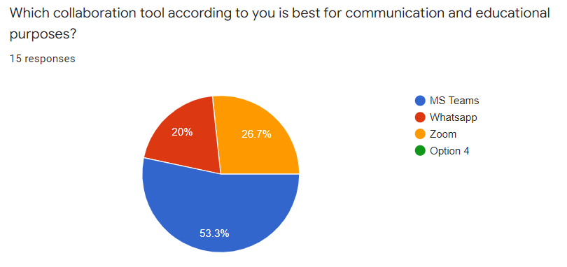

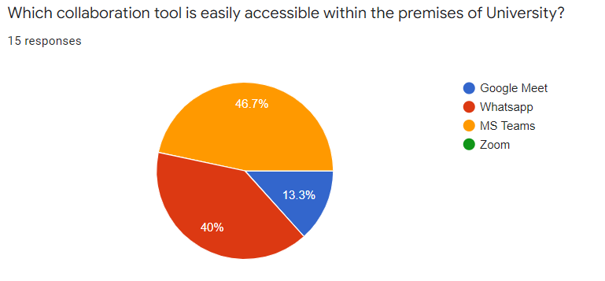

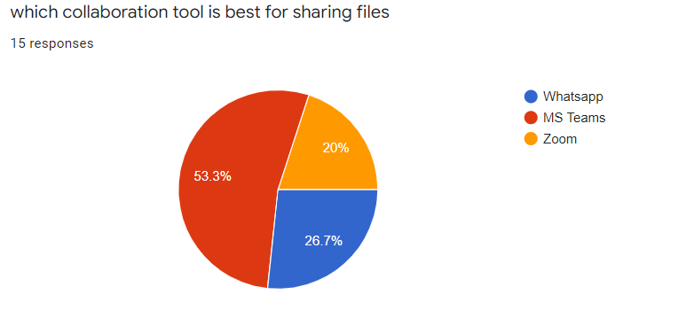

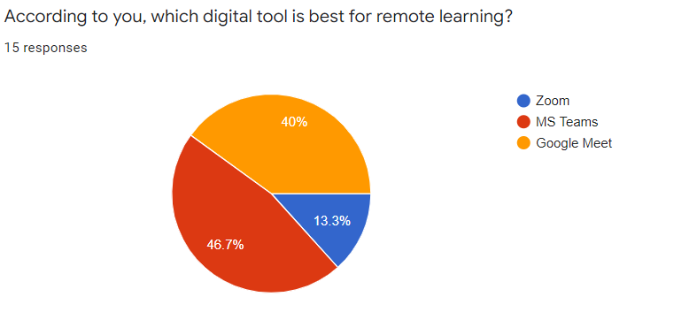

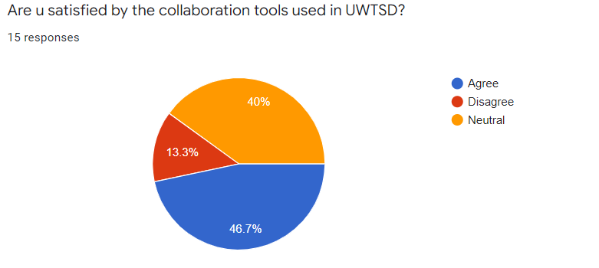

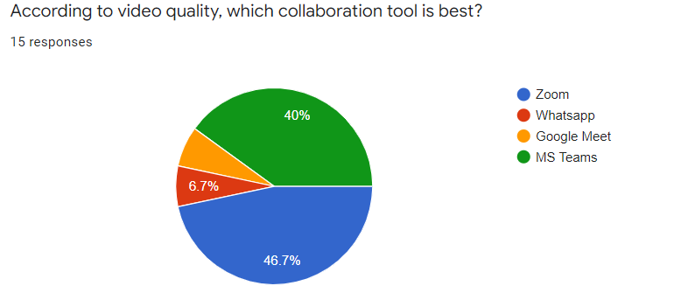
15 respondents took part in the survey where the researcher asked them different questions related to the usage of collaboration tools in UWTSD. Researchers offered those Google forms to fill those. Results were quite innovative as most of the participants said that as per to the video quality, Teams is the best tool for video conferencing but they find it hard to make use of Teams within the premises of UWTSD. Most of the participants also stated that they found MS Teams as the most effective tool when they desire to share files via online collaboration tools. Also, they stated they mostly use Whatsapp as a collaboration tool within the premises of University. Well, the students were satisfied with every collaboration tool but based on the resources and effectiveness, the stated that MS Teams is the best tool during e-learning and remote working. Along with these Google forms, the researchers also carried out group as well as 1-to-1 interviews where different questions were asked related to the security and effectiveness of every collaboration too where students stated that as per to the security, Teams and MS Teams are the utmost tools in terms of its quality. They also said that these two particular tools are really helpful when they are performing a group task over the internet for example file sharing, video calling, etc.

Ethical Consideration

Validity
The research design should discuss the questions of research. Therefore, the study`s conclusion should co-relate to the questions and the outcomes (Li et al., 2020). Moreover, ethics of research requires that the techniques exploited should relate purposely to the questions of research.

Voluntary Consent and Participation
Students of UWTSD must at no significant point sense any compulsion to take part in the research. This involves any kind of deception or persuasion in trying to acquire the trust of UWTSD students. Here, informed consent utters that students should offer their open consent to take part in research. One can consider consent form as a trust agreement amid UWTSD student’s researchers.

Sampling
Sampling is the initial step of this particular research design. Researchers are required to describe why they desire a specific group of students. They are required to define why they left out some groups or students. Additionally, if the research involves “special students”, then the researchers are required to take special permission from their parents first.

Confidentiality
The 3rd principle of ethics of “Economic and Social Research Council” (ESRC) declares that “the confidentiality of the information supplied by research subjects and the anonymity of respondents must be respected.” Though, at certain times confidentiality is restricted. For instance, if a student is at risk of hazard, then the researchers are required to guard them. This could need giving out confidential data.

Risk of Harm
Researchers are required to do everything in their power to secure the participants and their information. For this, researchers must concentrate on the “risk benefiting” ratio. If by chance the risks are more than the benefits, then researchers must redesign or abandon the research (Gunawan et al., 2021). Risk of harm moreover needs researchers to gauge the “risk benefiting” ratio as the research progresses. As the research includes students, researchers must ensure that they decrease any probable hazard to the minimum, or increase the benefits both to the students and other staff of UWTSD.
For instance, those researchers must not depict students to more examinations that are strictly essential to accomplish their objectives of research. Researchers must every time admire human rights, involving the autonomy and right of privacy. They might require taking specific care with susceptible groups, which involve, but are not restricted to, staff of old age, special students, and those with learning disabilities.

Results
The results were really simple. Most of the results were in favor of Teams and Zoom but students find Teams way better in terms of the video quality, but when they have to share files over the internet the students mostly preferred MS Teams. The results were not really in favor of Whatsapp and Google Meet but Whatsapp was the most usable application within the premises of university. So, the results were quite innovative as although the students were preferring Teams and MS Zoom the most, but as per to students, the university is making use of Whatsapp the most.

Discussion
UWTSD is making use of two online collaboration tools, additionally to Moodle, in order to endorse learning and teaching activities throughout the period of pandemic. These are Whatsapp and MS Teams. UWTSD has decided to use Teams as it is simple to exploit and is competent of dealing with several video connection at similar time, which is around 80 as per to the research of (Ganesha et al., 2021). MS Teams might have around 240 participants, but is restricted to displays just 4 video connection at a single time. UWTSD believe that having the capability for students to view each other and the professor, is the nearest they can get to re-make a general environment of lecture. Following are few steps that UWTSD is taking to ensure that Teams is secure:
- UWTSD has bought the application for Higher Education product purpose. This particular version incorporates the Moodle and offers extra security for UWTSD students.
- Professors of UWTSD will commence lectures/seminars on the application via activities related to Moodle. This restricts the meeting detail`s distribution and the innovative pass-codes to just the UWTSD students group on the course. Making use of closed meetings similar to this deducts “Teams Bombing”, where a fraud could disturb the session of Teams.
- Professors are capable to record the meeting of Teams for those particular students who were unable to attend the seminars, and for afterwards references by UWTSD students. Students are provided with an alternative to opt out of the meeting of Teams. If students opt out, they will directly be dropped from the seminar, but will be capable to see the recordings later onwards. The recordings are vital for UWTSD students who cannot attend the similar on the provided time. Their professor will be pleased to go through any questions they have after the meeting, if they chose to leave the session (Faisal et al., 2021).
- Every recorded session of Teams are secured with passwords to avert them being seen by anybody outside of the course. UWTSD considered universal seminar and lecture content as doubtful to be greatly confidential.
Classes constructed on Teams to provide students teachers the chances for online interactions, even when they are taking part from several locations with diverse degrees of equipment and access. With classes shifted to online format of learning for the rest of the course, students and professor are keen to sustain the intellectual vibrancy and academic rigor of the class. Live sessions with interactive contribution are one of the core means for professors and UWTSD students similar to replicate the experience of classroom (Bahasoan et al., 2020). At UWTSD, Teams is now accessible to every staff, faculty and students, is only the tool to aid them do it.

Teams Out for Big Image
Teams are a tool for video collaboration that offers a “click-and-connect” solution for conferencing. Students of UWTSD can exploit it for classroom learning, and teaching, group meetings, or also 1-on-1 office meetings. MS Teams is simple to use application to make video conferences, invite colleagues or students, share resources and solicit participation. This is as close to being in the simulate seminar office or hall as students can get whilst learning and working remotely. And with the new enterprise permit of UWTSD for Teams, staff, faculty and students can avail it for free.

Benefits

Platform Autonomous
Students can surely join the classes from any kind of device where there is no use of VPN.

Scalable
1-on-1 meetings, where around 450 students can join or meeting where around 250 individuals can join

Intuitive and Easy
Just a single-click connection for simple audio and video

Real-time Interaction
Annotations, white-boarding, sharing of content, breakout rooms, polls and chats

Keyboard Shortcuts and Closed Captioning
Guarantees convenience for every student

LMS Integration
Incorporated with CourseWeb and Canvas, additionally on add-on of Outlook

Teams is becoming accustomed in response to comment from educators and students
UWTSD runs what “Barzo” calls a “continuous road show” to ask for feedback related to how to enhance the service for exploitation in education. Students can moreover scan social media to view what is surely working well and not really well for UWTSD. Requests from students are inclined to concentrate on increasing the control of professors over seminars, as stated by Barzso. Professors desire to be capable to display their resources efficiently, guarantee that channels of communication is protective, take attendance and understand where UWTSD students are and what they really are doing. In reply, company of Teams is thinking about an option that would facilitate professors to examine each student by restrict every student to just observing the professor (Agusriadi et al., 2021). In UWTSD, teachers and students universally desire extra support for thorough engagement and collaborative learning with one another and the module material. That is where the rooms are breakout by Teams, which facilitates little-group discussions.

Conclusion
MS Teams is possibly really widespread software for video conferencing as this is really simple to exploit. Once a person set this up, they just require several clicks to begin talking to their friends and colleagues. To acquire a finest experience for remote and co-located participants at Teams meeting, choose a camera for video conferencing for their Teams Room that will ensure that meeting attendees sense involved and a core conversation`s part.

References
Agusriadi, A., Elihami, E., Mutmainnah, M. and Busa, Y., 2021, February. Technical Guidance for Learning Management in a Video Conference with the Teams and Youtube application in the Covid-19 Pandemic Era. In Journal of Physics: Conference Series (Vol. 1783, No. 1, p. 012119). IOP Publishing.
Bahasoan, A.N., Ayuandiani, W., Mukhram, M. and Rahmat, A., 2020. Effectiveness of online learning in pandemic COVID-19. International journal of science, technology & management, 1(2), pp.100-106.
Faisal, A., Handayanna, F. and Purnamasari, I., 2021. Implementation Technology Acceptance Model (Tam) on Acceptance of the Teams Application in Online Learning. Jurnal Riset Informatika, 3(2), pp.85-92.
Ganesha, P., Nandiyanto, A.B.D. and Razon, B.C., 2021. Application of online learning during the Covid-19 pandemic through Teams meeting at elementary school. Indonesian Journal of Teaching in Science, 1(1), pp.1-8.
Gunawan, G., Kristiawan, M., Risdianto, E. and Monicha, R.E., 2021. Application of the Teams meeting application in online learning during the pandemic. Education Quarterly Reviews, 4(2).
Li, C.H., Rajamohan, A.G., Acharya, P.T., Liu, C.S.J., Patel, V., Go, J.L., Kim, P.E. and Acharya, J., 2020. Virtual read-out: radiology education for the 21st century during the COVID-19 pandemic. Academic Radiology, 27(6), pp.872-881.
Prevalla, B., Shaidullina, A.R., Ishmuradova, I.I., Larionova, A.A., Kosarenko, N.N. and Andryushchenko, I.S., 2022. Determining University Students’ Availability on Teams. International Journal of Engineering Pedagogy, 12(2).

