Leading Digital and Strategic Change (BMSW7003_SWAN) (BMSW7003_CARD)
Assignment Advice

Please note the task as set out in the handbook and in our Week 1 PowerPoint lecture.
There is quite a lot of advice surrounding the task itself so do read this and see how you can fit your work in.
ANSWER THE TASKS set before going off into irrelevant areas. Answer using a simple view first (albeit hedging your answer by saying things are complicated). Build the problems of definition or interpretation in next.
The assignment task 1 FORCES YOU to recommend a digital investment/innovation at the end of Task 1. Even if you do not like this, you are stuck with it. If you really do not like it, you can always state the impossibility of making the innovation happen in section 3!!!

- Conduct a strategic audit for your organisation or an organisation you have studied. Evaluate its strategic environment, strategic opportunities and possible strategic choices. (40%)

- Analyse the organisation’s choices in the context of two different leadership theories to evaluate the likelihood of success for each. (20%)

- Make logically derived recommendations to the organisation on how to improve its strategic leadership function with special reference to a digital investment/implementation. (40%)
Comments:
- Style:

- My general advice is always to follow the structure of the questions/tasks set. This makes it easier for the marker, who will then give you more marks.

- Every assertion or debating point needs “back up” in evidence from researched data (which could simply be media or company documents) and/or academic articles.

- Use Harvard referencing style. Crucially use the same style for the full bibliography or else it could look like cut and paste plagiarism.

- Use a grammar and spell check.

- Avoid rhetorical questions. Instead reframe as debating points.

“Surely this old fashioned low investing company run by older geenration family founders, will not make a digital transformation that they do not understand!”
Could be rephrased as:
“Some might argue that senior management still dominated by older geenrations will fail to see or competently initiate digital investment (Morgan, 2019). Others see a general failure to manage such investments on behalf of senior mamangeent (Frankiewicz and Chamorro-Premuzic, 2020). However, Bughin et al. (2018) believe that most digital trasformations fail due to the underestimate of the need for huge disruption of the whole orgnasation, with a success level of 8%.
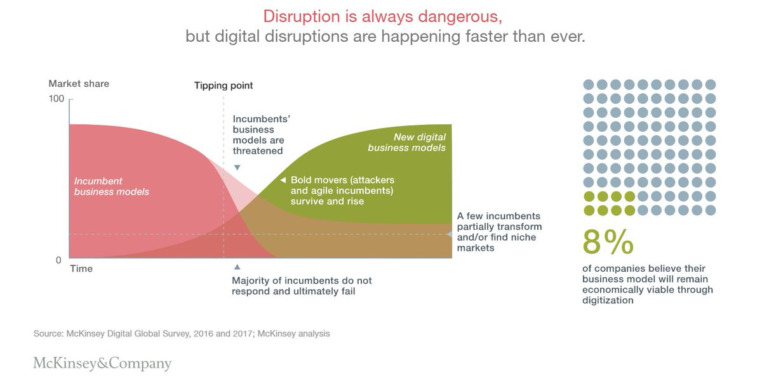
Fig. 1: Disruption is always dangerous. Source: Bughin et al, Mckinsey (2018).”

Bibliography: Only for this little example! Please note I have not used Harvard style so you can get the full names of the authors! Use author family name in alphbetical order. Note my comments on the difference between bibliogrpahies and reference lists!

Jacques Bughin, Tanguy Catlin, Martin Hirt, and Paul Willmott (2018) Why digital strategies fail. McKinsey Quarterly, 25 January. https://www.mckinsey.com/capabilities/mckinsey-digital/our-insights/why-digital-strategies-fail
Becky Frankiewicz and Tomas Chamorro-Premuzic (2020) Digital Transformation Is About Talent, Not Technology. HBR. May 06. https://hbr.org/2020/05/digital-transformation-is-about-talent-not-technology . (Accessed 11-03-23).

Morgan, B. (2019) Companies That Failed At Digital Transformation And What We Can Learn From Them. Forbes. Sep 30, https://www.forbes.com/sites/blakemorgan/2019/09/30/companies-that-failed-at-digital-transformation-and-what-we-can-learn-from-them/?sh=45475634603c. (Accessed 11-03-23).
Mike Sutcliff, Raghav Narsalay, and Aarohi Sen (2019) The Two Big Reasons That Digital Transformations Fail, HBR. 18 October. https://hbr.org/2019/10/the-two-big-reasons-that-digital-transformations-fail

Kim Ngan Tran (2021) Why do employees resist digital transformation? Be Informed. 21 June, https://www.beinformed.com/blog/why-do-employees-resist-digital-transformation/ (Accessed 11-03-23).

- The general strartegy tools are a good starting point to at least identify the past perfromance and future direction of the case company. For section 1; PESTEL, 5 Forces, SWOT etc. How a digital investment can help them achieve their objectives. What are its mission, objectives and challenges?

- The descriptions of the Case Company are not analysis or evaluation, which require discussion and debate. Therefore you could write up a description of the company and put this into an appendix. Sourcing the information. For example: For UWTSD https://digitalstrategy.uwtsd.ac.uk/ Then in the assignment text do a very quick and short introduction, followed by a section ‘Strategic implications of the XXX case’.

Reference the appendix….”As can be seen in Appendix 1. The key driver for digital change is a people orientation. However many people have not been trained and investments tend to be driven from top management (Griffiths, 2021).”

For this you can pull out some of the key features that will be used in the following analysis in all sections.

What are you looking for?
- The exact organisation case you are analysing. Most organisations have wider corporate links, so be specific about the one you are looking at. See my opening ppt on strategy……corporate, business and functional levels……you can choose any you like, but once you choose, stick to it. Of course they are all interrelated, but you can clarify these connections early in the report.
- Size of the operation
- Organisational chart
- Geographical spread
- History of the organisation
- Regulatory framework
- Current consumer profile
- State of technological adoption

You need not cover all of these but be selective and explain how each might impact on strategic choice and technology adoption. If you do not or can not apply it to the task don’t put it in!

- Whenever you make any statements, do back it up with evidence. This could be company information or references to articles.

- Google search on your topic e.g. “Strategic Leadership of Digital Transformation in the xyz industry” in the search engine.

It is amazing what is already out there. Your skill will be to manage the material to make a case for your case:

https://literature.rockwellautomation.com/idc/groups/literature/documents/br/metals-br004_-en-p.pdf

https://www.forbes.com/sites/patrickmoorhead/2023/02/28/arcelormittal-the-digital-transformation-of-a-steel-maker/?sh=287ea9ef7bd8

Your search will also find general advice:

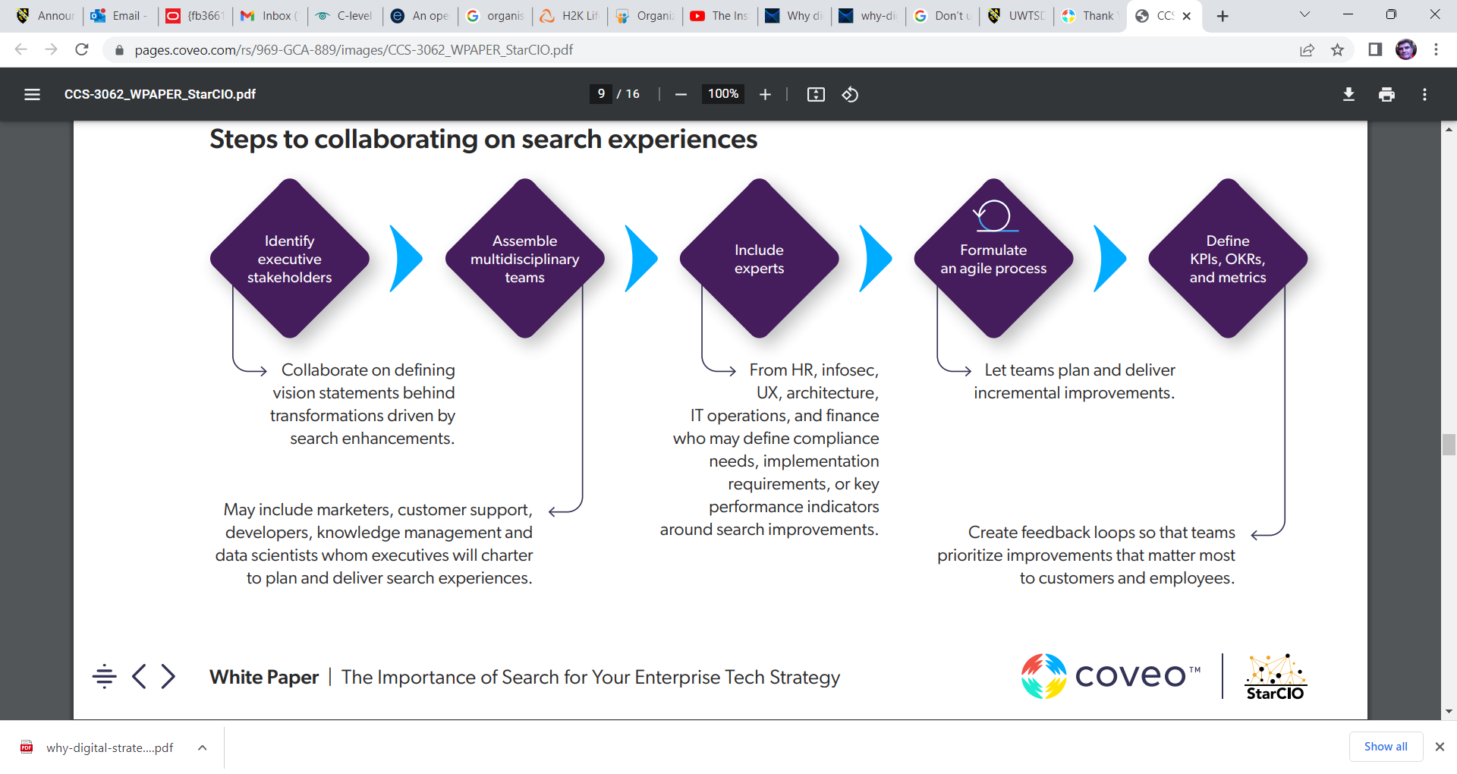
Source downloaded white paper: https://get.coveo.com/whitepaper-enterprise-tech-strategy/?utm_source=google&utm_medium=cpc&utm_channel=paid-search&utm_campaign=p-enterprise-architecture&utm_adgroup=p-enterprise-architecture-digital-transformation&utm_term=enterprise%20digital%20strategy&utm_content=enterprise-tech-strategy-cio-guide&gclid=Cj0KCQiA6rCgBhDVARIsAK1kGPLwuT-CA6uz78y9jUIBfgphxynWqmOn4UYQJUKqphgMavufS84ooh8aAhV2EALw_wcB

Register as a “Post Graduate Researcher”.

See what is already out there…follow their lead. Industry relevant sources or even see what works in another or related industry. Bend them to your industry, location and company case.

I am not saying cut and paste from these reports, without full referencing. Also there is a need to analyse the validity and reliability of some of these resources since they ARE NOT refereed academic journals. However I think it would be short sighted to ignore what they have to offer. (The more you read the more repetitious they are. Also they are sometimes guilty of stating the ”blindingly obvious”!!!) They can also help you refine your search for academic articles and models.

- Try to make sure as well as general references to the classic theories, you reference articles directly relevant to your industry or company. For example the higher education “industry” below:

https://www.greatstate.co/expertise/higher-education?gclid=Cj0KCQiA6rCgBhDVARIsAK1kGPI_5zK27qCweZ7VrvdKikfLpdeUY_apWBCzOc3xghVpVpdKowbbuIMaAg4YEALw_wcB

- Do quote what the company says about itself. Then analyse whether they are telling the truth or have the best policy.

They will usually be positive, but are they giving the full picture?
https://www.tatasteeleurope.com/automotive/blog/how-digitalisation-in-automotive-industry
Check what other think about the company:
https://www.industryweek.com/technology-and-iiot/article/21168392/inside-tata-steels-digital-transformation
Then see what academic sources say:
https://www.hbs.edu/faculty/Pages/item.aspx?num=63314

- The pressure to change may come from outside as well as inside your organisation, how might these be different? Look at stakeholders, who are they and what influence do they have.

- Which leadership models are you going to discuss to recommend how the digital investment/change will be achieved?

There is no need for a history of leadership theory, just nominate the two you want to compare and contrast. I have used a more command/hierarchical v transactional/ flatter management model in the past. For simplicity. Use the diagram from Redmond (Undated) if it helps.

Source: Redmond, J. (Undated) Strategy and the importance of strategic leadership. CPA Ireland. https://www.cpaireland.ie/CPAIreland/media/Education-Training/Study%20Support%20Resources/P2%20Strategy%20and%20Leadership/Relevant%20Articles/cpa-article-strategy-and-leadership-final.pdf (Accessed 12-01-23).
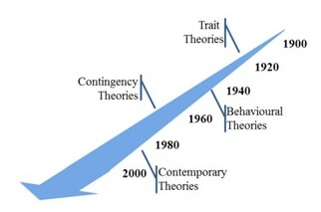

- Try to make sure you link the three sections together. Strategic Environment & Strategy choice (it will be a digital investment) then leadership model to make the digital investment happen then effective-the recommended organisational conditions/ approaches. These are the 3 sections!!!!

- Specific industry references?

Following up for TATA steel example:

Teresa Annunziata Branca¹, Barbara Fornai¹, Valentina Colla^{1*}, Maria Maddalena Murri², Eliana Streppa² and Antonius Johannes Schröder³ (2020) Current and future aspects of the digital transformation in the European Steel Industry.
Matériaux & Techniques Volume 108, Number 5-6,

DOI: https://doi.org/10.1051/mattech/2021010

https://www.researchgate.net/publication/350037654_Current_and_future_aspects_of_the_digital_transformation_in_the_European_Steel_Industry
Accessed via Research Gate (You can register on this site!!!)

The technological transformation in the European steel industry is driven by digitalization, which has the potential to strongly contribute to improving production efficiency and sustainability. The present paper describes part of the work developed in the early stage of the project entitled “Blueprint “New Skills Agenda Steel”: Industry-driven sustainable European Steel Skills Agenda and Strategy (ESSA)”, which is funded by the Erasmus Plus Programme of the European Union. The project aims at achieving an industry driven, sustainable and coordinated blueprint for addressing the economic, digital and technological developments, as well as increasing energy efficiency and environmental demands through continuously update of qualification, knowledge and skill profiles of the workforce. On the one hand, main aspects of the current state of the technological transformation in the steel sector are described through the analysis of the main recent innovation projects and developments. On the other hand, survey results from a dedicated questionnaire addressed to the European steel companies are analysed, providing an overview on the (planned) technological transformation affecting the steel sector. The existing levels of plant automation and the possible adoption of the new paradigm of Industry 4.0 are discussed, by also considering the possible impact on the workforce. Main results are that the steel industry foresees an implementation of almost all Industry 4.0 technologies not only for competitive but also environmental improvement. Because this is foreseen in an incremental way upskilling of the existing work-force is a precondition, not only because of recruitment difficulties on the employment market but also because the existing qualification and experience of the work-place is necessary to unfold the full potential of digital and green transformation.

Reference list
- Write this as you go along, to make sure you do not forget things and that you get the format right.
- Quote the classics (Porter, Ansoff, Mintzberg etc. go to the textbooks to get a summary and quote their work directly, NOT JUST Johnson and Scholes or Mullins, many many times.
- Try to quote some industry material. Trade Associations. Industry Magazines.
- Governmental regulation- relevant laws, regulatory frameworks (this might include self regulation, industry standards etc).

Joyce, P. (2011). Strategic Leadership in the Public Services (1st ed.). London: Routledge. https://doi.org/10.4324/9780203608937
Lahtero, T.J. and Kuusilehto-Awale, L. (2015) “Possibility to Engage in Pedagogical Leadership as Experienced by Finnish Newly Appointed Principals.” American Journal of Educational Research, Vol. 3, no. 3 (2015): 318-329. doi: 10.12691/education-3-3-11. https://www.researchgate.net/publication/277584131_Possibility_to_Engage_in_Pedagogical_Leadership_as_Experienced_by_Finnish_Newly_Appointed_Principals [Accessed 10 March 2023].
Some industry relevant sources. Bend them to your industry, location and company case.
For transport:
https://digital-strategy.ec.europa.eu/en/policies/technologies-digitalisation-transport

https://assets.publishing.service.gov.uk/government/uploads/system/uploads/attachment_data/file/918490/Transport_investment_strategy.pdf

https://iopscience.iop.org/article/10.1088/1757-899X/918/1/012184/pdf

https://www2.deloitte.com/tr/en/pages/public-sector/articles/transport-in-the-digital-age.html
file:///C:/Users/steve/Downloads/transport-strategy.pdf

https://www.restore.co.uk/Digital/Insights/Download/Levelling-Up-Digital-Transformation-in-Local-Government?gclid=Cj0KCQiAx6ugBhCcARIsAGNmMbix95In-n8B_N1I-O7RS0FyDmWxbhULzCmz_m8hz8R5ioBZg4lktP8aAlh7EALw_wcB

https://www.shs-conferences.org/articles/shsconf/pdf/2021/03/shsconf_glob20_05020.pdf
Maybe the company cannot do it all by itself but needs strategic alliance to fund the investment, rationaise bus routes and work with governemrnt at local, regional and national levels.???? See above link.

https://www.futuregenerations.wales/wp-content/uploads/2018/11/20180912-Transport-Fit-for-Future-Generations-C-1.pdf
Future generations Wales is a big deal here.

C-Suite announcement 11 March

"C-suite" refers to the executive-level managers within a company. Common c-suite executives include chief executive officer (CEO), chief financial officer (CFO), chief procurement officer (CPO), chief operating officer (COO), and chief information officer (CIO).
Just a thought.
One angle on your assignment could be to focus on one of the functional strategies, within the context of the general corporate, business evolving a functional strategy to manage/lead the digital change that your sections 1 and 2 will be recommending. This might be HR, Marketing, Procurement, Production.....inevitably it will involve IT (some are not sure this should be classified as a functional specialism, as it should pervade all others). Also the message of the strategy section is that we need to have an integrated approach to solutions to problems and development...teams, joint solutions, collaborative delivery......joined up organisations seem to be more effective....
https://www.efficioconsulting.com/en-gb/resources/insight/open-door-c-suite-cpos/
There are a lot more "Cs", see the link above....
Does your case company in your assignment have the capability to deliver the digital change that you are recommending (from your analysis in section 1 and 2 of the assignment). If not then recruitment and training will be part of your recommendation in section 3.
The bigger the digital change that you recommend at the end of section 1, the more profound and demanding of strong and effective leadership will be.
It depends………Of course different organisations will have different perspectives......the sector (private, public, not for profit), the size (SME, large, global), the industry (retail, industry production, services), the leadership history (see Organisational Life Cycle- similar to the PLC we covered in week 3. A new, established or old organisation will come to the game with different baggage. Here is a video, not bad even if it is delivered by President Putin! https://www.youtube.com/watch?v=OvIQpy2cSYg ) and the different environmental factors (covered in your PESTLE, SWOT etc. making this happen in a recession period will have different challenges to doing the same thing when the economy if growing quickly and resources may be scarce. See these slides https://www.slideshare.net/pradeepmgc/organizational-life-cycle ).

https://www.h2kconsulting.com/english/h2k-about-us/lifecycle-model/
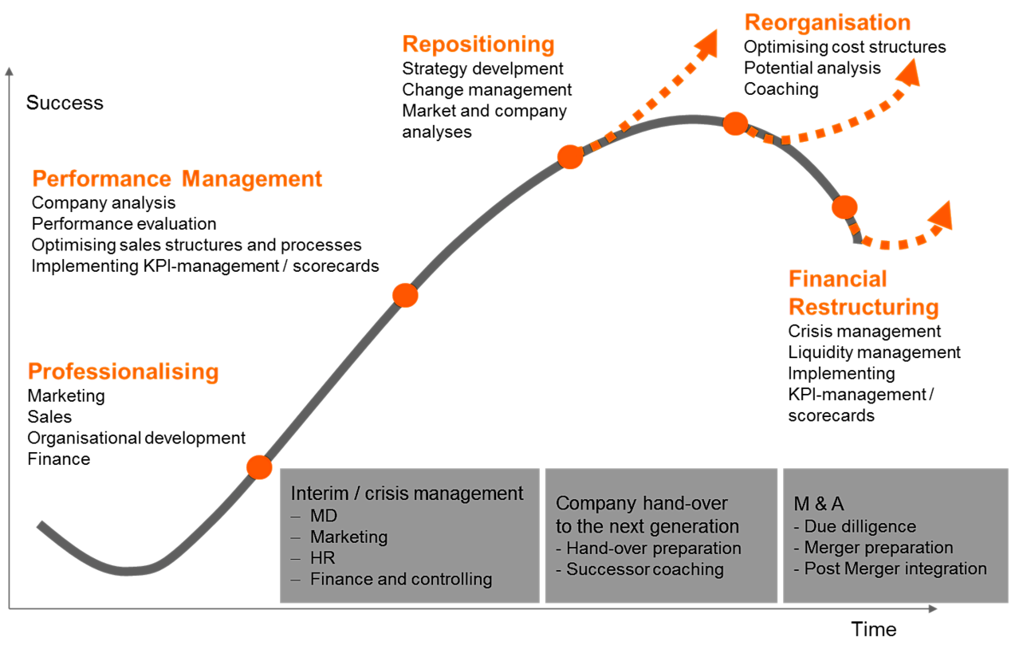
This organisational analysis will be covered in your organisational analysis in section 1 of the assignment. See my recommendation for tactical use of appendices.
I will be uploading advice and more resources to support your research for the assignment.

