PROFESSIONAL CAREER DEVELOPMENT

ASSIGNMENT TITLE: Professional Career Development Report
MODULE CODE: BMSW4005
LECTURER: Laila Surani
STUDENT: Patricia Beatriz Marin Artigas
ID: 2113585

Table of Contents
ABSTRACT 2
INTRODUCTION 2
CURRENT SKILLS 3
GAP IN SKILLS 4
SYSTEMATIC APPROACH TO SKILLS ACQUISITION 5
• Communication skills 5
• Decision Making 5
• Determining Policy 5
RECRUITMENT AND SELECTION ROLE PLAY 6
CONCLUSION 7
REFERENCES 8
APENDIX 10

ABSTRACT
This report contains a review of a career development plan, in which the current skills are discussed, it is analysed what skills are necessary in the chosen career path, following a step by step of the methods to be able to acquire such skills.
Finally making a reflection of the role play interview, discussing the weaknesses and strengths learned in such role play and throughout the module.
The reflection of this report is based on Kolb’s reflective model, added as appendix 1.

INTRODUCTION
Social workers are a fundamental part of the processes of fostering or adopting minors, since they oversee the well-being of the children and the families before, during and after the process. For that reason, it is important to consider the skills required for such work, before starting a career in social worker.
When I started studying Health and Social Care, It was very clear to me that I wanted to focus my profession on fostering and adoption children. Firstly because of my vocation since in my family we fostered disadvantaged children from other countries during summers, and secondly because I considered that I have some of the necessary skills, however, I needed to develop many other ones in order to become a social worker.

CURRENT SKILLS
When planning a career mainly is necessary to analyse certain aspects to determine if it is the desired career. The skills necessary to develop such career, consider the time it will take to achieve the objectives, and take into account the factors that can influence development.
Also, it is important to collect some data and statistics, which can help us examine the options ahead.
Government statistic shows that in 2020 there were 80.080 children in care, 3.440 of them were adopted. In March of 2021 there were 12.340 children looked after under voluntary agreement under section 20 of Children’s Act 1989.
Continuing with the statistics, the following percentage should be highlighted:
- 12.9% of families and children social worker were men.
- 87.1% of families and children social worker were women. (Corambaaf, 2022).
Considering the data and leaving aside stereotypes of specific jobs for men or women, it could be taken into account that the majority of positions in this branch of social work are held by women, due to the skills required such as patience, empathy, active listening or providing care. Skills that in psychology are considered more in women than in men, based on theories such as the ethic of care. (Pettersen, 2008 pp 2-6).
Those human relations skills that in my case I have developed through the experiences lived with my family as a foster home, and that they have helped me when transferring them to my current job as a school assistant.
On the other hand, safeguarding the well-being of minors is the main task of a social worker in the adoption or foster care branch. Therefore, identifying problems and their possible causes is another of the necessary skills in this profession.
The safeguarding training required in each term at the school, and the experience of a year working as a school assistant have helped me develop this important skill. Learning to identify the lack of basic needs such as rest, access to healthy food, hygiene, physical security, access to education, social interactions such as friendship and affection, or respect and trust (showed in appendix 2).
These types of deprivation or in more serious cases such as abuse or mistreatment can occur in family environments in the case of minors who live with their parents/other family members, schools, or in guardianship institutions such as centres or foster homes. (Coleman & May-Chahal. 2003, pp 1-15).

GAP IN SKILLS
When reflecting on the skills necessary to become a social worker, there are some that I lack and are crucial in such a job.
Determining policy is the necessary skill to apply the adoption and children act 2002, knowing how to act based on the adoption law is essential, both with the legislation of the United Kingdom and with international legislation, since a large part of the adoptions of children are carried out in foreign countries. (Mounts and Bradley. 2020, pp 36-37).
Making decisions in any branch of social work implies knowing how to interpret knowledge with evidence, always within a framework of laws, policies, legislation, and ethic.
According to O’connor & Leonard. (2014) in the article “Decision making in children and families social work: The practitioner’s voice. Pp1806-1807” some decision-making processes have been investigated after injuries or deaths of children in the United Kingdom. This reveals the importance of decision-making in this profession since it would imply both the well-being and the safety of human lives.
Also, social workers must apply theoretical foundations within a legal field, for this is necessary to have good communication tools. One of them is writing skill, due to the need for this work to communicate and record through reports and assessments.
In my personal case communication skills is one of my weaknesses since English is my second language, which I have not yet mastered at a fluent level. That is why it is important for my personal development to acquire the use of formal language and professional vocabulary. (Frith & Martin. 2021, pp 33-35).

SYSTEMATIC APPROACH TO SKILLS ACQUISITION
Once the necessary skills have been analysed and after assessing the lack of some such as writing and verbal communication, decision making and determining policy. The next step is to determine how to acquire these skills.
- Communication skills:
To improve my communication skills is not enough to just read books on theory, it is important to put them into practice, continuing to study the degree in Health and Social Care guarantees me the practice of both writing and speaking skills due to the exams as the oral presentation and the reports that I must write each term. (Koprowska. 2008, pp 1-8).
- Decision Making:
There are many points in common between social work in fostering and adoptions and the work of schools. In both, minors must be safeguarded and provided with the necessary care and education.
Continuing to work in the care of minors as a school assistant in schools or care assistant in nurseries, it is a way of gaining experience in decision-making, since in addition to putting into practice the theory learned in class and acquiring more knowledge, thanks to the interaction with other professionals who have more experience. Giving priority to gaining experience rather than earning more money by working in other sectors during my studies.
“All the various tasks involved in social work process, no matter how they are divided, involved the making of decision” (O’Sullivan. 2010, pp1).
- Determining Policy:
Possibly, at the end of the degree in Health and Social Care I will not have sufficient knowledge regarding the policies and legislation necessary to work as a social worker in adoptions and fostering of minors. If that is the case, the next step to obtain such knowledge it would be to study a specific master’s degree in such area.
On the other hand, volunteering in fostering agencies during my university studies is another option with which I can gain skills and experience. More and more organisations offer volunteer positions to meet their needs, it is estimated that 50% of the adult population of the UK has volunteered at least once in their life. (Wardell, Lishman & Whalley. 2020).

RECRUITMENT AND SELECTION ROLE PLAY
The role play carried out in class was a way of putting into practice everything learned during the professional career development module. (Showed in appendix 3).
As it explained earlier in the communication skills section, putting the knowledge into practice helps me particularly to improve communication and gain more confidence when speaking in public.
Working on the preparation of the job search has served me as experience in future job searches, since I have been able to expand places where to find the desired job offer.
The preparation of the job application form has been very useful to refresh my resume, since in the last year I had obtained new qualifications of which I was not aware of how useful they can be if I want to change companies.
Practicing for the role play focused on a job interview has made me significantly improve my answers compared to previous job interviews, understanding the importance of the body language, learning how to transfer skills from personal to professional, and considering the importance of finish the interview answering any question to the interviewer. (Corfield, R. 2009).
Regarding what to improve after the role play, I find that since there was no direct question about how I work in a team, I should have mentioned that I am a team player in some of the answers.
In the case of the question about what my greatest achievement was, I consider that there was a lack of information in my answer, since I limited myself to saying that it had been my recent academic degree because I had achieved it at the age of 41 years old, when it would have been more relevant to explain that this title has been extra difficult for me because I have achieved it in a foreign country, and in my second language, which is still one of my weaknesses.
When answering the question about one of my weaknesses, I made the mistake of talking about a personal aspect when I explained that I am too organized, giving as an example that I am not able to go to bed if the dishes were not in the dishwasher. (Houston. 2008, pp 114-126).
As an interviewer, I must point out that I did not finish the interview correctly, since it should have ended by saying if you are selected, we will contact you within a certain period of time.

CONCLUSION
When it comes to summarizing everything learned in professional career development module, I find a high improvement in my abilities in terms of confidence, better ability to plan new goals in my current job and greater ability to execute new searches and apply for new jobs. All this thanks to the group and individual exercises practiced during the classes, and the role play as an exam carried out.
On the other hand, it is advisable to continue this progress studying to get the qualifications required to become a social worker. Taking advantage of opportunities such as volunteering to gain experience and improve as a potential candidate in future job opportunities.

REFERENCES
- Coleman, S. & May-Chahal, C. (2003). Safeguarding Children and Young People. 1st ed. [Online]. Available from: file:///C:/Users/patri/Downloads/9780203865606_previewpdf%20(2).pdf (Accessed: 16 August 2022).
- Corambaaf. (2022). Statistics: England. Looked after children, adoption and fostering statistics for England. [online] Available from: https://corambaaf.org.uk/resources/statistics/statistics-england (Accessed: 13 August 2022).
- Corfield, R. (2009). Successful Interview Skills: How to Prepare, Answer Tough Questions and Get Your Ideal Job. 5th ed. [online]. Available from: https://www.proquest.com/publication/105878?OpenUrlRefId=info:xri/sid:primo&accountid=130472&parentSessionId=pJB3l1iEp%2B%2FcBEG%2FWm8LvWCRZhC5m6btvIMrf8ha%2Fag%3D (Accessed: 20 August 2022).
- Frith, L. and Martin, R. (2021). Professional Writing Skills for Social Workers. 2nd ed. [E-book] Available from: https://books.google.co.uk/books?hl=en&lr=&id=_MgvEAAAQBAJ&oi=fnd&pg=PA32&dq=writing+skills+for+social+workers&ots=0dfe2vYYsn&sig=5GaUwEToGRwRnRmgntUlmfcQ2gM#v=onepage&q=writing%20skills%20for%20social%20workers&f=false (Accessed: 17 August 2022).
- Houston, K. (2008). Winning Interviews for First - Time Job Hunters, 2nd ed. [online]. Available from: https://www.proquest.com/publication/51136?OpenUrlRefId=info:xri/sid:primo&accountid=130472&parentSessionId=lmOevSduUYAFQj%2B%2FMENQlbNQnJlXke0kqejgJ3kbo8w%3D (Accessed: 21 August 2022).

- Koprowska, J. (2008). Communication and Interpersonal Skills in Social Work. 2^{nc} ed. [online]. Available from: https://www-vlebooks-com.ezproxy.uwtsd.ac.uk/Product/Index/54266?page=0 (Accessed: 20 August 2022)
- Mounts, B. and Bradley, L. (2020) ‘Issues Involving International Adoption’, The Family Journal, 28(1), pp. 33–39. [online]. Available from: https://journals.sagepub.com/doi/full/10.1177/1066480719887494 (Accessed: 16 August 2022).
- O'Connor, L. & Leonard, K. (2014). “Decision Making in Children and Families Social Work: The Practitioner's Voice” The British Journal of Social Work. 44 (7), pp. 1805–1822. [online]. Available from: https://academic.oup.com/bjsw/article/44/7/1805/1717099?login=true (Accessed: 17 August 2022).
- O’Sullivan, T. (2010). Decision Making in Social Work. 2nc ed. [online]. Available from: https://books.google.co.uk/books?hl=en&lr=&id=HyNHEAAAQBAJ&oi=fnd&pg=PR7&dq=decision+making+skills+in+social+work&ots=HIoTW5cGsk&sig=3FhfaExA1ph8SpU14ECir8GLr-8&redir_esc=y#v=onepage&q=decision%20making%20skills%20in%20social%20work&f=false (Accessed: 20 August 2022).
- Pettersen, T. (2008). Comprehending Care: Problems and Possibilities in the Ethic of Care. [online]. Available from: https://books.google.co.uk/books?hl=en&lr=&id=SJde3oy8ZXEC&oi=fnd&pg=PP1&dq=gilligan+ethic+of+care&ots=s8AjifqvmP&sig=lu0FohLUwsi-5DfWLoltRfwqQc8#v=onepage&q=gilligan%20ethic%20of%20care&f=false (Accessed: 16 August 2022).
- Wardell, F. Lishman, J. Whalley, LJ. (2020). “Who volunteers?” The British Journal of Social Work, 30 (2), pp 227–248. [online]. Available from: https://academic.oup.com/bjsw/article/30/2/227/1699585?login=true (Accessed: 20 August 2022).

APENDIX
Number 1:
Concrete experience:
-Experience moving abroad
-Foster family experience

Active experimentation:
-Continuing the studies to get the bachelor
-Volunteer for experience.

a

AAa
Reflective observation:
-Reflect about transferable skills and skills needed
---

Abstract Conceptualization:
-Avoid thinking of age as a barrier (previous mistake)

Number 2:
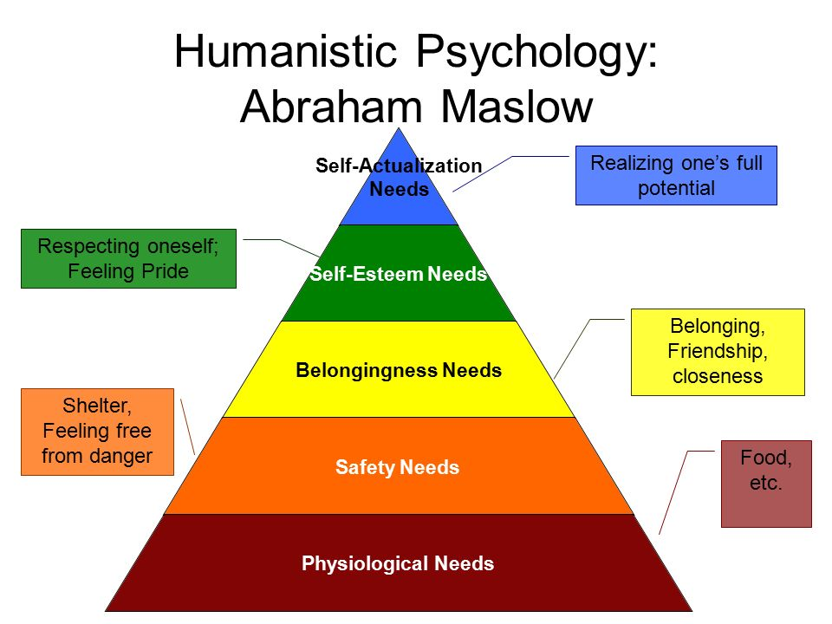
Picture from: UWTS.

Number 3:


