Info Engineering Controlled Assignment
Clear and easy to read.
No annotation of relationships.
Many to many??
Not clear to follow foreign keys.

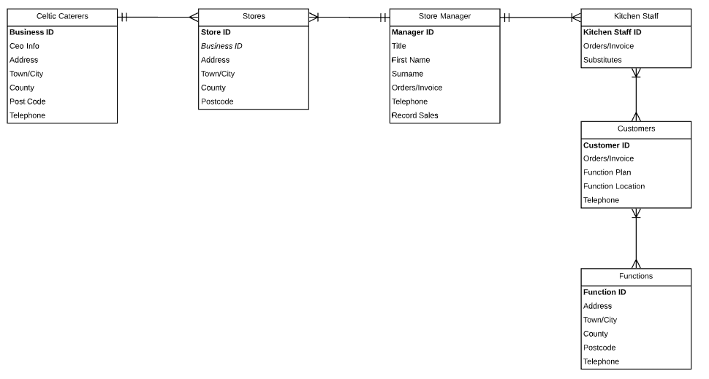
Entity Relationship Diagram
Seen above is a completed Entity Relationship Diagram that shows the process of placing an order for a function that will be supplied from an outside catering service.
It can be seen that all the entities involved are: Celtic Caterers, The Stores, Store Managers, Kitchen Staff, Customers, and Functions. The bold writing is Primary Key information and Italics writing is Foreign Key information. This information will now be portrayed through a data dictionary.

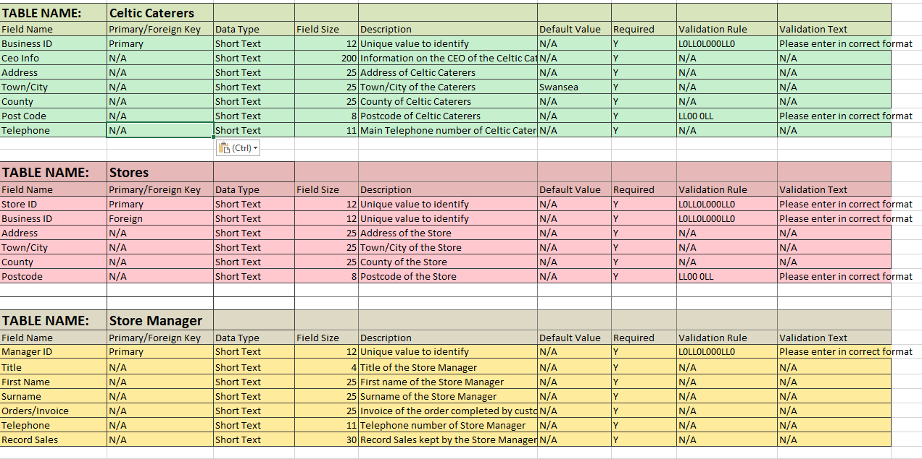
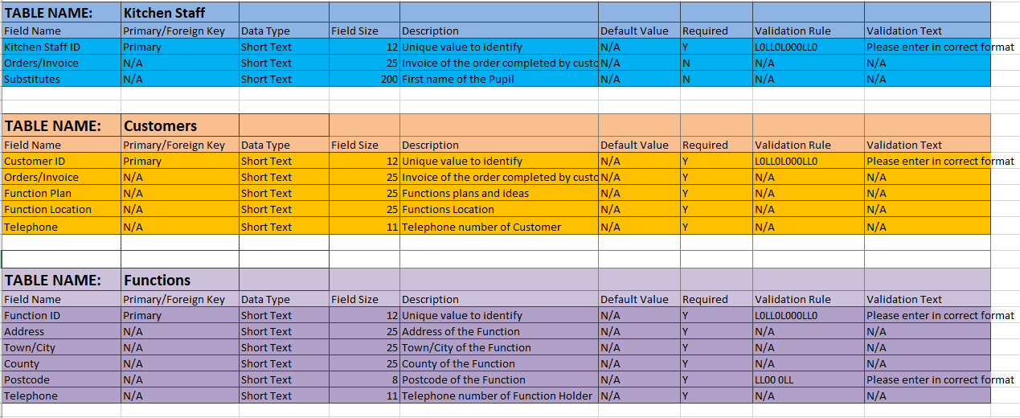
Data Dictionary
Data type all the same?
Lacking foreign keys
Seen above are two different snipping tool screengrabs from my data dictionary.
The information displayed is that of the Entity Relationship Diagram but in further detail. The assumptions made in this data dictionary are:
- The customers do not have a set location as they are providing services from function locations and venues.
- The stores locations values have been left blank due to the fact the company may want to branch further than they already have.

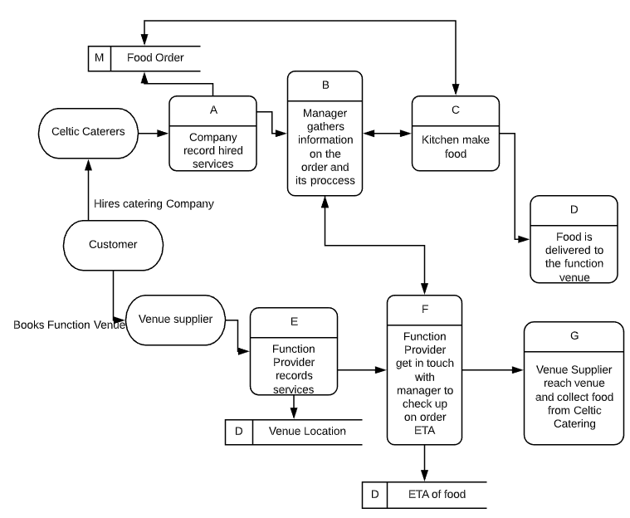
Data Flow Diagram
No dataflow descriptors.
You have external to external flow and dataflow ending at a process.
You are missing a level 0.
Some data flows missing.

The data flow diagram here shows what exactly would happen when the order goes through from the customer to both Celtic Caterers and the Venue Supplier.

