

University of Wales Trinity Saint David
School of Engineering

Vehicle Balance and Braking Report

Oscar Pollitt 1900412

BSc Motorsport Engineering

Table of Contents
CHAPTER 1.0 INTRODUCTION 3
1.1 Aims 3
1.2 Vehicle Specification 3
CHAPTER 2.0 RESEARCH 4
2.1 Handling and Comfort 4
2.2 Natural Frequency 4
2.3 Suspension Geometry and Setup 4
2.4 Weight Distribution 5
2.5 Tyres and Wheels 5
2.6 Aerodynamics 5
2.7 Standard Road Vehicle 5
2.8 High Performance Road Vehicle 6
2.9 Competition Vehicle 6
CHAPTER 3.0 RESULTS 7
3.1 Applied Accelerations 7
3.2 Combined Acceleration 8
3.3 Geometry Variation 9
CHAPTER 4.0 ANALYSIS 10
4.1 Applied Accelerations Analysis 10
4.2 Combined Acceleration Analysis 11
4.3 Geometry Variation Analysis 12
CHAPTER 5.0 CONCLUSION 13
CHAPTER 6.0 BIBLIOGRAPHY 14

CHAPTER 1.0 INTRODUCTION

1.1 Aims
The aim of this report is to compare and contrast various vehicle chassis and suspension design features and their behavioural characteristics. This report will look into how handling and comfort are affected by vehicle design and setup choices. Data will be analysed using excel to understand the effect of different scenarios a car undergoes.

1.2 Vehicle Specification

Mass | 628 | kg
Wheelbase | 2.8 | m
Centre of Gravity Height | 0.36 | m
Static Weight Distribution (Front) | 47 | % Front
Static Weight Distribution (Left) | 51 | % Left
Cl | -0.62
A | 1.2 | m²
Air Density | 1.223 | kg/m³
Centre of Pressure | 42 | % Front
Average Track | 1.62 | m
Maximum G | 1.5 | G

In this report a set of vehicle specifications have been given and will be entered into excel to create data and graphs that can be analysed and investigated.

CHAPTER 2.0 RESEARCH

2.1 Handling and Comfort
Ride and handling are important properties in a vehicle. Ride is mainly the degree of separation from the road surface and vehicle ride is more comfortable when more separated from the road surface. Handling is the responsiveness from the driver steering input and the ease that a driver can become synchronised with the car, and the vehicle reacting predictably. However, handling and comfort are often either ends of a spectrum where the need for improvement in one conflicts with the other. In general, neutral soft suspension will increase ride quality and stiff, aggressive suspension will improve the handling. Comfort can be affected by movement of the vehicle such as roll, squatting and pitching of the car body. Therefore, the purpose of the vehicle will influence the suspension design along with various other factors that affect a cars handling and comfort. (Jiang and Wang 2015) (Riley 2019)

2.2 Natural Frequency
Suspension setup for handling or comfort is affected by numerous features on a car such as tyres, suspension geometry and spring rate. One way to analyse suspension is using natural frequency of the springs. Higher natural frequency means the springs return to its neutral form faster after a compression improving responsiveness of the car but reducing comfort. For lower natural frequencies the opposite is applied, and the car is more comfortable. In typical passenger cars the frequency is around 0.5-1.0 Hz, Rally cars and high-performance road cars can be seen with up 2.0Hz and in extreme high downforce race cars like Formula cars can be seen with 3.5-5.0Hz. Ride is considered comfortable for people when the frequency is within 1-1.5Hz and explains why most passenger cars fit within this target. (Rajeev and Sudi 2019) (Riley 2019)

2.3 Suspension Geometry and Setup
Setup and geometry involves components such as dampers, springs and roll bars and geometry setting involves changing geometry such as camber and toe. Changing these geometries often either favours straight line stability or cornering ability, with stability offering comfort and improved cornering ability improving handling. Setting up dampers for handling or comfort means choosing how quick rebound and compression occurs. Quicker rates means more responsive suspension and slower rates mean more comfortable ride. Camber is the angle of the wheel to the road and can be utilized in cornering characteristics on a more handling orientated car, with negative values on the front wheels improving cornering as the car rolls onto the tyre maximizing the contact patch during a turn. Toe angle is the angle the wheels are pointing when looking from above the wheel. Toe in will give a car more stability and toe out will improve steering response. A component commonly found in cars are anti rolls bars which stops roll in corners keeping the car level and all wheels in contact with the floor. (Torque Cars 2015)

2.4 Weight Distribution
Weight distribution is an important factor in the handling of a car. It is affected by factors such as centre of gravity and its height, roll, yaw and pitch inertia, component placement and design of the car. Centre of gravity (also known as the centre of mass) is the average location of the weight of an object. When it comes to cars the centre of gravity is favourable around the centre of the car. To improve handling of a car the lower the centre of gravity the better, usually done by lowering the ride height of the car, to compensate for the body lean by keeping the car close to the floor in high speed turns and reducing load transfer. When talking about static weight distribution it is often aimed for a near balanced distribution around 50/50 when favouring handling. This is because when cornering the weight needs to be distributed evenly so that the car rotates without understeer or oversteer. Over and understeer can be compensated for by increasing weight on the front or rear of the car as these two problems are created by an imbalance of grip on the front and rear of the car. More weight on the affected side offers more grip. Track and wheelbase affect weight distribution with track affecting weight distribution laterally and wheelbase affecting it longitudinally. Wheelbase also affects yaw characteristics. Tyres on a car often work best when the car has near 50/50 weight distribution because the more load on a tyre, the less coefficient of friction there is. If the load is uneven one tyre will lose friction faster than the others. (CJ Pony Parts 2020) (Engineering Explained 2015) (Build Your Own Race Car 2020) (Nozaki 2008)

2.5 Tyres and Wheels
Tyres allow for a car to grip the road surface. Higher performance tyres offer more grip and therefore allow for increased cornering speeds, better acceleration and braking. The tyre’s grip level often depends on the compound, tread pattern and structure. Cars with bigger tyre sidewalls will often experience better ride and comfort due to the dampening in both road surface and noise that is created from having a thick tyre. Therefore, the smaller the tyre wall the more responsive the car is. The size of the wheel can affect the ride and handling of a car. Wider wheels and tires offer more traction. Less unsprung mass, either affected by material choice or wheel size, has multiple benefactors such as more control from the suspension of movement and the engine will use less power to move the wheel. (Pirelli 2016) (Riley 2019)

2.6 Aerodynamics
Aerodynamics affect multiple properties in vehicles, including comfort and driving characteristics. Good aerodynamics lead to noise reduction, improved ventilation, stability and handling improvement. Cars can be designed for reduced drag with streamlined design that reduces force resistance from the air. Cars can also be designed with areas that create reduced lift. For example, a rear spoiler would be a common component to reduce lift. In performance and racing cars negative lift is important because it increases the speed in corners. This is often achieved by multiple spoilers and devices around the car that aim to reduce lift. (Lajos 2002)

2.7 Standard Road Vehicle
A standard road vehicle aimed at the average consumer will favour comfort over handling but still consider handling. This means the suspension will be soft and the vehicle will have a high centre of gravity. It’s likely to have smaller wheels by width with standard tyres with a larger sidewall that dampens out bumps and vibrations and aerodynamics to reduce noise inside the cabin. The weight will be distributed more towards where the engine is placed and not as factored in as much other characteristics. Cars with neutral steering characteristics can easily oversteer if encouraged and therefore designers create a car with a degree of understeer in order to avoid oversteer. The cars handling ability would not be a problem for most drivers as they wouldn’t consider it a need and the car is unlikely to experience harsh driver inputs and high cornering speeds. (Riley 2019)

2.8 High Performance Road Vehicle
A high-performance vehicle will favour handling over comfort whilst still considering comfort. This means the suspension will be stiffer and the geometry balanced for cornering and straight-line speed meaning the ride will be harsher with more feeling of the road surface but still comfortable. The car will be engineered for a low centre of gravity and will have well balanced weight distribution. The setup will most likely favour oversteer in its design when pushed. The vehicle will have aerodynamic features that increase negative lift for increased cornering speed. This setup for handling over comfort is acceptable because the car is designed for drivers who enjoy driving and are willing to be more encouraging in pushing the car’s limits.

2.9 Competition Vehicle
A competition vehicle will completely favour handling over comfort with little to no consideration of comfort. This means the suspension will be extremely stiff and the geometry will usually be favoured for cornering. The ride won’t be comfortable, and the car will be as low to the ground as possible. The car will have well engineered weight distribution most likely near 50/50. The car will feature complicated aerodynamics that create high amount of negative lift. This is designed this way because the car is designed to achieve the fastest time around a circuit with high cornering speeds and responsiveness allowing the driver to achieve this by sacrificing comfort.

CHAPTER 3.0 RESULTS

3.1 Applied Accelerations

3.2 Combined Acceleration
Combined Lateral and Longitudinal Acceleration

Long G
Lat G

3.3 Geometry Variation

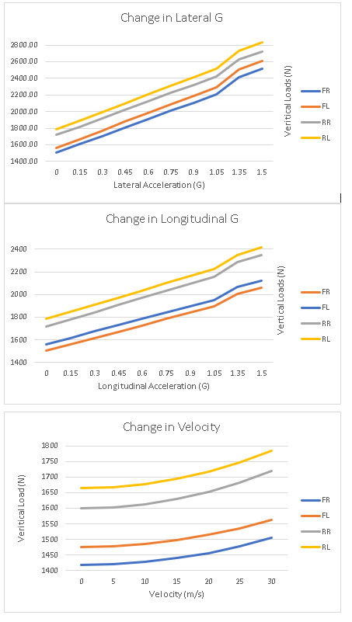
CHAPTER 4.0 ANALYSIS

4.1 Applied Accelerations Analysis
The graph showing change in lateral G shows how vertical load on the sides of the vehicle changes as the lateral acceleration increases. The result is a linear increase where, when acceleration increases, load increases on all 4 sections of the car. The lines for all sections share an anomaly at 1.05g where the gradient increases up until 1.35g and reduces back to a similar rate before 1.05g. The two areas with the most load is the rear sections. This is because there is more weight distributed onto the rear at 53%. The looking at the distribution of load from left to right shows that the left side has greater load with lines in 1st and 3rd highest values compared to the right side has 2nd and 4th highest values. This is because there is marginally more weight on the left side of the car at 51%. The graph showing change in longitudinal G is similar in nature to the graph showing change in lateral acceleration, with linear lines sharing similar gradients and an anomaly at the same values of 1.05g and 1.35g. The distance in values of load between the front and rear is greater at 1.50g than it was at 0g. Compared to the change in lateral g where the distance of values is lesser at 1.50g then it was when it was at 0g. Noticeably the change in lateral acceleration is greater than the change in longitudinal acceleration. This could be because the wheelbase is larger than the track and therefore laterally the load has less distance to travel and distributes more load compared to longitudinal acceleration. The graph showing change in velocity shows an exponential increase in load as velocity increases with the rear of the car having a steeper gradient. This could be because the centre of pressure is greater on the rear of the car at 58%. The reason for an exponential increase could be explained by the equation for aero load $Cl*0.5PV^{2}*A$ where the velocity is squared meaning as the velocity increase by 5 m/s, the aero increases by 25, then 50, 75, then 100 (and so on) between each increment.

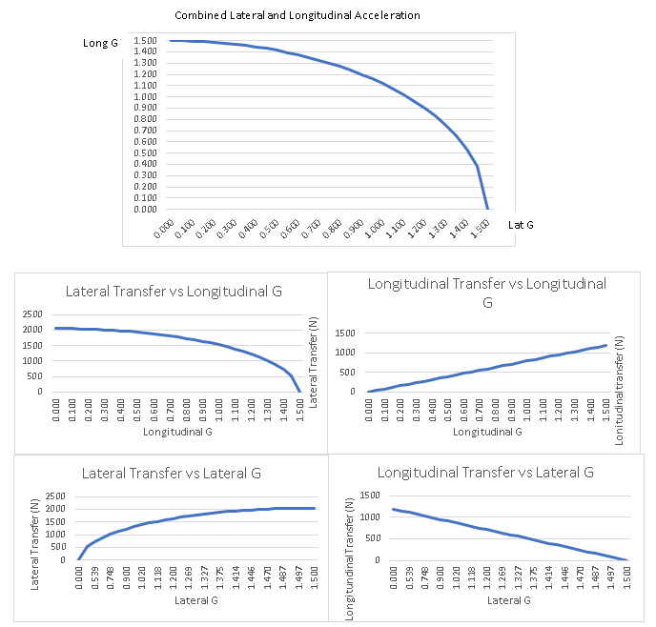
4.2 Combined Acceleration Analysis
The graph showing combined acceleration with a combined maximum value of 1.5g show that as one axis of acceleration increases the other decreases. It also shows part of a traction circle where if any value is outside the quarter circle the vehicle would lose grip. The graphs comparing load transfer and acceleration show that during combined acceleration an increase in one load transfer will increase with the same axis’s acceleration and decrease with the opposites acceleration. For example, as longitudinal transfer increases, longitudinal g increases and lateral g decreases. The reason that 1.5g can’t be achieved on both axis at the same time can be explained by Pythagoras’s theorem where $a^{2}+b^{2}=c^{2}$ and if “a” and “b” are 1.5;
${1.5}^{2}+{1.5}^{2}={4.5}^{2}$ c=2.12G. 2.12G is greater than the stated maximum G in the vehicle specification in the introduction of 1.5G and in theory the vehicle would lose traction as the its outside of the traction circle displayed in the combined acceleration graph.

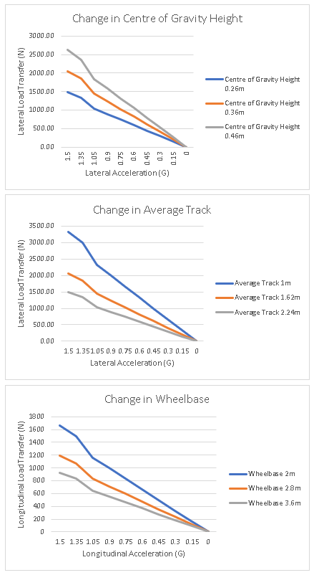
4.3 Geometry Variation Analysis
The graph showing change in centre of height shows that a lower of centre of gravity results in less load transfer. This means that the vehicle would be able to achieve higher values of lateral acceleration as the tyres would be under less lateral load transfer. The graph showing change in average track shows that the wider the track, the less load transfer there is laterally. This could be because there is greater distance for the weight to be distributed during lateral acceleration. A wider track therefore means that a vehicle could withstand higher lateral acceleration because the load on the vehicle is smaller. Lastly the graph showing change in wheelbase shows that the greater the wheelbase is the less longitudinal load transfer occurs. This means the same as the change in track where there is more distance for load to be distributed meaning it could take more load longitudinally.

CHAPTER 5.0 CONCLUSION
In conclusion the chassis and suspension systems were researched and analysed. The findings from research were that multiple features on a car are influential on the handling ability of a car. Then an investigation into load on a car during different scenarios including acceleration and cornering found that load increases when acceleration both combined and in one direction are applied to the vehicle. Vehicle geometry was also changed to see the effect on the cars load transfer, and it was found that by changing the cars design that it can positively affect the car reducing load transfer. During this investigation into vehicle balancing has gained a further understanding on handling and how it is affected by numerous features on car.

CHAPTER 6.0 BIBLIOGRAPHY

Jiang, R. and Wang D. (2015) Optimization of Vehicle Ride Comfort and Handling Stability Based on TOPSIS Method. Available at:https://saemobilus-sae-org.imeche.idm.oclc.org/content/2015-01-1348/ (Last Accessed 22 March 2020)
Riley, R. (2019) Automobile Ride, Handing, and Suspension Design and Implications for Low-Mass Vehicles Available at:https://rqriley.com/automobile-ride-handling-and-suspension-design-and-implications-for-low-mass-vehicles/ (Last Accessed 22 March 2020)
Rajeev, N, and Sudi, P. (2019) Natural Frequency, Ride Frequency and their Influence in Suspension System Design. Available at:https://www.ijera.com/papers/vol9no3/Series-3/K0903036064%20.pdf (Last Accessed 22 March 2020)
Smith, W. (2015) Fine tuning your suspension setup for your driving style. Available at: https://www.torquecars.com/tuning/suspension-settings.php (Last Accessed 22 March 2020)
CJ Pony Parts (2020) Centre of Gravity Available at:https://www.cjponyparts.com/resources/center-of-gravity-infographic (Last Accessed 22 March 2020)
Engineering Explained (2015) Why Do Wider Tires Have More Grip? Tire Load Sensitivity. Available at: https://www.youtube.com/watch?v=kNa2gZNqmT8 (Last Accessed 22 March 2020)
Build Your Own Race Car (2020) Car Handling Basics, How-To & Design Tips. Available at:https://www.buildyourownracecar.com/race-car-handling-basics-and-design/ (Last Accessed 22 March 2020)
Pirelli (2016) How Does Wheel Size Condition the Performance of Your Car? Available at: https://www.pirelli.com/global/en-ww/road/how-does-wheel-size-condition-the-performance-of-your-car (Last Accessed 22 March 2020)
Lajos, T. (2002) Basics of Vehicle Aerodynamics. Available at: https://www.ara.bme.hu/oktatas/letolt/Vehicleaerodyn/Vehicleaerodyn.pdf (Last Accessed 22 March 2020)
Nozaki, H (2008) Effect of The Front and Rear Weight Distribution Ratio of a Formula Car during Maximum-Speed Cornering on a Circuit. Available at: https://rd-springer-com.imeche.idm.oclc.org/content/pdf/10.1007/s12239-008-0037-2.pdf (Last Accessed 22 March 2020)
Guiggiani, M. (2014) The Science of Vehicle Dynamics. Available at: https://rd-springer-com.imeche.idm.oclc.org/content/pdf/10.1007%2F978-94-017-8533-4.pdf (Last Accessed 22 March 2020)
Bosch (2018) Automotive Handbook 10th Edition. Karlsruhe: Robert Bosch

