
Skills for the Workplace
Module Assignment Submission
Student Name: | Jahanara Begum
Student Number: | 1710632
Module No: | BMSK 6002
Module Title: | Developing Innovation and Creativity for Business Advantage

Statement of Confirmation of Authenticity
By the act of making this submission, the student declares that this is the work of the student named above. The work has not, in whole or in part, been knowingly presented elsewhere for assessment, or where assessment has been built on a previous assessment, this has been identified. Where materials have been used from other sources it has been properly acknowledged. If this statement is untrue, the student acknowledges that an assessment offence has been committed.
Attention is drawn to the plagiarism and unfair practice policies of both the University and of ILM.

Table of Contents
1.0 Introduction 4
1.1 Creativity and Innovation 4
2.0 Models of innovation 5
Linear innovation model 5
Disruptive innovation model 8
3.0 Overview of Care Home 10
How Home Instead Care relates with the models of innovation 10
4.0 Factors affecting the innovation of an organisation and how they relate with Home Instead Care: 11
Following indicators relate to disruptive innovation – 11
Recommendation 12
5.0 Evaluation of harness creativity of Home Instead Care 13
How Home Instead Care relates with creativity 14
Factors affecting creativity of an organisation and how they relate to Home Instead Care 14
Recommendation 16
6.0 Evaluation of the ability to foster a creative culture in the workplace of Home Instead Care 16
How Home Instead Care will foster a culture in the workplace 17
Factors affecting the culture of an organisation and how they relate with Home Instead Care 18
Recommendation 19
7.0 Conclusion 20
Reference 21

1.0 Introduction
In regular life, there are lots of innovations and development happening. Among these, some of the development and innovations are crucial for human beings and some are not as effective as others. Some innovative ideas may be successful in both the international and national environments. Some ideas may be spread among people and be very helpful for people. But most of the innovations remain in a very small stage and don’t get any chance to improve for lackings of a proper platform. Now people are talking much about these types of development and theoretical model of innovation. This report will describe and analyse two key models of innovation and the ability and analysis of the chosen organisation. To increase business strategy and innovation of the Home Instead organisation. Following this, an analysis will be provided of the organisation's ability to explain creativity with the workplace environment. And create some understanding of these theories in the business environment of Home Instead. These models of improvement will be applied in the business environment of the Home Instead business strategy. Every business institute needs different kinds of business environments and business strategies to establish effective business policies. These models of improvement will assist the company to be more successful and grow its future business.

1.1 Creativity and Innovation
Creativity is the ability to produce new and unique ideas, and innovation is the implementation of these ideas (Sokolova,S.2015).
Creativity goes hand in hand with innovation. Without creativity there will be no innovation.
Creativity and innovation is important as it can increase the productivity for any business.

2.0 Models of innovation

Linear innovation model
This model of innovations mentions a model that relates innovation and science with the essential examination fields and improvement. These innovations can at last impact on the development in the economy. Any innovation under this model of improvement needs to pass a for completing the previous stage (Ahmad, 2021). This guarantees that every stage must be completed with no errors to make sure the quality of innovation is maintained. The progression of this model includes a series of continuous and subsequent phases that are generally organised in such a way that the previous or earlier stage must be cleared or completed before going on to the next step (Liu et al., 2020). As a result, any venture must pass via a certain entrance with the guard's authorisation before proceeding to the next level (Zhou et al., 2020). Because of this model of development, the level of hazard is often low because the supply of goods or services is limited from the start. This model is significantly more productive and less stressful for beginners.
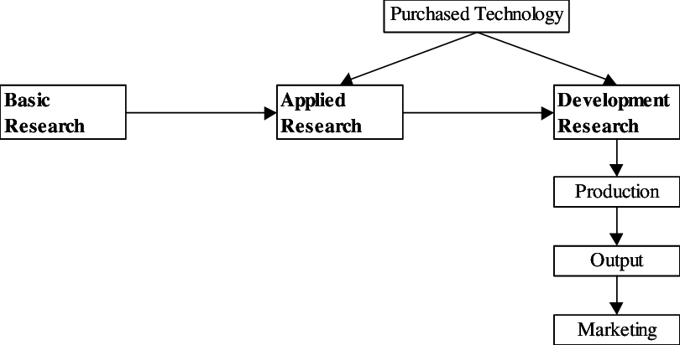Figure: Linear innovation model
Source: (Scielo, 2021)

The market pull model: The second-generation linear model is known by the name of the market pull model. It was created between the years 1960 to 1970. The demands and desires of the clients are the most important determinants in this development plan. The ways of this model's sequence are dissecting client needs and market necessities, developing innovative ideas, refining those plans to meet the fewest requirements, creating and assembling, planning, promoting, and selling (Terzidis and Vogel, 2018). A few limitations were also discovered in this direct development technique. If the initial idea of the model is poor then the model might fail and can not fill the target of all the expectations of the development process. The development cycle burns through a lot of time as the interaction has a severe grouping to keep up with. Therefore, the entire cycle is incredibly slow. The process cycle runs very slow from the initial consideration to the ever-changing marketplace (Bento et al., 2020). The interaction mainly centres around the guardian and its controlling cycle yet the buyers may be the fundamental concern. Taking the client's audit, on the other hand, consumes inordinate amount of time. Rather than learning, this strategy focuses on achieving the goal. This works on the connection between science and innovation that brings improvement and helps genuine marketing.
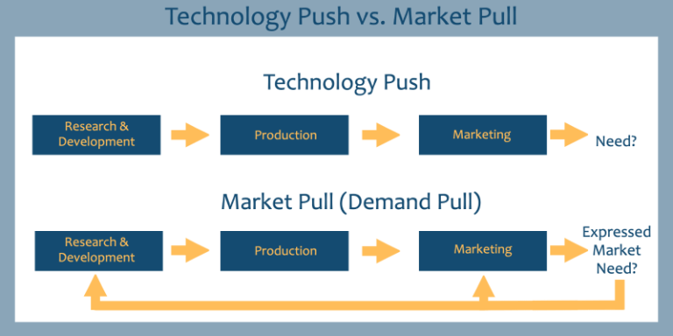
Figure 2: The market pull model
Source: (Arkaro. 2021).

The technology push model: This model brings innovation in different fields of scientific and modern business fields. When another innovation is imagined or developed, new things and administrations emerge on the market, and another cycle begins. For the progression sequence of innovation push development models, vital science, critical examination, application, exploration, assembling and creating, showcasing, planning, and deals are recalled in this model of push innovation (Terzidis and Vogel, 2018). According to this approach, consumers are merely passive beneficiaries of future outcomes and administrations. For this situation, the criticism of the clients can not affect much significance. The output of the model is so innovative that the customers can accept the new ideas (Hansen et al, 2017).
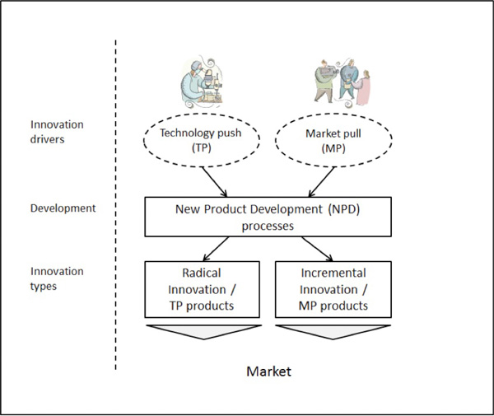
Figure 3: The technology push model
Source: (Scielo, 2021)

Disruptive innovation model
Clayton Christensen used the term "disruptive innovation" in the 1990s to describe how new market participants might damage and destroy established organisations. This model needed to be viewed more easily in the past because new organisations such as Uber, Etsy, and a variety of other new businesses or new competitors had emerged in the market with the expectation of changing their operations (Mendoza-Tello et al., 2019).
The disruptive model of innovation and the success of this model depends on various steps. The responsible organisations or the modest organisations can create and develop their administrations and items to interest the most requesting or most productive clients by analysing the need of the market. Competition typically focuses on the ignored market or downmarket segment to get a foothold by satisfying their requirements by offering a lower price in comparison to the price offered by those officeholder organisations. Most officeholders would prefer not to respond to these new participants and instead focus on the more advantageous aspects of them (Chen et al., 2020). The contestants climb on the market and they do that by offering numerous solutions for those officeholders' fundamental clients and appealing to them (Tyfield, 2018). When another contestant starts to draw in the standard clients of the occupant organisations an interruption happens. According to Merriam Webster, disruption is a cycle that causes something to lose the ability to progress in a typical or ordinary fashion, or to interfere with any normal innovation and movement of that item. When this term is applied to business, it is almost likely that whatever eventually enters the market and becomes profitable should be identified as disruptive (Chen et al., 2020). The new contestants become fruitful and accomplish their objectives as the initials or set up organisations stay occupied and extremely centre around serving their beneficial clients and they overlook the necessities and requests of lower or small segments.
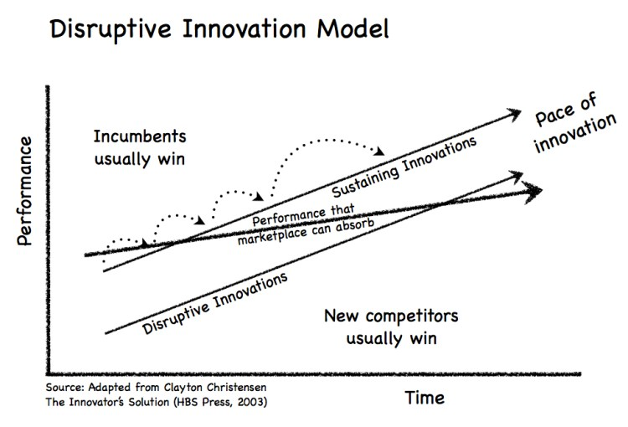
Figure 4: Disruptive innovation model
Source: (Posts, 2021)

Disruption can happen in different ways such as low-end disruption and new-market disruption. They are described below.
- Newmarket disruption: A new market disruption is another sort of disruption. It refers to businesses that are frequently confronted with underutilisation in the lower tiers of any industry (Rasool et al., 2018). They, like the low-end disruptors, offer items or administrations that appear to be acceptable on the surface, and these emerging businesses are producing at such cheap prices.
- Low-end disruption: This model denotes a company that generally joins the bottom segment of the market and serves its customers appealingly and appropriately. These are often the business sectors that provide less profit to the officeholders, and as a result, when another business joins, the occupiers will frequently shift further or upstream (Tyfield, 2018). They simply continue to focus on the more significant overall revenues.

3.0 Overview of Care Home
My company, Home Instead Care, is a consideration home business based in CARDIFF, United Kingdom. Home Instead Care works within constraints, such as providing great home consideration administration. Along with homecare assistance, they also provide specialised attention to fulfil the customers' specific needs (Morris, 2019). This company organisation, too, adheres to a few models of development, which are discussed below.

How Home Instead Care relates with the models of innovation
To expand its business, Home Instead Care will use the disruptive innovation model. In this pandemic situation, they will embrace new approaches to gain market share. Customers require home care assistance as never before during this pandemic. Furthermore, to meet these new customer needs, they will devise new arrangements by broadening the area of their administration. Initially, they will accept criticism from their most important and core clients. Elderly citizens and senior residents will be their primary customers (Al-Imarah and Shields, 2019). They will also target people who have been wiped out. In addition, Home Instead Care will enter the market by satisfying the needs of low-end customers and producing a disruptive development model.
Home Instead Care will give the accompanying sorts of working cycles –
- Maintenance: They will give significance to consumer loyalty and their criticism. Any flaws or abuses will be identified in Home Instead Care by accepting and recognising the purchaser feedback or customer requirements (Dina et al., 2019). The help quality will be maintained constantly, and they will make an honest attempt to ensure that the quality does not deteriorate.
- Enhancement: If the customer’s requests to add new administrations or capacities in any current task, Home Instead Care will likewise offer that specific assistance. Then, at that point, new administrations will be added to the general administrations and offices for the customers as per their necessities.

- Development: According to market demand, Home Instead Care will provide support to the sick and elderly. They will concentrate on clients in light of the lately arose circumstances of the pandemic. Because new requirements are unique in this sector, innovation will necessitate much more thought. Difficult concepts involve the proper evolution of assistance based on the needs of the buyers or customers, and our organisation will supply offices to both new and old clients (Cabell et al., 2019). Most home care firms focus on their most valuable customers; however, Home Instead Care will seek customers from all walks of life.
- Support: If customers face any sort of issue in the offered support, then, at that point, the staff of Home Instead Care will think about that with extreme attention to detail and genuineness to give backing and time with that specific model.

4.0 Factors affecting the innovation of an organisation and how they relate with Home Instead Care:

Following indicators relate to disruptive innovation –
- Market factors: It is made up of the creative field, the creative industry, the speciality market, and the types of clients. These characteristics have a major impact on imaginative interaction. The following procedures will be done to develop the innovative cycle deserving of a decent and set up the yield on the lookout. A certain site or house is required for disruptive growth, which is an unquestionable necessity (Lautenbach et al., 2017). Interest in the inventive business will be maintained for as long as is necessary to obtain a market analysis. The extent of machine tooling creation shall be kept within the extent of the quantity necessary. The level of the organisation will be established by dissecting the marketing mix (Janssen et al., 2020). To meet the market need, and increased manufacturing rate will be implemented, and market demand will be reviewed before the process cycle speed increases. To thrive, the challenging invention necessitates the development of a niche market. Regardless of how the market's interest is measured before the full engagement, an outcome may result in unhappiness. In this way, the investigation will be finished with the qualities of the speciality market (Janssen et al., 2020). Customers are a major piece of disruptive innovation since they are the individual to utilise the help by the result of the organisation. As a result, a large number of imaginative customers will be chosen to give the yield for them to promote the item to other buyers once the yield is ready.

- External factors: Macroeconomic, systems administration and competitiveness factors are the details of outside variables to consider (Mullen et al., 2019). Home Instead Care will consider these elements to identify with disruptive development however these are out of the control of the organisation.
- Internal factors: The interior elements are the main part to measure the capacity of an association for disruptive development. Good and bad times identified with these elements may effectively or gravely influence the development process. How these variables are taken care of is described in this section. Value proposition, innovation capacity, infrastructure and resources, qualification of personnel capacity is provided to measure the capacity of an organisation. Development limit is the vital variable in the disruptive innovation process (Vashchenko et al., 2017). Because the methodology allows for the disruption of current lead items or administrations, Home Instead Care will be able to identify and address the issue. Home Instead Care will employ qualified staff to make sure an effective group and they can make sure about the development process. Home Instead Care will consider these factors in therm of the improvements of the company and their innovation process.

Recommendation
Here are some recommendations that Home Instead Care can follow to be successful in their business.
- In the disruptive model of development, the clients are the primary goal and work with a different idea if the arrangement works or not (Vashchenko, 2017). As a result, the administration concept and business operations should be chosen with extraordinary care and research.
- While attempting the new administrations, innovation or items, they may try for a new start with new initiative ideas.
- The utilisation of the innovation and procedure are not proven yet. Thus, this might influence the customers or the clients. Before offering support to the clients, fundamental insurance steps may be taken.

5.0 Evaluation of harness creativity of Home Instead Care
The process of coming up with new and original ideas to produce brilliant things is referred to as inventiveness. These may include critical thinking tasks, correspondence cycles, entertainment, and other facets of our daily life. Individuals who generate ideas are sometimes considered innovative. Innovative persons are energetic, astute, responsible, disciplined, dreamers, and have a creative mind (Wakam et al., 2020). They are self-sufficient and humble. We want to improve our ability to innovate to create a new, improved, and faster cycle for every type of work we do in our lives. Imagining can be used to create better connection concepts. Each issue in our life is not quite the same as one another. Thus, every one of them requires various kinds of arrangements and this should be possible with an innovative process. There is some model of inventiveness which addresses imagination as a space in the culture. The creativity model is viewed as a field in which all of the watchmen of the specific area are conveyed. Then, at that time, the space or culture's solitary staff comes up with a new or real plan to address an issue with another example in a specific field (Kijima and Sun, 2021). An assessment can be gotten the showing society to inventive and imaginative thinking with innovative works.

How Home Instead Care relates with creativity
Home Instead Care is a home consideration business situated in the UK. It will offer support to both the seniors and unhealthy people of the space. The purpose of Home Instead Care planning is to deal with the traumatic events in our lives. Furthermore, calamitous events are unquestionably common in our lives. Individuals require support and care during difficult times in their lives. Individuals are confined in this age of digitalisation and pandemics, and they do not receive appropriate support when they are isolated from others or are wiped off. They require someone to look after and assist them in situations like the current one. As a result, Home Instead Care will develop new procedures to provide these folks with homecare support and administration (Gillam, 2018). They will keep their administrative costs low as the number of clients grows every day. They will make an effort to reach out to new clientele who haven't considered this type of management. They will concentrate more on their advertising and marketing strategies, as only a strong marketing strategy will enable them to reach the greatest number of customers. This is a successful project and solution for people who are suffering as a result of a lack of care. They will create fresh cycles to assist their customers and retain a growing number of new customers. Just innovative reasoning and policymaking can bring accomplishment for Home Instead Care. Their answer will get develop the homecare business and take care of any issues identified with it. Old issues continuously necessitate new arrangements, and this is their method of bringing the solution to the old issue (Hall et al., 2020). Because imagination needs qualities and administrations from a different wellspring of the brain with novel alterations, Home Instead Care will contribute new qualities and administrations to the field of home consideration administration by addressing concerns with new systems, innovation, and other cutting-edge ideas. That is the way Home Instead Care is identified with imagination by making new things for the existence of individuals and to serve humankind.

Factors affecting creativity of an organisation and how they relate to Home Instead Care
There are two types of factors that influence creativity. Individuals are the first, while groups or hierarchies are the second. Regardless, both have an impact on organisational creativity.
Organisational level: Time, location, environment, experience, and ruthless reasoning are all factors to consider. These are the factors that influence an organisation's ability to innovate. If the employees work for a long time, they will become bored with their work, which will limit their brain's creativity. The latter is a place of employment. A good working environment might provide enough space to start something new, which will eventually lead to creative output. Good and serious work can boost an organisation's staff's originality. Representatives of exceptional quality and understanding who exude a wonderful innovative mind will be hired by my organisation. In our organisation, every one of the offices will be given to the staff or representatives to expand their drives. An inspirational meeting will be coordinated each month to cheer the representatives (Ogbeibu et al., 2018). Furthermore, the imaginative working contact will be limited in time so that dreariness does not pervade the workspace. Home Instead Care will deal with every one of the boundaries to keep an innovativeness well-disposed climate.
Individual-level: Age, knowledge, characters, abilities, probability and attitude are the boundaries that influence the innovativeness in individual faculty. With the progression old enough, the innovative impact of people decreases. The neuronal association of the mind weakens with age until the solitary faculty consciously seeks to stay up with the capacity for certain practices. Another distinguishing feature of each faculty is insight (Gratton et al., 2018). A certain level of understanding is required in humans to perform the imaginative activity. Furthermore, the innovativeness level relies upon the insight level. The third one is personality. The character of people relies on the climate he comes from or his own choice of introducing himself to other people. Each individual conveys his certainty level, interests, intricacy and judgment. This impact is an innovative individual. An innovative person has a distinct personality among gregarious individuals and loners. The ability and possibly are the bounds to know about an individual's work restrictions. An innovative person pushes over his limitations to come up with a game-changing idea. Furthermore, the general attitude of every inspiration event aids a person in cultivating a creative psyche. These are the factors that influence individual ingenuity (Di Fabio, 2017). Alpha Technology will select representatives with the thought of these boundaries.

Recommendation
Following exercises can be coordinated in the workplace climate of Home Instead Care–
- A great and inventive framework in the workplace should be developed.
- Tours, picnics and trips can be arranged for every one of the workers consistently.
- Hire a therapist to help with the workers' psychological stress.
- Most of the pressure should be a positive pressure to work on the improvement of the employees.
- Overall medical issues of the workers should be taken care of.

6.0 Evaluation of the ability to foster a creative culture in the workplace of Home Instead Care
The term "culture" refers to the behaviour and characteristics of a certain group of people. Language, food, religion, music, rituals, proclivities, craftsmanship, and a variety of other things are included in the behaviour and qualities. Culture is classified into two types: material culture and non-material culture. Material culture blends the public's groundbreaking ideas and innovations with tangible goods such as clothing, transportation, technology, technology, cutlery, and other things. Symbolic aspects such as features, dialect, belief, district, and customs that help to characterise the wide public's traits are included in pure abstract culture. Different types of society convey different societies. They speak a different language, have different customs, eat different foods, innovate differently, and dress differently (Darvishmotevali et al., 2018). Various social orders have their way of carrying out their duties. Some, for example, have completed their studies in agribusiness. Individuals from rural areas are entwined with the farming sector. Some think about the area of innovation as their job. A custom in one society may not be endorsed in another public. Such as Facebook application is utilised by the entire world yet restricted in China. What's more, one nation has various types of social exercises too (Cletus et al., 2018). They have their terms, convictions and area. Social exercises influence a great deal in any activities of an organisation.

How Home Instead Care will foster a culture in the workplace
The way of life of the working environment implies the conduct of the representatives to one another. The methods of encouraging the way of life in the working environment of Home Instead Care is depicted underneath –

- Collaborative meetings: Projects, round table conversation, cooperation or coordinated effort. In these social affairs, members can share their perspectives and conclusions. A wide range of works affects the absolute yield of Home Instead Care. Accordingly, a strong local area can be cultivated in the workplace of Home Instead Care.

- Healthy competition: There will be various sorts of individuals in my office. Other than giving monthly revenue, I will see the value in their job with the acknowledgement cycle, such as handwritten notes, e-cards, birthday cards, commemorative cards, and so on. This will aid in creating a straightforward environment for Home Instead Care representatives working close to the office (Samara and Arenas, 2017).

- Communication: A decent correspondence among the representatives can make a beneficial routine to work under administration. The commitment of the representatives is a vital piece of cooperation in the organisation. A wide range of representatives will be acquainted with one another and a month-to-month overview will be taken with the correspondence cycle (Murray et al., 2018). Hence, a normal, powerful and clear correspondence cycle can be made in the workplace climate of Home Instead Care which will ultimately prompt better yield of the work.

- Recognition: In my office, there will be a variety of people. Apart from delivering monthly income, I would appreciate their work with the recognition process, such as handwritten notes, e-cards, birthday cards, anniversary cards, and so on. Apart from the office job of Home Instead Care, this will help to create a nice atmosphere for the personnel.
Different people from different social backgrounds will have different holidays, proclivities, convictions, and other material or non-material social boundaries. Every reasonable assessment will be allowed to take the lead at Home Instead Care, and everyone's firm conviction will be taken into account (Murray et al., 2018). Furthermore, many criteria will be maintained to maintain a decent culture among the workplace representatives in the Home Instead Care operating location.

Factors affecting the culture of an organisation and how they relate with Home Instead Care
The elements which might influence the culture of the organisation are mentioned below–
- Leadership: The authority of an organisation chooses the climate of working in an office and the conduct of the representatives to the others that applied in the way of life of an association. Legislative difficulties related to administration interaction or the primary subject of a pioneer proper employees to an exceptional culture or a dreadful culture (Arajo and Pestana, 2017). The primary topic of Home Instead Care will be "help to improve". What is more, our principal objective is to treat individuals with nobility either as workers or a purchaser. Also, this will assist with keeping a decent social climate all through the entire local area of Home Instead Care.
- Clients or the shoppers: Customers, or consumers, are an important part of the way of life since their feedback is passed on to representatives. If the feedback is bad, the representatives will be perplexed to work in the same position because customer loyalty is a big goal of the workforce. Home Instead Care will manage these rules with great attention to detail.
- Business nature: The idea of any business assumes a significant part to set up a culture in any association. If the organisation manages things that are brutal or damaging to people, then a decent culture is almost probably not usual among the workers' local area. With an exceptional drive in the farming area, Home Instead Care will strive for the government's help of humanity (Samara and Arenas, 2017). Along these lines, constructing a decent culture will be simple for the Home Instead Care people group as every individual who will be recruited for the work will convey an inclination to help other people.
- Values and climate of the organisation: The conduct of an individual comes out from the environmental elements and the qualities he had been treated with. The benefits of an organisation and the mood of the working environment have a significant impact on the social activities of the organisations (Arajo and Pestana, 2017). A good culture can be established if the organisation transmits an acceptable worth, arrangements, and mood. In-Home Instead Care, arrangements will be sufficient to encourage a decent culture in the worker local area.
- Employee enlistment: It is the main boundary to cultivate a decent culture. Since in such a case that the representatives convey a negative foundation or brain arrangement then it will be difficult to set up a decent climate in the workplace. As a result, Home Instead Care will hire representatives who are both innovative and humble. This sort of enlistment will be useful for the creation and culture of Home Instead Care.

Recommendation
- Home instead can establish a proper meeting and interview to hire new employees.
- Any business should recruit representatives from any social and local foundation to carry flexibility to the work. Since various societies have various customs, ideas and imaginative sources. This will work on the components of the business.
- The negative criticism from the clients ought to be taken emphatically and as an improvement scope for the representatives to work all the more mindfully. Thus bad criticism won't have any adverse consequence on the business.

7.0 Conclusion
Innovativeness expressed by the term new and certified thoughts is utilised in the viewpoint of making creative things. These could be some critical thinking challenges, correspondence cycles, diversion, or other items associated with our daily fundamental life. Furthermore, the faculty that generates the thoughts are referred to as imaginative persons. The term "culture" refers to the behaviour and characteristics of a specific group of people. The conduct and qualities incorporate language, food, religion, music, customs, propensities, workmanship and different things. Both innovativeness and culture have an important role in fostering an association. Every day, many developments are made from one side of the globe to the other. A few breakthroughs can become effective on both the public and global stages, becoming an unavoidable part of our daily lives. While a portion of the developments become essential and critical for some chose bunches just and they stay obscure to the people outside of those specific gatherings. What's more, most among them never make it that far external their little circle of the designers. As a result, to promote a company association or any imaginative association, specialists must produce business plans and methodologies based on a wide range of models and hypotheses of development. Purchasers or customers are a significant piece of the way of life because their input will turn around to the workers. If the criticism is negative, the representatives will be frustrated to work in the same position because consumer loyalty is a big goal of the representatives. The management of an organisation chooses the working environment in an office and the behaviour of its representatives to others, which reflects the style of life of the organisation. The legislative issues associated with the initiative cycle or the principal topic of a pioneer drive the representatives to an incredible culture or an awful culture.

Reference

Ahmad, M., 2021. Non-linear dynamics of innovation activities over the business cycles: Empirical evidence from OECD economies. Technology in Society, 67, p.101721.
Al-Imarah, A.A. and Shields, R., 2019. MOOCs, disruptive innovation and the future of higher education: A conceptual analysis. Innovations in Education and Teaching International, 56(3), pp.258-269.
Araújo, J. and Pestana, G., 2017. A framework for social well-being and skills management at the workplace. International Journal of Information Management, 37(6), pp.718-725.
Arkaro. 2021. Design Thinking vs. Technological Innovation - Arkaro. [online] Available at: <https://arkaro.com/design-thinking-vs-technological-innovation/> [Accessed 8 November 2021].
Bento, N., Borello, M. and Gianfrate, G., 2020. Market-pull policies to promote renewable energy: A quantitative assessment of tendering implementation. Journal of Cleaner Production, 248, p.119209.
Cabell, S.Q., Zucker, T.A., DeCoster, J., Melo, C., Forston, L. and Hamre, B., 2019. Prekindergarten interactive book reading quality and children’s language and literacy development: Classroom organisation as a moderator. Early Education and Development, 30(1), pp.1-18.
Chen, H., Zang, S., Chen, J., He, W. and Chieh, H.C., 2020. Looking for meaningful disruptive innovation: Counterattack from Pinduoduo. Asian Journal of Technology Innovation, pp.1-22.
Cletus, H.E., Mahmood, N.A., Umar, A. and Ibrahim, A.D., 2018. Prospects and challenges of workplace diversity in modern day organisations: A critical review. HOLISTICA–Journal of Business and Public Administration, 9(2), pp.35-52.
Darvishmotevali, M., Altinay, L. and De Vita, G., 2018. Emotional intelligence and creative performance: Looking through the lens of environmental uncertainty and cultural intelligence. International Journal of Hospitality Management, 73, pp.44-54.
Di Fabio, A., 2017. Positive Healthy Organisations: Promoting well-being, meaningfulness, and sustainability in organisations. Frontiers in psychology, 8, p.1938.
Dina, Q., Sayedb, A. and Yua, J., 2019. Automatic Authorized Access and Unauthorized Denied Security Data Maintenance for Organisation Using RFID Technology. International Journal of Scientific Research in Computer Science, Engineering and Information Technology 2019 IJSRCSEIT, 5(2).
Gillam, T., 2018. Creativity, wellbeing and mental health practice. Springer.
Gratton, C., Laumann, T.O., Nielsen, A.N., Greene, D.J., Gordon, E.M., Gilmore, A.W., Nelson, S.M., Coalson, R.S., Snyder, A.Z., Schlaggar, B.L. and Dosenbach, N.U., 2018. Functional brain networks are dominated by stable group and individual factors, not cognitive or daily variation. Neuron, 98(2), pp.439-452.
Hall, J., Stickler, U., Herodotou, C. and Iacovides, I., 2020. Expressivity of creativity and creative design considerations in digital games. Computers in Human Behavior, 105, p.106206.
Hansen, E.G., Lüdeke-Freund, F., Quan, X. and West, J., 2017, June. Beyond technology push vs. demand pull: The evolution of solar policy in the US, Germany and China. In 2017 IEEE Technology & Engineering Management Conference (TEMSCON) (pp. 119-124). IEEE.
Janssen, M., Weerakkody, V., Ismagilova, E., Sivarajah, U. and Irani, Z., 2020. A framework for analysing blockchain technology adoption: Integrating institutional, market and technical factors. International Journal of Information Management, 50, pp.302-309.
Kijima, R. and Sun, K.L., 2021. ‘Females Don’t Need to be Reluctant’: Employing Design Thinking to Harness Creative Confidence and Interest in STEAM. International Journal of Art & Design Education, 40(1), pp.66-81.
Lautenbach, P., Johnston, K. and Adeniran-Ogundipe, T., 2017. Factors influencing business intelligence and analytics usage extent in South African organisations. South African Journal of Business Management, 48(3), pp.23-33.
Liu, S., Hou, P., Gao, Y. and Tan, Y., 2020. Innovation and green total factor productivity in China: a linear and nonlinear investigation. Environmental Science and Pollution Research, pp.1-22.
Mendoza-Tello, J.C., Mora, H., Pujol-López, F.A. and Lytras, M.D., 2019. Disruptive innovation of cryptocurrencies in consumer acceptance and trust. Information Systems and e-Business Management, 17(2), pp.195-222.
Morris, M., 2019. What research reveals about gender, home care and caregiving: Overview and policy implications. Caring for/Caring about, pp.91-114.
Mullen, E., Alexander, J. and Coates, N., 2019. ‘Think about what our industry stands for….’: exploring the impact of external factors on line manager perceptions of graduate employability. Journal of Higher Education Policy and Management, 41(5), pp.569-581.
Murray, M., Sundin, D. and Cope, V., 2018. The nexus of nursing leadership and a culture of safer patient care. Journal of clinical nursing, 27(5-6), pp.1287-1293.
Ogbeibu, S., Senadjki, A. and Gaskin, J., 2018. The moderating effect of benevolence on the impact of organisational culture on employee creativity. Journal of Business Research, 90, pp.334-346.
Posts., V., 2021. Disruptive Innovation Theory. [online] Bullets. Available at: <https://blts.app/10463> [Accessed 8 November 2021].
Rasool, F., Koomsap, P., Afsar, B. and Panezai, B.A., 2018. A framework for disruptive innovation. foresight.
Samara, G. and Arenas, D., 2017. Practicing fairness in the family business workplace. Business Horizons, 60(5), pp.647-655.

Siklova,S.(2015). The Importance of Creativity and Inovation in Business Available at:
https://www.linkedin.com/pulse/importance-creativity-innovation-business-siyana-sokolova [Accessed 8th November 2021]
Scielo.2021. [online] Available at: <https://www.scielo.cl/scielo.php?script=sci_arttext&pid=S0718-27242015000100015> [Accessed 8 November 2021].
Terzidis, O. and Vogel, L., 2018. A unified model of the technology push process and its application in a workshop setting. In Technology Entrepreneurship (pp. 111-135). Springer, Cham.
Tyfield, D., 2018. Innovating innovation—Disruptive innovation in China and the low-carbon transition of capitalism. Energy Research & Social Science, 37, pp.266-274.
Vashchenko, M., 2017. An external perspective on CSR: What matters and what does not?. Business Ethics: A European Review, 26(4), pp.396-412.
Wakam, G.K., Montgomery, J.R., Biesterveld, B.E. and Brown, C.S., 2020. Not dying alone—modern compassionate care in the Covid-19 pandemic. New England Journal of Medicine, 382(24), p.e88.
Zhou, Q., Song, Y., Wan, N. and Zhang, X., 2020. Non-linear effects of environmental regulation and innovation–Spatial interaction evidence from the Yangtze River Delta in China. Environmental Science & Policy, 114, pp.263-274.

