Medieval landscape characterisation Llanllyr David Hinsull (2103522)

Intro
Llanllyr has a grid reference of SO 04410 62924 and is situated in the county of Ceredigion (gridreferencefinder.com, n.d.). See Figure 1. Llanllyr Abbey was a very active in the medieval period as it was the site of a Cistercian nunnery founded in 1180 by Rees ap Gruffydd (Gee, 2010). Cistercians are a Roman Catholic monastic order which was founded in 1098 (Britannica, n.d.). The Abbey was dissolved on 26th February 1537 however aspects of the architecture were reused in the Tudor Mansion (Knowles and Hadcock, 1953; Heneb Dyfed Archaeology, n.d.). In the early medieval period the majority of the population lived in the lowlands, however by the middle to late medieval period there was a movement to live on the upland landscape (Comeau, 2019). The landscape of Wales was covered in hills, treeless moors, heaths and peat deposits (Davies, 1982). An example of a peat deposit is Llanllyr itself. The climate in early medieval Wales was much cooler and wetter than it is today however by the late medieval period the climate was similar to today, with warm summers and mild winters (Davies, 1982). The focus of this landscape characterisation is on the late medieval period and the Cistercians.
Figure 1: Map of Llanllyr via an Ordnance Survey Map.
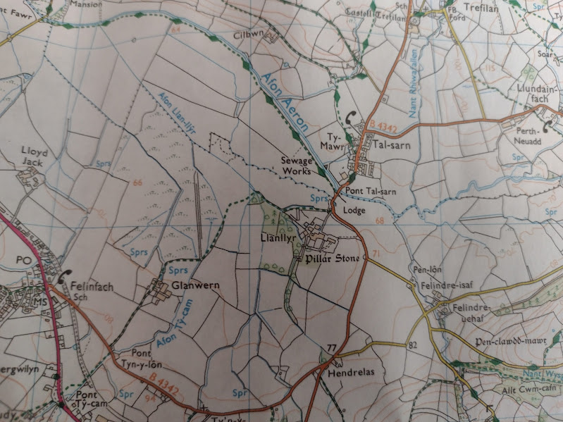
Ordnance Survey , 2015

Aeron Valley and the Aeron
Llanllyr is situated at the bottom of the Aeron Valley and near the river Aeron which was a commotal boundary (a secular division of land in medieval Wales) between the upper Aeron and Uwch Aeron which stands for below the Aeron (Vousden, 2021). The river may also have been a cantref boundary, which was a medieval land division that was important for the administration of Welsh law (Vousden, 2021). Llanllyr is situated between two ecological zones to the east Talsarn and Llangethio, it is prime hay bale land and to the west water meadows; this may be why the Cistercian nunnery was situated there (Vousden, 2021). After the valley floor, the land suddenly rises very steeply to the southeast till it reaches Clawdd Mawr which marks the boundary of enclosed fields to open pasture (Vousden, 2021). Clawdd Mawr is a dike which is a defensive boundary dating back to the late prehistoric and medieval period (Cadw, n.d.).

Welsh Medieval Landscape
Medieval Wales was separated into kingdoms. Llanllyr was in the kingdom of Deheubarth (Gee, 2010). The Deheubarth family ruled from 920 AD to 1234 AD (Ashley, 1998). There were many castles in Deheubarth, for example, Talsarn had TrefilanCastle. Trefilan Castle is situated between Llanllyr and Llanrhystud (about one mile away from Llanllyr) and was created by Maelgwyn Fych (son of Lord Rhys) in 1233 and was used as an administrative centre (Ross, n.d). Trefilan Castle was similar to Newcastle Emlyn Castle, which was also a timber and earth fort (Newcastle Emlyn Town Council, n.d.). The main castle of Deheubarth was Dinefwr Castle which was originally built by Rhodri the Great however is mainly linked to Rhys ap Gruffydd, ruler of Deheubarth from 1155 to 1197 (Rees and Jones, 1995). By the late medieval period, most of The Kingdoms of Wales were ruled by the House of Gwynedd (Cadw, n.d.). See Figure 2.

Figure 2: Map of the Welsh Kingdoms 1217.
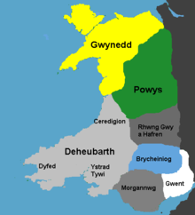
Pritchard, 2006

Edwardian Conquest of Wales
Llewyn Ap Gruffud was given Wales as a principality by Henry III in 1258 who was a pacifist (Carr, 2024). Subsequently, the first invasion of Wales was in 1276 with an army of sixteen thousand men (Carr, 2024). In 1282 war broke out again due to Dafydd ap Gruffyd's attack on Hawarden Castle (Carr, 2024). The revolt in 1282 was not confined to Gwynedd for example, the princelings of Dehabarth captured the castle of Aberystwyth (Chapman, 2015). The castle at Aberystwyth was only partly constructed when it was burned in the revolt (Johnson, n.d.). The revolt of 1282 was squashed and Llewellyn Ap Gwynedd was murdered at the battle of Ifron Bridge,11th December 1282 (Historic UK, n.d.). Rebellions from the Welsh continued till 1283 when the Welsh countryman handed Edward I Dafydd ap Gruffydd (Chapman, 2015).
Trefilan Castle was destroyed in 1282 when the English captured the castle, they discovered three thousand cattle hidden by the Welsh (Ross, n.d.). This led to the English burning the castle down (Ross, n.d.).

The Cistercian in Wales
In Wales, there are a total of sixteen Cistercian sites the oldest being Tintern Abbey which was founded in 1131 (Burton, n.d.). Strata Florida is one of the most famous Cistercian sites in Wales and has direct links to the Llanllyr nunnery (Gee, 2010). Strata Florida is about thirteen miles further inland compared to Llanllyr (Gee, 2010). There are two Cistercian nunneries in Wales, Llanllyr and Llanllugan (Burton, n.d.). Llanllugan was situated in the kingdom of Powys and was founded by Maredudd ap Robert in the late thirteenth century (National Churches Trust, n.d.). The nunnery was a very poor foundation however it was renowned for its discipline (National Churches Trust, n.d.). Llanllugan nunnery was dependent on the Cistercian Abbey of Strata Marcella which was founded in 1170 (Burton, n.d.). The Llanllugan site is similar to Llanllyr because they both were Celtic religion communities previously there before the Cistercian nunneries (Morgan, 1985).
Strata Florida was founded in 1201 (Cadw, n.d.). Strata Florida was founded by Lord Rhys ruler of Deheubarth (Gee, 2010). The Abbey was partially dismantled in 1539 during the dissolution of the monasteries by Henry VIII (Cadw, n.d.). Strata Florida was known for having masses of sheep and cattle on the upland granges (Cadw, 2007). Strata Florida had a total of around fifteen granges however this did bring them an array of problems (Cadw, 2007). For example, in 1196 there was disorder when the lay brothers overindulged in beer (Cadw, 2007). This case and similar resulted in a ban of beer from all Welsh granges (Cadw, 2007). Strata Florida also was very politically isolated due to “its loyalty of its first Welsh patrons,” for example, “many princes of Deheubarth are interred in its buildings” (Cadw, 2007, page 13). Strata Florida was also damaged under the conquest of Edward I probably due to its support of the Welsh patrons (Cadw, 2007). See Figure 3.
Figure 3: Strata Florida Abbey.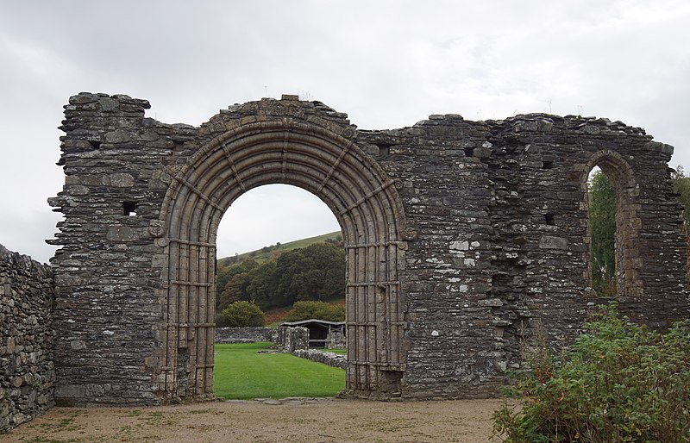
Otto, 2018.

Llanllyr Abbey
Llanllyr Abbey was a daughter house of Strata Florida Abbey (Discover Ceredigion, n.d.; Burton and Stöber, 2015 ). It was founded by Lord Rhys ap Gruffrydd and was possibly a retreat for his female relatives for example, Rhys ap Gruffydd widowed sister Gwladus (Gee, 2010). One of the river Aeron tributaries flows right past the Llanllyr nunnery site (see Figure 4). The nunnery was described by Gerald of Wales as poor and small compared to Strata Florida (Gerald of Wales, 2004). It was even suggested that the nuns were being exploited by Strata Florida as a form of oppression however there is no evidence of this (Burton and Stöber, 2015). Gerald of Wales also explains that the nuns at Llanllyr were permissive however it is argued that Gerald of Wales wrote this due to the possibility that nuns worked on some of the lands which was not allowed by the Cistercians (Gee, 2010). It appears that the nunnery was damaged during the Edwardian conquest of Wales as the nunnery was compensated forty marks which is the equivalent of around twenty six pounds (Burton and Stöber, 2015). Also, the abbess was pardoned after being found guilty of the alleged felling of an oak tree (Burton and Stöber, 2015). This crime would have been dealt in the Forest Court and be considered a High Forest offence which would have usually resulted in fines or even death (Tidswell, 2023). Llanllyr nunnery is forty years older than the first nunnery in England, Tarrant nunnery in Dorset, to be recognised by the Cistercian order (Gee, 2010). Llanllyr nunnery would have had several gardens as they believed they should grow their own food; there would have been cloister garden, an orchard, cellarers garden (food garden) and infirmary garden (Gee, 2010). Cistercians had to be self-sufficient as the Rule of St Benedict that states they should live communally under the abbot and to “ora et Labora” which means pray and work (Logeman, 1888). See Figure 4.
Figure 4: Map of where Llanllyr Abbey was located.
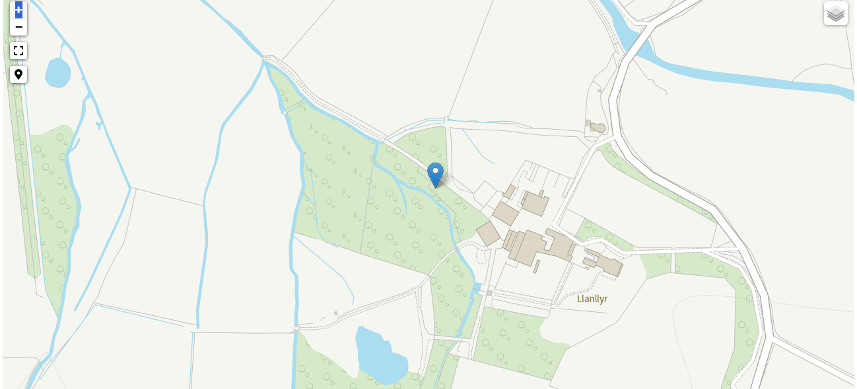 Coflien, n.d.
The trees around Llanllyr would have been oaks, ash and beech (Coflein, n.d.). The trees in the local landscape would have been important for the nunnery as they could have been used for repairs, firewood, buildings and the creation of objects.

Agriculture
Llanllyr nunnery would have had an array of granges, a small farm or estates run by the Cistercian Abbey and worked by lay brothers (Procter, 2016). An example of a grange under the control of the Llanllyr nunnery is the site at Felinfach which was a corn Mill, however nothing remains of it today (Ings, 2014). The majority of granges under Llanllyr's control were upland hill granges which were used to hold sheep (Bissa, 2016). The landscape was either mainly farms or fells (Bissa, 2016). Under the papal taxation of 1291 the Llanllyr nunnery owned 1,200 acres (Burton and Stöber, 2015).
Lay brothers were brought in to manage the granges by cultivating the lands and husbandry of crops and animals and some worked in the Abbeys themselves. Lay brothers could work as masons, blacksmiths, weavers and tanners (The Cistercians in Yorkshire, n.d.). Lay brothers were sometimes known as “conversi” which stands for bearded lay brothers (Burton, n.d.).
The crops grown near Llanllyr would have been wheat, oats and barley (Stout, n.d.). When growing the crops the Cistercians probably used manure, as this practice in the late 13th century at Tintern’s Merthyr Gerian grange (Stout, n.d.). It can, therefore, be presumed it was used at Llanllyr. Llanllyr was known for its hayford, a fenced enclosure and ford, due to its large sheep industry and the development into pedigree dairy herds managed by the Conversi (Stout, n.d.).
An animal which would have been common at Llanllyr was the Welsh Mountain sheep (Ryder, 1984). The Badger Face Welsh Mountain Sheep come in two types; Torddu which are white fleeced sheep and Torwen which are black fleeced (National Sheep Association, n.d.). The species are as old as the first Century however, during the medieval period there was more of an interest in Torddu species due to its white wool (National Sheep Association, n.d.). The nunnery owned sixty sheep in 1291 as that was recorded under the papal taxation (Burton and Stöber, 2015). Sheep where a important part of the medieval economy due to the wool trade in the 13th century (Donkin, 1958). Evidence to support this is that eighty five percent of Cistercian houses where wool producing (Donkin, 1958).
Another animal which would have been at Llanllyr was the Welsh Black Cattle which date from at least the Roman period (The Welsh Black Cattle Society, n.d.). They were bred for dairy and beef production during the medieval period (The Welsh Black Cattle Society, n.d.). In the early medieval period, however, Cistercians were not allowed to eat meat; by the late medieval period dietary restrictions were eased and meat was allowed on special occasions however it would be prepared in a separate kitchen (Burton, 2023).
Finally, another animal possibly kept at Llanllyr nunnery would have been chickens. The primary reason for chickens was for their eggs, as their meat was very expensive (Choudhury, 2022). Evidence to support why the nunnery might have had chickens is because on special occasions such as Pittances the Cistercians diet would allow eggs, fish or cheese (Burton, n.d.).

Burials
Llanllyr site is also a cemetery. Cistercian funerary practice was that when someone had died, they would wash the body and then pray for the body while the body was being sprinkled with holy water and incense before being buried (Burton, n.d.). The cemetery would probably have been north of the nunnery as this was common in Cistercian sites, evidence to support this is St Mary Graces (a Cistercian Abbey situated in Smithfield London) has its cemetery located to the north (Bekvalac, 2007).

Fishing
Fish was a pivotal part of the Cistercian's diet; this would have been easy to source due to Llanllyr’s nunnery’s location being so close to the Aeron. The Aeron would have contained fish such as salmon, sea trout and brown trout (The Fishing Passport, n.d.). Examples of medieval fishing techniques are weirs and traps (Kilpatrick, 2017). An example where weirs were used in Medieval Wales is at Aberarth in Ceredigion which has the best-preserved fish traps, others are located in places such as Tenby and Fishguard (Heneb Dyfed Archaeology, n.d.). The two forms of weirs were stone and wattle and would work by trapping the fish using a barrier in the tidal water to divert the fish to an area where they were usually contained and unable to escape (Kilpatrick, 2017). Weirs and traps would have been the technique at Llanllyr due to the site being located near the River Aeron. However, the nunnery itself would have also had a fish pond (Gee, 2010).

Conclusion
To conclude the landscape at Llanllyr was very different from today. The landscape was irrevocably changed, due to the conflict in especially Edward I’s invasion. The nunnery itself would have been isolated due to Cistercian beliefs and prior to is destruction in 1282, Trefilan Castle would have been in the distance. Wales was a Kingdom full of conflict, many of the Welsh medieval people revolted against Edward I at the time. The landscape would have changed again when the nunnery was surrendered during the dissolution of the monasteries.

Reference list
Ashley, M. (1998). The Early Welsh Kingdoms, Deheubarth. [online] www.castlewales.com. Available at: https://www.castlewales.com/debarth.html [Accessed 30 Mar. 2024].
Bekvalac , J. (2007). St. Mary Graces site. [online] Museum of London. Available at: https://www.museumoflondon.org.uk/collections/other-collection-databases-and-libraries/centre-human-bioarchaeology/osteological-database/medieval-cemeteries/st-mary-graces.
Bissa, E. (2016). Archaeological Discoveries at Llanllyr – Nuns, Trees and 3D Technology – UWTSD Humanities Blog. [online] UWTSD Humanities blog. Available at: https://humanitiesblog.uwtsd.ac.uk/?p=584.
Britannica (n.d.). Cistercian | Definition, History, & Facts. [online] Encyclopedia Britannica. Available at: https://www.britannica.com/topic/Cistercians.
Burton , J. (n.d.). The Cistercians in Wales - article from. [online] www.monasticwales.org. Available at: https://www.monasticwales.org/showarticle.php?func=showarticle&articleID=2#:~:text=Tintern%2C%20only%20the%20second%20Cistercian [Accessed 30 Mar. 2024].
Burton, J. (2023). Life in a Medieval Cistercian Monastery. Strata Florida Books.
Burton, J. and Stöber, K. (2015). Abbeys and Priories of Medieval Wales. University of Wales Press.
Cadw (n.d.). Clawdd Mawr, Pen-y-Bont-Fawr (Pen-y-bont-fawr), Powys. [online] ancientmonuments.uk. Available at: https://ancientmonuments.uk/128972-clawdd-mawr-pen-y-bont-fawr [Accessed 1 Apr. 2024].
Cadw (n.d.). Medieval Wales | Cadw. [online] cadw.gov.wales. Available at: https://cadw.gov.wales/learn/sites-through-centuries/medieval-wales.
Cadw (n.d.). Strata Florida Abbey | Cadw. [online] Cadw. Available at: https://cadw.gov.wales/visit/places-to-visit/strata-florida-abbey [Accessed 1 Apr. 2024].
Cadw (2007). Strata Florida Abbey Talley Abbey. 3rd ed. Cadw Welsh Assembly.
Carr, H. (2024). The Edwards: The Hammer of the Scots and the Lament of Edward II. Hist Fest. Available at: https://www.histcourses.com/the-plantagenets/week-3 [Accessed 12 Apr. 2024].
Chapman, A. (2015). Welsh soldiers in the later Middle Ages. Woodbridge, Suffolk: Boydell Press.
Choudhury, S. (2022). What Did the Rich Eat in Medieval Times? [online] Medium. Available at: https://sajjad-choudhury.medium.com/what-did-the-rich-eat-in-medieval-times-f24272487c3a#:~:text=Although%20chicken%20today%20is%20considered [Accessed 9 Apr. 2024].
Coflein (n.d.). Llanllyr Nunnery, Talsarn. [online] Coflein. Available at: https://coflein.gov.uk/en/site/400436?term=Llanllyr [Accessed 30 Mar. 2024].
Coflien (n.d.). Llanllyr Nunnery, Talsarn. [Online Image] Coflein. Available at: https://coflein.gov.uk/en/site/400436/?term=Llanllyr [Accessed 1 Apr. 2024].
Comeau, R. (2019). Land, people and power in early medieval Wales: the cantref of Cemais in comparative perspective. [PhD] Available at: https://discovery.ucl.ac.uk/id/eprint/10076045/ [Accessed 31 Mar. 2024].
Davies, W. (1982). Wales in the Early Middle Ages. Leicester University.
Discover Ceredigion (n.d.). The age of saints in Ceredigion - Discover Ceredigion. [online] Discover Ceredigion. Available at: https://www.discoverceredigion.wales/heritage-and-culture-to-explore/the-story-of-ceredigion/ceredigion-the-age-of-saints/ [Accessed 1 Apr. 2024].
Discover Ceredigion (n.d.). Welsh princes and Ceredigion castles - Discover Ceredigion. [online] www.discoverceredigion.wales. Available at: https://www.discoverceredigion.wales/heritage-and-culture-to-explore/the-story-of-ceredigion/welsh-princes-and-ceredigion-castles/#:~:text=At%20the%20age%20of%2025 [Accessed 30 Mar. 2024].
Donkin, R.A. (1958). Cistercian Sheep-Farming and Wool-Sales in the Thirteenth Century. The Agricultural History Review, [online] 6(1), pp.2–8. Available at: https://www.jstor.org/stable/40272846 [Accessed 9 May 2024].
Gee, L. (2010). A Very Small Corner of Paradise The Story of Llanllyr: a Garden in Wales. Ylolfa.
Gerald of Wales (2004). The Journey Through Wales and the Description of Wales. Penguin UK.
gridreferencefinder.com. (n.d.). Grid Reference Finder | OS Map. [online] Available at: https://gridreferencefinder.com/os.php#gr=SO0441062924 [Accessed 21 Apr. 2024].
Heneb Dyfed Archaeology (n.d.). Fish Traps/Weirs – Heneb – The Trust for Welsh Archaeology. [online] Archaeolg Dyfed Heneb. Available at: https://www.dyfedarchaeology.org.uk/wp/discovery/projects/fish-traps-weirs/ [Accessed 12 Apr. 2024].
Heneb Dyfed Archaeology (n.d.). Llanllyr Nunnery, Talsarn – Dyfed Archaeological Trust. [online] Heneb Dyfed Archaeology . Available at: https://www.dyfedarchaeology.org.uk/wp/discovery/projects/llanllyr-nunnery-talsarn/.
Historic UK. (n.d.). The English Invasion of Wales. [online] Available at: https://www.historic-uk.com/HistoryUK/HistoryofWales/The-English-conquest-of-Wales/#:~:text=In%201282%20the%20Welsh%2C%20led [Accessed 12 Apr. 2024].
Ings, M. (2014). MEDIEVAL AND EARLY POST-MEDIEVAL MILLS A THREAT-RELATED ASSESSMENT 2012-14. [online] Available at: https://www.dyfedarchaeology.org.uk/wp/wp-content/uploads/medievalmills2012-14.pdf [Accessed 9 Apr. 2024].
Johnson, B. (n.d.). List of Castles in Wales. [online] Historic UK. Available at: https://www.historic-uk.com/HistoryMagazine/DestinationsUK/CastlesinWales/#:~:text=Aberystwyth%20Castle%2C%20Aberystwyth%2C%20Ceredigion%2C%20Dyfed&text=Overlooking%20Aberystwyth%20harbour%2C%20the%20castle [Accessed 19 Apr. 2024].
Kilpatrick, K. (2017). Medieval Welsh fish weirs. [online] Flood and Flow. Available at: https://waternames.wordpress.com/2017/05/08/medieval-welsh-fish-weirs/ [Accessed 12 Apr. 2024].
Knowles, D. and Hadcock, R. (1953). Medieval Religious Houses: England and Wales. [online] Toronto, Longmans Green and Company. Available at: https://archive.org/details/medievalreligiou0000unse_z5r1/page/n5/mode/2up [Accessed 9 May 2024].
Morgan, R. (1985). An Early Charter of Llanllugan Nunnery .
Logeman, H. (1888). The Rule of S. Benet, Latin and Anglo-Saxon.
National Churches Trust (n.d.). Llanllugan St Mary. [online] National Churches Trust. Available at: https://www.nationalchurchestrust.org/church/st-mary-llanllugan [Accessed 31 Mar. 2024].
National Sheep Association. (n.d.). Sheep Breeds | National Sheep Association. [online] Available at: https://www.nationalsheep.org.uk/for-the-public/culture/sheep-breeds/ [Accessed 9 Apr. 2024].
Newcastle Emlyn Town Council (n.d.). Cyngor Tref Castell Newydd Emlyn | Newcastle Emlyn Town Council - Newcastle Emlyn Castle. [online] www.newcastleemlyntowncouncil.co.uk. Available at: https://www.newcastleemlyntowncouncil.co.uk/nceTownCouncil/the-castle [Accessed 30 Mar. 2024].
Ordnance Survey (2015). Map number 199: Lampeter/ Llanbedr Pont Steffan Tregaron & Llan-non . [Map].
Otto (2018). Strata Florida Abbey. [Online Image] Wikimedia Commons. Available at: https://commons.wikimedia.org/wiki/File:Strata_Florida_Abbey_20171018_west_entrance_of_church.jpg [Accessed 21 Apr. 2024].
Pritchard, R. (2006). File:CymruMap1093.PNG. [Online Image] Wikimedia Commons. Available at: https://commons.wikimedia.org/wiki/File:CymruMap1093.PNG [Accessed 30 Mar. 2024].
Procter , E. (2016). Landscapism: In search of monastic granges. [online] Landscapism. Available at: https://landscapism.blogspot.com/2016/11/in-search-of-monastic-granges.html [Accessed 9 Apr. 2024].
Rees, S. and Jones, S. (1995). Llandeilo History - Dinefwr Castle. [online] www.llandeilo.org. Available at: https://www.llandeilo.org/pl_dinefwrcastle.php [Accessed 30 Mar. 2024].
Ross, D. (n.d.). Trefilan Castle | History, Photos & Visiting Information. [online] Britain Express. Available at: https://www.britainexpress.com/attractions.htm?attraction=4718#heritage [Accessed 30 Mar. 2024].
Ryder, M.L. (1984). Medieval Sheep and Wool Types. The Agricultural History Review, [online] 32(1), pp.14–28. Available at: https://www.jstor.org/stable/40274301.
Stout, G. (n.d.). The Cistercian grange: a medieval farming system. [online] Available at: https://beaubec.home.blog/wp-content/uploads/2019/06/farmsettlement03-1.pdf [Accessed 9 Apr. 2024].
The Cistercians in Yorkshire. (n.d.). Lay-Brothers – The Cistercians in Yorkshire. [online] Available at: https://www.dhi.ac.uk/blogs/cistercians/cistercian-life/lay-brothers/#:~:text=The%20lay%2Dbrothers%20were%20essentially.
The Fishing Passport. (n.d.). Aeron & Arth | The Fishing Passport. [online] Available at: https://www.fishingpassport.co.uk/fishing/aeronarth [Accessed 9 Apr. 2024].
The Welsh Black Cattle Society . (n.d.). History of the Breed. [online] Available at: https://www.welshblackcattlesociety.com/breed-history.html#:~:text=The%20Ancient%20Breed&text=There%20is%20evidence%20that%20the [Accessed 9 Apr. 2024].
Tidswell, E. (2023). Medieval Commoner’s Dilemma: The Forest Law. [online] RuralHistoria. Available at: https://ruralhistoria.com/2023/06/15/forest-law/ [Accessed 12 Apr. 2024].
Vousden, N. (2021). Early Medieval Ecclesiastical Sites in the Landscape of South-West Wales. [Doctor Thesis ] Available at: https://media.proquest.com/media/hms/PFT/2/PYmsR?_s=5%2Bkm1wkW%2B16uaZy6VBYX%2Fwmcg%2Fw%3D [Accessed 1 Apr. 2024].

