

Student Name: Bhaumik Rakeshkumar Trivedi

Student ID: 2430320

Module Name: Strategic Management

Module Code: LCMB7003

Lecturer’s Name: Amare Desta

Assignment Title – Market Entry Business Strategy of Airbnb in India

Table of contents
1. Introduction 3
2. Selection of Organisation and Target Market 3
3. Comprehensive Strategic Analysis 7
3.1 PESTLE Analysis 8
3.2 Porter’s Five Forces 12
3.3 Porter’s Diamond Model 14
3.4 VRIO Analysis 15
4. Strategy Development and Formulation 16
4.1. Strategic Direction: Market development 16
4.2. Entry Strategy: 18
4.3. Sustainable Competitive Advantage: 19
5. Performance Evaluation Framework 21
5.1. Balanced Scorecard 21
5.2. Triple Bottom Line (TBL): 25
6. Conclusion 26
References 28

1. Introduction
In today’s volatile global business landscape, international expansion represents both an opportunity and a strategic challenge for global firms. As globalization, digital innovation, and shifting consumer expectations redefine the hospitality industry, companies must exhibit strategic agility and a nuanced understanding of local markets. This report focuses on Airbnb, Inc., a leading peer-to-peer accommodation platform, and presents a comprehensive international expansion plan into India, one of the world’s fastest-growing travel and tourism markets. The analysis integrates key strategic management frameworks, including PESTLE, Porter’s Five Forces, VRIO, and the Balanced Scorecard, to develop a coherent strategy that aligns with Airbnb’s mission of creating a world where anyone can belong anywhere.
Founded in 2008 in San Francisco, Airbnb revolutionised the travel industry by connecting hosts offering short-term accommodation with travellers seeking affordable, authentic experiences. As of 2024, Airbnb operates in over 220 countries and regions, with more than 4 million hosts and 7 million active listings. Despite its global reach, Airbnb’s penetration in emerging economies like India remains limited compared to developed markets such as the United States and Europe. India’s rapid digitalisation, urban expansion, and growing middle-class population provide fertile ground for Airbnb’s next phase of international growth.

2. Selection of Organisation and Target Market
2.1 Overview of Organisation
Airbnb’s business model thrives on cultural exchange, affordability, and technology-driven convenience, making it well-suited to the Indian market. India’s tourism and hospitality industry is projected to reach USD 125 billion by 2027, supported by government initiatives such as “Incredible India” and “Dekho Apna Desh.” The country’s expanding domestic travel segment—particularly among millennials and Gen Z consumers—has created rising demand for short-stay accommodations that offer personalised and local experiences. Furthermore, the increasing use of smartphones, online booking platforms, and fintech solutions supports Airbnb’s technology-oriented service model.
However, India’s complex regulatory environment and high competition from local players such as OYO Rooms and MakeMyTrip necessitate a well-formulated market entry strategy. Airbnb’s strategic fit in India rests on leveraging its global brand equity, digital innovation, and commitment to sustainability while adapting to local customer behaviours and legal frameworks. Through partnerships with local tourism authorities, hosting training programs, and community-driven initiatives, Airbnb can establish a resilient and ethically responsible presence in India.
The subsequent sections of this report will conduct a comprehensive strategic analysis of the Indian market, develop an evidence-based market entry strategy, and propose a performance measurement framework to evaluate Airbnb’s progress and success in achieving sustainable growth in the region.
2.2 Target Market and its Analysis
The target market of Airbnb primarily focuses on young adults, with an abundance of millennials and Gen Zs. The company focuses on cost-effective, unique, and localized travel experiences that the guests may need, while putting value on its affordability, authenticity, and community. In India, the organisation primarily attracts international tourists and domestic travelers interested in group travel and local experiences. In recent times, 90% of the travelers are Gen Z, with a focus on local traveling. This group is a major focus for Airbnb in India due to its large population size and adventurous spirit, which aligns with the desire for unique and authentic travel experiences.
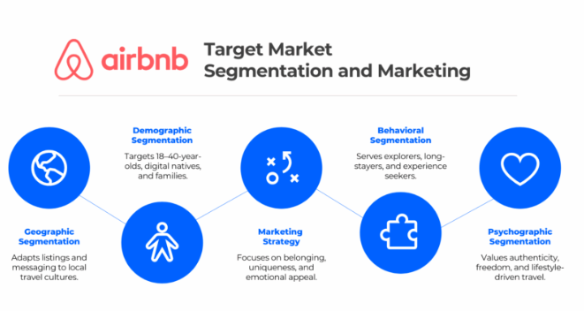
Figure 1: Target Market of Airbnb
(Source: Business Model Analyst, 2025)
The organisation currently has a value of $110 billion, and in India, it is estimated to be around INR 113 billion in 2024. Even with a 30% loss during the COVID-19 pandemic, it still earned $1 billion in 2020 (Start.io, 2022). Therefore, an STP analysis of the company describes segmentation, Targeting, and positioning of the company in the country. From 2012 to 2018, the revenue of the company was around $6 million. The Airbnb app now has over 150 million users, who are open to customisation options.
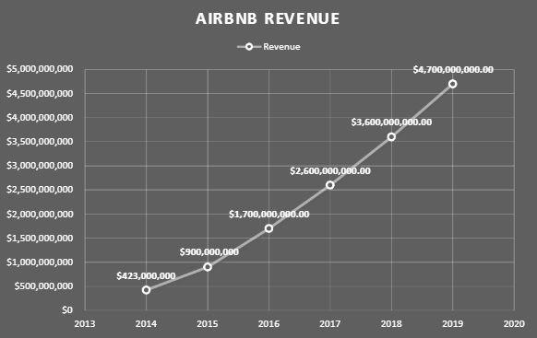
Figure 2: Revenue of Airbnb
(Source: Ahmed, 2021)
Segmentation
The segmentation of the target market of Airbnb primarily focuses on the age, gender, lifestyle, and occupation of its guests. As mentioned before, the age demographic of the company spans from 18 to 30, while experience seekers range from 18-60, and the company has a slightly higher gender demographics of females, at 54%. It primarily targets students, employees, and professionals, with a wide range of lifestyles, including bachelors, newly married couples, families, and even people who live alone (Scribd, 2025). Airbnb has the biggest market in countries such as the UK and the USA. However, in India, the demand for Airbnb is growing, and while people are using the services of Oyo, Make My Trip, and other organisations. It primarily focuses on the people from upper-class society, with an easygoing mind and a passion for exploration.
For its geographical segmentation, it focuses on the Urban side of the country with a primary focus on a colder climate. They segment based on destination and origin, and focus on the preferences of customers, most importantly during long-distance journeys (Segismundo, 2025). They also target customers seeking cost advantages, variety, unique experiences, or specific types of stays, such as whole-home rentals for families. With distinct campaigns, the company understands the needs and preferences of the customers and tailors services to them.
Targeting
Airbnb can grow in the Indian market by following the rapid growth of the hospitality industry in the country. The company is directing its investments towards the country to create a surge in both international and domestic tourism, particularly after the pandemic. India is said to be at the top for expansion in the global market, and thus, Airbnb can make it its goal for the future (Sarkar, 2024). The primary target for the market is the low-budget culture seekers for the highest profit and effect. Airbnb has the opportunity to provide lower accommodations for its customers, and through this, it can gain significant success in the sector. They can align with the local saying, "Atithi Devo Bhava," by providing homestays and hotels with local guides.
Positioning
Airbnb needs to position itself as a key player in the hospitality industry in India, and for that, the positioning of its outlets needs to be in places with a higher density of population density. Various reports from The Economic Times, The Times of India, and Inc42 explained that a large and growing portion of Airbnb's bookings in India come from Gen Z and millennials, making them a crucial demographic for the company's strategy (Ajithkumar, 2025). If the company can cater to the evolving trends among Gen Z, it can successfully implement its operations in the company. The reports also show that the company considers India as a major growth market with substantial boos in the economy in the future. It can expand its business to metropolitan cities, including Delhi, Mumbai, Bengaluru, and Kolkata.

3. Comprehensive Strategic Analysis
An in-depth is necessary to grasp the company's potential attractiveness, competitive position and readiness for growth in India. Through conducting external environment analysis, industry dynamics as well as national competitiveness in tourism factors will be used here, along with Airbnb's internal strategic capabilities is done with using frameworks such as PESTEL, Porter's Diamond Model and VRIO analysis. This comprehensive analysis guided by these instruments provides the groundwork for a well-founded long-term strategy that would ensure Airbnb's growth in harmony with unfolding changes in the tourism and digital economic sector.

3.1 PESTLE Analysis
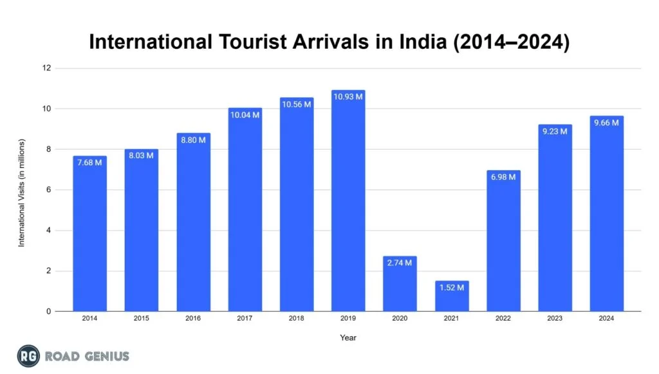
Figure 3: International Tourist Arrivals in India (2014-2024)
Source: (RoadGenius, 2023)
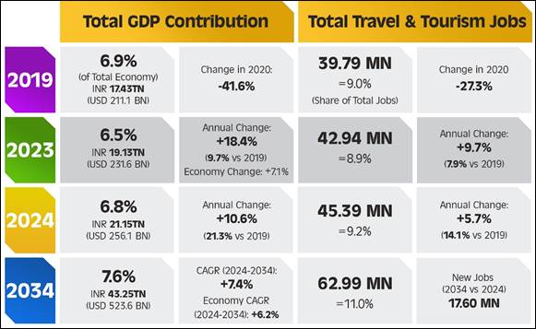
Figure 4: Tourism Expansion in India
Source: PiB (2024)
PESTEL | Description | Opinion
Political | India's political environment is a favourable platform for Airbnb's growth, mainly as a result of the government's policy focus on tourism, digitalisation, and entrepreneurship. The "Incredible India," "Dekho Apna Desh," and Smart City Mission campaigns are all examples of the government's commitment to tourism and urban renewal, which are the two main areas that benefit digital accommodation platforms (CHANDRAN and TG, 2024). In 2024, the number of international visitors came to 9.66 million, which was 4.7% more than 2023 but still 11.6% less than 2019 (RoadGenius, 2023). There are different rules for hospitality and short-term rentals at the state and local government levels, which makes it difficult to comply. Regulations concerning homestays, taxes, and safety standards vary significantly in a city like Delhi as compared to Bengaluru or Mumbai. Therefore, even if political initiatives open doors for the company, the lack of regulatory consistency presents operational risks that the company has to deal with through local partnerships and good legal governance. | Opportunity
Economy | India continues to be among the top rapidly growing economies worldwide and the tourism industry contributed a whopping USD 249.3 billion to the economy by the year 2023. Factors such as increased domestic travel, higher disposable incomes, post-pandemic recovery, and the rising aspirations of the middle class are major contributors to the country's attractiveness to investors (PiB, 2024). The trend of spending on travel experiences, taking short vacations, and staying in culturally immersive accommodations is totally in line with Airbnb's unique value proposition. Lower business costs and a favourable currency rate also enhance Airbnb's competitive position as compared to Western markets. However, there are still some differences in the standard of living between various regions, especially between tier-1 cities and rural areas, which result in uneven demand. Inflationary pressures and exchange rate fluctuations could have some impact on travel spending from time to time, especially in the price-sensitive domestic segments. However, India's long-term economic journey is still strong. Thus, the market remains economically viable for Airbnb's sustained expansion. | Opportunity
Social | Demographically, India has one of the youngest populations that is also highly adaptive to the current global digital-savvy culture (Cheng Kian et al.. 2025). Western business concepts is very and lifestyle is very prevalent across many urban and semi-urban parts of India. Furthermore, the vacation rental model is gaining significant traction to accommodate the growing number of Indian tourists as well as foreign tourists on weekend getaways, solo travelling, pilgrimage tourism and remote work-based tourism. On the contrary, India has a huge number of conservative-minded people and vocational renting may not be compatible for them, and it might affect the number of hosts.
Technological | India's fast digital change is a great support to Airbnb's growth. India has more than 850 million smartphone users, 4G and 5G networks are available almost everywhere, and the country has one of the highest digital payment adoption rates in the world (UPI) (Joshi, Pathak and Kulkarni, 2025). All this makes the technological environment very favourable for platform-based business models. People's trust in online transactions has also increased and the use of digital wallets has become very common, which makes the booking and payment processes of Airbnb very easy. Innovations such as Al-powered search engines, unattended check-in terminals, and pricing algorithms based on supply and demand are leading India's travel industry to a new era that is more efficient and seamless, and Airbnb is benefiting from that too.  However, issues such as security attacks on the internet, data privacy, and the government's increasing attention to foreign digital platforms mean that Airbnb has to spend a lot of money on secure IT infrastructure, local data compliance, and strong digital trust mechanisms in order to be able to deal with these issues (Waris and Kim, 2023). Keeping up with the latest technology while at the same time conforming to local digital regulations is the key to success in the long run. | Opportunity
Enviromental | As travel increases, both Airbnb and its hosts face pressure to adopt sustainable practices to mitigate the environmental impact on tourist destinations. Growing awareness of climate change may influence traveler choices and place pressure on the hospitality sector to reduce its footprint. Community-led initiatives and local environmental concerns can impact the desirability of locations and affect hosts' operations. | Threats
Legal | India's​‍​‌‍​‍‌​‍​‌‍​‍‌ legal environment is a challenge as well as an opportunity for Airbnb. The platform has to deal with a complicated maze of state laws regulating homestays, giving rights to tenants, safety standards, and short-term rentals. In big cities such as Mumbai and Bengaluru, the conditions for obtaining licenses and the taxation systems are changing, thus Airbnb has to be equipped with strong mechanisms for compliance (Vyas, Vyas and Mishra, 2022). Laws related to data governance, such as the Digital Personal Data Protection Act (2023), stipulate that companies must keep the user information secure in storage, processing, and protection (Yadav et al., 2023). To co-exist peacefully with the local law and foster trust with the public, the company's global data infrastructure has to be Airbnb ​‍​‌‍​‍‌​‍​‌‍​‍‌India-specific. | Threats

3.2 Porter’s Five Forces

Porter’s Five Forces | Description | Risk
Threat of New Entrants | The threat of new entrants to India is neither very low nor very high, as digital platform businesses require relatively low capital. One can think of local players stepping into the market with app-based rental services or niche hospitality models (Bappy. and Avi, 2021). However, Airbnb has a handful of conditions that make it almost impregnable, such as worldwide brand recognition, the large number of hosts, the maturity of the platform, trust-points, and deriving cost advantages from economies of scale. | Moderate
Bargaining Power of Suppliers (Hosts) | Hosts are suppliers to Airbnb, and the supply side in India is extremely fragmented. The potential hosts are the millions of homeowners, small property managers, and rural households (Cocola-Gant et al., 2021). Their abundance limits their power to negotiate with the buyers. Nevertheless, high-quality or luxury ones in the most sought-after locations could have more freedom by simultaneously listing on different platforms to attract more guests. | Low
Bargaining Power of Customers | The power of customers to bargain in India is significant. By using platforms such as Booking.com, OYO, MakeMyTrip and hotel websites, travellers may quite easily compare prices. Being price-sensitive is very typical of the domestic market. therefore customers ask for affordable products with good quality (Nassar, Gad and Kortam, 2021). Reviews done by real users give even more power to customers, as they force hosts and platforms to keep standards. | High
Threat of Substitutes | Substitutes encompass of hotels, guest houses, serviced apartments, family stays, and community-based travel groups. OYO's budget model is one of the trailblazers in the rented space segment, which offers a more cost-effective substitute that offers a viable alternative to the traditional hotel (Kumar and Singh, 2022). As a result, Airbnb needs to differentiate itself through authentic local experiences, personalised services, and unique property offerings to remain at the forefront. | High
Competitive Rivalry | The competition in the Indian accommodation sector is becoming intense with the emergence of different model of space co-sharing. Domestic players such as OYO and MakeMyTrip have deen local market presence, cultural alignment, and extensive networks (Kumar and Singh, 2022). Meanwhile, international competitors like Booking.com are also operating aggressively. The rivalry is further intensified by discounting, marketing battles, and loyalty program offerings. | High

3.3 Porter’s Diamond Model
Factor Conditions
India has factor conditions that are beneficial for Airbnb: a young workforce, a high level of English proficiency, a digitally-savvy population, and an internet infrastructure that is constantly expanding. Cheap labour and the increase in remote working are also good for the development of flexible tourism models (Krishn, 2024). Nevertheless, there are some skill gaps in high-end hospitality services, so Airbnb needs to invest in the development of its hosts' capabilities.
Demand Conditions
India's​‍​‌‍​‍‌​‍​‌‍​‍‌ domestic travel market is what has been driving the demand conditions upward. Among these factors which are perfectly suitable for Airbnb are middle-class aspirations, cultural diversity, and the desire for immersive travel experiences. Demand segments have become diversified as a result of the seasonality of domestic tourism which is caused by festivals, pilgrimages, and heritage ​‍​‌‍​‍‌​‍​‌‍​‍‌tourism. The growth of domestic tourism is faster than that of international arrivals, thus allowing Airbnb to expand without being dependent on foreign travellers (Adamiak, 2022).
Related and Supporting Industries
India is home to a vibrant community of fintech providers (UPI, Paytm), logistics networks, digital travel agencies, and tourism service providers (Nazar and Kareem, 2024). Thus, it facilitates very easy payment processing, marketing integration, and digital operations. The presence of strong supporting industries helps to lower transaction costs and makes it possible for Airbnb to operate efficiently.
Firm Strategy, Structure, and Rivalry
The hospitality companies in India are energetic, competitive, and willing to change (Kaur, 2021). The local players quickly innovate and effectively cater to the cultural expectations. Such competition compels Airbnb to have a flexible, localized strategy, actively participate with communities, and differentiate by empowering hosts, ensuring quality, and using sustainable tourism initiatives.

3.4 VRIO Analysis

Element | Valuable | Rare | Inimitable | Organisational | Advantage
Brand Reputation | Yes | Yes | No | Yes | Temporary Advantage
Community Driven Model | Yes | Yes | Yes | Yes | Sustained Competitive Advantage
Data-Driven Algorithm | Yes | No | No | Yes | Temporary Advantage
Organisational structure | Yes | Yes | Yes | Yes | Sustainable advantage

Analysis of Airbnb's Indian market through VRIO framework points out that the company faces a mixed competitive landscape. Brand Reputation is a significant, somewhat rare, and well-structured resource, but since it is also an imitable one, it only brings a temporary advantage. Community-Driven Model and the Organisational Structure supporting it. However, a full analysis of Airbnb's Indian market through VRIO framework points out that the company faces a mixed competitive landscape. Brand Reputation is a significant, somewhat rare, and well-structured resource, but since it is also an imitable one, it only brings a temporary advantage. Community-Driven Model and the Organisational Structure supporting it, however, fulfill all VRIO criteria (they are valuable, rare, inimitable, and well-organized), which means that they bring a sustained competitive advantage as they generate unique local experiences and an efficient operational model which is hard to replicate by traditional competitors like hotels or other online travel agencies.
The​‍​‌‍​‍‌​‍​‌‍​‍‌ strategic reviews shows that India is a promising market with great potential for Airbnb, which is backed by India's robust economic growth, increasing local tourism, digital adoption, and changing consumer preferences. Even though there are challenges such as competition and regulatory fragmentation, Airbnb's worldwide brand, platform ecosystem, and technology capabilities put it in a position to make long-term success if the company makes local adaptations and develops good relationships with the community and the ​‍​‌‍​‍‌​‍​‌‍​‍‌regulators.

4. Strategy Development and Formulation

4.1. Strategic Direction: Market development
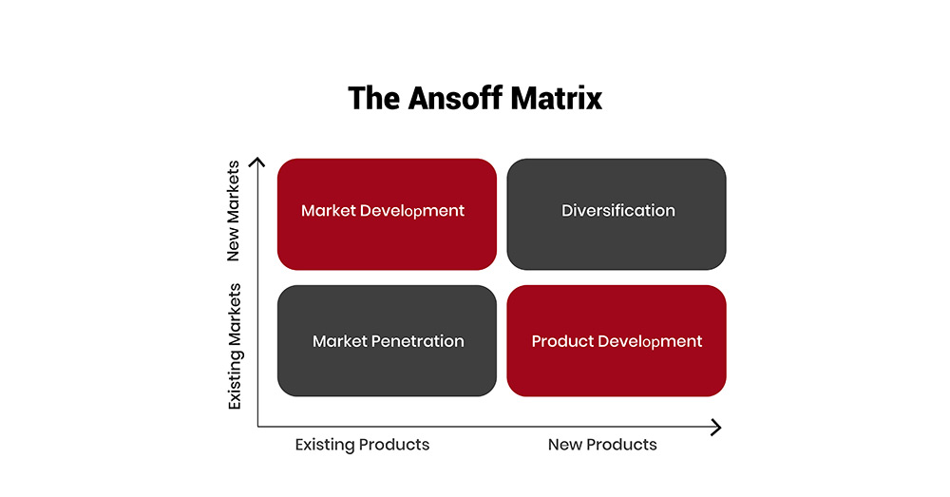
Figure 5:Ansoff Matrix
Source: (thestrategyinstitute, 2025)
By employing the “Ansoff Matrix”, it can be stated that Airbnb’s strategic direction for India has highlighted the market development segment. It is targeting the existing service and peer-to-peer accommodation for the new geographical and demographical section of India (Farmaki and Miguel, 2022). It has been noticed that Airbnb has obtained significant majority in developed market where as India demonstrated the wide ranges opportunities for its developing middle class community, enhancing disposable income and increasement in domestic tourism. This strategy has highly concentrated on improving Airbnb's developed model into India' urban and semi urban market where tourism development and digital accessibility are enhancing increasingly. Additionally, Airbnb's market development in India is effectively depending on localising its global model through implementing the particular Indian travel trends such as family experimental travel, providing multilingual support and local payment options, developing tactical collaboration with government and local companies (Mehta, 2020). These strategies enhancing the inventory such as hotel and unique stays for providing services to rising digital-savvy, young Indian travelers for making India a dominant growth market.
Unlike the Western regions where Airbnb is incorporating with leisure travel, India's travel system includes religious tourism, family vacations and business-related short travel. Hereby, Airbnb’s product diversification need to incorporate budget home stays, heritage properties and family accommodations in India. Moreover for assisting the direction, Airbnb can create partnership with tourism department and local development authorities by aligning with various initiatives such as incredible India, Swadesh Darshan, Dekho apna Desh and incredible India tourist facilitator program(innovateindia, 2025). These partnerships can improve visibility, develop Government support. Airbnb need to use India's digital infrastructure by incorporating with reputed local payment methods such as UPI and Paytm for assuring smooth transactions for the customers and hosts. It can be added that by using digital marketing campaign, Airbnb can effectively position itself as a platform for providing authentic local experiences rather than just accommodation. Additionally through fostering regional travel experience and using customer-generated content Airbnb can attract domestic travellers who are increasingly prefer innovative customised travel options. So its market development strategy in India includes the holistic cultural incorporation which integrated with India's emerging tourism market.

4.2. Entry Strategy:
For entering in India's tourism market, Airbnb's market entry strategy can focus strategic collaboration with local host, tourism boards and government organisations. This partnerships can help in developing trust, directing regulatory challenges and fostering sustainable development in India tourism market. The tourism and hospitality market of India is fragmented and heavily dominated by the local players such as OYO and MakeMyTrip. Additionally its collaborative strategy can help them to differentiate by promoting community involvement and obtaining long-term advantages rather than depending only on the price competition.
Moreover the core component of these tactics includes partnering with state tourism boards for creating accountable tourism initiatives (Graci, 2020). For example it can be highlighted that by launching joint campaigns with the states such as Kerala, Rajasthan, and Himachal Pradesh, which is reputed for their effective cultural factors and eco tourism prospect Airbnb can successfully enter in India. Moreover through following the Indian government tourism missions this organisation can attain reliability, trust and local endorsement along with access to policy support that can improve the tourism development. At the micro level, Airbnb can develop robust relationship with local hosts through providing capacity building programs (Khatri and Khadka, 2025). Through conducting effective training workshops centring on digital literacy, hospitality standards and safety integration, it can assist hosts, enhance service quality and customer satisfaction. This community driven strategy incorporates well with Airbnb’s global ethos of “belonging anywhere”, along with solidifying the optimum entrepreneurship in India(further, 2020). Further more Airbnb need to concentrate on domestic travellers by tapping into the post-pandemic increase in domestic tourism system. As there has been a 25% increase in the number of Indians taking 3 or more trips annually compare to the pre-Covid times(India, 2024). Most of the Indian travelers are enhancingly exploring the short stay accommodation within the country for the accessibility and convenience. Through providing localised marketing, multilingual language support and regionally customised experiences this organisation can efficiently gather this segment before increasing to International tourism sector.

4.3. Sustainable Competitive Advantage:
Airbnb’s sustainable competitive advantage in India is heavily dependent on three components such as innovation in technology, brand trust and local cultural incorporation. Technology considered as the key differentiator for Airbnb. By using emerging technology such as machine learning for emerging pricing and AI powered chatbots for multilingual customer support and blockchain for securing verification this organisation provide a premium service compared to the domestic and local competitors such as OYO(Kumar, Chidipothu and Leelavathi, 2025). It can uses Flow Builder and Action Store to power conversational AI and tackle complex workflows, improving customer support and operations. Using the data analytics Airbnb can anticipate market requirement and improve the market offerings to local preferences. Moreover brand trust shapes the optimum advantages for Airbnb. As it is a worldwide reputed brand century on reliability and community based travel, this organisation enjoys robust brand equity (Bose et al., 2022). In the emerging market as India which face difficulties from the safety and quality prospect, Airbnb can capitalise on its reputation by developing strong verification tools for host and accountable review system along with 24/7 customer support. Lastly the local cultural incorporation where Airbnb can innovatively position they are organisation by providing selected services for staying and facing that reflect India's cultural prospect such as heritage stay in Rajasthan, eco-stay in Kerala and art-driven experiences in Odisha and West Bengal. Collaborating with local artisans and cultural group, this organisation can transition travel with the efficient emersive experience is for providing services to both domestic and international traveller who prefers authenticity in India.
4.4. CSR and Ethical Strategy:
Airbnb's “corporate social responsibility” and “ethical strategy” in India effectively focused on fostering sustainable tourism and community promotion which can incorporating profitability with social and environmental facts. Initially it can be presented that Airbnb can improve sustainable tourism through assisting eco-friendly practices between the hosts and guests (Zhichao and Yashu, 2024). Moreover it can demonstrate sustainable certificate program by identifying the hosts who are properly using renewable energy, waste reduction practices and water preservation initiative. By launching this practices can incorporate Airbnb with India's environmental focus along with can appeal to the developing segment of Eco conscious travellers. This organisation also can collaborate with NGO and government agencies for fostering green tourism zones and accountable trouble awareness campaign (Zada et al., 2025). Additionally, this organisations ethical responsibility can enlarge for encouraging local community. However by using its “Airbnb Entrepreneurship Academy” model it can collaborate with local organisations for providing skills regarding tourism entrepreneurship specially for the women, youth and indigenous groups. Through providing training they can help in fostering economic inclusion and skill growth in the rural and semi urban regions. Further mode this organisation need to maintain ethical governance by incorporating with India's data protection law such as “Digital Personal Data Protection Act (DPDP Act) of 2023”and the consumer rights law such as “Consumer Protection Act, 2019, National Tourism Policy (2002)”(PRS Legislative Research, 2023).

Figure 6:United Nations sustainable development goals
Source:(social, 2025)
Moreover by maintaining clear pricing policies, security digital payments and adopting transparent communication platforms about booking cancellation or refund policy it can promote customer trust and regulatory compliance in organisation. However, it can be highlighted that Airbnb's CSR framework need to incorporate well with “United Nations sustainable development goals” mainly with the “SDG 8 (Decent Work and Economic Growth), SDG 11 (Sustainable Cities and Communities), and SDG 12 (Responsible Consumption and Production)”(social, 2025). Lastly it can be demonstrated that through actively covering the ethical and environmental focus into its operations and system Airbnb can position itself as a dominant and responsible organisation by maintaining sustainable development in the Indian tourism sector.

5. Performance Evaluation Framework

5.1. Balanced Scorecard
The Balanced Scorecard (BSC) is a management framework which evaluates performance with its four key perspectives and these are financial, customer, internal processes and lastly learning and growth. This framework was coined by Robert S. Kaplan and David P. Norton in 1992 (Hayes, 2025). The key functions of this framework may involve strategic alignment, performance measurement, communication and prioritization (Madsen, 2025). The core components of this framework are -
- Financial - This part measures the traditional performance of the business like profitability, revenue and return on investment (ROI).
- Customer - This part assesses the performance of the business’s guest satisfaction index , net Promoter Score, customer Acquisition cost (CAC).
- Internal Process - This part evaluates the business’s occupancy rate, booking cycle time, health and safety compliance and dispute resolution time.
- Learning and Growth - This part focuses the employee satisfaction, training and development, innovation rate and data and technology utilisation to expand the business.
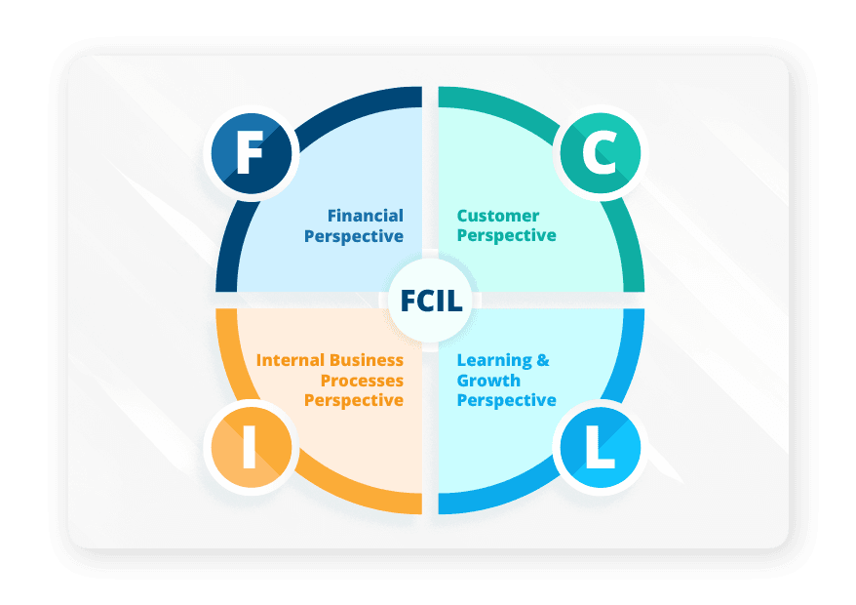
Figure 7 : Balanced Scorecard Framework (BSC)
(Source : LTS, 2025)
Perspectives | Strategic Objectives | Key Performance Indicators (KPIs)
Financial | The strategic objectives of Airbnb are to achieve profitable growth and market leadership in the Indian market. | - Market - Airbnb may include commission rates and overall profitability for its profit margin.  - Revenue Growth - Airbnb increases its booking revenue and its total contribution also has been increased to the Indian economy (INR).  - Return on Investment (ROI) - Airbnb invests in the Indian market and expands its business by fostering technology effectively.
Customer | The strategic objective of Airbnb in terms of the customer is to enhance the guest satisfaction and build a loyal host community in India. | - Guest Satisfaction Index - Rating and reviews in the platform of the guests and customers are involved in this area.  - Net Promoter Score - The loyalty of the guest and host also plays a pivotal role and their willingness to recommend Airbnb can increase its business.  - Customer Acquisition Cost (CAC) - The cost to acquire new guests and hosts in the Indian cities is also important to expand the business of Airbnb.
Internal Process | The objective for the internal process is to optimize platform operations and ensure a seamless and reliable experience for all users of India. | - Occupancy Rate - The average utilisation of listed properties  - Booking cycle time - Time from initial search to confirmed booking.  - Health and Safety Compliance - Maintaining safety guidelines also plays pivotal especially after Covid-19 .  - Dispute Resolution Time - Resolving conflicts between the guests and the hosts are also important.
Learning and Growth | The last objective in terms of the learning and growth of Airbnb includes innovation, local talent and necessary infrastructure for its future growth in India. | - Employee Satisfaction - Engagement and retention rates for local teams is necessary.  - Training and Development - investment in local teams and host training programs also plays a pivotal role.  - Innovation Rate - Implementing new features or services in the Indian market frequently also plays a very important role to expand the business of Airbnb.  - Data and Technology Utilisation - The use of the data analytics to understand the preferences, patterns of the Indian guest can play role effectively.
Table : Balanced Scorecard (BSC) of Airnb
(Source : Rizvi, 2021)
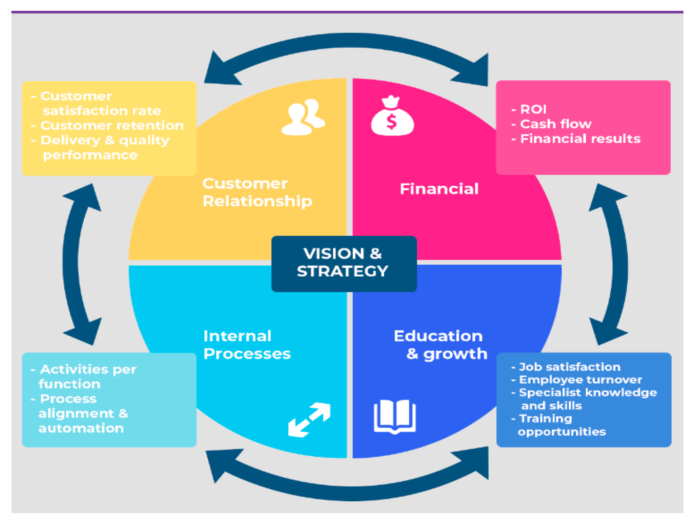
Figure 8 : Balanced Scorecard (BSC)
(Source : Oliveira et al., 2022)

5.2. Triple Bottom Line (TBL):
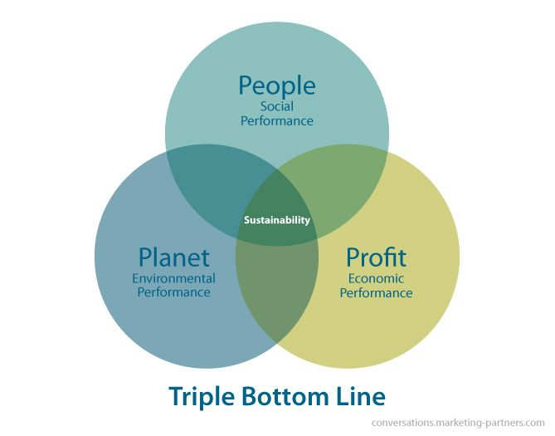
Figure 9: Triple bottom line
Source:(inchainge, 2025)
Factors | Impact on organisation
People (Social Outcomes) | Centering on the community assistance, inclusiveness and cultural transformation, it can be stated that Airbnb promoted the social sustainability through assisting local individuals. By using the Airbnb Entrepreneurship Academy it delivers training for people to improve their knowledge and deliver more chances. Airbnb's employee count is around 7,300 as of 2024. By encouraging cultural aspects by interlinking with tourism, and accurate local experiences, Airbnb can improve the community bond and brand trust.
Profit (Economic Outcomes) | This organisation generates profits mainly through redistributing tourism income along with the individual businesses. The local Airbnb hosts can get advantages from the additional earning along with the restaurants, shops and transport services can also face enhanced rqeuirements in tourism.These can increase profit. Moreover, collaborating with reputed tourism boards and progarms, it can able to assist domestic tavel which can improve economical development. It has produced around $11.1 in 2024 and net income of $2.6 billion(Curry, 2025). It had 491 million bookings in 2024, a 9.5% increase year-over-year.
Planet (Environmental Outcomes) | Airbnb actively assist environmental sustainability through fostering eco-friendly accommodations. Moreover, Airbnb assisted hosts to implement sustainability practices such as energy efficiency (LEDs, smart thermostats), waste reduction (refillable toiletries, washable cloths), and water conservation (low-flow fixtures, promoting window use)(Hrovat, 2023). Its dedication to meeting net-zero corporate operations by 2030 includes effective mitigation in Scope 1 (direct), Scope 2 (electricity), and Scope 3 (value chain) emissions. Through maintaining this, Airbnb can improve the environmental awareness in Indian tourism sector.

6. Conclusion
To conclude, it can be said that Airbnb has a significantly high demand and need in India, especially among its younger generation. This report focuses on Airbnb, Inc., a leading peer-to-peer accommodation platform, and presents a comprehensive international expansion plan into India, one of the world’s fastest-growing travel and tourism markets. However, despite having a global reach, Airbnb’s penetration in emerging economies like India remains limited compared to developed markets such as the United States and Europe. Its business model thrives on cultural exchange, affordability, and technology-driven convenience, making it a suitable competitor in the market alongside other organisations, such as Oyo, Make My Trip, and more.
The target market of the company mainly focuses on the age demographics, targeting a highly dense population and positioning among its competitors. The PESTLE analysis evaluates all the factors in India regarding the entry of Airbnb and provides data on the tourist arrivals in India. The Porter’s Five Forces focus on the Indian market and the threats it poses to the company. Porter’s Diamond Model also focuses on the several conditions the company may face. The Vrio analysis explains the resources and assesses their competitive advantage. The Ansoff matrix provides strategic directions for market development and entry strategy. Both the Balanced Scorecard and the Triple Bottom Line framework evaluate the performance of the company.
For a proper implementation of its operation in India, the company needs to follow the strategies for market penetration to achieve success in the market (Hireavilla, 2025). In Hill stations, the company can establish villas or homestays, with a luxury option for activities, such as stargazing. In beach areas, they can opt for beachside tents with a sea view, or provide rooms with a gateway to the beach. Meanwhile, in rural areas, it can focus on establishing private villas with options for local experiences. Airbnb has opportunities in India, and it should follow these steps for significant growth.

References
inchainge (2025). Redirect Notice. [online] Google.com. Available at: https://www.google.com/url?sa=i&url=https%3A%2F%2Finchainge.com%2Fknowledge%2Fsustainability%2Fwhat-do-we-know-about-the-triple-bottom-line%2F&psig=AOvVaw1ChQzCCSOZJnlJozRXuPMA&ust=1763130822811000&source=images&cd=vfe&opi=89978449&ved=0CBgQjhxqFwoTCPjq1qas75ADFQAAAAAdAAAAABAV [Accessed 13 Nov. 2025].
social (2025). Redirect Notice. [online] Google.com. Available at: https://www.google.com/url?sa=i&url=https%3A%2F%2Fsocial.desa.un.org%2F2030agenda-sdgs&psig=AOvVaw3ca9KtAm4DoRKAoHPTUmXI&ust=1763130964992000&source=images&cd=vfe&opi=89978449&ved=0CBgQjhxqFwoTCODjkuis75ADFQAAAAAdAAAAABAE [Accessed 13 Nov. 2025].
PRS Legislative Research (2023). The Digital Personal Data Protection Bill, 2023. [online] PRS Legislative Research. Available at: https://prsindia.org/billtrack/digital-personal-data-protection-bill-2023.
Zhichao, Y. and Yashu, Y., 2024. Promoting Environmental Sustainability Through The Principles Of Green, Eco-Friendly Tourism. Imras, 7(12), pp.63-74.https://journal.imras.org/index.php/sps/article/download/1942/2603
Zada, M., Khan, S., Zada, S., Dhar, B.K. and Marcão, R., 2025. Harnessing Social Media and NGO Collaboration for Advancing Sustainable Ecotourism Policy: A Pathway to Sustainable Tourism Development. Sustainable Development, 33(3), pp.4702-4717.https://onlinelibrary.wiley.com/doi/am-pdf/10.1002/sd.3373
Bose, S., Pradhan, S., Bashir, M. and Roy, S.K., 2022. Customer-based place brand equity and tourism: A regional identity perspective. Journal of travel research, 61(3), pp.511-527.https://www.academia.edu/download/67889533/2021_JTR_April.pdf
further (2020). Airbnb: Developing ‘Belong Anywhere’ Branding Strategy. [online] Further.group. Available at: https://www.further.group/work/airbnb.
India, T.O. (2024). ‘Post-Covid, 25% rise in Indians taking 3+ trips/yr’. [online] The Times of India. Available at: https://timesofindia.indiatimes.com/city/delhi/post-covid-25-rise-in-indians-taking-3-trips/yr/articleshow/109483117.cms [Accessed 13 Nov. 2025].
Curry, D. (2025). Airbnb Revenue and Usage Statistics. [online] Business of Apps. Available at: https://www.businessofapps.com/data/airbnb-statistics/.
Hrovat, J. (2023). Enhance Your Airbnb Listing with Sustainable and Green Initiatives. [online] UpRev. Available at: https://www.uprev.co/post/enhance-airbnb-listing-sustainable-green-initiatives.
Ahmed, S.T. (2021). The business practice of Airbnb. [online] doi:https://doi.org/10.6084/m9.figshare.21739967.
Ajithkumar, K.G. (2025). Airbnb Marketing Strategy: Case Study. [online] SKILLFLOOR. Available at: https://skillfloor.com/blog/airbnb-marketing-strategy-case-study-pdf [Accessed 13 Nov. 2025].
Business Model Analyst. (2025). Airbnb Target Market Analysis. [online] Available at: https://businessmodelanalyst.com/airbnb-target-market-analysis/?srsltid=AfmBOoooeGxmX9Hokdr0q68Pv_ZK1jBznFfajITYsLMqfGQBWivIP2tv [Accessed 13 Nov. 2025].
Hireavilla . (2025). Airbnb Requirements for Hosts in India – Essential Guide. [online] Available at: https://blog.hireavilla.in/airbnb-requirements-for-hosts-in-india/ [Accessed 13 Nov. 2025].
Sarkar, G. (2024). Airbnb Sees India’s Potential To Be Among Top 10 Global Markets. [online] Inc42 Media. Available at: https://inc42.com/buzz/airbnb-sees-indias-potential-to-be-among-top-10-global-markets/ [Accessed 13 Nov. 2025].
Scribd. (2025). Marketing Strategy. [online] Available at: https://www.scribd.com/document/517876078/MARKETING-STRATEGY [Accessed 13 Nov. 2025].
Segismundo, J. (2025). AIRBNB-2. [online] Scribd. Available at: https://www.scribd.com/document/594689739/AIRBNB-2 [Accessed 13 Nov. 2025].
Start.io (2022). Airbnb Target Market Segmentation - Customer Profile. [online] Start.io - a Mobile Marketing and Audience Platform. Available at: https://www.start.io/blog/airbnb-target-market-segmentation-customer-profile-brand-positioning/ [Accessed 13 Nov. 2025].
Hayes, A. (2025). What is a balanced scorecard (BSC)? Examples and uses. [online] Investopedia. Available at: https://www.investopedia.com/terms/b/balancedscorecard.asp.
LTS (2025). BSC Framework: Key Perspectives, Benefits, and How to Apply It. [online] Leandatapoint.com. Available at: https://leandatapoint.com/resources/balancedscorecard-framework.
Madsen, D.O. (2025). Balanced Scorecard: History, Implementation, and Impact. Encyclopedia, [online] 5(1), p.39. doi:https://doi.org/10.3390/encyclopedia5010039.
Rizvi, R. (2021). Airbnb: How it’s making lives better? [online] reflections.live. Available at: https://reflections.live/articles/99/all-about-airbnb-and-how-its-making-lives-better-1496-ks8yf37e.html.
innovateindia (2025). Innovateindia.mygov.in | Dekho Apna Desh. [online] https://innovateindia.mygov.in/. Available at: https://innovateindia.mygov.in/dekho-apna-desh/.
thestrategyinstitute (2025). Redirect Notice. [online] Google.com. Available at: https://www.google.com/url?sa=i&url=https%3A%2F%2Fwww.thestrategyinstitute.org%2Finsights%2Fthe-ansoff-matrix-a-powerful-tool-for-business-strategy-and-growth&psig=AOvVaw0LD4k9oy5DAOepr3ZC6_f9&ust=1763130301901000&source=images&cd=vfe&opi=89978449&ved=0CBgQjhxqFwoTCLDHuq6q75ADFQAAAAAdAAAAABAE [Accessed 13 Nov. 2025].
Farmaki, A. and Miguel, C., 2022. Peer-to-peer accommodation in Europe: trends, challenges and opportunities. The sharing economy in Europe: Developments, practices, and contradictions, pp.115-136.https://library.oapen.org/bitstream/handle/20.500.12657/52834/978-3-030-86897-0.pdf?sequence=1#page=140
Mehta, S., 2020. Localization, diversification and heterogeneity: Understanding the linguistic and cultural logics of Indian new media. International Journal of Cultural Studies, 23(1), pp.102-120.https://eprints.qut.edu.au/133369/2/133369.pdf
Graci, S., 2020. Collaboration and partnership development for sustainable tourism. In Tourism and sustainable development goals (pp. 232-249). Routledge.https://www.researchgate.net/profile/Sonya-Graci/publication/306136833_Collaboration_and_partnership_development_for_sustainable_tourism/links/5b5e88e1458515c4b2522785/Collaboration-and-partnership-development-for-sustainable-tourism.pdf
Khatri, B.B. and Khadka, G., 2025. International volunteering for capacity development of the host community: a relational approach. Development in Practice, pp.1-14.https://www.researchgate.net/profile/Bishnu-Khatri/publication/389042305_International_volunteering_for_capacity_development_of_the_host_community_a_relational_approach/links/67b220724c479b26c9e2fdb6/International-volunteering-for-capacity-development-of-the-host-community-a-relational-approach.pdf
Kumar, A.K., Chidipothu, V.K. and Leelavathi, M., 2025. Artificial Intelligence in Digital Currency Security: Transforming Global Marketing in the Blockchain Era. Cuestiones de Fisioterapia, 54(3), pp.1907-1928.https://cuestionesdefisioterapia.com/index.php/es/article/download/1373/1054
Oliveira, C., Rodrigues, M., Silva, R., Meirinhos, G. and Franco, M. (2022). BSC’s Perspectives Ranking towards Organizational Performance: An Empirical Study Performed with Portuguese Exporters. Sustainability, [online] 14(23), p.15979. doi:https://doi.org/10.3390/su142315979.
RoadGenius (2023). India Tourism Statistics - How Many Tourists Visit? (2023). [online] Road Genius. Available at: https://roadgenius.com/statistics/tourism/india/ [Accessed 13 Nov. 2025].
PiB (2024). Factsheet Details: [online] Pib.gov.in. Available at: https://www.pib.gov.in/FactsheetDetails.aspx?Id=149085 [Accessed 13 Nov. 2025].
CHANDRAN, A. and TG, D.K., (2024). REIMAGINING TOURISM AND RAIL INDUSTRY: TRENDS AND OUTLOOK IN THE POST-PANDEMIC ERA. Journal of Tourism Insights, 14(1), p.26.https://scholarworks.gvsu.edu/jti/vol14/iss1/26/
Cheng Kian, K.T., Cheng, M.G., Liu, C. and Chang, M.S., (2025). The role of Information and communication technology (ICT) in the relationship between grandparents and grandchildren in Asia: a review of literature. Asia Pacific Journal of Social Work and Development, pp.1-19.https://www.tandfonline.com/doi/abs/10.1080/29949769.(2025).2516223
Joshi, N., Pathak, A. and Kulkarni, V., (2025). UNDERSTANDING THE ADOPTION OF DIGITAL PAYMENT: AN ECONOMIC PERSPECTIVE ON UPI APP USAGE AND SECURITY PERCEPTIONS. VIDYA-A JOURNAL OF GUJARAT UNIVERSITY, 4(1), pp.10-17.https://www.vidyajournal.org/index.php/vidya/article/view/534
Waris, M. and Kim, S.I., (2023). A Study of Safety and Security Enhancement Measures of Sharing Accommodation Platform ‘Airbnb’.„. Journal of Digital Media & Culture Technology, 3(2), pp.81-91.https://scholar.archive.org/work/atdhzit6c5a6rmkp3ghre2phga/access/wayback/http://www.nciss.or.kr/journal/file_down.asp?file_idx=1121
Vyas, I., Vyas, H.N. and Mishra, A.K., (2022). Land‐based financing of cities in India: A study of Bengaluru and Hyderabad and directions for reforms. Journal of Public Affairs, 22(1), p.e2378.https://onlinelibrary.wiley.com/doi/abs/10.1002/pa.2378
Yadav, N., Pandey, S., Gupta, A., Dudani, P., Gupta, S. and Rangarajan, K., (2023). Data privacy in healthcare: in the era of artificial intelligence. Indian Dermatology Online Journal, 14(6), pp.788-792.https://journals.lww.com/idoj/fulltext/2023/14060/data_privacy_in_healthcare__in_the_era_of.5.aspx
Bappy, T.A. and Avi, M.A.R., (2021). Technological innovation application in the tourism and hospitality industry of Bangladesh. In Technology Application in the Tourism and Hospitality Industry of Bangladesh (pp. 63-77). Singapore: Springer Singapore.https://link.springer.com/chapter/10.1007/978-981-16-2434-6_4
Cocola-Gant, A., Jover, J., Carvalho, L. and Chamusca, P., (2021). Corporate hosts: The rise of professional management in the short-term rental industry. Tourism Management Perspectives, 40, p.100879.https://www.sciencedirect.com/science/article/pii/S2211973621000921
Nassar, Y., Gad, G. and Kortam, W., (2021). The effect of demographic variables on price sensitivity of customers A field study. Arch. Bus. Res, 9, pp.101-142.https://www.researchgate.net/profile/Yehia-Nassar/publication/351152444_The_Effect_of_Demographic_Variables_on_Price_Sensitivity_of_Customers_A_Field_Study/links/608a8f1c299bf1ad8d65a95c/The-Effect-of-Demographic-Variables-on-Price-Sensitivity-of-Customers-A-Field-Study.pdf
Kumar, R. and Singh, J., (2022). OYO: Growth, Descend, Resilience, Resurgence. Emerging Economies Cases Journal, 4(2), pp.55-71.https://journals.sagepub.com/doi/abs/10.1177/25166042221116724
Kumar, R. and Singh, J., (2022). OYO: Growth, Descend, Resilience, Resurgence. Emerging Economies Cases Journal, 4(2), pp.55-71.https://journals.sagepub.com/doi/abs/10.1177/25166042221116724
Krishn, R., (2024). The Digital Nomad Revolution: Redefining Tourism in the Era of Remote Work. Smart Internet of Things, 1(2), pp.161-175.https://www.siot.reapress.com/journal/article/view/53
Adamiak, C., (2022). Current state and development of Airbnb accommodation offer in 167 countries. Current Issues in Tourism, 25(19), pp.3131-3149.https://www.tandfonline.com/doi/abs/10.1080/13683500.2019.1696758
Nazar, A. and Kareem, S.A., (2024). The Digitalization Impact on the Indian Financial Sector: Reviewing the Challenges and Future Prospects. Navigating the Future of Finance in the Age of AI, pp.167-180.https://www.igi-global.com/chapter/the-digitalization-impact-on-the-indian-financial-sector/355227
Kaur, B., (2021). A study of barriers to environmentally sustainable practices in hotel businesses in Punjab, India: Preliminary Findings. Academica Turistica-Tourism and Innovation Journal, 14(1).https://academica.turistica.si/index.php/AT-TIJ/article/view/260

