

Module: Leading and Implementing Workplace Change
(BMSW6103_LON)
Lecturer: Nadeem Mirza
Student: Nevyana Nikolova (2111481)

Barclays Bank
A Change Management Plan

Table of Contents

Ⅰ. Introduction 3
Barclays Bank Overview 3
Ⅱ. Main body 3
Definition of change management 4
Recent History and Strategic Changes 4
Change management models 6
Lewin's model 6
Kotter's Eight-Step Change Model 9
The Pettigrew Model 10
Analysing change models critically 13
The impact of organizational culture on the change management program at Barclays Bank 15
Strategic Implications for Change Management at Barclays 17
SWOT Analysis 18
PESTEL Analysis 21
Porter's Five Forces model 24
Change Management Plan / Barclays Bank 27
Proposed Change 27
Financial Plan 28
Evaluation Plan 28
Communication Plan 29
Counclusion………..………………………………………………………………………………...30
References……………….……...…………………………………………………….…………….31

Ⅰ. Introduction

- Barclays Bank Overview

Barclays Bank is a British multinational investment bank and financial services company, founded in London in 1690 by John Freame and Thomas Gould. The company expanded its operations and became a leading financial institution in the United Kingdom. Barclays’s Bank change management plan aimed at enhancing its operational efficiency, adapting to market changes, and driving sustainable growth. This report details the objectives, strategies, and expected outcomes of the change management plan.
Source: https://www.shieldsgazette.com, 2024)

Figure 1: Old Barclays Bank building in Liverpool
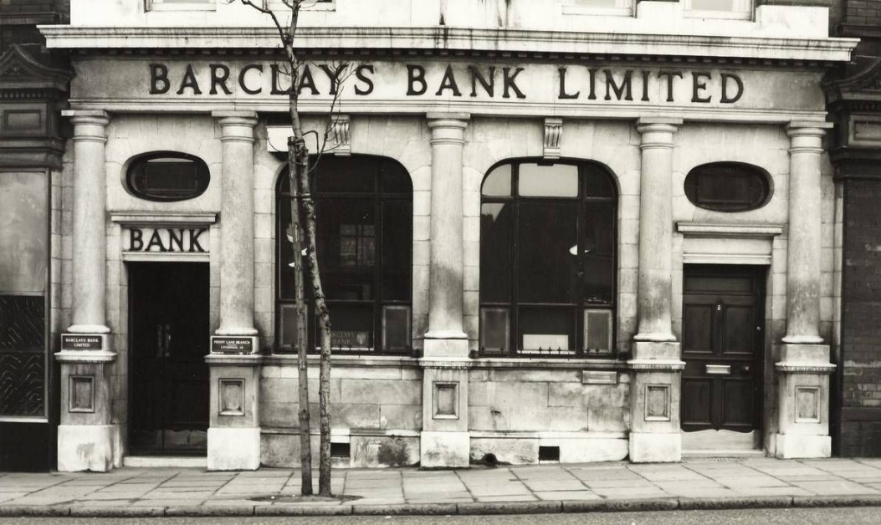
Source: ( https://www.shieldsgazette.com, 2024)

Ⅱ. Main body

- Definition of change management

Change management is a crucial aspect of any organization's success. It refers to the process through which organizations manage and lead employees through changes, ensuring a smooth transition and adoption of new strategies or initiatives.

- Recent History and Strategic Changes

  - Post-Financial Crisis 2008–2015

- In the wake of the 2008 global financial crisis, Barclays faced considerable challenges. The bank had exposure to risky assets and needed to raise capital to shore up its balance sheet. Barclays responded by implementing a restructuring plan that included selling non-core businesses and refocusing on its core operations, particularly investment banking through its "Barclays Investment Bank" division.

  - Post-2015 Restructuring

- Barclays focused on streamlining its operations and improving profitability. CEO Jes Staley, appointed in 2015, emphasized technological innovation, cost-cutting measures, and a strategic shift towards growth in its consumer banking and wealth management divisions. Under Staley’s leadership, Barclays divested from non-core markets, focusing more on its UK and US operations.

  - Leadership Transition and Strategy Shift 2021–Present

- After Jes Staley’s departure in 2021, following an investigation into his relationship with convicted financier Jeffrey Epstein, Barclays appointed C.S. Venkatakrishnan as CEO. Venkat’s leadership is focused on reinforcing the bank's digital transformation, improving sustainability efforts, and embracing environmental, social, and governance criteria.

- The bank has made strides in expanding its retail banking business through initiatives like Barclays’ digital bank, which has grown alongside the use of mobile banking apps and other innovations.

  - Impact of External Environment on Barclays

- Digital Disruption

- Investments in Digital and Tech: Barclays has embraced digital transformation to stay competitive. This includes heavy investments in artificial intelligence (AI), big data analytics, and blockchain technologies.

- Challenges of Innovation: While Barclays has made strides in digital innovation, it still faces significant challenges in competing with nimble FinTech and challenger banks that provide lower-cost services and cater to underserved segments.

- The increasing pressure to maintain a balance between traditional banking services and cutting-edge digital solutions has required Barclays to allocate significant resources to its technology infrastructure.

- Economic Uncertainty

- Brexit: The UK’s exit from the European Union has had profound effects on Barclays. While the bank has maintained a strong presence in both the UK and Europe, it has had to reconfigure its operations to comply with new regulations. This involved the relocation of certain operations from London to other EU cities like Dublin and Frankfurt to ensure it could continue offering services to European customers post-Brexit. Source: (www.ft.com, 2024)

- Interest Rates and Inflation: The global economic environment has been characterized by fluctuating interest rates, which directly impact Barclays’ profitability, particularly in its lending and mortgage business. In a low-interest-rate environment, banks tend to experience tighter margins, making it harder to generate profits from traditional lending activities.

- Regulatory Environment: Governments and regulatory bodies around the world have introduced new laws and compliance requirements. These include stricter anti-money laundering regulations, tax transparency rules, and capital adequacy requirements.

- Sustainability and ESG Trends

- Climate Change: Barclays has committed to financing the transition to a low-carbon economy, pledging to reach net-zero emissions in its lending and investment portfolios by 2050. This commitment requires balancing short-term profitability with long-term sustainability, especially as the bank navigates the regulatory landscape surrounding green finance.

- Social Responsibility: Additionally, there is a growing consumer demand for socially responsible banking. Barclays has worked to ensure that its operations, including its lending and investment practices, align with social values, including diversity and inclusion.

- Change management models

Change management models provide frameworks and guidelines to help organisations navigate complex changes effectively. By examining various models and incorporating issues related to strategic change, we can gain insights into how Barclays Bank managed change and what leadership styles were utilized in the process.

  - Lewin's model

Figure 5: Lewin’s model diagram
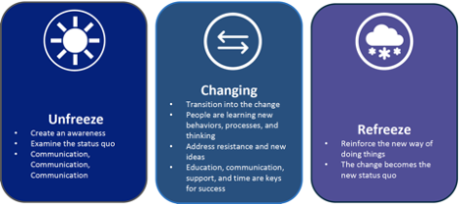

Source: (https://hrcoursesonline.com, 2024)

Lewin's model is a comprehensive framework that aims to guide organizations through the change process, ensuring a smooth transition and maximizing the likelihood of success. Applying Lewin's Change Management Model to Barclays Bank's transformation can provide a structured approach to driving change within the organization. By effectively unfreezing the existing mindsets, moving the organization towards the desired future state, and freezing the new behaviours,

Unfreezing Stage

The first step in Lewin's model is the unfreezing stage. During this stage, the existing behaviours and mindsets of employees are challenged and disrupted. Barclays Bank can utilize various strategies to achieve this unfreezing, including:

1. Communication: Communicate the need for change and its potential benefits to all employees. Use various channels, such as town hall meetings, emails, and posters, to ensure widespread understanding.

2. Empathy and Understanding: Show empathy towards employees' fears and concerns. By acknowledging their resistance and providing support, you can create a sense of trust and encourage open dialogue.

3. Training and Education: Offer training and development programs to enhance employees' skills and knowledge required for the change. This can help them transition more easily and adapt to new ways of working.

Moving Stage

Once the existing mindsets and behaviours have been unfrozen, the moving stage begins. During this stage, Barclays Bank can facilitate the implementation and adoption of new processes, systems, or behaviours. Strategies to facilitate this include:

1. Role Models: Identify and highlight successful individuals who have embraced change within the organization. Their examples can serve as inspiration and role models for others.

2. Training and Support: Provide ongoing training and support to help employees navigate the change effectively. Offer resources, such as user manuals, workshops, and coaching, to ensure a smooth transition.

3. Feedback and Recognition: Encourage employees to provide feedback on the change process. Recognize and reward those who embrace the change and contribute positively.

Freezing Stage

The final stage of Lewin's model is freezing. During this stage, Barclays Bank solidifies the new behaviours, attitudes, and mindsets that have been adopted during the change process. Strategies to achieve this include:

1. Supervisory Support: Ensure that supervisors and managers are aligned with the change and provide the necessary support and guidance to employees. Foster a culture of continuous learning and improvement.

2. Regular Review: Regularly assess the change's effectiveness and make necessary adjustments. This can help identify any areas that need further attention or reinforcement.

3. Celebration and Recognition: Celebrate milestones and achievements associated with the change. Recognize and acknowledge the contributions of individuals and teams who have played a crucial role in the transformation.

  - Kotter's Eight-Step Change Model

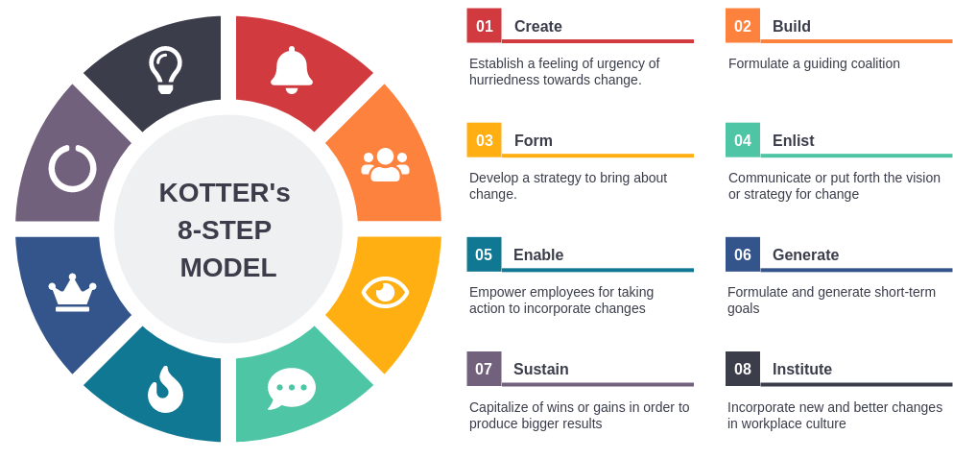
Figure 6: Kotter's Eight-Step Change Model Diagram
Source: (https://www.inkstrategy.com, 2024)

Kotter's Eight-Step Change Model is a popular framework for change management. Developed by John Kotter, a renowned leadership expert, this model provides a systematic approach to leading and managing change within organizations. It outlines the key steps involved in initiating, implementing, and sustaining change. Applying Kotter's eight-step change model for Barclays Bank can guide the institution through successful transformations. By implementing each step effectively, the bank can create urgency, build a coalition, develop a vision and establish a guiding coalition.

Step 1: Create Urgency
- The first step in Kotter's model involves creating a sense of urgency. Barclays Bank needs to communicate the urgency for change by highlighting the current state's limitations and the potential risks associated with not addressing them. By emphasizing the negative consequences of the status quo, the bank can motivate its staff and stakeholders to act.

Step 2: Build a Coalition
- To bring about change effectively, it is crucial to build a coalition. Barclays Bank should identify key stakeholders, such as employees, customers, and suppliers, who can contribute to and support the transformation. Engaging these stakeholders early on ensures that they have a voice in the process and are invested in the outcomes.

Step 3: Develop a Vision
- A clear and compelling vision is essential for guiding change efforts. Barclays Bank should define its desired future state and articulate a compelling vision that resonates with its stakeholders. This vision should inspire employees, customers, and investors to embrace change and align their efforts towards a common purpose.

Step 4: Create a Guiding Coalition
- To lead the change effectively, Barclays Bank needs to establish a guiding coalition. This involves selecting and delegating responsibility to a group of individuals who possess the necessary skills and experience to guide the transformation. The guiding coalition is responsible for overseeing the implementation of change and addressing any challenges that arise.

Step 5: Communicate the Vision
- Effective communication is key to ensuring the success of any change initiative. Barclays Bank should communicate the vision and the changes it intends to make to its stakeholders. This communication should be clear, consistent, and tailored to different audiences. By providing regular updates and feedback, the bank can ensure that everyone understands the purpose and direction of the transformation.

Step 6: Empower Action
- To drive change, Barclays Bank needs to empower its employees to act. This can be achieved by providing the necessary resources, training, and support to enable staff to execute change initiatives. By removing obstacles and creating a supportive environment, the bank can foster innovation and encourage employees to contribute their ideas and suggestions.

Step 7: Create Short-Term Wins
- To sustain momentum and create a sense of progress, Barclays Bank needs to create short-term wins. These wins can be small victories that serve as stepping stones towards the overall transformation. By celebrating these wins, the bank can build morale and demonstrate the effectiveness of the change process.

Step 8: Anchor the Changes in the Culture
- To ensure that change is sustained, Barclays Bank needs to embed it in the culture of the organization. This can be done through ongoing communication, reinforcement of the desired behaviours, and recognizing and rewarding employees who embrace the transformation. By anchoring changes in the culture,

  - The Pettigrew Model

Figure 7: The Pettigrew Mode diagram
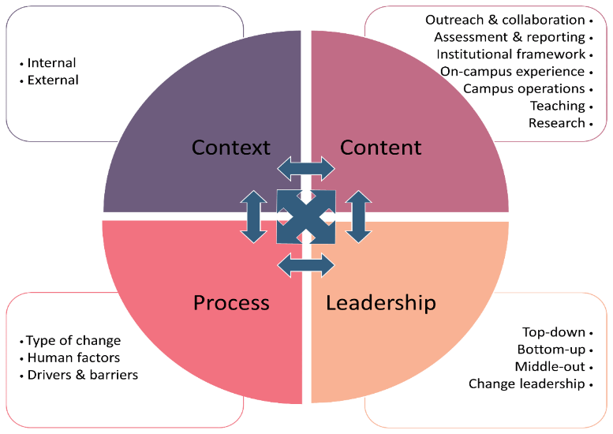

Source: (https://www.mdpi.com, 2024)

- Context

External Context

- Technological Disruption: The rise of fintech, digital banking platforms, and cryptocurrencies has altered customer expectations and competitive dynamics.

- Regulatory Environment: Barclays must comply with stringent financial regulations, including anti-money laundering, data privacy laws and environmental, social, and governance requirements.

- Economic Pressures: Economic downturns or fluctuations in interest rates can impact profitability, prompting the need for cost-cutting and innovation.

- Societal Expectations: Customers demand more ethical banking practices, inclusivity, and sustainability, pressing Barclays to adapt its corporate social responsibility strategies.

Internal Context

- Cultural Legacy: As a legacy institution, Barclays may face resistance to change due to entrenched practices and hierarchical structures.

- Financial Strength: Barclays’ capital resources allow investment in technology and talent for transformation.

- Leadership Vision: The effectiveness of leadership in articulating and driving the change plan is critical.

- Content

Key Components of Barclays’ Change Plan

- Digital Transformation: Developing advanced mobile banking platforms, AI-driven customer insights, and blockchain applications.

- Sustainability Goals: Achieving net-zero carbon emissions and offering green financing options to align with ESG objectives.

- Customer-Centric Strategies: Introducing personalized banking products, enhancing data security, and streamlining user experiences.
- Operational Efficiency: Implementing AI for fraud detection, automation of routine processes, and reducing operational costs.
- Workforce Modernization: Upskilling employees and fostering a culture of innovation to embrace technological advancements.
- Process

Implementation Strategies

- Leadership Engagement: Leaders must act as change champions, clearly communicating the vision and aligning organizational goals with the transformation agenda.

- Stakeholder Involvement: Active participation from employees, customers, and regulators ensures alignment and reduces resistance.

- Phased Approach: Barclays can roll out change initiatives in phases to mitigate risks and adapt based on feedback.

- Feedback Mechanisms: Continuous monitoring and evaluation of the change process to identify challenges and course correct.

- Investment in Training: Equipping employees with the skills needed to adopt new technologies and embrace new working methods.

Challenges

- Resistance to change from employees accustomed to traditional practices.
- Balancing short-term performance with long-term transformation goals.
- Aligning various departments to ensure seamless execution of cross-functional initiatives.

- Analysing change models critically

While different change management models offer valuable insights, it is important to acknowledge and address potential issues that can arise during the implementation of strategic change in Barclays Bank. These issues may include:

- Resistance and Resistance Management: Resistance to change is a natural reaction, and Barclays Bank needed to manage this resistance effectively. This involved addressing concerns, providing support, and offering training to ensure a smooth transition.

- Communication Challenges: Effective communication is crucial during organizational change. Barclays Bank needed to ensure clear and consistent messaging, addressing any concerns or doubts employees may have.

- Organizational Culture: Barclays Bank needed to adapt its organizational culture to support the strategic change. This involved fostering a culture of adaptability, collaboration, and innovation.

- Leadership Styles: Leaders play a significant role in driving change. Barclays Bank employed a range of leadership styles, including transformational, transactional, and servant leadership, to ensure effective change leadership.

  - Key Challenges and Opportunities

- Challenges

- Lack of Digital Transformation: Barclays Bank has struggled to keep pace with the digital revolution, which poses a significant threat to its market position.

- Competition from Fintech Startups: The bank's traditional business model is being challenged by innovative fintech startups, which are disrupting the financial services landscape.

- Regulatory Compliance: Barclays Bank must comply with constantly evolving regulations, which adds complexity and cost to its business operations.

- Opportunities

- Digital Transformation: By embracing digital technologies, Barclays Bank can enhance customer experiences, improve operational efficiency, and attract a younger customer base.

- Collaboration with Fintech Startups: The bank can leverage partnerships with Fintech startups to access cutting-edge technologies, innovative solutions, and new markets.

- Regulatory Compliance: Barclays Bank can utilize its expertise and experience in compliance to provide advisory services to its clients, generating additional revenue streams.

- The impact of organizational culture on the change management program at Barclays Bank

  - Organisational Culture of Barclays Bank

Barclays has a strong corporate culture, rooted in values such as integrity, customer focus, innovation, and diversity. Barclays has worked to instil a culture of accountability, ethics, and high performance, with a clear emphasis on stakeholder trust and regulatory compliance, particularly in the wake of previous scandals and crises. The culture emphasizes leadership, with an increasing focus on developing a diverse leadership team to drive innovation and success.

  - Impact on the Change Management Programme

A. Employee Resistance or Acceptance

- One of the major impacts of organisational culture on change management is the potential for employee resistance or acceptance. At Barclays employees may be accustomed to traditional ways of working. If the culture emphasizes stability and has a resistance to risk, employees may be more hesitant to embrace change.

- Barclays' historical focus on stability and risk management means employees could be cautious about changes that introduce uncertainty, particularly in regulatory environments.

- Change management must address concerns about uncertainty, clarify the benefits of change, and encourage a mindset shift. Leadership should work to foster a culture of continuous learning and adaptability to reduce resistance.

B. Leadership and Communication

- Leadership is central to managing change, and in a culture where leadership is valued, effective communication can greatly influence the success of the change management process.

- Leaders are expected to promote and support change by demonstrating commitment to the transformation and clearly communicating the reasons for change. A culture of strong leadership ensures that managers and executives are aligned and advocate for change across different departments.

- Barclays’ leaders must adopt a transformational leadership style that motivates employees to engage in and support change. Additionally, leadership communication is key in aligning the goals of the change program with the overall vision of the organization. If leaders are not adequately involved, change initiatives may face greater resistance.

- Innovation and Adaptability

- A culture that values innovation and adaptability support smoother transitions during periods of change. Barclays has been investing heavily in technology and digital transformation to keep pace with the rapidly evolving banking sector.

- Cultural readiness for innovation can vary among employees. While younger or more tech-savvy staff may embrace new technologies, others may be less comfortable with these changes.

- Ensuring that the culture promotes learning and development, through upskilling and reskilling initiatives, can significantly improve the success of change management programs related to technological transformation.

- Employee Engagement and Motivation

- Barclays’ culture emphasizes accountability and performance, which can both motivate and challenge employees during change. Employees might feel disengaged if they believe that change is imposed without proper consultation or consideration of their needs.

- Employee engagement initiatives, such as feedback channels, inclusive decision-making processes, and reward systems, can help overcome challenges. Involving employees in the change process and giving them a voice increases the chances of success and ensures smoother transitions.

- Collaboration and Cross-functional Teams

- Barclays' organisational culture has become more collaborative, with an increasing emphasis on teamwork, especially in cross-functional teams.

- A culture that encourages collaboration can help integrate diverse perspectives and expertise during change processes.

- This collaborative approach is crucial for successfully implementing complex changes, such as restructuring, merging business units, or launching new products or services.

- Organizational Values and Ethical Standards

- Barclays has worked hard to rebuild its reputation and embed a culture of ethics, integrity, and compliance into its daily operations.

- When change initiatives are aligned with organisational values, employees are more likely to support them, particularly when the changes involve maintaining regulatory compliance or improving customer service standards.

- The challenge arises if employees perceive that a change program contradicts core values or ethical standards. If there is any misalignment between the change initiatives and the organization’s ethical commitments, employees may resist the change or undermine the program’s objectives.

- Strategic Implications for Change Management at Barclays

A. Aligning Change with Culture

- Change programs related to diversity and inclusion, corporate social responsibility, and customer-centric banking should align with Barclays’ emphasis on integrity and ethical behaviour.

- Technological transformations, such as implementing digital banking solutions, need to respect and enhance the culture of customer service and innovation, ensuring employees feel empowered rather than alienated.

B. Creating a Culture of Continuous Improvement

- Barclays must cultivate a culture that is open to continuous improvement and learning. Change should not be seen as a one-time event but as part of an ongoing process of growth.

- This can be achieved by reinforcing the importance of innovation and learning, investing in employee training, and fostering a mindset that sees change as an opportunity rather than a threat.

- SWOT Analysis


Figure 2: SWOT Analysis diagram
Source (https://www.rhythmsystems.com,2024)

- Strengths

- Strong Leadership: Barclays Bank has an experienced and capable management team that has been instrumental in developing and implementing effective change management strategies.

- Global Reach: With operations in over 50 countries, Barclays Bank can leverage its global presence and knowledge to implement change initiatives across various regions and adapt to diverse cultural and operational contexts.

- Continuous Improvement: Barclays Bank commits to continuous improvement, allowing it to identify areas for improvement and proactively implement changes to enhance its competitiveness and operational efficiency.

- Weaknesses

- Resistance from Employees: Resistance to change is a common challenge faced by any organization, and Barclays Bank is no exception. Some employees may resist change due to fear of the unknown, resistance to change, or resistance to change agents.

- Cultural Resistance: Different cultural aspects within Barclays Bank may pose challenges when implementing change. Different countries and regions may have unique cultural norms and values that influence attitudes towards change.

- Complexity and Scope: Implementing change within a large and complex organization like Barclays Bank can be a complex task. The bank has diverse business units, product lines, and systems, which may require significant changes.

- Opportunities

- Digital Transformation: The increasing adoption of digital banking services presents significant opportunities for Barclays Bank. By leveraging cutting-edge technology, the bank can enhance customer experiences, improve operational efficiency, and gain a competitive edge.

- Risk Management: Barclays Bank can explore opportunities to enhance its risk management practices, particularly in areas such as cybersecurity, data privacy, and regulatory compliance. Investing in robust risk management systems can protect the bank from potential threats.

- Innovation and Disruption: Barclays Bank can foster a culture of innovation and embrace disruptive technologies to stay ahead in the rapidly changing financial services landscape. This can involve partnering with fintech companies or investing in research and development.

- Threats

- Competitive Landscape: The financial services industry is highly competitive, and new entrants and disruptive technologies can challenge Barclays Bank's position. The bank needs to stay agile and adapt to changing market dynamics to maintain its competitive advantage.

- Cybersecurity Risks: Cyberattacks have become a major concern for financial institutions, and Barclays Bank is exposed to cyber threats. The bank needs to invest in robust cybersecurity measures to protect customer data and prevent unauthorized access.

- Customer Trust: Maintaining trust with customers is crucial in the banking industry. Barclays Bank needs to maintain its reputation for reliability and transparency, as data breaches or scandals can erode customer trust and impact the bank's reputation.

- PESTEL Analysis

Figure 3: PESTEL Analysis diagram
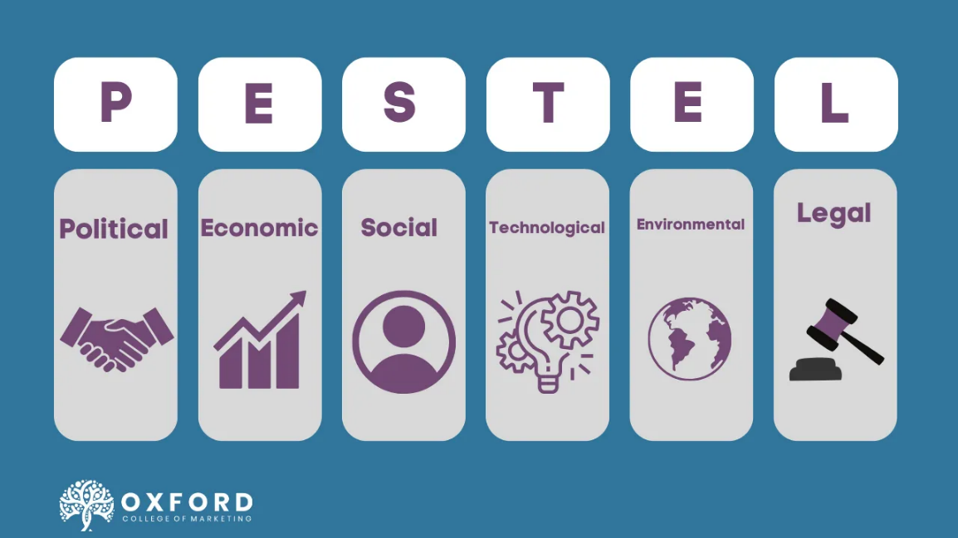
Source: (https://blog.oxfordcollegeofmarketing.com, 2024

- Political Factors

Recent History

- Barclays Bank, one of the largest financial institutions in the United Kingdom, has experienced significant changes in its recent history. In 2008, the global financial crisis caused significant disruptions to the banking system, resulting in losses for Barclays. The bank received government bailout funds to support its financial stability and survived the crisis.

Economic Uncertainty

- Economic uncertainty has been a pressing concern for Barclays Bank. The ongoing Brexit process, which threatens to disrupt trade relations and financial stability, has posed significant challenges for the bank. Uncertainty surrounding the UK's future economic relationship with the European Union has raised concerns about the bank's ability to navigate changing market conditions.

- Economic Factors

Digital Disruption

- Digital disruption has significantly impacted the banking industry, including Barclays. The rise of online banking and mobile banking has challenged traditional business models. Barclays has responded by investing in digital technologies to enhance customer experience and provide innovative banking services.

Ongoing Economic Uncertainty

- Economic uncertainty continues to pose challenges for the industry and Barclays Bank. The impact of Brexit, coupled with global macroeconomic factors, has subdued economic growth, affecting both businesses and individuals. This has had a ripple effect on the banking industry, including reduced lending activity and subdued demand for financial services.

- Social Factors

Changing Customer Preferences

- Customer preferences and behaviours have evolved, influenced by factors such as urbanization, the ageing population, and changing demographics. Barclays Bank has had to adapt to these changes to remain relevant and competitive. The bank has prioritized personalized customer experiences, including mobile banking and digital tools, to cater to changing customer preferences.

Ethical Concerns

- Ethical concerns have gained prominence in recent years, with customers demanding more socially responsible business practices. Barclays Bank has faced criticism for its involvement in controversial transactions and has faced scrutiny from regulators and stakeholders. The bank has responded with measures to enhance transparency and increase its commitment to ethical practices.

- Technological Factors

Digital Transformation

- Technological advancements have transformed the banking industry, and Barclays is no exception. The bank has invested heavily in digital platforms and technologies to enhance customer experience, improve operational efficiency, and stay competitive. This includes mobile banking, online banking, data analytics, and artificial intelligence.

Data Privacy and Security

- Data privacy and security have become increasingly important in the digital era. Barclays Bank has had to grapple with challenges such as data breaches, cyber threats, and regulatory requirements to protect customer data. The bank has invested heavily in cybersecurity measures and is developing new technologies to safeguard sensitive information.

- Environmental Factors

Sustainable Banking

- Environmental sustainability has become a priority for the banking industry, including Barclays Bank. The bank has recognized the importance of reducing its environmental footprint and has committed to sustainable banking practices. This includes promoting renewable energy, reducing carbon emissions, and supporting sustainable initiatives.

Regulatory Compliance

- The regulatory environment continues to evolve, driven by factors such as evolving industry standards, regulatory requirements, and changes in consumer behaviour. Barclays Bank has had to adapt to these changes to remain compliant and avoid regulatory penalties. The bank has invested heavily in compliance infrastructure and resources to ensure adherence to regulatory requirements.

- Legal Factors

Regulatory Compliance

- Barclays Bank operates in a highly regulated environment, subject to various laws and regulations. The bank must comply with regulatory requirements such as capital adequacy standards, anti-money laundering measures, and consumer protection regulations. Failure to do so can result in legal consequences and financial penalties.

Litigation and Legal Risks

- Barclays Bank is exposed to legal risks arising from various sources, including customer disputes, regulatory investigations, and litigation. The bank has risk management processes in place to mitigate legal risks and ensure fair treatment of customers.

- Porter's Five Forces model

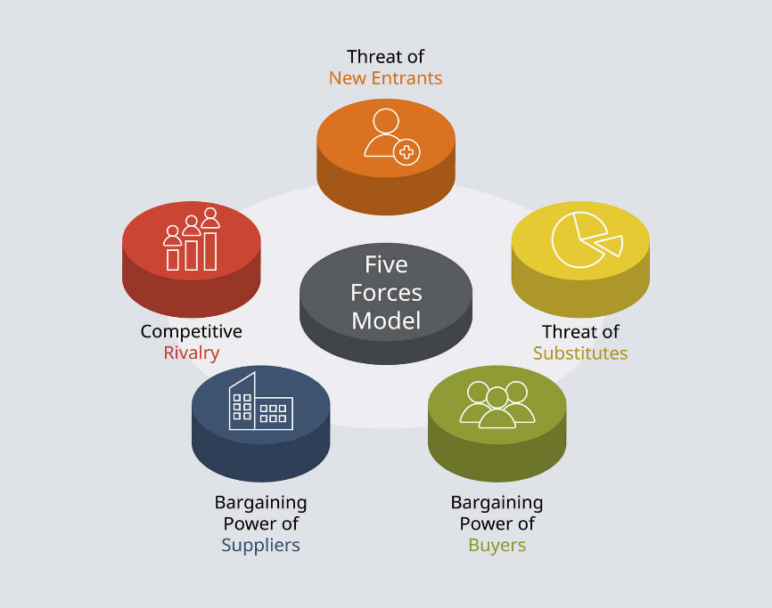
Figure 4: Porter's Five Forces Model diagram
Source: (https://zorgle.co.uk, 2024)

1. Threat of New Entrants: Moderate
Impact on Change Plan: Barclays faces moderate competition from new entrants, particularly fintech companies leveraging digital innovation to provide streamlined financial services. A successful change plan can help Barclays bolster its digital capabilities, customer engagement, and competitive edge.

Barriers to Entry
- High regulatory and capital requirements in banking limit new entrants.
- However, lower costs for digital startups create pressure on traditional banks like Barclays to innovate.

2. Bargaining Power of Buyers (Customers): High
Impact on Change Plan: Customers have significant power due to the availability of alternative financial solutions (e.g., fintech apps, challenger banks). Barclays’ change plan needs to prioritize customer-centric innovations, such as enhanced digital experiences and personalized financial products, to retain and attract clients.

Customer Expectations
- Seamless digital banking services.
- Transparent fees and competitive interest rates.
- Ethical banking and corporate social responsibility.

3. Bargaining Power of Suppliers: Moderate
Impact on Change Plan: In the financial sector, suppliers include technology providers, data analytics firms, and regulatory bodies. Barclays’ change plan must focus on strengthening partnerships with tech suppliers and ensuring compliance with regulatory changes to maintain operational efficiency.

Supplier Dynamics
- Dependence on advanced technology providers for digital transformation.
- High costs associated with cybersecurity and maintaining infrastructure.

4. Threat of Substitutes: High
Impact on Change Plan: Alternatives like mobile payment systems (e.g., PayPal, Apple Pay) and peer-to-peer lending platforms increase the threat of substitution. Barclays’ transformation efforts should address these risks by expanding digital payment solutions and exploring partnerships with FinTech.

Market Substitutes
- Cryptocurrency and blockchain-based financial products.
- Non-traditional lending and investment platforms.

5. Industry Rivalry: High
Impact on Change Plan: Barclays operates in a highly competitive banking industry, contending with both traditional competitors and digital disruptors. A robust change plan focused on innovation and cost efficiency is critical to gaining an advantage.
Key Rivalry Drivers:
- Price competition for loans and deposit rates.
- Innovation in customer services and digital capabilities.
- Brand reputation and trust in handling customer data.

- Change Management Plan / Barclays Bank

  - Proposed Change

- Enhanced Customer Relationship Management: The bank will invest in upgrading its CRM system to improve customer interaction and streamline processes. This will enable the bank to better understand customer needs and provide personalized products and services.

- Digital Transformation: Barclays Bank will focus heavily on digital transformation initiatives to enhance customer experience and introduce innovative banking solutions. This will involve upgrading the bank's digital platforms and integrating new technologies like artificial intelligence and blockchain.

- Enhanced Risk Management: The bank will implement enhanced risk management practices to identify and mitigate potential risks. This will involve implementing robust internal controls, conducting regular risk assessments, and fostering a culture of risk management throughout the organization.

- Global Expansion: Barclays Bank will explore opportunities for global expansion by targeting new markets and customer bases. This will involve conducting market research, establishing strategic partnerships, and tailoring products and services to meet the unique needs of international customers.

  - Financial Plan

A. Investment in Technology: The bank will invest a significant amount in upgrading its IT infrastructure, including CRM systems, digital platforms, and data analytics tools. This investment will be funded through a combination of internal resources and external financing.
B. Staff Training and Skill Development: Barclays Bank will allocate resources to conduct training programs for its employees to enhance their skills and knowledge in areas such as customer relationship management, digital transformation, and risk management. These training programs will be funded through salaries and training budgets.

- Marketing and Advertising: To drive awareness and adoption of the enhanced products and services, Barclays Bank will invest in marketing and advertising campaigns. This will involve both online and offline initiatives, including social media, targeted email campaigns, and traditional media channels.

- Operational Costs: The bank will incur additional costs related to the implementation and operation of the proposed changes. These costs will include additional staff salaries, consultants, software licenses, and IT infrastructure upgrades. These expenses will be carefully planned and managed to ensure they do not exceed allocated budgets.

  - Evaluation Plan

- Assessment: To assess the impact of the change on Barclays, a thorough assessment will be conducted. This will involve analyzing key performance indicators, conducting employee surveys, and reviewing customer feedback.

- Feedback: Employees and stakeholders will be allowed to provide feedback on the changes. This feedback will be collected through surveys, focus groups, and one-on-one interviews.

- Evaluation: The evaluation team will review the feedback received and assess the impact on the organization. Key performance indicators will be compared before and after the change to identify any positive or negative outcomes.

- Lessons Learned: Lessons learned from each evaluation will be documented and shared within the organization. This will help inform future change initiatives and ensure that best practices are followed.

  - Communication Plan

- Internal Communication

- Upfront Communication: Senior management will provide initial communication about the change, its purpose, and the expected outcomes.

- Departmental Briefings: Department heads and team leaders will conduct briefings to their teams to explain the changes, their roles, and any associated responsibilities.

- Training: Training sessions will be organized to provide employees with the necessary knowledge and skills to adapt to the changes effectively.

- Support Resources: Support resources such as FAQs, toolkits, and helplines will be created to address any questions or concerns employees may have.

- External Communication

- Customer Announcement: Barclays Bank will publish an announcement on its website, social media, and other channels to inform customers about the change and its impact on their services.

- Customer Support: Dedicated customer support teams will be in place to assist customers with any queries or concerns regarding the change.

- Customer Feedback: Barclays Bank will actively seek feedback from customers to understand the impact of the change on their experiences.

- Partnerships: The bank will maintain open lines of communication with partners, suppliers, and other stakeholders affected by the change to ensure a smooth implementation.

Ⅲ. Conclusion

Barclays Bank's change management plan is a strategic initiative designed to transform the organization to meet the challenges of a dynamic financial landscape. By focusing on operational efficiency, technological advancements, cultural transformation, and customer-centricity, Barclays aims to achieve sustainable growth and reinforce its position as a leading global bank. The successful implementation of this plan will require careful execution, continuous monitoring, and a commitment to excellence.

Ⅳ. References

(Firm), M., 2014. Power generation in Kuwait: MarketLine industry profile, London, England: MarketLine.
Anderson, D., 2010. Beyond change management [electronic resource]: how to achieve breakthrough results through conscious change leadership. San Francisso : Pfeiffer.
Anon., 2014. Power generation in Kuwait: MarketLine industry profile, London, England: MarketLine.
Anon., 2015. Leading sustainable change: an organizational perspective. Oxford: Oxford University Press.
Anon., 2023. Our strategy. [Online]
Available at: https://home.barclays
Anon., 2024. Managing Turbulence. [Online]
Available at: https://www.exed.hbs.edu
[Accessed 1 December 2024].
Anon., n.d. MarketLine Advantage. MarketLine Advantage, p. Database.
Cameron, E., 2020. Making sense of change management: a complete guide to the models, tools and techniques of organizational change. London; New York, New York: Kogan Page.
Carnall, C. A., 2014. Managing change in organizations. Harlow, England: Pearson.
Huff, R., 2024. Organizational culture. [Online]
Available at: https://www.britannica.com
[Accessed 1 December 2024].
Kotter, J. P., 2012. Leading change. Boston, Massachusetts: Harvard Business Review Press.
Ralph, S. M. a. O., 2024. Barclays to return £10bn to shareholders. [Online]
Available at: https://www.ft.com
Watkins, M. D., 2023. What Is Organizational Culture? And Why Should We Care? [Online]
Available at: https://hbr.org
[Accessed 1 December 2024].

