MOR20857548 (Max Lewis)

Reflection upon the application of the academic and professional skills learned.

Course-HND Applied computing
Word Count: 2409
Contents
Introduction 2
(1) Application of fundamental learning techniques 3
(1.2) Application of learning techniques 3
(1.4) Self-management 4
(1.6) Problem solving 4
(1.8) application of research methods 4
(2) Development throughout the year 5
(2.4) Presentation techniques 5
(2.8) Professional writing of reports 5
(3) Professional skills with lifelong potential applications 6
(3.1) Soft skills 6
(3.2) Employability skills 6
(3.3) Team working. 6
(3.4) Skills audit 7
(3.5) Professional, legal, ethical and sustainability issue related to higher education and employment. 7
Appendix 8
Figure 1 9
Figure 2 9
Figure 3 10
Figure 4 10
Figure 5 11
Figure 6 11
Figure 7 11
Figure 8 11
Figure 9 12
Figure 10 12
Figure 11 13
Figure 12 14
Figure 13 14
Figure 14 15
Figure 15 16
Figure 16 16
Figure 17 17
Figure 18 17
Figure 19 18
Figure 20 18
Figure 21 18
Figure 22 19
Figure 23 20
Figure 24 20
Figure 25 20
Figure 26 21
Figure 27 21
Figure 28 21
Figure 29 22
Figure 30 23
Figure 31 23
Figure 32 24

Introduction
In this assignment I will be demonstrating the skills I have gathered from “Academic and employability skills” and how I have used these techniques in other aspects of this course.

Application of fundamental learning techniques

(1.2) Application of learning techniques
See Figure 1
You can see from the image that my learning style has not changed from the three visual styles test I have done. The first visual styles test I did was not very conclusive as it was close between visual and auditory and least is kinaesthetic. The seconds test I did was bit more conclusive and the points for visual increased by 3, and then the final test proves very conclusively that am a visual learner. The reason for the dramatic increase is because each test I test was spaced out between each other. This gave me time between each test to use these techniques on this course and other “Assignments and test”. I do also feel this is course with other units promotes a more visual and auditory style approach to learning. So, I feel that even if you had a different style of learning you would most likely get familiar with these learning styles than kinaesthetic. This test does show that I much prefer visual learning than any other style. One of my goals is to complete the first year and second year of this course. Then after this the goal is to find a job in network, software development or royal signals officer. Any of these jobs I would be fine with as networking and software development I enjoy, and the royal army is something I am looking forward to pursuing a job in. I feel as these goals give me a motivation to try harder in these subject and prove that I can reach the level is requires for these jobs.

Self-management
See figures 4-10
From figures 4-10 you can see that I have managed and named my files appropriately depending on what they are for related to the course. Most files have a sub file in them depending on how many assignments I have for each of the course and the amount of work I have done for each. The names I have also given to each of the folder is appropriate and have been named correctly. This is important because it makes it more obvious where everything is stored. It makes saving new work a lot easier to place and find for future purposes, I also find it makes distinguishing work from one assignment to another easier, as if I had 5 assignments name “assignment 1” it would make it harder for me to know which ones are for which topic.

See figures 11 to 14
I have also managed my set up so it more conductive to learning. As you can see, I like to place some of my belongings on the desk, but this can make the desk cluttered and give me no room to move my mouse and can distracted me time to time. I find having my desk in this condition also makes it hard to be productive as I must search my desk for paper and other Items, I may need for working. Having my desk as cluttered as it is also showing my lack of time management skills, I should have cleaned my desk ages ago but never got around to doing it. So, I cleaned my desk and made lots more room as you can see form the images. I feel now that my workspace is more conducive for learning and gives me more room at my desk. I feel as if I have more room to place work and place my ideas done when working at home.

Problem solving
I have used problem solving a lot in software development, using computational thinking to break down problems and find patterns that will help me find the solution. This has helped with not only software development but with other aspects of this course. I find it useful to break down any problems I have and find what is the best way to continue with work. This can also increase how quick I finish a task, as am not trying to work and tackle the problem in one I break into multiple parts and finish each one quickly and I find this also increase my productivity.

application of research methods
See Figure 18
For my “Introduction to Web and Database Concepts” assignment 1, one of the requirements during the assignment was to use a peer reviewed journal and use it for accessing web sites “Useability, accessibility and search engine optimisation” I found 3 peer reviewed journals and used them to back up my points in the assignment. I used the Trinity of Saint Davids Online library to find these peer reviewed articles. On the website each article has a peer reviewed icon on it has been peer reviewed (See Figure 20 for an example). This made it very easy to find a peer reviewed article and one that was relevant to what I was talking about. I also used two articles in that assignment as well, to help me with the referencing I used an IEEE generator that when the link to a website, book or article is placed will show you how to reference them in word using IEEE. This helped me to reference what I wanted very quickly but also made sure it was done correctly in a professional manner. (See figure 21)

Development throughout the year

(2.4) Presentation techniques
See figure 22 and 29
I did a PowerPoint on the 21st of February and got feedback for this PowerPoint about the “Oblique wind Aircraft”. The feedback was constructive and made me reflect upon the first attempt to make a better second attempt. The first batch of feedback Told me that I had “rushed” my PowerPoint, “spelling/grammatical errors”, poorly designed layout and lacked organisation and my pages were hard to see along with the text. I was also told from the feedback that I should face my audience more and speak with more enthusiasm, you can see the feedback I was given in figure 22.
On the 6th of March I did my second PowerPoint and was a big improvement from the first presentation. I improved upon everything I was asked to do in the first batch of feedback. I talked with more enthusiasm, faced my audience, made my slides more appealing to my audience and I spread out images and included less text on my slides. This overall I think improved my presentation skills as it gave me more confidence in my ability to talk to a crowd of people.

(2.8) Professional writing of reports
For each of the reports I write I use a template I made. This makes it easy to start an assignment off but makes laying out an assignment quick, this means I can spend more time writing and planning than setting up the report. The first templates look very basic, and I personally don’t think look that good for a professional report. But I have recently used a different report structure and I think it looks more professional than the old one. I like to break my assignments down into steps (step one) which assignment is due first (second step) how much content have I got left for the assignment (step three) Organise the assignment. These three steps I find help me Find which assignment is more important to complete and which one can come at a later data. When it comes to writing assignments, I like to search what some of the terminology is before I start writing, if I don’t understand something. This makes it easier for me down the line, with better understanding as I can access more resources because of the understanding and break these resources down for the assignment.

Professional skills with lifelong potential applications

(3.1) Soft skills
See figure 23,24 and 25
The skills I think are requires for higher education is very good note taking skills. I can’t tell you the number of times setting out and making good notes could have helped my so much more with assignments and other parts of the course. I also think good listening skills are required as well, being able to listen what you are being told and taking on the advice to help improve your work and other aspects of your academic life is important. I think it important for personal development to address weakness and strengths. I think one of my weaknesses is when talking am unable to link what am talking about back to a subject matter. I think of the skill I have used that is transferable is note taking. I have gotten quite good with taking notes in Figures 23, 24 and 25 are notes I made on my phone one for when I went to the army careers office and the other one where question for the army reserve 3rd company (Rokes Drift). The question I had were ones I thought would be most important to talk about. There are some questions that I haven’t put down because I didn’t think about it at the time. I thinking this is another weakness and that’s not thinking ahead. I should a spent more time thinking about the questions a put more down even if I didn’t think they were important or stupid.

(3.2) Employability skills
See Figure 2 and 3
With second year of my HND complete I would be looking for a job in software development or as an officer in the royal signals. In figure 2 you can see the requirements for the royal signals officer from the official army website. If this does not work out, I can use my HND to go for a career in ICT. One of the jobs I found is a software developer in the DVLA in figure 3 you can see the requirements for the job on indeed. It requires you to be able to “work with a team”, be able to build test and deliver features and services”, being able to code in “C#, HTML, java, Ruby and python” and a motivation to develop skills in delivering “using a public cloud provider”.

(3.3) Team working.
I think being able to socialise with other people is important because it can allow people to synergize, work more efficiently and can make a group of people more coherent but most importantly being able to talk to other people allow you to better plan you work and help each other if there are any problems with the work. Having good leadership skill, I think is the most important part of working as a group but is also a hard role to be. You must make sure that everybody is doing their work, but you also must be understandable and reasonable. I would also say you have to be quite a charismatic person somebody who can lead but also do it without being forceful.
See figure 28
An example of me using teamwork is on the 28th of November 2023. I was approached by a friend if I could alter some images he had for the “Website design assignment” In figure 28 you can see the images he sent me. I would do this by using my Ipad and an app called procreate. I could blur and change colour of the image for him. I changed the image the way he wanted but he ended up not using it which is unfortunate.

(3.4) Skills audit
See Figures 27 and 26
I can see I have made skills audit for my skills, how confident I am with each one, are they transferable and what I can do to improve. I feel I can also come back to this skills audit later and reflexed to see if some of the skills am confident in have changed. This can also improve my chances of employability if I improve on what I put in my skill audit. I also think its good for self-reflection and improvement.

(3.5) Professional, legal, ethical and sustainability issue related to higher education and employment.
Professional issues regarding higher education and employment would include code of conduct, standards of practices and professional associations. These could cause issues for higher education and employment, as if views and associations are deemed unprofessional then that can cause issues for your education and for your company. This could affect how many people apply for course/company but may have a negative impact on your image.
Legal issues could include intellectual property laws, Contracts, and employment laws. These could be important because if you disobey these laws you could end up in a lot of trouble. For example, if you use something that is not yours and you don’t mention the creator this could force higher education website to take down the website. For companies this could cost them lots of money.
Ethical issues could be conflict of interest, farness, and confidentiality. These could be in place at employment to make sure information about another employee is kept safe for higher education it be to protect the information about a student safe. It is also important that you treat every person that is sending employment that they are treated fair same goes for higher education.
Sustainability issues may include environmental sustainability, social responsibility, and ethical sourcing. Many higher education institutions buy many different types of items to help with education like office supplies, food, and technology and its important that all of these are sourced ethically. This means that the companies that sell and make the items are using the right standards when it comes to labour and supply chains. If employment and higher education do not meet the ethical consideration, then it could look bad on the institution and people with in it.

Appendix

Figure 1
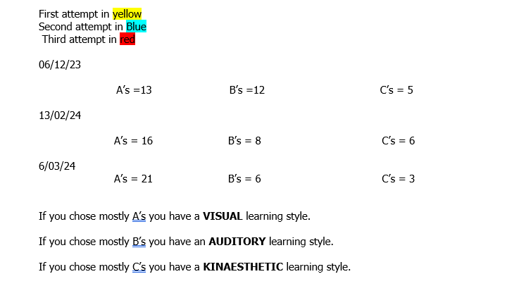

Figure 2
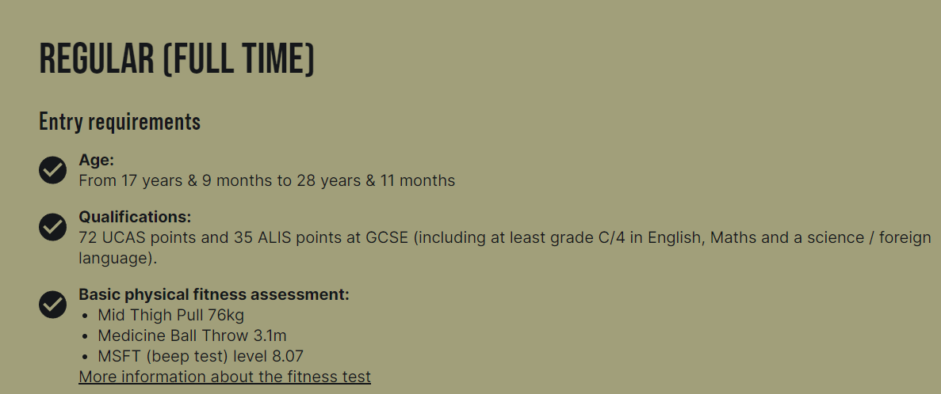

Figure 3
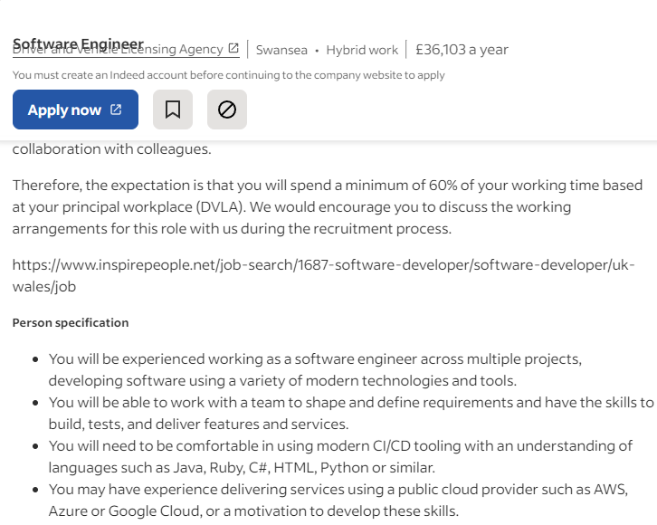

Figure 4
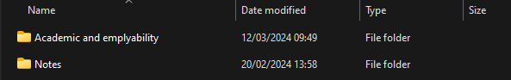

Figure 5
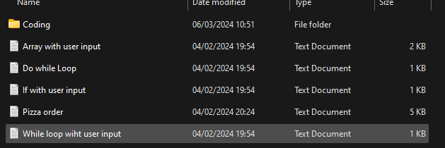

Figure 6
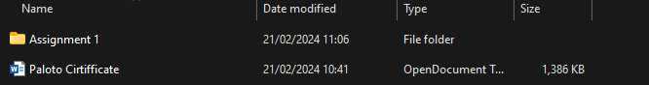

Figure 7
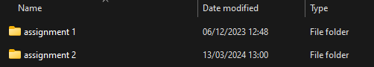

Figure 8
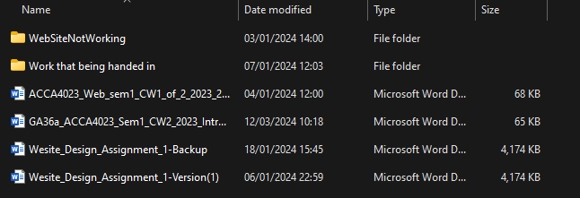

Figure 9

Figure 10
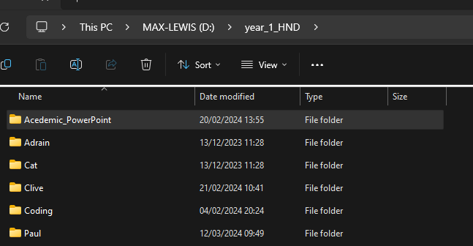

Figure 11
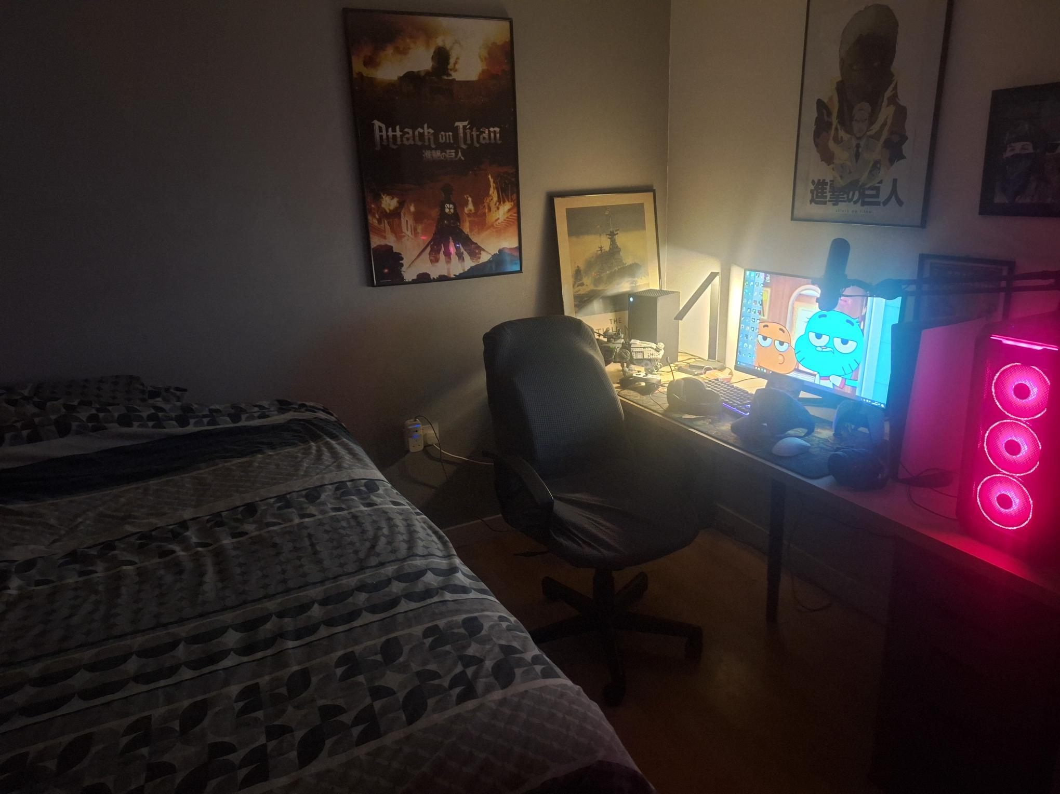

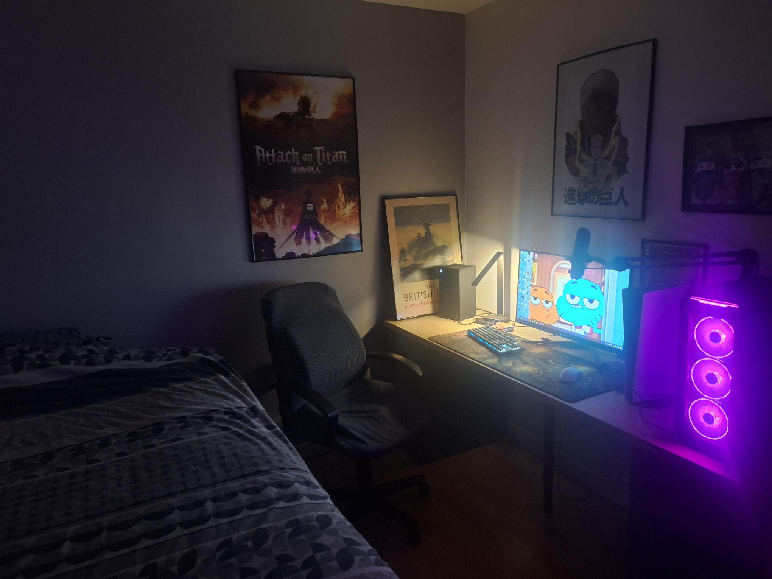
Figure 12

Figure 13


Figure 14


Figure 15
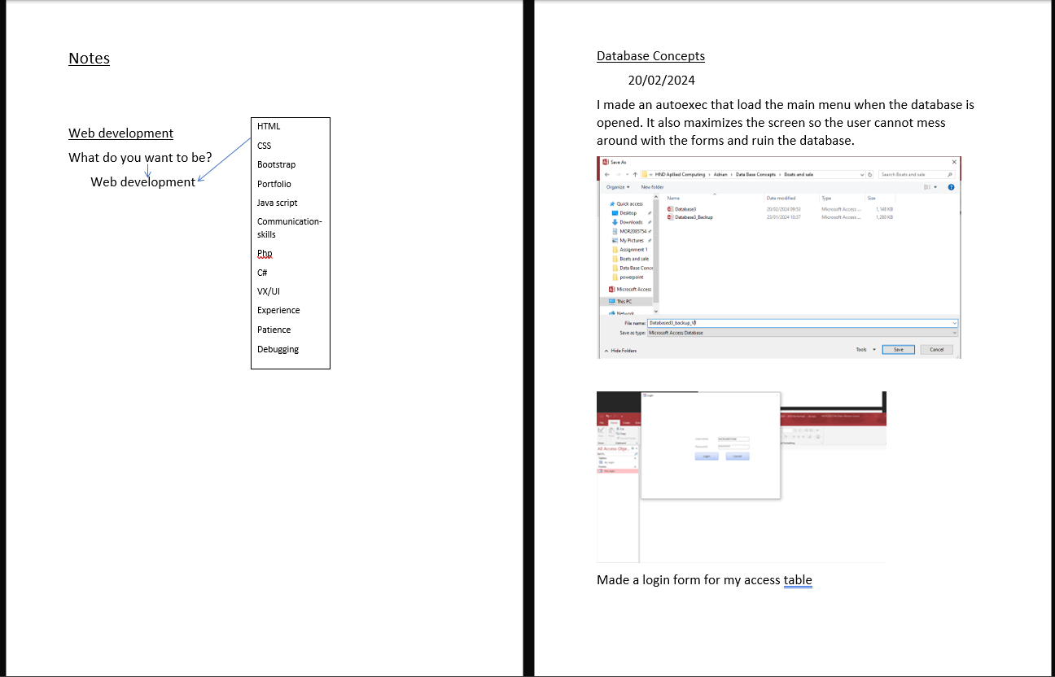

Figure 16
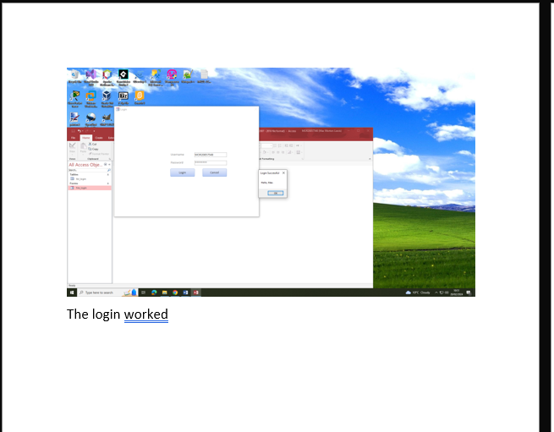

Figure 17
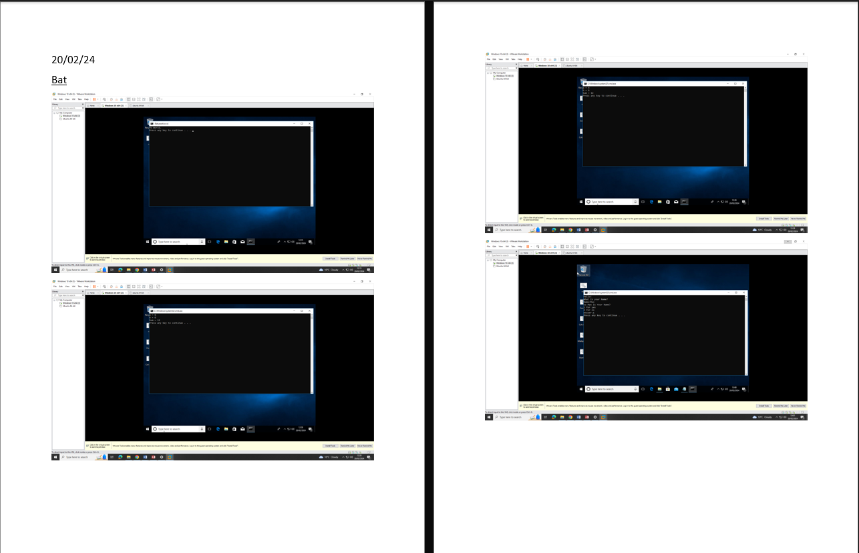

Figure 18
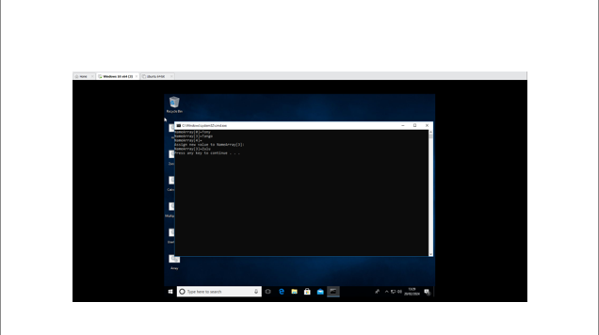

Figure 19
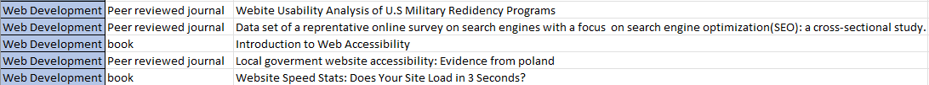

Figure 20
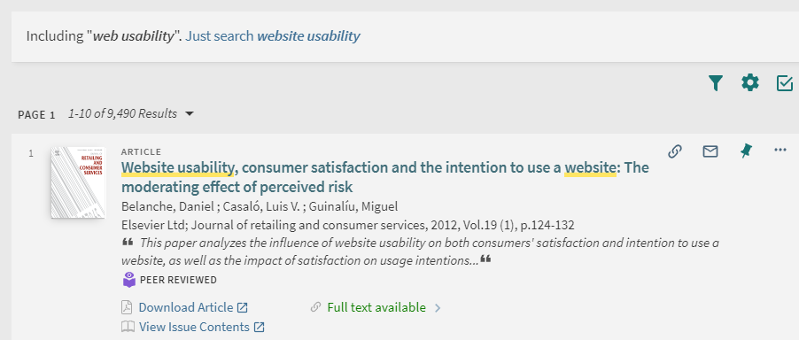

Figure 21
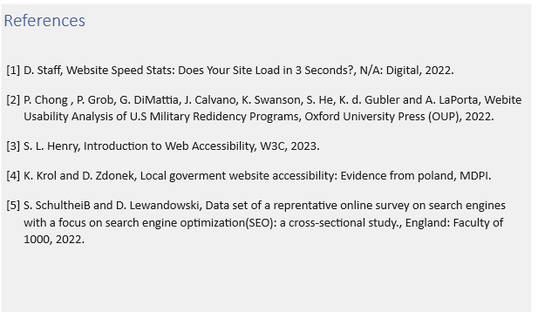

Figure 22
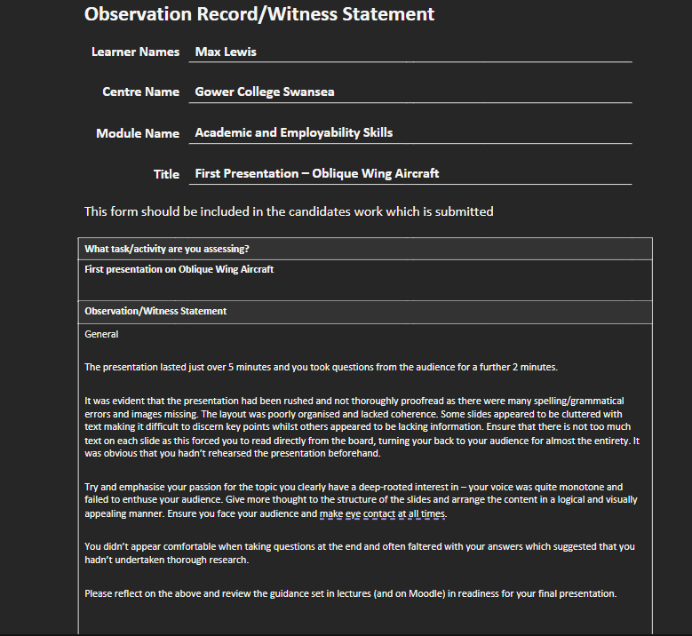
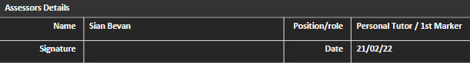

Figure 23


Figure 24


Figure 25
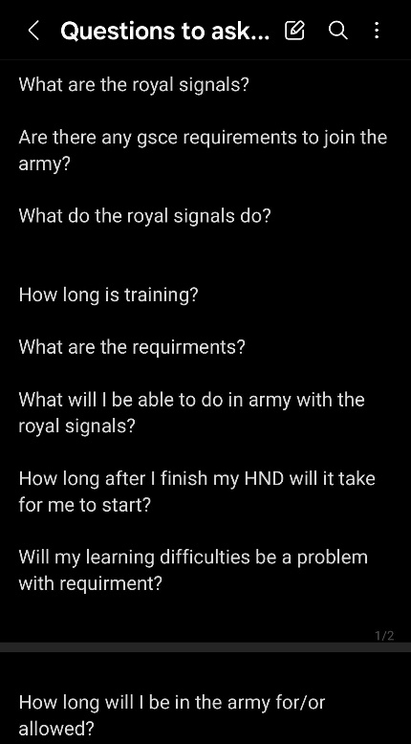

Figure 26
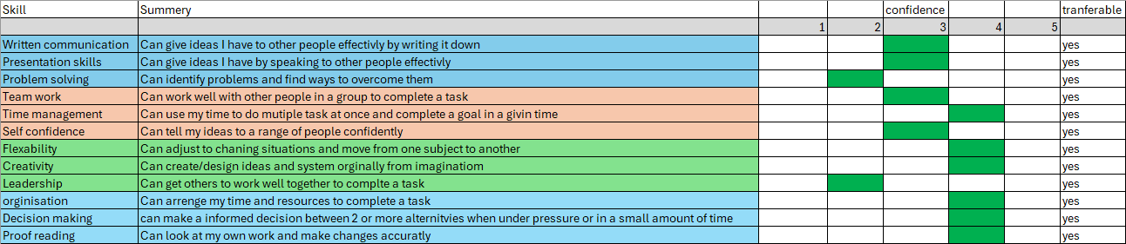

Figure 27
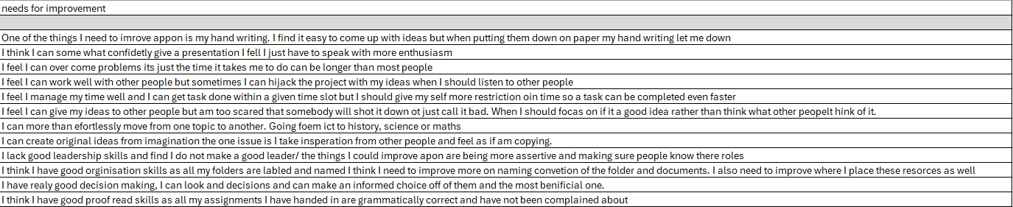

Figure 28
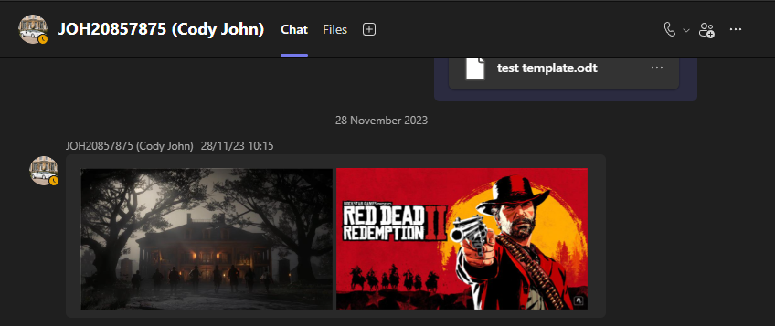

Figure 29
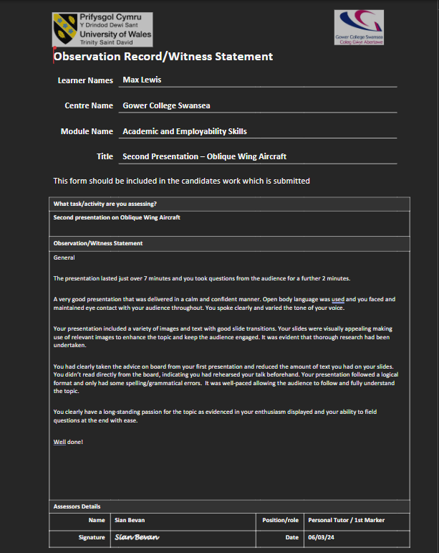

Figure 30
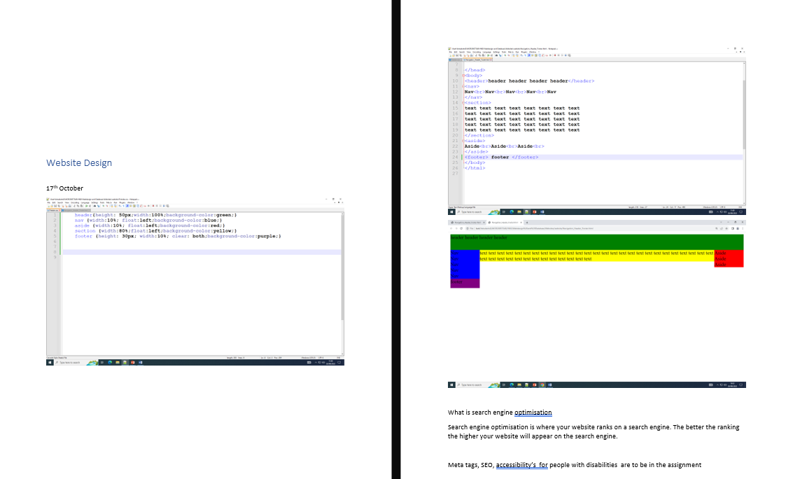

Figure 31
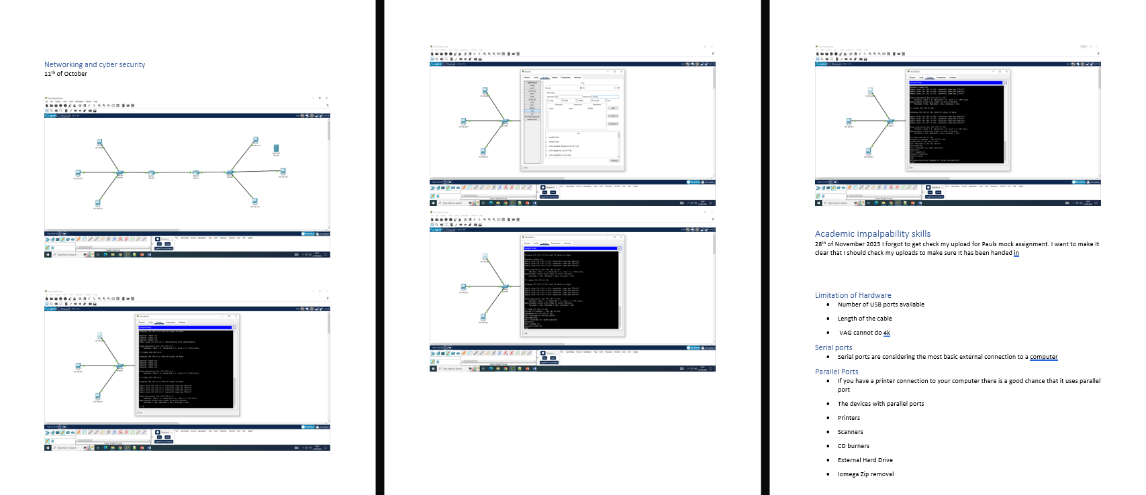

Figure 32


